Supplemental information

Supplemental Figure 1
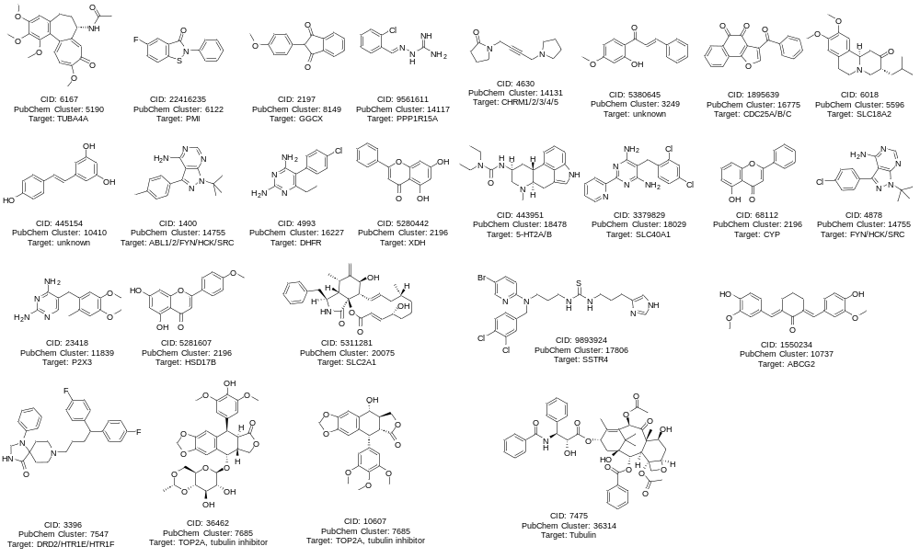
Supplemental Figure 1: Chemogenomic library compounds present in PubChem GCM. Structures and annotated targets of Novartis chemogenetics library members contained within PubChem GCM data.

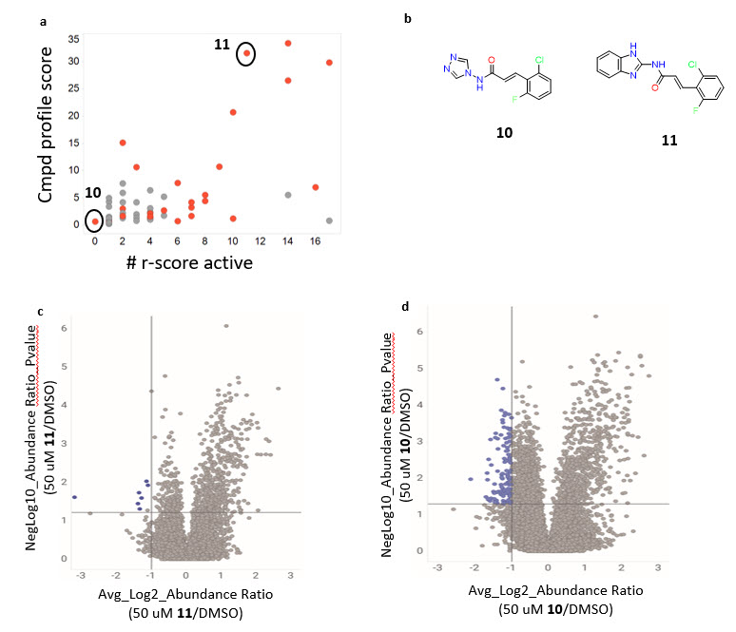
Supplemental Figure 2: GCM selectivity is consistent with proteome-wide selectivity. a Scatter plot of compound profile score versus activity in assay panel. Each circle denotes an individual compound within the cluster. Red indicates that compound contains Michael Acceptor, while grey does not. b structure of representative active (11) and inactive compound (10) from cluster. c,d iTRACE profiles from covalent chemoproteomic competition studies. Each circle denotes an individual cysteine-containing peptide identified. Blue circles indicate peptides competed by competition compound with sufficient magnitude and statistical significance.

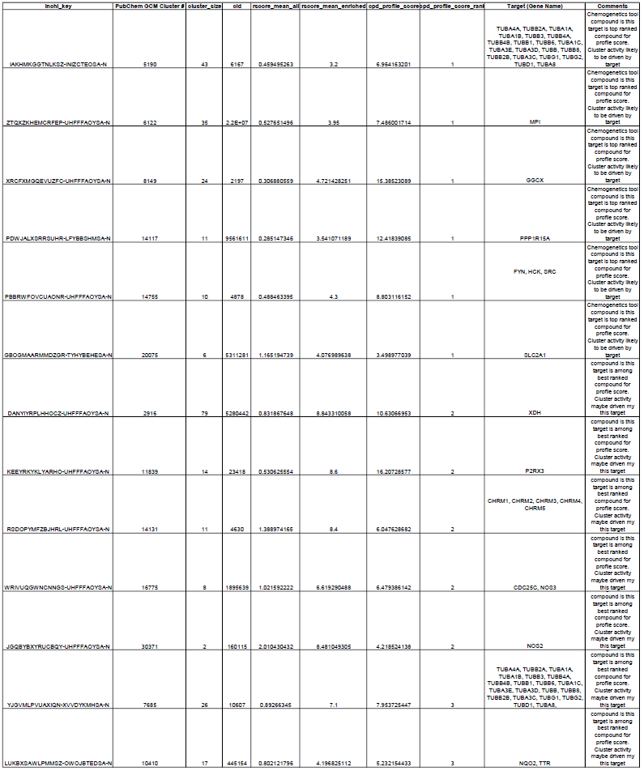
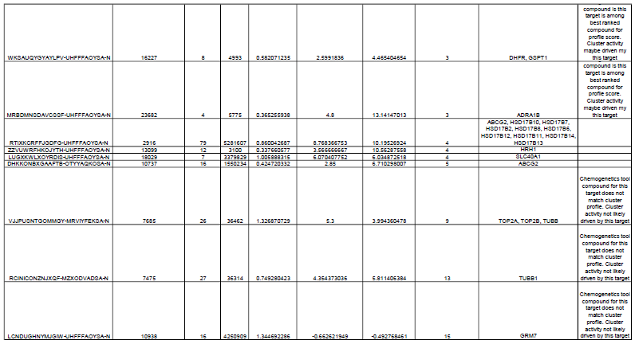
Supplemental Table 1: High rank in cluster profile score of Novartis chemogeneitcs tools compounds suggests that annotated target is likely responsible for cluster activity.

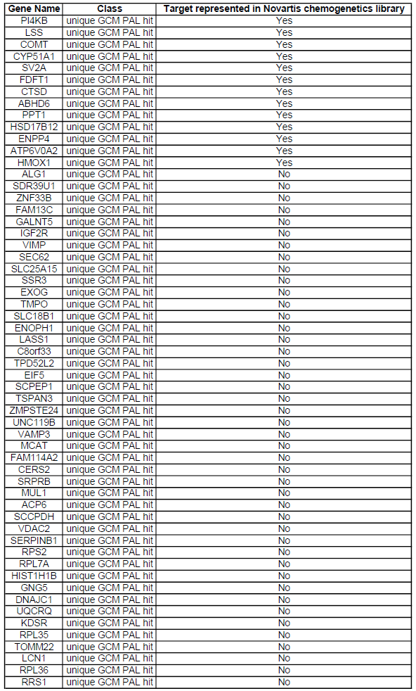
Supplemental Table 2: Targets uniquely enriched by GCM PAL probes.

