SUPPLEMENTARY FIGURES & TABLES:

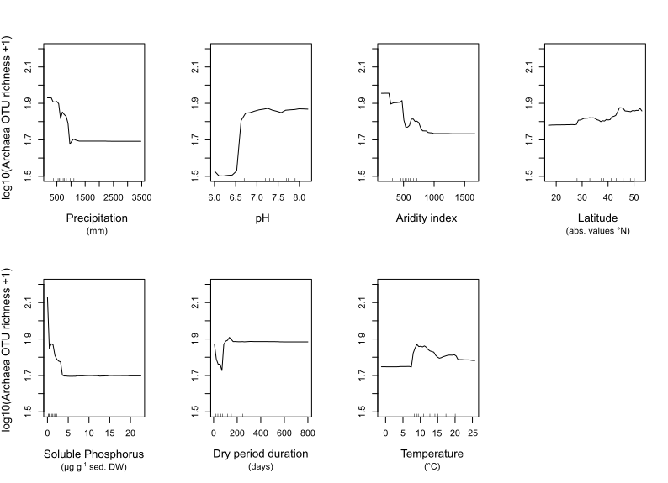
SUPPLEMENTARY FIGURE 1: Partial dependence plot of Archaea OTU richness indicating the contribution of predictor variables to log10(x+1) OTU richness (y-axis) as a function of the predictors (i.e. when the other contributing predictors are held at their mean). Hash marks at the bottom of the plot indicate the deciles of the predictor variables. Only predictors with a %IncMse above the first quartile value of the non-null %IncMse values are shown, in order of decreasing importance (from the top-left to the bottom-right).

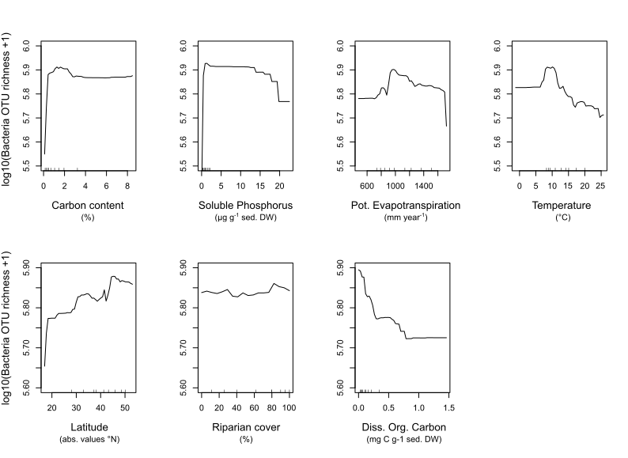
SUPPLEMENTARY FIGURE 2: Partial dependence plot of Bacteria OTU richness. The plots show the contribution of predictor variables to log10(x+1) OTU richness (y-axis) as a function of the predictors (i.e. when the other contributing predictors are held at their mean). Hash marks at the bottom of the plot indicate the deciles of the predictor variables. Only predictors with a %IncMse above the first quartile value of the non-null %IncMse values are shown, in order of decreasing importance (from the top-left to the bottom-right).

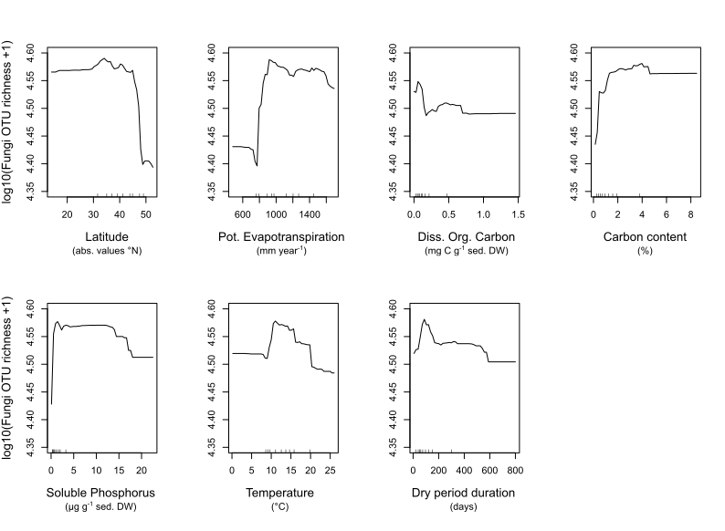
SUPPLEMENTARY FIGURE 3: Partial dependence plot of Fungi OTU richness. The plots show the contribution of predictor variables to log10(x+1) OTU richness (y-axis) as a function of the predictors (i.e. when the other contributing predictors are held at their mean). Hash marks at the bottom of the plot indicate the deciles of the predictor variables. Only predictors with a %IncMse above the first quartile value of the non-null %IncMse values are shown, in order of decreasing importance (from the top-left to the bottom-right).

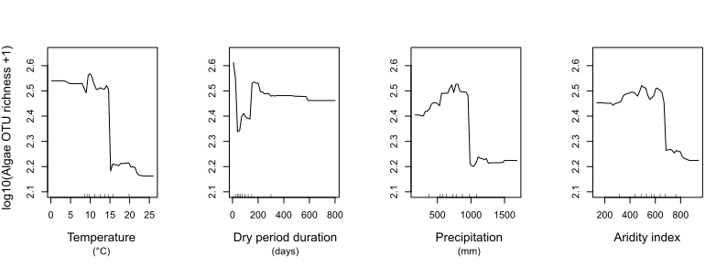
SUPPLEMENTARY FIGURE 4: Partial dependence plot of Algae OTU richness. The plots show the contribution of predictor variables to log10(x+1) OTU richness (y-axis) as a function of the predictors (i.e. when the other contributing predictors are held at their mean). Hash marks at the bottom of the plot indicate the deciles of the predictor variables. Only predictors with a %IncMse above the first quartile value of the non-null %IncMse values are shown, in order of decreasing importance (from the top-left to the bottom-right).

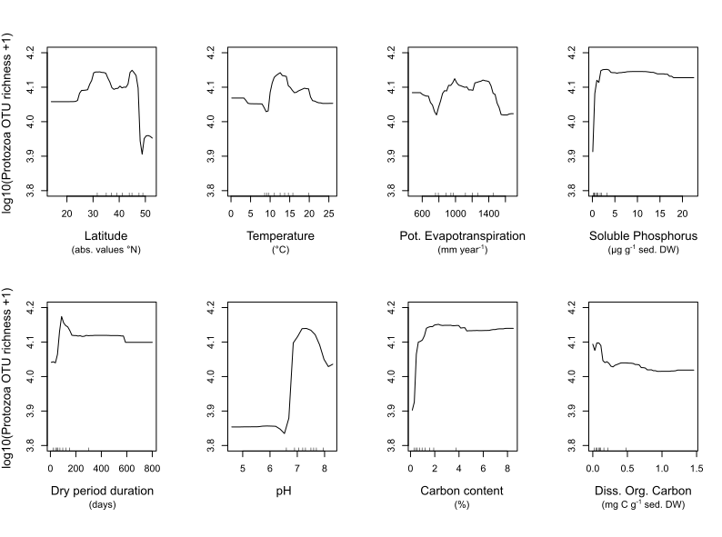
SUPPLEMENTARY FIGURE 5: Partial dependence plot of Protozoa OTU richness. The plots show the contribution of predictor variables to log10(x+1) OTU richness (y-axis) as a function of the predictors (i.e. when the other contributing predictors are held at their mean). Hash marks at the bottom of the plot indicate the deciles of the predictor variables. Only predictors with a %IncMse above the first quartile value of the non-null %IncMse values are shown, in order of decreasing importance (from the top-left to the bottom-right).

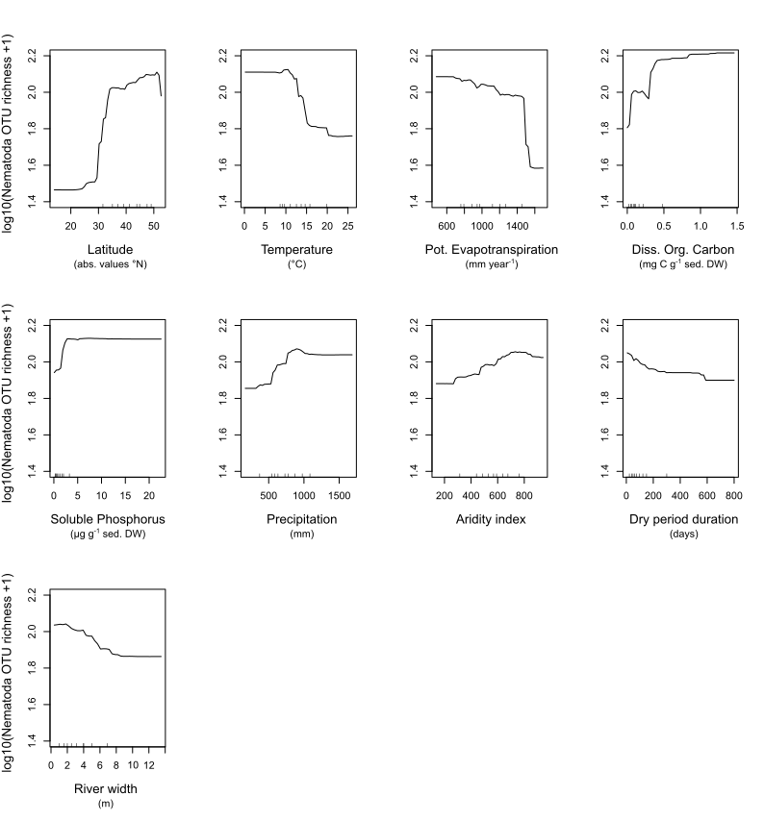
SUPPLEMENTARY FIGURE 6: Partial dependence plot of Nematoda OTU richness. The plots show the contribution of predictor variables to log10(x+1) OTU richness (y-axis) as a function of the predictors (i.e. when the other contributing predictors are held at their mean). Hash marks at the bottom of the plot indicate the deciles of the predictor variables. Only predictors with a %IncMse above the first quartile value of the non-null %IncMse values are shown, in order of decreasing importance (from the top-left to the bottom-right).

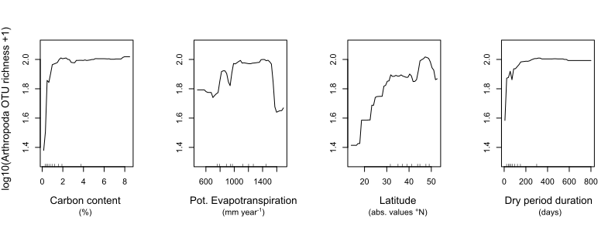
SUPPLEMENTARY FIGURE 7: Partial dependence plot of Arthropoda OTU richness. The plots show the contribution of predictor variables to log10(x+1) OTU richness (y-axis) as a function of the predictors (i.e. when the other contributing predictors are held at their mean). Hash marks at the bottom of the plot indicate the deciles of the predictor variables. Only predictors with a %IncMse above the first quartile value of the non-null %IncMse values are shown, in order of decreasing importance (from the top-left to the bottom-right).

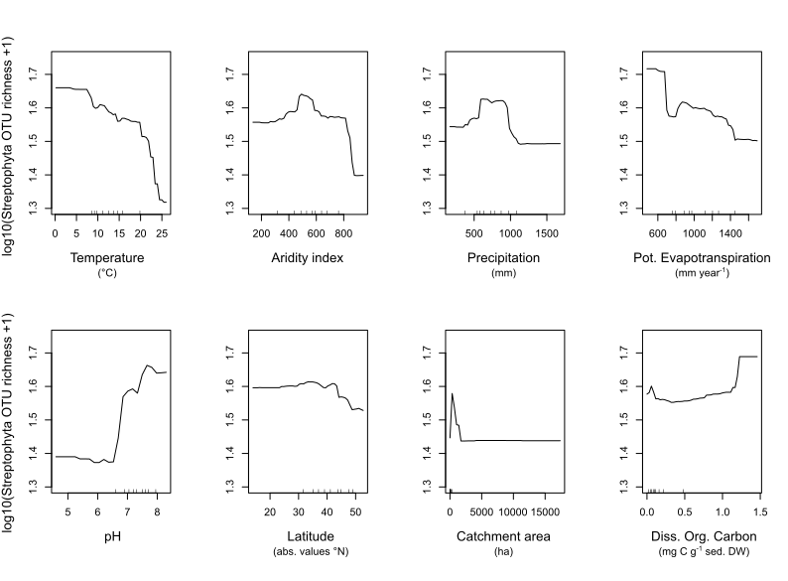
SUPPLEMENTARY FIGURE 8: Partial dependence plot of Streptophyta OTU richness. The plots show the contribution of predictor variables to log10(x+1) OTU richness (y-axis) as a function of the predictors (i.e. when the other contributing predictors are held at their mean). Hash marks at the bottom of the plot indicate the deciles of the predictor variables. Only predictors with a %IncMse above the first quartile value of the non-null %IncMse values are shown, in order of decreasing importance (from the top-left to the bottom-right).

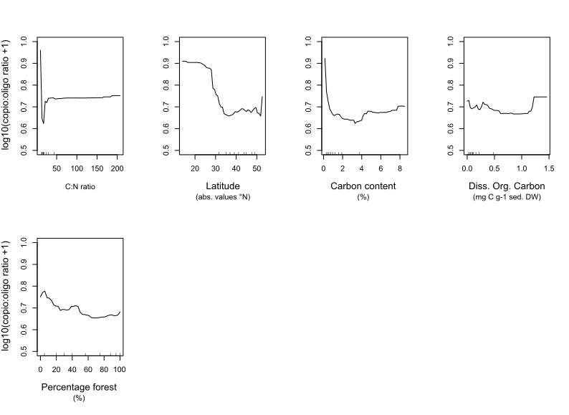
SUPPLEMENTARY FIGURE 9: Partial dependence plot of the relative abundance of fungal copiotrophic and oligotrophic OTUs indicating the contribution of predictor variables to log10(copio:oligo ratio +1) (y-axis) as a function of the predictors (i.e. when the other contributing predictors are held at their mean). Hash marks at the bottom of the plot indicate the deciles of the predictor variables. Only predictors with a %IncMse above the first quartile value of the non-null %IncMse values are shown, in order of decreasing importance (from the top-left to the bottom-right).

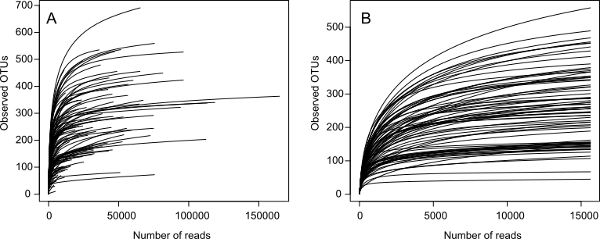

SUPPLEMENTARY FIGURE 10: Rarefaction curves showing Eukaryotic OTU richness as a function of the number of reads (sample size) in each sample before (A) and after rarefaction to 15624 reads for the 18S marker. Each curve corresponds to a sample.

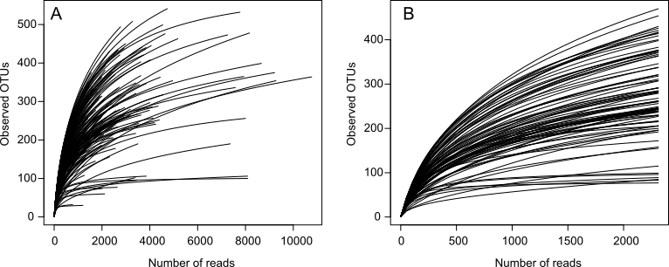

SUPPLEMENTARY FIGURE 11: Rarefaction curves showing Bacteria/Archaea OTU richness as a function of the number of reads (sample size) in each sample before (A) and after rarefaction to 2311 reads for the 16S marker. Each curve corresponds to a sample.

SUPPLEMENTARY TABLE 1: Number of samples, PCR replicates, reads and unique sequences (=OTUs) for the Bacteria (Bact02) and Eukaryota (Euka02) marker after each filtering step.

Filtering step | Bact02 |  |  |  | Euka02
Filtering step | Samples | PCR Replicates | Reads | OTUs | Samples | PCR Replicates | Reads | OTUs
Raw data | 177 | 531 | 6259902 | 2357163 | 177 | 531 | 19134518 | 1013900
Basic filter (singletons, length) | 177 | 531 | 2921780 | 282351 | 177 | 531 | 13196993 | 234390
Removal of OTUs found in only 1 PCR replicate | 177 | 530 | 2339063 | 80513 | 177 | 531 | 13196993 | 82161
obiclean | 177 | 530 | 1303834 | 5751 | 177 | 531 | 9555919 | 4302
OTU clustering 97% | 177 | 530 | 691283 | 2166 | 177 | 531 | 7989962 | 2692
Removal of dysfunctional PCRs | 167 | 488 | 542701 | 2154 | 152 | 388 | 6761322 | 2676
Removal of contaminants and non-target taxa | 167 | 488 | 466680 | 2117 | 152 | 388 | 4020797 | 2629

