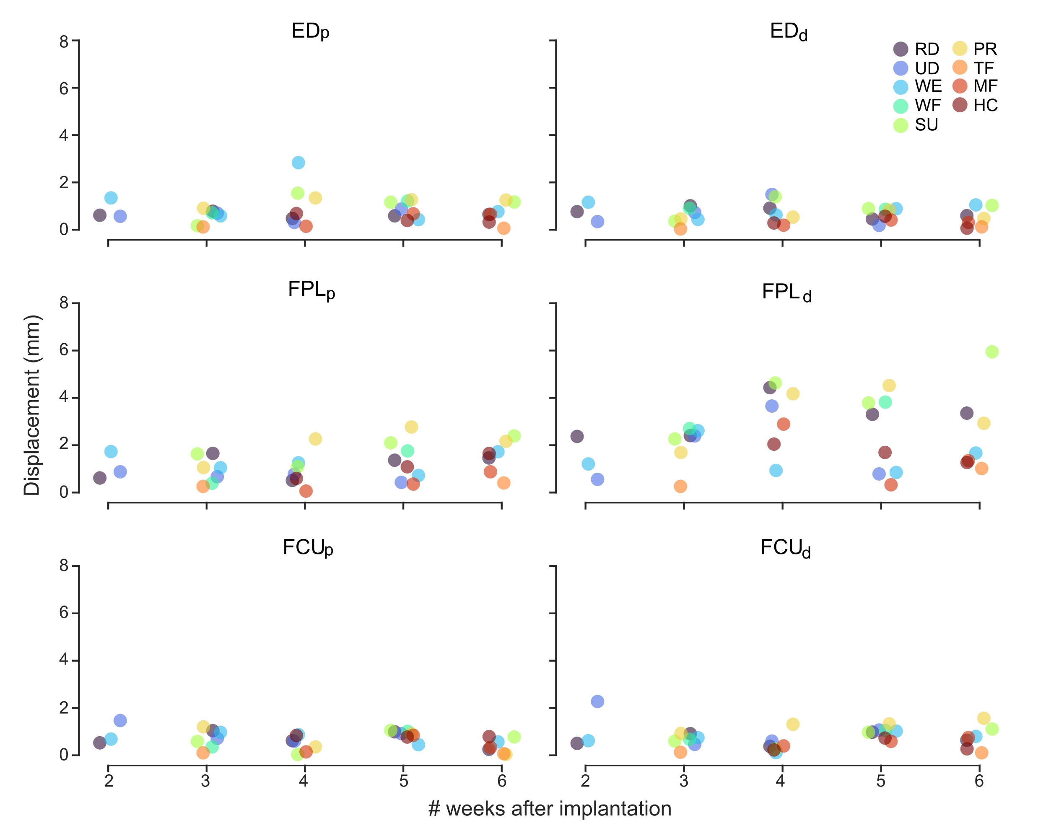

Extended Data Fig. 1 | Displacement of each implanted magnet following muscle activation throughout the implantation period. The graphs report the mean value of the displacement of each magnet from its rest position following muscle contraction induced by different movements. The patterns of displacement proved stable throughout the six weeks period, in agreement with the outcomes of the periodic ultrasound measures. The maximum displacement was achieved by FPL_{d} following wrist supination (>6mm). Acronyms: radial deviation (RD), ulnar deviation (UD), wrist extension (WE), wrist flexion (WF), wrist supination (SU), wrist pronation (PR), thumb flexion (TF), middle finger flexion (MF), HC (hand closing).
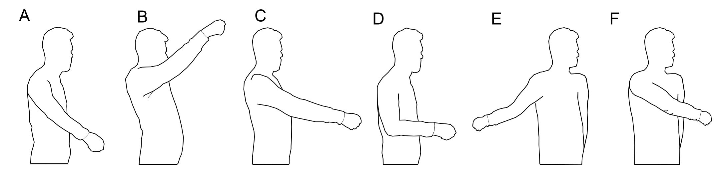

Extended Data Fig. 2 | Target positions of the arm during the Motion Test. The figure represents the target positions that the participant was asked to match with the arm during the Motion Test, namely: shoulder flexed at 45° (A); shoulder flexed at 90° (B); shoulder flexed at and 135° (C); elbow flexed at 90% (D); reaching front obliquely to the right (E) and to the left (F).

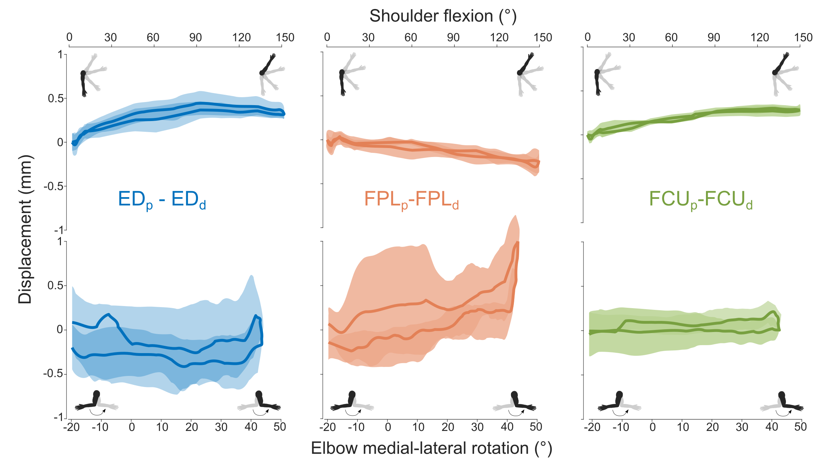
Extended Data Fig. 3 | Effect of limb movements on the rest distance between magnet pairs. Displacement from rest of the distance between magnet pairs as a result of limb movements, specifically shoulder flexion/extension and elbow medial/lateral rotation. As for the elbow flexion/extension (Fig.1d), these data were collected by asking the participant to move the elbow and shoulder following sinusoidal waves with different periods (8s, 6s, 4s, 3s, and 2s) displayed on the GUI, while keeping the implanted muscles relaxed. The graphs show that the displacement proved generally below 0.5mm, with the only exception of FPL for which the rest distance varied >1mm following elbow medial/lateral rotation. Overall, these artifacts proved negligible compared to those induced by the elbow flexion/extension.

Extended Data Table 1 | Scores obtained in the functional tests for EMG, direct, and pattern recognition controllers (EMG, DC, PR)
 | SHAP |  |  |  |  |  |  | MMDT | CRT
 | IoF* | Spherical | Power | Tip | Tripod | Lateral | Extension | 3 Trials Time (s) | Up + Down (s) | Up (s) | Down (s)
EMG | 52 | 77 | 43 | 48 | 22 | 59 | 70 | 531 | 40.46 | 20.62 | 21.28
DC | 38 | 45 | 24 | 25 | 29 | 45 | 43 | 807 | 52.84 | 24.44 | 26.28
PR | 52 | 55 | 59 | 25 | 26 | 50 | 70 | 747 | 48.65 | 23.75 | 26.81

* Index of Function.

