SI Appendix: Hydrogenotrophic Methanogenesis at 7-12 mbar by Methanosarcina barkeri under Simulated Martian Atmospheric Conditions

*Rachel L. Harris¹ and *Andrew C. Schuerger²
¹ Dept. of Organismic and Evolutionary Biology, Harvard University, Cambridge, MA 02138, USA; email: rachel_harris@fas.harvard.edu; Ph: 336-883-5905.
² Dept. of Plant Pathology, University of Florida, 505 Odyssey Way, Space Life Sciences Lab, Exploration Park, Merritt Island, FL 32953, USA; email: schuerg@ufl.edu; 321-261-3774.

This document contains:
Figures S1 – S6
Tables S1 – S8 can be found as additional .xlsx files

Supplementary Figures

Figure S1. Gas chromatograph standard curves for CH₄ measurements from the Methane Assay Chambers (MAC units) within the Planetary Atmospheric Chamber (PAC), as described in the main text.
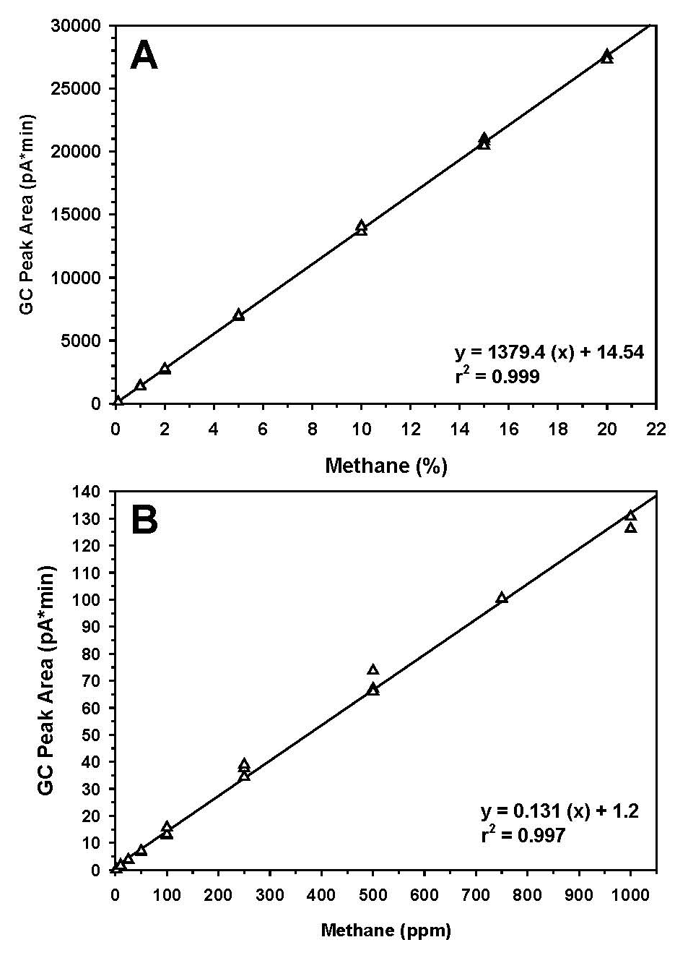

Figure S2. M. barkeri CH₄ production rates across diverse Mars-simulated conditions. Normalized CH₄ production data from this study in comparison to those published by Harris et al., 2021 (38). Minimum quantifiable limit (MQL; 10 ppm in the current study) dashed line represents transformed minimum threshold for quantifiable detection above GC-FID background signal.
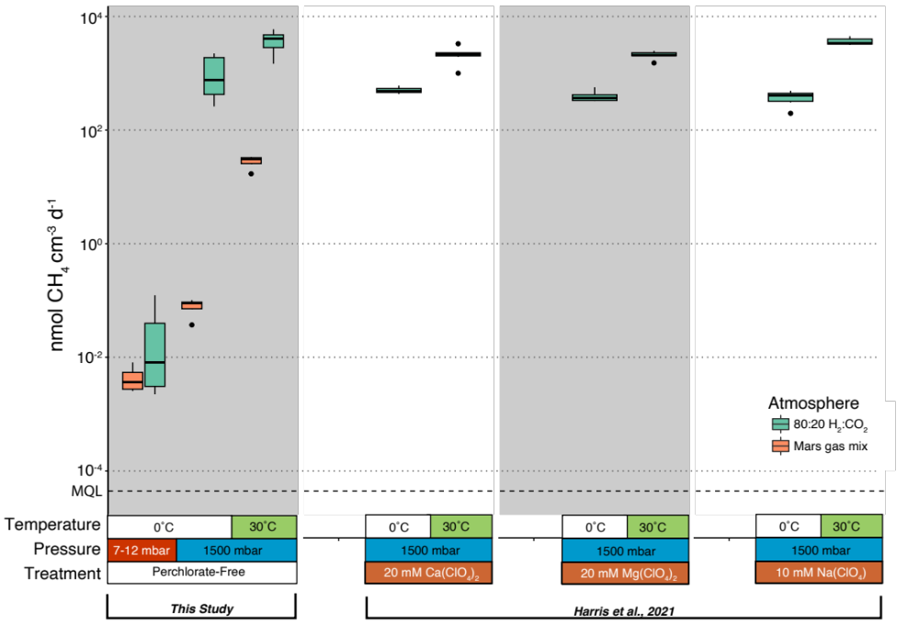

Figure S3. Non-metric multidimensional scaling (NMDS) solutions based on Bray-Curtis dissimilarities between factored conditions. NMDS solutions are derived from regularized log (rlog)-transformed transcript counts. Data are color-coded by atmospheric condition (80:20 H₂:CO₂ or Mars gas mix), symbolized by pressure condition (1500 mbar or 7-12 mbar), and sized by temperature condition (30˚C or 0˚C). Ellipses represent 95% confidence intervals based on standard error of the mean for each factored level: (A) atmosphere (green ellipse = 80:20 H₂:CO₂, orange ellipse = Mars gas mix); (B) pressure (blue ellipse = 1500 mbar; red = 7-12 mbar); and (C) temperature (yellow-green ellipse = 30˚C; black ellipse = 0˚C). Stress value = 0.13.

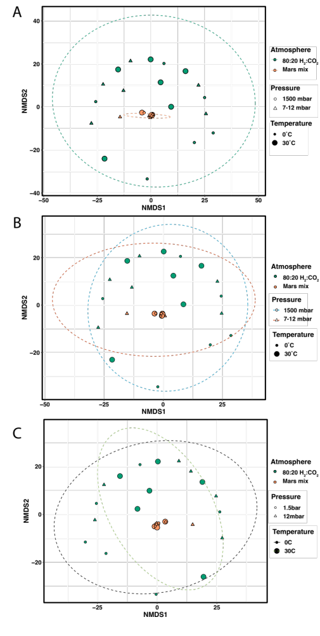
Figure S4. Differential gene expression (Log₂-fold change, LFC) of M. barkeri’s methanogenesis pathway under 0˚C relative to the 30˚C temperature control. Text sizes of individual genes are scaled according to average regularized transcript copy numbers. Statistically significant differential expressions are indicated by red genes and determined via Wald tests (P ≤ 0.05). Standard error bars are not shown as they exceed the scale of the x-axis for all genes (see SI Appendix, Table S5). Full names of listed genes are found in SI Appendix, Table S7. 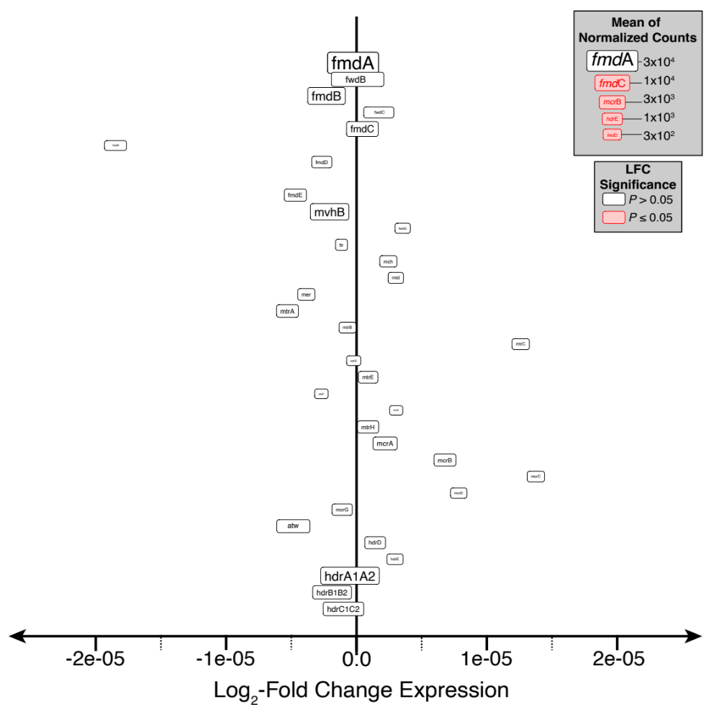

Figure S4. Differential gene expression (Log₂-fold change, LFC) of M. barkeri’s methanogenesis pathway under 7-12 mbar relative to the 1500 mbar pressure control. Text sizes of individual genes are scaled according to average regularized transcript copy numbers. Statistically significant differential expressions are indicated by red genes and determined via Wald tests (P ≤ 0.05). Standard error bars are not shown as they exceed the scale of the x-axis for all genes (see SI Appendix, Table S6). Full names of listed genes are found in SI Appendix, Table S7.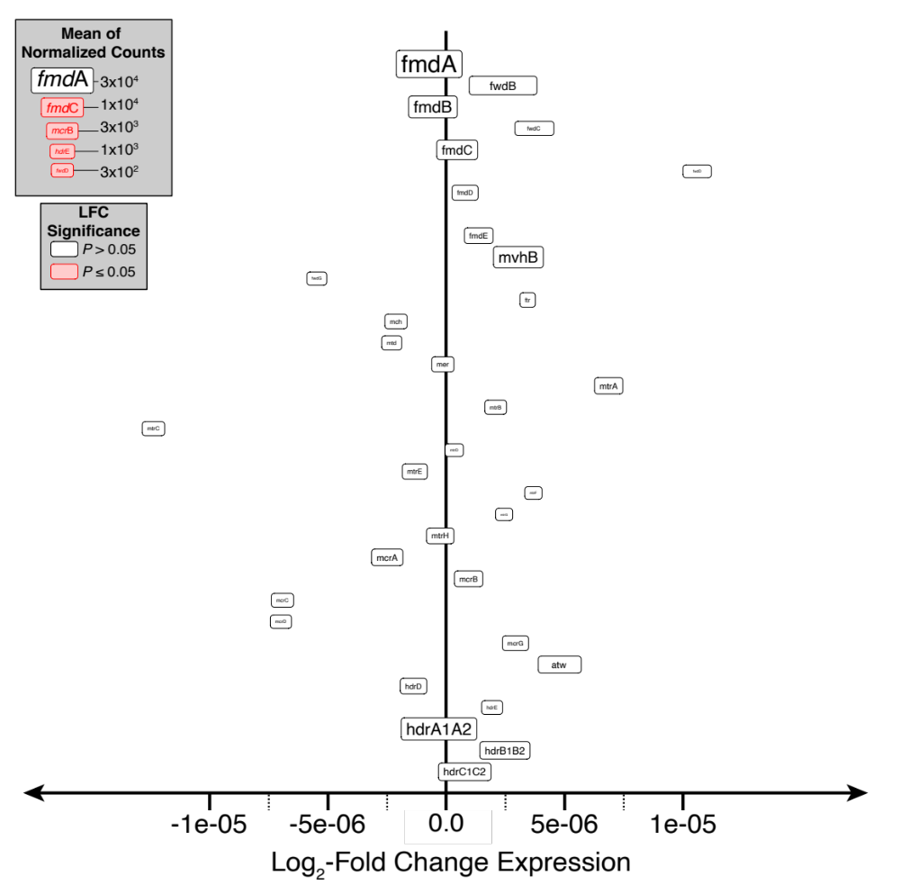

Figure S6. Heatmap of regularized log (rlog)-transformed transcript counts for genes involved in the hydrogenotrophic pathway of methanogenesis in M. barkeri. Z-scores were calculated as (Gene expression values in genes of interest) – (Mean expressions across all samples) / Standard Deviations. Full names of listed genes are found in SI Appendix, Table S7.
