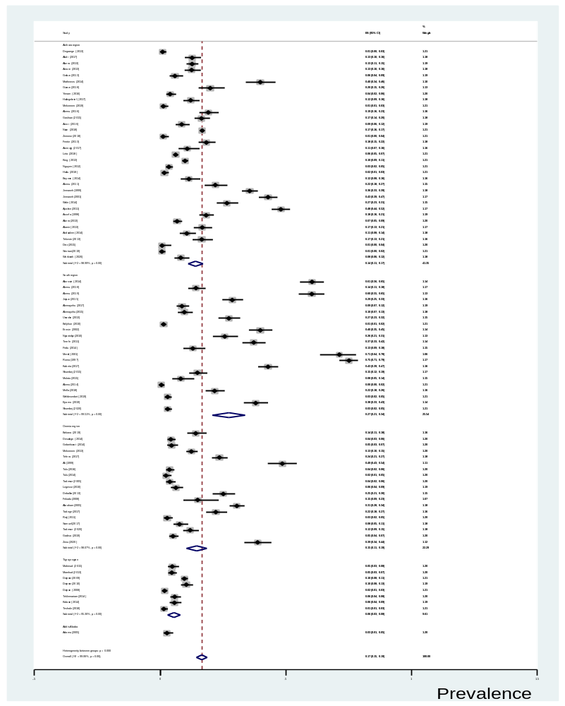
Supplementary 1: Forest plot showing the prevalence of A. lumbricoides by region

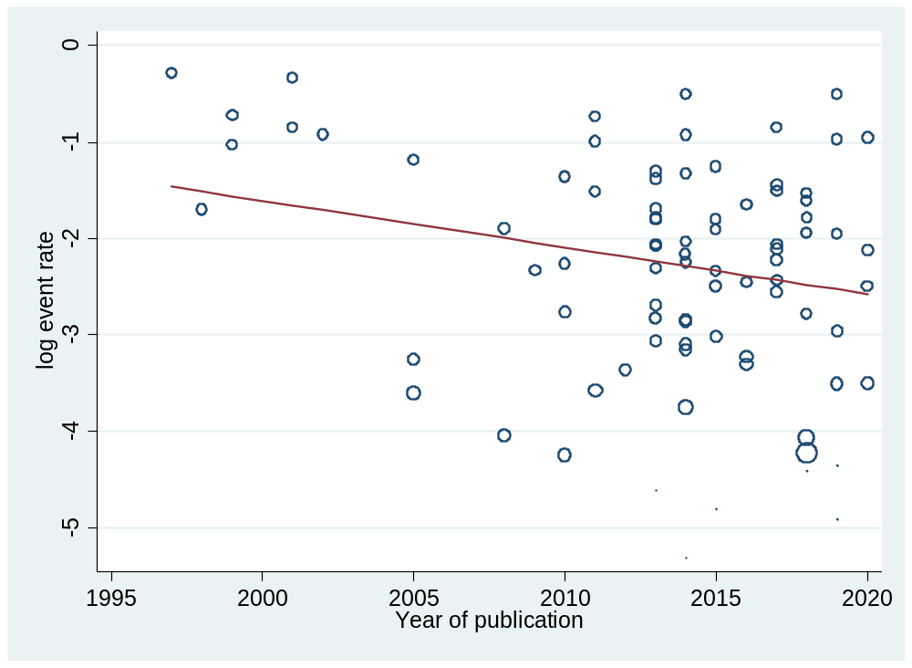
Supplementary 2: Meta regression result of A. lumbricoides by year of publication.
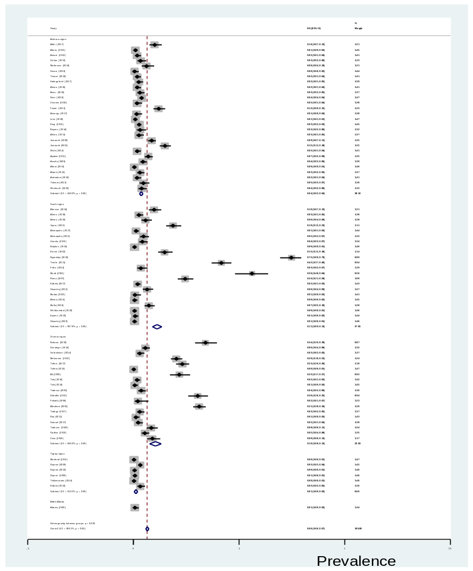Supplementary 3: Forest plot showing prevalence of T. trichiura by region

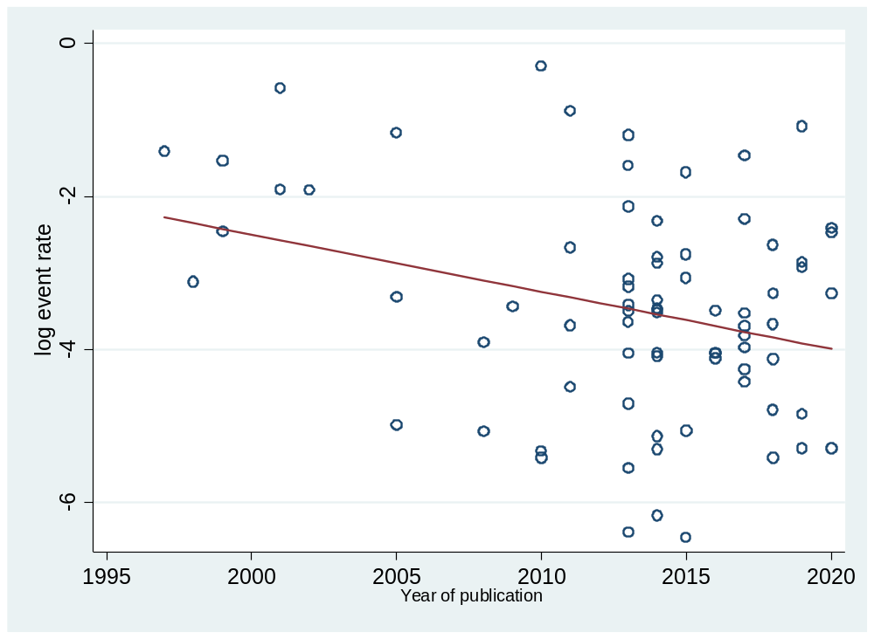

Supplementary 4: Meta regression result of T. trichiura by year of publication

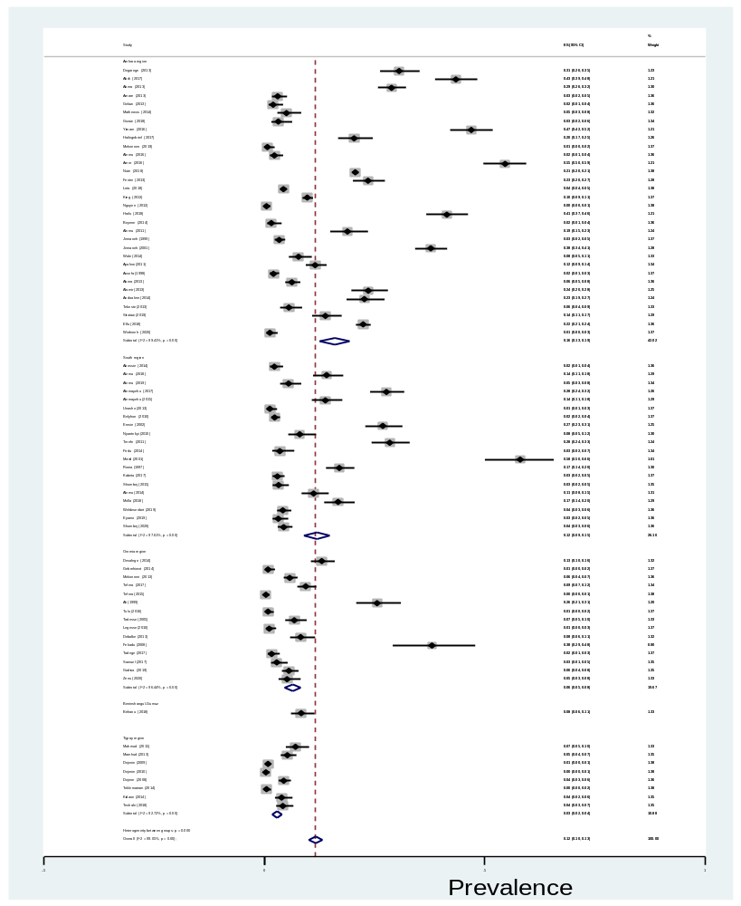
Supplementary 5: Forest plot showing the prevalence of hookworm by region

A

B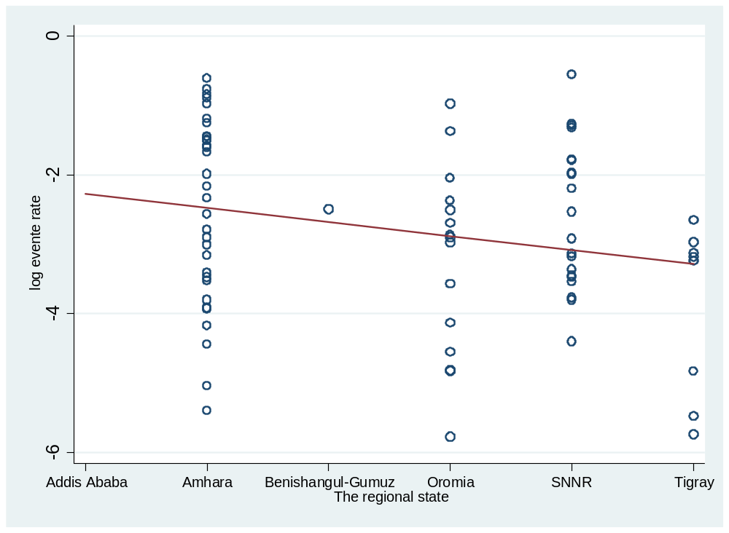
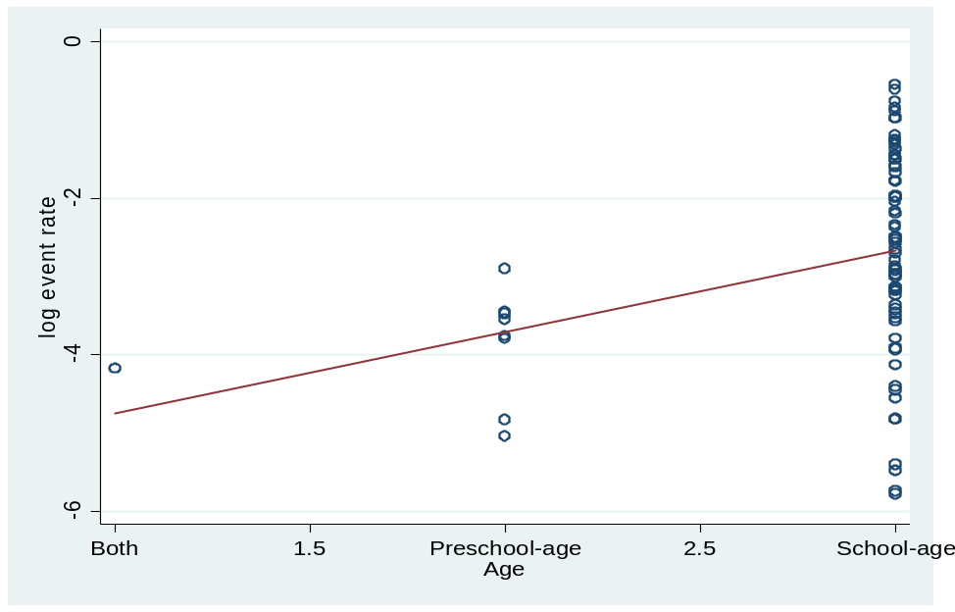
Supplementary 6: Meta regression result of A. the geographic distribution B. the distribution by age of Hookworms

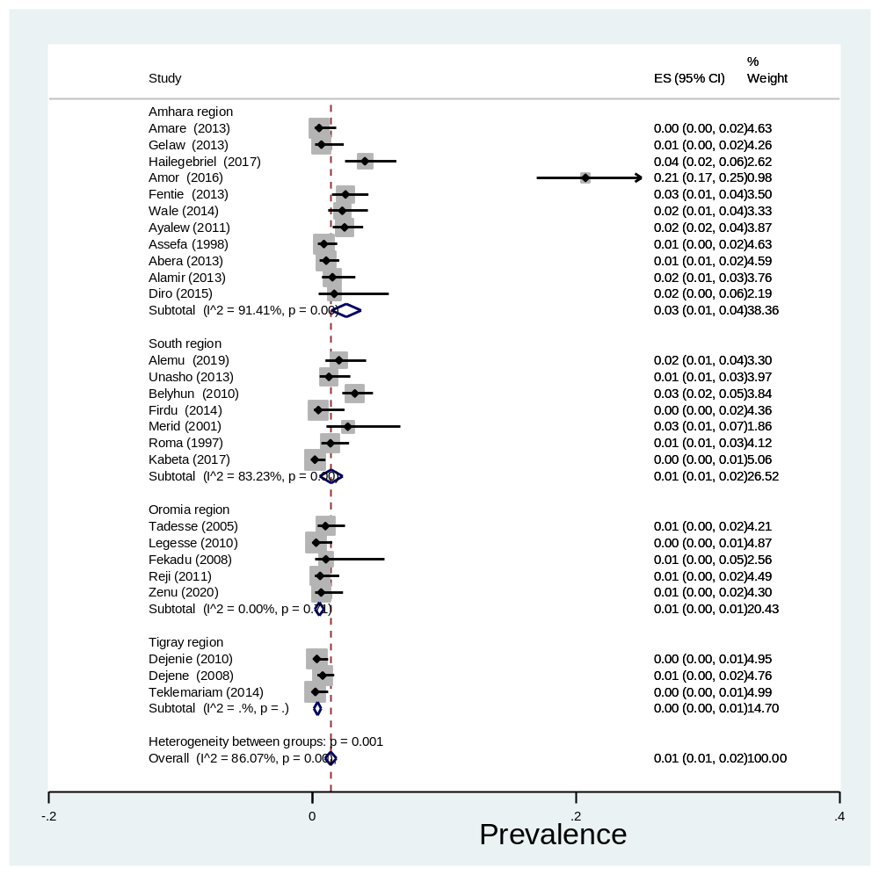
Supplementary 7: Forest plot showing the prevalence of Strongyloides stercoralis by region
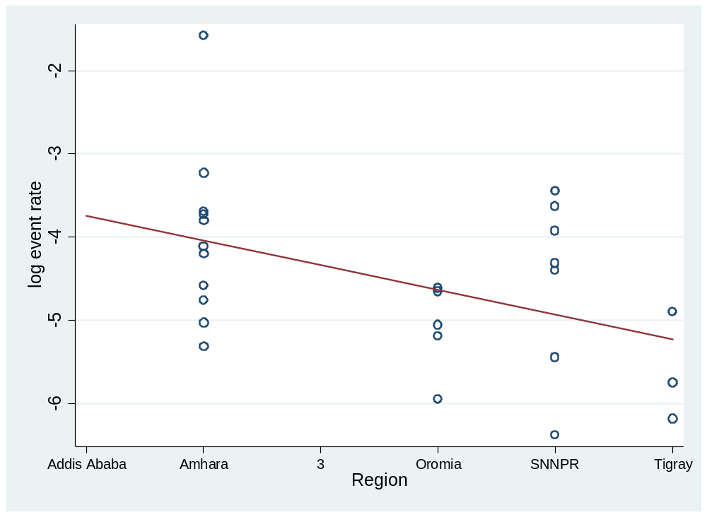
Supplementary 8: Meta regression result of prevalence of Strongyloides stercoralis by region

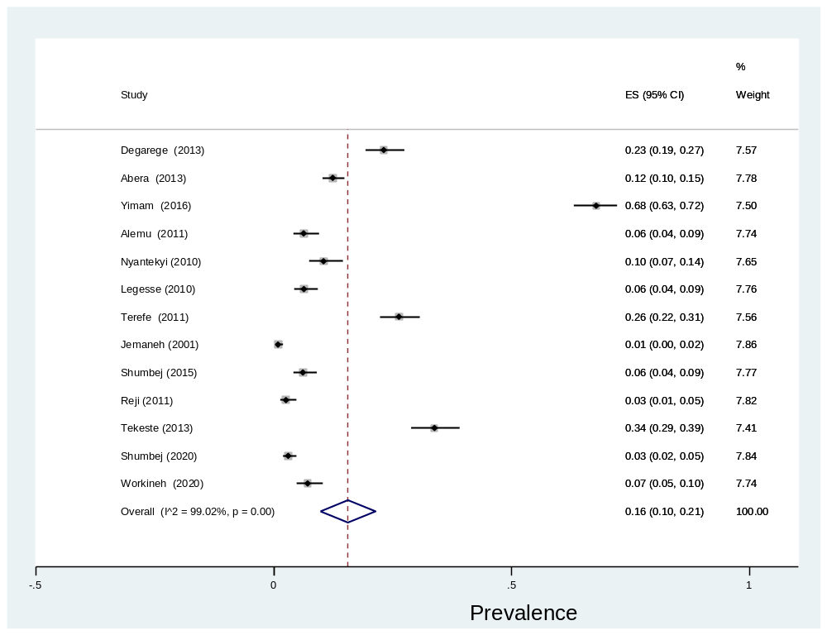
Supplementary 9: forest plot showing prevalence of low intensity of infection of A. lumbricoides

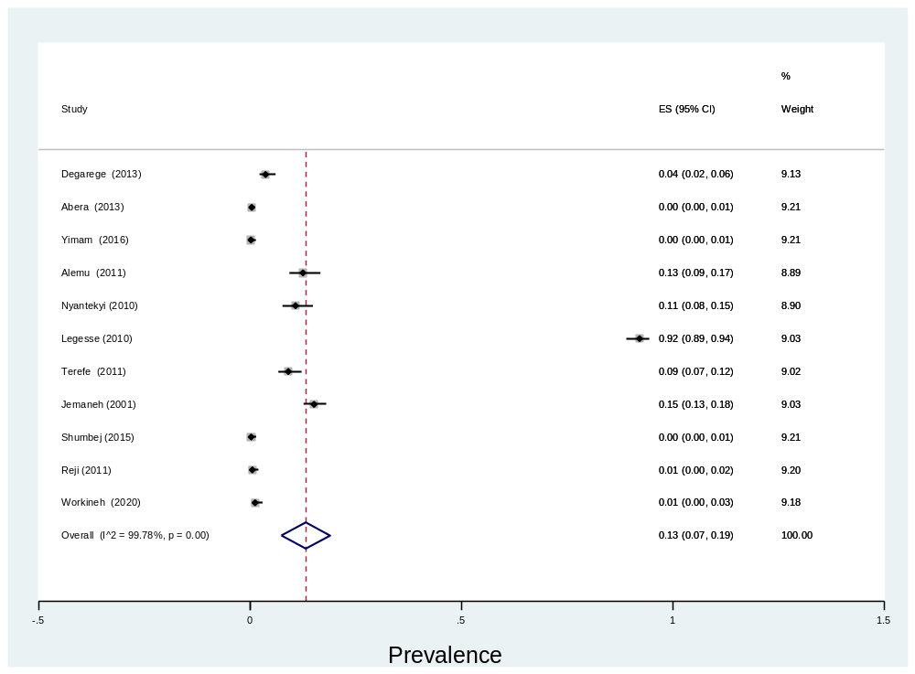
Supplementary 10: forest plot showing prevalence of moderate intensity of infection of A. lumbricoides

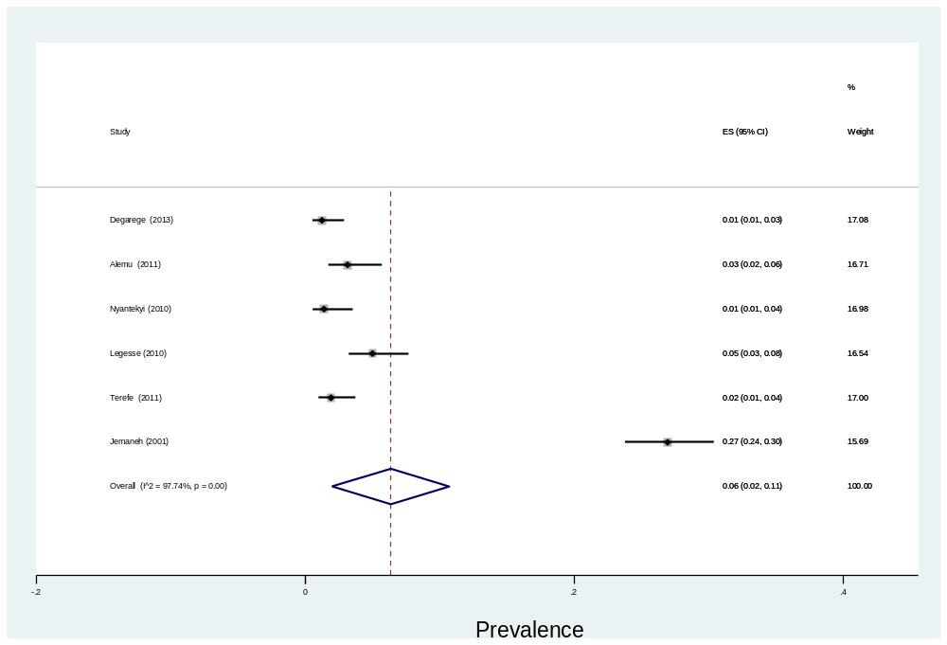
Supplementary 11: forest plot showing prevalence of high intensity of infection of A. lumbricoides
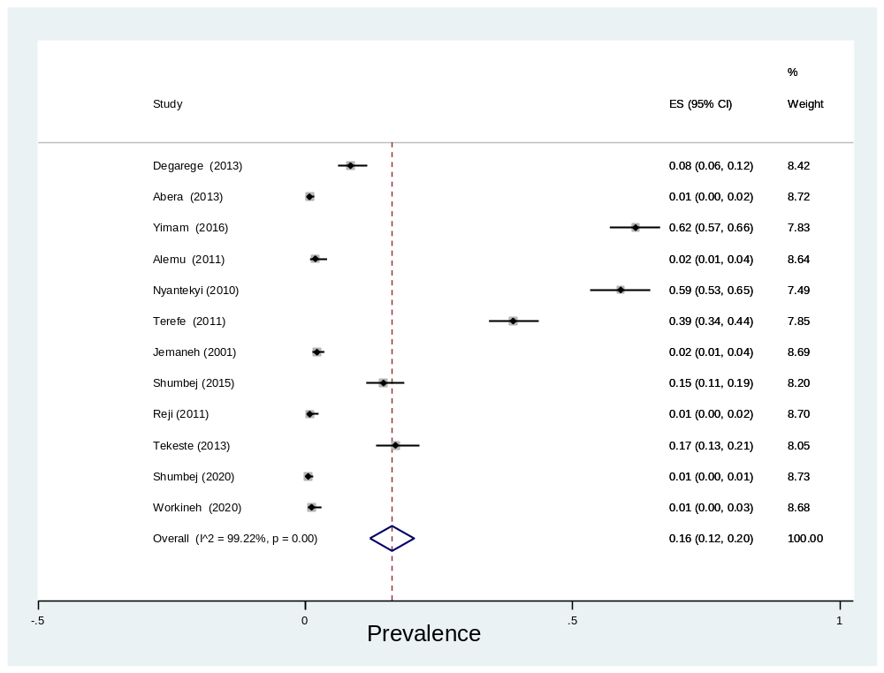
Supplementary12: forest plot showing prevalence of low intensity of infection of T. trichiura
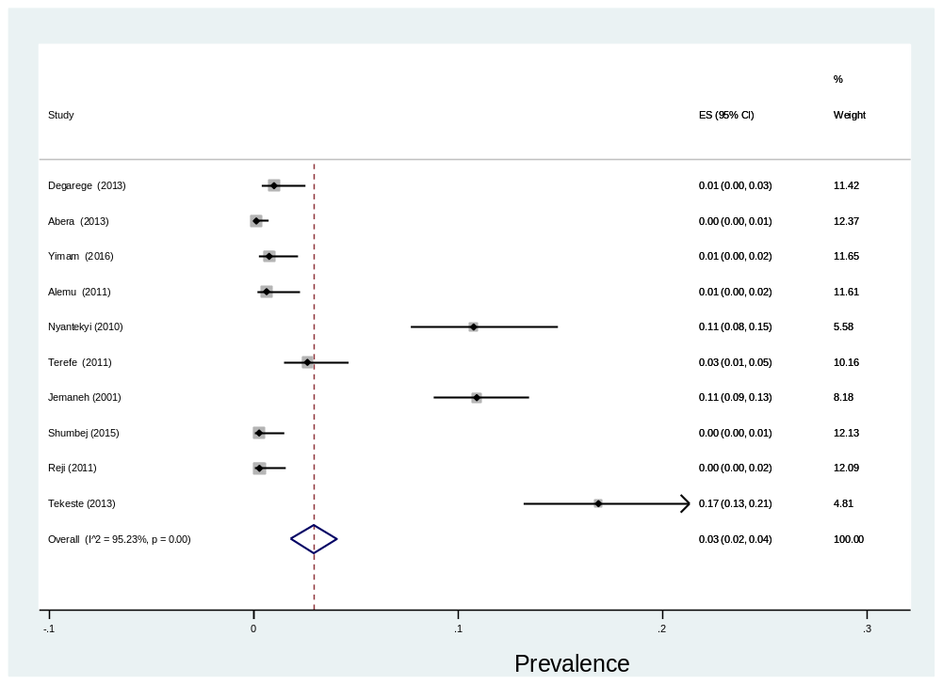

Supplementary 13: forest plot showing prevalence of moderate intensity of infection of T. trichiura

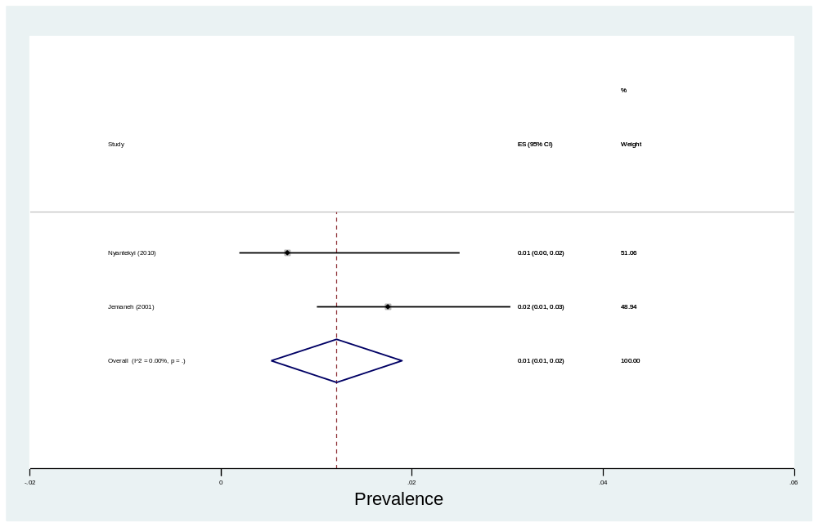
Supplementary 14: forest plot showing prevalence of high intensity of infection of T. trichiura

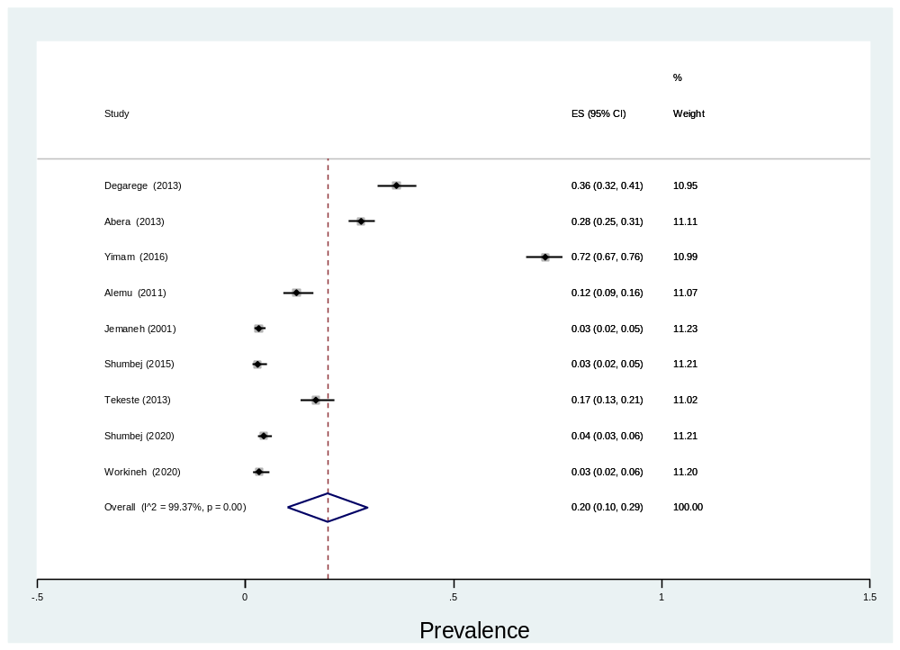
Supplementary 15: forest plot showing prevalence of low intensity of infection of Hookworms
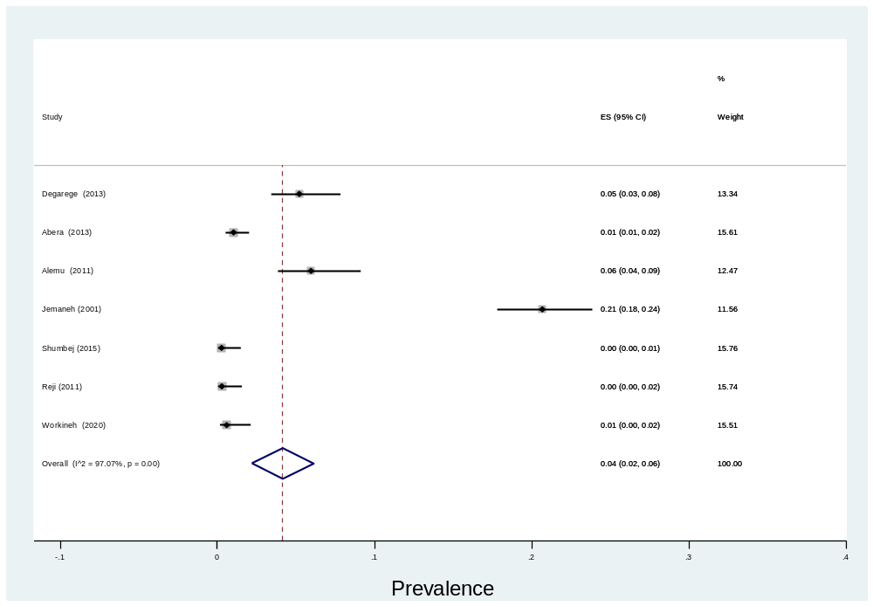Supplementary 16: forest plot showing prevalence of moderate intensity of infection of Hookworms

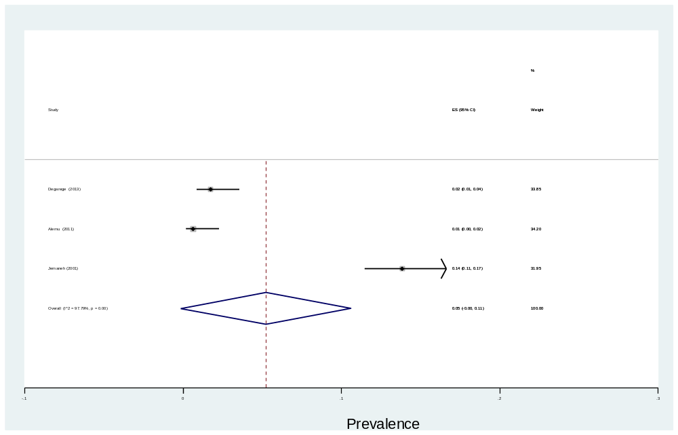
Supplementary 17: forest plot showing prevalence of high intensity of infection of Hookworms

