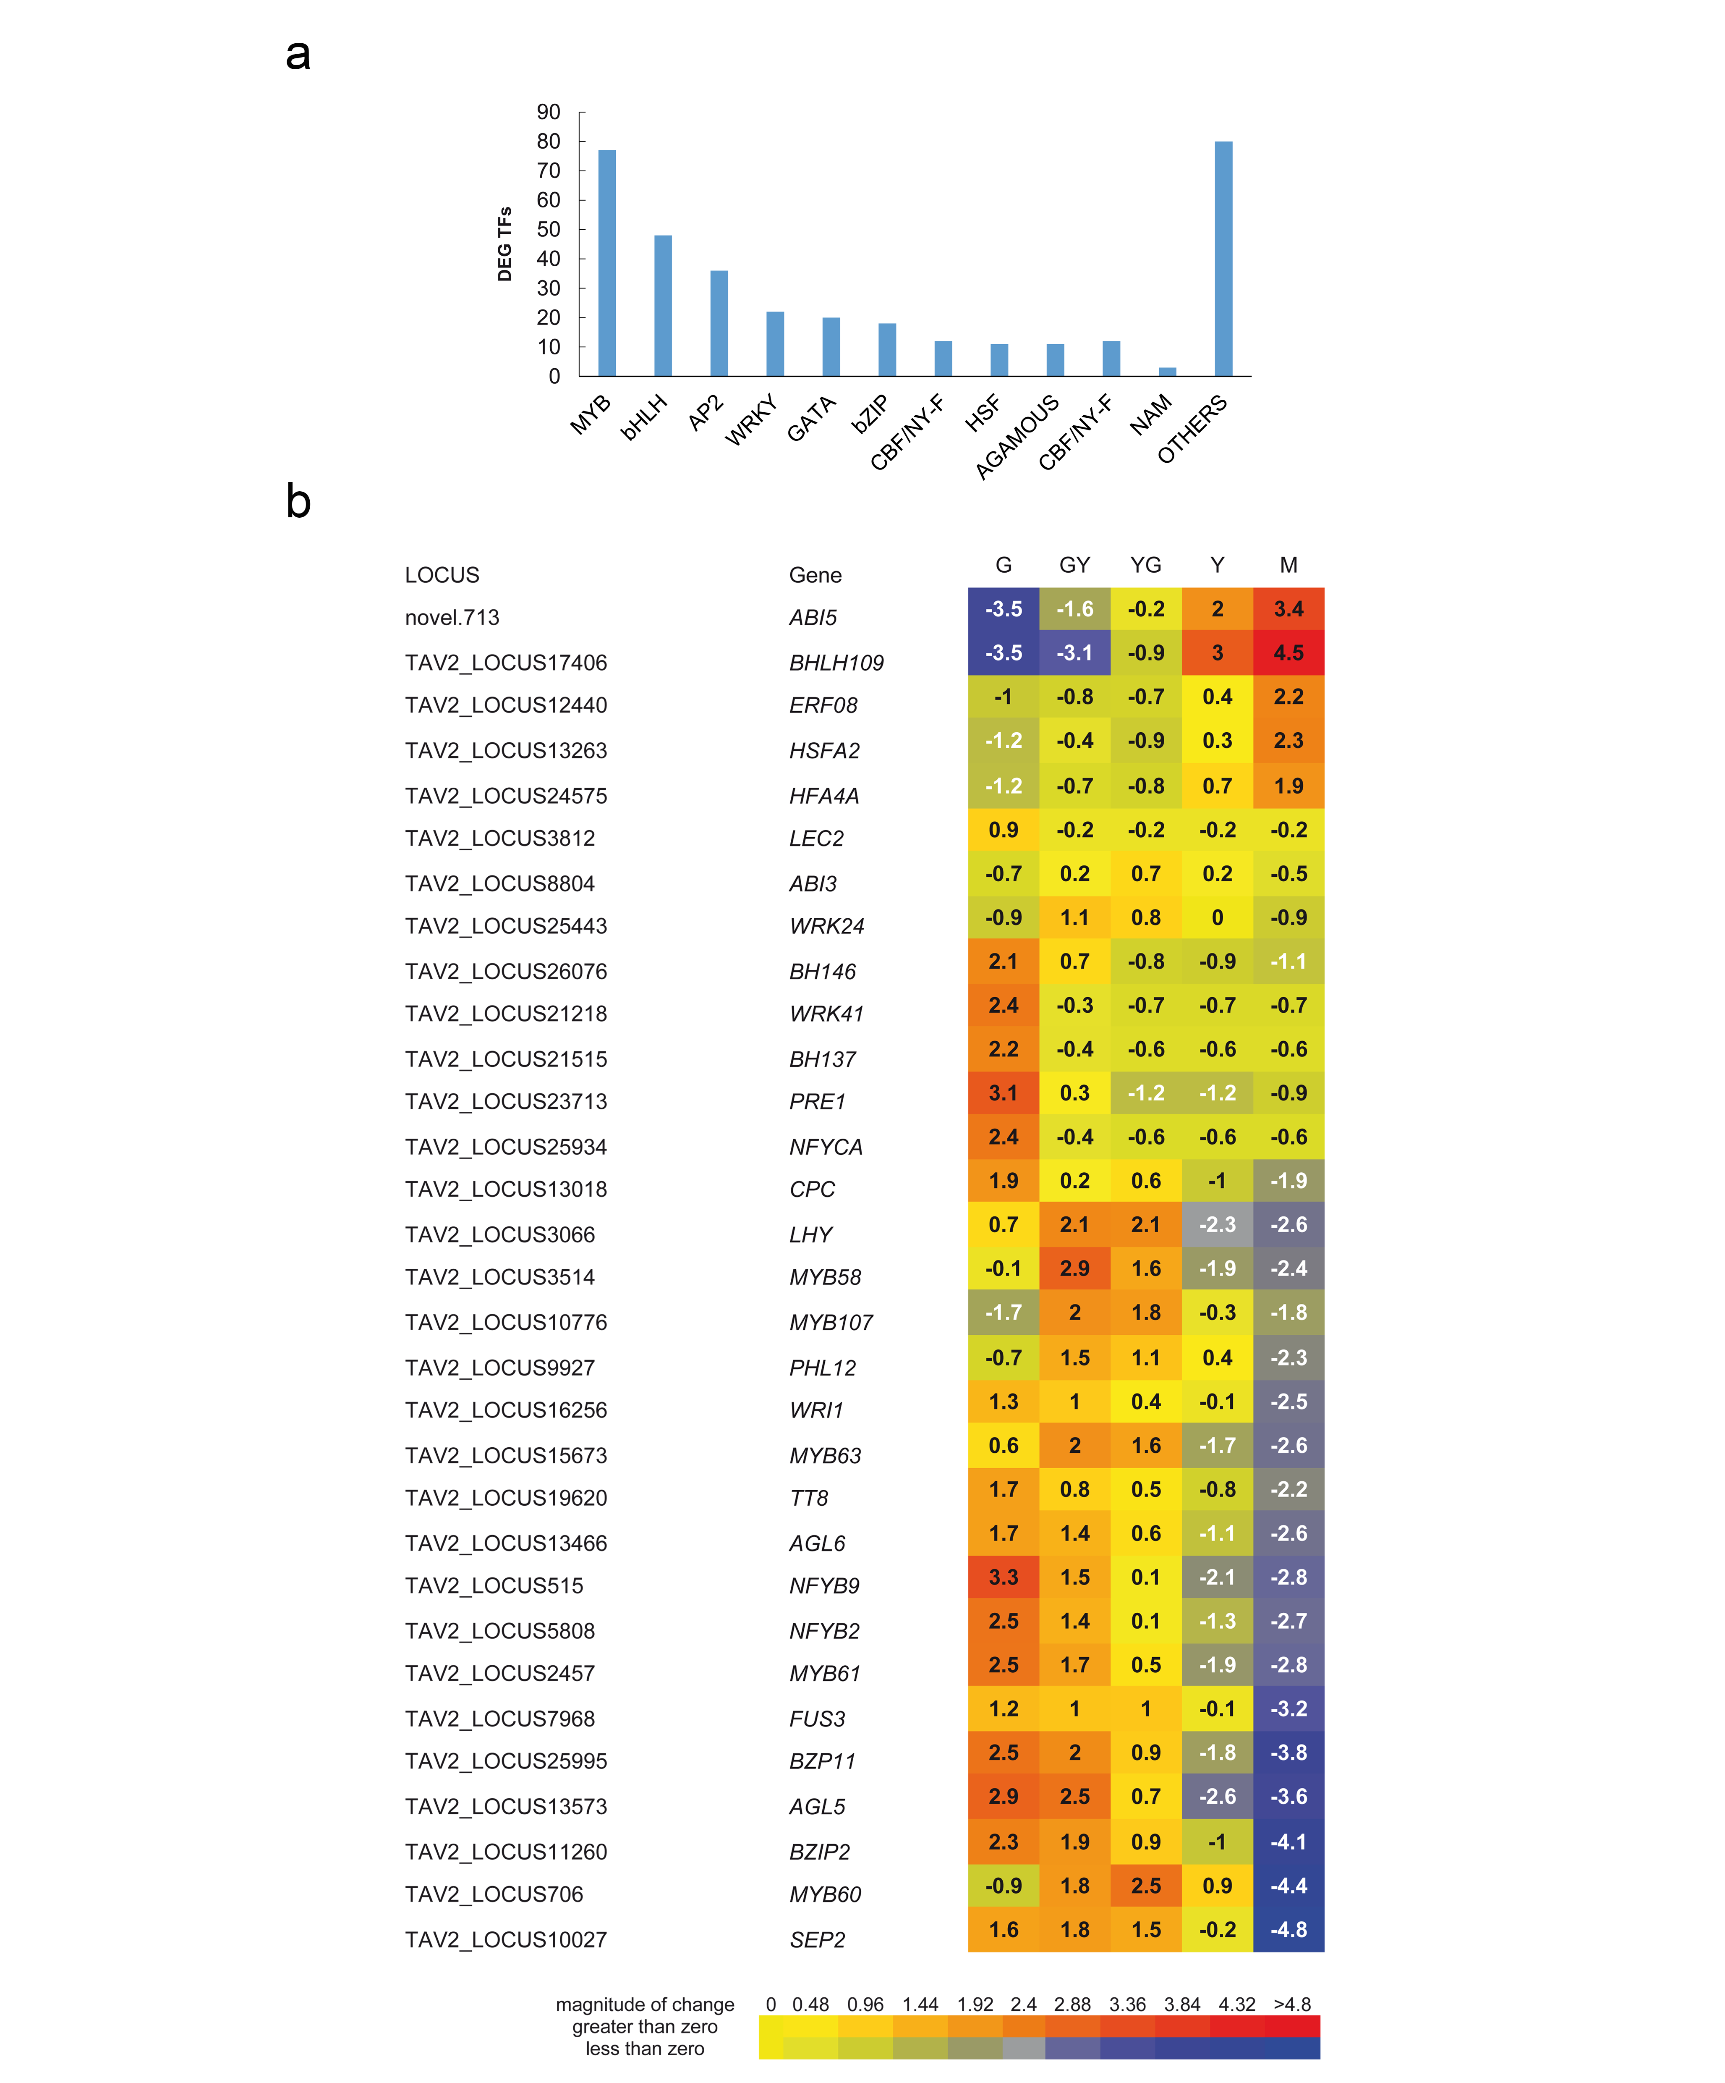
Fig. S1. Differential expression of genes encoding transcription factors. (a) Distribution of DEGs among different transcription factor families. (b) Differential expression of genes encoding transcription factors for each of the five seed maturation stages used in this work. Values represent average log₂(fpkm +1) values from each of the biological repeats and were used to generate heatmaps from http://bar.toronto.ca/ntools/cgi-bin/ntools_heatmapper_plus.cgi. The Thlaspi arvense annotated genome (Nunn et al., 2022) was used for identification of the gene ID.

