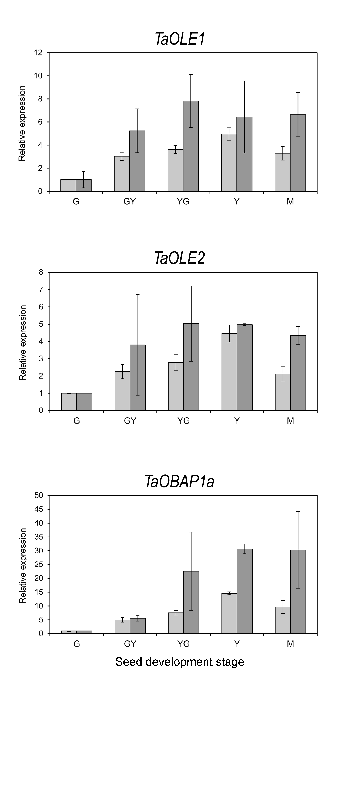
Fig. S2. Expression profiling of individual genes and isoforms involved in oil bodies formation during seed maturation by RNA-Seq (light grey bars) and qPCR (dark grey bars). For RNA-Seq data, expression levels represented by FPKM values were normalized to GREEN stage. The genes analysed, OLE1, OLE2, and OBA1a, are indicated in each figure. For qPCR analysis, data were obtained from three independent pools of seeds from five plants of each line. Data represent means of at least three biological replicates.

