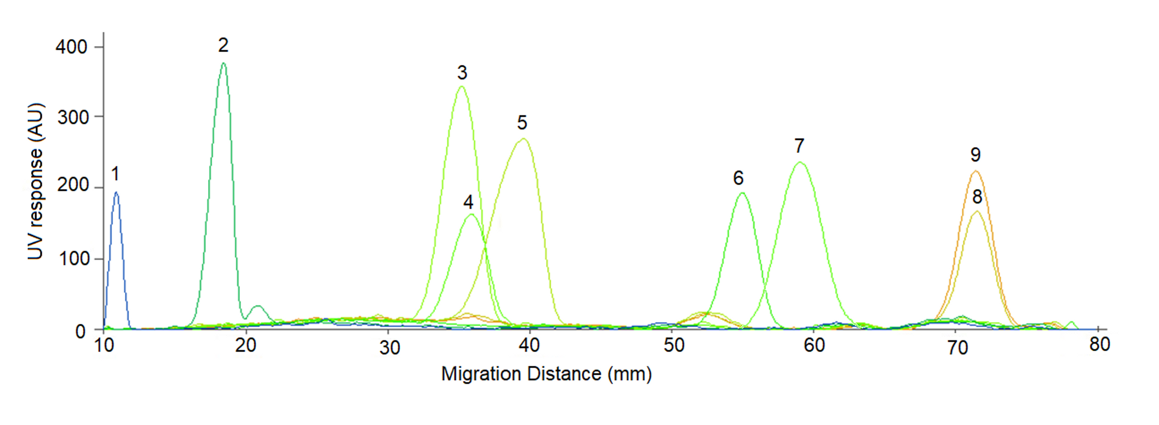
Fig. S3. HPTLC chromatograms of standards at UV 190 nm: pic1: 1-Oleoyl-rac-glycerol, pic 2: 1,2-dioleoyl-rac-glycerol, pic 3: linoleic acid, pic 4: oleic acid, pic 5: erucic acid, pic 6: glyceryl trioleate, pic 7: methyl oleate, pic 8: cholesteryl stearate, and pic 9: cholesteryl oleate.

