Supporting Information
Molecular Anchoring of Free Solvents for High-Voltage and High-Safety Lithium Metal Batteries
Zhuangzhuang Cui¹, Zhuangzhuang Jia², Digen Ruan¹, Qingshun Nian¹, Jiajia Fan¹, Shunqiang Chen¹, Zixu He¹, Dazhuang Wang¹, Jinyu Jiang¹, Jun Ma¹, Xing Ou³, Shuhong Jiao¹, Qingsong Wang^{2,*}, Xiaodi Ren^{1,*}

¹Hefei National Research Center for Physical Sciences at the Microscale, CAS Key Laboratory of Materials for Energy Conversion, Department of Materials Science and Engineering, University of Science and Technology of China, Hefei, Anhui, 230026, China
²State Key Laboratory of Fire Science, University of Science and Technology of China, Hefei, Anhui 230026, China
³Engineering Research Center of the Ministry of Education for Advanced Battery Materials, School of Metallurgy and Environment, Central South University, No.932 South Lushan Road, Changsha, Hunan 410083, PR China
*Corresponding Author: pinew@ustc.edu.cn; xdren@ustc.edu.cn

Experimental
Materials: LiNi_{0.8}Co_{0.1}Mn_{0.1}O₂ (sc-NCM811) cathode material was purchased from MTI. LiFSI (99%) was kindly provided by Nippon Shokubai (Japan). Li metal chips (450 μm) were purchased from China Energy Lithium Co. Ltd. 1,2-dimethoxyethane (DME, 99.9%) was obtained from Sigma. 2,2,3,3-Tetrafluoro-1-(1,1,2,2-tetrafluoroethoxy) propane (TTE, >98%), Dimethyl carbonate (DMC,99%), 2-Methoxyethyl ether (G2, 99%), 1,1,2,2-Tetrafluoroethyl 2,2,2-Trifluoroethyl Ether (D2, >97%) were obtained from MACKLIN. All solvents are dried with 3Å molecular sieve for more than 48 hours. Lithium hexafluorophosphate (LiPF₆, 99.5%), bistrifluoromethanesulfonimidate (LiTFSI, 99%) were obtained from DADO New Material. Celgard2500, Al foil, and spring piece, gasket and cell case (2032) were purchased from Canrd. The electrolytes were prepared by dissolving the lithium salt LiPF₆, LiFSI or LiTFSI in the selected solvents inside a glovebox full of inert argon gas, where the water and oxygen content was＜0.1 ppm. The NMC811 cathodes were prepared by mixing NCM811 active materials, super P Li (Timcal), and polyvinylidene fluoride (HSV900, Shenzhen Kejing) in N-methyl-2-pyrrolidone (NMP, Aladdin) with a ratio of 8:1:1 to make a slurry before coating on Al foil. The cathodes were first dried at 60 °C for 4 h and then in a vacuum oven at 110 °C for 12h before use. The NMC811 cathode average active material loading was 7.5 mg cm⁻² for coin cell tests.
Electrochemical measurement: CR2032 coin cells were assembled for the electrochemical tests in an argon-filled glovebox, and 100 μL electrolyte was added inside before it was crimped. LSV, CA and CV tests were carried out on BioLogic potentiostat, and the galvanostatic cycling tests were performed on LAND and NEWARE instruments. The anodic stability was measured by LSV from initial potential to 5 V with a scan rate of 0.1 mV s^{–1} using Li||PVDF+SP|Al cells. For CA, the cells were first cycled at 2.8-4.5 V for three times with 0.1 C current and then charged to 4.5 V and kept at 4.6 and 4.7 V for eight hours, respectively. For CV test, all cells were cycled between 2.8-4.7 V with a scan rate of 0.1 mV s⁻¹. For the Li||NCM811 cells, after the initial two activation cycles at C/10 charge-discharge rate, the cells were subsequently cycled at C/3 between 2.8-4.7 V. The CE tests were measured in Li||Cu cells with a current density and areal capacity of 0.5 mA cm⁻² and 1 mAh cm⁻², respectively. Lithium deposition morphology was collected from Cu foil with 16 mm diameter after 0.5 mA/cm² deposition for 8 hours
Characterizations: NMR was tested by AVAVCEⅢ HD400. The deuterated reagent (d₆-DMSO) is encapsulated in a capillary tube without direct interaction with the electrolyte. Raman mapping was conducted by LabRam HR Evolution. Ionic conductivity was tested using BioLogic VMP-3 and temperature variable oven (DHT test). The calculation of electrolyte ionic conductivity was through the resistance of 1M KCl at 25ºC. Scanning electron microscopy (SEM, Gemini SEM 450) was used to observe the sample morphology. X-ray photoelectron spectroscopy (XPS) sputtering tests were performed on an ESCALAB 250Xi to characterize sample surface components. For HR-TEM (Talos F200X), the Al current collector of the cathode electrode was peeled off, and the cathode sample was dispersed by ultrasonic in N, N-Dimethylacetamide. Thermal effects of mixing DME or HCE with TTE were tested by Isothermal Titration Calorimetry (Nano ICT). In-situ XRD was performed with Cu Kα radiation (λ=1.5418 Å) in the 2θ range 10º~50º using a Bruker diffractometer to characterize the evolution of sample structure. The mold was purchased from BJSCISTAR. After activating in MADE-1 and LHCE, the cathodes were recovered and tested using 1M LiPF₆ in EC/DMC/EMC electrolyte to investigate the effect of surface CEI on the evolution of electrode structure. DSC was carried out by adding 30 mg of electrolyte and 2 mg Li metal or 4 mg 4.6 V-charged cathode material into tightly sealed high-pressure crucibles before being heated at a rate of 5 °C min⁻¹ from room temperature to 300 °C. The crucible material of DSC is gold-plated stainless steel, with a diameter of 6.35 mm, a thickness of 0.1 mm in the middle gasket, and a protrusion thickness of 0.5 mm. The ARC was tested by Extended Volume Adiabatic Acceleration Calorimeter (EV-ARC), and the pouch cell (Li||NMC811, 2 Ah, EVE Energy) with 3 g/Ah electrolyte amount was first charged to the cut-off voltage of 4.6 V at 0.1 C to induce the formation of electrode-electrolyte interphases before the ARC test. An electric wire is fixed on the surface of the battery to measure the temperature changes of the battery. The temperature gradient is 5 ºC, and the waiting time is 30 minutes. Soft X-ray absorption spectroscopy was performed at beamlines BL12B-a and BL12B-b of the NSRL in Hefei, China. The photon energy coverage was from 50 to 1000 eV, the resolving power (E/ΔE) is ≈2000, and the photon flux is 5 × 109 photons per second.
MD simulation: The molecular dynamics simulations were conducted in the Forcite module in Materials studio^{1, 2}.All the dynamics simulations used COMPASS II force field. For MADE-1, the box contains 11 LiFSI, 100 DME and 300 TTE molecules. For MADE-3, the box contains 33 LiFSI,100 DME and 300 TTE molecules. For LHCE, the box contains 100 LiFSI,100 DME and 300 TTE molecules. The electrolyte systems were first simulated annealing between 600 K and 300 K using NTV ensemble for 15 cycles and optimized the structure of each annealing. The structure with the lowest energy is selected for the next optimization. The electrolyte systems were equilibrated in the isothermal-isobaric ensemble (constant NPT) using the Berendsen barostat to maintain the pressure of 0.0001 GPa for 500 ps, aiming to make the system have proper density. Then, the last frame from NPT simulation then run for 800 ps in the canonical ensemble (NVT) at 298 K. Thereafter, the radial distribution function was obtained by dynamic simulation of the optimized model and calculated the molecular coordination number by the following formula:

$$n\left(r^{'}\right)=4Πρ\int_{0}^{r'}{g(r)r^{2}dr}$$
ρ is the Number density of certain types of atoms.
Density functional theory (DFT) calculation: All the DFT calculation was conducted on the Gaussian16 package³. The initial geometry structures all extracted from molecular dynamics simulations. All molecules and complexes were optimized by B3LYP method at 6–311++G (d,p) basis set⁴. Frequency analysis was performed to guarantee that all the structures were the minimum points on the potential energy surface. All calculations were performed under implicit solvation model with dielectric properties of Aniline (dielectric constant = 7.3). The oxidation potential E_{ox} vs. Li/Li⁺ was calculated as follows:
$$E_{OX}=\frac{G\left(M^{+}\right)-G\left(M\right)}{F}-1.4V$$
where G(M) and G(M+ ) are the free energy of species M, its oxidized forms at 298.15 K, respectively. F is the Faraday constant. The extreme points of ESP are achieved through Multiwfn software⁵ combined with VMD programming.

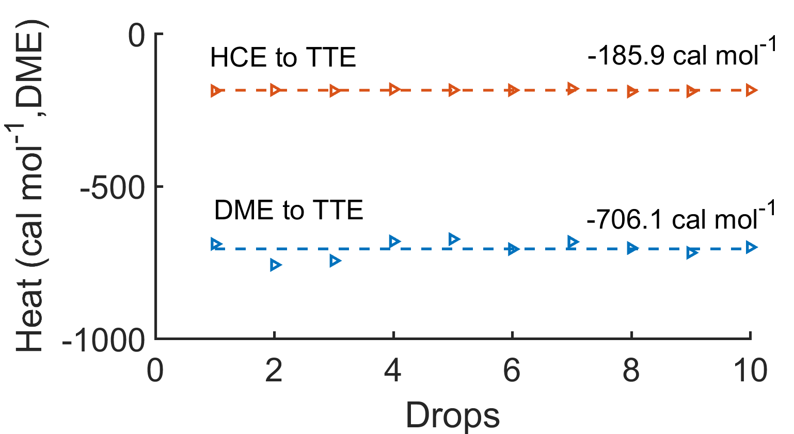
Figure S1. Heat release with HCE to TTE and DME to TTE. To avoid exceeding the instrument measurement range, the volume of DME per droplet was 0.2 μL when added into TTE, and that of HCE was 1 μL. The heat release from HCE to TTE was calculated based on the actual amount of DME in each droplet.

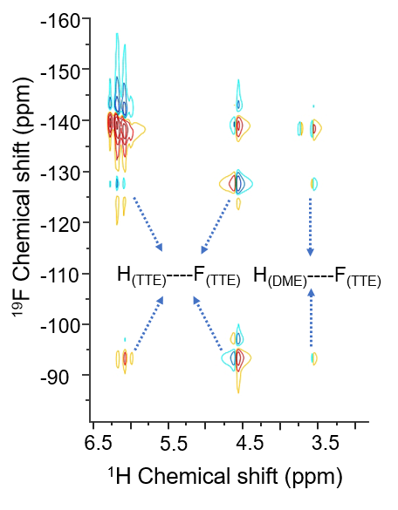
Figure S2. Two-dimensional ¹H-¹⁹F NMR spectra for the solution with a mole ratio of DME:TTE=1:3.

Based on the two-dimensional spectra, it can be observed that the correlation between hydrogen in DME and fluorine in TTE is weaker than that between hydrogen and fluorine within TTE. However, isothermal titration calorimetry (ITC) has demonstrated a strong interaction between DME and TTE. Therefore, it can be concluded that the interaction between DME and TTE is predominantly governed by the hydrogen in TTE and the oxygen in DME.

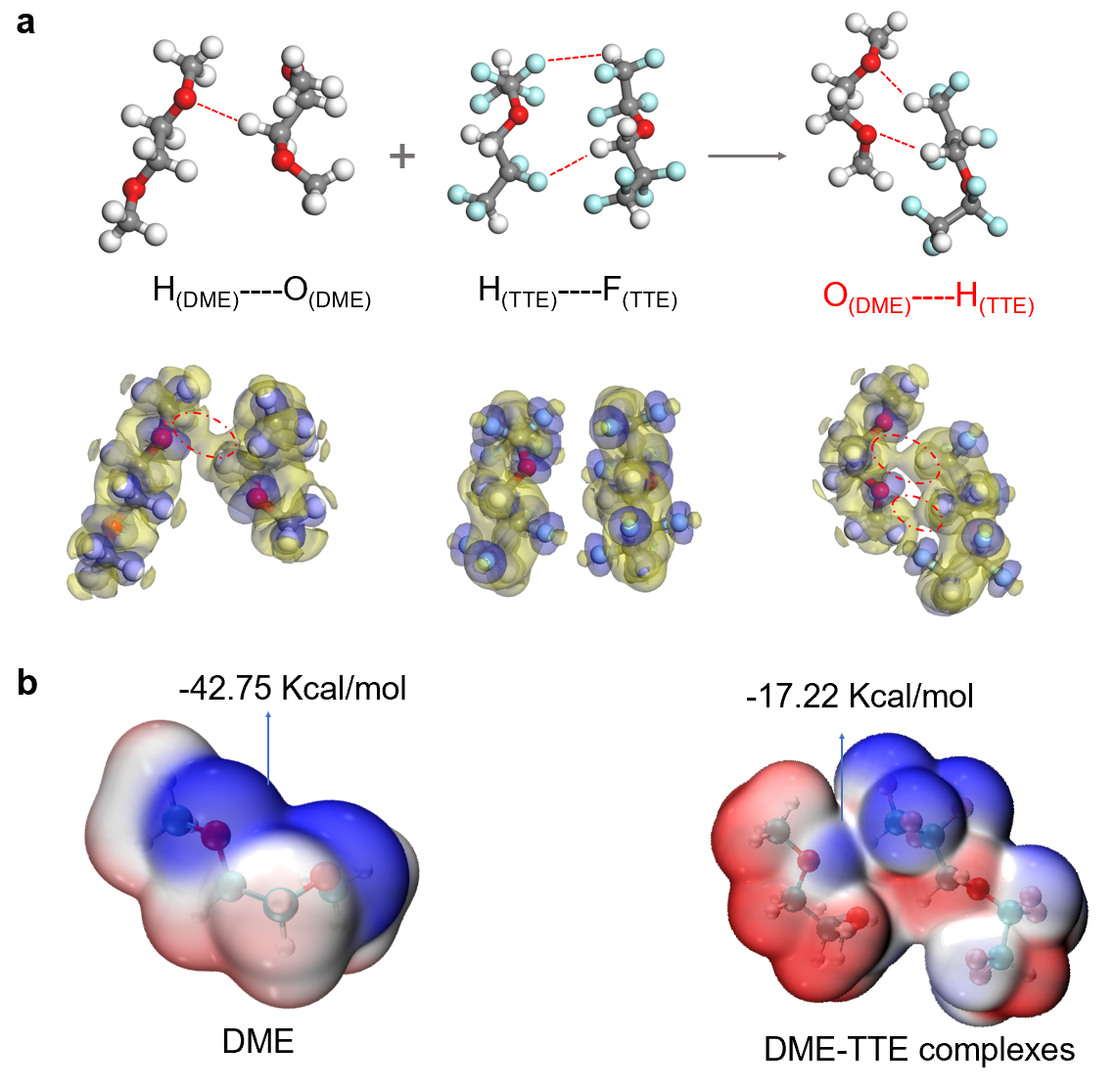
$${Li}^{+}({DME)}_{X}{\left({FSI}^{-}\right)}_{y}+TTE⇋DME\left(TTE\right)+LiFSI↓+\left(y-1\right){FSI}^{-}$$
Figure S3. a The optimized structure and plot of deformation electron density of DME-DME, TTE-TTE and DME-TTE complexes. isosurface: 0.03 a.u. b The projection of the electrostatic potential onto the electron equipotential surface before and after TTE coordination.

After TTE coordination, the electrostatic potential of the O atom in DME was significantly reduced. Dispersing the polarity of oxygen aids in enhancing the oxidative stability of molecules. This result can also explain the frequently observed experimental phenomenon: the ability of DME to dissolve salts decreases when mixed with TTE or adding a diluent to a high concentration electrolyte may cause salting out. This is because of the competition between salt and TTE for coordinating to DME, leading to the establishment of a coordination equilibrium for DME.

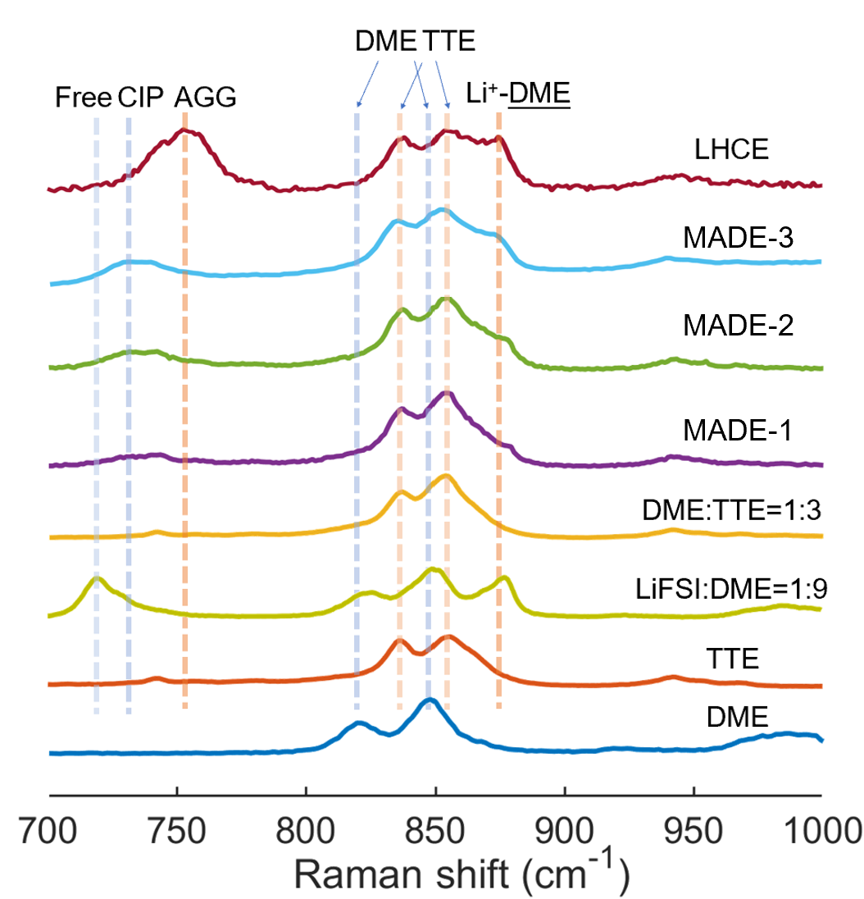
Figure S4. The Raman shift of DME, TTE, DE, DME-TTE (1:3 by mole), MADE-1, MADE-2, MADE-3 and LHCE.

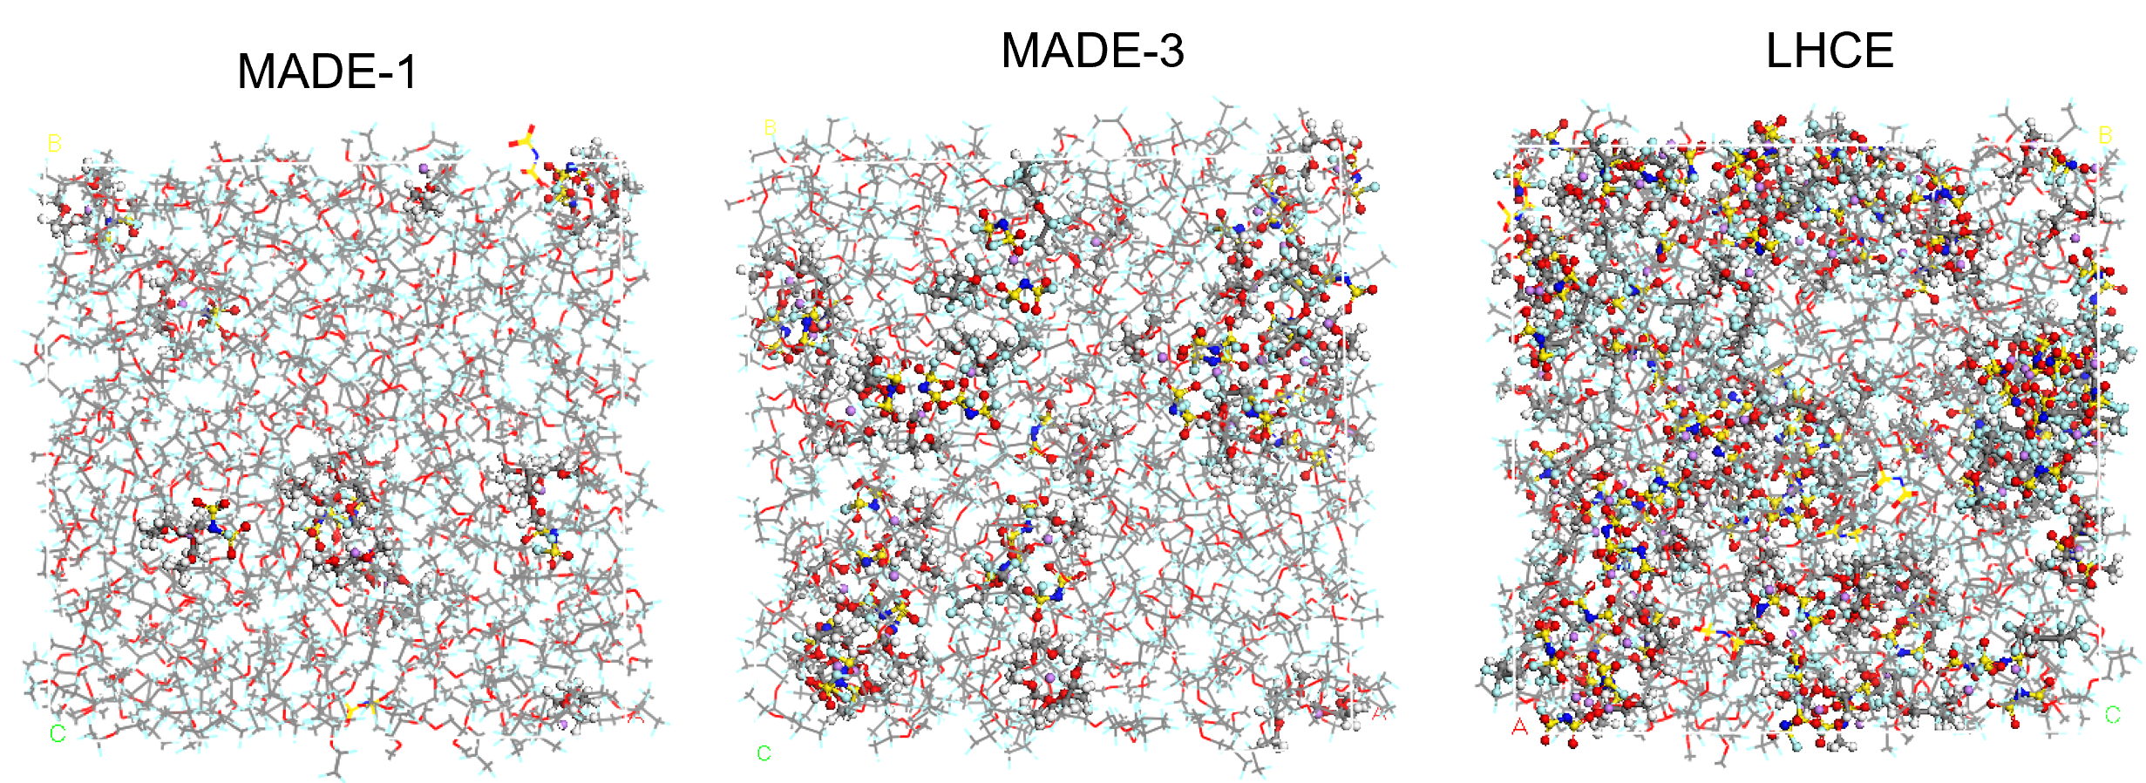
Figure S5. Molecular dynamics (MD) simulation snapshots of MADE-1, MADE-3, and LHCE. (The coordination structure of Li⁺ was shown with the ball and stick model and the rest molecules were shown with the line model).

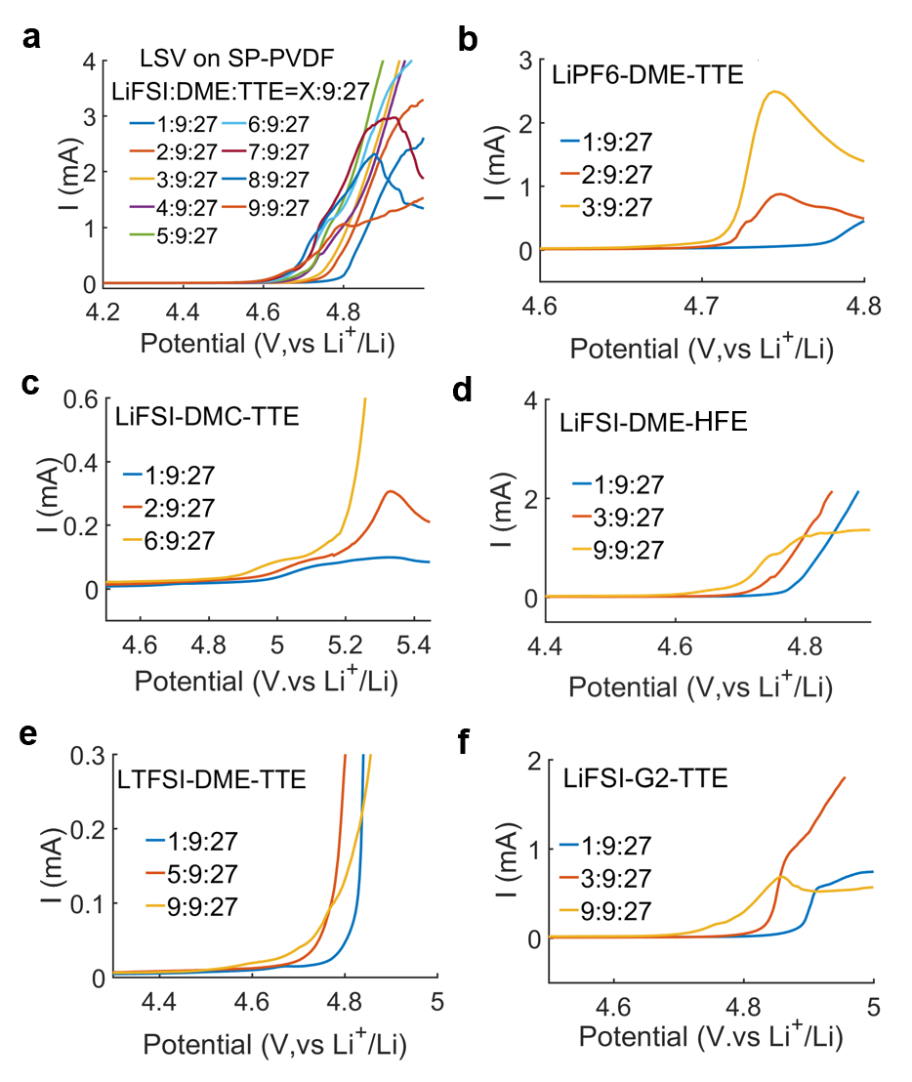
Figure S6. The LSV results for different concentration electrolytes of LiFSI-DME-TTE (a), LiPF6-DME-TTE (b), LiFSI-DMC-TTE (c), LiFSI-DME-HFE (d), LiTFSI-DME-TTE (e) and LiFSI-G2-TTE (f).

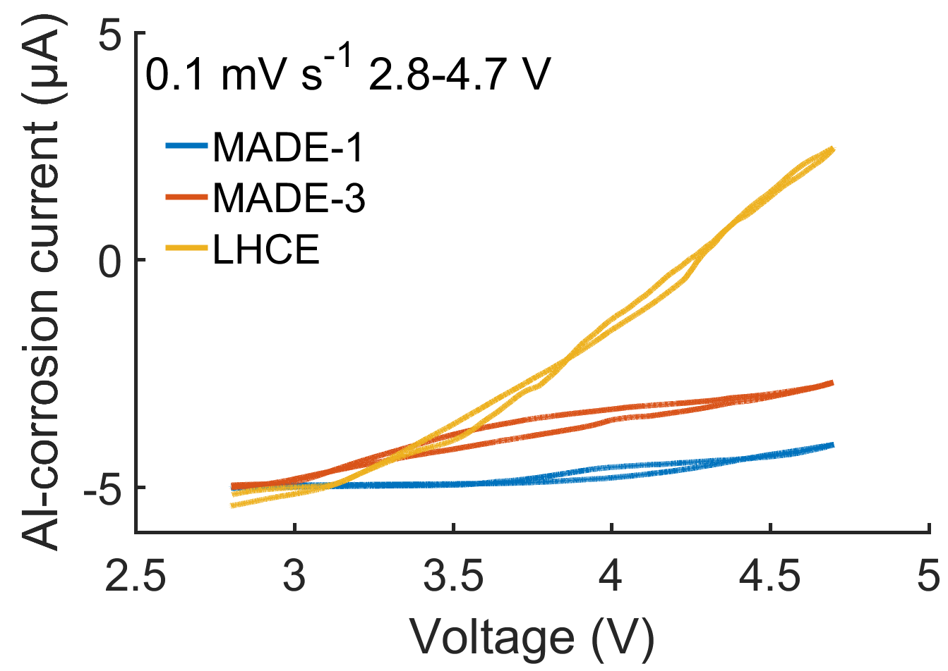
Figure. S7. The Al corrosion currents for MADE-1, MADE-3 and LHCE.

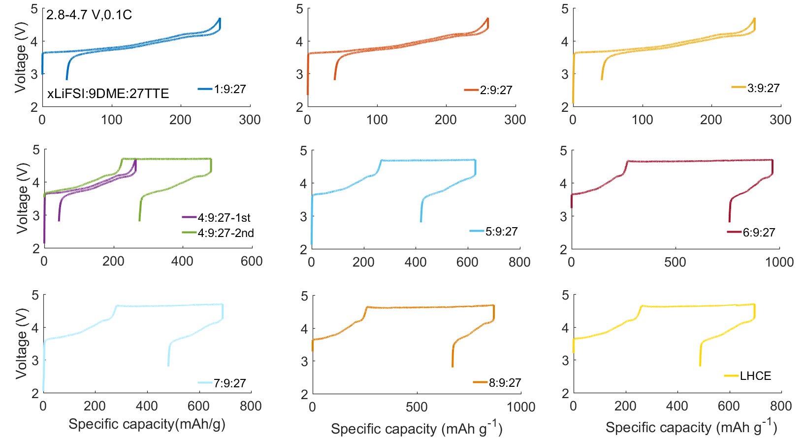
Figure S8. The potential curves of the cell using electrolytes with different concentrations of LiFSI.

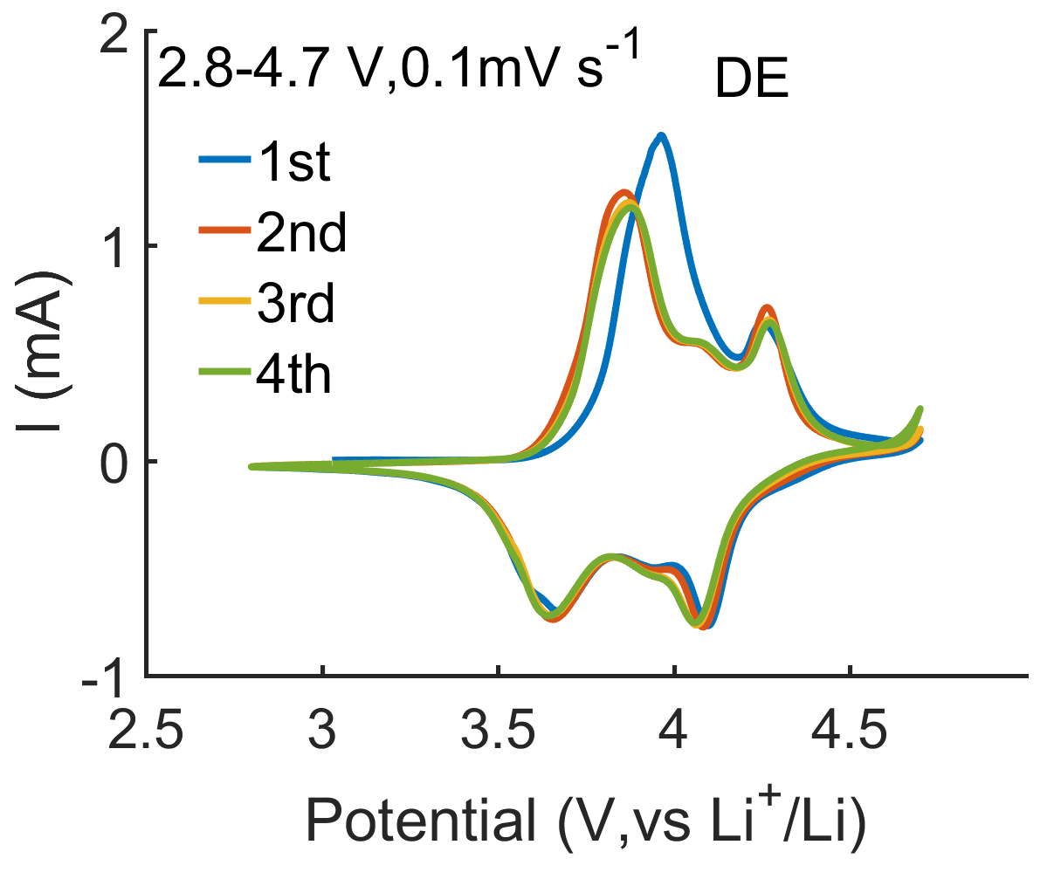
Fugure S9. CV curves for DE with a voltage range between 2.8 and 4.7 V.

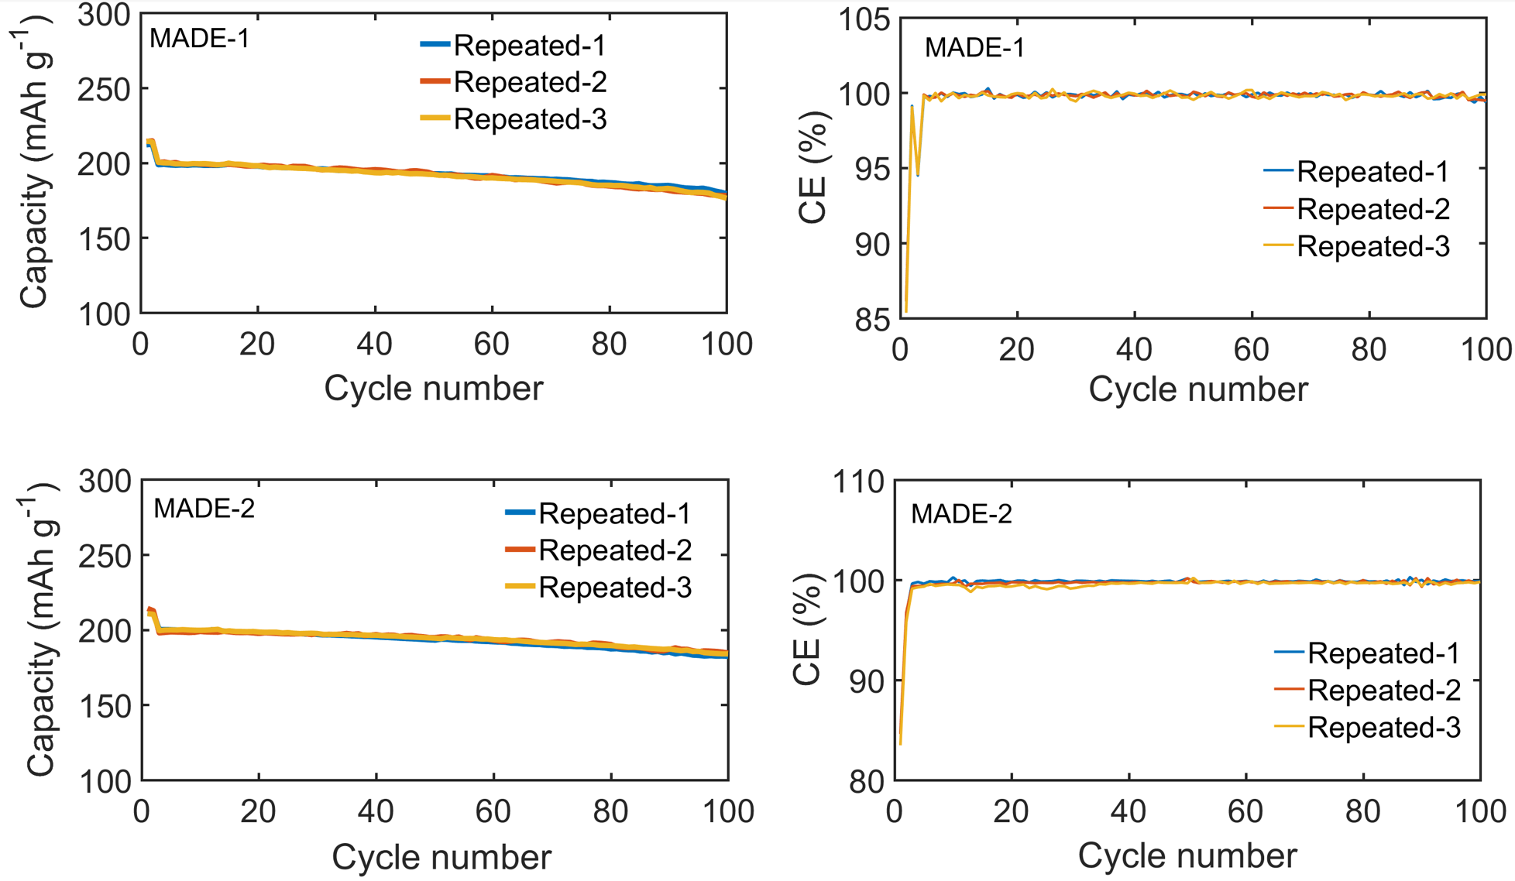
Figure S10. The repeated cycling performance for MADE-1 and MADE-2 between 2.8-4.7 V.

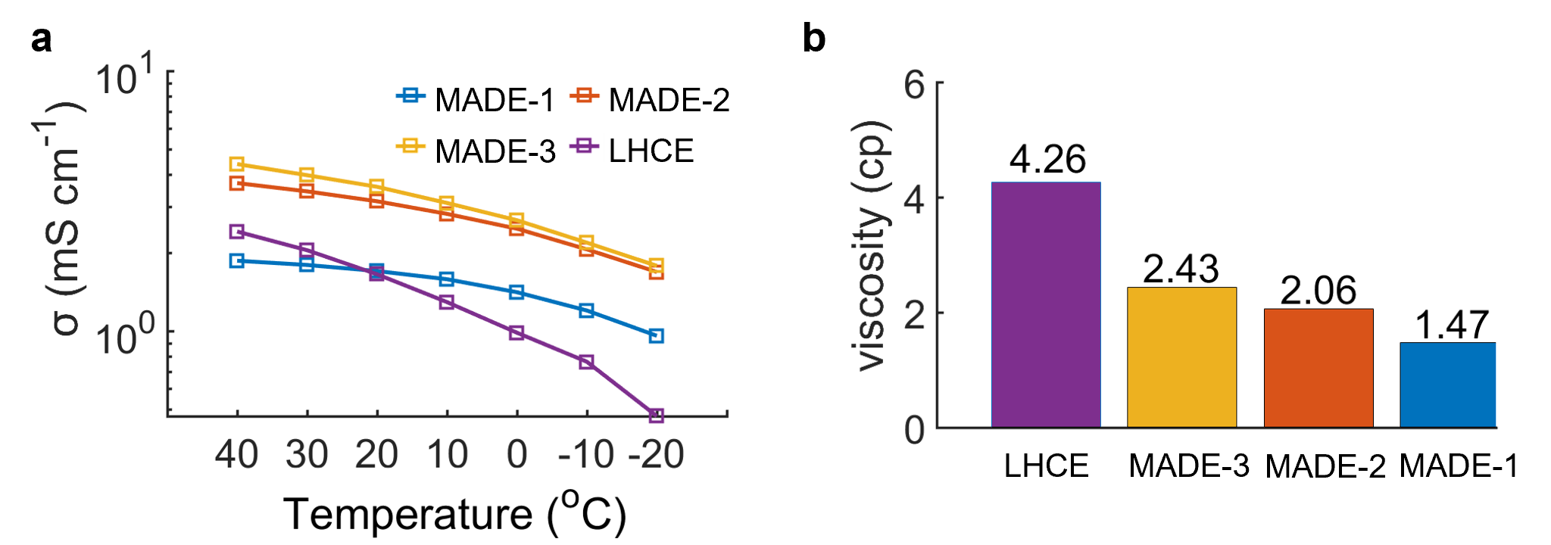
Figure S11. a Temperature-dependent ionic conductivity for MADEs and LHCE. b The viscosity of MADE-1, MADE-2, MADE-3 and LHCE.

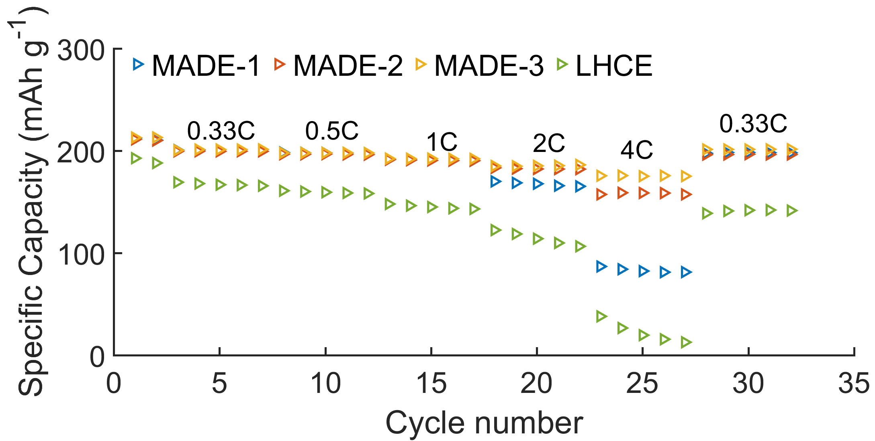
Figure S12. The rate capacity of MADE-1, MADE-2, MADE-3 and LHCE.

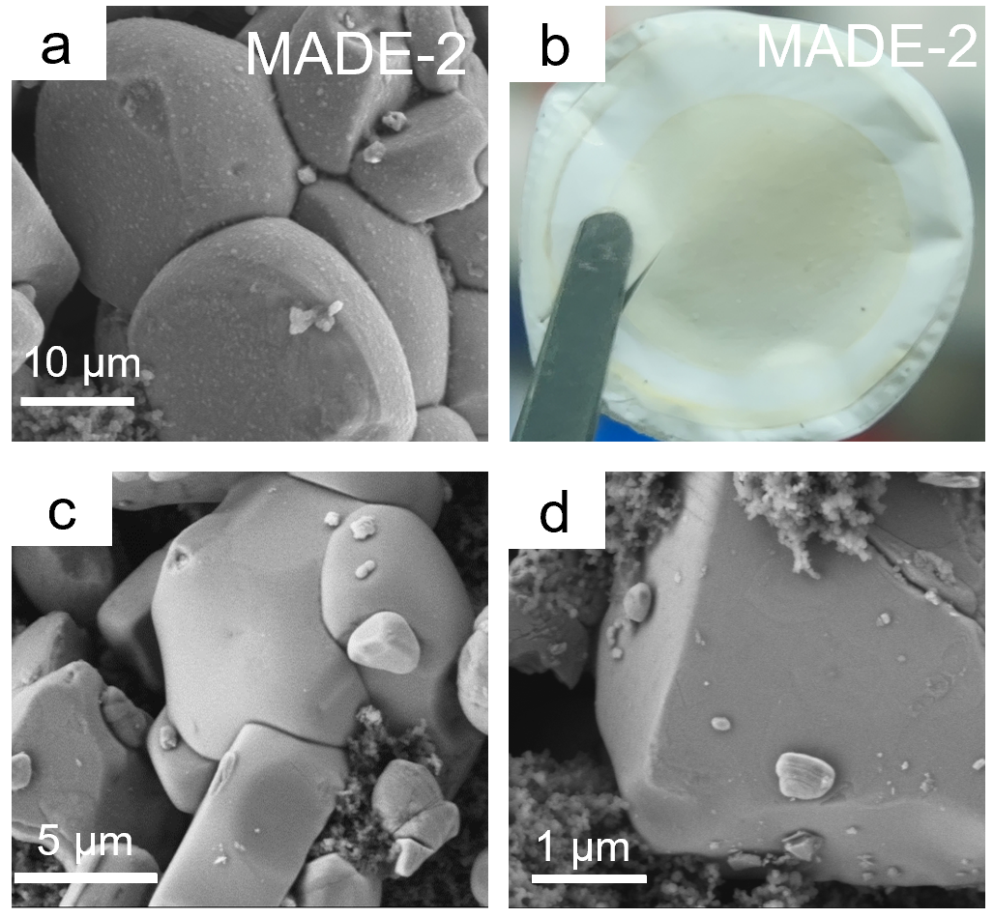
Figure S13. SEM morphology of cathodes recovered from MADE-2 (a). Optical image of the separator (b); (c-d) SEM morphology of pristine NCM811.

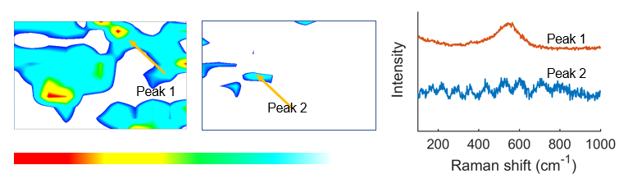
Figure S14. The Raman mapping for the cathodes with MADE-1 or LHCE. The intensity of each point in the graph corresponds to the integration of Raman signal intensities within the 385-700 cm⁻¹ range at that point.

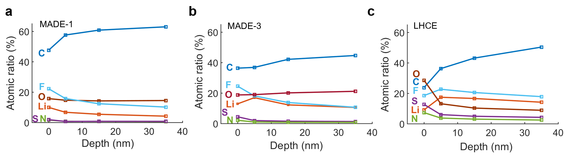
Figure S15. a-c Quantified atomic ratios of CEI at various intervals of Ar⁺ sputtering on cycled NCM811 cathodes in MADE-1, MADE-3 and LHCE

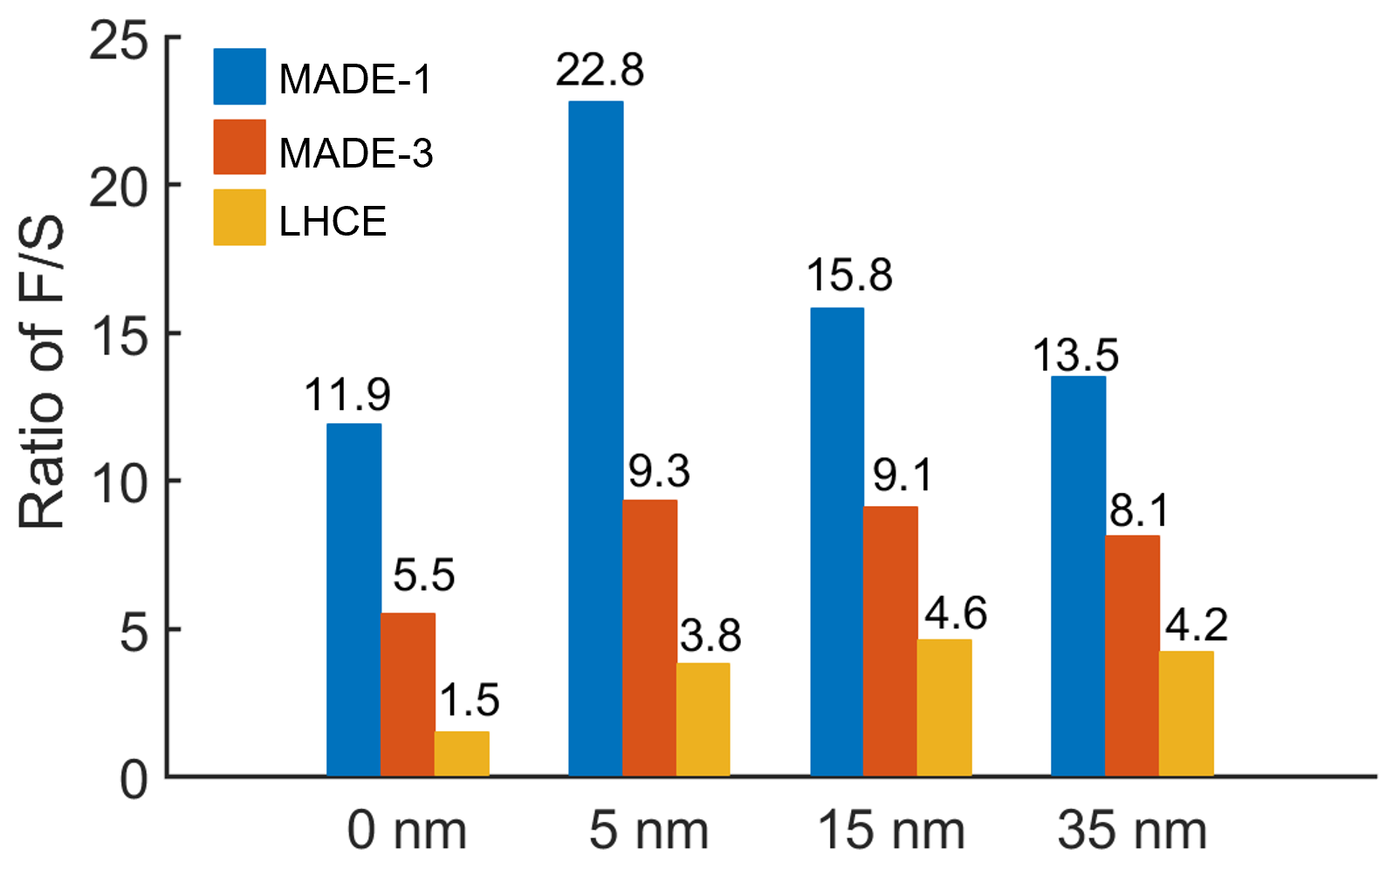
Figure S16.The ratio of F/S for MADE-1, MADE-3 and LHCE.

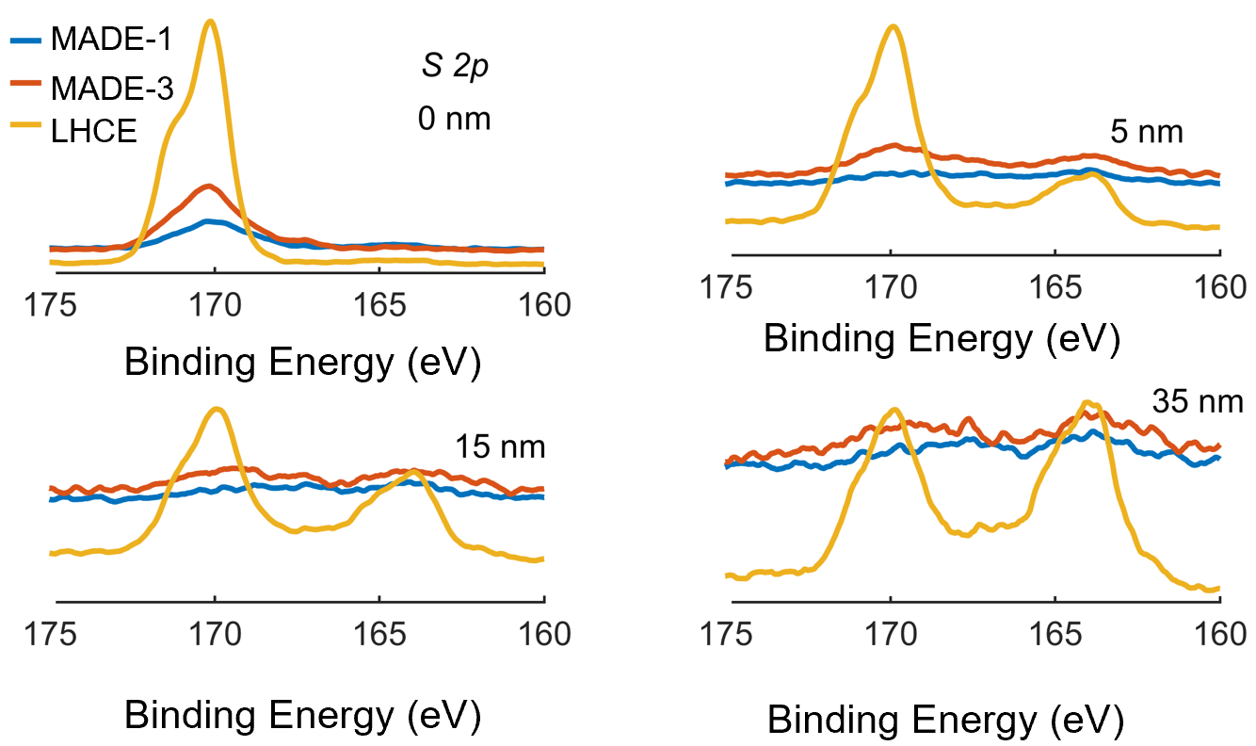
Figure S17. The comparison of S 2p spectrum after 50 cycles at 4.7V for MADE-1, MADE-3 and LHCE.

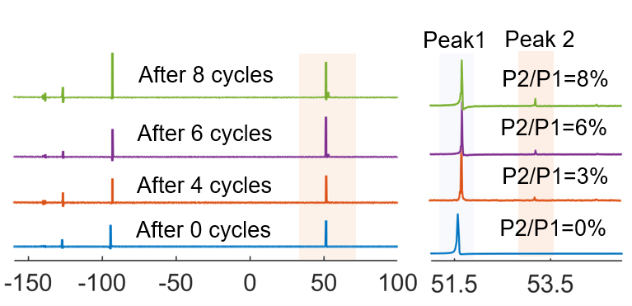
Figure S18. The ex-situ ¹⁹F NMR for LHCE after 0, 2, 4, 6, and 8 cycles.

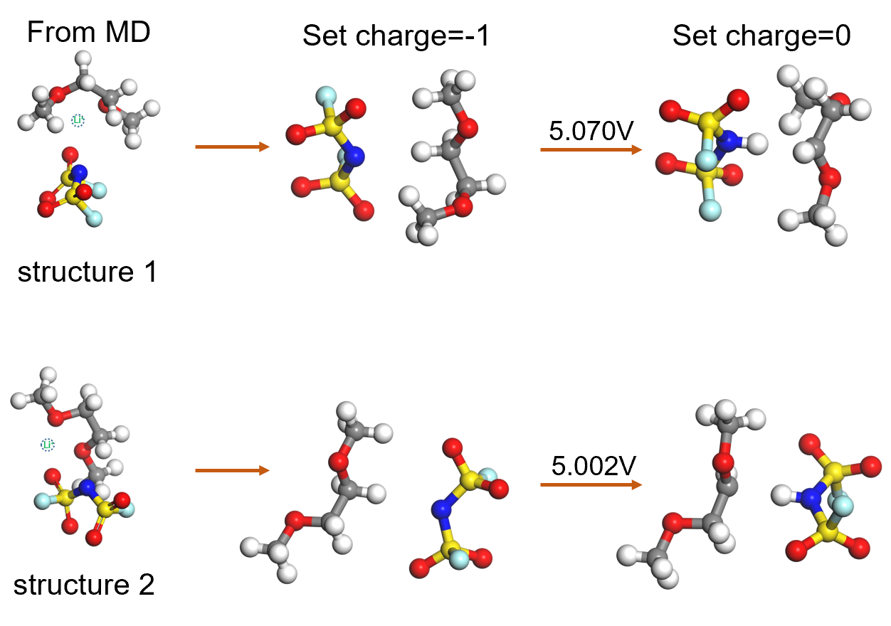
Figure S19. Simulation and optimization of the oxidation process of DME-FSI⁻ complexes.

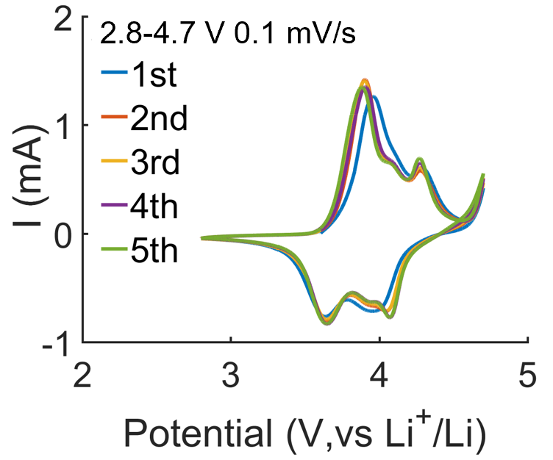
Figure S20. CV curves with LHCE (the cathode from the cell with MADE-1 after three cycles at 0.1C).

To verify whether the CEI layer formed in MADE-1 could inhibit electrolyte oxidation at 4.7 V. The NCM811 electrode is first cycled in MADE-1, and then the cathode is retrieved for battery assembly using LHCE, followed by CV testing. The test results indicate that the CEI cannot prevent the oxidation of LHCE at 4.7V, indicating that the stability of MADE-1 under high voltage is independent of the CEI.

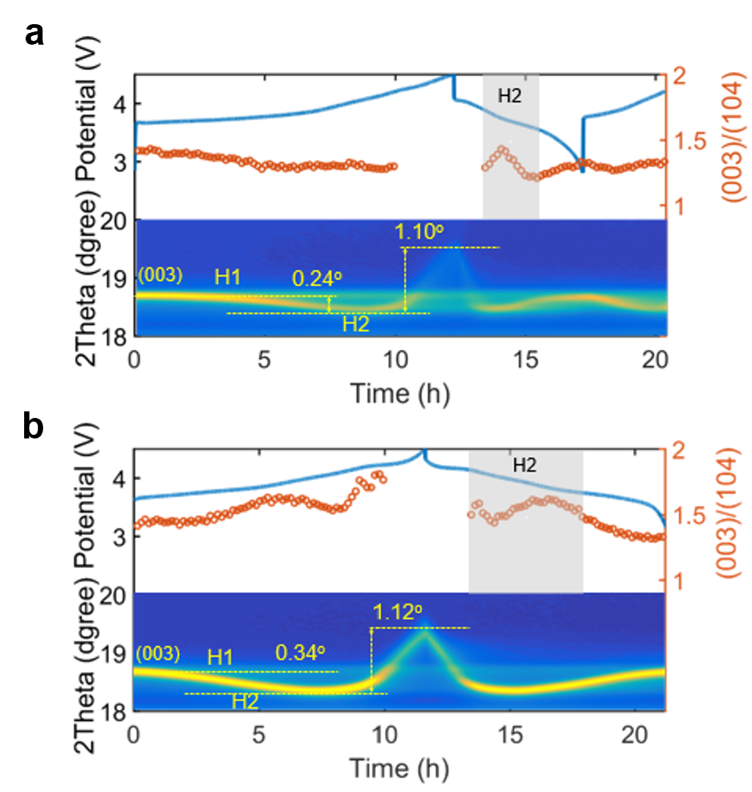
Figure S21. In-situ XRD pattern of the cathode recovered from the cell cycled four times at 0.1C in LHCE (a) and MADE-1 (b).

In order to investigate the effect of excessive side reactions on the electrode structure, the NCM811 electrode was first activated in MADE-1 and LHCE, respectively, and then the cathode was used for in situ XRD testing. To be fair, the same carbonate-based electrolyte (1M LiPF6 in EC/DMC/EMC) was used during in-situ XRD testing to characterize the differences caused by the CEI layer. The results indicate that excessive side reactions not only thicken the interface layer of the cathode, but also induce the failure of the electrode structure. This may be due to the irreversible transition of electrode structure towards lithium deficient phase caused by lithium not being embedded in a timely manner or lithium loss caused by side reactions.

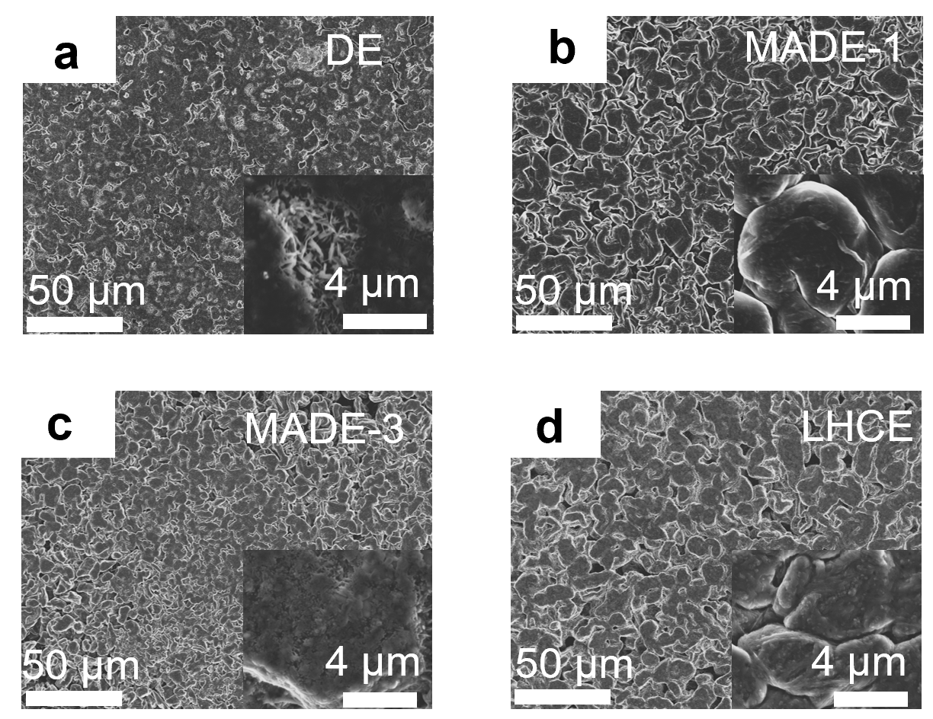
Figure S22. Li decomposition morphology of DE (A), MADE-1 (B), MADE-3 (C) and LHCE (D) with a current density of 0.5 mA cm⁻² for 4 mAh cm⁻².

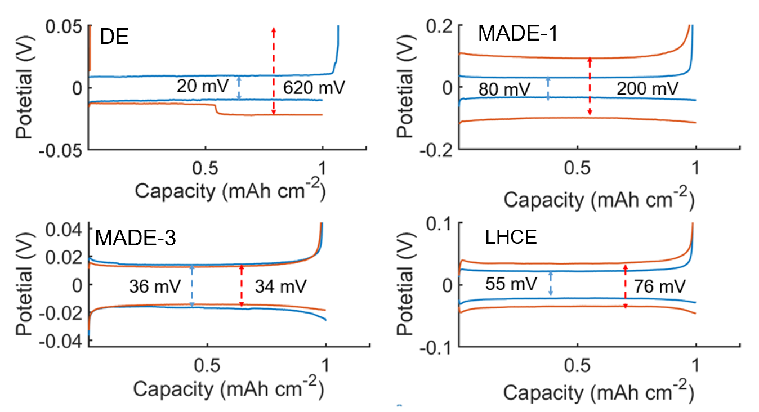
Figure S23. The potential curves at 20th and 100th cycle of Li||Cu cell with 0.5 mA cm⁻² and 1 mAh cm⁻² for DE, MADE-1, MADE-3 and LHCE.

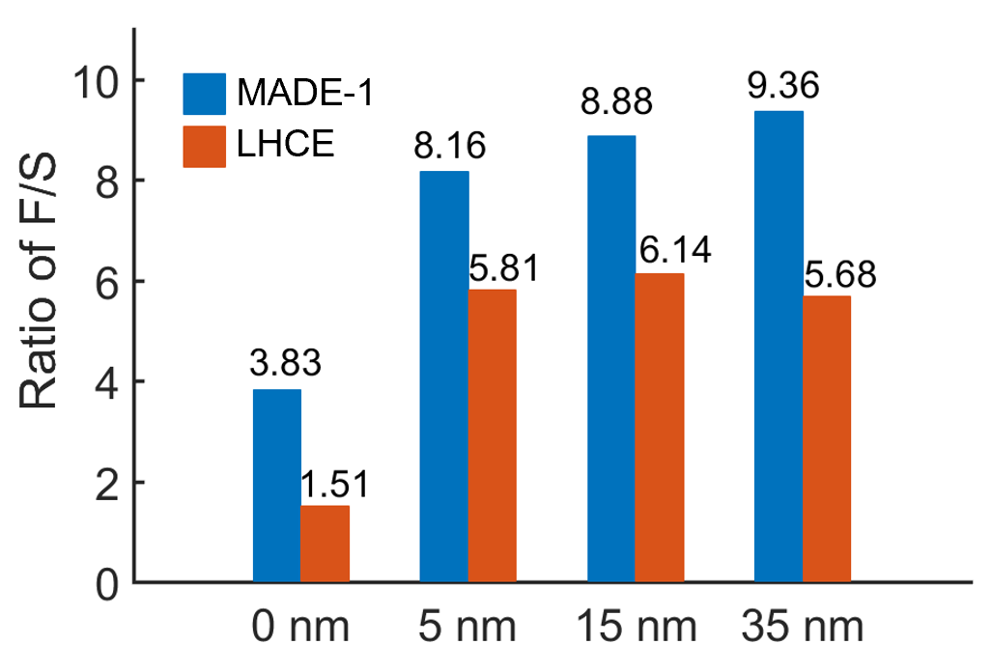
Figure 24. The ratio of F/S of SEI on Li metal recovered from the Li||NCM811 cell after 50 cycles for MADE-1 and LHCE.

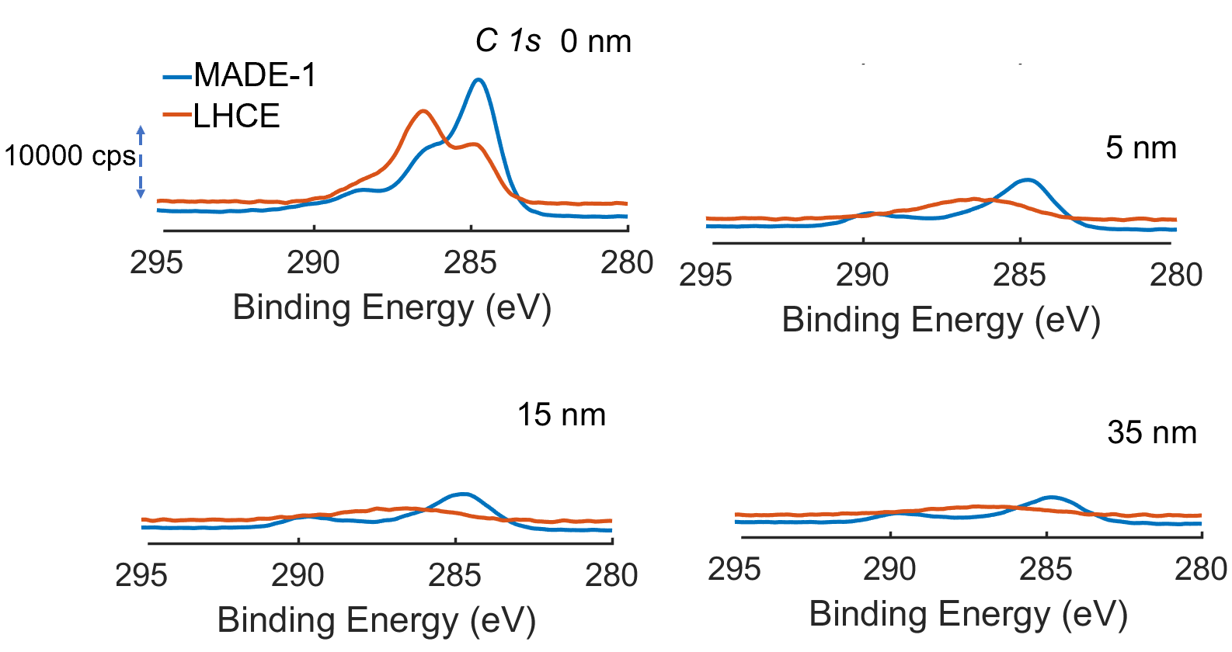
Figure S25. XPS C 1s spectrum for MADE-1 and LHCE after 0 nm, 5 nm, 15 nm and 35 nm sputtering.

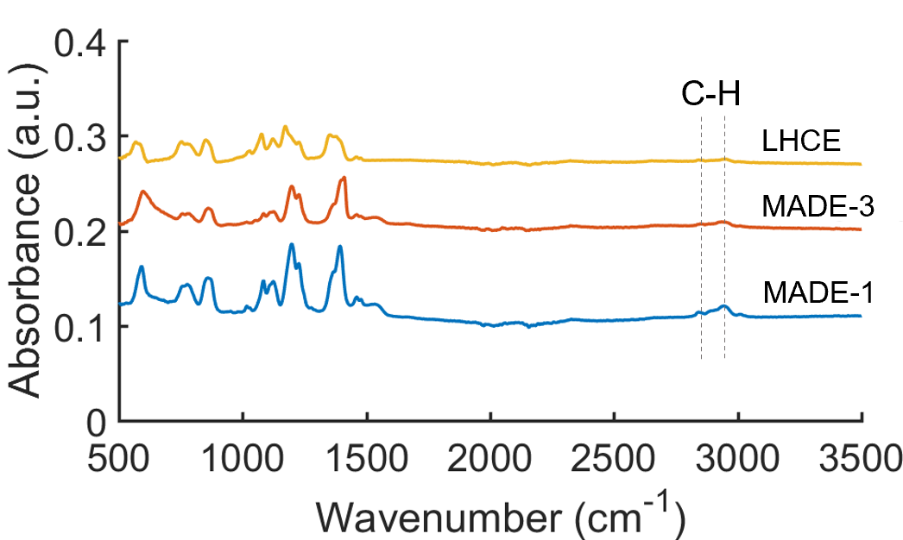
Figure S26. The FT-IR spectra of the Li SEI layers formed on Cu foils in the three ether-based electrolytes. All samples of Li SEI layers for FT-IR tests were obtained from the Li||Cu cells after 5 deposition/stripping cycles.

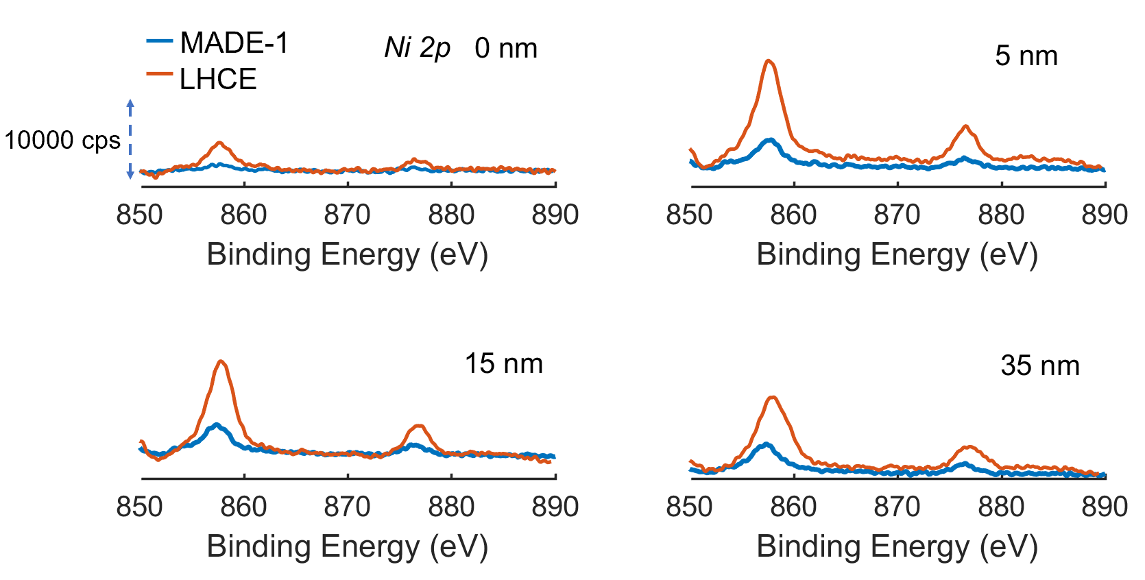
Figure S27.XPS Ni 2p spectrum for MADE-1 and LHCE after 0 nm, 5 nm, 15 nm and 35 nm sputtering.

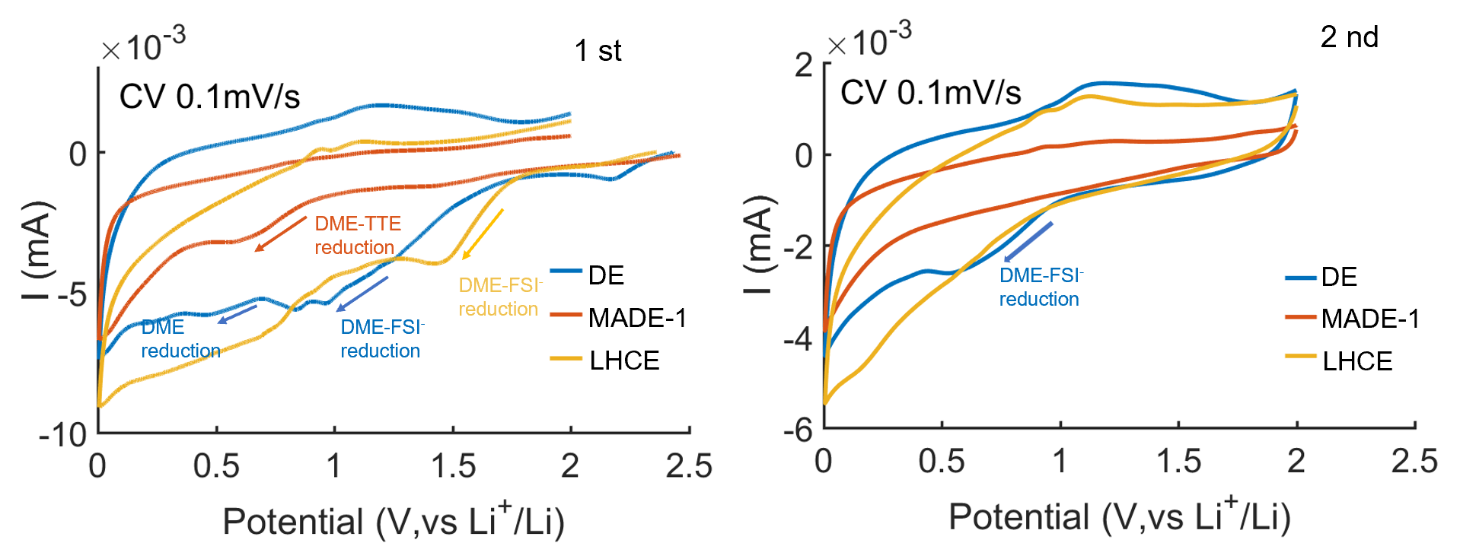
Figure S28. The cyclic voltammetry with a scanning rate of 0.1 mV s⁻¹ in a potential range from 2.5 V to 0.0 V of DE, MADE-1 and LHCE. The intensity of the LHCE reduction peak and the initial potential are higher than those of MADE-1, indicating that LHCE has stronger reactivity on the anode.

Reference
1. Lai P, Hua H, Huang B, Zhang P, Zhao J. A Carboxylic Ester-Based Electrolyte with Additive to Improve Performance of Lithium Batteries at Ultra-Low Temperature. Journal of The Electrochemical Society 169, 100539 (2022).

2. Han JG, et al. Unsymmetrical fluorinated malonatoborate as an amphoteric additive for high-energy-density lithium- ion batteries. Energy & Environmental Science 11, 1552-1562 (2018).

3. Gibson LD, Pfaendtner J. Solvent oligomerization pathways facilitated by electrolyte additives during solid-electrolyte interphase formation. Physical Chemistry Chemical Physics 22, 21494-21503 (2020).

4. Ren X, et al. Role of inner solvation sheath within salt–solvent complexes in tailoring electrode/electrolyte interphases for lithium metal batteries. Proceedings of the National Academy of Sciences 117, 28603-28613 (2020).

5. Lu T, Chen F. Multiwfn: A multifunctional wavefunction analyzer. Journal of Computational Chemistry 33, 580-592 (2012).

