Supplementary Information Note: This file only contains supplementary Fig. S1 and supplementary Fig. S2, respectively.

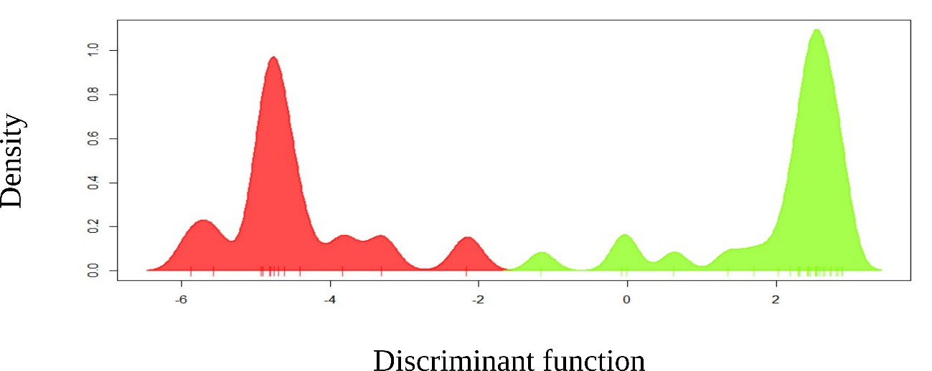

Fig. S1 DAPC analysis generated with K = 2 e15 principal components. The red group corresponds to the G1 group formed by the yellow mombin (Spondias mombin) populations from Paudalho - Pernambuco, São Lourenço da Mata - Pernambuco, Mata de São João - Bahia, Areia - Paraíba and Chapadinha - Maranhão. The green group corresponds to the G2 group composed of Iranduba, Novo Airão, Presidente Figueiredo, and Silves populations, all from the State of Amazonas.

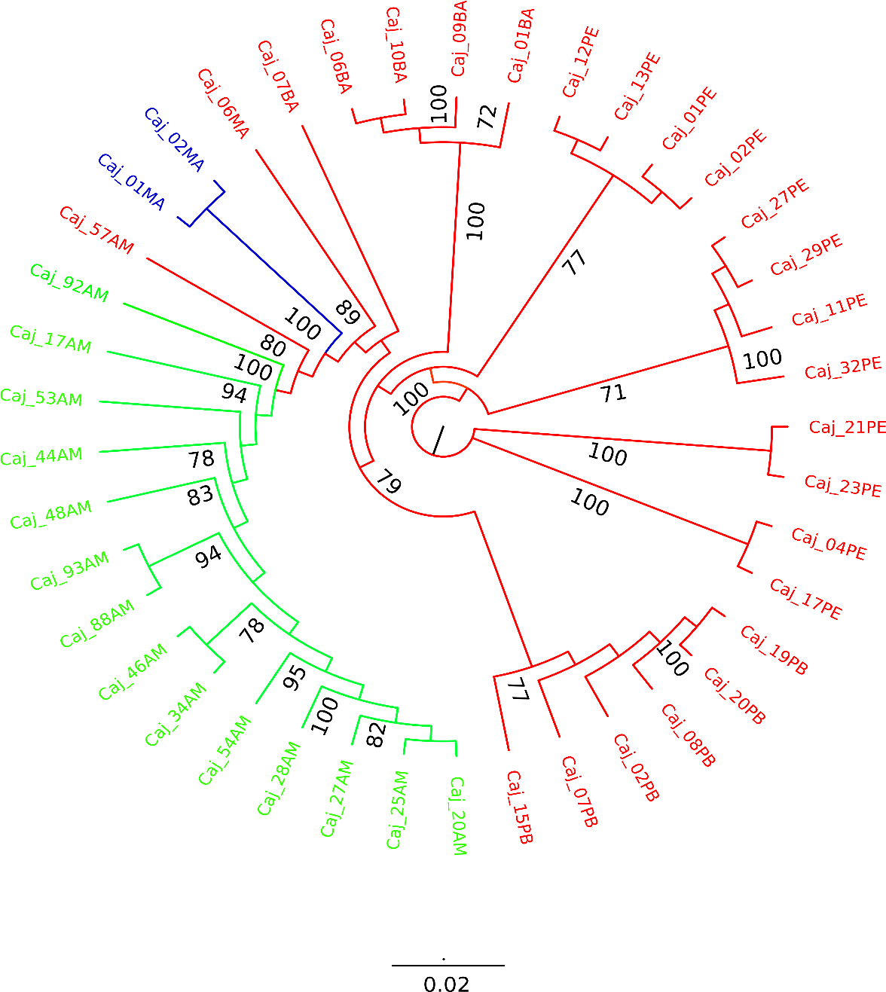

Fig. S2 Dendrogram obtained by the Neighbor-Joining method with representation in the same color of the groups identified by the DAPC analysis (G1 in red, G2 in green, and G3 in blue) with identification and positioning of each of them. The codes present at the end of the branches represent the identification and positioning of each of the Spondias mombin individuals analyzed, where: caja. means yellow mombin; AM – Amazonas; MA – Maranhão; BA – Bahia; PB – Paraíba; and PE – Pernambuco. The numbers are bootstrap values.

