Supporting information
Transforming Inert CeCl₃ into a Recyclable Heterogeneous Visible Light Photocatalyst

CONTENTS

1. Experimental section. | S3-S6
- Chemicals. | S3
- Instrumentation and methods. | S3-S6
2. Synthesis of 2,2-dibromo-1-phenylethan-1-one (3a). | S6-S7
3. Synthesis of 2,2-dichloro-1-(p-tolyl)ethan-1-one (4a). | S7
4. Synthesis of 2-(4-(tert-butyl)phenyl)-2-oxoethane-1,1-diyl diacetate (5a). | S7-S8
5. Synthesis of 2,2-di(pyrrolidin-1-yl)-1-(p-tolyl)ethan-1-one (5b). | S8
6. Synthesis of 2-oxo-2-(p-tolyl)ethane-1,1-diyl bis(4-methylbenzenesulfonate) (5c). | S9
7. Gram scale preparation of 2,2-dibromo-1-phenylethan-1-one (3a). | S10
8. Radical quenching experiment. | S10-S11
9. No reaction in the absence of oxygen and H₂O. | S11
10. Successful formation of 2,2-dibromo-1-phenylethan-1-one (3a) in presence of oxygen. | S12
11. Successful formation of 2,2-dibromo-1-phenylethan-1-one (3a) in the presence of water and labeling experiment with H₂¹⁸O. | S12-S13
12. UV spectrum of NBS, DBHT and DBIA in CH₃CN in absence and presence of CeCl₃. | S13
13. IUPAC-CV analysis of DBHT and DBHT+CeCl₃. | S14
14. IUPAC-CV analysis of DBIA and DBIA+CeCl₃. | S14
15. EPR studies of CeCl₃ and reaction mixture with DMPO. | S15-S16
16. Light ON-OFF-ON experiment. | S16
17. Catalyst recovery and reuse. | S17
18. FESEM images. | S17
19. Optimization of reaction conditions. | S18-S20
20. X-ray analysis of 3r. | S20-S22
21. Characterization data. | S23-S31
22. References | S32-S34
23. NMR spectra. | S35-S69
24. GC-MS spectrum of 2,2-dibromo-1-phenylethan-1-one (3a-¹⁸O). | S70
25. ESI-MS of NBS-CeCl₃ CT complex. | S71-S72

EXPERIMENTAL SECTION
Chemicals: Reagents like phenylacetylenes, N-bromosuccinimide (NBS), N-chlorosuccinimide (NCS), 1,3-Dibromo-5,5-dimethylhydantoin (DBHT), Dibromoisocyanuric acid (DBIA) and cerium chloride (CeCl₃) were purchased commercially and used without further purification.

Instrumentation and methods
Microfocus Single Crystal X-ray diffraction measurement (MSXRD): MSXRD was collected using Rigaku (Model: XtaLAB Supernova; Sl. No. Pl7250193) diffractometer (Cu Kα radiation; λ = 1.54184).
FESEM: The FESEM images were collected from CARL Zeiss FESEM instrument.
Absorption: UV-VIS absorption spectra of N-halosuccinimide (NXS: X = Br, Cl), DBIA, and DBHT in the absence and presence of CeCl₃ in acetonitrile were recorded with JascoV-730 spectrophotometer (Sl. No. Ao33661798).
Nuclear magnetic resonance (NMR) measurements: NMR spectra were recorded on 400 MHz and 700 MHz (BRUKER® ULTRASHIELD) instruments at 25 °C. The chemical shift values are reported in parts per million (ppm) for residual chloroform (7.26 ppm for ¹H and 77.16 ppm for ¹³C). The peak patterns are designated as follows: s: singlet; d: doublet; t: triplet; q: quartet; m: multiplet; dd: doublet of doublets; td: triplet of doublets; brs: broad singlet. The coupling constants (J) are reported in hertz (Hz). Samples solutions were prepared by dissolving in CDCl₃.
High-resolution mass spectra (HR-MS): HR-MS were recorded on a TOF Q-II (Bruker) (time of flight) mass spectrometer. Clear solutions of samples were prepared after dissolving in MeOH or MeCN.
Fourier transform infrared spectroscopy (FTIR): FTIR analysis data were collected from Thermo Scientific (NICOLET iS5) instrument under transmittance mode and reported in wavenumber (cm⁻¹). A thin layer of the compounds on the surface of the KBr pallet was prepared using dichloromethane as a solvent to record the data.
Electron paramagnetic resonance (EPR): EPR spectrum was recorded with a Bruker System EMX-microX at 298K and 9.4335 GHz. Typical EPR spectrometer parameters are shown as follows, scan range: 100 G; centre field set: 3480.00 G; time constant: 0.16 ms; scan time: 128.22 s; modulation amplitude: 20.0 G; modulation frequency: 100 kHz; receiver gain: 2.00 x 10²; microwave power: 7.14e⁻⁰⁰¹ mW; g = 2.007092. A description of sample preparation is given later.
Cyclic Voltammetry (CV): Cyclic voltammetric data were obtained from the CH Instruments Electrochemical Workstation (Model: 600E, SN: I1599) in dry and oxygen-free acetonitrile containing 0.1 M tetrabutylammonium hexafluorophosphate as a supporting electrolyte and 0.1 mM N-halosuccinimide (NXS: X = Br, Cl), DBHT or DBIA in the absence and presence of CeCl₃ as the analyte with a decoration of a platinum electrode, a Ag/AgCl electrode, and a platinum wire as the working electrode (with a circular geometry of the surface), reference electrode, and counter electrode, respectively starting from +2.0 V initial potential to -2.0 V switching potential with an oxidative direction of initial scan using a scan rate 50 mV/s at 25 ℃. Redox potential was referenced against ferrocene/ferrocenium (Fc/Fc⁺). Before and after using the platinum electrode (working electrode), it is polished using 0.5 micron of Al₂O₃ and a few drops of water over a flat glass surface. The deoxygenation of acetonitrile was done by purging Ar gas into the electrolytic solution with the help of a long needle syringe for 2 min.
Melting points: The compounds’ melting points (mp) were determined using a digital melting point apparatus and are uncorrected.
Photoreactor: This photoreactor was hand-made by us. It was constructed using an abandoned plastic container that held ten slots for quartz tubes and four 3W blue LEDs (Made: Murphy), and then the setup was placed over a magnetic stirrer. The entire assembly is surrounded by a cardboard box accommodated with four cooling fans. The whole light setup is placed in a well-ventilated place. The intensity of the blue LED is (580 x 100) lx (measured by Sigma-Digital Lux Meter 101, Model: 20036176). In contrast, the average intensity of the sunlight was (1390 x 100) lx between 9:30 AM to 1:30 PM (Place: School of Chemical Sciences building, 2nd floor, NISER Bhubaneswar).
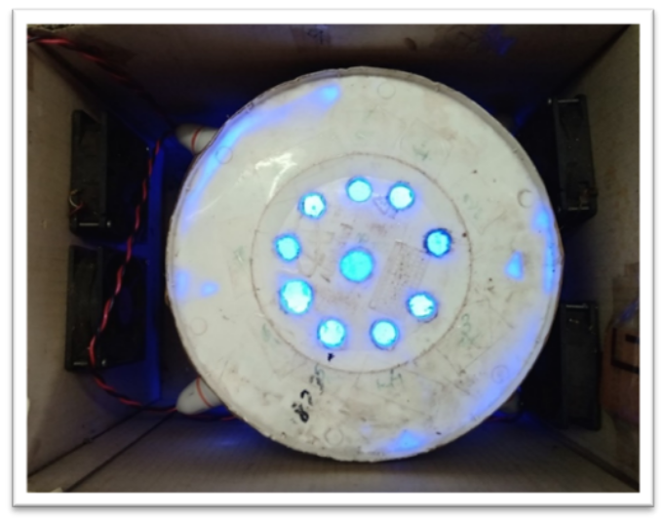
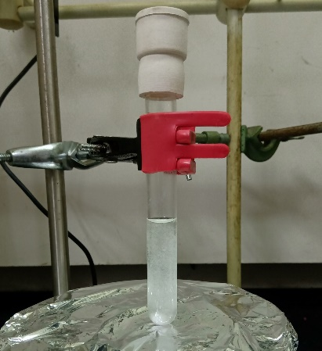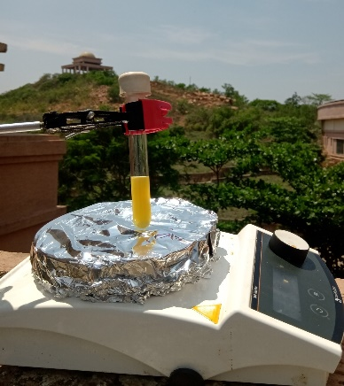
Figure S1. Image of the handmade photoreactor utilized to synthesize α, α dibromoketones (top). Reaction mixture before irradiation of blue LED (lower-left), and the formation of α, α dibromoketones under sunlight (lower-right).

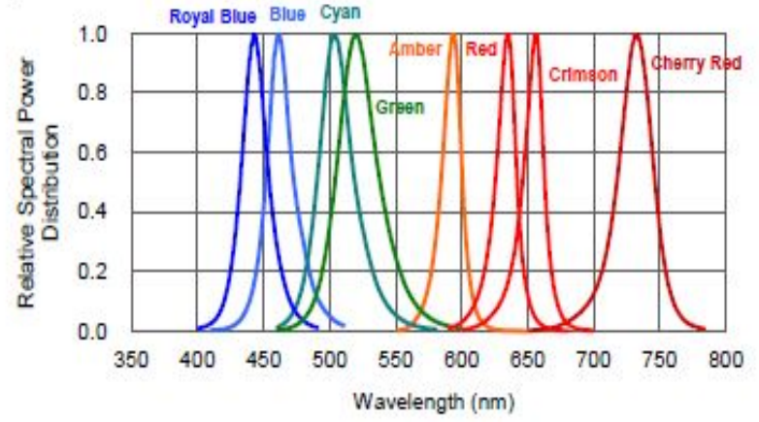
Figure S2: Spectra of various wavelength lights provided by Cryonano Labs.
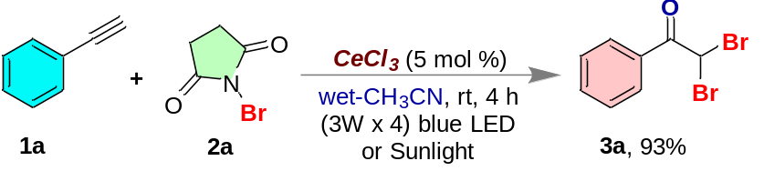
Figure S3. Procedure for the synthesis of 2,2-dibromo-1-phenylethan-1-one (3a).
A representative method for the preparation of 2,2-dibromo-1-phenylethan-1-one (3a). In a 10 mL quartz tube containing a reaction mixture of phenylacetylene (1a) (60 mg, 0.58 mmol, 64 µL, 1.0 equiv), N-bromosuccinimide (NBS) (2a) (0.258 g, 1.45 mmol, 2.5 equiv) in 3.0 mL moist-CH₃CN, the photocatalyst anhydrous-CeCl₃ (7 mg, 0.029 mmol, 0.05 equiv) was charged. Then, the quartz tube was sealed by a septum and paraffin tape and exposed to sunlight or put inside a blue LED (3W x 4) light set up for 4 h at room temperature. After the reaction monitored by TLC was completed, the reaction mixture was extracted with DCM (3 x 5 mL), the collected organic layer dried over anhydrous-Na₂SO₄, and removed under vacuum. Crude products were purified by column chromatography (eluent: hexane/EtOAc = 98:02), and 152 mg (93%, on sunlight exposure) of yellow liquid was isolated as 2,2-dibromo-1-phenylethan-1-one (3a).
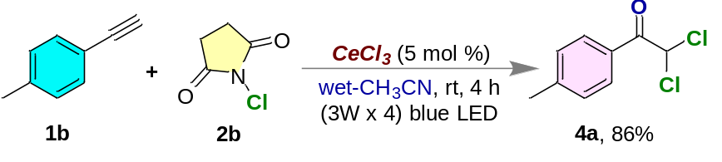
Figure S4. Procedure for the synthesis of 2,2-dichloro-1-(p-tolyl)ethan-1-one (4a).
A representative method for the preparation of 2,2-dichloro-1-(p-tolyl)ethan-1-one (4a). In a 10 mL quartz tube containing a reaction mixture of 1-ethynyl-4-methylbenzene (1b) (60 mg, 0.52 mmol, 60 µL, 1.0 equiv), N-chlorosuccinimide (NCS) (2b) (0.172 g, 1.29 mmol, 2.5 equiv) in 3.0 mL moist-CH₃CN, the photocatalyst anhydrous-CeCl₃ (6 mg, 0.026 mmol, 0.05 equiv) was charged. Then, the quartz tube was sealed by a septum and paraffin tape and put inside a blue LED (3W x 4) light set up for 4 h at room temperature. After the reaction monitored by TLC was completed, the reaction mixture was extracted with DCM (3 x 5 mL), the collected organic layer dried over anhydrous-Na₂SO₄, and removed under vacuum. Crude products were purified by column chromatography (eluent: hexane/EtOAc = 98:02), and 90 mg (86%) of yellow semi-solid was isolated as 2,2-dichloro-1-(p-tolyl)ethan-1-one (4a).

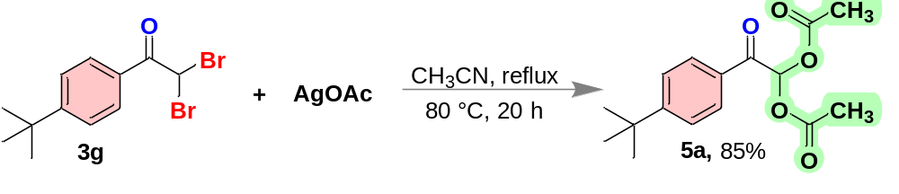
Figure S5. Procedure for the synthesis of 2-(4-(tert-butyl)phenyl)-2-oxoethane-1,1-diyl diacetate (5a).
A representative method for the preparation of 2-(4-(tert-butyl)phenyl)-2-oxoethane-1,1-diyl diacetate (5a).¹ In a 25 mL round bottom flask containing 2,2-dibromo-1-(4-(tert-butyl)phenyl)ethan-1-one (3g) (60 mg, 0.18 mmol, 1.0 equiv) in 3.0 mL CH₃CN charged AgOAc (67 mg, 0.40 mmol, 2.2 equiv) at room temperature. Then the reaction vessel equipped with a water condenser was allowed to heat at 80 °C for 20 h. After the mentioned time, the reaction was checked to confirm its completion. Then, the reaction mixture was extracted with DCM (3 x 5 mL), and the collected organic layer dried over anhydrous-Na₂SO₄, removed under vacuum, and crude products were purified by column chromatography (eluent: hexane/EtOAc = 90/10), and 45 mg (85%) of yellow liquid was isolated as 2-(4-(tert-butyl)phenyl)-2-oxoethane-1,1-diyl diacetate (5a).
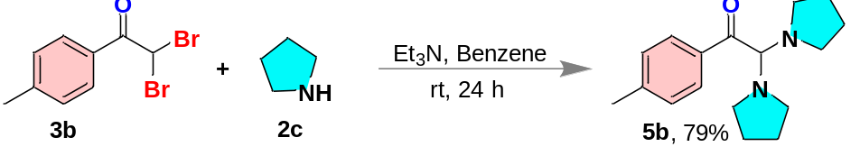
Figure S6. Procedure for the synthesis of 2,2-di(pyrrolidin-1-yl)-1-(p-tolyl)ethan-1-one (5b).
Representative method for the preparation of 2,2-di(pyrrolidin-1-yl)-1-(p-tolyl)ethan-1-one (5b).² A stirring solution of 2,2-dibromo-1-(p-tolyl)ethan-1-one (3b) (62 mg, 0.21 mmol, 1.0 quiv) in 4.0 mL dry-benzene in a 10 mL round bottom flask charged with pyrrolidine (2c) (32 mg, 37 µL, 0.45 mmol, 2.1 equiv) followed by triethylamine (46 mg, 63 µL, 0.45 mmol, 2.1 equiv) at room temperature (30 ℃) and sealed with a septum and paraffin tape. Then, with the help of a long needle syringe N₂-gas was purged for 2 mins and allowed to stir for 24 h. Then, the reaction mixture was dried under vacuum, and the reaction mixture was extracted with DCM (3 x 5 mL), and the collected organic layer dried over anhydrous-Na₂SO₄, removed under vacuum, crude products were purified by column chromatography (eluent: hexane/EtOAc = 70/30), and 46 mg (79%) of yellow liquid was isolated as 2,2-di(pyrrolidin-1-yl)-1-(p-tolyl)ethan-1-one (5b).
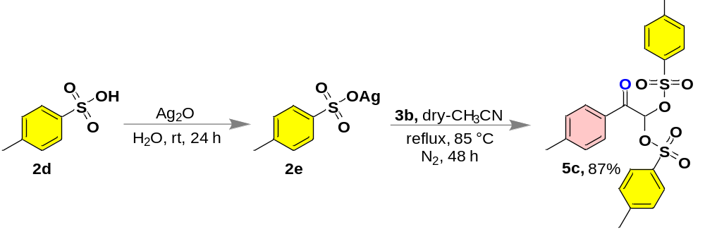
Figure S7. Procedure for the synthesis of 2-oxo-2-(p-tolyl)ethane-1,1-diyl bis(4-methylbenzenesulfonate) (5c).
Representative method for the preparation of 2-oxo-2-(p-tolyl)ethane-1,1-diyl bis(4-methylbenzenesulfonate) (5c).³ First, the (tosyloxy)silver was prepared by vigorous stirring of the mixture of 4-methylbenzenesulfonic acid (0.25 g, 1.32 mmol, 1.0 equiv) and silver oxide (0.34 g, 1.44 mmol, 1.1 equiv) in water at room temperature for 24 h. After that, the reaction mixture was filtered off and the supernatant was evaporated and dried under vacuum for next step. Then, in a stirring solution of 2,2-dibromo-1-(p-tolyl)ethan-1-one (3b) (65 mg, 0.22 mmol, 1.0 quiv) in 5.0 mL dry-CH₃CN in a 10 mL round bottom flask charged with (tosyloxy)silver (2e) (0.13 g, 0.48 mmol, 2.2 equiv) at room temperature (30 ℃) and sealed with a septum and paraffin tape. Then, with the help of a long needle syringe N₂-gas was purged for 2 mins and allowed to reflux under N₂ atmosphere for 48 h. Then, the reaction mixture was extracted with DCM (3 x 5 mL), and the collected organic layer dried over anhydrous-Na₂SO₄, removed under vacuum, crude products were purified by column chromatography (eluent: hexane/EtOAc = 75/25), and 92 mg (87%) of white solid was isolated as 2-oxo-2-(p-tolyl)ethane-1,1-diyl bis(4-methylbenzenesulfonate) (5c).
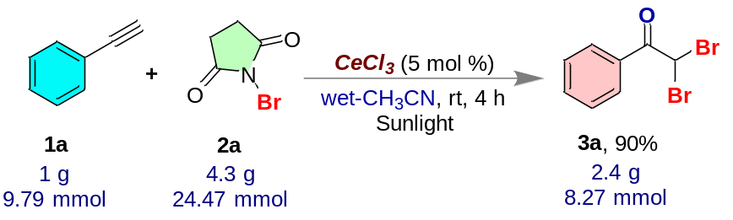
Figure S8. Procedure for gram-scale synthesis of 2,2-dibromo-1-phenylethan-1-one (3a).
Gram scale preparation of 2,2-dibromo-1-phenylethan-1-one (3a). In a 25 mL round bottom flask containing a reaction mixture of phenylacetylene (1a) (1.0 g, 9.79 mmol, 1.06 µL, 1.0 equiv), N-bromosuccinimide (NBS) (2a) (4.3 g, 24.47 mmol, 2.5 equiv) in 10 mL wet CH₃CN, the photocatalyst anhydrous-CeCl₃ (0.12 g, 0.49 mmol, 0.05 equiv) was charged. Then, the round bottom flask was sealed by a septum and paraffin tape and exposed to sunlight for 4 h. After the reaction monitored by TLC was completed, the reaction mixture was extracted with DCM (3 x 10 mL), the collected organic layer dried over anhydrous-Na₂SO₄, and removed under vacuum. Crude products were purified by column chromatography (eluent: hexane/EtOAc = 98:02), and 2.4 g (90%) of yellow liquid was isolated as 2,2-dibromo-1-phenylethan-1-one (3a).

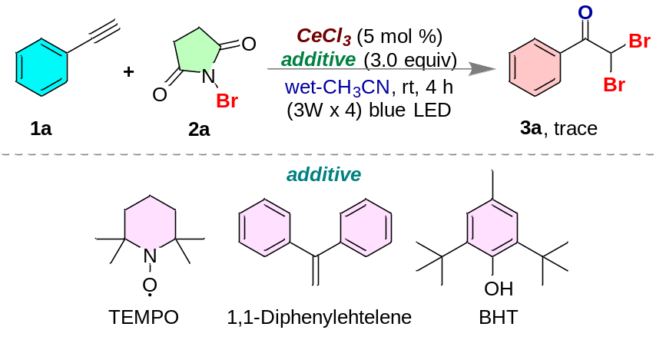
Figure S9. Procedure for radical quenching experiments.
Radical quenching experiments with TEMPO/BHT/1,1-Diphenylehtelene. In a 25 mL round bottom flask containing a reaction mixture of phenylacetylene (1a) (60 mg, 0.58 mmol, 64 µL, 1.0 equiv), N-bromosuccinimide (NBS) (2a) (0.258 g, 1.45 mmol, 2.5 equiv) in 3.0 mL moist-CH₃CN, the photocatalyst anhydrous-CeCl₃ (7 mg, 0.029 mmol, 0.05 equiv) followed by TEMPO (0.272 g, 1.74 mmol, 3.0 equiv) were charged. Then, the round bottom flask was sealed by a septum and paraffin tape and put inside a blue LED (3W x 4) light set up for 4 h at room temperature. After the period, the reaction mixture was monitored by TLC, but a trace amount of product formation occurred. The same reaction was again carried out with BHT (3.0 equiv) and 1,1-Diphenylehtelene (3.0 equiv) separately, but the same observations were there as with TEMPO.
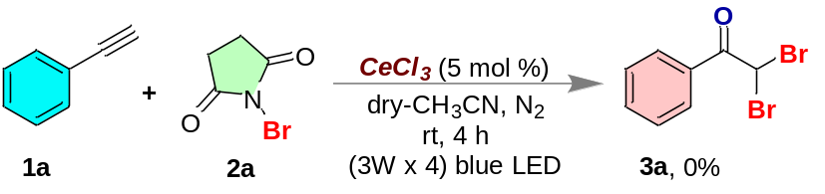
Figure S10. Quenching experiment in absence of oxygen and H₂O.

No reaction in the absence of oxygen and H₂O. In a 10 mL quartz tube containing a reaction mixture of phenylacetylene (1a) (60 mg, 0.58 mmol, 64 µL, 1.0 equiv), N-bromosuccinimide (NBS) (2a) (0.258 g, 1.45 mmol, 2.5 equiv) in 3.0 mL dry-CH₃CN, the photocatalyst anhydrous-CeCl₃ (7 mg, 0.029 mmol, 0.05 equiv) was charged. Then, the quartz tube was sealed by a septum and paraffin tape and with a long needle syringe N₂ gas was purged for 2 mins. Then, the quartz was put inside a blue LED (3W x 4) light set up for 4 h at room temperature. After the time period, the reaction mixture was monitored by TLC, but no desired product formation occurred. This indicates that the presence of H₂O and/oxygen is essential for this transformation.
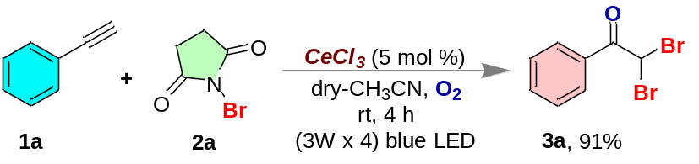
Figure S11. Essentiality of oxygen for the formation of 2,2-dibromo-1-phenylethan-1-one (3a).
A successful formation of 2,2-dibromo-1-phenylethan-1-one (3a) in the presence of oxygen. In a 10 mL quartz tube containing a reaction mixture of phenylacetylene (1a) (60 mg, 0.58 mmol, 64 µL, 1.0 equiv), N-bromosuccinimide (NBS) (2a) (0.258 g, 1.45 mmol, 2.5 equiv) in 3.0 mL dry-CH₃CN, the photocatalyst anhydrous-CeCl₃ (7 mg, 0.029 mmol, 0.05 equiv) was charged. Then, the quartz tube was sealed by a septum and paraffin tape and with a long needle syringe O₂ gas was purged for 2 min. Then, the quartz equipped with an oxygen balloon was put inside a blue LED (3W x 4) light set up for 4 h at room temperature. After the time period, the reaction mixture was monitored by TLC, and the desired product formation was observed (91% isolated yield). This indicates that the presence of oxygen is essential for this transformation.
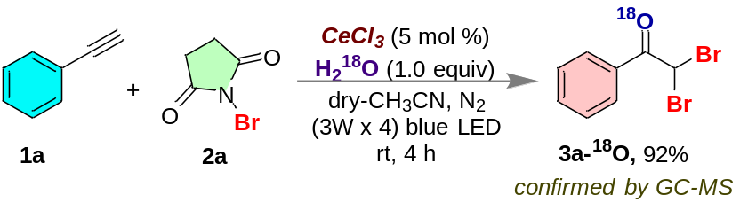
Figure S12. Procedure for labeling experiment.
A successful formation of 2,2-dibromo-1-phenylethan-1-one (3a) in presence of water and labeling experiment with H₂¹⁸O. In a 10 mL quartz tube containing a reaction mixture of phenylacetylene (1a) (60 mg, 0.58 mmol, 64 µL, 1.0 equiv), N-bromosuccinimide (NBS) (2a) (0.258 g, 1.45 mmol, 2.5 equiv) in 3.0 mL dry-CH₃CN, the photocatalyst anhydrous-CeCl₃ (7 mg, 0.029 mmol, 0.05 equiv) and H₂¹⁸O (10 µL, 0.58 mmol, 1.0 equiv) were charged. Then, the quartz tube was sealed by a septum and paraffin tape and with a long needle syringe N₂ gas was purged for 2 mins. Then, the quartz was put inside a blue LED (3W x 4) light set up for 4 h at room temperature. After the time period, the reaction mixture was monitored by TLC, and the desired product formation was observed (92% isolated yield) and confirmed by GC-MS. This indicates that the water molecule can be a source of oxygen in the desired product.

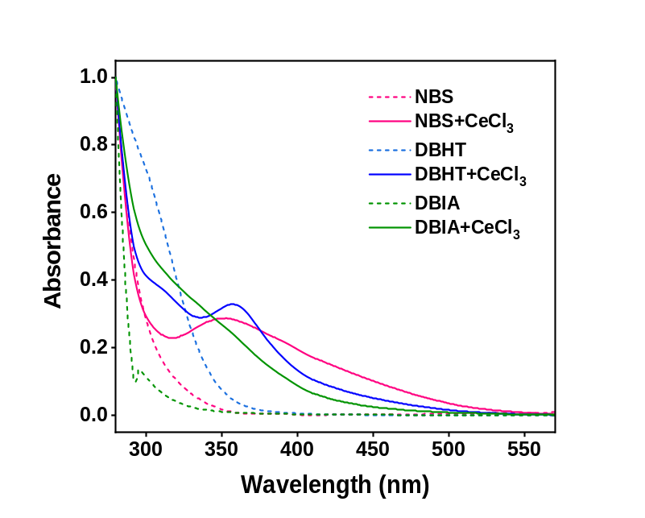
Figure S13. UV spectrum of NBS, DBHT and DBIA in CH₃CN in absence and presence of CeCl₃.

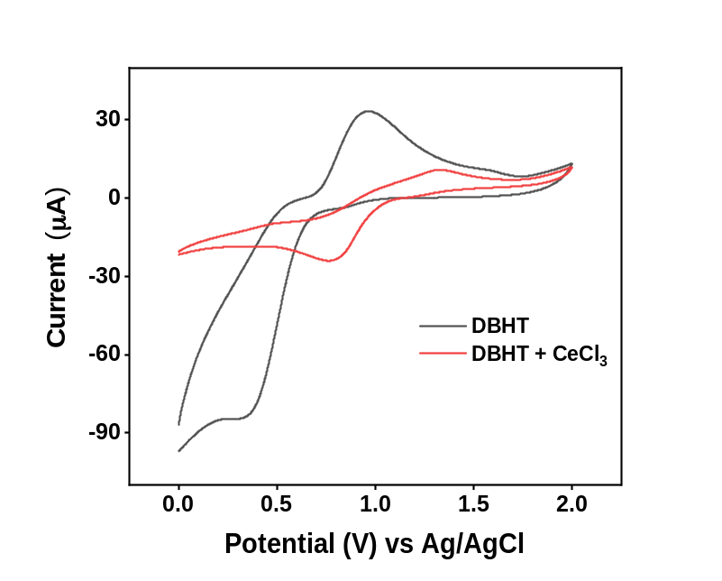
Figure S14. IUPAC-CV analysis of DBHT and DBHT+CeCl₃.

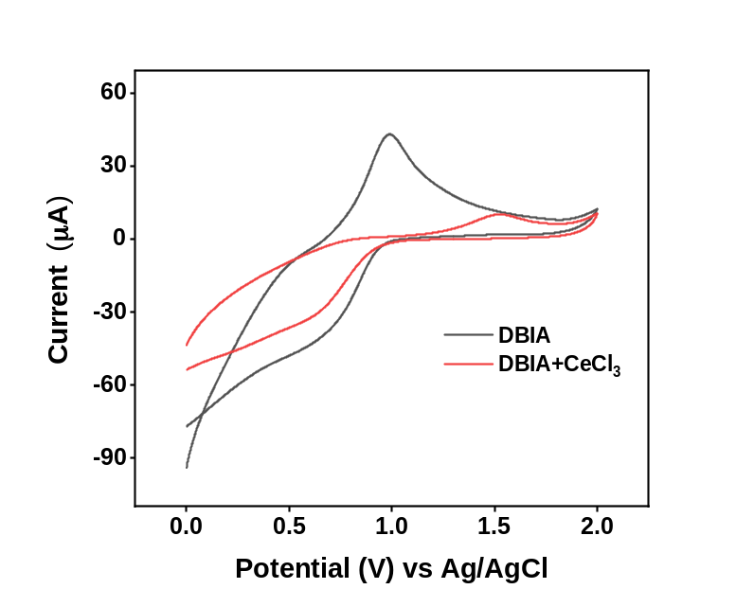
Figure S15. IUPAC-CV analysis of DBIA and DBIA+CeCl₃.

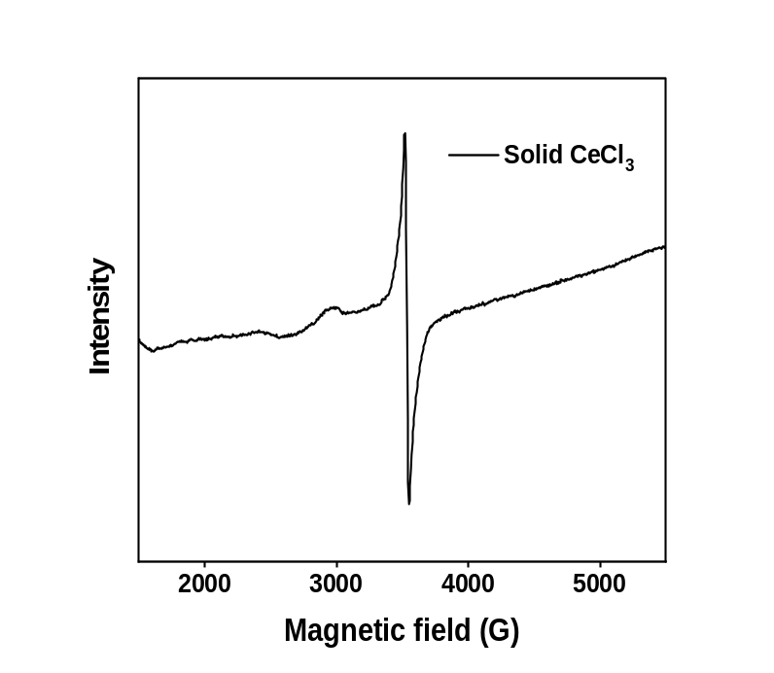
Figure S16. EPR study of CeCl₃ in solid state.
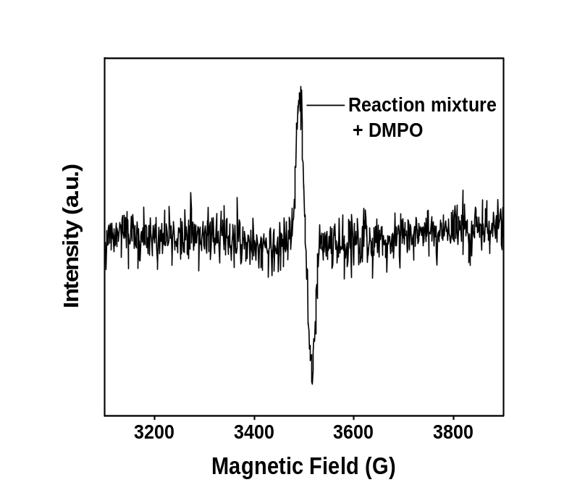
Figure S17. EPR study of the reaction mixture in presence of DMPO.

Spin-trapping experiment with DMPO. In a 10 mL quartz tube containing a reaction mixture of phenylacetylene (1a) (60 mg, 0.58 mmol, 64 µL, 1.0 equiv), N-bromosuccinimide (NBS) (2a) (0.258 g, 1.45 mmol, 2.5 equiv) in 3.0 mL moist-CH₃CN, the photocatalyst anhydrous-CeCl₃ (7 mg, 0.029 mmol, 0.05 equiv) was charged and followed by DMPO (20 µL) was added. Then, the quartz tube was sealed by a septum and paraffin tape, and put inside the blue LED (3W × 4) light set up for 2 h at room temperature. Afterward, 300 µL of the uncompleted reaction mixture was quickly taken out of the quartz tube and poured in an EPR tube and immediately around 200 µL of toluene was appended and EPR experiment was done.
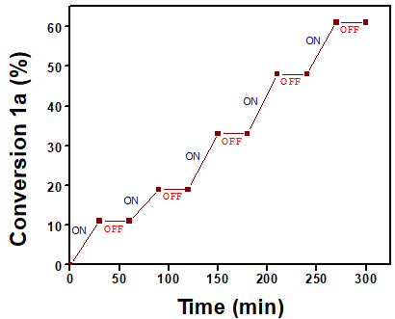
Figure S18. Representative plot for conversion of phenylacetylene (1a) Vs. Time in the presence and absence of light, respectively.

Light ON-OFF-ON experiment. In a 10 mL quartz tube containing a reaction mixture of phenylacetylene (1a) (60 mg, 0.58 mmol, 64 µL, 1.0 equiv), N-bromosuccinimide (NBS) (2a) (0.258 g, 1.45 mmol, 2.5 equiv) in 3.0 mL moist-CD₃CN, the photocatalyst anhydrous-CeCl₃ (7 mg, 0.029 mmol, 0.05 equiv) was charged. Then, the quartz tube was sealed by a septum and paraffin tape, oxygen gas was purged for 2 min with a long needle syringe and put inside a blue LED (3W x 4) light set up for 5 h at room temperature. Then, the progress of the reaction was closely monitored every 30 min in the presence of light and absence of light repeatedly by the ¹H-NMR experiment.

Catalyst recovery and reuse. In a 25 mL round bottom flask containing a reaction mixture of phenylacetylene (1a) (0.3 g, 2.94 mmol, 0.323 µL, 1.0 equiv), N-bromosuccinimide (NBS) (2a) (1.31 g, 7.34 mmol, 2.5 equiv) in 6 mL wet CH₃CN, the photocatalyst anhydrous-CeCl₃ (36 mg, 0.15 mmol, 0.05 equiv) was charged. Then, the round bottom flask was sealed by a septum and paraffin tape and exposed to blue LED (3W x 4) for 4 h. After the completion of the reaction monitored by TLC, the reaction mixture was transferred to a 15 mL centrifuge tube and the round bottom flask was washed with minimum amount of CH₃CN and added to the centrifuge tube. Then, the reaction mixture was centrifuged for 10 min at 6500 rpm. The supernatant was decanted and another 5 mL of CH₃CN was added to the residue and again centrifuged for 10 min. After the 2nd centrifuge, the supernatant was discarded, and the residue was used for next reaction with the same scale. The recovered catalyst used for five successive reactions without any loss in the catalytic efficiency.

Figure S19. FESEM images of CeCl₃. Initial (left) after 5th cycle (right).

Table S1. Optimization of reaction condition.ª

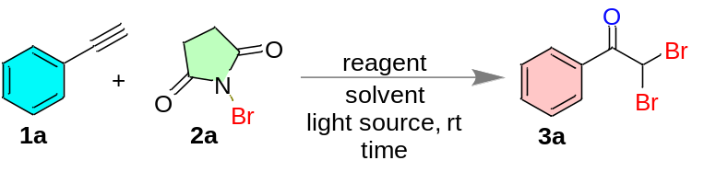
entry | catalyst  (5 mol %) | halogen source  (equiv) | solvent^{b} | time (h) | yield^{c}
1 | ---- | NBS (2.0) | DCE | 6 | 12
2 | ---- | NBS (2.5) | DCE | 12 | 19
3 | ---- | NBS (2.5) | DCE | 48 | 39
4 | Eosin Y | NBS (2.5) | DCE | 12 | 20
5 | Rose Bengal | NBS (2.5) | DCE | 12 | 23
6 | anhydrous-CeCl₃ | NBS (2.5) | DCE | 6 | 73
7 | anhydrous-CeCl₃ | NBS (2.5) | THF | 6 | 79
8 | anhydrous-CeCl₃ | NBS (3.0) | THF | 6 | 78
9 | anhydrous-CeCl₃ | NBS (2.5) | CH₃CN^{d/e} | 4 | 93^{d}/92e
10 | anhydrous-CeCl₃ | NBS (3.0) | CH₃CN | 6 | 92
11 | anhydrous-CeCl₃ | Br₂ (2.0) | CH₃CN | 4 | 23
12 | anhydrous-CeCl₃ | NCS (2.5) | CH₃CN | 4 | NR^{f}
13 | anhydrous-CeCl₃ | NIS (2.5) | CH₃CN | 4 | NR^{f}
14 | anhydrous-CeCl₃ | NBS (2.5) | CH₃CN^{g} | 4 | NR
15 | anhydrous-CeCl₃ | NBS (2.5) | CH₃CN^{h} | 4 | 91

ªAll reactions were carried out on a 60 mg scale with 5 mol % of photocatalysts under aerobic conditions under the exposure of blue LED (3W x 4, 450-455 nm) unless specified else. ^{b}Undried solvents were used unless specified else. ^{c}Isolated yields after column chromatography. ^{d}Reaction performed under N₂ atmosphere under sunlight. ^{e}Reaction performed under N₂ atmosphere under blue LED (3W x 4, 450-455 nm). ^{f}No reaction. ^{g}Reaction performed under an N₂ atmosphere using a dry solvent. ^{h}Reaction performed under an O₂ atmosphere using a dry solvent.

The optimized reaction condition (Table 1) was achieved using phenylacetylene (1a) and N-bromosuccinimide (NBS, 2a) as the model substrates for the synthesis of 2,2-dibromo-1-phenylethan-1-one (3a). When the reaction mixture of phenylacetylene (1a, 1.0 equiv) and N-bromosuccinimide (2a, 2.0 equiv) in DCE was irradiated radiation using a handmade visible light photoreactor containing blue LEDs (3W x 4, 450-455 nm) for 6 h in the absence of any photocatalyst (entry 1), a negligible amount (12%) of the desired product was isolated. Then, we elevated the equivalency of 2a to 2.5 equiv and the reaction time to 12 h (entry 2), but no significant growth in the reaction yield was observed. We also monitored the reaction for up to 48 h, and it gave only 39% of the isolated product (entry 3). After this, we assumed photosensitizer might change the scenario, so we used Eosin Y (entry 4) and Rose Bengal (entry 5) for up to 12 h. The maximum yield we achieved was around 23%. Then, we shifted our focus toward heterogeneous photocatalysis and speculated that CeCl₃ might be a suitable photocatalyst. Afterward, to our delight, on using anhydrous-CeCl_{3,} the yield increased to 73% (entry 6). After this achievement, we changed the solvent (entry 7), and equivalency of NBS (2a, entry 8), and the maximum yield obtained was up to 79%. When we combined 2.5 equiv of 2a and CH₃CN as the solvent under the N₂ atmosphere (entry 9), within 4 h, the reaction was completed with an excellent yield of 92 % under blue LED irradiation (93% under sunlight). However, no significant change in isolated yield was observed on increasing the reaction time to 6 h (entry 10). On replacing NBS with Br₂, the desired product was isolated with a poor yield of 23% (entry 11). We also used other halogen sources like NCS (entry 12) and NIS (entry 13), but no reaction happened. No desired product formation was observed when we carried out the reaction in the N₂ atmosphere using dry CH₃CN (entry 14). Interestingly, in entry 15, where the reaction was performed under an O₂ atmosphere using dry acetonitrile, the reaction was fruitful as earlier. These observations indicate that O₂ and/or H₂O have a vital role in the reaction mechanism.

X-RAY CRYSTALLOGRAPHY ANALYSIS
Procedure for preparing the crystal sample. In a 10 mL round bottom flask, 20 mg of 2, 2-dibromo-1-(6-methoxynaphthalen-2-yl)ethan-1-one (3q) was dissolved using ethyl acetate and hexane mixture = 1:1 (6 mL). After that, the solution was allowed for slow evaporation to obtain good-quality of crystal.

Crystal measurement
The crystals data were collected with a Bruker SMART D8 goniometer equipped with an APEX CCD detector and an INCOATEC micro source (Cu-Kα radiation, λ = 1.54184 Å). SAINT+⁴ and SADABS integrated the intensities and correct absorption, respectively. The structure was resolved by direct methods and refined on F² with SHELXL-97.⁵ ORTEP drawing of the compounds shows ellipsoid contour at the 50% probability level.
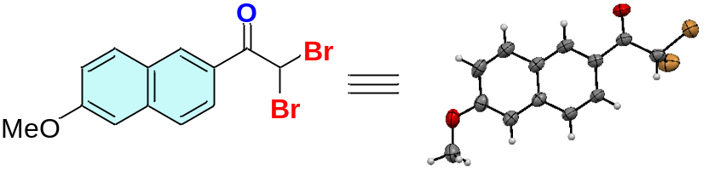
Figure S20. Crystal structure of 3r (50% ellipsoid probability).

CCDC | 2259841
Empirical formula | C₁₃H₁₀Br₂O₂
Formula weight | 358.03
Temperature/K | 297.56(14)
Crystal system | monoclinic
Space group | P2₁/n
a/Å | 9.50840(10)
b/Å | 10.35540(10)
c/Å | 13.20560(10)
α/° | 90
β/° | 93.0920(10)
γ/° | 90
Volume/Å³ | 1298.37(2)
Z | 4
ρ_{calc}g/cm³ | 1.832
μ/mm⁻¹ | 7.820
F(000) | 696.0
Crystal size/mm³ | 0.32 × 0.27 × 0.26
Radiation | Cu Kα (λ = 1.54184)
2Θ range for data collection/° | 10.864 to 155.618
Index ranges | -10 ≤ h ≤ 12, -13 ≤ k ≤ 12, -16 ≤ l ≤ 16
Reflections collected | 10087
Independent reflections | 2681 [R_{int} = 0.0611, R_{sigma} = 0.0531]
Data/restraints/parameters | 2681/0/156
Goodness-of-fit on F² | 1.054
Final R indexes [I>=2σ (I)] | R₁ = 0.0509, wR₂ = 0.1442
Final R indexes [all data] | R₁ = 0.0587, wR₂ = 0.1471
Largest diff. peak/hole / e Å⁻³ | 1.28/-0.82

CHARACTERIZATION DATA
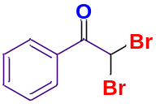2,2-dibromo-1-phenylethan-1-one (3a).⁶ R_{f} = 0.3 (hexane); yellow liquid; yield 93% (152 mg); ¹H NMR (400 MHz, CDCl₃) δ 8.08 (d, J = 8.6 Hz, 2H), 7.64 (t, J = 7.4 Hz, 1H), 7.51 (t, J = 7.8 Hz, 2H), 6.72 (s, 1H); ¹³C NMR (100 MHz, CDCl₃) δ 186.1, 134.6, 131.0, 130.0, 129.1, 40.0.

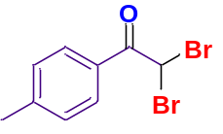2,2-dibromo-1-(p-tolyl)ethan-1-one (3b). R_{f} = 0.3 (hexane); white solid; mp 95 ℃ (lit.⁷ 95-96 ℃); yield 90% (136 mg); ¹H NMR (700 MHz, CDCl₃) δ 7.98 (d, J = 8.2 Hz, 2H), 7.31 (d, J = 8.2 Hz, 2H), 6.69 (s, 1H), 2.44 (s, 3H); ¹³C NMR (175 MHz, CDCl₃) δ 185.8, 145.9, 130.0, 129.8, 128.3, 77.34, 77.16, 76.98, 40.00, 22.0.

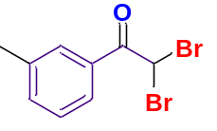2,2-dibromo-1-(m-tolyl)ethan-1-one (3c).⁸ R_{f} = 0.3 (hexane); yellow liquid; yield 88% (133 mg); ¹H NMR (400 MHz, CDCl₃) δ 7.86 (d, J = 6.2 Hz, 2H), 7.45 (d, J = 7.6 Hz, 1H), 7.39 (t, J = 8.0 Hz, 1H), 6.74 (s, 1H), 2.43 (s, 3H); ¹³C NMR (100 MHz, CDCl₃) δ 186.2, 139.1, 135.4, 131.0, 130.2, 128.9, 126.9, 40.0, 21.5.

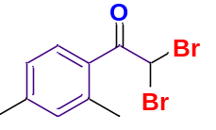2,2-dibromo-1-(2,4-dimethylphenyl)ethan-1-one (3d). R_{f} = 0.3 (hexane); yellow liquid; yield 91% (128 mg); ¹H NMR (400 MHz, CDCl₃) δ 7.50 (s, 1H), 7.31 (d, J = 7.7 Hz, 1H), 7.25 (d, J = 7.8 Hz, 1H), 6.76 (s, 1H), 2.51 (s, 3H), 2.43 (s, 3H); ¹³C NMR (100 MHz, CDCl₃) δ 188.8, 137.1, 135.5, 133.6, 132.3, 132.2, 128.5, 42.5, 21.0, 20.6; ῦ = 2964, 1702, 1448, 1262, 822 cm⁻¹; HRMS (ESI/QTOF) m/z: [M + H]⁺ calcd for C₁₀H₁₁Br₂O 304.9177; Found 304.9197.

2,2-dibromo-1-(4-propylphenyl)ethan-1-one (3e).⁹ R_{f} = 0.3 (hexane); yellow liquid; yield 89% (118 mg); ¹H NMR (400 MHz, CDCl₃) δ 8.00 (d, J = 8.2 Hz, 2H), 7.31 (d, J = 8.2 Hz, 2H), 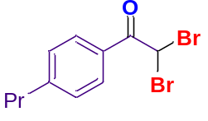6.71 (s, 1H), 2.66 (t, J = 7.6 Hz, 2H), 1.70 – 1.64 (m, 2H), 0.95 (t, J = 7.3 Hz, 3H); ¹³C NMR (100 MHz, CDCl₃) δ 185.8, 150.5, 130.0, 129.2, 128.5, 40.0, 38.2, 24.2, 13.9.

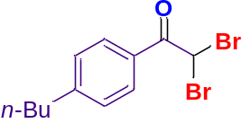2,2-dibromo-1-(4-butylphenyl)ethan-1-one (3f).¹⁰ R_{f} = 0.3 (hexane); colourless liquid; yield 85% (107 mg); ¹H NMR (400 MHz, CDCl₃) δ 8.00 (d, J = 8.4 Hz, 2H), 7.31 (d, J = 8.2 Hz, 2H), 6.71 (s, 1H), 2.79 (t, J = 7.4 Hz, 2H), 1.7-1.6 (m, 2H), 1.4-1.3 (m, 2H), 0.93 (t, J = 7.3 Hz, 3H); ¹³C NMR (100 MHz, CDCl₃) δ 185.7, 150.7, 130.0, 129.1, 128.4, 40.0, 35.9, 33.2, 22.4, 14.0.

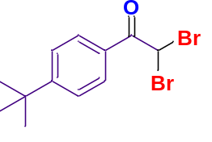2,2-dibromo-1-(4-(tert-butyl)phenyl)ethan-1-one (3g).⁷ R_{f} = 0.3 (hexane); yellow liquid; yield 92% (116 mg); ¹H NMR (400 MHz, CDCl₃) δ 8.03 (d, J = 8.6 Hz, 2H), 7.52 (d, J = 8.6 Hz, 2H), 6.71 (s, 1H), 1.35 (s, 9H); ¹³C NMR (100 MHz, CDCl₃) δ 185.7, 158.7, 129.9, 128.2, 126.1, 40.0, 35.5, 31.1.
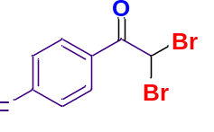2,2-dibromo-1-(4-fluorophenyl)ethan-1-one (3h). R_{f} = 0.3 (hexane); white solid; mp 38 ℃ (lit.⁷ 36 ℃); yield 90% (133 mg); ¹H NMR (700 MHz, CDCl₃) δ 8.16-8.14 (m, 2H), 7.18 (t, J = 8.5 Hz, 2H), 6.62 (s, 1H); ¹³C NMR (175 MHz, CDCl₃) δ 184.7, 166.8 (d, ¹J_{C-F} = 256.6 Hz), 132.8 (d, ³J_{C-F} = 9.6 Hz), 127.2 (d, ⁴J_{C-F} = 2.6 Hz), 116.3 (d, ²J_{C-F} = 22.0 Hz), 39.5.

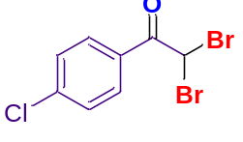2,2-dibromo-1-(4-chlorophenyl)ethan-1-one (3i). R_{f} = 0.3 (hexane); white solid; mp 89 ℃ (lit.⁷ 91-92 ℃); yield 87% (119 mg); ¹H NMR (400 MHz, CDCl₃) δ 8.05 (d, J = 8.6 Hz, 2H), 7.49 (d, J = 8.6 Hz, 2H), 6.61 (s, 1H); ¹³C NMR (100 MHz, CDCl₃) δ 185.0, 141.2, 131.3, 129.4, 129.2, 39.4.

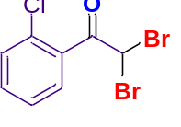2,2-dibromo-1-(2-chlorophenyl)ethan-1-one (3j).⁷ R_{f} = 0.3 (hexane); yellow liquid; yield 77% (105 mg); ¹H NMR (400 MHz, CDCl₃) δ 7.63 – 7.60 (m, 1H), 7.50 – 7.44 (m, 2H), 7.40 – 7.36 (m, 1H), 6.77 (s, 1H); ¹³C NMR (100 MHz, CDCl₃) δ 188.9, 134.2, 133.1, 131.2, 131.0, 130.6, 127.4, 42.2.

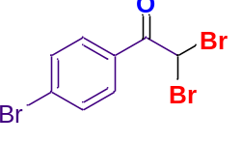2,2-dibromo-1-(4-bromophenyl)ethan-1-one (3k). R_{f} = 0.3 (hexane); white solid; mp 90 ℃ (lit.⁷ 90-91 ℃); yield 91% (107 mg); ¹H NMR (400 MHz, CDCl₃) δ 7.97 (d, J = 8.8 Hz, 2H), 7.66 (d, J = 8.7 Hz, 2H), 6.60 (s, 1H); ¹³C NMR (100 MHz, CDCl₃) δ 185.2, 132.4, 131.4, 130.0, 129.6, 39.3.

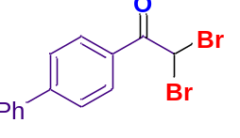1-([1,1'-biphenyl]-4-yl)-2,2-dibromoethan-1-one (3l).⁶ R_{f} = 0.3 (hexane); white solid; mp 96 ℃; yield 83% (99 mg); ¹H NMR (400 MHz, CDCl₃) δ 8.17 (d, J = 8.5 Hz, 2H), 7.73 (d, J = 8.4 Hz, 2H), 7.65-7.64 (m, 1H), 7.63 (s, 1H), 7.51-7.47 (m, 2H), 7.45 – 7.41 (m, 1H), 6.73 (s, 1H); ¹³C NMR (100 MHz, CDCl₃) δ 185.7, 147.3, 139.5, 130.5, 129.5, 129.2, 128.8, 127.6, 127.5, 39.9.

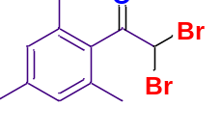2,2-dibromo-1-mesitylethan-1-one (3m). R_{f} = 0.3 (hexane); yellow liquid; yield 84% (112 mg); ¹H NMR (400 MHz, CDCl₃) δ 6.80 (s, 2H), 6.21 (s, 1H), 2.21 (s, 9H); ¹³C NMR (100 MHz, CDCl₃) δ 192.9, 140.7, 135.1, 133.1, 129.1, 44.5, 21.3, 20.2; ῦ = 2922, 1712, 1451, 1252, 854 cm⁻¹; HRMS (ESI/QTOF) m/z: [M + H]⁺ calcd for C₁₁H₁₃Br₂O 318.9333; Found 318.9330.

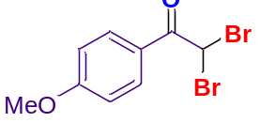2,2-dibromo-1-(4-methoxyphenyl)ethan-1-one (3n).⁶ R_{f} = 0.3 (hexane); yellow semi-solid; yield 90% (126 mg); ¹H NMR (400 MHz, CDCl₃) δ 8.06 (d, J = 9.0 Hz, 2H), 6.96 (d, J = 9.0 Hz, 2H), 6.68 (s, 1H), 3.88 (s, 3H); ¹³C NMR (100 MHz, CDCl₃) δ 184.8, 164.6, 132.3, 123.4, 114.3, 55.7, 40.0.

2,2-dibromo-1-(3-methoxyphenyl)ethan-1-one (3o).¹¹ R_{f} = 0.3 (hexane); pale-pink liquid; yield 82% (115 mg); ¹H NMR (400 MHz, CDCl₃) δ 7.64 (d, J = 7.8 Hz, 1H), 7.59 (t, J = 2.0 Hz, 1H), 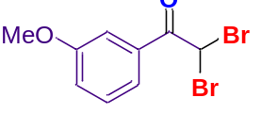7.41 (t, J = 8.0 Hz, 1H), 7.18 (dd, J = 8.2, 2.6 Hz, 1H), 6.71 (s, 1H), 3.87 (s, 3H); ¹³C NMR (100 MHz, CDCl₃) δ 186.0, 160.1, 132.2, 130.0, 122.1, 121.2, 114.2, 55.7, 39.7.

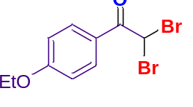2,2-dibromo-1-(4-ethoxyphenyl)ethan-1-one (3p).¹² R_{f} = 0.3 (hexane); yellow liquid; yield 93% (123 mg); ¹H NMR (400 MHz, CDCl₃) δ 8.04 (d, J = 9.0 Hz, 2H), 6.94 (d, J = 8.9 Hz, 2H), 6.68 (s, 1H), 4.11 (q, J = 7.0 Hz, 2H), 1.44 (t, J = 7.0 Hz, 3H); ¹³C NMR (100 MHz, CDCl₃) δ 184.7, 164.1, 132.3, 123.2, 114.7, 64.1, 40.1, 14.7.

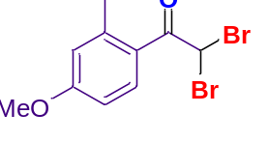2,2-dibromo-1-(4-methoxy-2-methylphenyl)ethan-1-one (3q). R_{f} = 0.3 (hexane); yellow liquid; yield 90% (119 mg); ¹H NMR (400 MHz, CDCl₃) δ 7.78 (d, J = 8.7 Hz, 1H), 6.81 (d, J = 2.2 Hz, 1H), 6.77 (dd, J = 8.7, 2.5 Hz, 1H), 6.72 (s, 1H), 3.85 (s, 3H), 2.54 (s, 3H); ¹³C NMR (100 MHz, CDCl₃) δ 186.7, 163.1, 144.8, 131.7, 123.6, 118.2, 110.9, 55.6, 42.3, 22.5; ῦ = 2967, 1682, 1452, 1249, 819 cm⁻¹; HRMS (ESI/QTOF) m/z: [M + H]⁺ calcd for C₁₀H₁₁Br₂O₂ 320.9126; Found 320.9121.

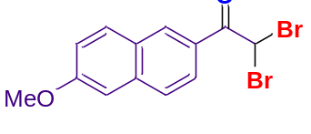2,2-dibromo-1-(6-methoxynaphthalen-2-yl)ethan-1-one (3r). R_{f} = 0.3 (hexane); yellow solid; mp 93-95 ℃; yield 95% (112 mg); ¹H NMR (400 MHz, CDCl₃) δ 8.52 (d, J = 1.5 Hz, 1H), 8.03 (dd, J = 8.7, 1.8 Hz, 1H), 7.84 (d, J = 9.0 Hz, 1H), 7.76 (d, J = 8.7 Hz, 1H), 7.21 (dd, J = 9.0, 2.5 Hz, 1H), 7.14 (d, J = 2.4 Hz, 1H), 6.87 (s, 1H), 3.94 (s, 3H); ¹³C NMR (100 MHz, CDCl₃) δ 185.8, 160.6, 138.0, 131.7, 131. 5, 127.7, 127.6, 125.9, 125.5, 120.3, 105.9, 55.6, 40.1; ῦ = 2934, 1682, 1479, 1273, 857 cm⁻¹; HRMS (ESI/QTOF) m/z: [M + H]⁺ calcd for C₁₃H₁₁Br₂O₂ 356.9126; Found 356.9126.

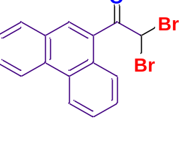2,2-dibromo-1-(phenanthren-9-yl)ethan-1-one (3s). R_{f} = 0.3 (hexane); yellow gum; yield 87% (98 mg); ¹H NMR (700 MHz, CDCl₃) δ 8.72 (d, J = 8.0 Hz, 1H), 8.69 (d, J = 8.3 Hz, 1H), 8.35 (d, J = 8.0 Hz, 1H), 8.16 (s, 1H), 7.95 (d, J = 7.8 Hz, 1H), 7.79 (t, J = 7.6 Hz, 1H), 7.75-7.69 (m, 2H), 7.67 (t, J = 7.4 Hz, 1H), 6.94 (s, 1H); ¹³C NMR (175 MHz, CDCl₃) δ 188.7, 132.4, 130.9, 130.2, 130.1, 129.8, 128.6, 128.1, 127.9, 127.6, 126.4, 123.1, 123.0, 42.7; ῦ = 2924, 1695, 1447, 1253, 861 cm⁻¹; HRMS (ESI/QTOF) m/z: [M + H]⁺ calcd for C₁₆H₁₁Br₂O 376.9177; Found 376.9180.

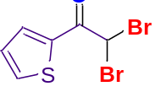2,2-dibromo-1-(thiophen-2-yl)ethan-1-one (3t).⁷ R_{f} = 0.3 (hexane); black liquid; yield 67% (105 mg); ¹H NMR (400 MHz, CDCl₃) δ 7.98 (dd, J = 3.9, 0.8 Hz, 1H), 7.77 (dd, J = 4.9, 0.8 Hz, 1H), 7.19 (t, J = 4.4 Hz, 1H), 6.51 (s, 1H); ¹³C NMR (100 MHz, CDCl₃) δ 179.8, 136.6, 136.5, 134.8, 128.7, 39.1.

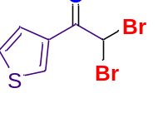2,2-dibromo-1-(thiophen-3-yl)ethan-1-one (3u).¹³ R_{f} = 0.3 (hexane); yellow liquid; yield 80% (126 mg); ¹H NM R (700 MHz, CDCl₃) δ 8.36 (s, 1H), 7.66 (d, J = 5.0 Hz, 1H), 7.37-7.36 (m, 1H), 6.45 (s, 1H); ¹³C NMR (175 MHz, CDCl₃) δ 180.6, 135.4, 134.6, 128.1, 126.9, 77.34, 40.4.

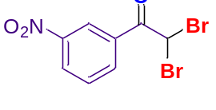2,2-dibromo-1-(3-nitrophenyl)ethan-1-one (3v).¹⁴ R_{f} = 0.3 (hexane); yellow liquid; yield 52% (68 mg); ¹H NMR (400 MHz, CDCl₃) δ 8.96 (t, J = 1.9 Hz, 1H), 8.49 (t, J = 8.2 Hz, 2H), 7.75 (t, J = 8.0 Hz, 1H), 6.60 (s, 1H); ¹³C NMR (175 MHz, CDCl₃) δ 184.2, 148.6, 135.5, 132.3, 130.3, 128.6, 124.9, 38.7; ῦ = 2961, 1634, 1441, 1251, 842 cm⁻¹; HRMS (ESI/QTOF) m/z: [M + H]⁺ calcd for C₂₃H₁₈ClS 361.0818; Found 361.0810.

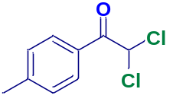2,2-dichloro-1-(p-tolyl)ethan-1-one (4a).¹⁵ R_{f} = 0.3 (hexane); yellow semi-solid; yield 86% (90 mg); ¹H NMR (400 MHz, CDCl₃) δ 7.98 (d, J = 8.2 Hz, 2H), 7.32 (d, J = 8.2 Hz, 2H), 6.67 (s, 1H), 2.45 (s, 3H); ¹³C NMR (100 MHz, CDCl₃) δ 185.7, 146.0, 130.0, 129.8, 128.8, 67.9, 22.0.

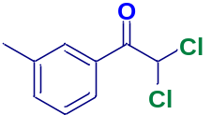2,2-dichloro-1-(m-tolyl)ethan-1-one (4b).¹⁶ R_{f} = 0.3 (hexane); yellow liquid; yield 80% (84 mg); ¹H NMR (400 MHz, CDCl₃) δ 7.87 (d, J = 6.4 Hz, 2H), 7.47 – 7.38 (m, 2H), 6.71 (s, 1H), 2.43 (s, 3H); ¹³C NMR (100 MHz, CDCl₃) δ 186.2, 139.1, 135.5, 131.5, 130.3, 128.9, 127.0, 67.9, 21.5.

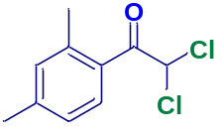2,2-dichloro-1-(2,4-dimethylphenyl)ethan-1-one (4c). R_{f} = 0.3 (hexane); yellow liquid; yield 91% (91 mg); ¹H NMR (400 MHz, CDCl₃) δ 7.49 (s, 1H), 7.29 (s, 1H), 7.21 (d, J = 7.6 Hz, 1H), 6.67 (s, 1H), 2.47 (s, 3H), 2.38 (s, 3H); ¹³C NMR (100 MHz, CDCl₃) δ 188.7, 139.1, 137.6, 135.6, 133.8, 132.4, 129.0, 69.0, 21.1, 20.9; ῦ = 2925, 1710, 1496, 1235, 814 cm⁻¹; HRMS (ESI/QTOF) m/z: [M + H]⁺ calcd for C₁₀H₁₁Cl₂O 217.0187; Found 217.0190.

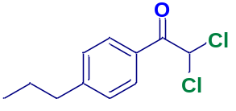2,2-dichloro-1-(4-propylphenyl)ethan-1-one (4d).¹⁷ R_{f} = 0.3 (hexane); yellow liquid; yield 83% (79 mg); ¹H NMR (400 MHz, CDCl₃) δ 8.00 (d, J = 8.3 Hz, 2H), 7.31 (d, J = 8.3 Hz, 2H), 6.70 (s, 1H), 2.66 (t, J = 7.4 Hz, 2H), 1.71-1.62 (m, 2H), 0.95 (t, J = 7.3 Hz, 3H); ¹³C NMR (100 MHz, CDCl₃) δ 185.7, 150.6, 130.0, 129.1, 129.0, 67.9, 38.2, 24.2, 13.9.

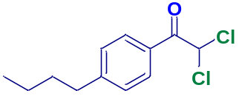1-(4-butylphenyl)-2,2-dichloroethan-1-one (4e). R_{f} = 0.3 (hexane); yellow liquid; yield 78% (72 mg); ¹H NMR (400 MHz, CDCl₃) δ 8.00 (d, J = 8.3 Hz, 2H), 7.32 (d, J = 8.4 Hz, 2H), 6.68 (s, 1H), 2.69 (t, J = 7.6 Hz, 2H), 1.66 – 1.59 (m, 2H), 1.40 – 1.32 (m, 2H), 0.94 (t, J = 7.3 Hz, 3H); ¹³C NMR (100 MHz, CDCl₃) δ 185.7, 150.9, 131.9, 130.0, 129.1, 67.9, 35.9, 33.2, 22.4, 14.0; ῦ = 2930, 1702, 1460, 1280, 849 cm⁻¹; HRMS (ESI/QTOF) m/z: [M + H]⁺ calcd for C₁₂H₁₅Cl₂O 245.0500; Found 254.05006.

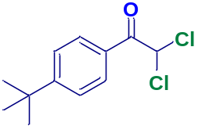1-(4-(tert-butyl)phenyl)-2,2-dichloroethan-1-one (4f).¹¹ R_{f} = 0.3 (hexane); yellow liquid; yield 85% (79 mg); ¹H NMR (400 MHz, CDCl₃) δ 8.03 (d, J = 8.5 Hz, 2H), 7.53 (d, J = 8.5 Hz, 2H), 6.68 (s, 1H), 1. 35 (s, 9H); ¹³C NMR (100 MHz, CDCl₃) δ 185.7, 158.8, 129.9, 128.7, 126.1, 68.0, 35.5, 31.1.

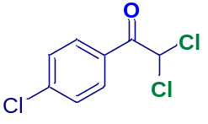2,2-dichloro-1-(4-chlorophenyl)ethan-1-one (4g).¹⁸ R_{f} = 0.3 (hexane); white gummy solid; yield 89% (87 mg); ¹H NMR (400 MHz, CDCl₃) δ 8.05 (d, J = 8.7 Hz, 2H), 7.50 (d, J = 8.6 Hz, 2H), 6.59 (s, 1H); ¹³C NMR (100 MHz, CDCl₃) δ 185.1, 141.4, 133.1, 131.4, 129.4, 67.9.

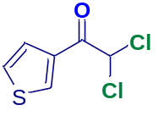2,2-dichloro-1-(thiophen-3-yl)ethan-1-one (4h).¹³ R_{f} = 0.3 (hexane); red liquid; yield 49% (53 mg); ¹H NMR (400 MHz, CDCl₃) δ 8.38 (dd, J = 2.8, 1.1 Hz, 1H), 7.68 (dd, J = 5.1, 1.1 Hz, 1H), 7.40-7.38 (m, 1H), 6.42 (s, 1H); ¹³C NMR (100 MHz, CDCl₃) δ 180.8, 135.7, 135.1, 128.1, 126.9, 68.7.

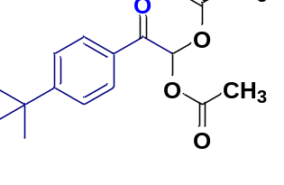2-(4-(tert-butyl)phenyl)-2-oxoethane-1,1-diyl diacetate (5a). R_{f} = 0.3 (hexane : EtOAc = 95:05); yellow liquid; yield 85% (45 mg); ¹H NMR (400 MHz, CDCl₃) δ 7.88 (d, J = 8.5 Hz, 2H), 7.62 (s, 1H), 7.50 (d, J = 8.4 Hz, 2H), 2.18 (s, 6H), 1.34 (s, 9H); ¹³C NMR (100 MHz, CDCl₃) δ 188.4, 168.9, 158.5, 130.7, 129.0, 126.1, 86.3, 35.4, 31.1, 20.8; ῦ = 2961, 1767, 1464, 1231, 841 cm⁻¹; HRMS (ESI/QTOF) m/z: [M + H]⁺ calcd for C₁₆H₂₁O₅ 293.1389; Found 293.1383.

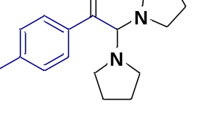2,2-di(pyrrolidin-1-yl)-1-(p-tolyl)ethan-1-one (5b). R_{f} = 0.1 (hexane : EtOAc = 90:10); yellow liquid; yield 79% (46 mg); ¹H NMR (400 MHz, CDCl₃) δ 7.84 (d, J = 8.1 Hz, 2H), 7.25 (d, J = 8.1 Hz, 2H), 7.21 (s, 1H), 3.60 (t, J = 6.7 Hz, 2H), 3.36 (t, J = 6.4 Hz, 2H), 2.38 (s, 4H), 1.91 – 1.86 (m, 4H), 1.21 (s, 4H); ¹³C NMR (100 MHz, CDCl₃) δ 191.5, 165.3, 146.0, 130.7, 130.2, 129.8, 46.8, 45.3, 26.1, 24.2, 22.0; ῦ = 2925, 1637, 1450, 1255, 800 cm⁻¹; HRMS (ESI/QTOF) m/z: [M + H]⁺ calcd for C₁₇H₂₅N₂O 273.1967; Found 273.1961.

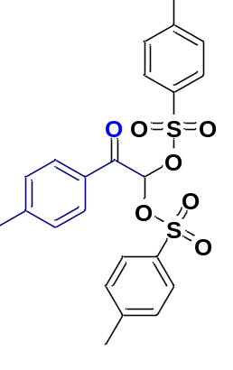2-oxo-2-(p-tolyl)ethane-1,1-diyl bis(4-methylbenzenesulfonate) (5c). R_{f} = 0.1 (hexane : EtOAc = 90:10); white solid; mp 98 ℃; yield 87% (92 mg); ¹H NMR (400 MHz, CDCl₃) δ 7.82 (d, J = 8.2 Hz, 2H), 7.73 (d, J = 8.4 Hz, 4H), 7.30 (d, J = 8.1 Hz, 4H), 7.24 (s, 2H), 6.95 (s, 1H), 2.44 (s, 6H), 2.41 (s, 3H); ¹³C NMR (100 MHz, CDCl₃) δ 185.6, 146.0, 146.0, 133.0, 130.0, 129.9, 129.7, 129.4, 128.4, 94.9, 77.48, 22.0, 21.9; ῦ = 2923, 1704, 1450, 1375, 808 cm⁻¹; HRMS (ESI/QTOF) m/z: [M + H]⁺ calcd for C₂₃H₂₃O₇S₂ 475.0885; Found 475.0879.

REFERENCES

1 Nolla-Saltiel, R., Carrillo-Arcos, U. A. & Porcel, S. Silver Acetate Mediated Acetoxylations of Alkyl Halides. Synthesis 46, 165-169, doi:10.1055/s-0033-1338551 (2014).
2 Kolanos, R. et al. Structural Modification of the Designer Stimulant α-Pyrrolidinovalerophenone (α-PVP) Influences Potency at Dopamine Transporters. ACS Chem. Neurosci. 6, 1726-1731, doi:10.1021/acschemneuro.5b00160 (2015).
3 Klán, P., Paola Pelliccioli, A., Pospíšil, T. & Wirz, J. 2,5-Dimethylphenacyl esters: A photoremovable protecting group for phosphates and sulfonic acids. Photochem. Photobiol. Sci. 1, 920-923, doi:10.1039/B208171G (2002).
4 SAINT+, Bruker AXS Inc., Madison, Wisconsin, USA, 1999 (Program for Reduction of Data collected on Bruker CCD Area Detector Diffractometer V. 6.02.)
5 Sheldrick, G. A short history of SHELX. Acta Crystallogr. A 64, 112-122, doi:doi:10.1107/S0108767307043930 (2008).
6 Tada, N. et al. Tandem oxidation/bromination of ethyl aromatics to α,α-dibromoacetophenones with molecular oxygen under visible light irradiation. Tetrahedron Lett. 52, 3821-3824, doi:https://doi.org/10.1016/j.tetlet.2011.05.077 (2011).
7 Wang, H. et al. Selective Debromination of α,α,α-Tribromomethylketones with HBr–H2O Reductive Catalytic System. Eur. J. Org. Chem., 6455-6458, doi:https://doi.org/10.1002/ejoc.202001118 (2020).
8 Wu, C. et al. Water-controlled selective preparation of α-mono or α,α′-dihalo ketones via catalytic cascade reaction of unactivated alkynes with 1,3-dihalo-5,5-dimethylhydantoin. Green Chem. 19, 1983-1989, doi:10.1039/C7GC00283A (2017).
9 Dutta, M. M., Rajbongshi, K. K. & Phukan, P. CoFe2O4–SiO2–SO3H nanocomposite as a magnetically recoverable catalyst for oxidative bromination of alkynes. Synth. Commun. 47, 2330-2341, doi:10.1080/00397911.2017.1376333 (2017).
10 Liu, J., Li, W., Wang, C., Li, Y. & Li, Z. Selective 1,2-dihalogenation and oxy-1,1-dihalogenation of alkynes by N-halosuccinimides. Tetrahedron Lett. 52, 4320-4323, doi:https://doi.org/10.1016/j.tetlet.2011.06.047 (2011).
11 Touqeer, S., Senatore, R., Malik, M., Urban, E. & Pace, V. Modular and Chemoselective Strategy for Accessing (Distinct) α,α-Dihaloketones from Weinreb Amides and Dihalomethyllithiums. Adv. Synth. Catal. 362, 5056-5061, doi:https://doi.org/10.1002/adsc.202001106 (2020).
12 Paul, S., Gupta, V., Gupta, R. & Loupy, A. Microwave-induced selective synthesis of α-bromo and α,α-dibromoalkanones using dioxane–dibromide and silica gel under solvent-free conditions. Tetrahedron Lett. 44, 439-442, doi:https://doi.org/10.1016/S0040-4039(02)02601-1 (2003).
13 Finck, L., Brals, J., Pavuluri, B., Gallou, F. & Handa, S. Micelle-Enabled Photoassisted Selective Oxyhalogenation of Alkynes in Water under Mild Conditions. J. Org. Chem. 83, 7366-7372, doi:10.1021/acs.joc.7b03143 (2018).
14 Mishra, D., Loukrakpam, D. C., Neog, S. R., Hazarika, D. & Phukan, P. A Switchable Protocol for Selective Synthesis of gem-Dibromo Compounds and Amides from Ketoximes using TsNBr2. ChemistrySelect 7, e202203449, doi:https://doi.org/10.1002/slct.202203449 (2022).
15 Madabhushi, S., Jillella, R., Mallu, K. K. R., Godala, K. R. & Vangipuram, V. S. A new and efficient method for the synthesis of α,α-dihaloketones by oxyhalogenation of alkynes using oxone®–KX (X=Cl, Br, or I). Tetrahedron Lett. 54, 3993-3996, doi:https://doi.org/10.1016/j.tetlet.2013.05.072 (2013).
16 Tu, D., Luo, J., Jiang, W. & Tang, Q. Solvent-free preparation of α,α-dichloroketones with sulfuryl chloride. Tetrahedron Lett. 81, 153335, doi:https://doi.org/10.1016/j.tetlet.2021.153335 (2021).
17 Rather, S. A., Kumar, A. & Ahmed, Q. N. Iodine–DMSO-promoted divergent reactivities of arylacetylenes. Chem. Commun. 55, 4511-4514, doi:10.1039/C9CC00346K (2019).
18 Zheng, Z., Han, B., Cheng, P., Niu, J. & Wang, A. A simple, mild, and efficient method for the preparation of α,α-dichloroketones with DCDMH catalyzed by ammonium chloride. Tetrahedron 70, 9814-9818, doi:https://doi.org/10.1016/j.tet.2014.11.004 (2014).

NMR Spectra
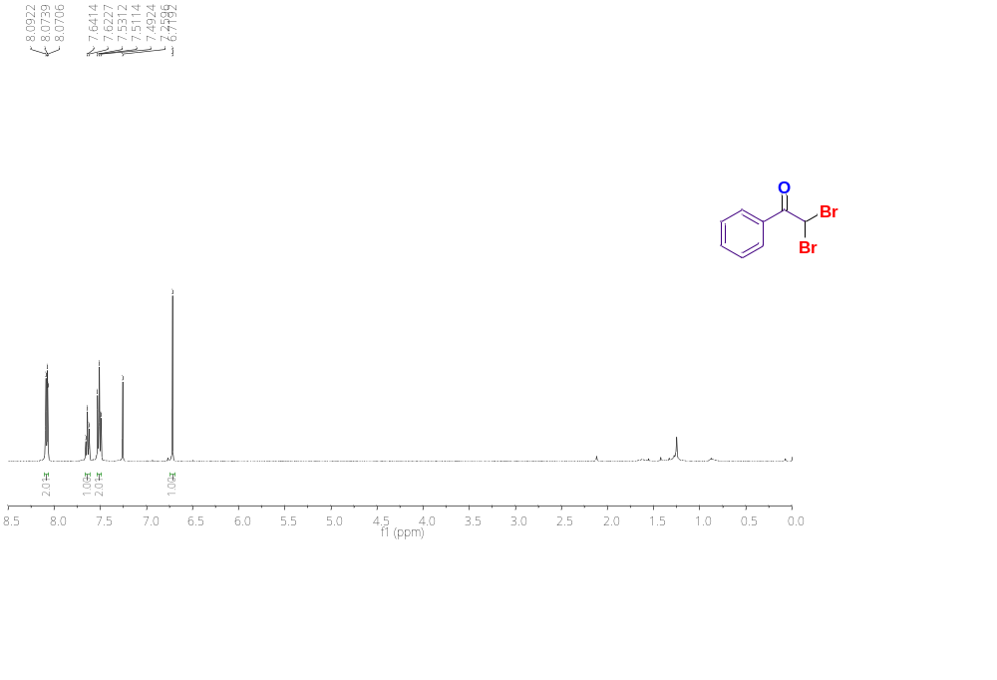
Figure S21.¹H NMR (400 MHz) spectrum of 2,2-dibromo-1-phenylethan-1-one (3a) in CDCl₃.
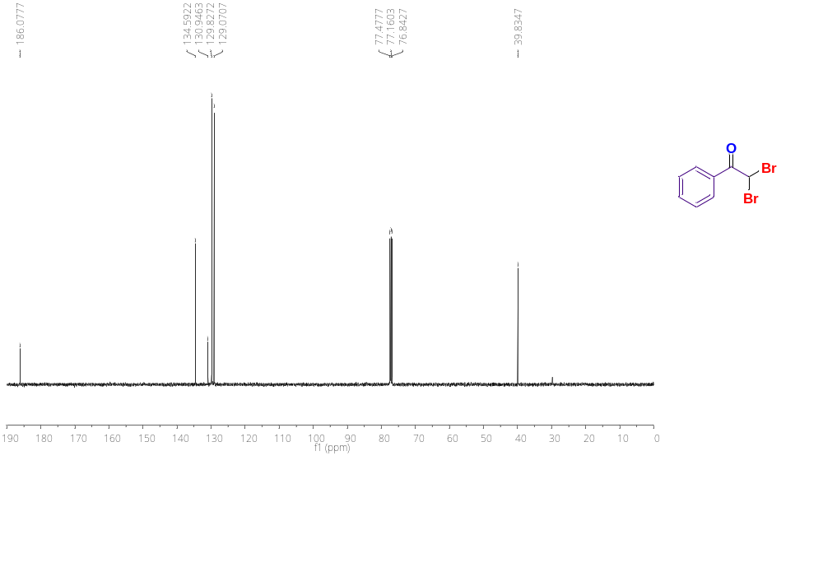
Figure S22. ¹³C{¹H} NMR (100 MHz) spectrum of 2,2-dibromo-1-phenylethan-1-one (3a) in CDCl₃.
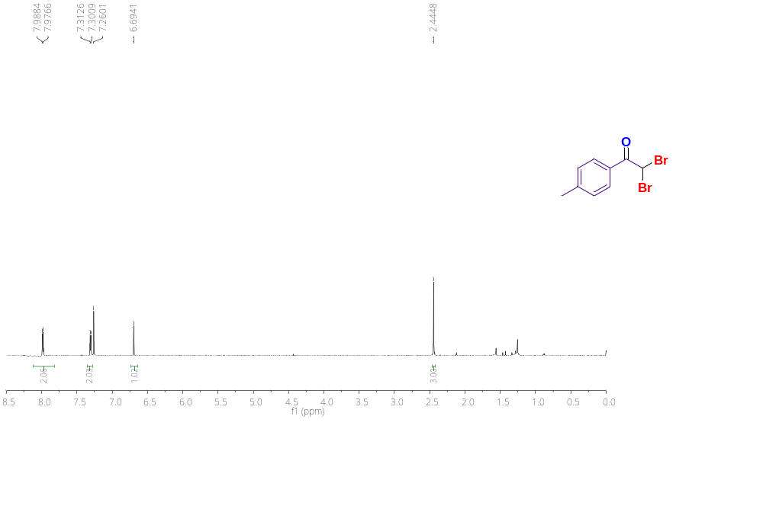
Figure S23.¹H NMR (400 MHz) spectrum of 2,2-dibromo-1-(p-tolyl)ethan-1-one (3b) in CDCl₃.

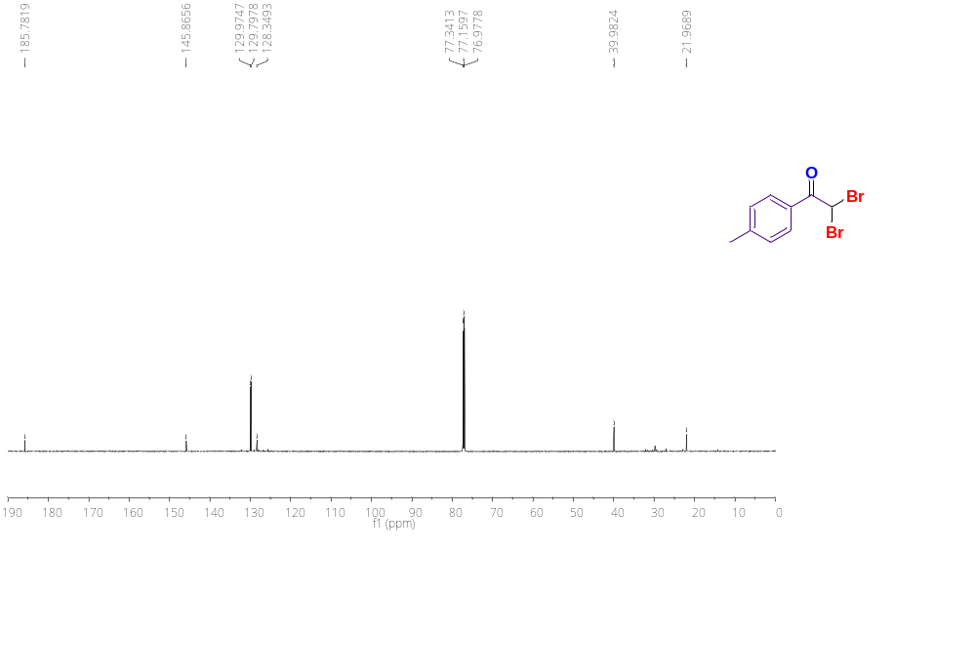
Figure S24. ¹³C{¹H} NMR (100 MHz) spectrum of 2,2-dibromo-1-(p-tolyl)ethan-1-one (3b) in CDCl₃.
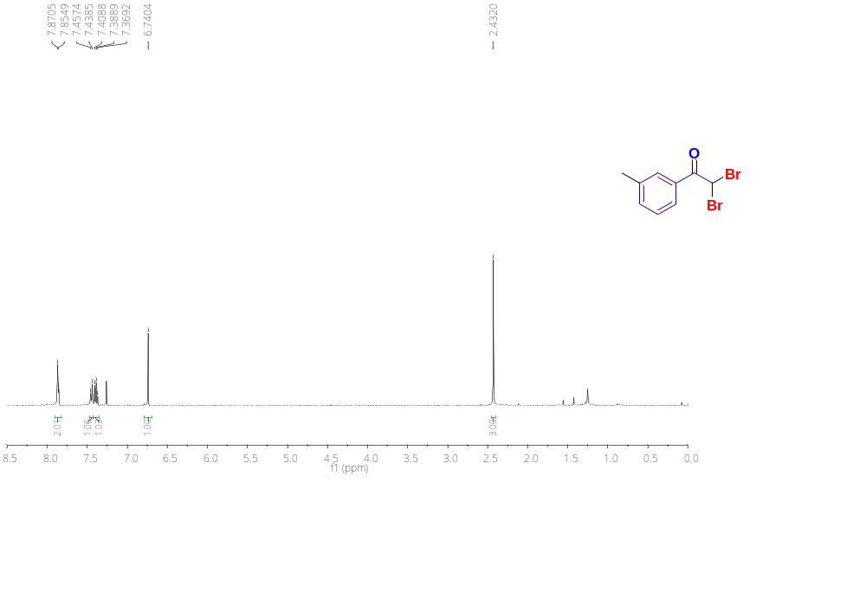
Figure S25.¹H NMR (400 MHz) spectrum of 2,2-dibromo-1-(m-tolyl)ethan-1-one (3c) in CDCl₃.

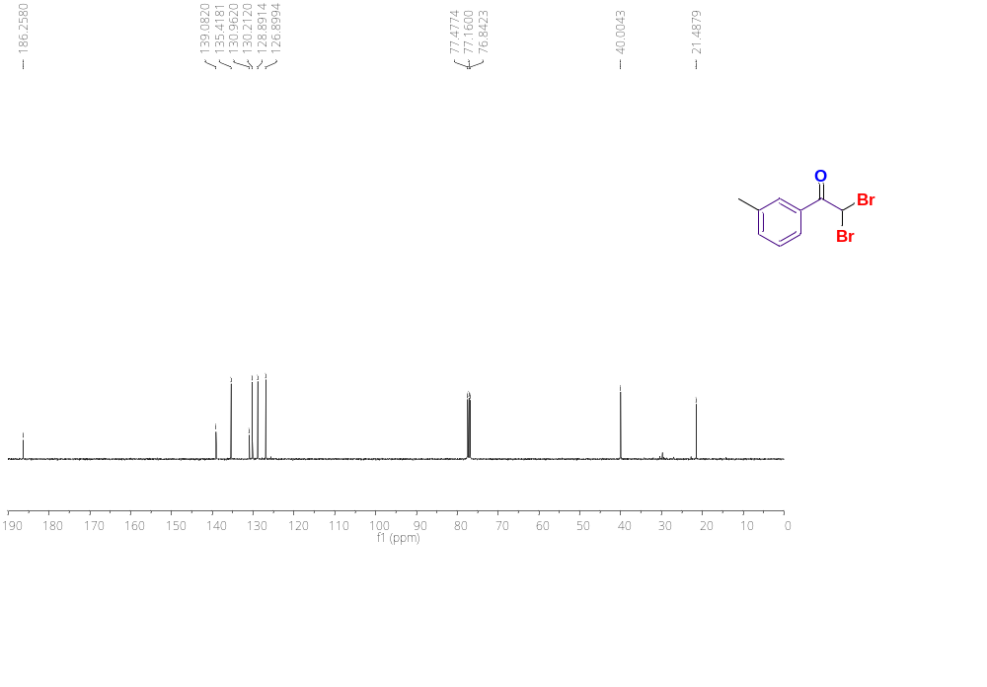
Figure S26. ¹³C{¹H} NMR (100 MHz) spectrum of 2,2-dibromo-1-(m-tolyl)ethan-1-one (3c) in CDCl₃.
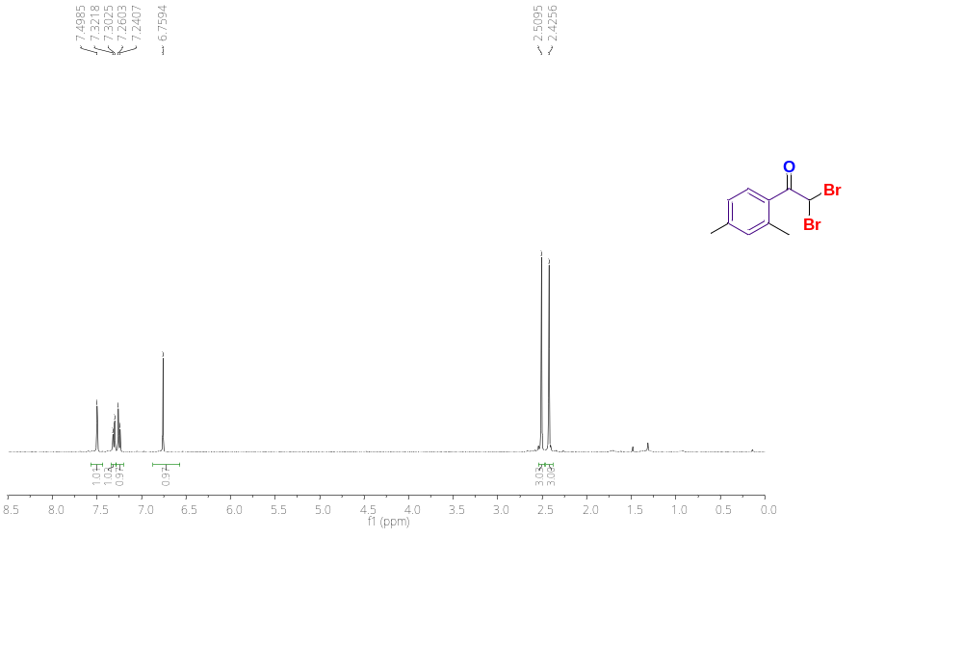
Figure S27.¹H NMR (400 MHz) spectrum of 2,2-dibromo-1-(2,4-dimethylphenyl)ethan-1-one (3d) in CDCl₃.

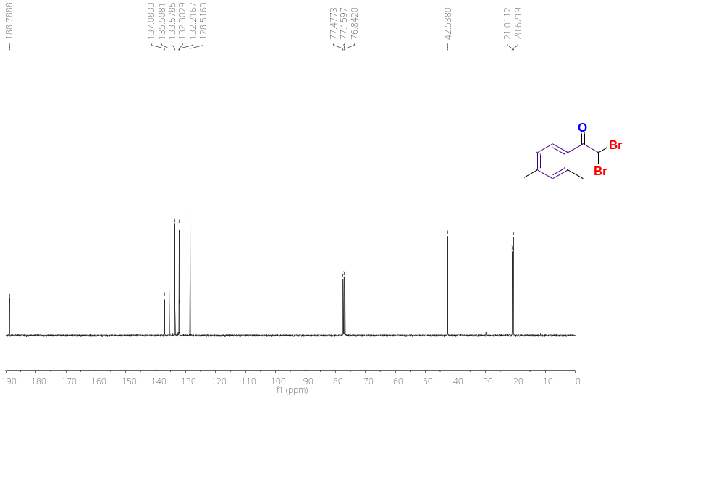
Figure S28. ¹³C{¹H} NMR (100 MHz) spectrum of 2,2-dibromo-1-(2,4-dimethylphenyl)ethan-1-one (3d) in CDCl₃.
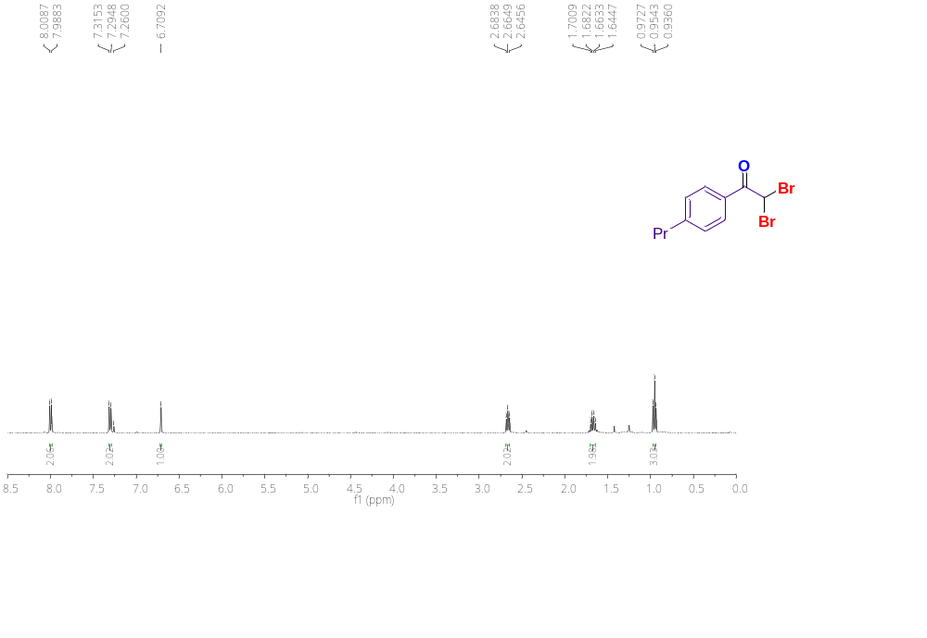
Figure S29.¹H NMR (400 MHz) spectrum of 2,2-dibromo-1-(4-propylphenyl)ethan-1-one (3e) in CDCl₃.

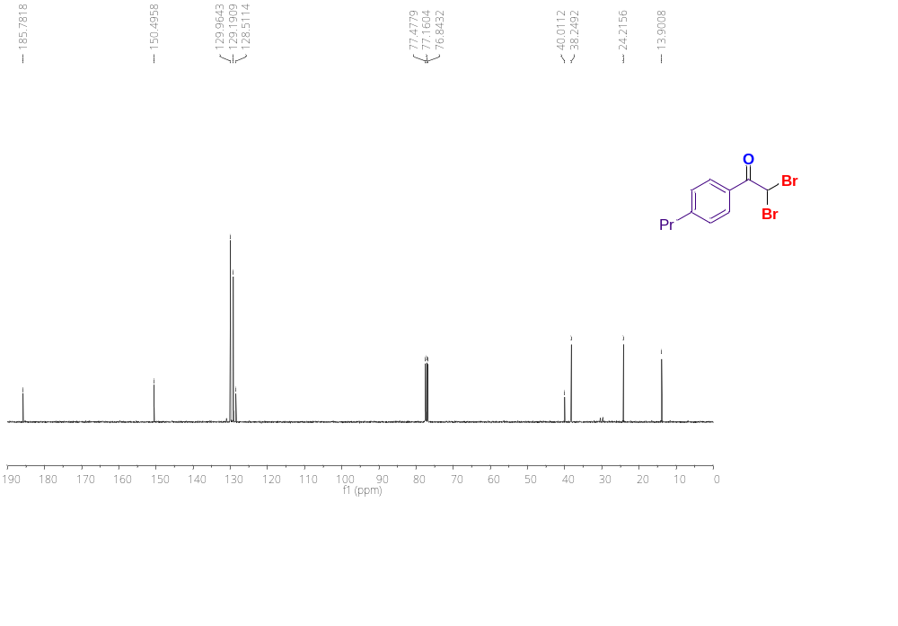
Figure S30. ¹³C{¹H} NMR (100 MHz) spectrum of 2,2-dibromo-1-(4-propylphenyl)ethan-1-one (3e) in CDCl₃.
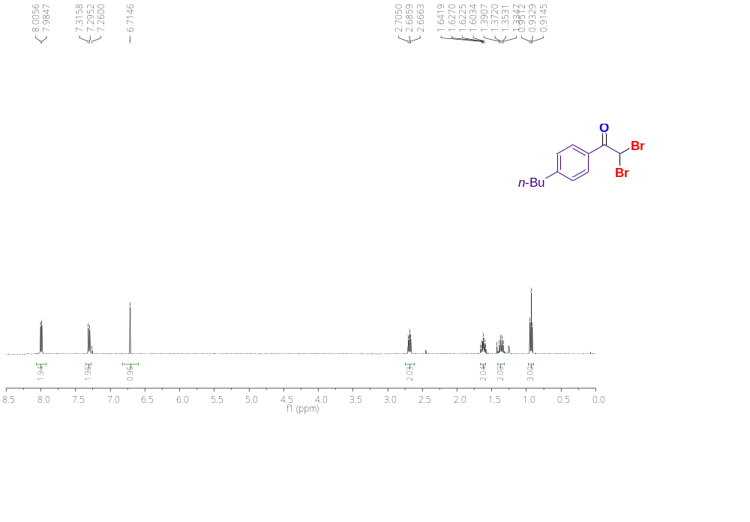
Figure S31.¹H NMR (400 MHz) spectrum of 2,2-dibromo-1-(4-butylphenyl)ethan-1-one (3f) in CDCl₃.

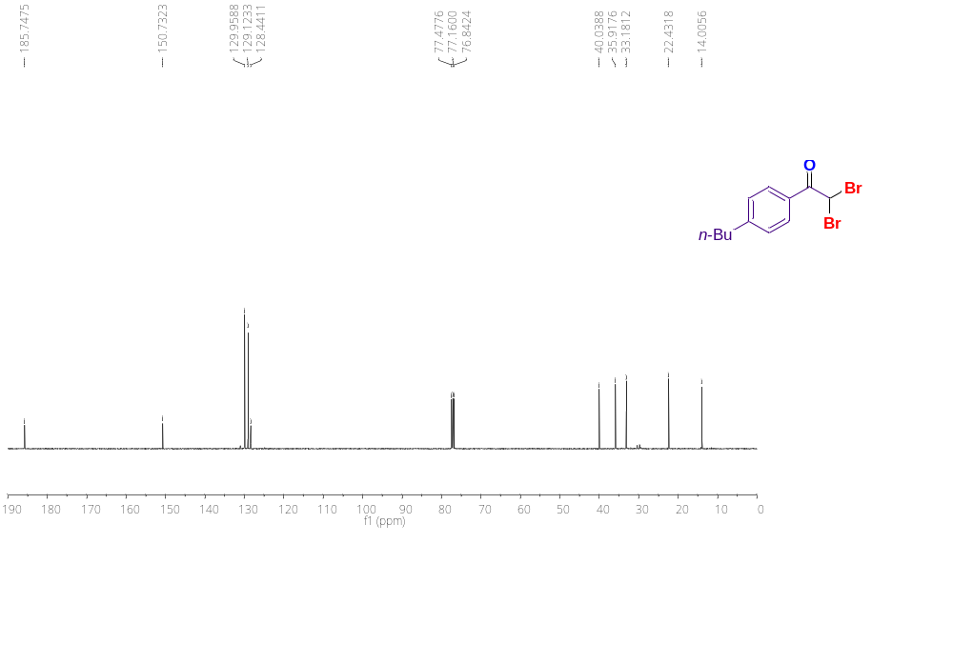
Figure S32. ¹³C{¹H} NMR (100 MHz) spectrum of 2,2-dibromo-1-(4-butylphenyl)ethan-1-one (3f) in CDCl₃.
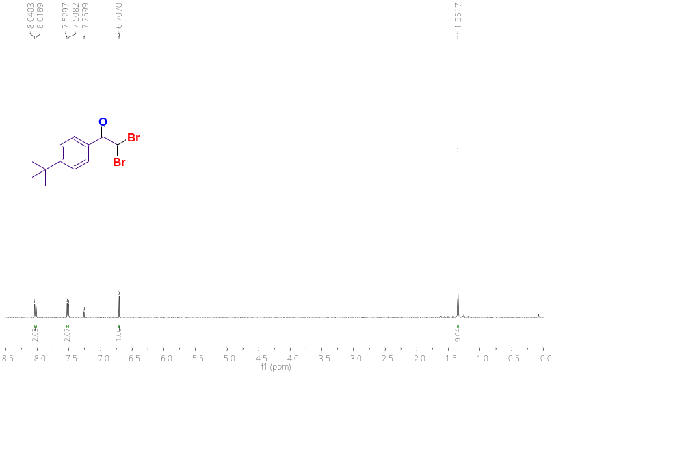
Figure S33.¹H NMR (400 MHz) spectrum of 2,2-dibromo-1-(4-(tert-butyl)phenyl)ethan-1-one (3g) in CDCl₃.

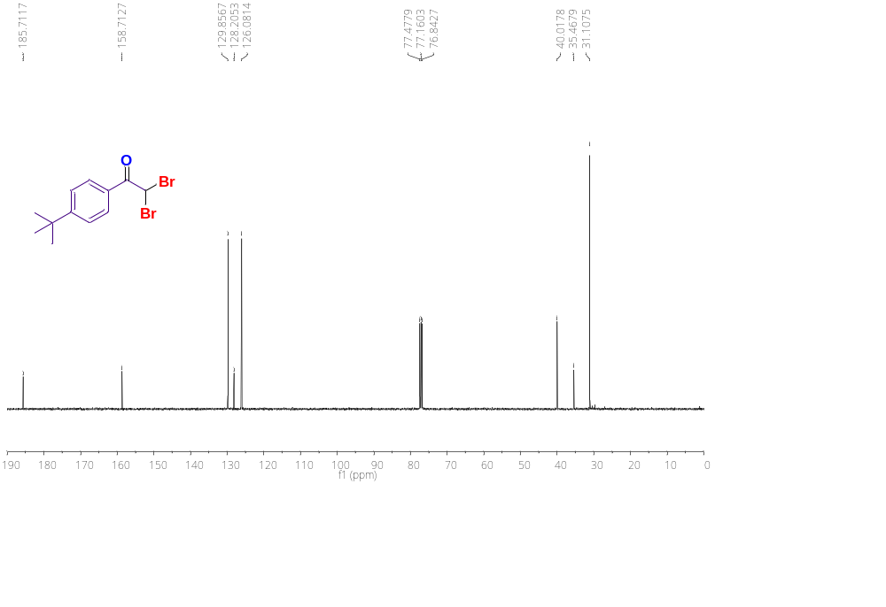
Figure S34. ¹³C{¹H} NMR (100 MHz) spectrum of 2,2-dibromo-1-(4-(tert-butyl)phenyl)ethan-1-one (3g) in CDCl₃.
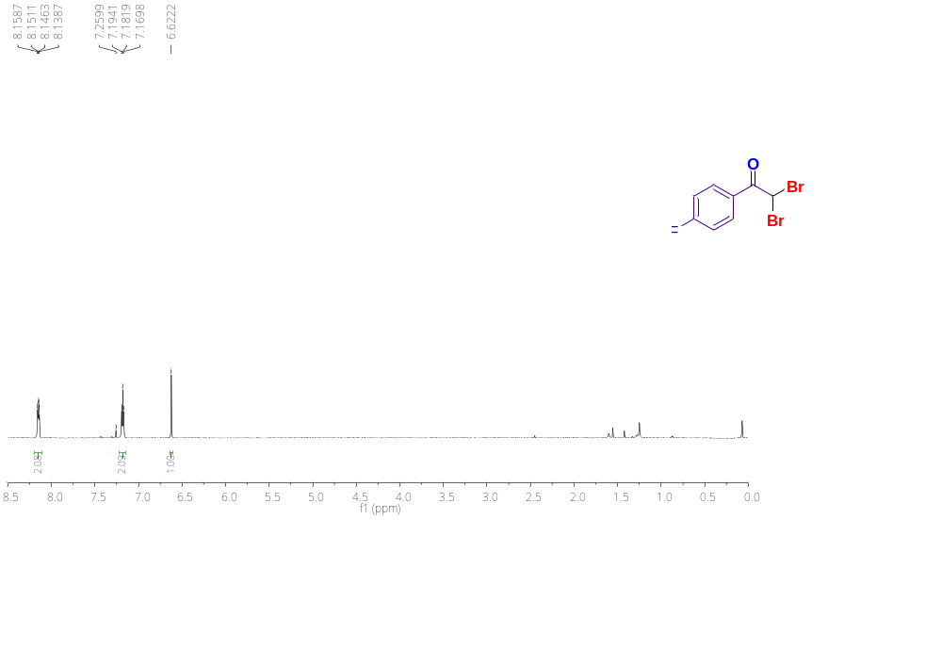
Figure S35.¹H NMR (400 MHz) spectrum of 2,2-dibromo-1-(4-fluorophenyl)ethan-1-one (3h) in CDCl₃.

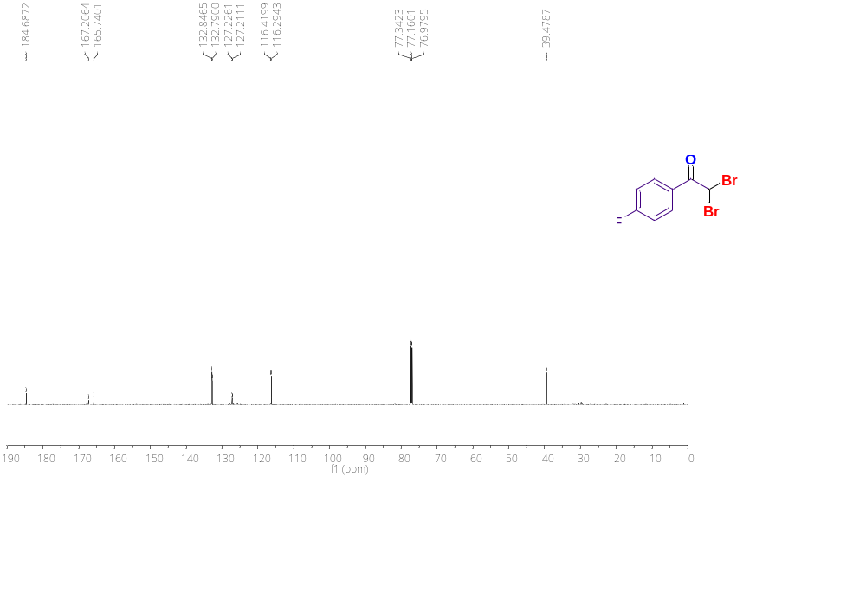
Figure S36. ¹³C{¹H} NMR (100 MHz) spectrum of 2,2-dibromo-1-(4-fluorophenyl)ethan-1-one (3h) in CDCl₃.
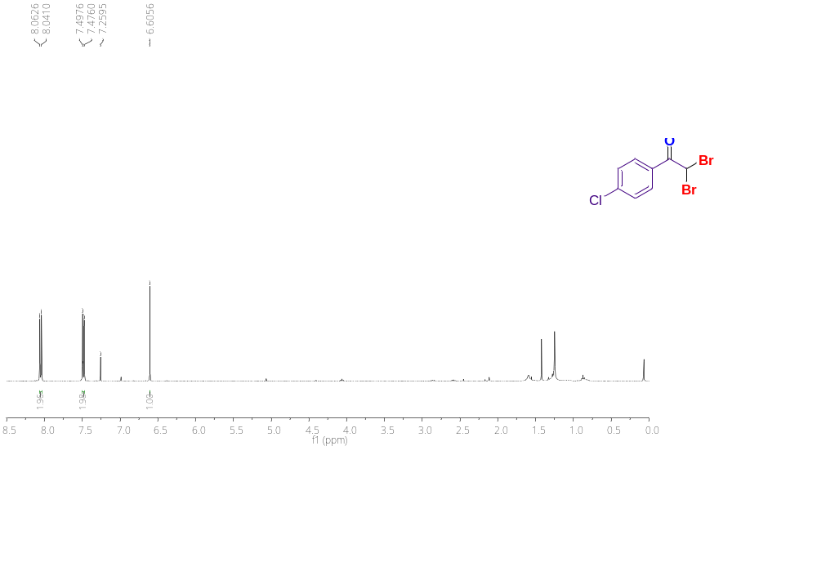
Figure S37.¹H NMR (400 MHz) spectrum of 2,2-dibromo-1-(4-chlorophenyl)ethan-1-one (3i) in CDCl₃.

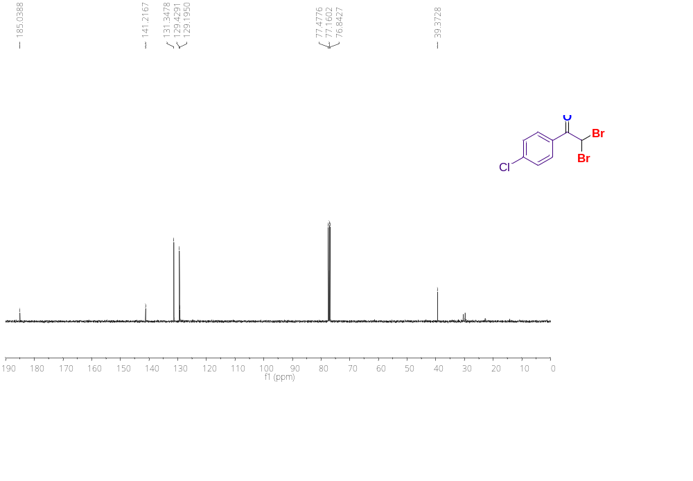
Figure S38. ¹³C{¹H} NMR (100 MHz) spectrum of 2,2-dibromo-1-(4-chlorophenyl)ethan-1-one (3i) in CDCl₃.
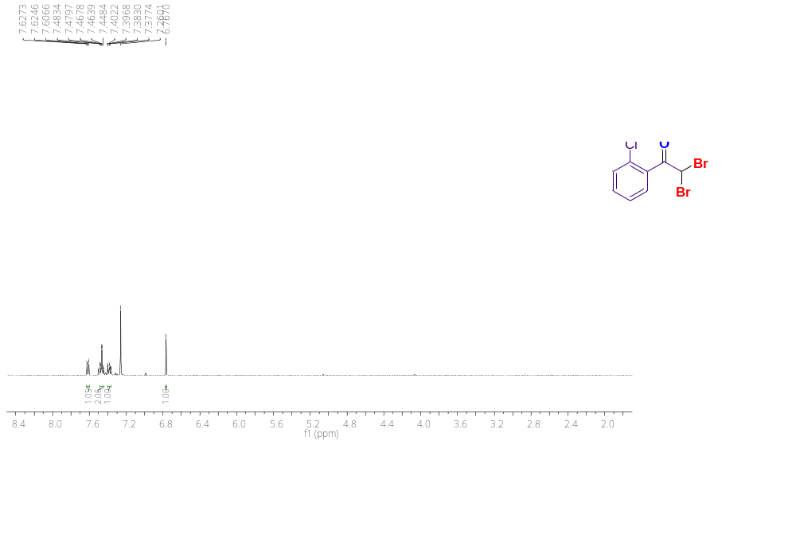
Figure S39.¹H NMR (400 MHz) spectrum of 2,2-dibromo-1-(2-chlorophenyl)ethan-1-one (3j) in CDCl₃.

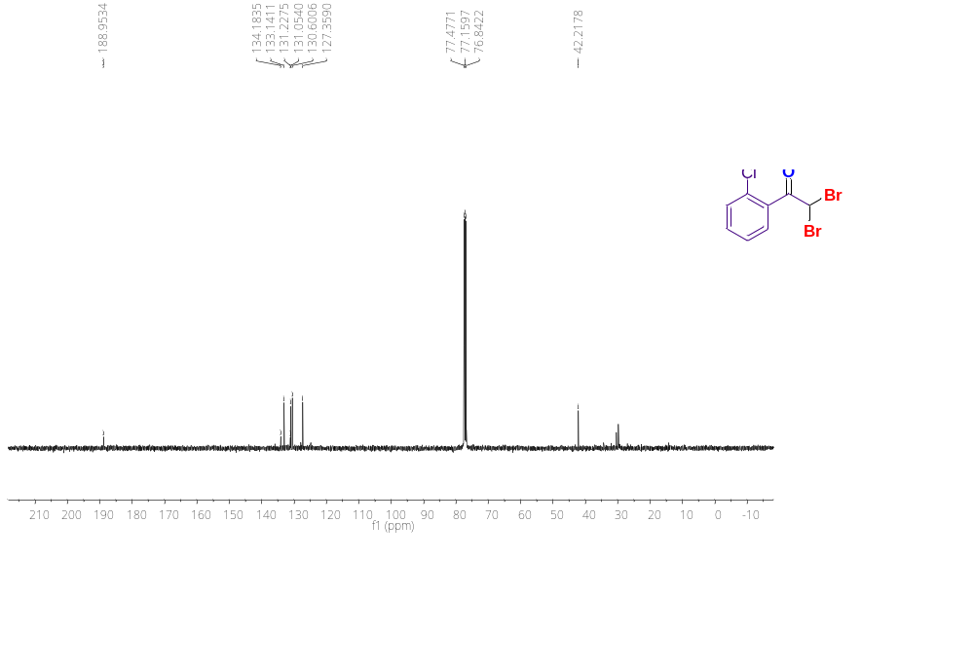
Figure S40. ¹³C{¹H} NMR (100 MHz) spectrum of 2,2-dibromo-1-(2-chlorophenyl)ethan-1-one (3j) in CDCl₃.
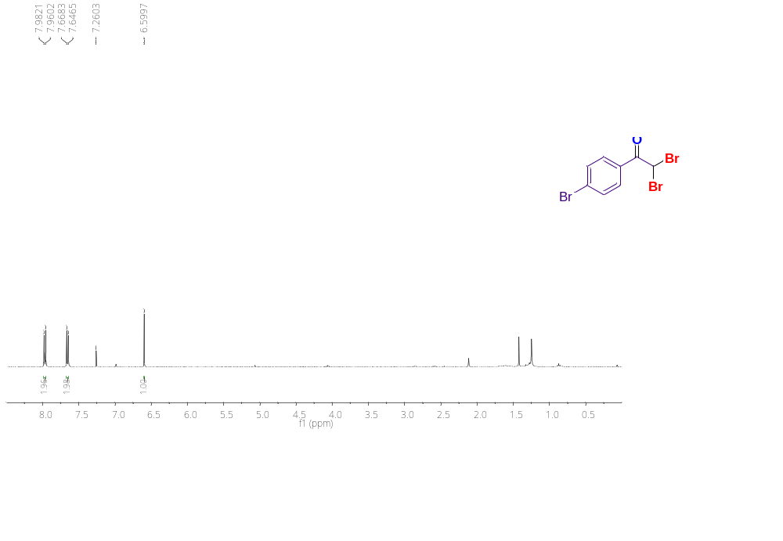
Figure S41.¹H NMR (400 MHz) spectrum of 2,2-dibromo-1-(4-bromophenyl)ethan-1-one (3k) in CDCl₃.

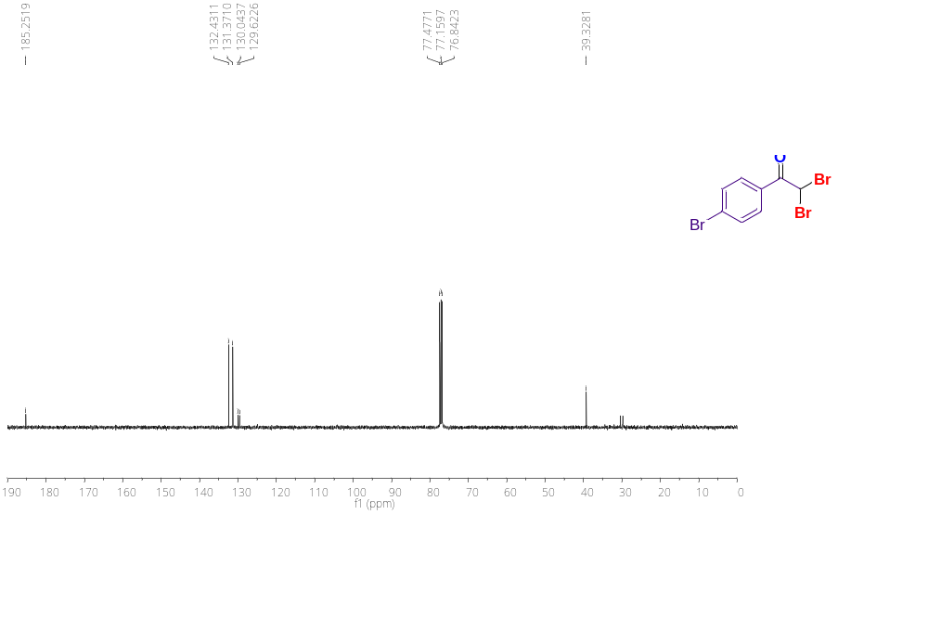
Figure S42. ¹³C{¹H} NMR (100 MHz) spectrum of 2,2-dibromo-1-(4-bromophenyl)ethan-1-one (3k) in CDCl₃.
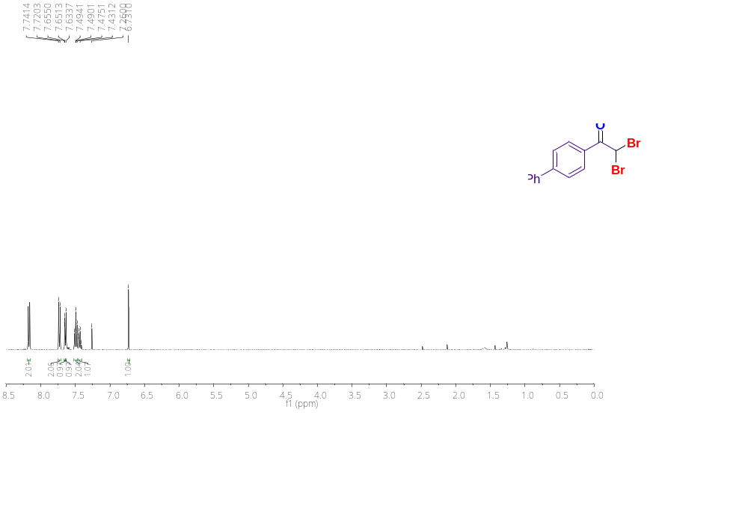
Figure S43.¹H NMR (400 MHz) spectrum of 1-([1,1'-biphenyl]-4-yl)-2,2-dibromoethan-1-one (3l) in CDCl₃.

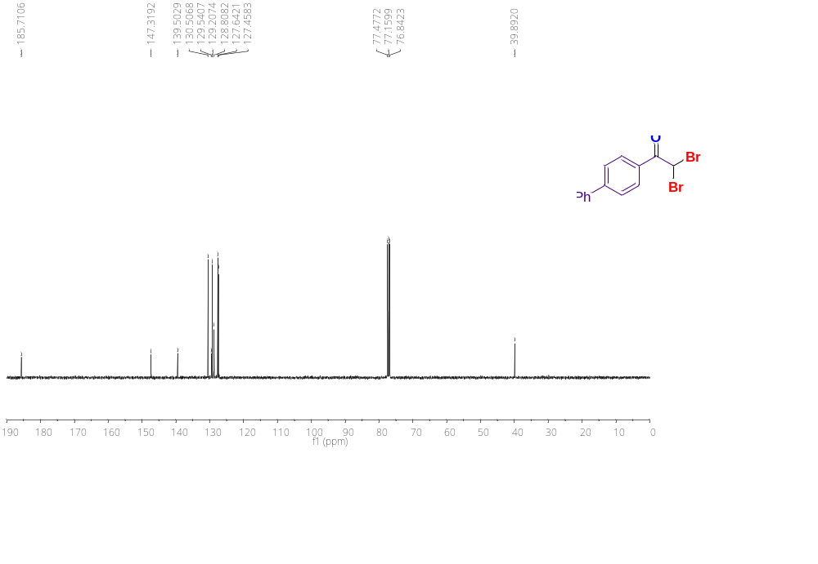
Figure S44. ¹³C{¹H} NMR (100 MHz) spectrum of 1-([1,1'-biphenyl]-4-yl)-2,2-dibromoethan-1-one (3l) in CDCl₃.
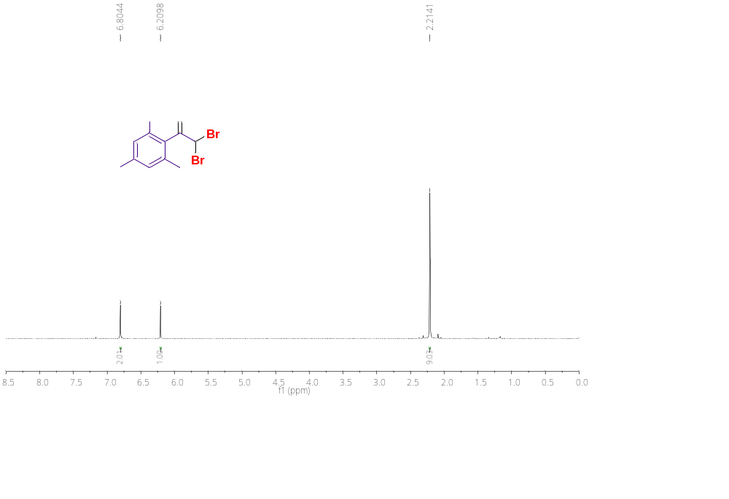
Figure S45.¹H NMR (400 MHz) spectrum of 2,2-dibromo-1-mesitylethan-1-one (3m) in CDCl₃.

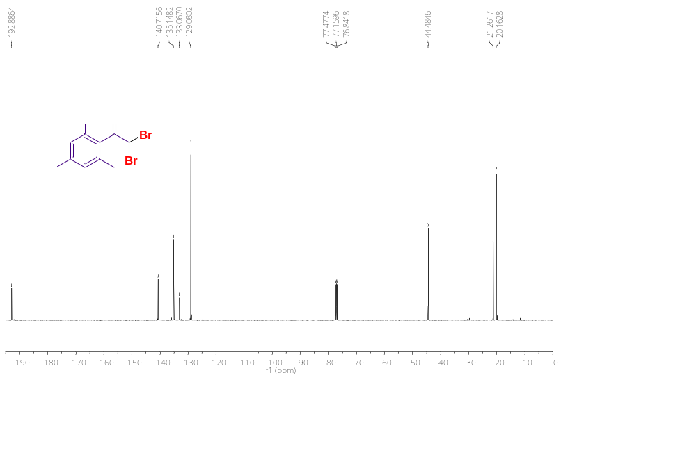
Figure S46. ¹³C{¹H} NMR (100 MHz) spectrum of 2,2-dibromo-1-mesitylethan-1-one (3m) in CDCl₃.
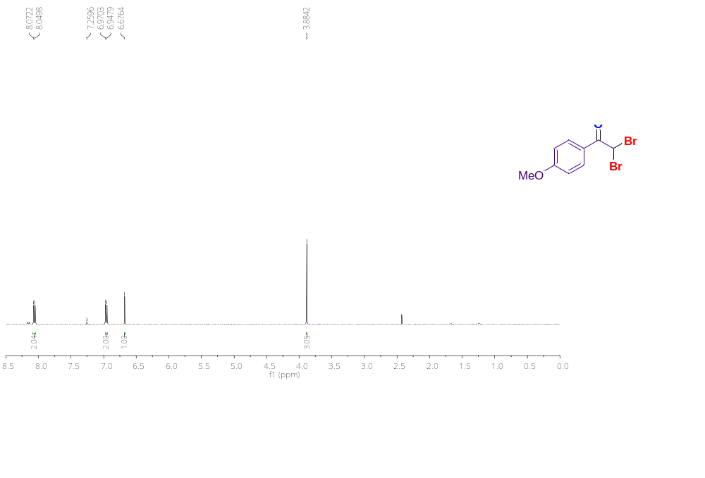
Figure S47.¹H NMR (400 MHz) spectrum of 2,2-dibromo-1-(4-methoxyphenyl)ethan-1-one (3n) in CDCl₃.

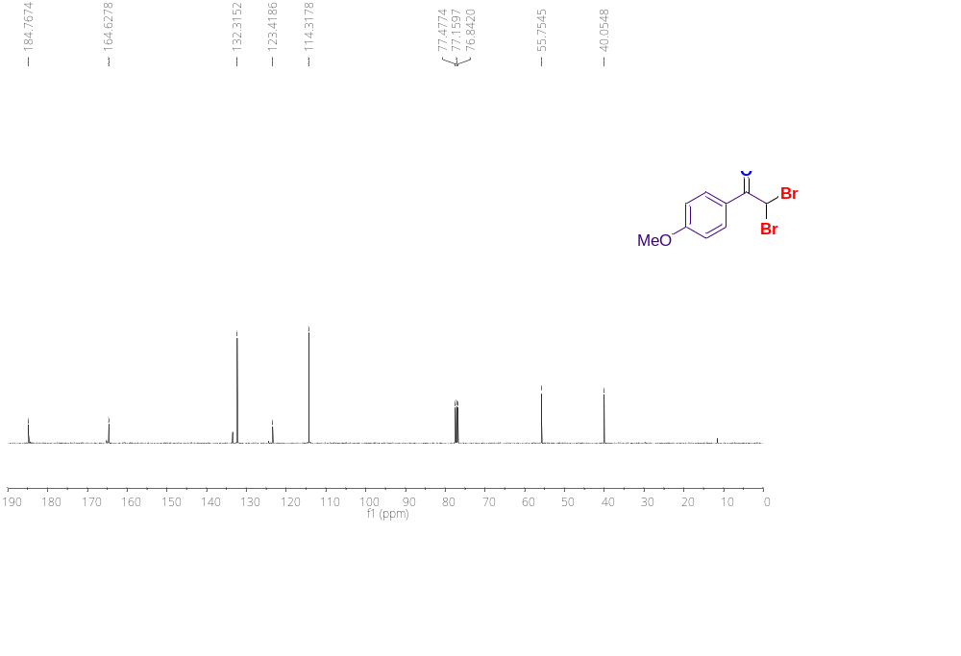
Figure S48. ¹³C{¹H} NMR (100 MHz) spectrum of 2,2-dibromo-1-(4-methoxyphenyl)ethan-1-one (3n) in CDCl₃.
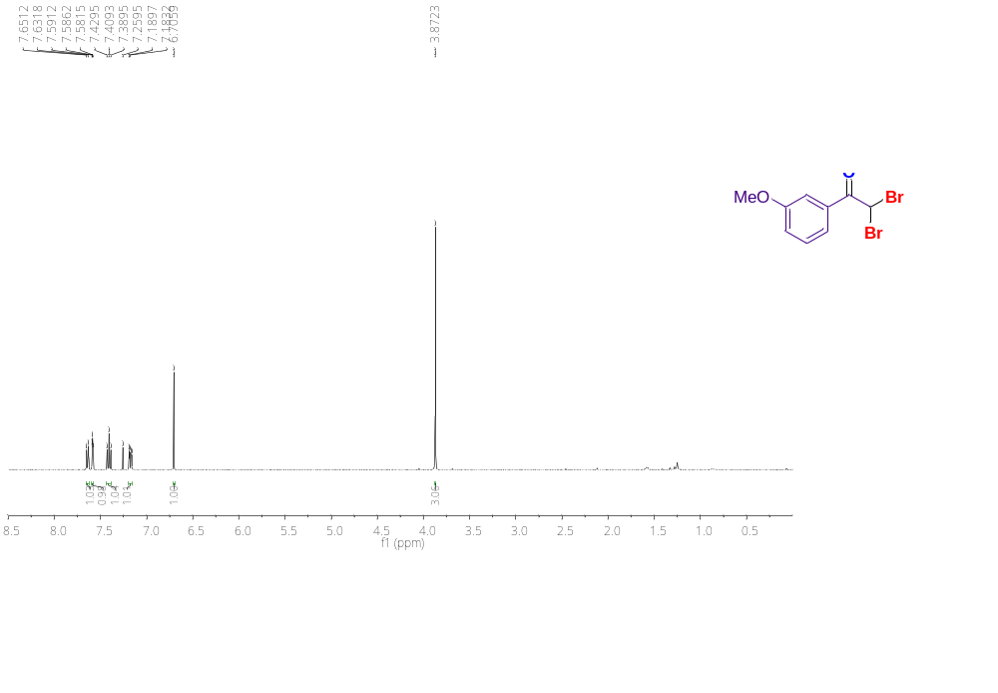
Figure S49.¹H NMR (400 MHz) spectrum of 2,2-dibromo-1-(3-methoxyphenyl)ethan-1-one (3o) in CDCl₃.

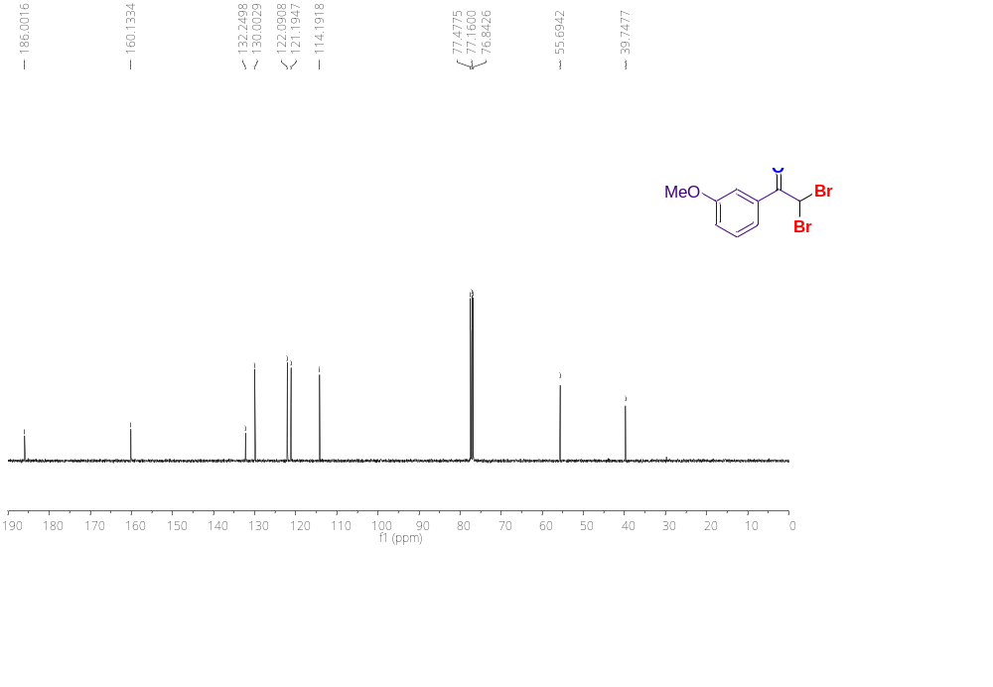
Figure S50. ¹³C{¹H} NMR (100 MHz) spectrum of 2,2-dibromo-1-(3-methoxyphenyl)ethan-1-one (3o) in CDCl₃.
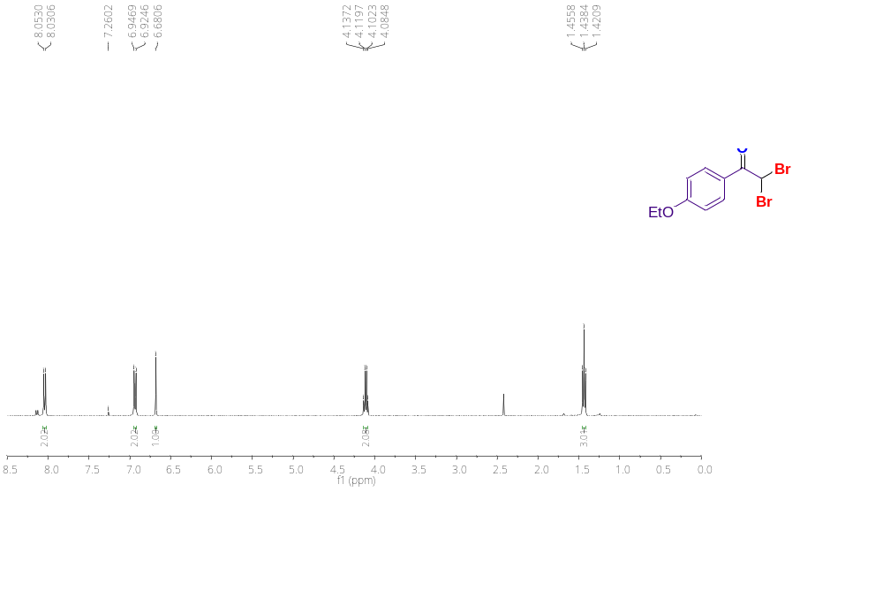
Figure S51.¹H NMR (400 MHz) spectrum of 2,2-dibromo-1-(4-ethoxyphenyl)ethan-1-one (3p) in CDCl₃.

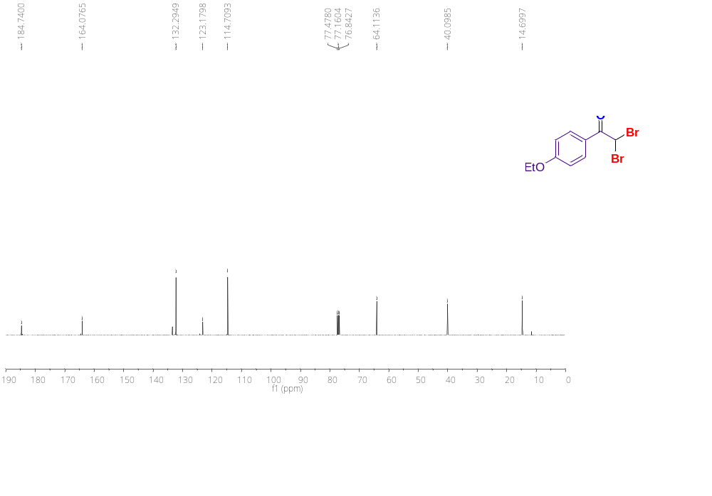
Figure S52. ¹³C{¹H} NMR (100 MHz) spectrum of 2,2-dibromo-1-(4-ethoxyphenyl)ethan-1-one (3p) in CDCl₃.
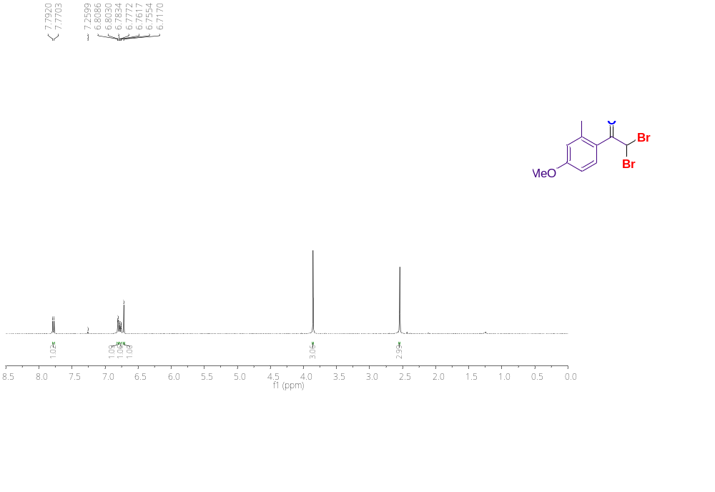
Figure S53.¹H NMR (400 MHz) spectrum of 2,2-dibromo-1-(4-methoxy-2-methylphenyl)ethan-1-one (3q) in CDCl₃.

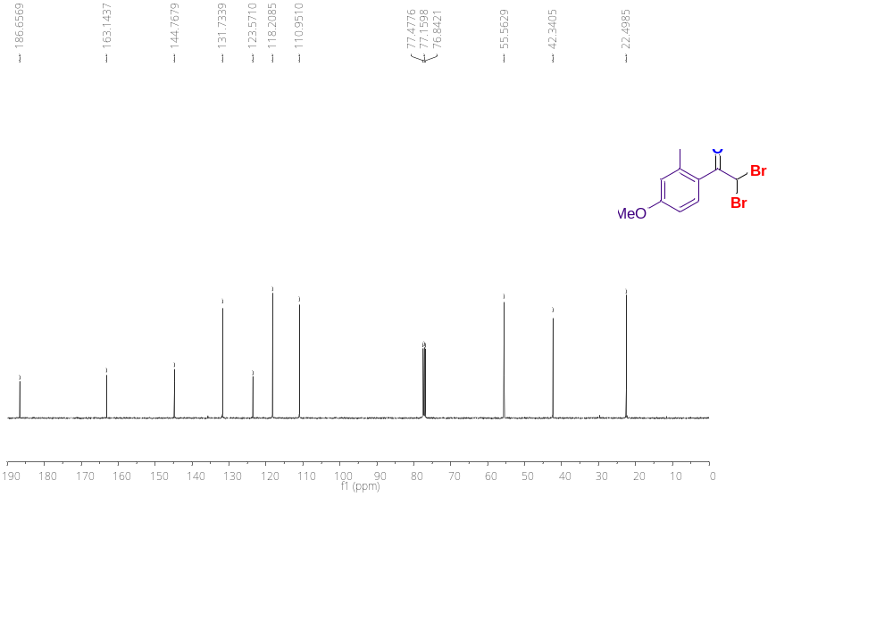
Figure S54. ¹³C{¹H} NMR (100 MHz) spectrum of 2,2-dibromo-1-(4-methoxy-2-methylphenyl)ethan-1-one (3q) in CDCl₃.
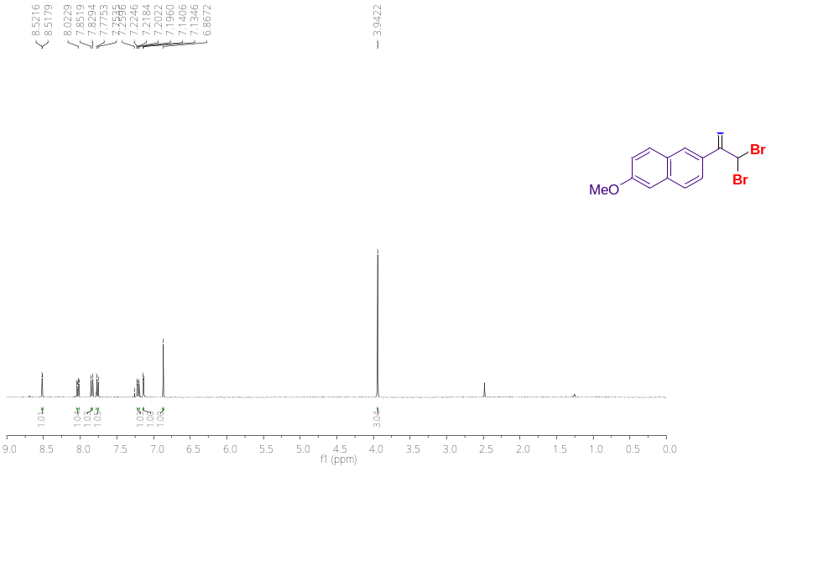
Figure S55.¹H NMR (400 MHz) spectrum of 2,2-dibromo-1-(6-methoxynaphthalen-2-yl)ethan-1-one (3r) in CDCl₃.

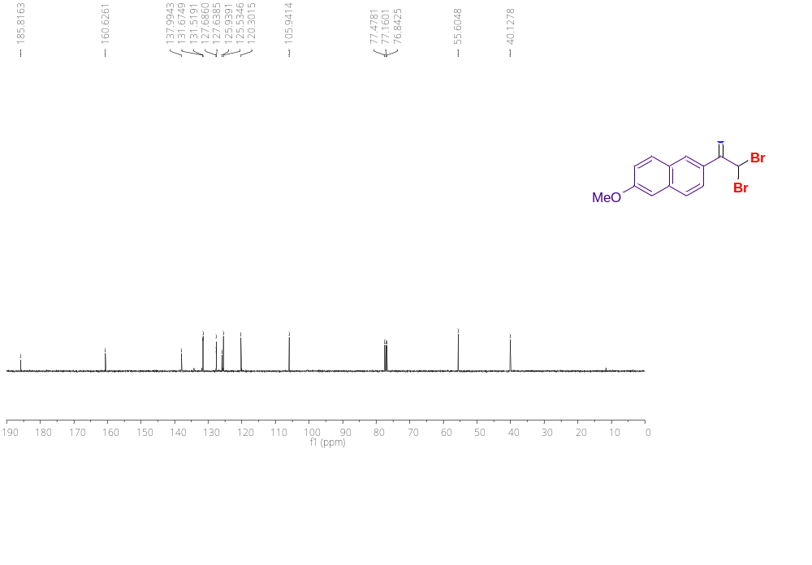
Figure S56. ¹³C{¹H} NMR (100 MHz) spectrum of 2,2-dibromo-1-(6-methoxynaphthalen-2-yl)ethan-1-one (3r) in CDCl₃.
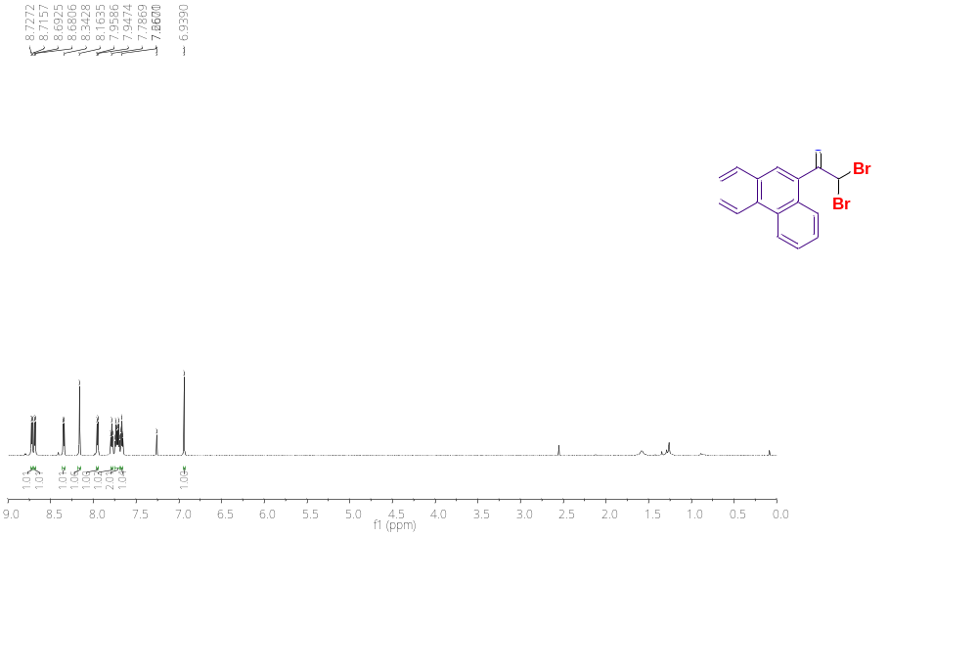
Figure S57.¹H NMR (400 MHz) spectrum of 2,2-dibromo-1-(phenanthren-9-yl)ethan-1-one (3s) in CDCl₃.

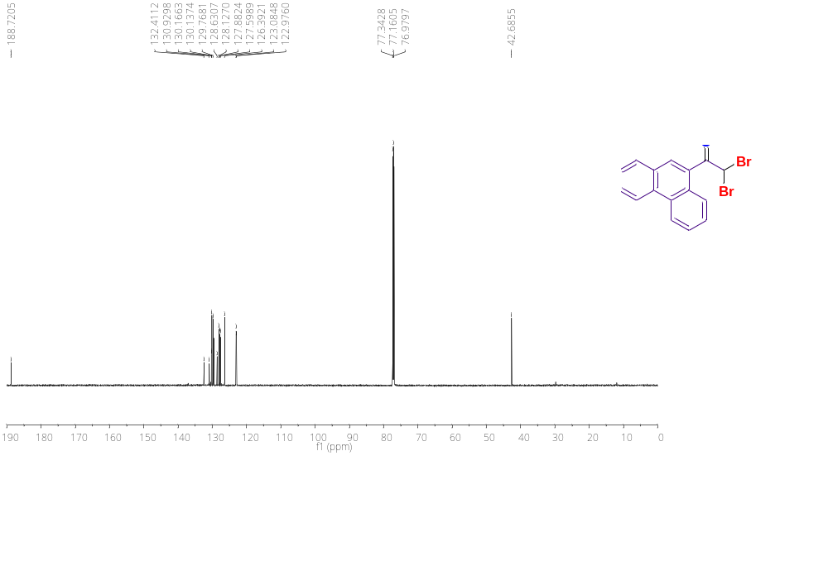
Figure S58. ¹³C{¹H} NMR (100 MHz) spectrum of 2,2-dibromo-1-(phenanthren-9-yl)ethan-1-one (3s) in CDCl₃.
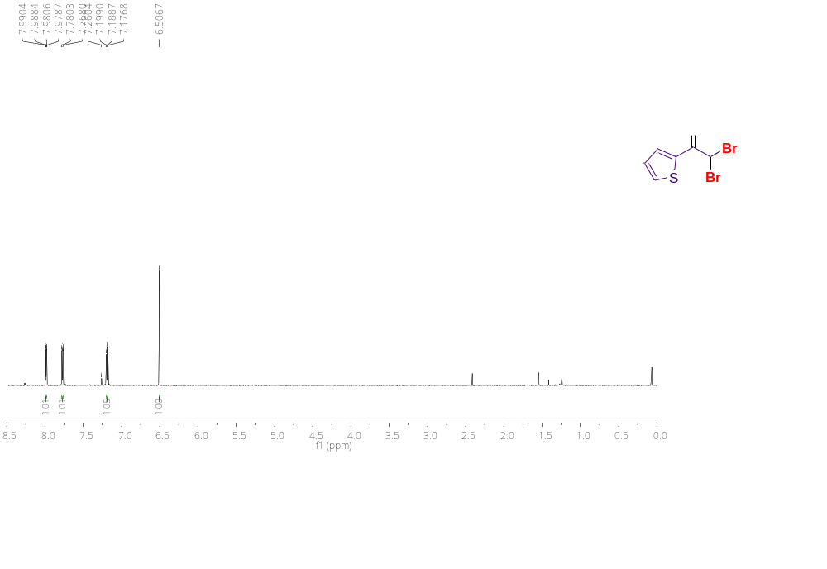
Figure S59.¹H NMR (400 MHz) spectrum of 2,2-dibromo-1-(thiophen-2-yl)ethan-1-one (3t) in CDCl₃.

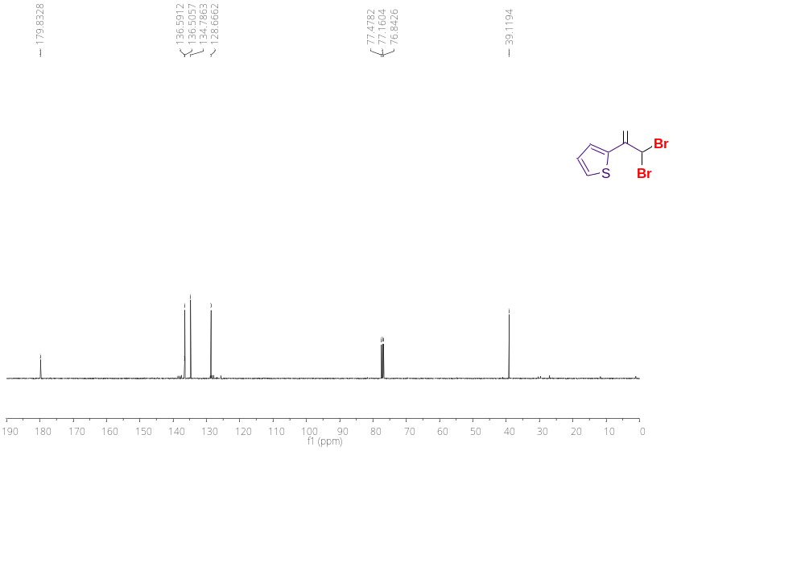
Figure S60. ¹³C{¹H} NMR (100 MHz) spectrum of 2,2-dibromo-1-(thiophen-2-yl)ethan-1-one (3t) in CDCl₃.
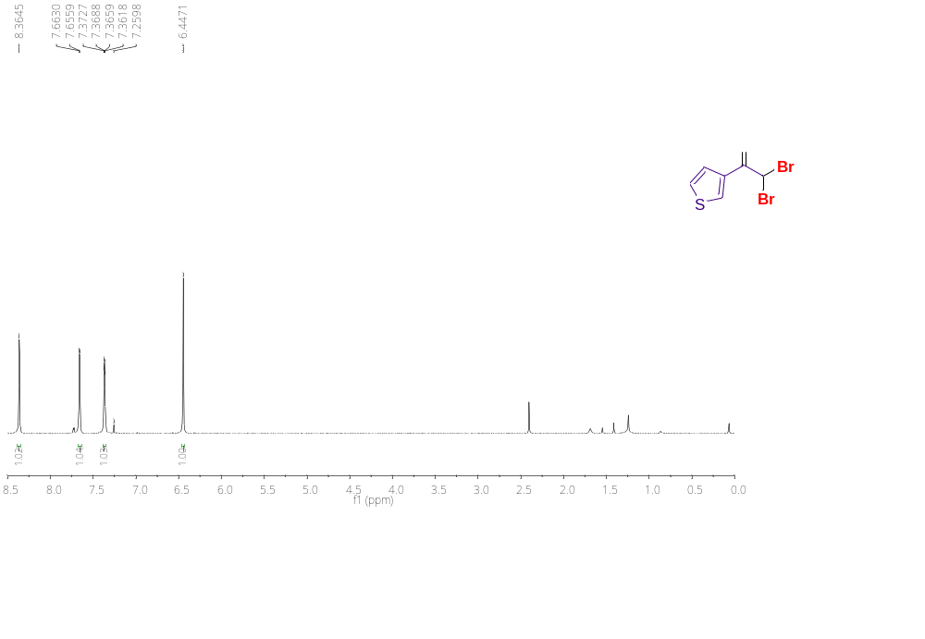
Figure S61.¹H NMR (400 MHz) spectrum of 2,2-dibromo-1-(thiophen-3-yl)ethan-1-one (3u) in CDCl₃.

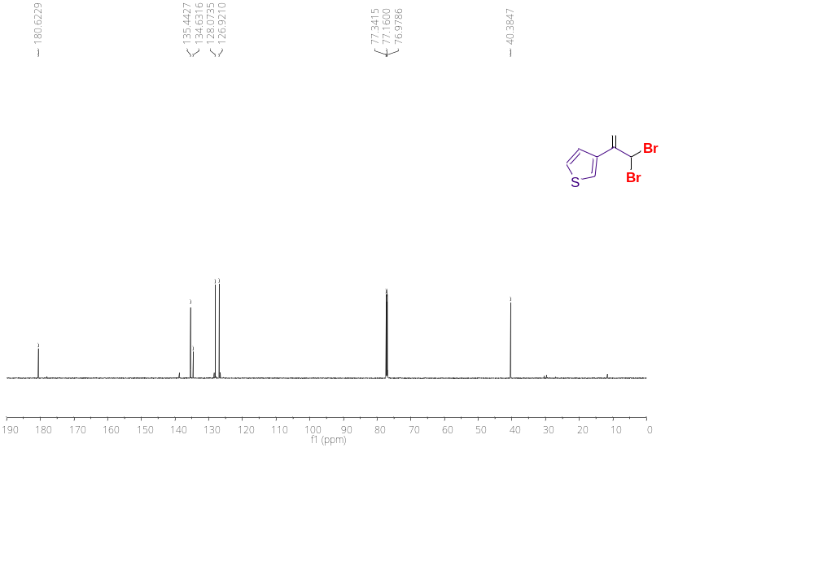
Figure S62. ¹³C{¹H} NMR (100 MHz) spectrum of 2,2-dibromo-1-(thiophen-3-yl)ethan-1-one (3u) in CDCl₃.
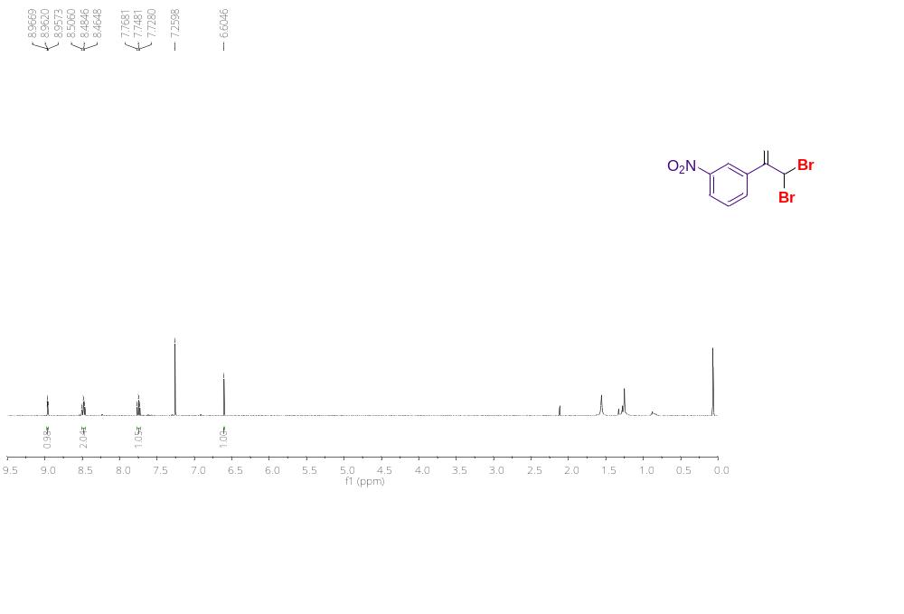
Figure S63.¹H NMR (400 MHz) spectrum of 2,2-dibromo-1-(3-nitrophenyl)ethan-1-one (3v) in CDCl₃.

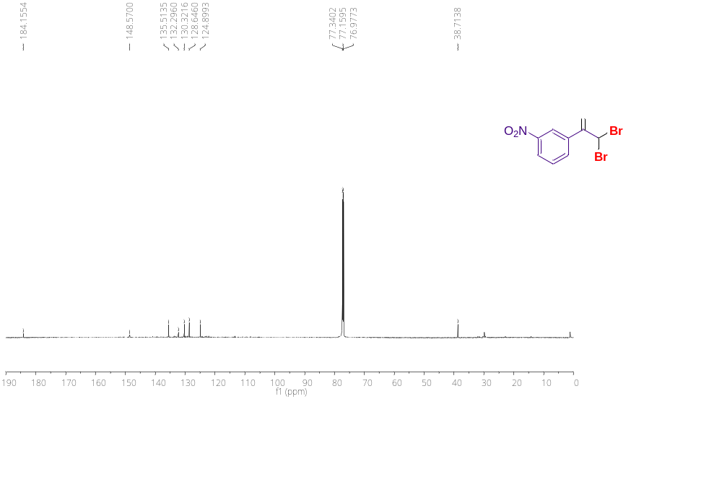
Figure S64. ¹³C{¹H} NMR (100 MHz) spectrum of 2,2-dibromo-1-(3-nitrophenyl)ethan-1-one (3v) in CDCl₃.
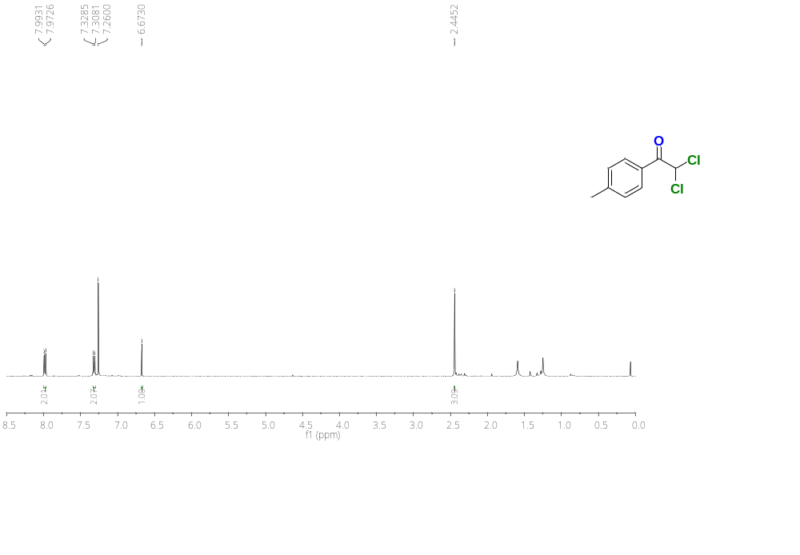
Figure S65.¹H NMR (400 MHz) spectrum of 2,2-dichloro-1-(p-tolyl)ethan-1-one (4a) in CDCl₃.

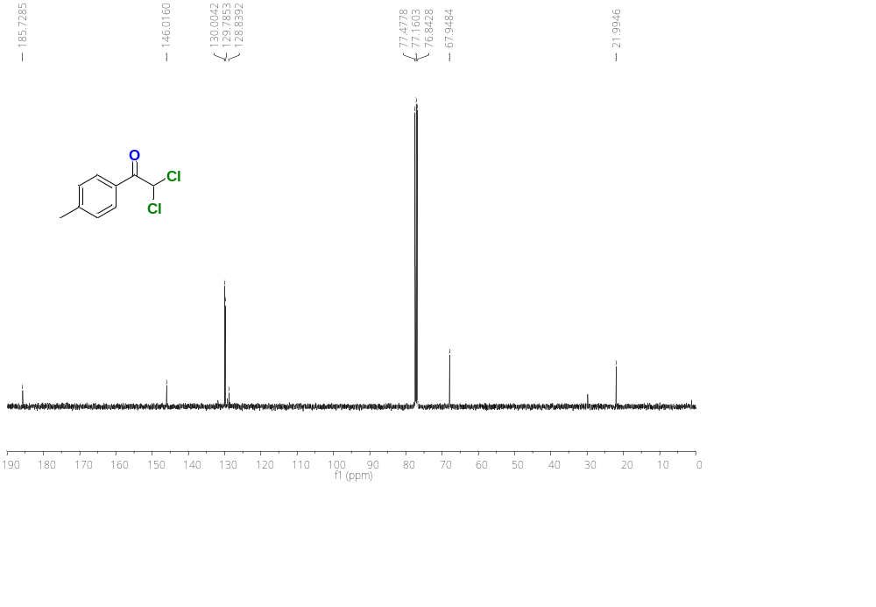
Figure S66. ¹³C{¹H} NMR (100 MHz) spectrum of 2,2-dichloro-1-(p-tolyl)ethan-1-one (4a) in CDCl₃.
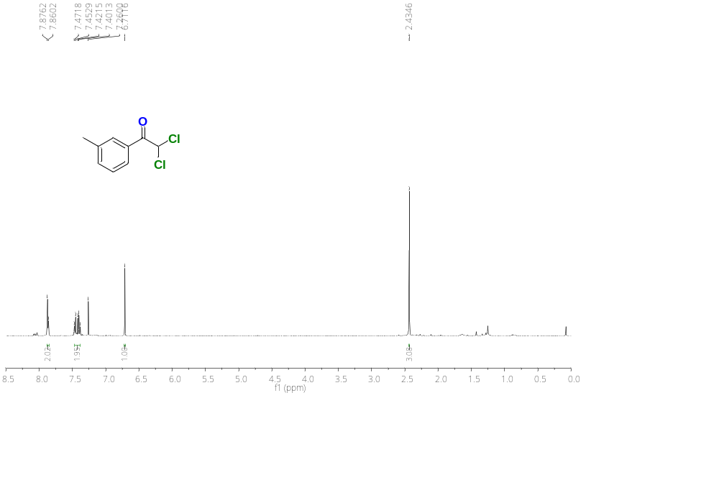
Figure S67.¹H NMR (400 MHz) spectrum of 2,2-dichloro-1-(m-tolyl)ethan-1-one (4b) in CDCl₃.

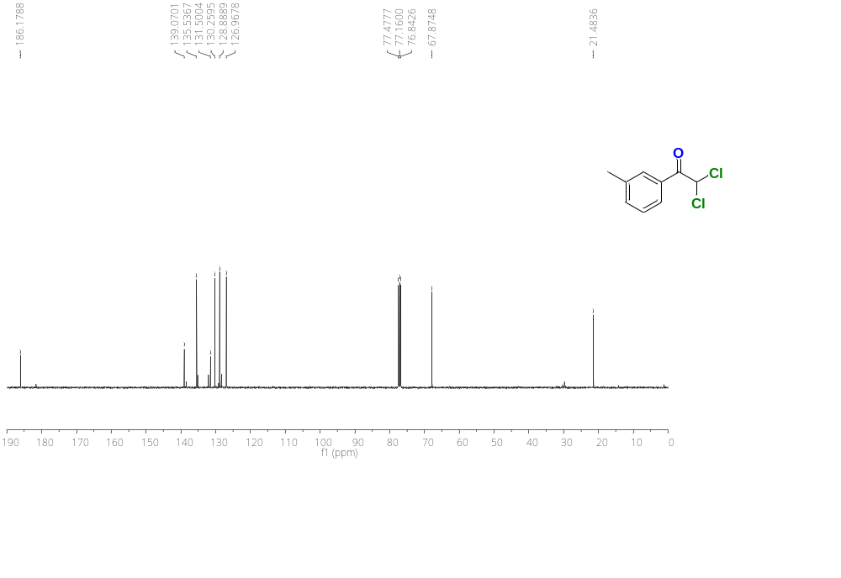
Figure S68. ¹³C{¹H} NMR (100 MHz) spectrum of 2,2-dichloro-1-(m-tolyl)ethan-1-one (4b) in CDCl₃.
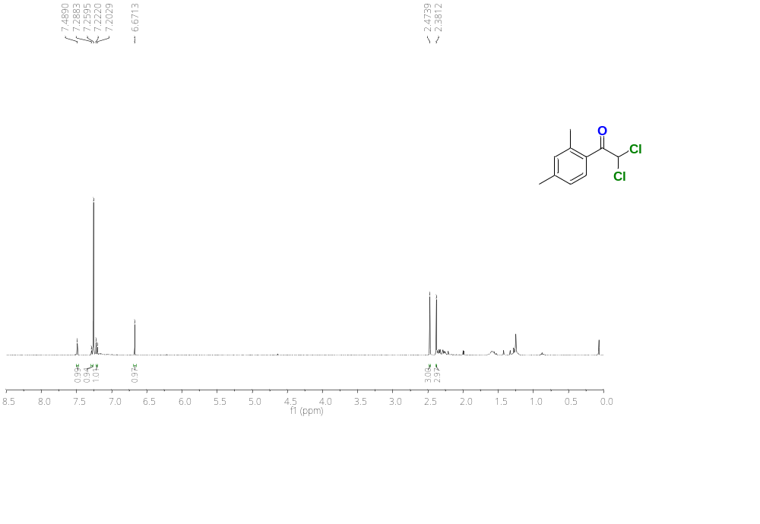
Figure S69.¹H NMR (400 MHz) spectrum of 2,2-dichloro-1-(2,4-dimethylphenyl)ethan-1-one (4c) in CDCl₃.

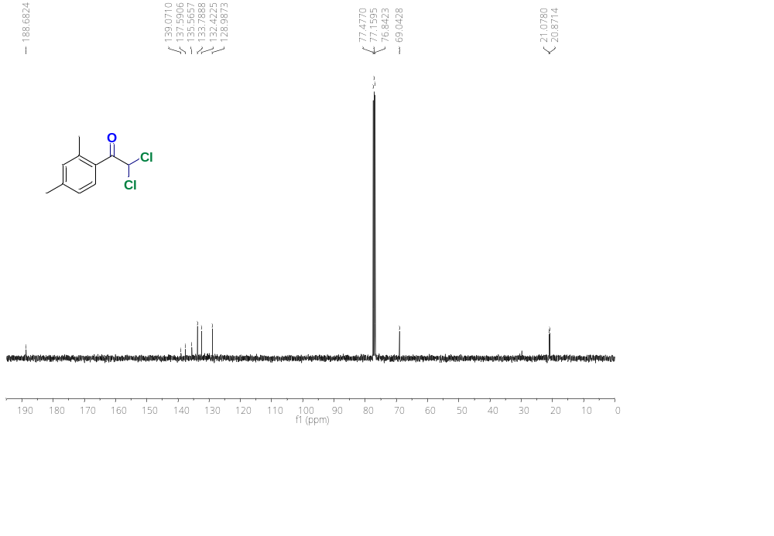
Figure S70. ¹³C{¹H} NMR (100 MHz) spectrum of 2,2-dichloro-1-(2,4-dimethylphenyl)ethan-1-one (4c) in CDCl₃.
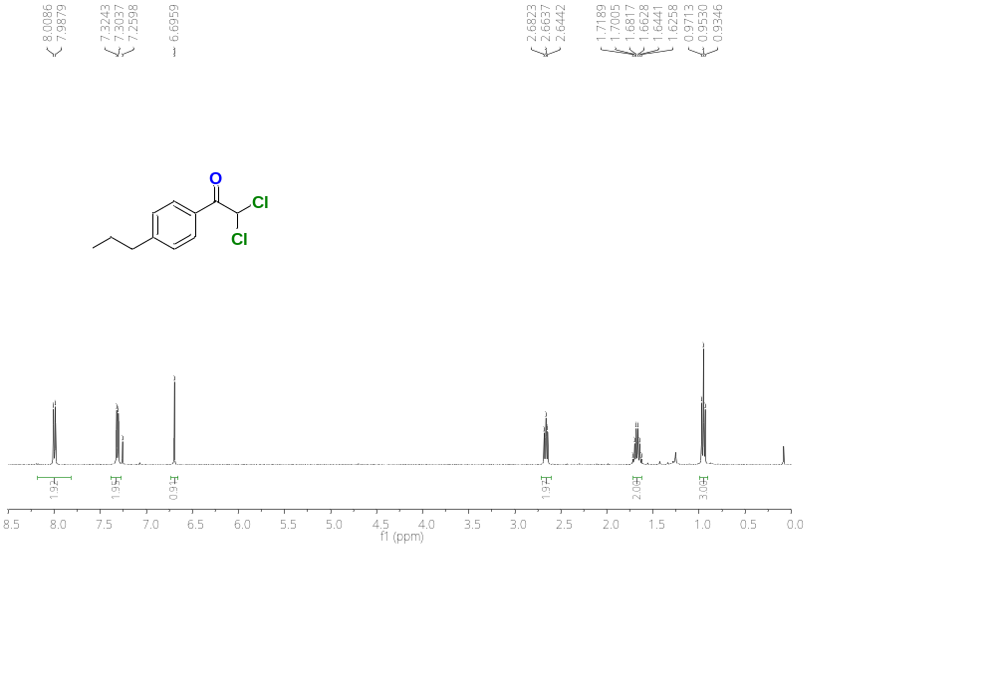
Figure S71.¹H NMR (400 MHz) spectrum of 2,2-dichloro-1-(4-propylphenyl)ethan-1-one (4d) in CDCl₃.

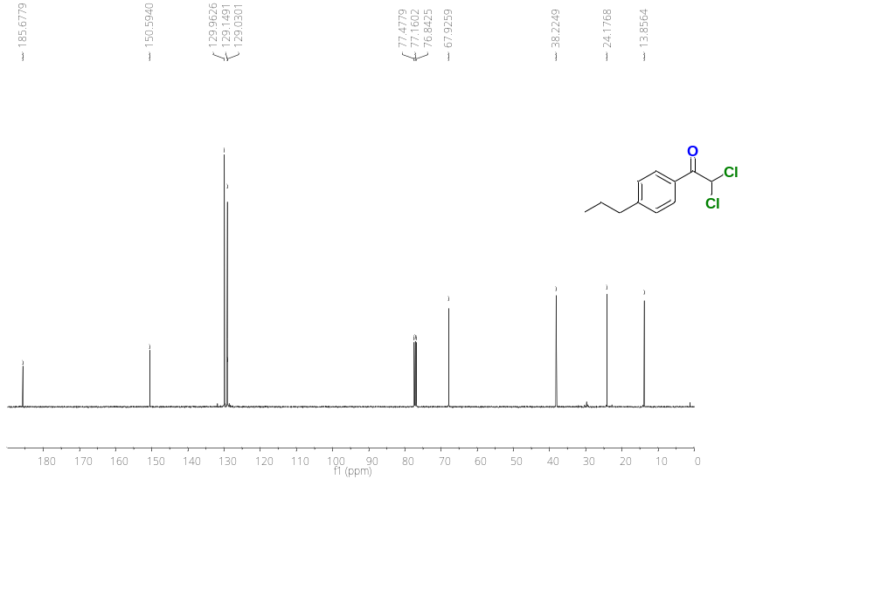
Figure S72. ¹³C{¹H} NMR (100 MHz) spectrum of 2,2-dichloro-1-(4-propylphenyl)ethan-1-one (4d) in CDCl₃.

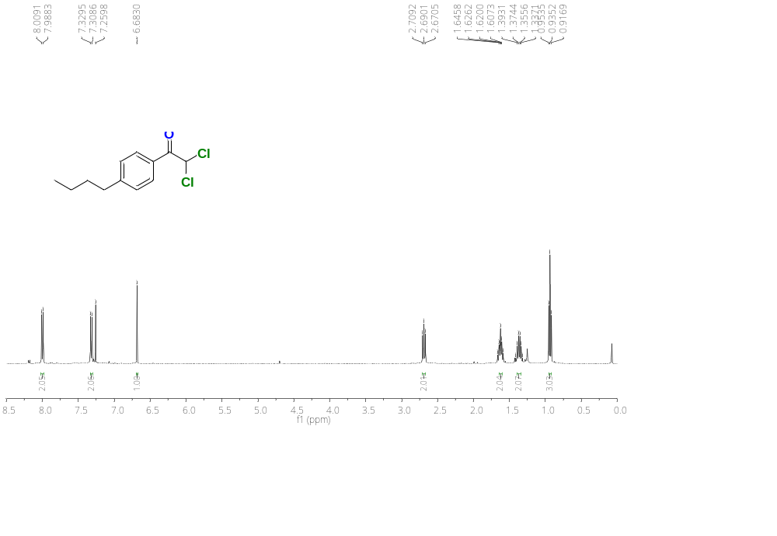
Figure S73.¹H NMR (400 MHz) spectrum of 1-(4-butylphenyl)-2,2-dichloroethan-1-one (4e) in CDCl₃.

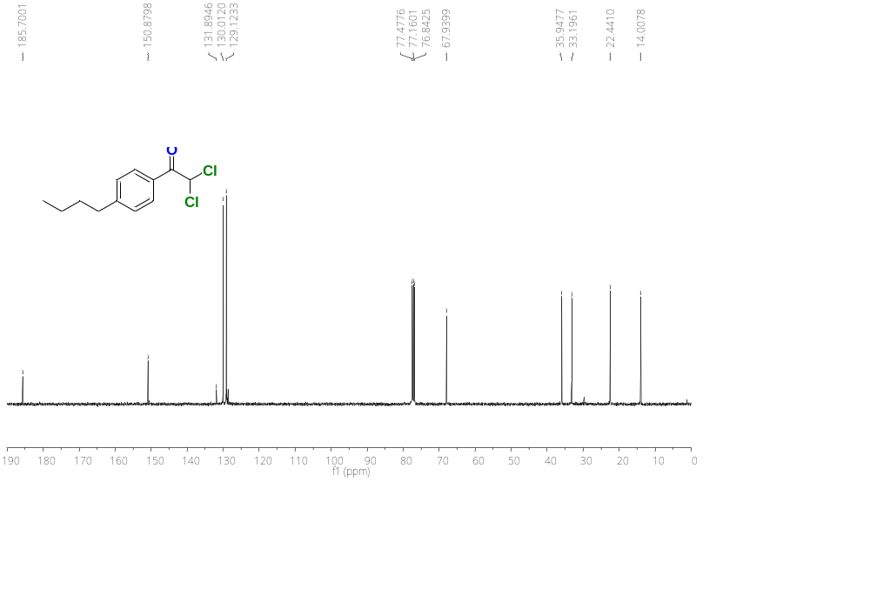
Figure S74. ¹³C{¹H} NMR (100 MHz) spectrum of 1-(4-butylphenyl)-2,2-dichloroethan-1-one (4e) in CDCl₃.

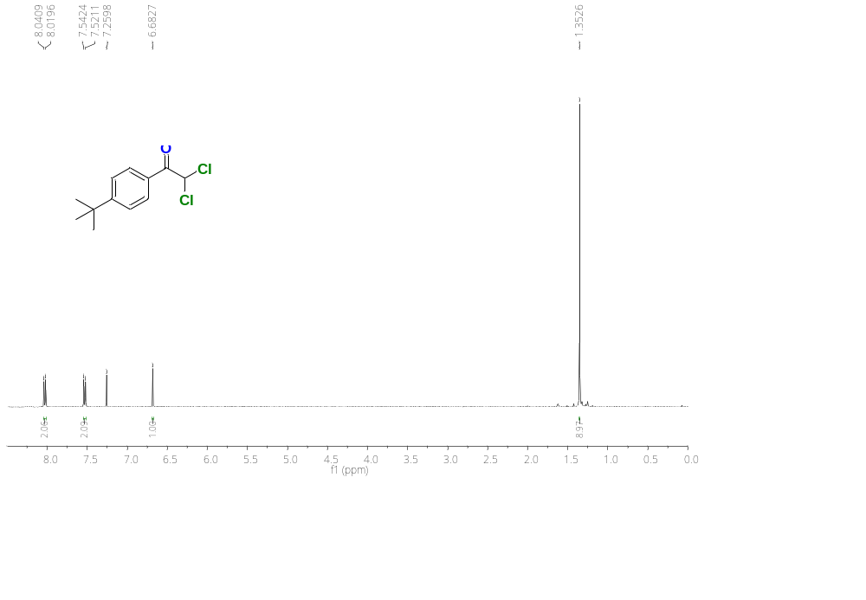
Figure S75.¹H NMR (400 MHz) spectrum of 1-(4-(tert-butyl)phenyl)-2,2-dichloroethan-1-one (4f) in CDCl₃.

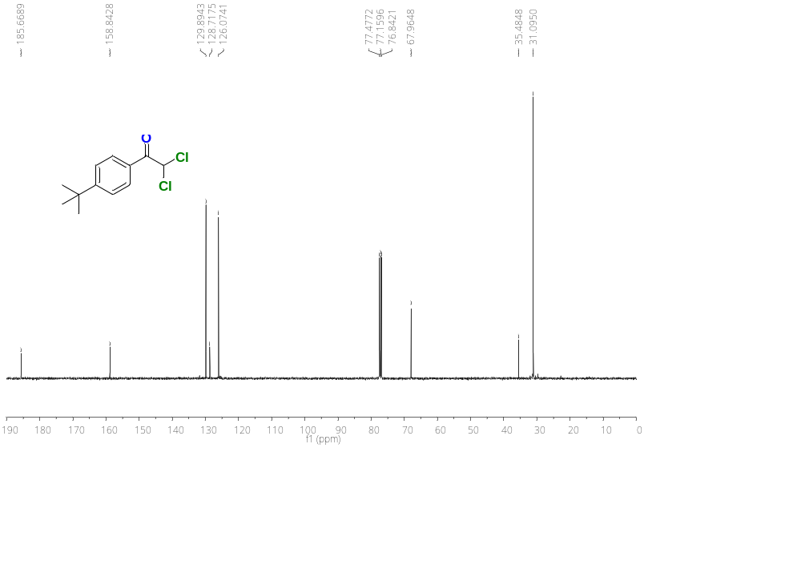
Figure S76. ¹³C{¹H} NMR (100 MHz) spectrum of 1-(4-(tert-butyl)phenyl)-2,2-dichloroethan-1-one (4f) in CDCl₃.
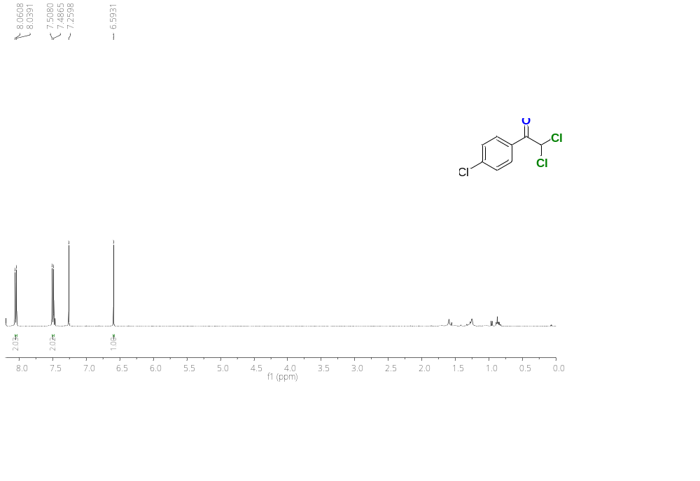
Figure S77.¹H NMR (400 MHz) spectrum of 2,2-dichloro-1-(4-chlorophenyl)ethan-1-one (4g) in CDCl₃.

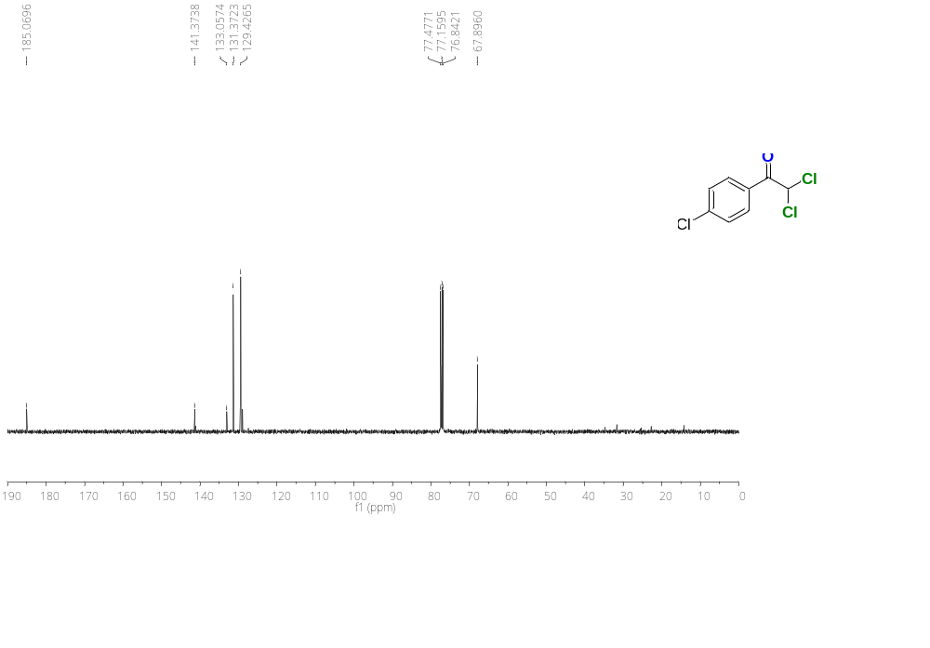
Figure S78. ¹³C{¹H} NMR (100 MHz) spectrum of 2,2-dichloro-1-(4-chlorophenyl)ethan-1-one (4g) in CDCl₃.
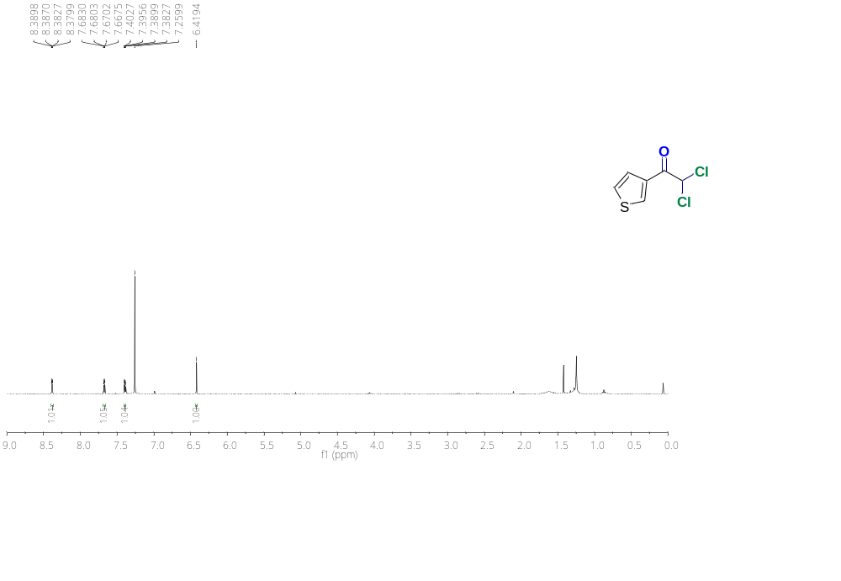
Figure S79.¹H NMR (400 MHz) spectrum of 2,2-dichloro-1-(thiophen-3-yl)ethan-1-one (4h) in CDCl₃.

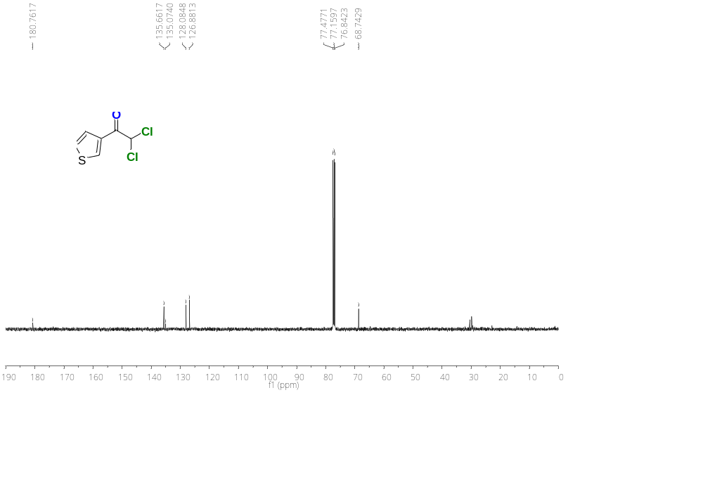
Figure S80. ¹³C{¹H} NMR (100 MHz) spectrum of 2,2-dichloro-1-(thiophen-3-yl)ethan-1-one (4h) in CDCl₃.
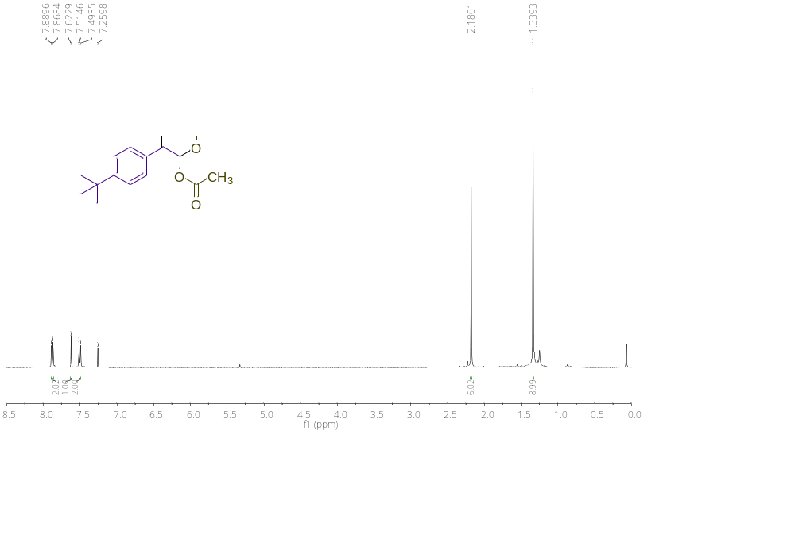
Figure S81.¹H NMR (400 MHz) spectrum of 2-(4-(tert-butyl)phenyl)-2-oxoethane-1,1-diyl diacetate (5a) in CDCl₃.

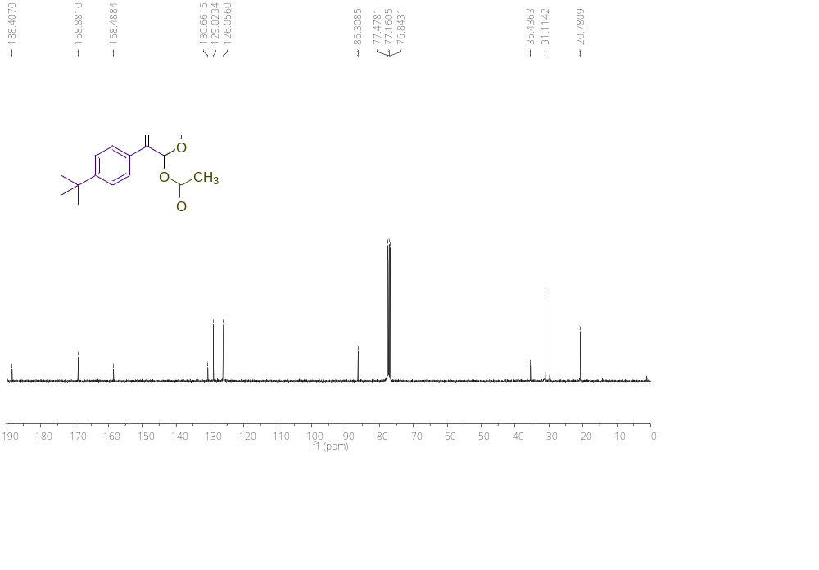
Figure S82. ¹³C{¹H} NMR (100 MHz) spectrum of 2-(4-(tert-butyl)phenyl)-2-oxoethane-1,1-diyl diacetate (5a) in CDCl₃.
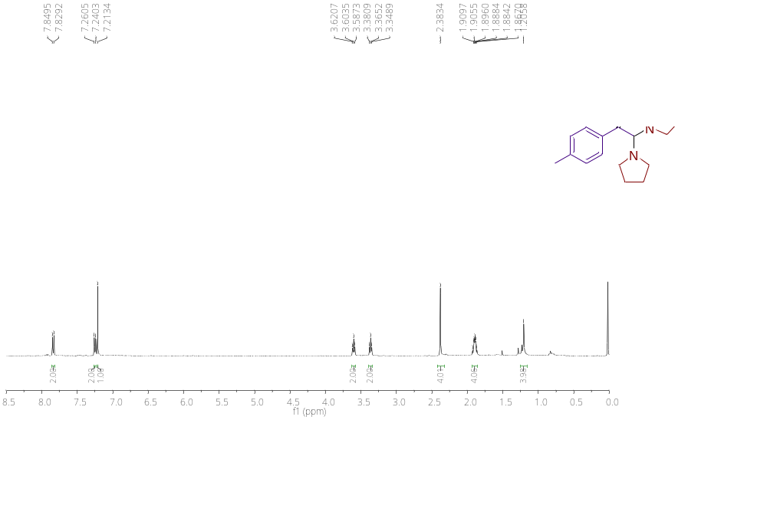
Figure S83.¹H NMR (400 MHz) spectrum of 2,2-di(pyrrolidin-1-yl)-1-(p-tolyl)ethan-1-one (5b) in CDCl₃.

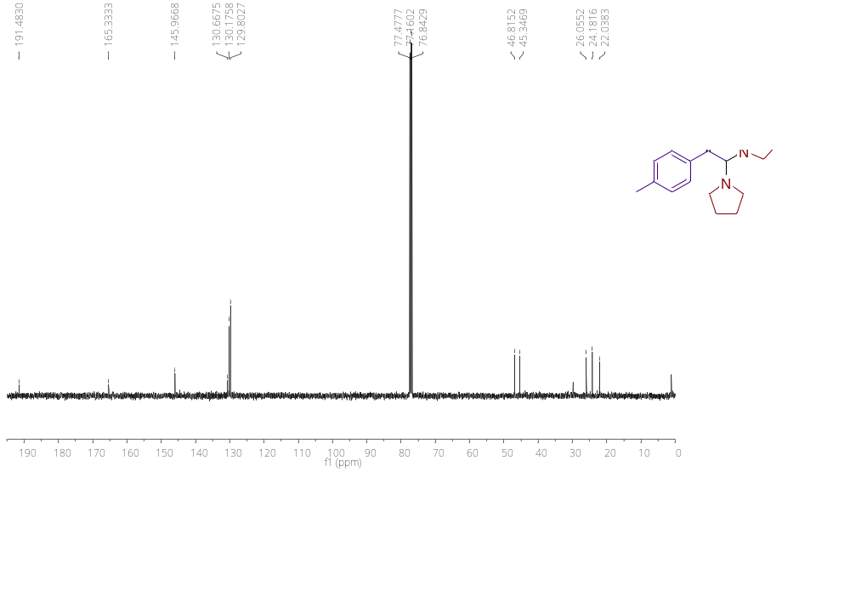
Figure S84. ¹³C{¹H} NMR (100 MHz) spectrum of 2,2-di(pyrrolidin-1-yl)-1-(p-tolyl)ethan-1-one (5b) in CDCl₃.
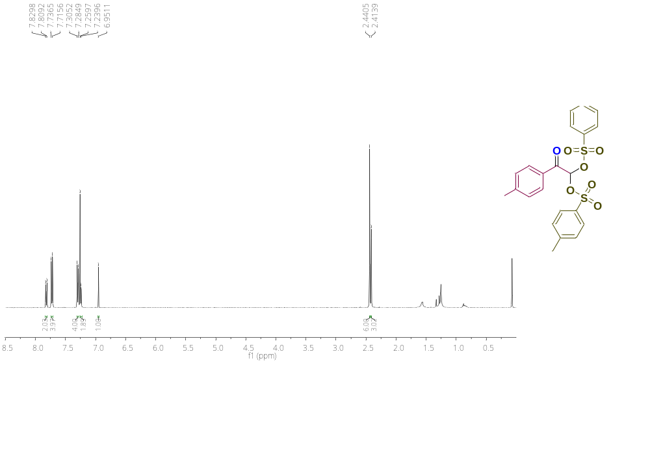
Figure S85.¹H NMR (400 MHz) spectrum of 2-oxo-2-(p-tolyl)ethane-1,1-diyl bis(4-methylbenzenesulfonate) (5c) in CDCl₃.

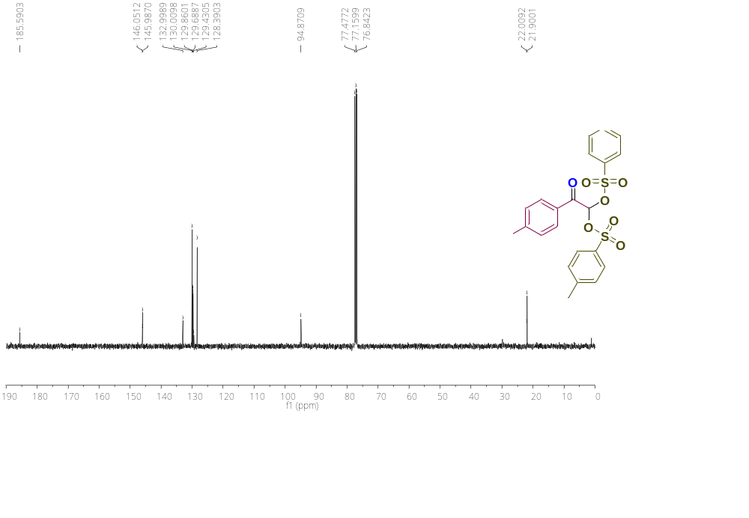
Figure S86. ¹³C{¹H} NMR (100 MHz) spectrum of 2-oxo-2-(p-tolyl)ethane-1,1-diyl bis(4-methylbenzenesulfonate) (5c) in CDCl₃.
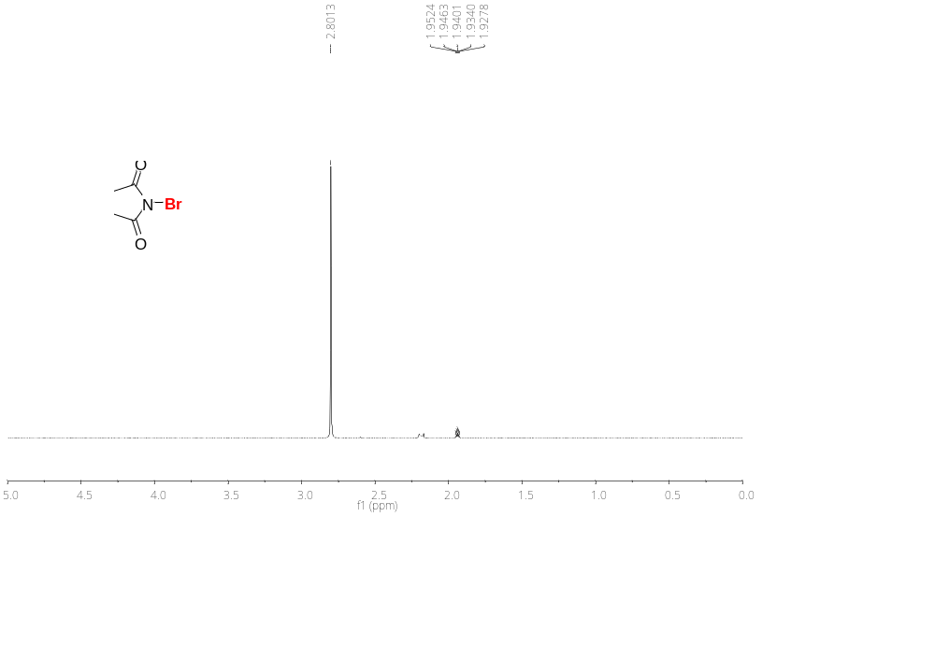
Figure S87.¹H NMR (400 MHz) spectrum of N-bromosuccinimide (NBS) in CD₃CN.
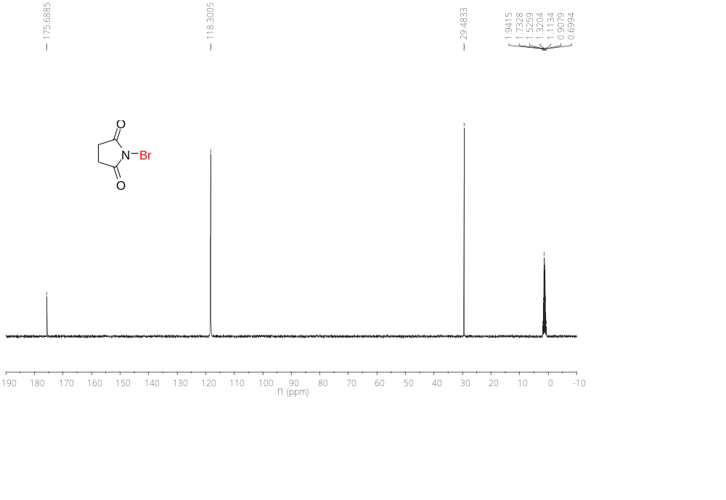
Figure S88. ¹³C{¹H} NMR (100 MHz) spectrum of N-bromosuccinimide (NBS) in CD₃CN.

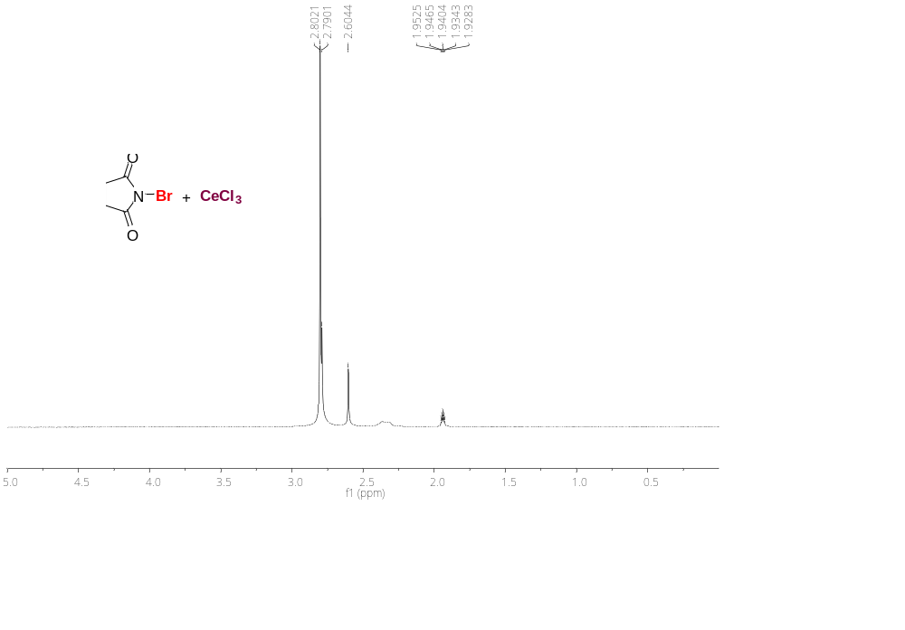
Figure S89.¹H NMR (400 MHz) spectrum of NBS-CeCl₃ charge-transfer complex in CD₃CN.

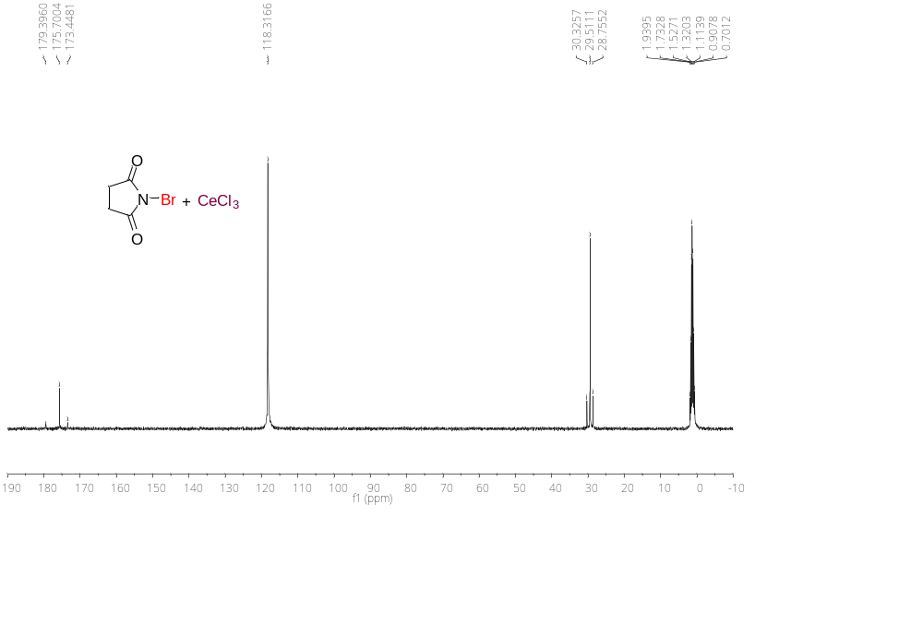
Figure S90. ¹³C{¹H} NMR (100 MHz) spectrum of NBS-CeCl₃ charge-transfer complex in CD₃CN.

GC-MS spectrum

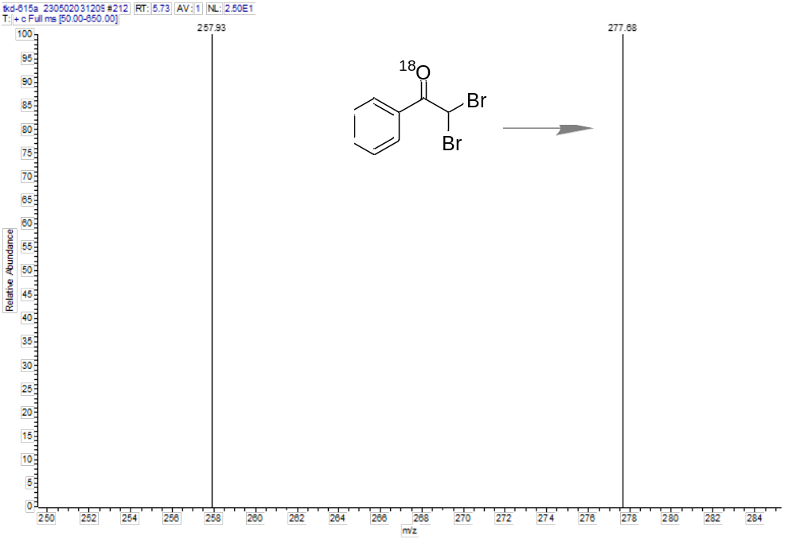
Figure S91. GC-MS spectrum of 2,2-dibromo-1-phenylethan-1-one (3a-¹⁸O) in CH₃CN.

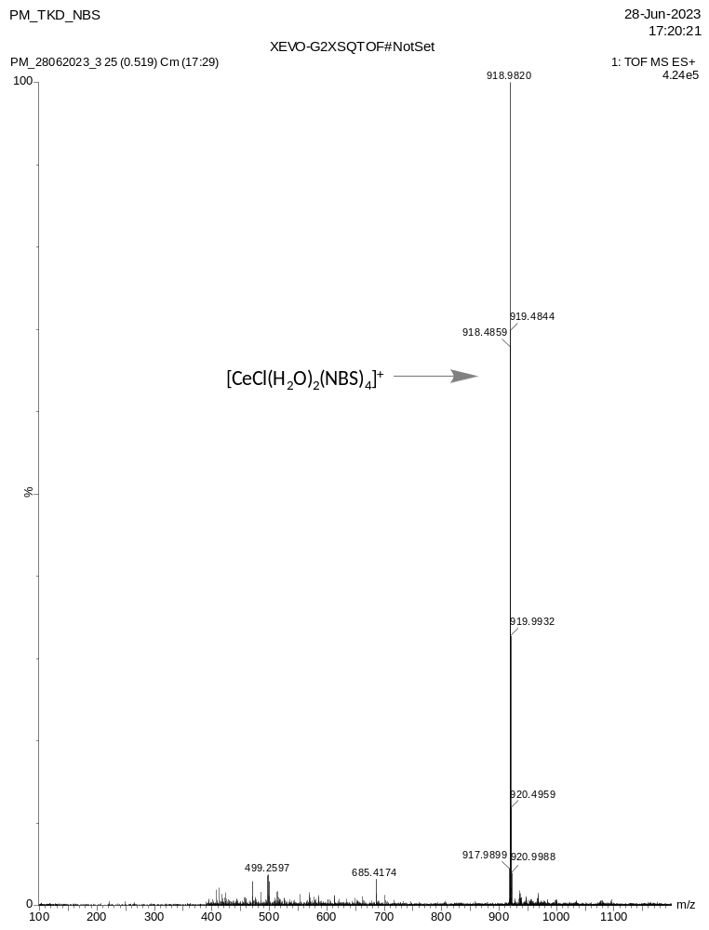

Figure S92. ESI-MS spectrum (Full spectrum) of NBS-CeCl₃ charge-transfer complex in CH₃CN.

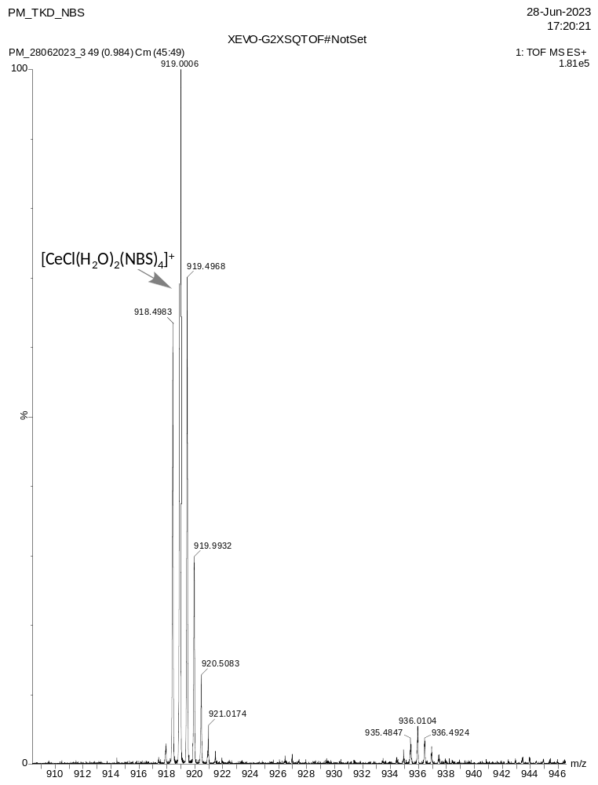
Figure S93. ESI-MS spectrum (Expanded version) of NBS-CeCl₃ charge-transfer complex in CH₃CN.

