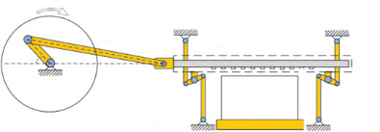



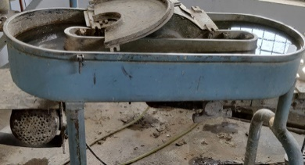
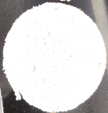
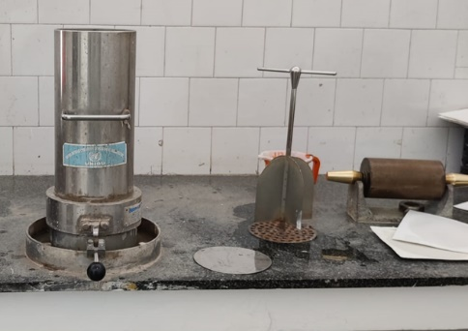
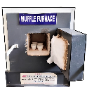
CO₂ Cylinder or reutilised in the process from calcination and acid dissolution
Foam bed
reactor
Air Compressor
PCC synthesis
Marble waste slurry collection tank
Calcination
(in Muffle furnace)
(i) Ball milling
(ii) Size separation
Dissolution
in HCl
Hydration
Gas
Mixer
Paper sheet casting
(British handsheet former)
Marble waste to Ca(OH)₂ and marble waste slurry to CaCl₂
Marble block cutting & processing site
Lean CO₂ gas
Product PCCs
Ca(OH)₂ slurry
CaCl₂ solution
Beating
(Hollander beater)
15% filler loaded Paper Handsheet
Pulp slurry
Preparation of Paper Handsheets
(i) Pressing
(ii) Drying
(iii) Calendaring
Chopped waste
cotton rags
(Textile Industry)
Additives (PAA, H₂O₂, NaOH)
Marble waste (Dumping yard)
Wet grinding
Marble block
Surfactants
CaO
Water
HCl
Paper handsheet casting
British handsheet former)

