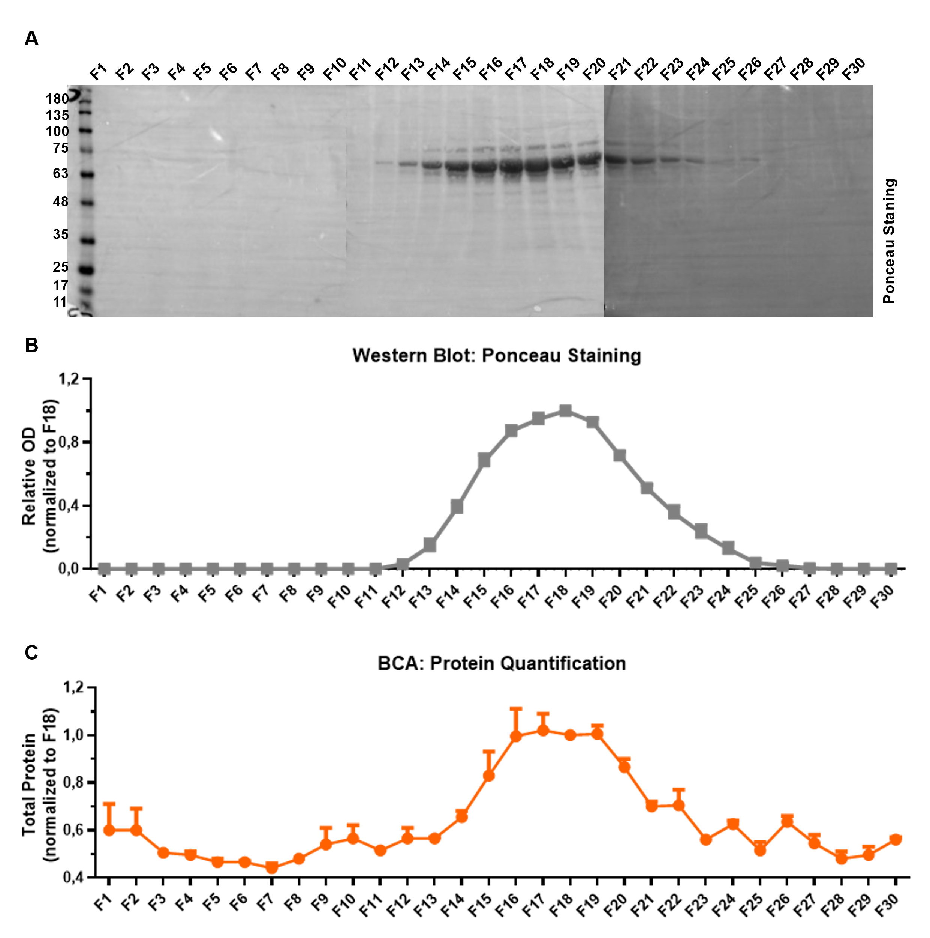
Supplementary Figure 1 - EV-enriched fractions present low protein contamination
(A) To confirm that free proteins were not co-eluted with EVs by SEC, western blots were performed. The same volume of each SEC fraction was loaded, and membranes were stained with Ponceau. (B) Protein bands corresponding to “contaminating proteins” were detected between F12 and F26. (C) The protein elution profile was confirmed by BCA. (B, C) Results are shown as mean ± SEM for Ponceau staining (N = 3) and BCA (N = 2).

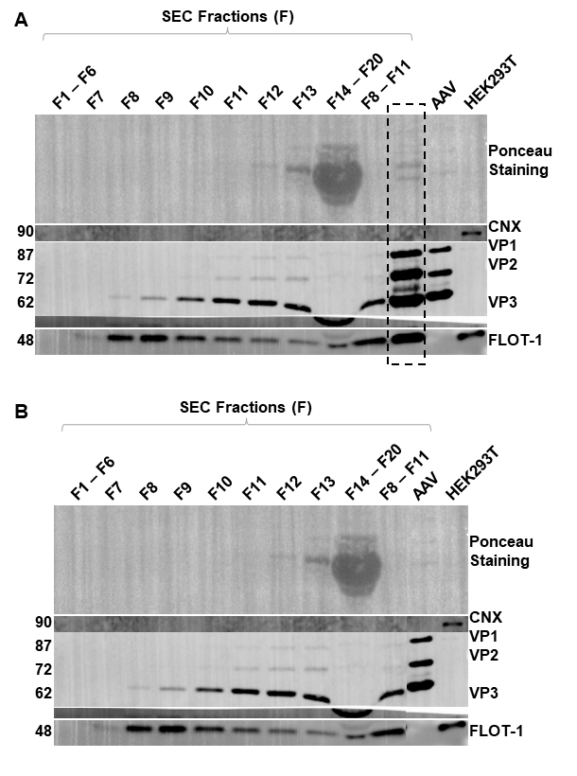
Supplementary Figure 2 - Uncropped western blot from main figure
(A) Uncropped western blot from the corresponding cropped western blot shown within the main text (B).

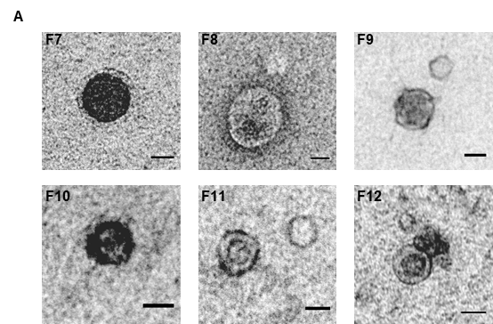
Supplementary Figure 3 – Characterization of SEC F7 to F12 by negative Transmission Electron Microscopy (TEM)
(A) SEC fractions (F7 to F12) were imaged by negative stain TEM. Scale bar = 50nm.
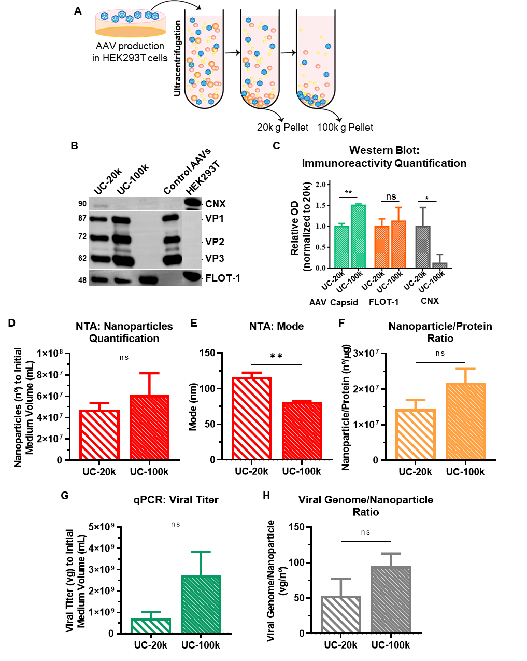
Supplementary Figure 4 - Two different populations of EVs are obtained during ultracentrifugation of AAV production medium at 20 000 g (UC-20k) and 100 000 g (UC-100k)
(A) Schematic representation of the extracellular vesicle-associated adeno-associated virus (EV-AAV) isolation protocol by ultracentrifugation (UC). AAV production medium was submitted to two steps of ultracentrifugation (1h at 20k g followed by 1h30 at 100k g). In both steps, pelleted material was collected and subsequently analyzed. (B) The presence of EV protein markers (FLOT-1, AAV capsid proteins (VP1, VP2, VP3) and cell contamination markers (CNX) was analyzed by Western Blot. UC-20k and UC-100k were loaded in the same proportion. FLOT-1 and AAV capsid proteins were present in UC-20k and UC-100k. CNX was mostly present on UC-20k. Relative expression of AAV capsid proteins, FLOT-1 and CNX normalized to 20k fraction was quantified (C). AAV capsid proteins were significantly enriched in UC-100k fraction. AAV purified by FPLC and HEK293T cell lysates were used as controls. (D, E, F) Nanoparticle quantity and size distribution were determined by Nanoparticle Tracking Analysis (NTA). No significant differences were observed regarding nanoparticles concentration. Nanoparticles population was smaller in the UC-100k fraction (UC-20k: 116.3 nm ± 6.093; UC-100k: 80.90 nm ± 2.011). (G) Viral titter was quantified by quantitative polymerase chain reaction (qPCR). (H) Number of viral genomes per nanoparticle showed a tendency to be higher in UC-100k. (C - H) Statistical analysis was performed using the unpaired Student’s t-test (** p < 0.01). Results are shown as mean ± SEM for UC-20k (N = 3), UC-100k (N = 3), except in (G) qPCR (N = 9) per group.

