Supplement

eFigure 1
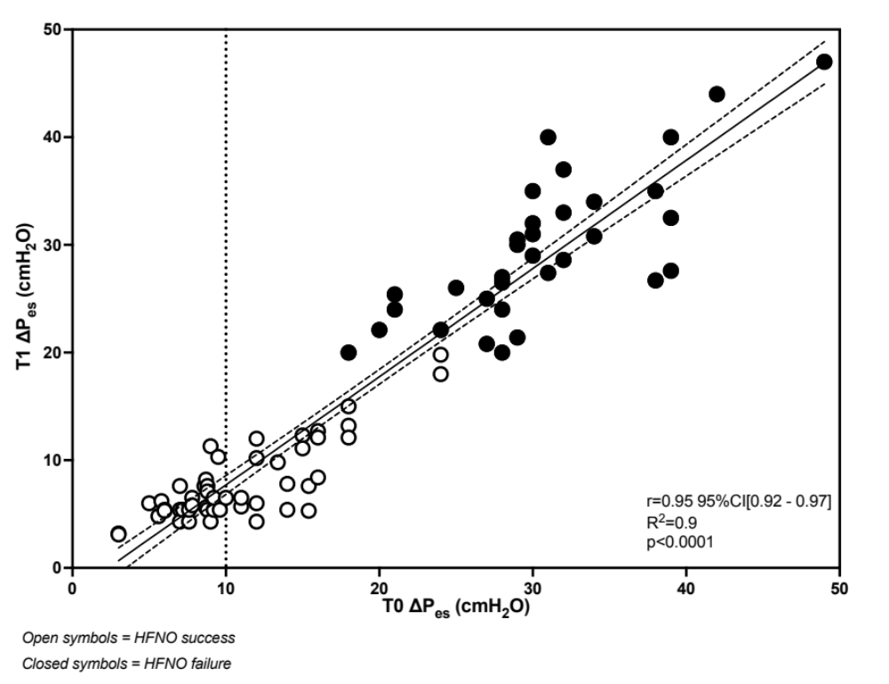
eFigure 1. Correlation between ΔP_{es} values measured at baseline and 2 hours after HFNO start. All the patients who failed HFNO showed ΔP_{es} values above 20 cmH₂O after 2 hours of treatment.

HFNO, high flow nasal oxygen; ΔP_{es}, esophageal pressure swing.

eFigure 2

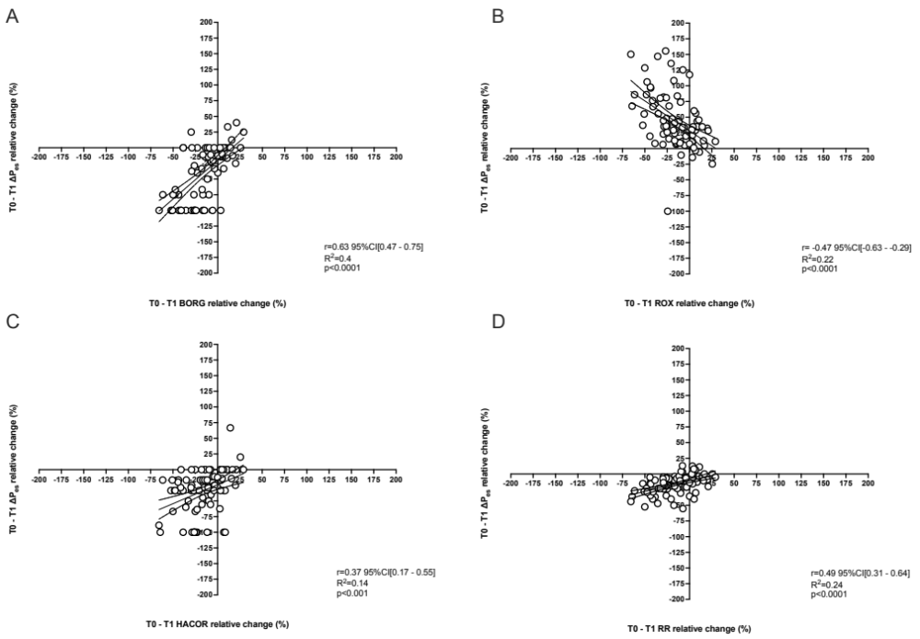

eFigure 2. Correlation between breathing effort variation after 2 hours of HFNO and the change in perceived dyspnea as assessed by BORG (panel A), ROX index (panel B), HACOR score (panel C) and RR (panel D). A significant correlation was found for all the variables explored.

