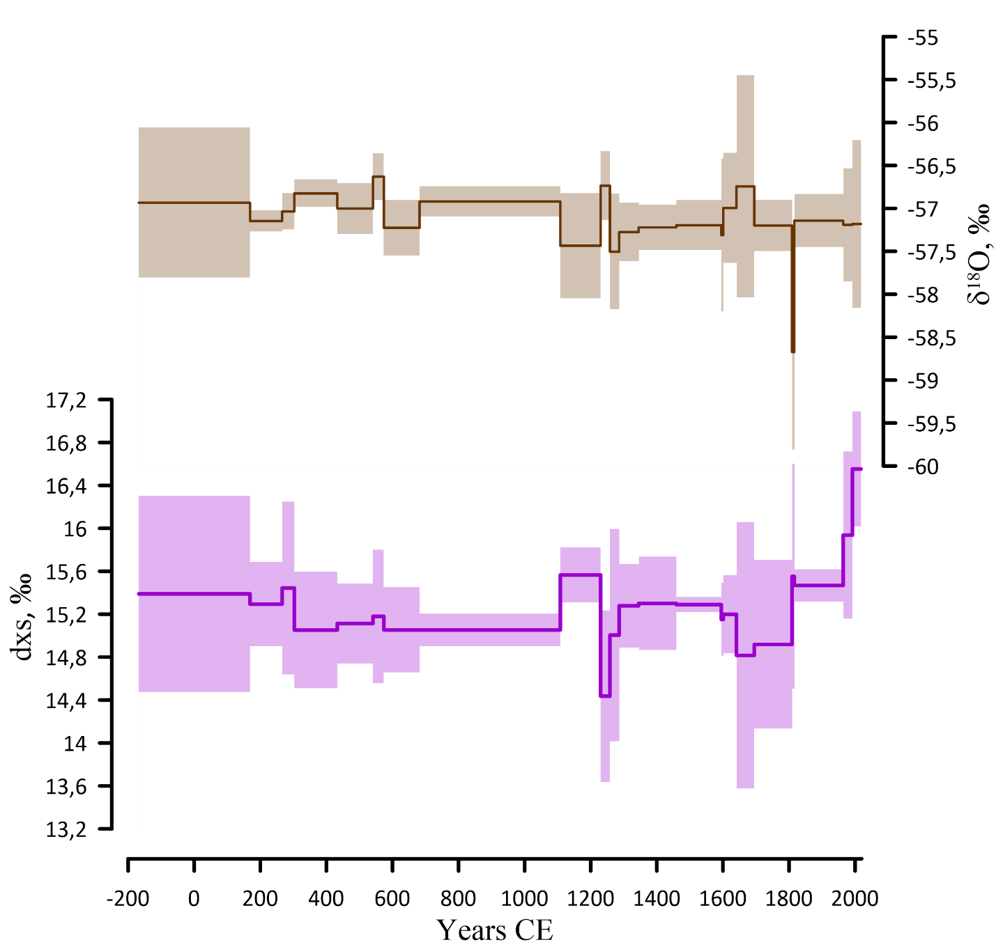
Supplementary Figure 1. The mean values of oxygen 18 concentrations (δ¹⁸O), grey, and deuterium excess parameter (dxs = δD – 8*δ¹⁸O), magenta, for the same time intervals for which the surface mass balance (SMB) values were reconstructed (see Fig. 2).

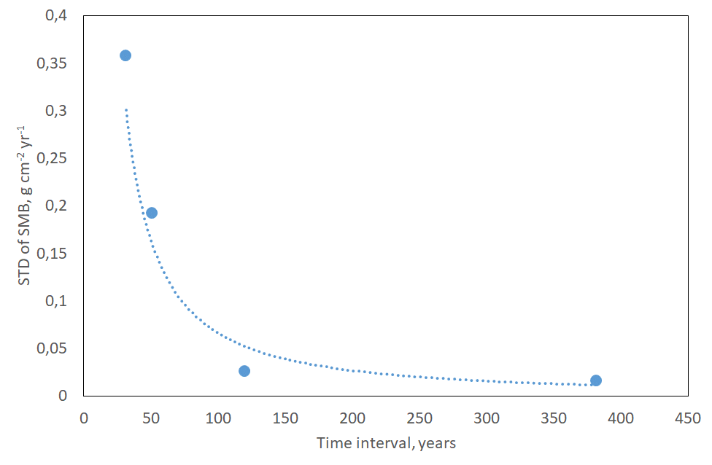
Supplementary Figure 2. Relationship between standard deviation of the mean SMB values and the period over which the SMB was obtained.

Supplementary Table 1.
The volcanic age markers in the Vostok firn cores and the mean values of the surface mass balance (SMB), near-surface air temperature (T_{g}) and moisture source temperature (T_{s}) in the time intervals between two adjacent age markers.
Upper marker | Time interval, years CE | Accumulation rate, g cm⁻² yr⁻¹ | Anomaly of the Vostok near-surface air temperature, °C | Anomaly of the near-surface air temperature in the moisture source, °C
Snow surface | 1992-2018 | 2.23±0.05 | -0.02±0.43 | -0.02±0.61
Pinatubo | 1964-1992 | 1.99±0.06 | -0.28±0.47 | -0.57±0.79
Agung | 1816-1964 | 2.06±0.02 | -0.47±0.13 | -0.99±0.18
Tambora | 1809-1816 | 1.37±0.08 | -0.76±0.68 | -1.12±1.09
UE1809 | 1695-1809 | 1.82±0.02 | -0.71±0.39 | -1.48±0.75
UE1695 | 1641-1695 | 1.72±0.02 | -0.66±0.79 | -1.52±1.29
Parker | 1601-1641 | 1.89±0.05 | -0.55±0.29 | -1.21±0.41
Huaynaputina | 1595-1601 | 1.53±0.08 | -0.64±0.33 | -1.30±0.43
Nevado del Ruiz | 1459-1595 | 1.85±0.01 | -0.56±0.09 | -1.16±0.10
UE1459 | 1345-1459 | 1.81±0.01 | -0.56±0.24 | -1.15±0.43
El Chichon | 1286-1345 | 2.10±0.02 | -0.58±0.23 | -1.18±0.40
Quilotoa | 1258-1286 | 1.14±0.02 | -0.74±0.56 | -1.45±0.98
Samalas | 1230-1258 | 1.83±0.05 | -0.82±0.42 | -1.86±0.77
UE1230 | 1108-1230 | 1.78±0.02 | -0.49±0.24 | -0.94±0.31
UE1108 | 683-1108 | 1.83±0.01 | -0.60±0.10 | -1.33±0.16
Rabaul | 574-683 | 1.85±0.03 | -0.66±0.23 | -1.37±0.40
Rabaul | 541-574 | 1.87±0.04 | -0.48±0.32 | -1.18±0.59
Ilopango | 433-541 | 1.81±0.02 | -0.59±0.22 | -1.29±0.37
Tierra Blanca Joven | 303-433 | 1.84±0.01 | -0.58±0.26 | -1.32±0.51
UE303 | 266-303 | 1.87±0.02 | -0.46±0.38 | -1.00±0.75
UE266 | 169-266 | 1.84±0.05 | -0.54±0.19 | -1.15±0.37
UE169* | -168-169 | 1.81±0.05 | -0.46±0.56 | -1.030.94
Notes:
The error bars are ±2SEM (standard error of means, see ‘Surface mass balance’ in the Methods).
The temperature anomalies are relative to the mean values for the last 30 years (1988-2018).
UE = Unknown volcanic event.
* the lower age marker for this interval is UE168 BCE.

