SUPPLEMENTARY MATERIALS

Hyun J, Kim A, Lee SE, Kim MS. B-line by Lung Ultrasound as a Predictor of Re-intubation in Mechanically Ventilated Patients with Heart Failure

Supplementary Figures
Figure S1. Distribution of the total number of B-line measurements
Figure S2. Receiver-operating characteristic curves for prediction of early re-intubation

Supplementary Tables
Table S1. Baseline Characteristics of the Study Population
Table S2. Number of B-line and proportion of positive results at each region of the thorax
Table S3. Number of B-line and proportion of positive results in each region according to the B-line result
Table S4. Rates of re-intubation according to the tertile of B-line number
Table S5. Predictive value of B-line result for re-intubation using regression analyses

Figure S1. Distribution of the total number of B-line

Figure S2. Receiver-operating characteristic curves for prediction of early re-intubation
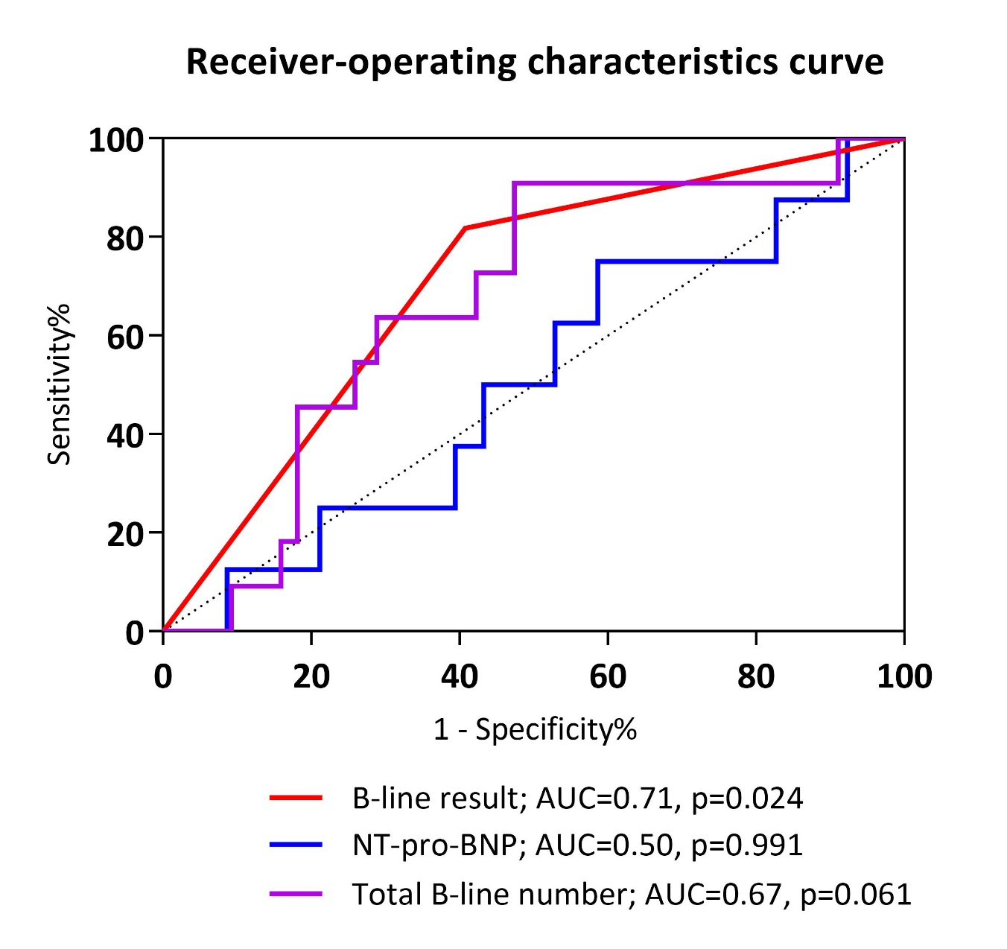

Table S1. Baseline Characteristics of the Study Population
 | Positive B-line  N=64 | Negative B-line  N=82 | p Value
Demographic data
Age, years | 72.8 ± 10.0 | 67.8 ± 13.0 | 0.012
Male sex | 40 (62.5) | 56 (68.3) | 0.464
Height, cm | 163.0 ± 0.1 | 163.6 ± 0.1 | 0.714
Body weight, kgª | 62.8 ± 13.2 | 67.6 ± 13.2 | 0.037
Hypertension | 39 (60.9) | 54 (65.9) | 0.540
Diabetes | 27 (42.2) | 34 (41.5) | 0.930
Chronic kidney disease | 25 (39.1) | 29 (35.4) | 0.646
Renal replacement therapy | 5 (7.8) | 10 (12.2) | 0.387
Chronic lung disease | 9 (14.1) | 9 (11.0) | 0.573
Peripheral arterial disease | 5 (7.8) | 13 (15.9) | 0.143
Stroke | 8 (12.5) | 7 (8.5) | 0.434
Prior cardiac surgery | 24 (37.5) | 23 (28.0) | 0.225
Coronary artery disease | 25 (39.1) | 44 (53.7) | 0.080
PCI | 13 (20.3) | 31 (37.8) | 0.022
CABG | 7 (11.3) | 13 (15.9) | 0.433
Causes of HF
Ischemic | 31 (48.4) | 41 (50.0) | 0.851
ICMP | 11 (17.2) | 15 (18.3) | 0.862
MI | 20 (31.3) | 26 (31.7) | 0.953
Valvular | 17 (26.6) | 15 (18.3) | 0.231
Dilated cardiomyopathy | 4 (6.3) | 5 (6.1) | 1.000
Hypertrophic cardiomyopathy | 3 (4.7) | 2 (2.4) | 0.654
Arrhythmia | 3 (4.7) | 7 (8.5) | 0.513
Others | 6 (9.4) | 12 (14.6) | 0.338
Echocardiographic measures
Interval, days^{b} | 6 (2–8) | 4 (1–9) | 0.744
LVEF, % | 40 (28–56) | 45 (32–57) | 0.368
LVEDD, mm | 52 (46–58) | 50 (44–56) | 0.341
Peak TR velocity, m/s | 2.5 (2.3–3.1) | 2.5 (2.2–2.9) | 0.502
Characteristics at extubation
Duration on ventilator, days | 8 (4–13) | 5 (3–10) | 0.027
PaO₂/FiO₂ ratio after extubation, mmHg | 265 (210–349) | 265 (227–327) | 0.814
Body weight, kg | 59.4 ± 12.6 | 64.0 ± 12.2 | 0.028
Change in body weight^{c} | -2.8 (-1.0–-5.4) | -3.1 (-1.2–-5.1) | 0.451
Laboratory data
Hemoglobin, mg/dL | 9.0 ± 1.4 | 9.7 ± 1.8 | 0.008
eGFR, ml/min/1.73 m² | 55.0 ± 29.8 | 58.2 ± 35.4 | 0.547
Sodium mmol/L | 138.6 ± 4.9 | 138.6 ± 4.0 | 0.938
NT-pro-BNP, ng/L^{d} | 12539 (4795–25109) | 4916 (2241–10549) | 0.001
Troponin I, pg/mL^{d} | 683.5 (90.3–3799.0) | 3730 (113.8–2235.0) | 0.542
Rhythm |  |  | 0.176
Sinus rhythm | 35 (54.7) | 57 (69.5)
AF or AFL | 22 (34.4) | 18 (22.0)
Pacing | 6 (9.4) | 4 (4.9)
Others | 1 (1.6) | 3 (3.7)
Values are presented as patient number (percentage) or median (IQR) or mean ± standard deviation.
ªBody weight on the day of initiation of mechanical ventilation.
^{b}Interval between echocardiography and extubation.
^{c}Change in body weight was calculated as body weight at extubation – body weight at intubation.
^{d}Levels of NT-pro-BNP and troponin I were available in 112 and 132 patients, respectively.
AF = atrial fibrillation; AFL = atrial flutter; CABG = coronary artery bypass graft; eGFR = estimated glomerular filtration rate; FiO₂ = fraction of inspired oxygen; HF = heart failure; ICMP = ischemic cardiomyopathy; LVEDD = left ventricular end-diastolic dimension; LVEF = left ventricular ejection fraction; MI = myocardial infarction; NT-pro-BNP = N-terminal pro-B-type natriuretic peptide; PaO₂ = partial pressure of oxygen in arterial blood; PCI = percutaneous coronary intervention; TR = tricuspid regurgitation.

Table S2. Number of B-line and proportion of positive results at each region of the thorax
Region | Number of B-line,  Median (IQR) | Proportion of positive regionª,  n (%)
Total | 10 (6–16) | 292/1168 (25.0)
Right upper medial | 1 (0–2) | 26 (17.8)
Right lower medial | 1 (0–2) | 32 (21.9)
Right upper lateral | 1 (1–2) | 33 (22.6)
Right lower lateral | 2 (1–3) | 64 (43.8)
Left upper medial | 0 (0–2) | 19 (13.1)
Left lower medial | 0 (0–1) | 14 (9.6)
Left upper lateral | 1 (0–3) | 37 (25.3)
Left lower lateral | 2 (1–3) | 67 (45.9)
ªPositive region was defined as the region that had 3 or more B-lines.
IQR = interquartile range.
Table S3. Number of B-line and proportion of positive results in each region according to the B-line result
Region | Positive B-line group  N=64 | Negative B-line group  N=82
Number of B-line, median (IQR)
Right upper medial | 2 (0–3) | 0 (0–1)
Right lower medial | 2 (1–4) | 1 (0–2)
Right upper lateral | 2 (1–3) | 1 (0–1)
Right lower lateral | 3 (3–4) | 1 (1–2)
Left upper medial | 2 (0–3) | 0 (0–1)
Left lower medial | 1 (0–2) | 0 (0–1)
Left upper lateral | 3 (1–4) | 1 (0–1)
Left lower lateral | 3 (3–4) | 2 (1–2)
Proportion of positive region, n (%)
Right upper medial | 21 (32.8) | 5 (6.1)
Right lower medial | 28 (43.8) | 4 (4.9)
Right upper lateral | 31 (48.4) | 2 (2.4)
Right lower lateral | 53 (82.8) | 11 (13.4)
Left upper medial | 19 (29.7) | 0 (0.0)
Left lower medial | 13 (20.3) | 1 (1.2)
Left upper lateral | 33 (51.6) | 4 (4.9)
Left lower lateral | 54 (84.4) | 13 (15.9)
IQR = interquartile range.

Table S4. Rates of re-intubation according to the tertile of B-line number
 | 1st tertile  N=50 | 2nd tertile  N=48 | 3rd tertile  N=48 | p Value
Number of B-line | 0–7 | 8–13 | ≥14
Re-intubation within 72 hours | 1 (2.0) | 3 (6.3) | 7 (14.6) | 0.055
Tertile 1st vs. 2nd |  |  |  | 0.357
Tertile 2nd vs. 3rd |  |  |  | 0.181
Tertile 1st vs. 3rd |  |  |  | 0.029
Total re-intubation during admission | 2 (4.0) | 6 (12.5) | 16 (33.3) | <0.001
Tertile 1st vs. 2nd |  |  |  | 0.155
Tertile 2nd vs. 3rd |  |  |  | 0.015
Tertile 1st vs. 3rd |  |  |  | <0.001

Table S5. Predictive value of B-line result for re-intubation using regression analyses
 | Univariable |  | Multivariable
 | HR (95% CI) | p Value | HR (95% CI) | p Value
Re-intubation within 72 hours
Positive B-line | 6.55 (1.36–31.47) | 0.019 | 6.00 (1.15–31.42) | 0.034
Total number of B-line | 1.03 (0.97–1.09) | 0.343 | 1.07 (0.96–1.20) | 0.243
Age | 1.05 (0.98–1.12) | 0.149
Hypertension | 0.66 (0.19–2.28) | 0.514
Diabetes | 0.78 (0.22–2.80) | 0.705
Chronic kidney disease | 0.62 (0.16–2.44) | 0.491
Body weight changeª | 1.06 (0.89–1.26) | 0.503
LVEF | 1.01 (0.97–1.05) | 0.663
NT-pro-BNP† | 1.01 (0.59–1.71) | 0.981
Total re-intubation during admission
Positive B-line | 3.88 (1.50–10.05) | 0.005 | 5.54 (1.60–19.18) | 0.007
Total number of B-line | 1.06 (1.02–1.11) | 0.004 | 1.11 (1.02–1.21) | 0.018
Age | 1.02 (0.98–1.06) | 0.310
Hypertension | 0.94 (0.38–2.33) | 0.894
Diabetes | 0.99 (0.41–2.42) | 0.990
Chronic kidney disease | 1.27 (0.52–3.09) | 0.604
Body weight changeª | 1.02 (0.91–1.14) | 0.777
LVEF | 1.01 (0.99–1.04) | 0.354
NT-pro-BNP^{b} | 1.26 (0.82–1.94) | 0.295
Variables of positive B-line and the total number of B-line were analyzed independently by adjusting the following variables: age, hypertension, diabetes, chronic kidney disease, body weight change, LVEF, and NT-pro-BNP.
ªBody weight change was calculated as the change between the value at the time of intubation and extubation.
^{b}NT-pro-BNP level was analyzed with log-transformed value.
CI = confidential interval; HR = hazard ratio; LVEF = left ventricular ejection fraction; NT-pro-BNP = N-terminal pro-B-type natriuretic peptide

