Supplementary Materials for
Soluble TGF-β decoy receptor TGFBR3 exacerbates AD lesions by modifying microglial function

Lijun Zhou, ¹ Nan Wang,^{1,3} Wenzheng Feng,¹ Xin Liu,^{1,3} Zihua Xu,^{1,3} Qiong Wu,³ Jiangxia Chen,¹ Xinming Jiao,¹ Xinyue Ning,¹ Zhentong Qi,¹ Xiaowen Jiang,^{2,*} Qingchun Zhao^{1,3, *}

Author affiliations:
1 Department of Clinical Pharmacy, Shenyang Pharmaceutical University, Shenyang 110016, People’s Republic of China
2 School of Traditional Chinese Materia Medica, Shenyang Pharmaceutical University, Shenyang 110016, People’s Republic of China
3 Department of Clinical Pharmacy, General Hospital of Northern Theater Command, Shenyang110840, People's Republic of China

*Correspondence authors：
Q.C. Zhao, Department of Clinical Pharmacy, Shenyang Pharmaceutical University, Shenyang 110840, People’s Republic of China.
Tel.: 86-24-28856262, Email address: zhaoqingchun1967@163.com
X.W. Jiang, School of Traditional Chinese Materia Medica, Shenyang Pharmaceutical University, Shenyang 110016, People’s Republic of China.
Tel.: 86-24-43520732, Email address: jxwphu@syphu.edu.cn

This PDF file includes: Supplementary Fig. 1 to 8
Whole un-cropped images of the original western blots
Supplementary Fig. 1 Correlation of crucial pathology with CDR and PCA analysis.
(A-B) Correlation analysis of Aβ and Tau pathology with CDR using Spearman's correlation coefficient. (C) PCA analysis of different CDR scores
Supplementary Fig. 2 The differential expression of candidate genes by cross-platform standardized data in Alzdata.
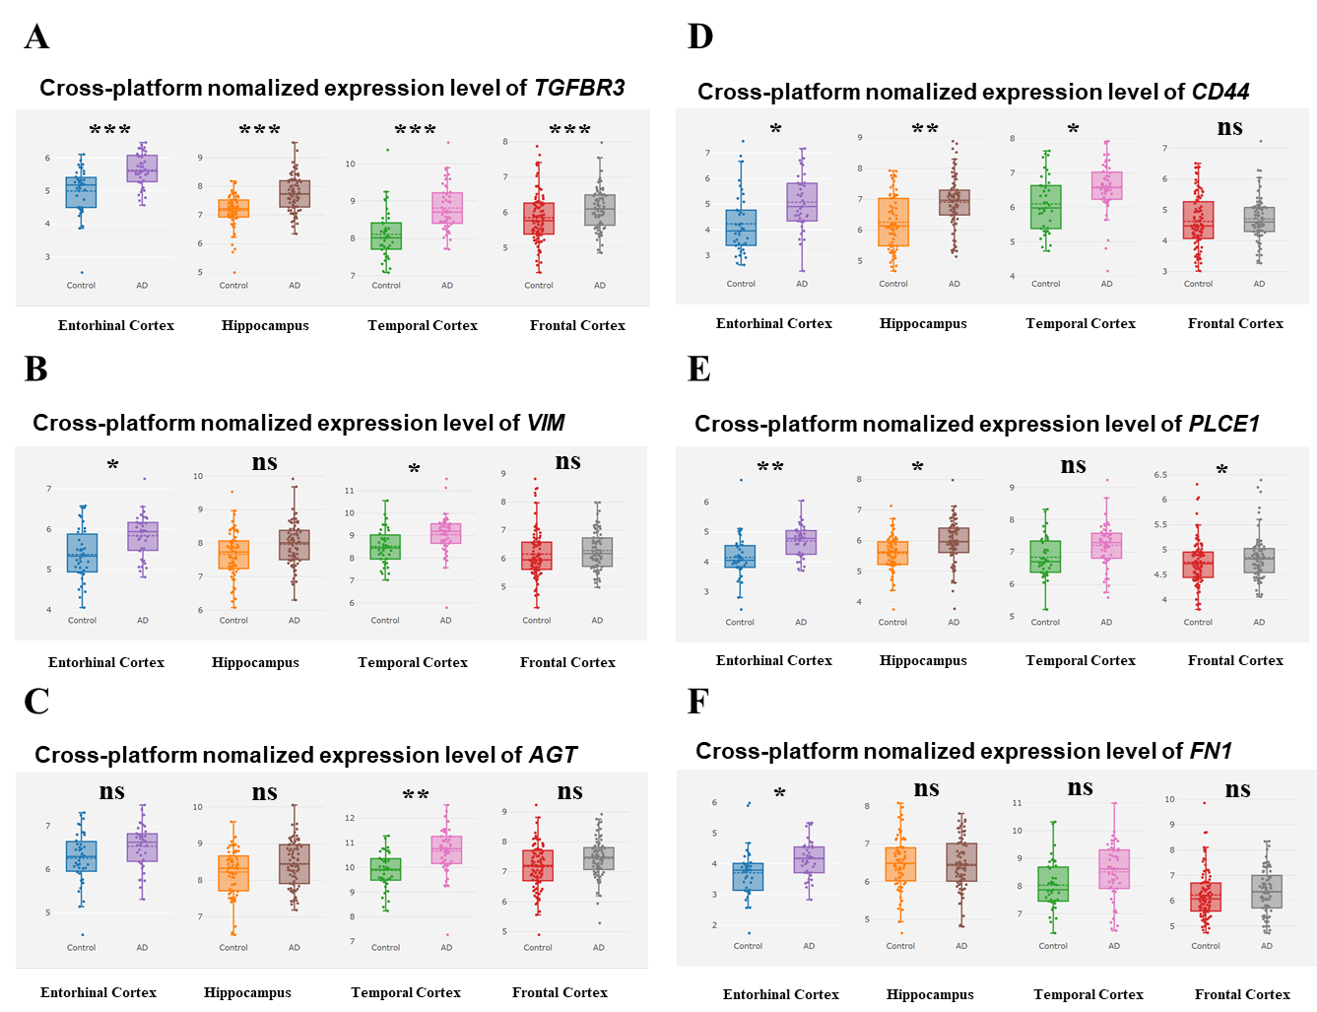
(A) TGFBR3 (B) VIM (C) AGT (D) CD44 (E) PLCE1 (F) FN1. ^{ns} P>0.05, *P < 0.05, **P < 0.01, ***P < 0.001.
Supplementary Fig. 3 The expression level of TGFBR3 in the single-cell type of brain.
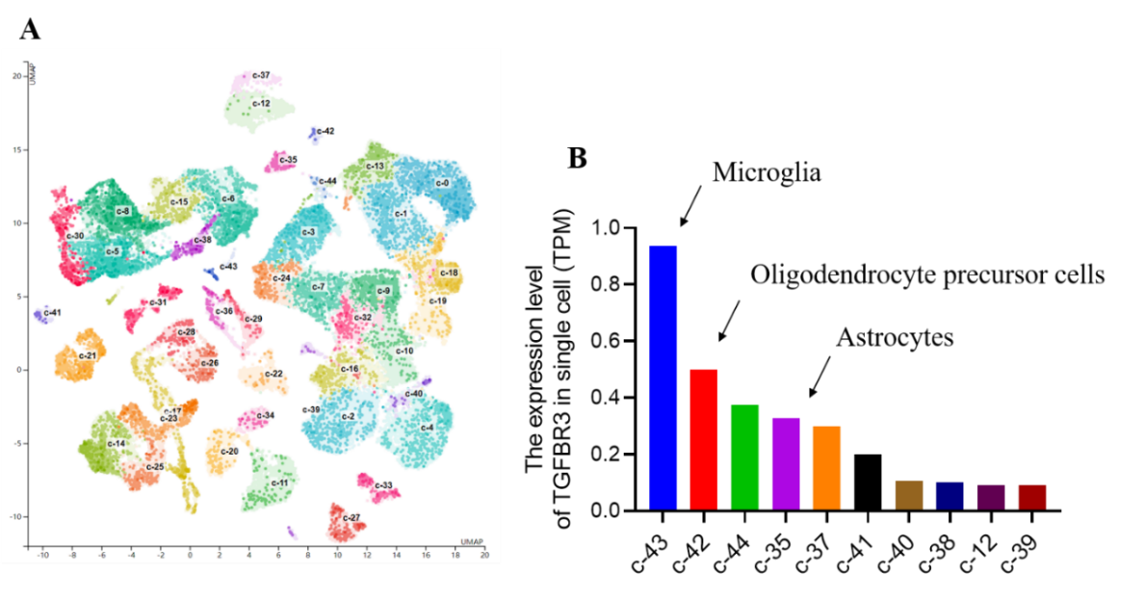
(A) Different color classifications represent different cell groups, including microglia, oligodendrocyte precursor cells, inhibitory neurons, and astrocytes. (B) The expression level of TGFBR3 in different cell types, only the top 10 cell types were shown. the data was from The Human Protein Atlas (https://www.proteinatlas.org).
Supplementary Fig. 4 Pathology in which TGFBR3 participates in aging mice and AD patients.
(A-B) Immunoblotting analysis of P-Smad2/3 and Smad2/3 in aging mice brain extracts. The ratio of P-Smad2/3 and Smad2/3 relative intensity to GAPDH was quantified (n = 4). Data were presented as mean ± SEM. **P < 0.01, ***P < 0.001 one-way ANOVA test. (C) Representative immunofluorescence image of plaque-associated TGFBR3 in the AD patient cortex. Scale bar, 10 μM.
Supplementary Fig. 5 sTGFBR3 is involved in the phagocytosis and chemotaxis of microglia.

(A-B) Representative immunofluorescence image of plaque-associated microglia in the cortex. Scale bar, 20 μM. Circle indicates the edge of Aβ plaque. Quantification of the distance between microglia and the center of Aβ plaques in APP/PS1 (n = 39 to 50 slices from three mice per group) and APP/PS1 knockdown sTGFBR3 mice (n = 39 microglia from 3 mice). Data were presented as mean ± SEM. ***P < 0.001, student’s t-test. (C-D) Immunoblotting analysis of TREM2 and Iba1 in APP/PS1 mouse brain extracts. The ratio of TREM2 and Iba1 relative intensity to GAPDH was quantified (n = 3). Data were presented as mean ± SEM. *P < 0.05, one-way ANOVA test. (F-H) Immunoblotting analysis of CCR2 and MCP1 in APP/PS1 mouse brain extracts. The ratio of CCR2 and MCP1 relative intensity to GAPDH was quantified (n = 4). Data were presented as mean ± SEM. *P < 0.05, one-way ANOVA test.
Supplementary Fig. 6 sTGFBR3 knockdown promotes the polarization of M1 pro-inflammatory microglia into M2 anti-inflammatory microglia.
(A-D) ELISA analysis of IL-6 and TNFα in cortex and hippocampus of APP/PS1 mouse (n = 6). Data were presented as mean ± SEM. *P < 0.05, **P < 0.01, one-way ANOVA test. (E-G) Immunoblotting analysis of IL-10 and IL-4 in APP/PS1 mouse brain extracts. The ratio of IL-10 and IL-4 relative intensity to GAPDH was quantified (n = 3). Data were presented as mean ± SEM. *P < 0.05, **P < 0.01, one-way ANOVA test. (H-J) Immunoblotting analysis of NLRP3 and P65 in APP/PS1 mouse brain extracts. The ratio of NLRP3 and P65 relative intensity to GAPDH was quantified (n = 5~8). Data were presented as mean ± SEM. ***p < 0.001, one-way ANOVA test.
Supplementary Fig. 7 sTGFBR3 knockdown can restore synaptic plasticity in STZ-induced mice.
(A-B) Neuronal loss was analyzed in 6-month-old WT, STZ-induced and sTGFBR3 knockdown: STZ-induced mice. Neuronal density in cortical layer 5 of cortex and hippocampus was analyzed by Nissl staining (n = 6 slices from three mice per group). Scale bar, 200 μm; magnified inset, 50 μm. Data were presented as mean ± SEM. *P < 0.05, ***P < 0.001, one-way ANOVA test. (C-F) Immunoblotting analysis of synaptic associated protein including PSD95, SYT and SYP in STZ-induced mouse brain extracts. The ratio of protein relative intensity to GAPDH was quantified (n = 4~6). Data were presented as mean ± SEM. *P < 0.05, ***P < 0.001, one-way ANOVA test.
Supplementary Fig. 8 Correlation analysis of classical TGF-β family ligand receptors with CDR using Spearman's correlation coefficie

(A) TGFBR1 (B) TGFBR 2(C) TGFBR3 (D) TGF-β1 (E) TGF-β2, (F) TGF-β3.

Whole un-cropped images of the original western blots
Un-cropped images of the original western blots for Figure 3
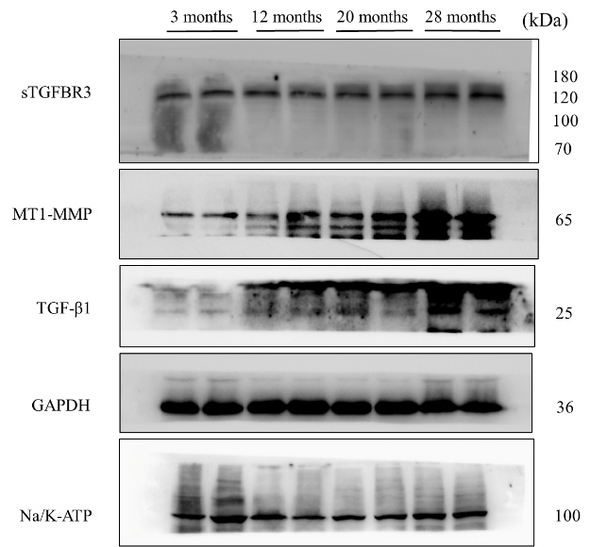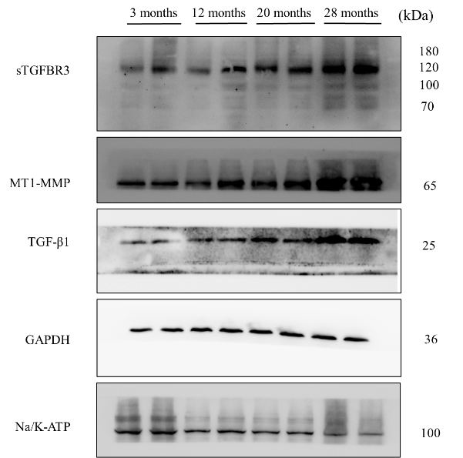

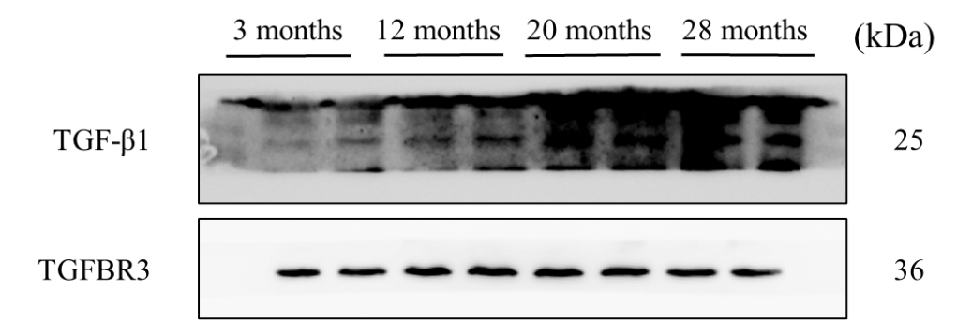

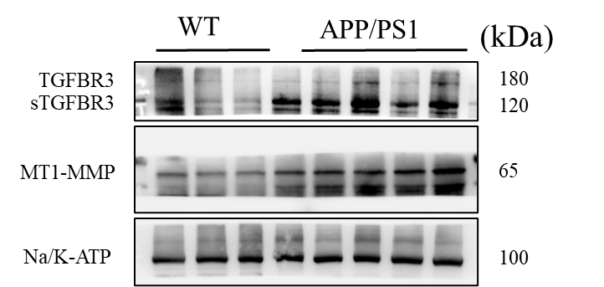

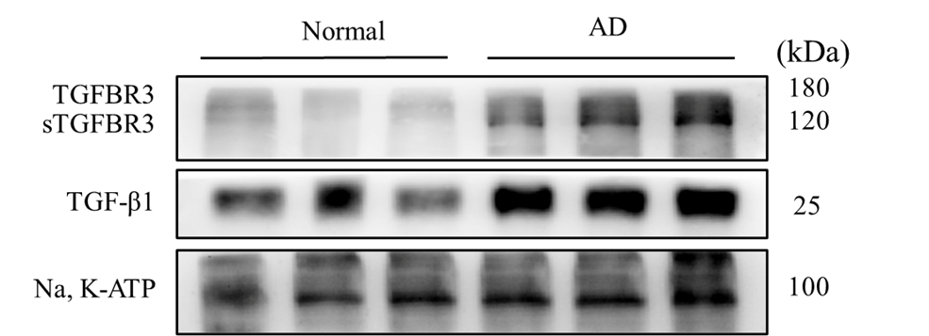

Un-cropped images of the original western blots for Figure 4
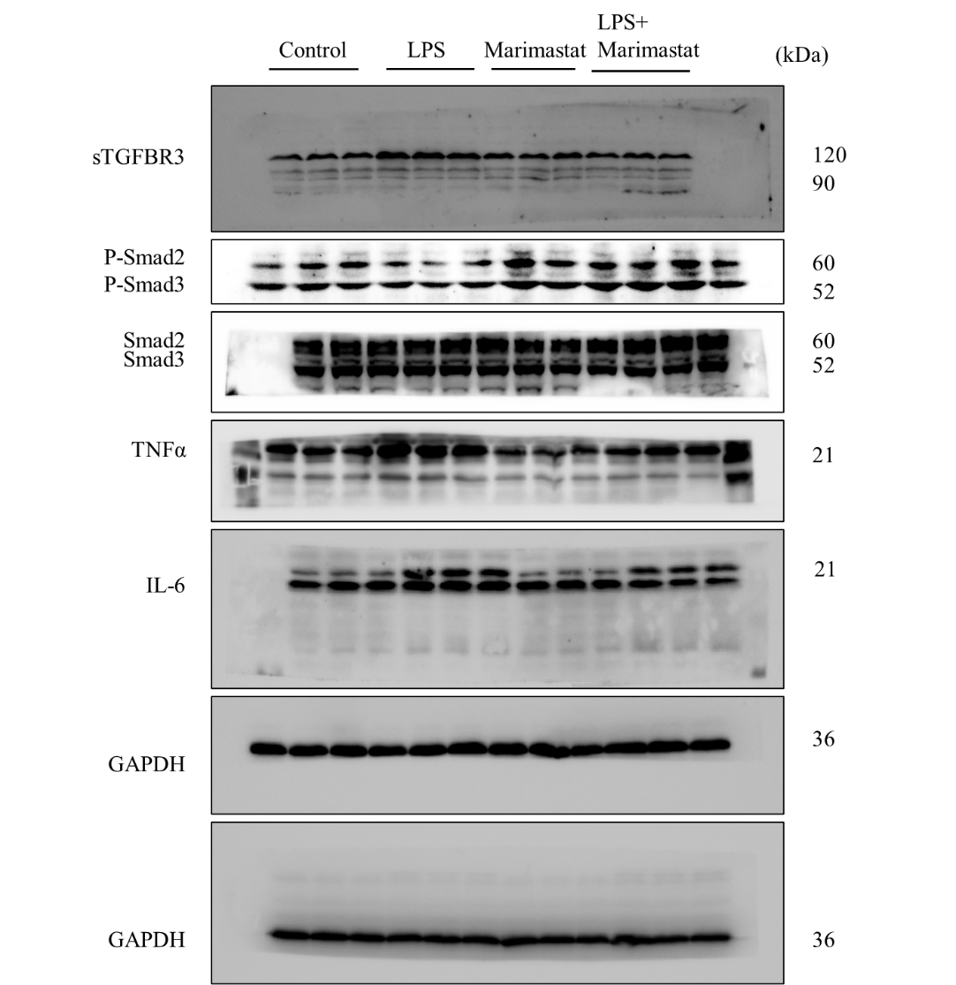

Un-cropped images of the original western blots for Figure 5
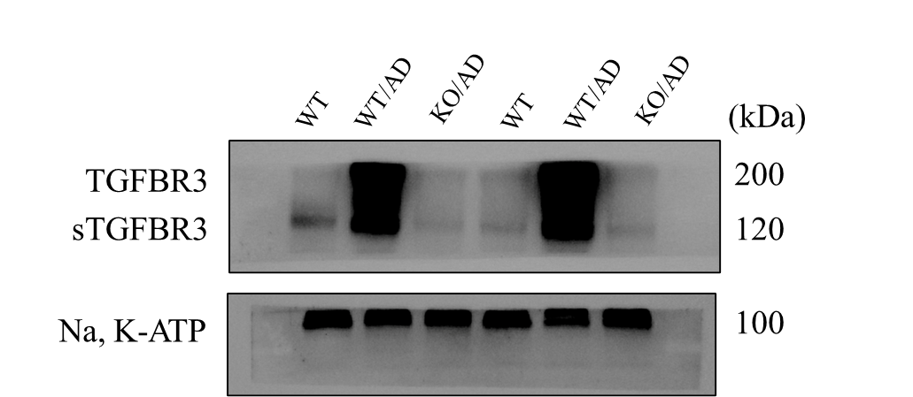

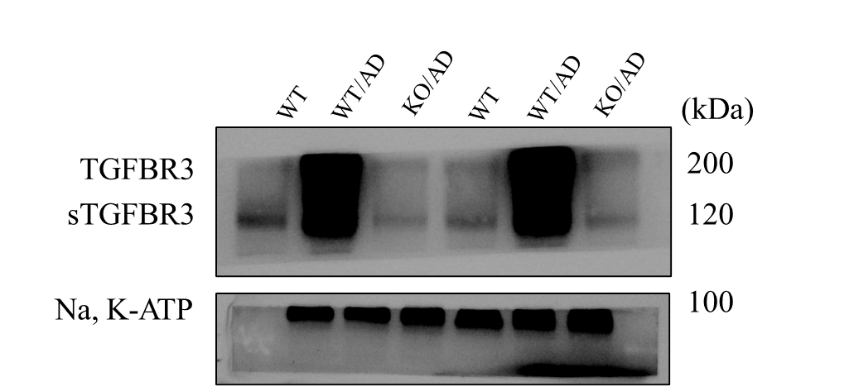

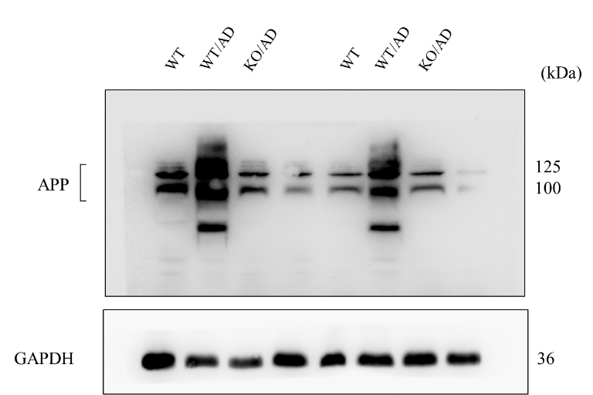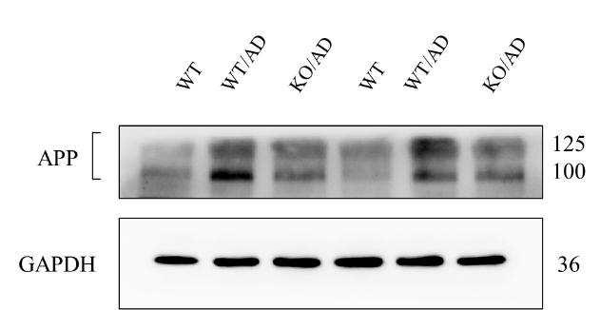

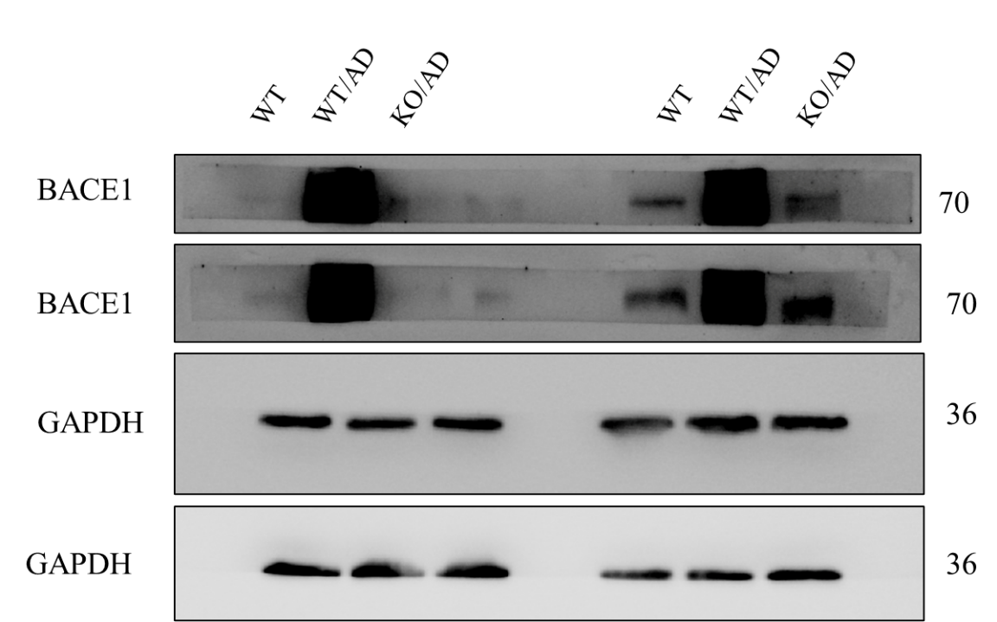

Un-cropped images of the original western blots for Figure 6
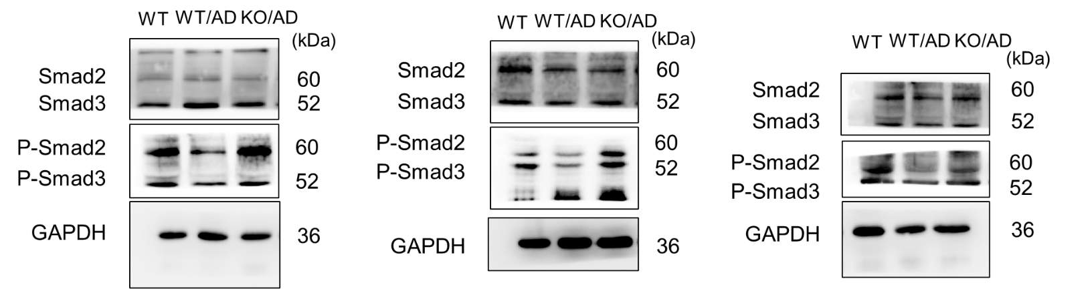

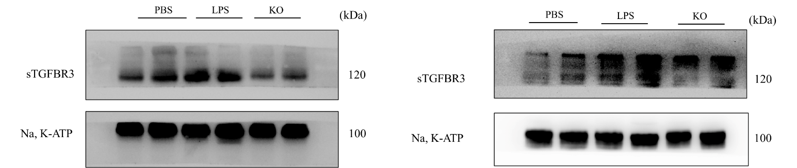

Un-cropped images of the original western blots for Figure 6
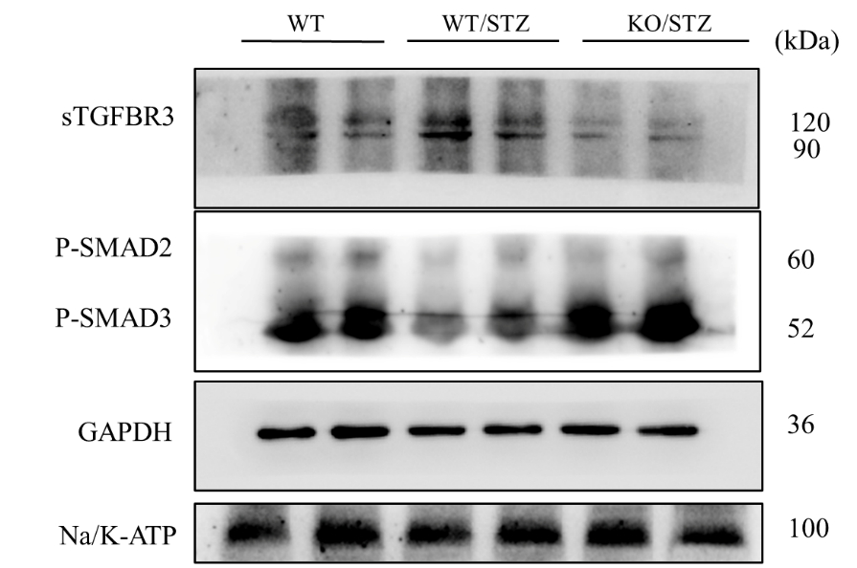

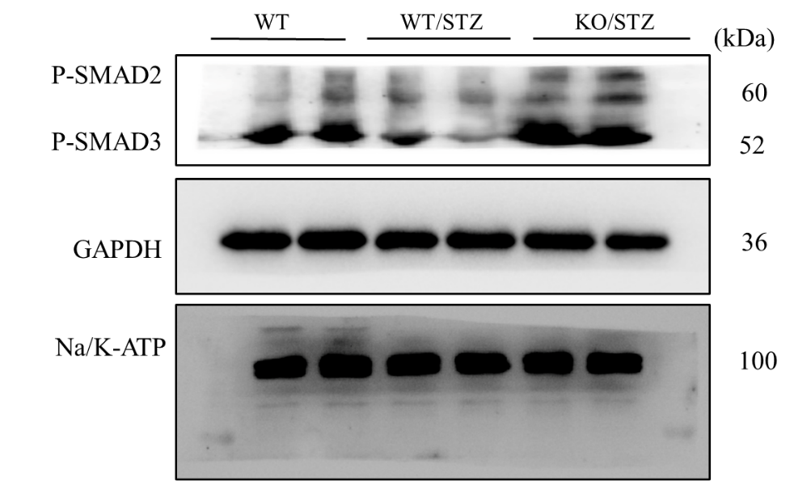

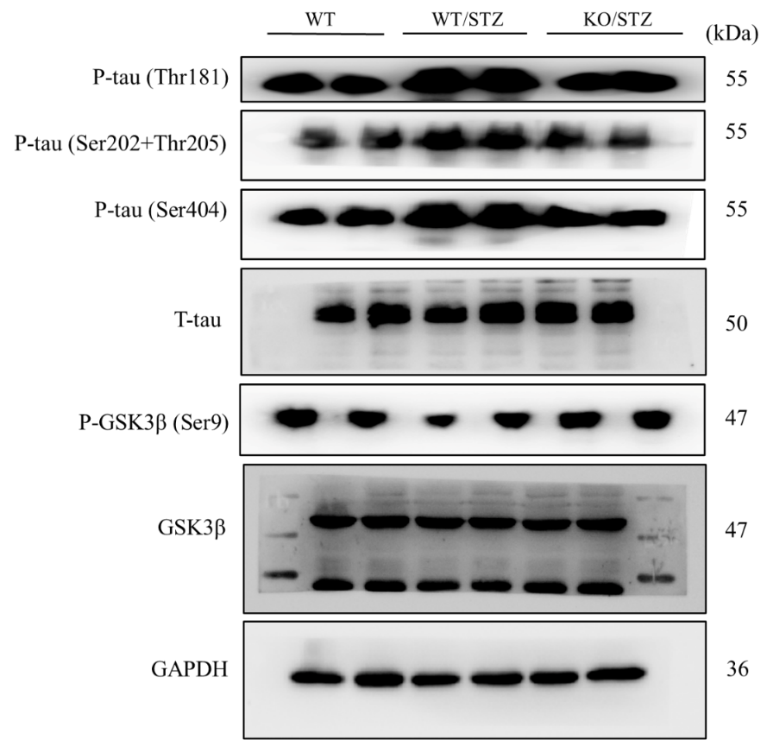

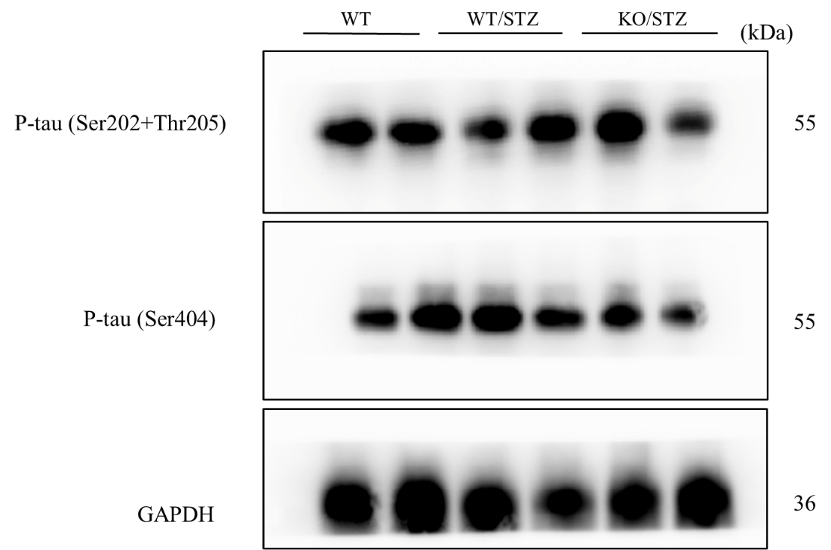

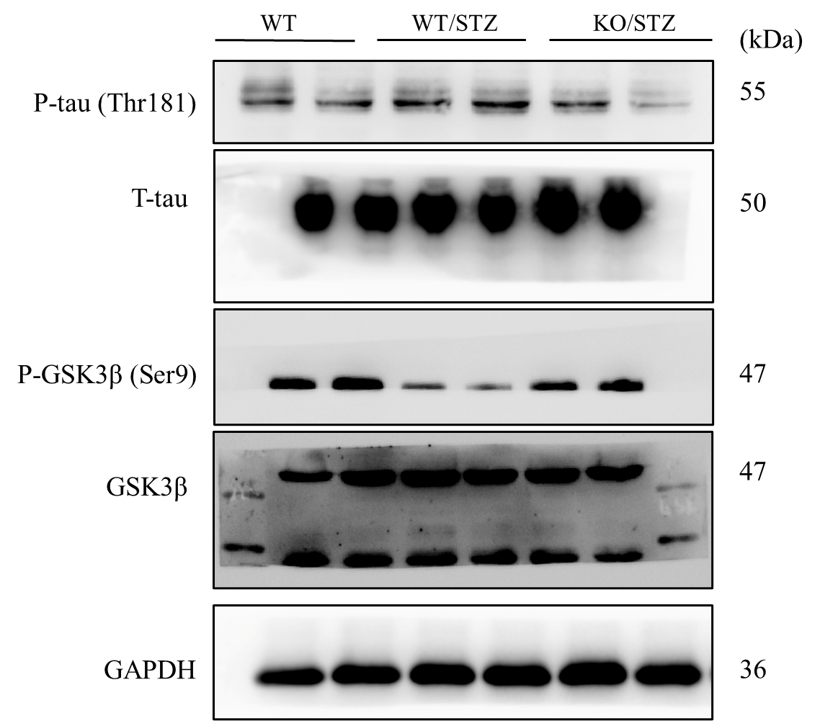

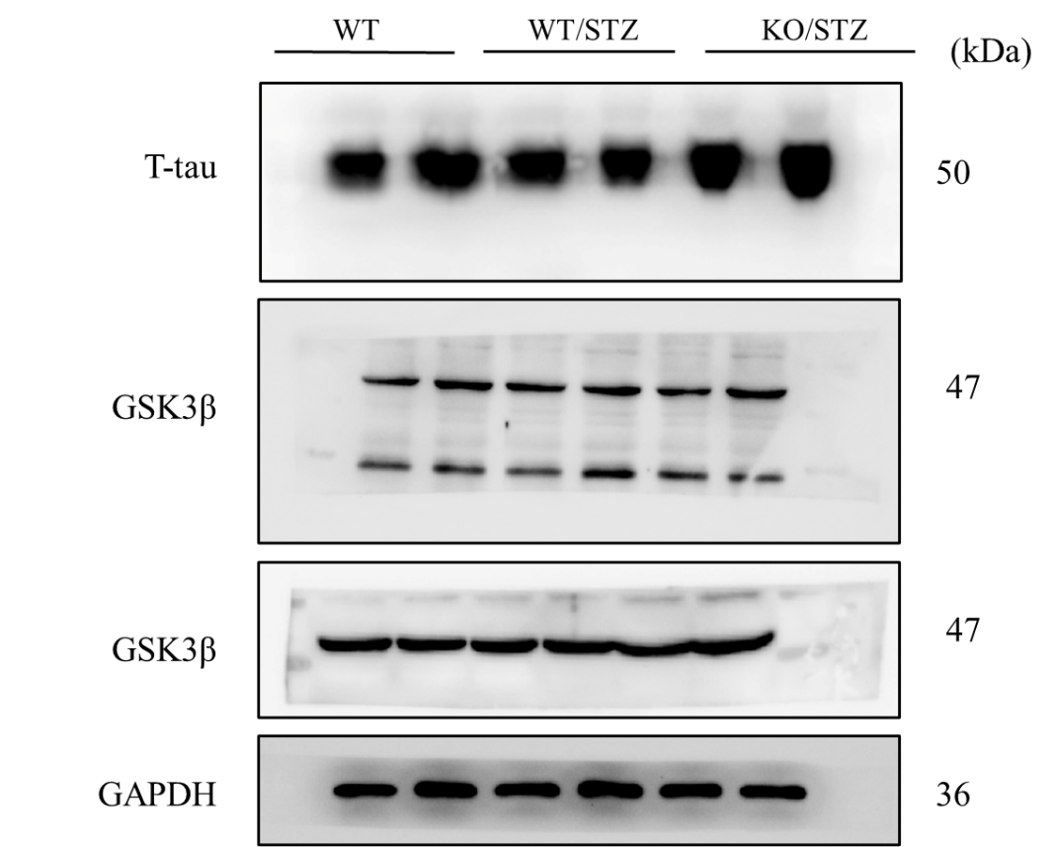
Un-cropped images of the original western blots for Supplementary Figure 4
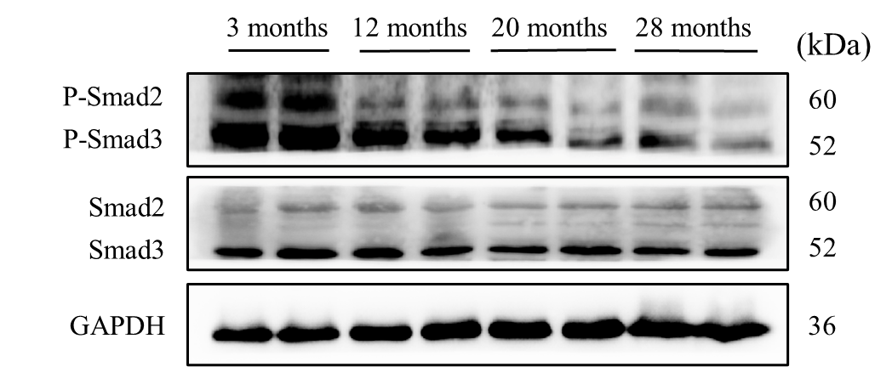

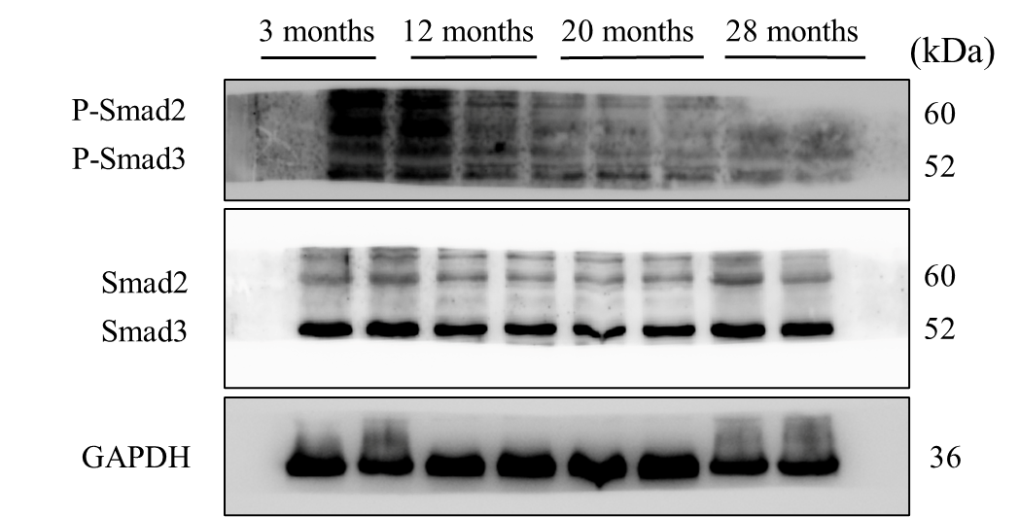

Un-cropped images of the original western blots for Supplementary Figure 5
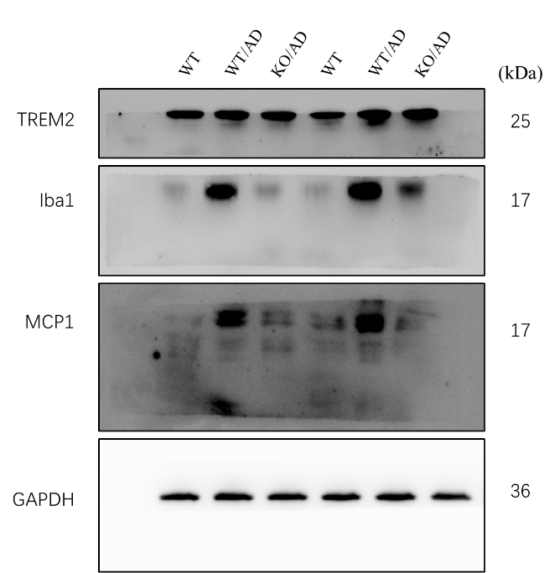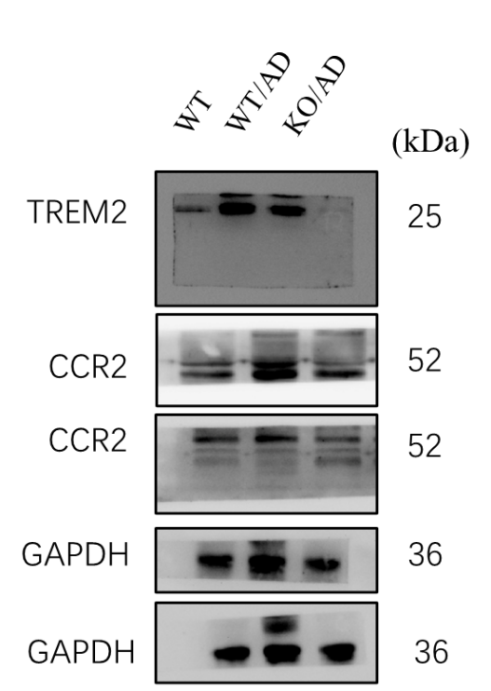

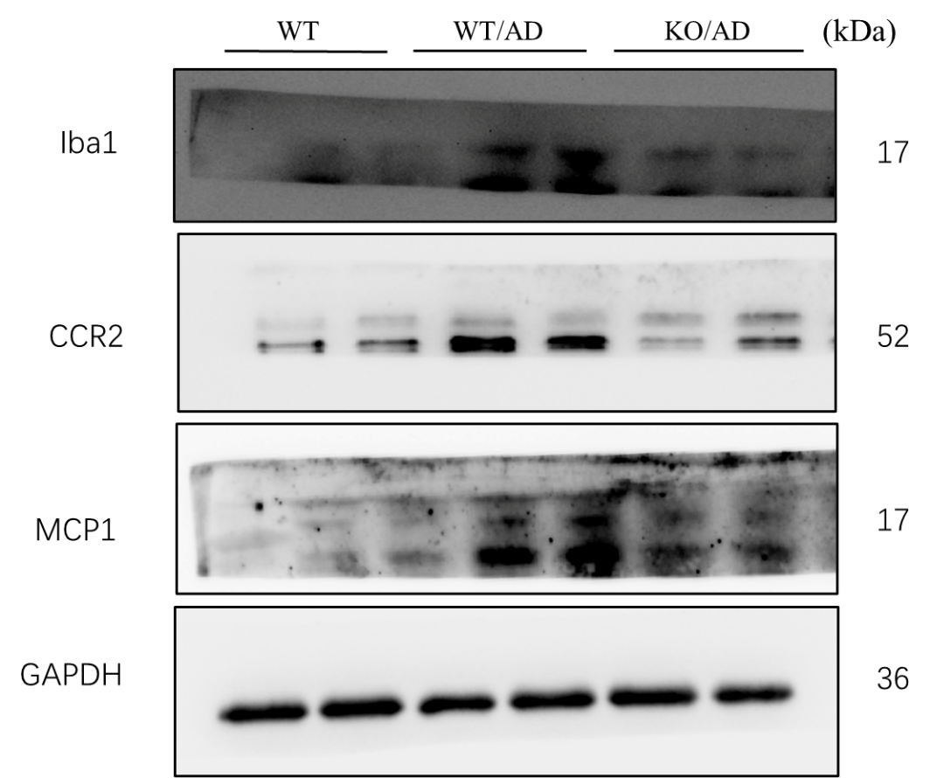

Un-cropped images of the original western blots for Supplementary Figure 6
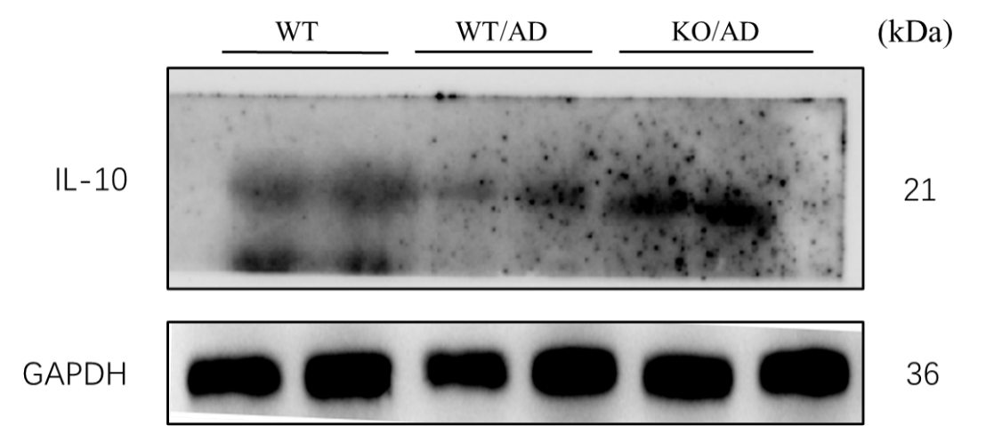

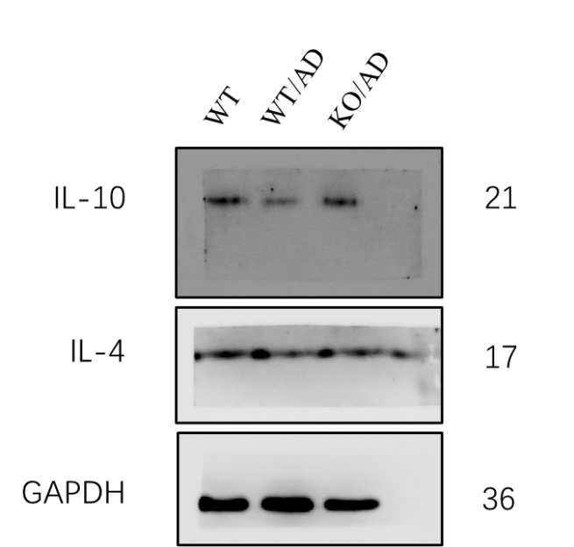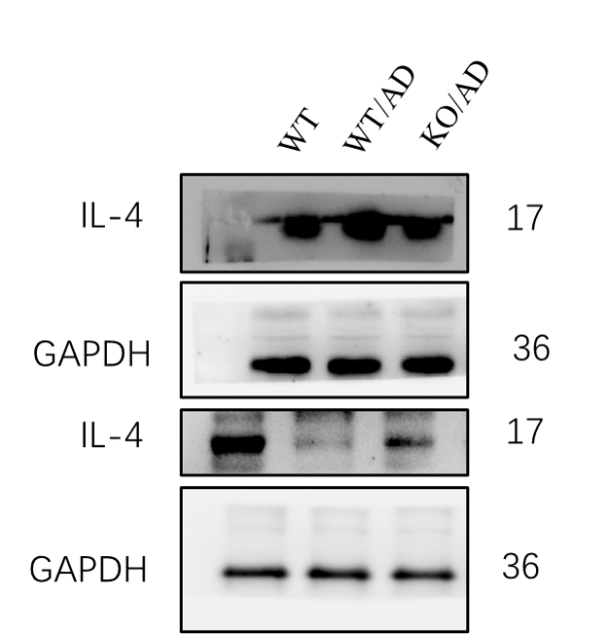

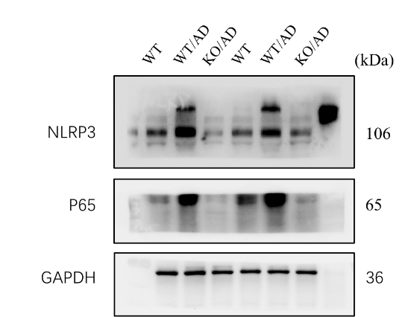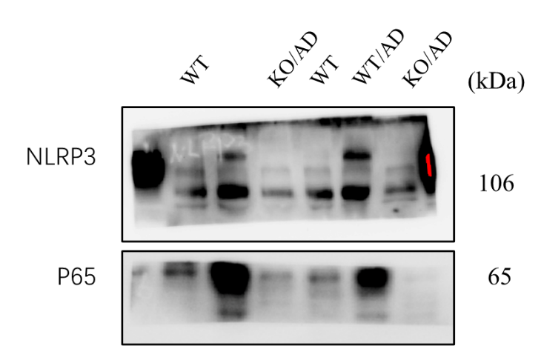

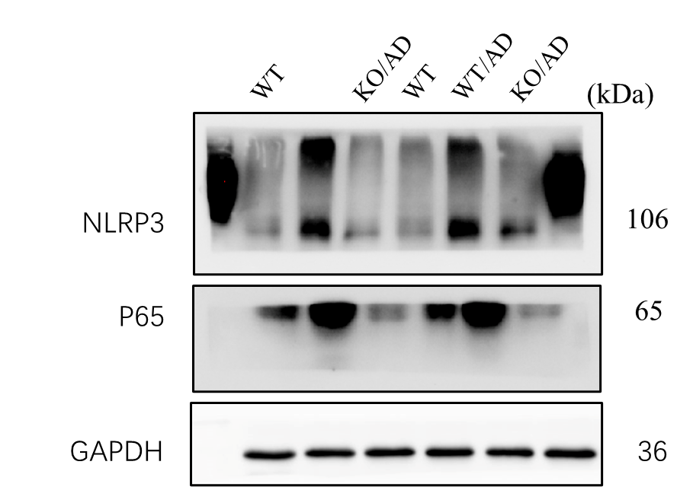

Un-cropped images of the original western blots for Supplementary Figure 7
