Synergy Effect of Nitrogen and Molybdenum on Activated Carbon Matrix for Selective Adsorptive Desulfurization: Insights into Surface Chemistry Modification
Musa O. Azeez, Abdulkadir Tanimu, Khalid Alhooshani, Saheed A. Ganiyu*.
Department of Chemistry, King Fahd University of Petroleum & Minerals, 31261, Dhahran, Saudi Arabia.

Supplementary Information
EDX analysis of adsorbents
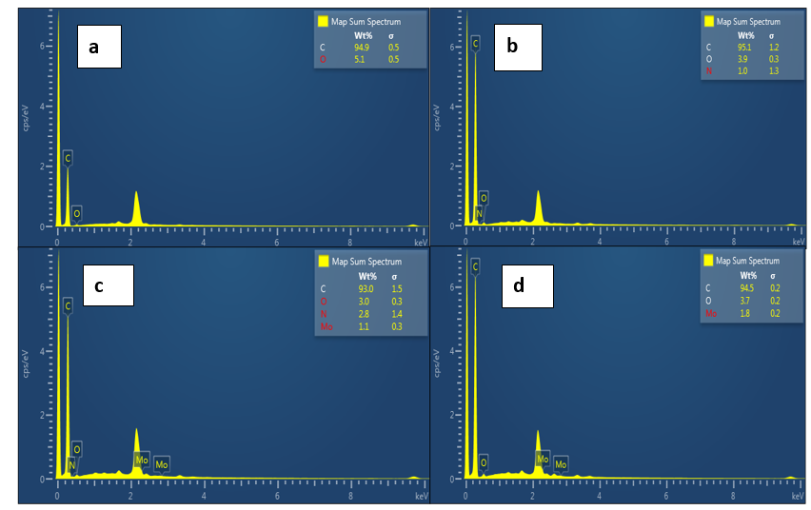
Fig. SI-1: EDS images of (a) AC (b) AC-N (c) AC-N-Mo and (d) AC-Mo

Table SI-1: Surface atomic percent of elements present in modified carbon.
States | C1s | C1s | N1s | N1s | N1s | O1s | O1s | O1s | O1s | Mod3 | Mod3 | Mod3
BE (eV) | 284.5 | 283 | 396 | 398 | 401.6 | 530.2 | 530.8 | 530.9 | 531 | 227.8 | 230.8 | 233
AC-N | 23.7 | 33.66 | 3.33 | - | - | - | 39.31 | - | - | - | - | -
AC-N-Mo | 16.89 | 32.83 | 1.97 | 0.93 | 0.28 | - | - | 46.8 | - | 0.18 | 0.09 | 0.03

NH₃-TPD analysis of sorbents
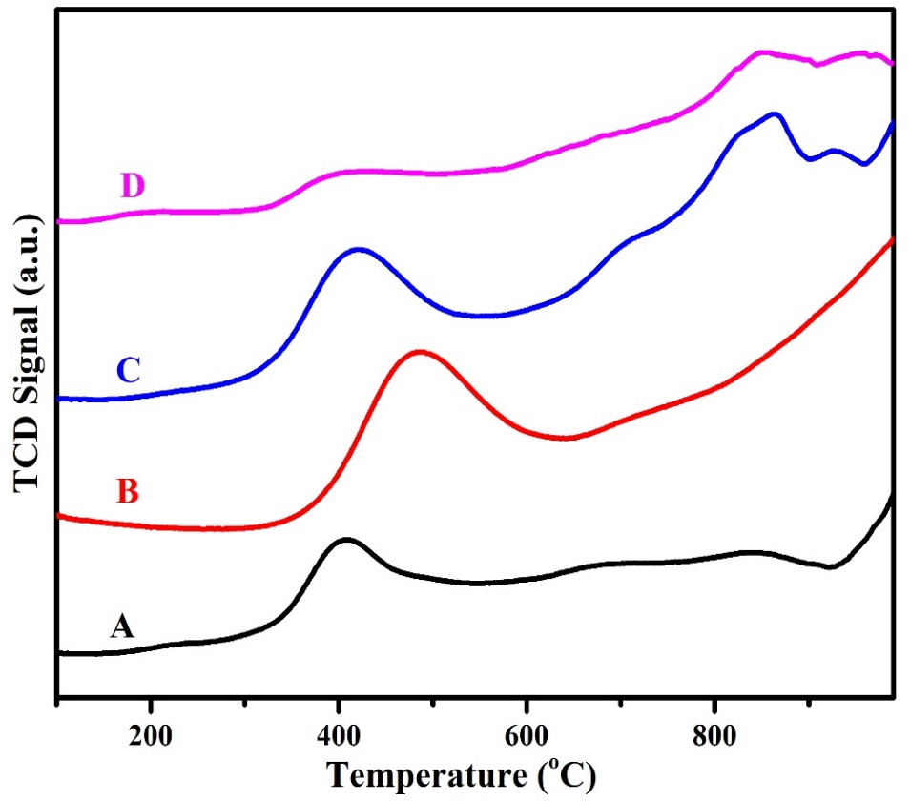
Fig. SI-2: Surface acidity by ammonia-temperature-programmed desorption (NH₃-TPD) of adsorbents (A) AC (B) AC-N (C) AC-N-Mo and (D) AC-Mo

Table SI-2: NH₃-TPD of the adsorbents
Adsorbents | Temp. (s) (ºC) | Quantity (mmol/g at STP)
AC | 410, 844 | 4.67, 0.31
AC-N | 485 | 8.03
AC-N-Mo | 421, 856, 935 | 6.23, 1.84
AC-Mo | 214, 400, 847 | 0.22, 2.59, 0.60

Adsorption kinetics
Pseudo-first order equation as given by Lagergren 1988 is as shown in equation 4 below.
$$\ln{(q_{e }- q_{t}})=lnq_{e }- k_{1}t……………4$$
Where $q_{e }$(mg/g) and $q_{t}$ (mg/g) denote quantity of sulfur adsorbed at equilibrium and time t (min) respectively, $k_{1}$ (min⁻¹) represents rate constant for pseudo- first order kinetics.

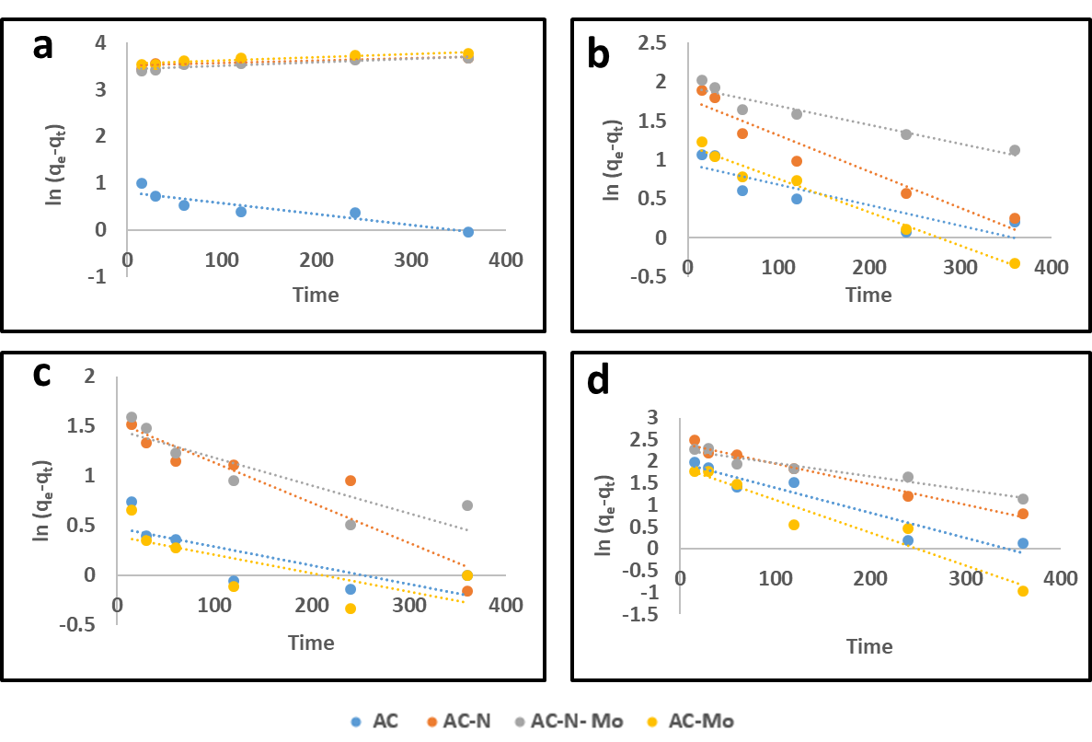
Fig. SI-3: Pseudo first order kinetics at the concentration of (a) 50 mg-S/L, (a) 100 mg-S/L, (a) 150 mg-S/L, (a) 200 mg-S/L

Pseudo-second order equation and the interpretation of the terms are expressed in equation 5 below:
$$\frac{t}{q_{t}}= \frac{1}{k_{2}q_{e}^{2}}+ \frac{t}{q_{e}}……………5$$
Where $q_{e}$ (mg/g) and $q_{t}$ (mg/g) denote quantity of sulfur adsorbed at equilibrium and time t (min) respectively, $k_{2}$ (g/(mg-S.min)) represents rate constant for pseudo second order kinetics model. The value of $\frac{1}{q_{e}}$ and $\frac{1}{k_{2}q_{e}^{2}}$ are both obtained from the slope and intercept of the plot of $\frac{t}{q_{t}}$ versus t.
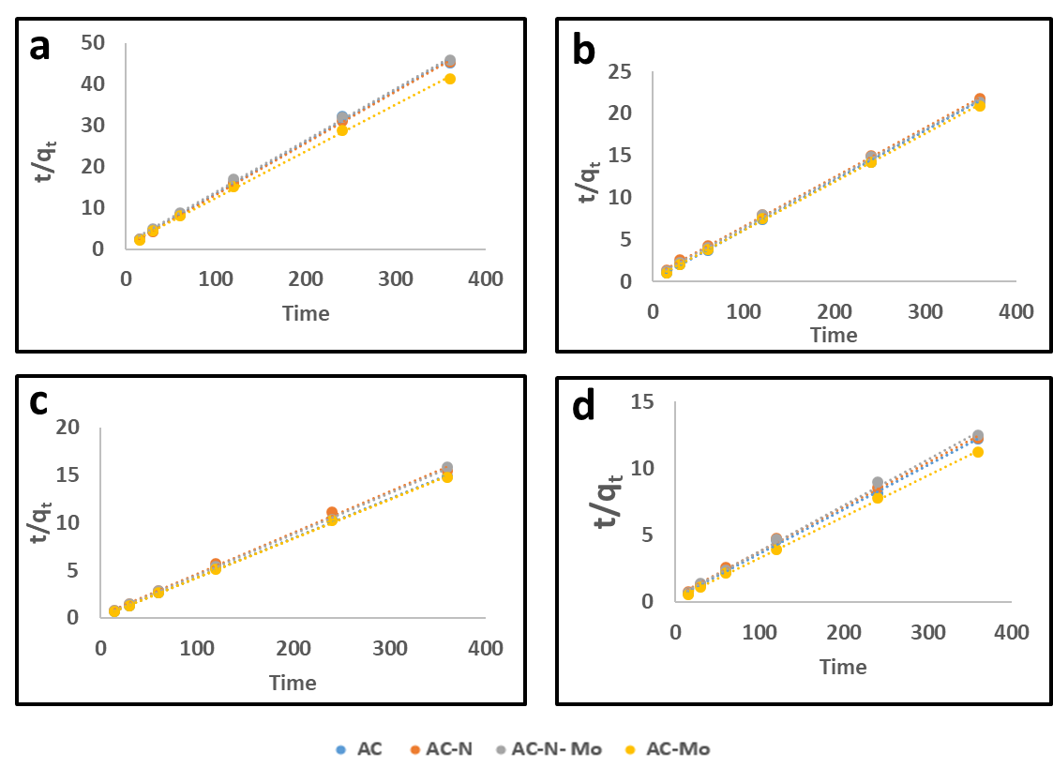
Fig. SI-4: Pseudo second order kinetics at the concentration of (a) 50 mg-S/L, (a) 100 mg-S/L, (a) 150 mg-S/L, (a) 200 mg-S/L
Intraparticle-diffusion equation as given by Weber and Morris and the interpretation of the terms are given in equation 6 below:
$$q_{t}=K_{i.d}t^{1/2}+C……….. 6$$
Where $q_{t}$ (mg/g),${ t}^{1/2}$ (min^{1/2}), $K_{i.d}$ (mg/g.min), and $C(mg/g)$ represent quantity of sulfur adsorbed at equilibrium, the square root of the contact time, the intraparticle diffusion rate constant and boundary layer thickness respectively.

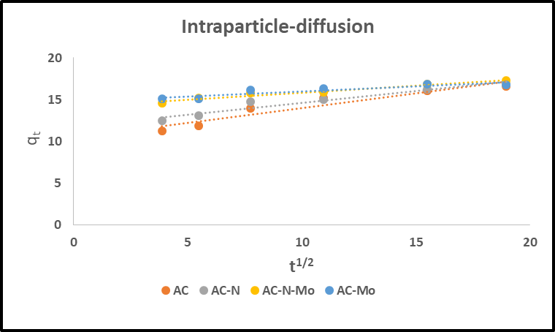
Fig. SI-5: Intraparticle diffusion at the concentration of 100 mg-S/L

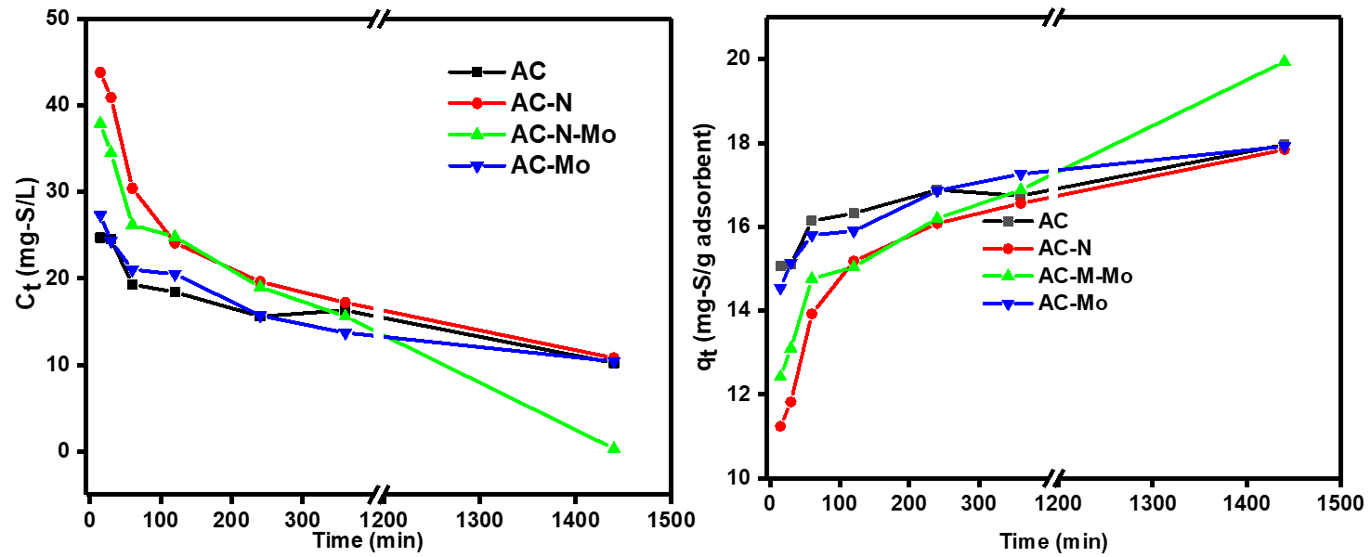
Fig. SI-6: Graphs of sulfur content as a function of concentration and quantity adsorbed at different time intervals
Table SI-3: Kinetic parameter of 100 mg-S/L on the investigated adsorbent materials
100 mg-S/L |  | Pseudo-first order |  |  |  | Pseudo-second order |  |  |  | Intraparticle diffusion
Adsorbent | q_{e}(exp)ª | q_{e}(cal)ª | k₁(10³)^{b} | R² |  | q_{e}(cal)ª | k₂(10³)^{c} | R² |  | $$K_{i.d}$$ | C | R²
AC | 17.96 | 2.57 | 2.7 | 0.7573 |  | 16.92 | 20.6 | 0.9999 |  | 0.1221 | 14.768 | 0.8270
AC-N | 17.84 | 5.89 | 4.6 | 0.9213 |  | 17.01 | 4.9 | 0.9996 |  | 0.3579 | 10.404 | 0.9061
AC-N-Mo | 19.94 | 6.92 | 2.4 | 0.9221 |  | 17.15 | 5.7 | 0.9989 |  | 0.2829 | 11.786 | 0.9340
AC-Mo | 17.98 | 3.27 | 4.3 | 0.9760 |  | 17.42 | 9.5 | 0.9994 |  | 0.1659 | 14.151 | 0.9581
a: (mgS/g), b: (min⁻¹), c: g/(mg-S.min)
Adsorption Isotherms
The Langmuir linear equation expressed in equation 7 governs the quantity of DBT adsorbed.
$$\frac{C_{e}}{q_{e}}=\frac{1}{k_{L}q_{m}}+\frac{C_{e}}{q_{m}}……….. 7$$
Where $C_{e}$ (mg/L), $q_{e}$ (mg/g), $q_{m}$ (mg/g) and $k_{L}$ represent equilibrium concentration, sorption capacity and maximum adsorption capacity, Langmuir constant related to adsorption energy respectively. The expression $\frac{1}{q_{m}}$ and $\frac{1}{k_{L}q_{m}}$ are obtained from the slope and intercept of the plot of $\frac{C_{e}}{q_{e} }$versus$C_{e}$.
The Freundlich isotherm is represented in equation 8 below;
$$\ln{q_{e}}{=}\ln{K_{F}+\frac{1}{n}\ln{C_{e}…………8}}$$
Where K_{F} (mg g⁻¹) and n represents Freundlich constant related to adsorption capacity, and intensity respectively.
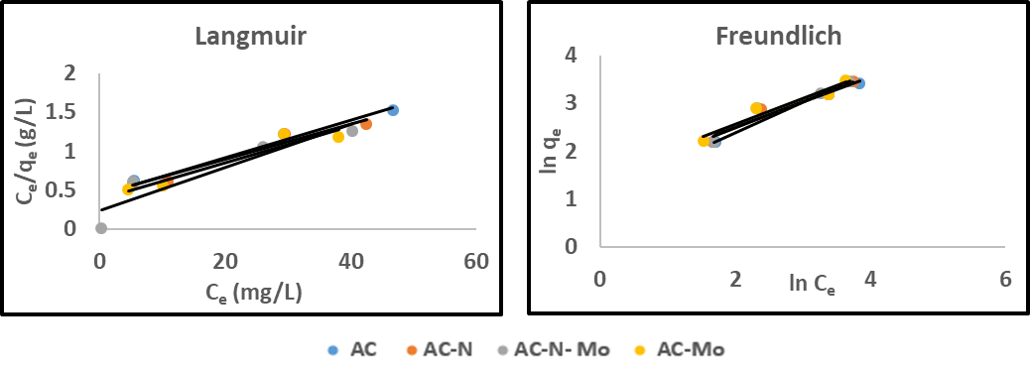
Fig. SI-7: Adsorption isotherm of adsorbents by Langmuir and Freundlich. (Initial conc. = 50-250 mg-S/L contact time = 24 h, adsorbent dosage = 100 mg, and 20 mL solution of isooctane containing DBT)

Table SI-4: Isotherm parameters for adsorption of 50-200 mg-S/L DBT on adsorbent materials
 | Langmuir |  |  |  |  | Freundlich
Adsorbent | ªq_{max} | ^{b}K_{L} | R² | R_{L} |  | ^{C}K_{F} | 1/n | n | R²
AC | 41.3 | 0.056 | 0.9662 | 0.26 |  | 4.24 | 0.5246 | 1.90 | 0.9110
AC-N | 43.9 | 0.052 | 0.9508 | 0.16 |  | 3.96 | 0.5546 | 1.80 | 0.9413
AC-N-Mo | 36.1 | 0.118 | 0.8409 | 0.05 |  | 3.05 | 0.6383 | 1.57 | 0.9997
AC-Mo | 42.9 | 0.060 | 0.9207 | 0.08 |  | 4.36 | 0.5397 | 1.85 | 0.9422
a: (mgS/g), b: (L/mg), c: (𝑚𝑔^{(1− 1 /𝑛 )} 𝑆 × 𝐿 ^{1⁄𝑛} × 𝑔 ⁻¹)

