Appendix 1. Barkman’s (1988) system of plant architecture recorded in 413 2x2m plots in Canton de Vaud (Switzerland)

Key for tracheophytes with table illustrating classes inside the 5 main types.
- Plants supported by other plants (Scandentia)
1.1. Climbing herbs
1.1.1 Winding herbs (Convolvulids)
1.1.2 Spread-climbers with slack, scrambling-ascending stems, spreading over and between other plants (Aparinids)
1.1.3 Tendril climbers (Bryonids)
1.2 Vines (Hederids)
- Self-supporting plants
2.1 Herbaceous plants with strongly reduced leaves (Equisetoids)
2.1.1. Erect, unbranched herbs solitary or growing in mats (Eleocharids)
2.1.2. Erect, strongly branched herbs, solitary or growing in mats (Equisylvatids)
2.1.3. Erect, unbranched herbs growing in tufts (Junceffusids)
2.2. Herbs with unbranched stems or only at the very base, usually with many vegetative shoots with long, narrow leaves (Graminoids, Table A)
2.2.1. Graminoids with stolons or runners (Stolonifera)
2.2.2. Graminoids with long rhizomes (Rhizomatosa)
2.2.2.1. Short herbs, 10-50cm (Trisetids)
2.2.2.2. Tall herbs, >50cm (Arrhenaterids)
2.2.3. Cespitose graminoids (Cespitosa)
2.2.2.3.1. Short herbs, 5-40cm (Nardids)
2.2.2.3.2. Tall herbs, >50cm (Molinids)
2.2.4. Solitary stems, annual plants (Airids)
2.3. Forbs with well developed leaves, apical growth (Herbae)
2.3.1. Stems very short, plants compacted into dense cushions (Pulvinatae: Androsaceids)
2.3.2. Stems long, plants prostrate or decumbent (Decumbentes; Table A)
2.3.2.1. Stems prostrate, leaves in one plane (Illecebrids)
2.3.2.2. Stems decumbent, leaves in several planes (Thymids)
2.3.3. Main stem arching (Arcuatae: Polygonatids)
2.3.4. Main stem erected (Erectae)
2.3.4.1. With basal leaves only (Rosulatae; Table B)
2.3.4.1.1. With stolons (Fragariids)
2.3.4.1.2. Plants solitary, stem single or absent (Primulids)
2.3.4.1.3. With short branched rhizomes, basal rosette crowded (Bellids)
2.3.4.1.4. With long rhizomes, no rosette, only basal leaves (Oxalids)
2.3.4.2. Both a differentiated rosette and stem leaves (Scaposo-Rosulatae; Table C)
2.3.4.2.1. With long rhizomes (Aegopodiids)
2.3.4.2.2. Solitary plants, stems strongly branched (Ranunculids)
2.3.4.2.3. With stolons (Ajugids)
2.3.4.2.4. Solitary plants, stems unbranched (Verbascids)
2.3.4.2.5. Basal rosette crowded (Arabids)
2.3.4.3. Stem leaves only (Scaposae; Table D)
2.3.4.3.1. Many unbranched stems from a cespitose base (Linariids)
2.3.4.3.2. Many strongly branched stems from a cespitose base (Minuartids)
2.3.4.3.3. Solitary, unbranched plants (Epipactids)
2.3.4.3.4. Solitary, strongly branched plants (Gypsophilids)
2.3.4.3.5. With long rhizomes (Asperulids)
2.3.4.4. Leaves in a rosette at the top of the stem (Epirosulatae)
2.3.4.4.1. With long rhizomes (Trientalids)
2.3.4.4.2. Solitary plants sprouting from a short rhizome, bulb or tuber (Eranthids)
2.4. Woody plants, <1m tall (dwarf shrubs)
2.4.1. Ascending plants with decumbent stems, 10-30 cm high (Empetrids)
2.4.2. Erect plants, 10-100 cm high (Myrtillids)
2.4.3. Creeping plants with prostrate stems, 5-10 cm high (Loiseleureids)
2.5. Woody plants, 1-5m tall (shrubs)
2.5.1. Erect shrubs with arching branches (Sambucids)
2.5.2. Erect fastigiate shrubs with stiff, erect branches (Sarothamnids)
2.5.3. Erect shrubs with straight, divergent, erecto-patent branches (Cornids)
2.5.4. Creeping shrubs with decumbent stems (Mugids)
2.6. Trees
2.6.1. Most branches horizontal (Quercids)
2.6.2. Middle and lower branches hanging down (Piceids)
2.6.3. Branches erecto-patent (Fagids)
2.6.4 Branches arcuate, erecto-patent at base, drooping near apex (Tillids)

A | Graminoids |  |  | Decumbentes
A | Stolonifera | Rhizomatosa | Caespitosa | Illecebrids | Thymids
Characteristic features | Presence of stolons or runners | Presence of long rhizomes | Presence of short rhizomes, isolated clumps | Stems prostrate, leaves in one plane | Stems decumbent, leaves in several planes
Illustrations | 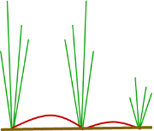 | 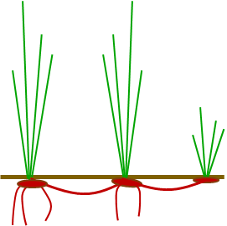 | 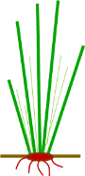 |  | 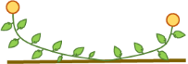

B | Rosulatae
B | Fragariids | Bellids | Oxalids | Primulids
Characteristic features | Presence of stolons | Presence of short rhizomes, basal rosette crowded | Presence of long rhizomes, no rosette, only basal leaves | Plants solitary, stem single or absent
Illustrations | 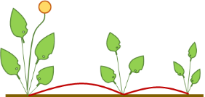 | 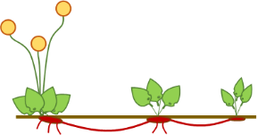 | 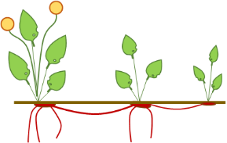 | 

C | Scaposo-Rosulatae
C | Ajugids | Arabids | Aegopodiids | Verbascids | Ranunculids
Characteristic features | Presence of stolons | Basal rosette crowded | Presence of long rhizomes | Solitary plants, stems unbranched | Solitary plants, stems strongly branched
Illustrations | 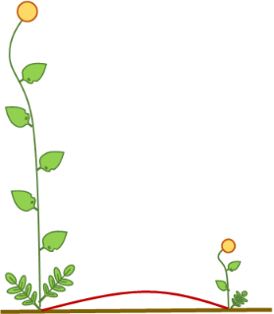 | 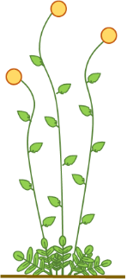 | 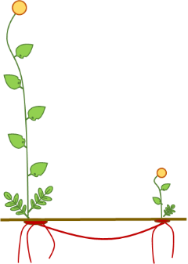 | 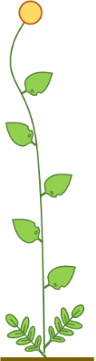 | 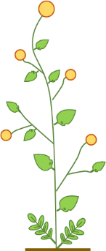

D | Scaposae
D | Linariids | Minuartiids | Asperulids | Epipactids | Gypsophilids
Characteristic features | Many unbranched stems from a cespitose base | Many strongly branched stems from a cespitose base | Presence of long rhizomes | Solitary, unbranched plants | Solitary, strongly branched plants
Illustrations | 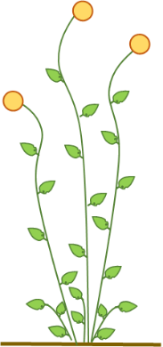 | 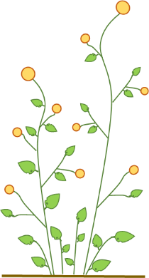 | 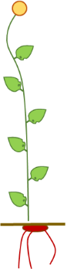 | 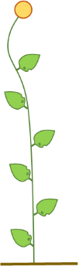 | 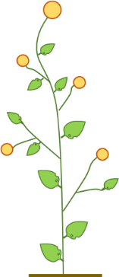

Bryophyte growth forms in Barkman’s (1988) typology

- Archidiids. Mostly annual, very short (1-3 mm) acrocarpous mosses, often growing isolated or in loose tufts
- Bryids. Low (3-20 mm) but dense turf of perennial mosses with erect, unbranched or slightly and sympodially branched stems.
- Polytrichids. Samer as Bryids, but taller (3-10 cm).
- Sphagnids. Talll turfs of erect, strongly and monopodially branched stems. Branches in fascicles, many short branches at the stem top.
- Rhodobryids. Erect unbranched mosses with leaves in an apical rosette.
- Anomodontids. Monopodially branched, decumbent species with a creeping stem and erect branches.
- Climaciids. Erect, dendroid or arched stems, mainly branched and leafy near the top.
- Amblystegiids. Prostrate, not or monopodially branched species forming low, compact mats. Leafy stems not complanate.
- Plagiotheciids. As Amblystegiids, but leafy stelms complanate.
- Pleuroziids. Monopodially branched pecies with ascending stems, forming lose wefts. Branching irregular.
  - Pleuroziids s.str. Leafy stems not complanate.
  - Bazzaniids. Leafy stems complanate.
- Thuidiids. As Pleuroziids s.str., but stems regularly pinnate or bipinnate

