Supplementary data
Description of Tropicibacter oceani sp. nov, isolated from the intertidal zone sediment of Chinese Yellow Sea

Dan-dan Zhou, Xiudan Xu, Bin-zhe Zhang, Ji-xing Feng, Jian Zhang*

School of Ocean, Yantai University, Yantai, China

*To whom correspondence should be addressed
Mailing address:

Yantai University
30 QingQuan Road
Yantai 264005, China
Phone: 86-535-6705292

Email: zhangjian@ytu.edu.cn
Table S1 Summary of the genome information of strain YMD87^{T}.

Genome feature | Number
Genome size (bp) | 4,147,834
Encoded genes | 3,950
Annotated genes | 3,740
5S rRNA | 3
16S rRNA | 3
23S rRNA | 3
tRNA | 49
ncRNA | 3
Genomics islands | 10
Prophage | 3
CRISPR | 2
Secreted protein | 341
Secondary metabolites gene clusters:
Hserlactone | 2 (41 genes)
NRPS | 1 (40 genes)
RiPP-like | 1 (13 genes)
NRPS-like, T1PKS | 1 (31 genes)
Terpene | 1 (24 genes)
Betalactone | 1 (28 genes)
Ectoine | 1 (9 genes)

Table S2. Assimilation substrates and antibiotic resistance of the strain YMD87^{T} and the reference strain.
Strains: 1, YMD87^{T}; 2, Tropicibacter alexandrii LMIT003^{T} (KCTC 62895^{T}). All strains are positive for assimilation of aescin iron citrate, 4-nitrobenzene-β-D-galactopyranoside, and susceptibility to penicillin, piperacillin, cephalexin, cefamezin, cefradine, cefuroxime, ceftazidime, ceftriaxone, cefoperazone, amikacin, neomycin, tetracycline, doxycycline, minocycline, midecamycin, norfloxacin, ofloxacin, ciprofloxacin, polymyxin B, furazolidone. All strains are negative for assimilation of potassium nitrate, L-tryptophan, L-arginine, urea, potassium gluconate, capric acid, adipic acid, sodium citrate, phenylacetic acid, and susceptibility to gentamicin.
Strains: 1, YMD87^{T}; 2, Tropicibacter alexandrii LMIT003^{T} (KCTC 62895^{T}). Data for strains 1 and 2 are from this study. +, positive; w, weakly positive; –, negative; nd, not detected.
Characteristic | 1 | 2
Assimilation of (API 20NE):
L-arabinose | w | -
D-mannose | w | -
N-Acetyl Glucosamine | w | -
D-maltose | w | -
Susceptibility to antibiotics:
Sulfamethoxazole | + | -
Clindamycin | w | -

Figure S1. Two-dimensional thin-layer chromatogram of the total polar lipid profile of strain YMD87^{T}. Phosphatidylglycerol (PG), phosphatidylethanolamine (PE), unidentified lipids (L1-5), unidentified phospholipids (PL1-5), phosphatidylcholine (PC), unidentified glycolipid (GL), unidentified amino lipids (AL1-5) are shown.
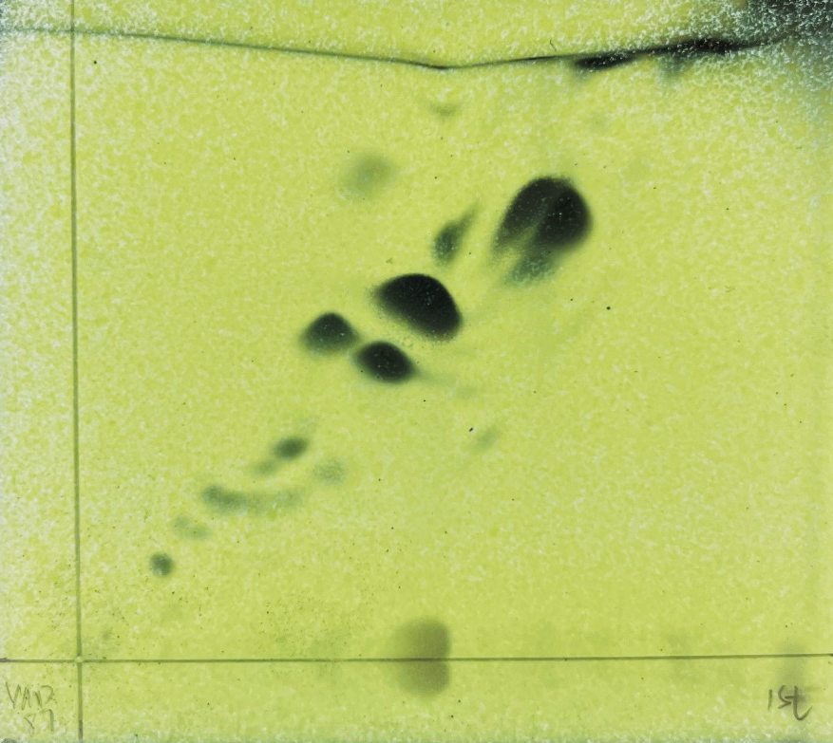
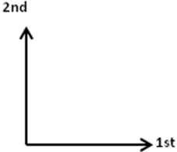
AL1
PE
PG
PL2
PL3
PC
PL1
L1
L2
GL
L3
AL2
AL3
AL4
AL5
PL4
PL5
L4
L5

