Supplementary data

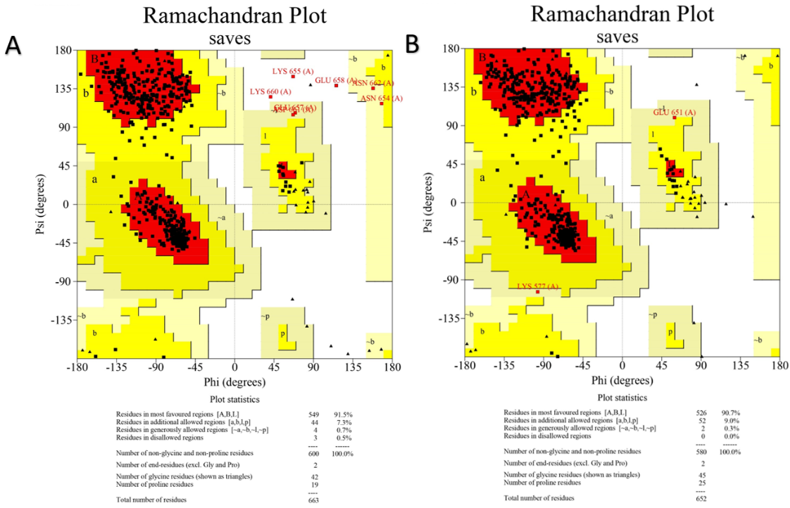
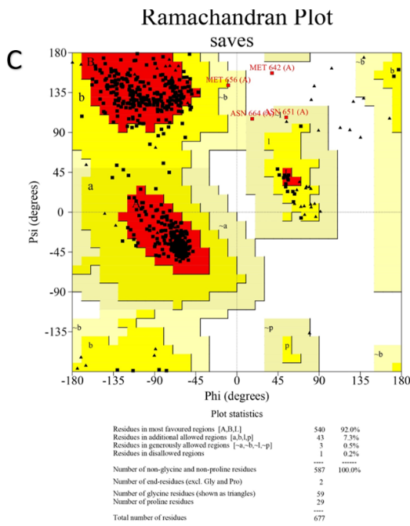
Figure S1: Validation of predicted structures of PfHSP70s by Ramachandran plot analysis (A) PfHSP70-3 (B) PfHSP70-2 (C) PfHSP70-1

