Integrated Metabolomic and Transcriptomic Analysis of the triterpenoid Accumulation in the Roots of Codonopsis pilosula. var. modesta (Nannf.) L.T.Shen at Different Altitudes

In total: 17 pages
Figures:4
Tables:7
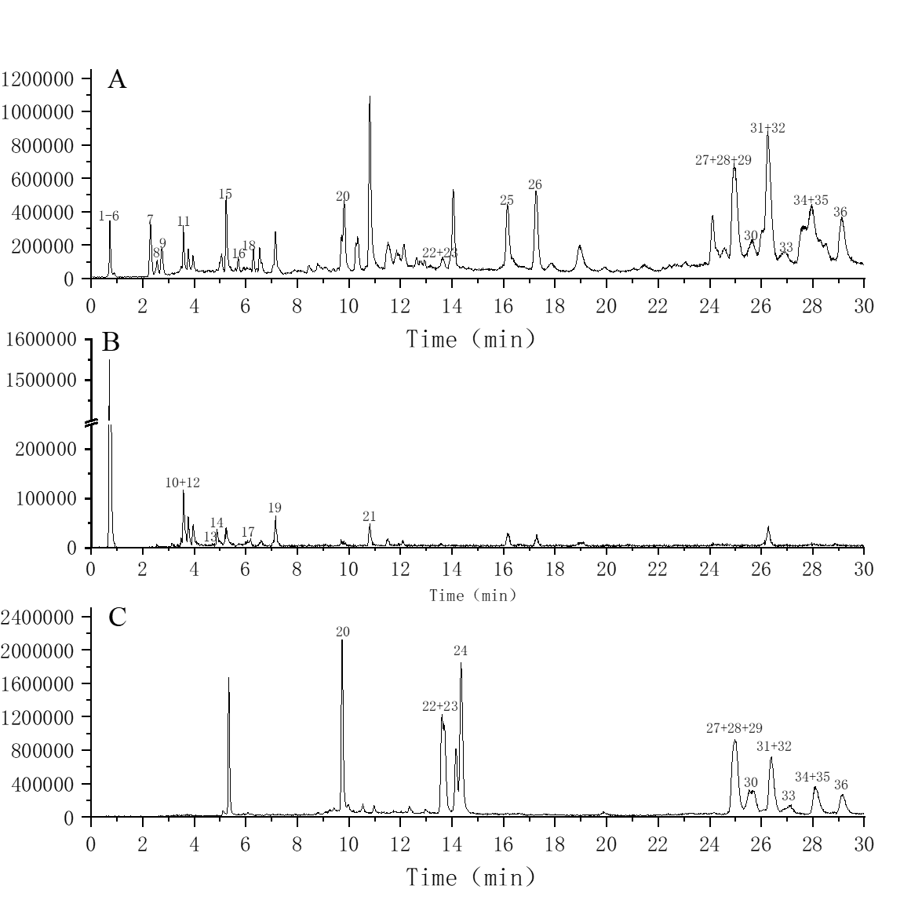
Figure S1. Total ion current diagram of UPLC-APCI-Q-TOF-MS/MS. (A) Total ion flow chart of weakly polar extract of Codonopsis pilosula. var. modesta (Nannf.) L.T.Shen in positive ion mode; (B) Total ion flow diagram of weak polar extract of C. pilosula. var. modesta in negative ion mode; (C) Total ion flow diagram of reference product in positive ion mode

Figure S2. Real-time quantitative polymerase chain reaction (RT-qPCR) validation of candidate unigenes involved in Codonopsis pilosula. var. modesta (Nannf.) L.T.Shen triterpenoid biosynthesis. The histogram shows the relative gene expression obtained via RT-qPCR.
Figure S3. GO(A) and KEGG pathway(B) enrichment of differentially expressed genes (DEGs) in the roots of Codonopsis pilosula. var. modesta (Nannf.) L.T.Shen between low and high altitude

Figure S4. The visual analysis results of pathway enrichment in KEGG database

Table S1. The results of non-targeted metabolites annotated in KEGG database
Pathway category | Pathway subcategory | Number
Cellular Processes | Cell growth and death | 1
Cellular Processes | Cellular community - prokaryotes | 1
Cellular Processes | Transport and catabolism | 1
Drug Development | Skeleton-based classification | 1
Drug Development | Structure-based classification | 1
Drug Development | Target-based classification: G protein-coupled receptors | 1
Drug Development | Target-based classification: Ion channels | 1
Drug Development | Target-based classification: Nuclear receptors | 1
Environmental Information Processing | Membrane transport | 13
Environmental Information Processing | Signal transduction | 7
Environmental Information Processing | Signaling molecules and interaction | 3
Genetic Information Processing | Translation | 9
Metabolism | Amino acid metabolism | 31
Metabolism | Biosynthesis of other secondary metabolites | 34
Metabolism | Carbohydrate metabolism | 26
Metabolism | Chemical structure transformation maps | 34
Metabolism | Energy metabolism | 9
Metabolism | Global and overview maps | 101
Metabolism | Glycan biosynthesis and metabolism | 1
Metabolism | Lipid metabolism | 20
Metabolism | Metabolism of cofactors and vitamins | 18
Metabolism | Metabolism of other amino acids | 8
Metabolism | Metabolism of terpenoids and polyketides | 12
Metabolism | Nucleotide metabolism | 11
Metabolism | Xenobiotics biodegradation and metabolism | 16
Organismal Systems | Aging | 1
Organismal Systems | Circulatory system | 2
Organismal Systems | Digestive system | 17
Organismal Systems | Endocrine system | 6
Organismal Systems | Immune system | 3
Organismal Systems | Nervous system | 6
Organismal Systems | Sensory system | 8

Table S2. Metabonomics of triterpenoids in high and low altitude Codonopsis pilosula. var. modesta (Nannf.) L.T.Shen.
Name | Class | Formula | Molecular Weight | RT [min] | m/z | Pvalue
Oleanolic acid | Oleanane pentacyclic triterpene | C30 H48 O3 | 478.34 | 10.11 | 479.35 | 0.40
Alisol B | Dammarane tetracyclic triterpenes | C30 H48 O4 | 472.36 | 11.44 | 471.35 | 0.26
Ursolic acid | Ursane pentacyclic triterpene | C30 H48 O3 | 456.36 | 10.93 | 455.35 | 0.13
Roburic acid | Cycloartane tetracyclic triterpenes | C30 H48 O2 | 440.37 | 8.75 | 441.37 | 0.20
Protopanaxadiol | Cycloartane tetracyclic triterpenes | C30 H52 O3 | 460.39 | 9.05 | 461.40 | 0.48
Name | H1 | H2 | H3 | L1 | L2 | L3
Oleanolic acid | 20829448.55 | 14418395.91 | 37328532.46 | 15908102.66 | 50719269.49 | 58196322.28
Alisol B | 28881582.71 | 10985200.86 | 8056139.93 | 24434724.04 | 19796777.62 | 31524794.21
Ursolic acid | 22400392.52 | 769085.87 | 24811527.69 | 761567.61 | 498076.74 | 314717.25
Roburic acid | 3824256.47 | 6335629.22 | 6677483.43 | 5529908.01 | 18498947.97 | 10822404.85
Protopanaxadiol | 52687.18 | 815786.02 | 48988.09 | 58033.59 | 56728.62 | 59335.97

Table S3. Concentrations (mg/kg) of triterpenoids in high and low altitude Codonopsis pilosula. var. modesta (Nannf.) L.T.Shen.
Compound | Retention time(min) | Molecular formula | L1 | L2 | L3 | H1 | H2 | H3
codopitirol A | 9.578 | C₃₀H₅₀O₃ | 2.137 | 1.877 | 1.876 | 1.729 | 1.783 | 2.050
kokoonol | 13.637 | C₃₀H₅₀O₂ | 1.346 | 1.076 | 1.234 | 0.495 | 0.423 | 0.498
bryonolol | 13.529 | C₃₀H₅₀O₂ | 1.980 | 1.884 | 2.079 | 5.455 | 4.960 | 5.325
codopimodol A | 14.312 | C₃₀H₅₀O₂ | 0.762 | 0.647 | 0.675 | 0.794 | 0.806 | 0.810
taraxerol | 25.072 | C₃₀H₅₀O | 28.832 | 19.043 | 24.489 | 79.890 | 51.882 | 83.412
α-amyrin | 25.657 | C₃₀H₅₀O | 7.094 | 3.157 | 7.895 | 26.216 | 19.679 | 23.684
glut-5-en-3β-ol | 26.05 | C₃₀H₅₀O | 0.446 | 0.280 | 1.575 | 3.396 | 3.404 | 2.018
friedel-1-en-3-one | 27.029 | C₃₀H₄₈O | 1.899 | 1.247 | 1.387 | 1.896 | 2.621 | 3.069
24-methylenecycloartanol | 27.951 | C₃₁H₅₂O | 25.537 | 25.035 | 28.632 | 26.099 | 23.831 | 23.759
friedelin | 29.142 | C₃₀H₅₀O | 102.043 | 91.051 | 99.539 | 133.260 | 138.456 | 137.755

Table S4. Summary statistics for sequence quality control and mapped data of samples (L1~L3 and H1~H3).
sample | library | raw_reads | clean_reads | Q20 | Q30 | GC_pct | Total mapped
H1 | FRAS220096887-1r | 23218197 | 21852496 | 97.77 | 93.62 | 44.54 | 33471224(76.58%)
H2 | FRAS220096887-2r | 23196084 | 22350891 | 97.13 | 92.27 | 44.46 | 33948592(75.94%)
H3 | FRAS220096887-3r | 19610953 | 18878152 | 97.28 | 92.68 | 44.5 | 28755290(76.16%)
L1 | FRAS220096884-1r | 24028266 | 22849269 | 97.86 | 93.88 | 44.16 | 35081094(76.77%)
L2 | FRAS220096885-1r | 24397875 | 23211271 | 97.78 | 93.68 | 44.27 | 35444620(76.35%)
L3 | FRAS220096884-2r | 23472771 | 22620497 | 97.11 | 92.24 | 44.28 | 34295276(75.81%)

Table S5. Transcript length distribution of transcriptome
Transcript length interval | 300-500bp | 500-1kbp | 1k-2kbp | >2kbp | Total
Number of transcripts | 29691 | 33200 | 35603 | 33934 | 132428
Number of Unigenes | 18460 | 17383 | 12362 | 10415 | 58620

Table S6. Identified triterpene biosynthesis accociated genes with their fragments per kilobase of transcript per milllion mapped reads(FPKM) values.
No. | Enzyme | EC | GENES | FPKM values
 |  |  |  | H1 | H2 | H3 | L1 | L2 | L3
1 | hydroxymethylglutaryl-CoA reductase (HMGR) | 1.1.1.34 | HMGR | 25.08 | 25.77 | 26.06 | 96.98 | 79.52 | 90.2
2 | acetyl-CoA C-acetyltransferase(AATC) | 2.3.1.9 | AATC1 | 1 | 1.1 | 1.36 | 0 | 0 | 0
3 | acetyl-CoA C-acetyltransferase(AATC) | 2.3.1.9 | AATC2 | 2.24 | 1.84 | 1.7 | 0 | 0 | 0
4 | acetyl-CoA C-acetyltransferase(AATC) | 2.3.1.9 | AATC3 | 74.26 | 78.17 | 73.93 | 223.9 | 256.4 | 230.25
5 | hydroxymethylglutaryl-CoA synthase(HMGS) | 2.3.3.10 | HMGS | 0.79 | 1.67 | 0.59 | 0 | 0 | 0
6 | mevalonate kinase(MVK) | 2.7.1.36 | MVK1 | 6.27 | 7.14 | 7.42 | 14.73 | 18.67 | 13.96
7 | mevalonate kinase(MVK) | 2.7.1.36 | MVK2 | 1.17 | 1.49 | 2.38 | 0 | 0 | 0
8 | phosphomevalonate kinase(PMVK) | 2.7.4.2 | PMVK | 1.76 | 1 | 1.33 | 0 | 0 | 0
9 | diphosphomevalonate decarboxylase(MVD) | 4.1.1.33 | MVD | 12.04 | 12.89 | 12.67 | 42.49 | 52.25 | 42.07
10 | 1-deoxy-D-xylulose-5-phosphate reductoisomerase(DXR) | 1.1.1.267 | DXR | 26.11 | 28.05 | 29.99 | 50.03 | 46.5 | 50.66
11 | 1-deoxy-D-xylulose-5-phosphate synthase(DXS) | 2.2.1.7 | DXS | 5.09 | 6.04 | 6.04 | 13.36 | 14.03 | 15.1
12 | isopentenyl-diphosphate Delta-isomerase(IDI) | 5.3.3.2 | IDI | 1.79 | 1.18 | 1.52 | 0 | 0 | 0
13 | geranylgeranyl diphosphate synthase, type II (GGPS) | 2.5.1.1,2.5.1.10,2.5.1.29 | GPPS1 | 1.61 | 1.12 | 1.63 | 0 | 0 | 0
14 | geranylgeranyl diphosphate synthase, type II (GGPS) | 2.5.1.1,2.5.1.10,2.5.1.29 | GPPS2 | 1.58 | 1.04 | 0.77 | 0.14 | 0.32 | 0.09
15 | geranylgeranyl diphosphate synthase, type II (GGPS) | 2.5.1.1,2.5.1.10,2.5.1.29 | GPPS3 | 1.43 | 1.38 | 1.86 | 0 | 0 | 0
16 | geranylgeranyl diphosphate synthase, type II (GGPS) | 2.5.1.1,2.5.1.10,2.5.1.29 | GPPS4 | 6.11 | 6.78 | 14.47 | 0 | 1.45 | 0.78
17 | geranylgeranyl diphosphate synthase, type II (GGPS) | 2.5.1.1,2.5.1.10,2.5.1.29 | GPPS5 | 1.77 | 3.12 | 3.45 | 1.33 | 0.36 | 0.81
18 | farnesyl diphosphate synthase (FPPS) | 2.5.1.1,2.5.1.10 | FPPS | 2.54 | 1.02 | 1.41 | 0 | 0 | 0
19 | farnesyl-diphosphate farnesyltransferase(SS) | 2.5.1.21 | SS | 1.53 | 1.68 | 1.51 | 0 | 0 | 0
20 | squalene monooxygenase(SE) | 1.14.14.17 | SE1 | 2.35 | 1.82 | 1.74 | 0 | 0 | 0
21 | squalene monooxygenase(SE) | 1.14.14.17 | SE2 | 1.9 | 0.61 | 0.87 | 0 | 0 | 0
22 | beta-amyrin synthase(β-AS) | 5.4.99.39 | β-AS1 | 2.71 | 3.39 | 3.92 | 0.32 | 1.95 | 0.41
23 | beta-amyrin synthase(β-AS) | 5.4.99.39 | β-AS2 | 14.38 | 15.36 | 14.4 | 1.07 | 0.46 | 1.15
24 | beta-amyrin synthase(β-AS) | 5.4.99.39 | β-AS3 | 1.55 | 0.59 | 1.51 | 0 | 0 | 0
25 | lupeol synthase (LS) | 5.4.99.41 | LS | 26.91 | 30.56 | 33.29 | 7.02 | 6.51 | 9.07

Table S7. The KEGG biochemical pathways and signal transduction pathways in which the DEGs and DAMs were shared
Description | Pvalue | Ratio | Count | Type
C5-Branched dibasic acid metabolism | 0.002 | 0.750 | 3 | Meta
C5-Branched dibasic acid metabolism | 0.516 | 0.462 | 6 | Tran
Citrate cycle (TCA cycle) | 0.007 | 1.000 | 2 | Meta
Citrate cycle (TCA cycle) | 0.192 | 0.500 | 49 | Tran
Glyoxylate and dicarboxylate metabolism | 0.021 | 0.667 | 2 | Meta
Glyoxylate and dicarboxylate metabolism | 0.028 | 0.560 | 79 | Tran
Carbon fixation pathways in prokaryotes | 0.021 | 0.667 | 2 | Meta
Carbon fixation pathways in prokaryotes | 0.435 | 0.450 | 27 | Tran
Phenylalanine, tyrosine and tryptophan biosynthesis | 0.040 | 0.500 | 2 | Meta
Phenylalanine, tyrosine and tryptophan biosynthesis | 0.122 | 0.561 | 32 | Tran
Alanine, aspartate and glutamate metabolism | 0.064 | 0.400 | 2 | Meta
Alanine, aspartate and glutamate metabolism | 0.388 | 0.453 | 43 | Tran
Novobiocin biosynthesis | 0.090 | 1.000 | 1 | Meta
Novobiocin biosynthesis | 0.205 | 0.833 | 5 | Tran
Sphingolipid metabolism | 0.090 | 1.000 | 1 | Meta
Sphingolipid metabolism | 0.720 | 0.368 | 14 | Tran
Toluene degradation | 0.090 | 1.000 | 1 | Meta
Toluene degradation | 0.347 | 0.750 | 3 | Tran
Thiamine metabolism | 0.090 | 1.000 | 1 | Meta
Thiamine metabolism | 0.545 | 0.429 | 12 | Tran
Betalain biosynthesis | 0.090 | 1.000 | 1 | Meta
Betalain biosynthesis | 0.344 | 1.000 | 2 | Tran
Ferroptosis | 0.090 | 1.000 | 1 | Meta
Ferroptosis | 0.501 | 0.441 | 15 | Tran
Necroptosis | 0.090 | 1.000 | 1 | Meta
Necroptosis | 0.214 | 0.495 | 47 | Tran
Fc gamma R-mediated phagocytosis | 0.090 | 1.000 | 1 | Meta
Fc gamma R-mediated phagocytosis | 0.499 | 0.433 | 29 | Tran
Long-term depression | 0.090 | 1.000 | 1 | Meta
Long-term depression | 0.710 | 0.357 | 5 | Tran
Phototransduction - fly | 0.090 | 1.000 | 1 | Meta
Phototransduction - fly | 0.394 | 0.545 | 6 | Tran
GnRH signaling pathway | 0.090 | 1.000 | 1 | Meta
GnRH signaling pathway | 0.585 | 0.414 | 12 | Tran
Aldosterone synthesis and secretion | 0.090 | 1.000 | 1 | Meta
Aldosterone synthesis and secretion | 0.220 | 0.611 | 11 | Tran
Fructose and mannose metabolism | 0.172 | 0.500 | 1 | Meta
Fructose and mannose metabolism | 0.103 | 0.559 | 38 | Tran
Ubiquinone and other terpenoid-quinone biosynthesis | 0.172 | 0.500 | 1 | Meta
Ubiquinone and other terpenoid-quinone biosynthesis | 0.671 | 0.388 | 19 | Tran
Monobactam biosynthesis | 0.172 | 0.500 | 1 | Meta
Monobactam biosynthesis | 0.477 | 0.471 | 8 | Tran
Tyrosine metabolism | 0.172 | 0.500 | 1 | Meta
Tyrosine metabolism | 0.216 | 0.517 | 30 | Tran
Benzoate degradation | 0.172 | 0.500 | 1 | Meta
Benzoate degradation | 0.160 | 0.857 | 6 | Tran
Taurine and hypotaurine metabolism | 0.172 | 0.500 | 1 | Meta
Taurine and hypotaurine metabolism | 0.763 | 0.333 | 6 | Tran
Cyanoamino acid metabolism | 0.172 | 0.500 | 1 | Meta
Cyanoamino acid metabolism | 0.230 | 0.508 | 32 | Tran
D-Glutamine and D-glutamate metabolism | 0.172 | 0.500 | 1 | Meta
D-Glutamine and D-glutamate metabolism | 0.653 | 0.500 | 1 | Tran
Linoleic acid metabolism | 0.172 | 0.500 | 1 | Meta
Linoleic acid metabolism | 0.934 | 0.240 | 6 | Tran
Butanoate metabolism | 0.172 | 0.500 | 1 | Meta
Butanoate metabolism | 0.610 | 0.405 | 17 | Tran
Sesquiterpenoid and triterpenoid biosynthesis | 0.172 | 0.500 | 1 | Meta
Sesquiterpenoid and triterpenoid biosynthesis | 0.528 | 0.444 | 8 | Tran
Isoquinoline alkaloid biosynthesis | 0.172 | 0.500 | 1 | Meta
Isoquinoline alkaloid biosynthesis | 0.092 | 0.667 | 18 | Tran
Two-component system | 0.172 | 0.500 | 1 | Meta
Two-component system | 0.402 | 0.456 | 31 | Tran
Vascular smooth muscle contraction | 0.172 | 0.500 | 1 | Meta
Vascular smooth muscle contraction | 0.289 | 0.542 | 13 | Tran
Platelet activation | 0.172 | 0.500 | 1 | Meta
Platelet activation | 0.456 | 0.500 | 6 | Tran
Fc epsilon RI signaling pathway | 0.172 | 0.500 | 1 | Meta
Fc epsilon RI signaling pathway | 0.154 | 0.636 | 14 | Tran
Ovarian steroidogenesis | 0.172 | 0.500 | 1 | Meta
Ovarian steroidogenesis | 0.423 | 0.571 | 4 | Tran
Oxytocin signaling pathway | 0.172 | 0.500 | 1 | Meta
Oxytocin signaling pathway | 0.115 | 0.551 | 38 | Tran
Regulation of lipolysis in adipocytes | 0.172 | 0.500 | 1 | Meta
Regulation of lipolysis in adipocytes | 0.710 | 0.357 | 5 | Tran
Arachidonic acid metabolism | 0.247 | 0.333 | 1 | Meta
Arachidonic acid metabolism | 0.537 | 0.435 | 10 | Tran
Pantothenate and CoA biosynthesis | 0.247 | 0.333 | 1 | Meta
Pantothenate and CoA biosynthesis | 0.453 | 0.452 | 19 | Tran
Glucosinolate biosynthesis | 0.247 | 0.333 | 1 | Meta
Glucosinolate biosynthesis | 0.466 | 0.667 | 2 | Tran
Retrograde endocannabinoid signaling | 0.247 | 0.333 | 1 | Meta
Retrograde endocannabinoid signaling | 0.136 | 0.532 | 42 | Tran
Serotonergic synapse | 0.247 | 0.333 | 1 | Meta
Serotonergic synapse | 0.681 | 0.375 | 3 | Tran
Metabolic pathways | 0.302 | 0.120 | 9 | Meta
Metabolic pathways | 0.002 | 0.461 | 1226 | Tran
Pentose and glucuronate interconversions | 0.316 | 0.250 | 1 | Meta
Pentose and glucuronate interconversions | 0.272 | 0.487 | 37 | Tran
Galactose metabolism | 0.316 | 0.250 | 1 | Meta
Galactose metabolism | 0.546 | 0.421 | 32 | Tran
Arginine biosynthesis | 0.316 | 0.250 | 1 | Meta
Arginine biosynthesis | 0.703 | 0.375 | 15 | Tran
Lysine biosynthesis | 0.316 | 0.250 | 1 | Meta
Lysine biosynthesis | 0.577 | 0.421 | 8 | Tran
beta-Alanine metabolism | 0.316 | 0.250 | 1 | Meta
beta-Alanine metabolism | 0.367 | 0.462 | 36 | Tran
Methane metabolism | 0.316 | 0.250 | 1 | Meta
Methane metabolism | 0.280 | 0.475 | 48 | Tran
Nicotinate and nicotinamide metabolism | 0.316 | 0.250 | 1 | Meta
Nicotinate and nicotinamide metabolism | 0.529 | 0.433 | 13 | Tran
Ascorbate and aldarate metabolism | 0.379 | 0.200 | 1 | Meta
Ascorbate and aldarate metabolism | 0.303 | 0.484 | 31 | Tran
Biosynthesis of unsaturated fatty acids | 0.379 | 0.200 | 1 | Meta
Biosynthesis of unsaturated fatty acids | 0.025 | 0.655 | 38 | Tran
Degradation of aromatic compounds | 0.379 | 0.200 | 1 | Meta
Degradation of aromatic compounds | 0.382 | 0.538 | 7 | Tran
Pyrimidine metabolism | 0.437 | 0.167 | 1 | Meta
Pyrimidine metabolism | 0.194 | 0.506 | 43 | Tran
Histidine metabolism | 0.437 | 0.167 | 1 | Meta
Histidine metabolism | 0.815 | 0.333 | 13 | Tran
Aminobenzoate degradation | 0.437 | 0.167 | 1 | Meta
Aminobenzoate degradation | 0.958 | 0.125 | 1 | Tran
2-Oxocarboxylic acid metabolism | 0.437 | 0.167 | 1 | Meta
2-Oxocarboxylic acid metabolism | 0.616 | 0.405 | 30 | Tran
Inflammatory mediator regulation of TRP channels | 0.437 | 0.167 | 1 | Meta
Inflammatory mediator regulation of TRP channels | 0.446 | 0.476 | 10 | Tran
Phenylalanine metabolism | 0.489 | 0.143 | 1 | Meta
Phenylalanine metabolism | 0.251 | 0.525 | 21 | Tran
Carbon metabolism | 0.489 | 0.143 | 1 | Meta
Carbon metabolism | 0.130 | 0.467 | 199 | Tran
Phenylpropanoid biosynthesis | 0.581 | 0.111 | 1 | Meta
Phenylpropanoid biosynthesis | 0.153 | 0.496 | 70 | Tran
Aminoacyl-tRNA biosynthesis | 0.581 | 0.111 | 1 | Meta
Aminoacyl-tRNA biosynthesis | 0.782 | 0.368 | 32 | Tran
ABC transporters | 0.581 | 0.111 | 1 | Meta
ABC transporters | 0.955 | 0.279 | 17 | Tran
Biosynthesis of antibiotics | 0.638 | 0.125 | 2 | Meta
Biosynthesis of antibiotics | 0.077 | 0.466 | 324 | Tran
Biosynthesis of amino acids | 1.000 | 0.100 | 1 | Meta
Biosynthesis of amino acids | 0.312 | 0.446 | 145 | Tran

