Supplementary Information for

Basalt Accumulation Fuels Warm Slab’s Subduction into Lower Mantle

Danian Shi, Yang Shen, Jianyu Shi, Hua Xiang and Rongtao Zhao

Danian Shi
Email: shidanian@cags.ac.cn

Yang Shen
Email: yshen@uri.edu

This PDF file includes:

Figures S1 to S6
Tables S1 to S3
SI References

Data and methods
Receiver-function data processing and signal enhancement for the mantle discontinuities
We collected all publicly available seismic data from 2001 to 2022 from the IRIS Data Center, then visually selected the P arrivals with signal-to-noise (S/N) ratios ≥5 from teleseismic earthquakes with magnitudes ≥6, and rejected data with strong later arrivals (PP, PcP, pP, and sP phases, etc) in the P wave coda. We used the time-domain iterative deconvolution⁴² in the calculation of RFs, in which the Gaussian filter factor was set to 2 to suppress high frequency (≥1 Hz) noise. We finally obtained 2752 receiver functions (RFs) from 75 seismic stations to construct the seismic profile (Fig. 2a).
Previous studies showed the 410-km discontinuity undulates from -50 to +30 km with respect to 410 km in the region^{28,43}. In this study, we reproduced the image for the 410-km discontinuity by selecting the RFs with coherent amplitudes between 380 km and 440 km. The rebuilt image shows a noticeably more coherent and continuous discontinuity, particularly north of the subducting zone (Fig. 2b). Similarly, we searched in the depth range between 470 km and 590 km for the possible split 520-km discontinuities¹⁹. The rebuilt image of selected RFs shows a more pronounced and continuous 520-km discontinuity by search in depth range of 470-530 km (Fig. 2c). In addition, we observed a discontinuity at ~560 km depth beneath the central section (approximately between 900 km to 1200 km along the profile in the Figure) by search in depth range of 530-590 (Fig. 2e). We performed similar search between 620-825 km for discontinuities at and near the bottom of the MTZ. Searches within depth ranges of 620-680 km, 680-750 km and 760-825 km reveal a continuous 660-km discontinuity across the profile (Fig. 2d), an intermittent 730-km discontinuity (Fig. 2f) and an upward concaved 780-km discontinuity beneath the subduction zone (Fig. 2g).

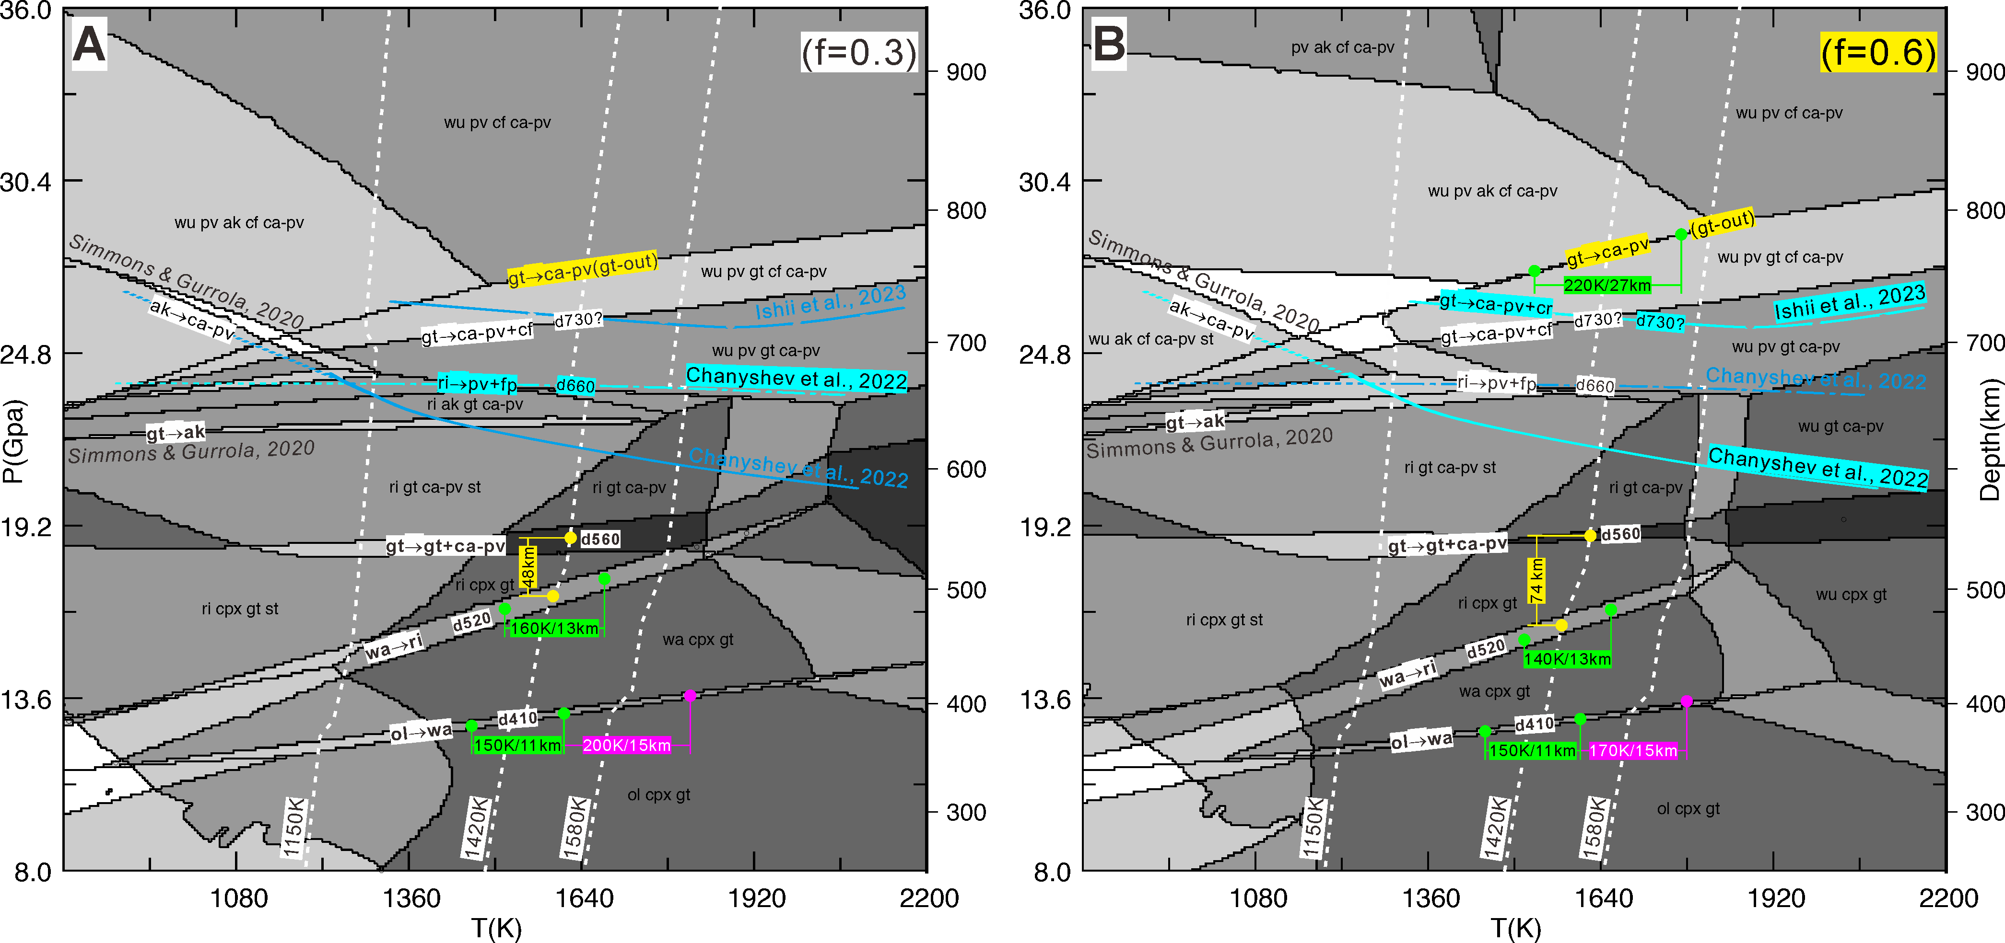
Extended Data Fig. S1|Phase transition diagrams respectively for basalt fraction f=0.3 (A) and f=0.6 (B), calculated with the thermodynamic code Perple X³⁵ and the elastic parameter database of ref.³⁸. White dashed lines show the 1150-, 1420- and 1580-K mantle potential temperature³³ adiabats. Bluish curves show the recent results for the akimotoite-bridgmanite, post-spinel and post-garnet transition boundaries determined using in situ X-ray diffraction multi-anvil techniques^{5,12}. Green and pink dots show the temperature variations predicted for the observed depth variations along the Clapeyron slopes. Yellow dots show the predicted separations of the split 520-km discontinuities. ol: olivine; sp: spinel; cpx: clinopyroxene; wa: wadleysite; ri: ringwoodite; pv: perovskite; wu: magnesio-wuestite; gt: Garnet with Fe-majorite/Ca-majorite; fp: ferropericlase; ak: akimotoite (ilmenite-structure); cf: Ca-ferrite; cr: corundum.

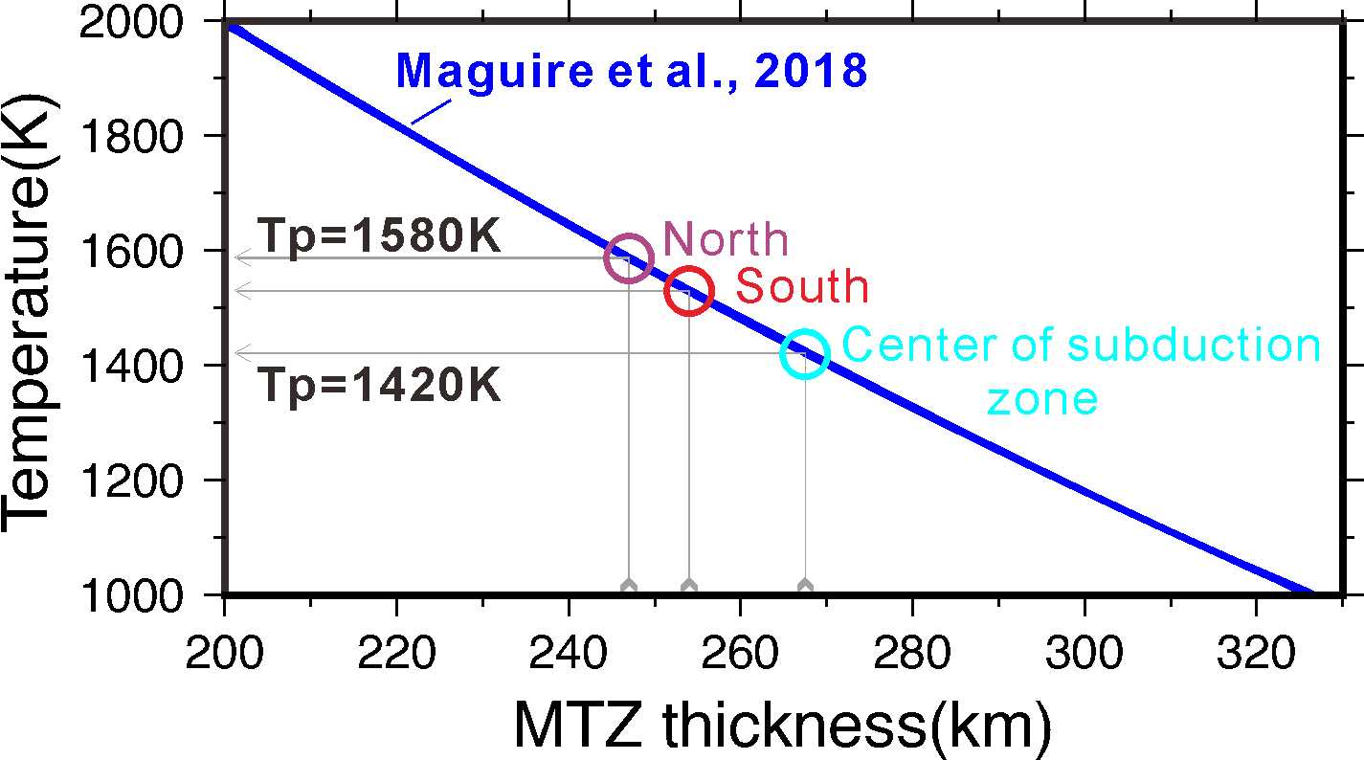
Extended Data Fig. S2|Estimates of the mantle potential adiabatic temperatures (Tp) based on the theoretical relationship curve obtained by ref.³² and the MTZ thicknesses observed in this study, respectively for the profile sections south, north and central of the Sumatra subduction zone (denoted by circles; see Table S1).

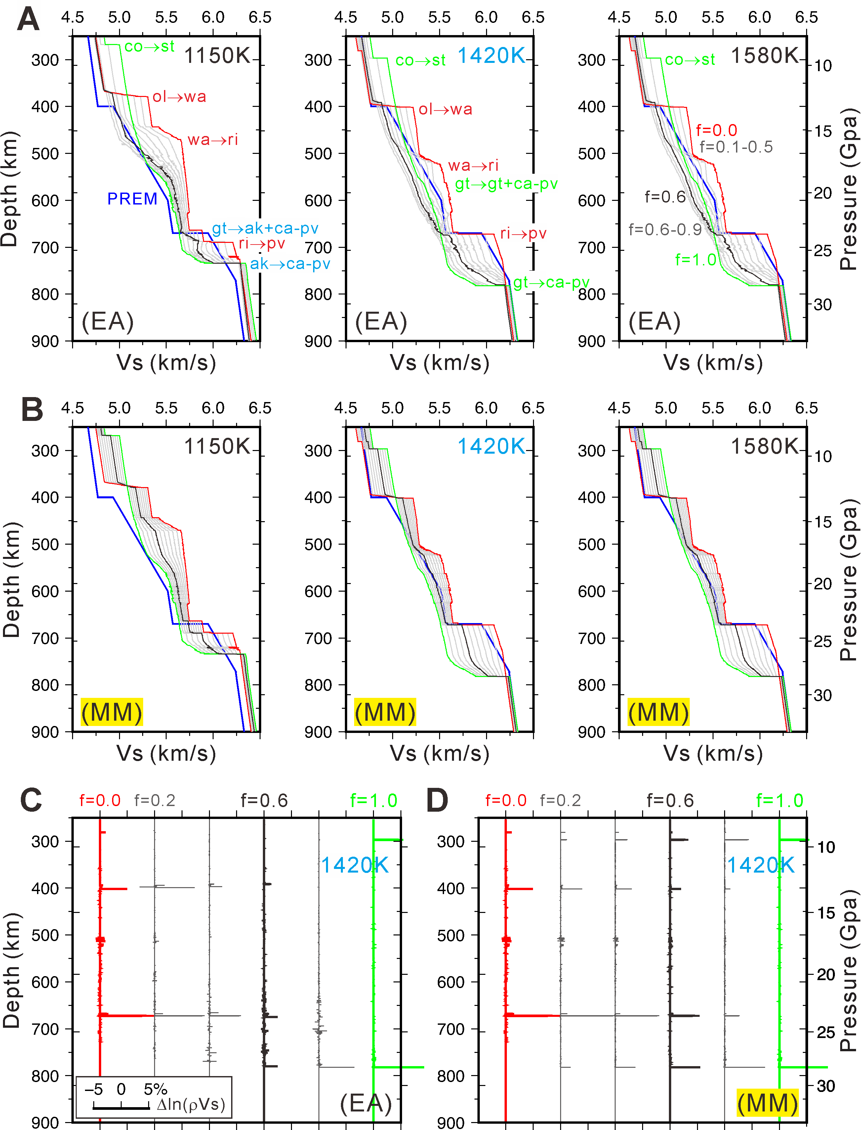

Extended Data Fig.S3|Theoretical variations of shear-wave velocity (Vs) and wave-impendence contrast (Δln(ρVs)) with depth along different adiabats, obtained with the thermodynamic code Perple X³⁵ and the elastic parameter database of ref.³⁸. A) and B) Variations of Vs with depth respectively along the 1150-, 1420- and 1580-K adiabats for the equilibrium assemblage (EA) and mechanical mixture(MM)³⁹ mantle. The PREM Vs model is shown in blue for reference. C) and D) Variations of Δln(ρVs) with depth along the 1420 K adiabat for the EA and MM mantle. f is the relative fraction of basalt, ranges from 0.0 to 1.0, corresponding to variations of mantle composition from hazburgite (in red) to basalt (in green; Table S3).

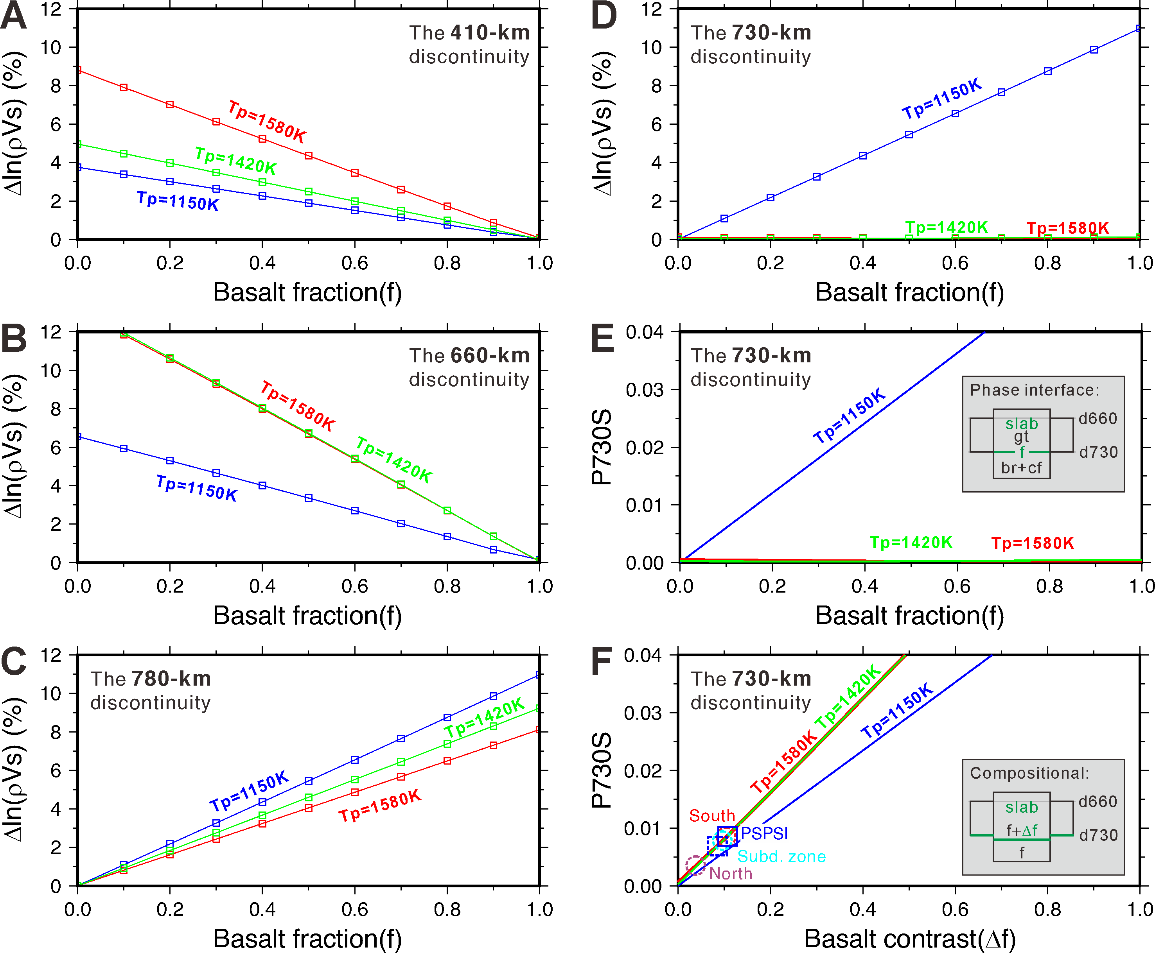
Extended Data Fig. S4| A)-D)Theoretical variations of wave-impendence contrast (Δln(ρVs)) with basalt fraction respectively for the 410-, 660-, 780- and 730-km discontinuities under different mantle potential temperatures (Tp), obtained with the Perple X for mechanical mixture mantle. E)-F)Theoretical variations of RF-amplitude with basalt fraction for the 730-km discontinuity, assuming the discontinuity to be a phase transition boundary or a compositional boundary between a more basalt-enriched and a more basalt-depleted slab assemblage. A ray parameter of 6.54639 seconds per degree (average for all the observed RFs) is used in the calculation of the theoretical RF-amplitudes, which is approximately for seismic waves coming from an epicentral distance (Δ) of ~65 degrees. Circles and rectangles show the estimates of basalt fractions based on the RF amplitudes stacked for the selected sections south, central and north of the profile (Table S1), and for the station PSPSI (Table S2).

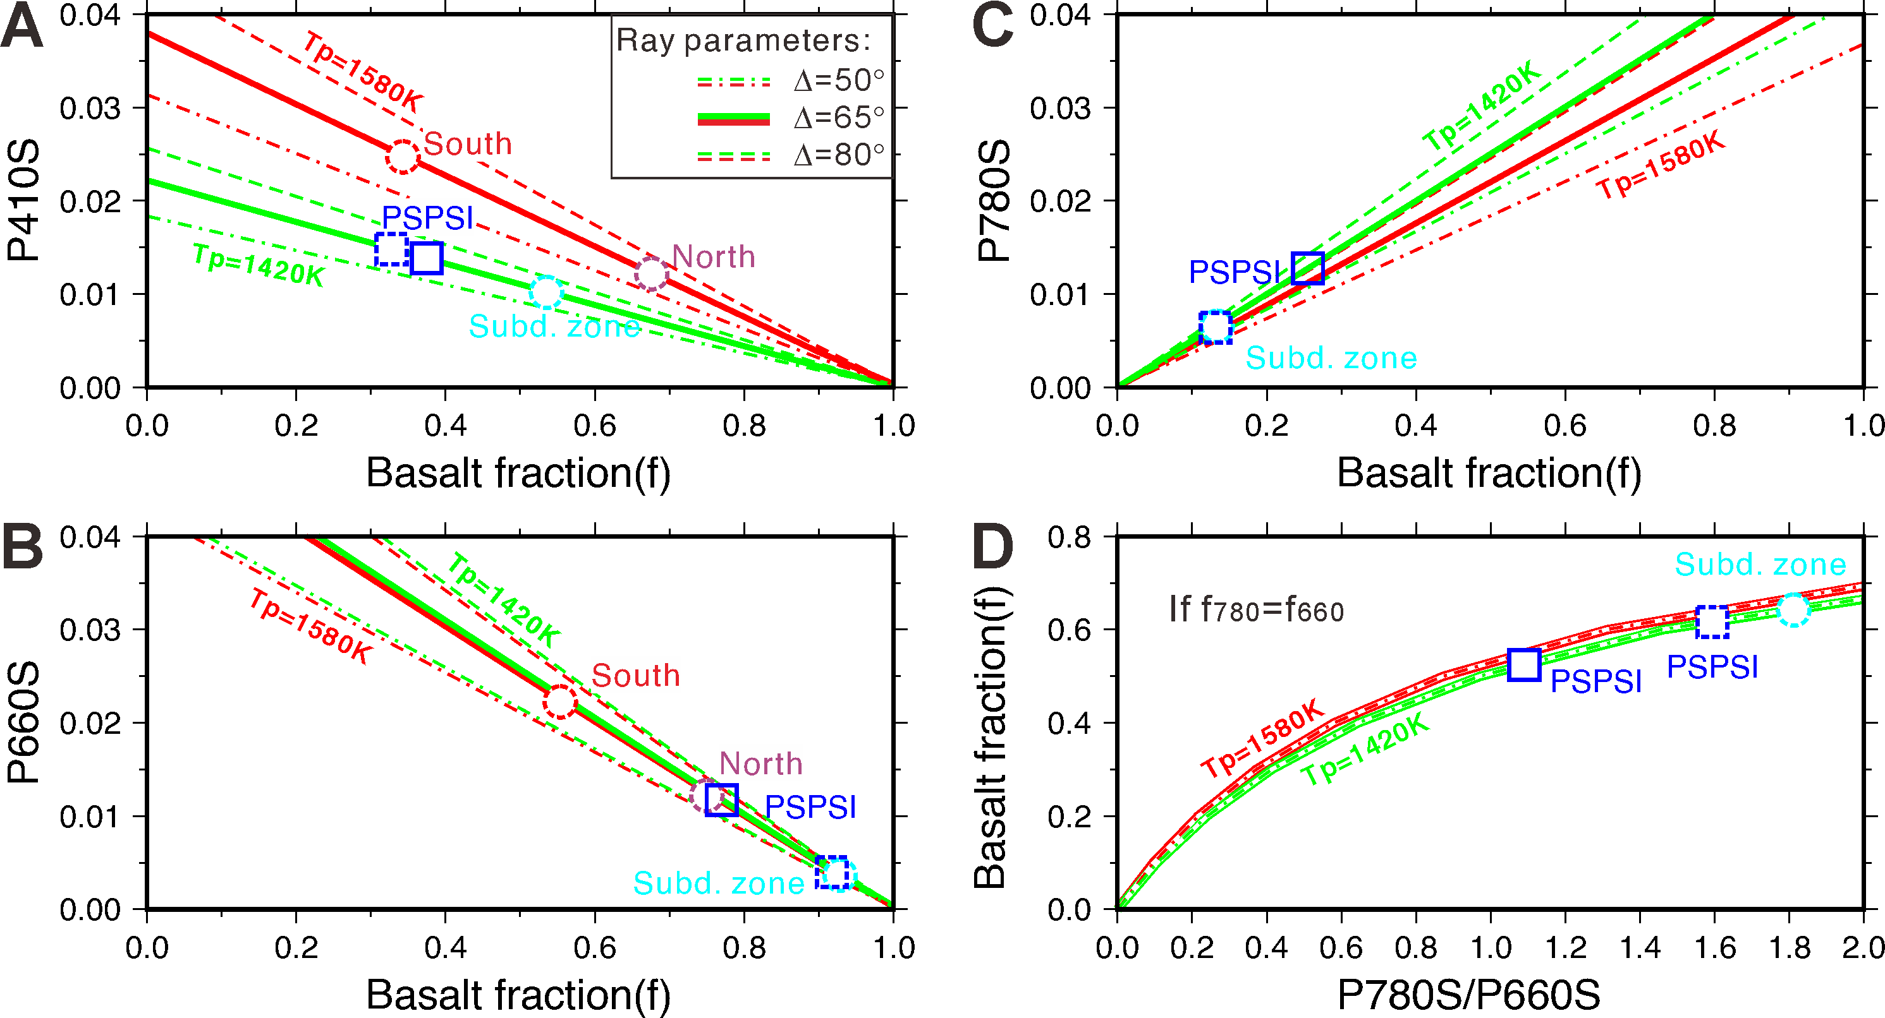
Extended Data Fig. S5|Theoretical curves similar to Fig. 3 but also for seismic waves from different epicentral distances (Δ), or for seismic waves with different incident ray parameters, showing that ray parameter and mantle potential temperature(Tp) have much influence on the P410S(A), P660S(B) and P780S amplitudes(C), but relatively little influence on the P780S/P660S ratio (D).

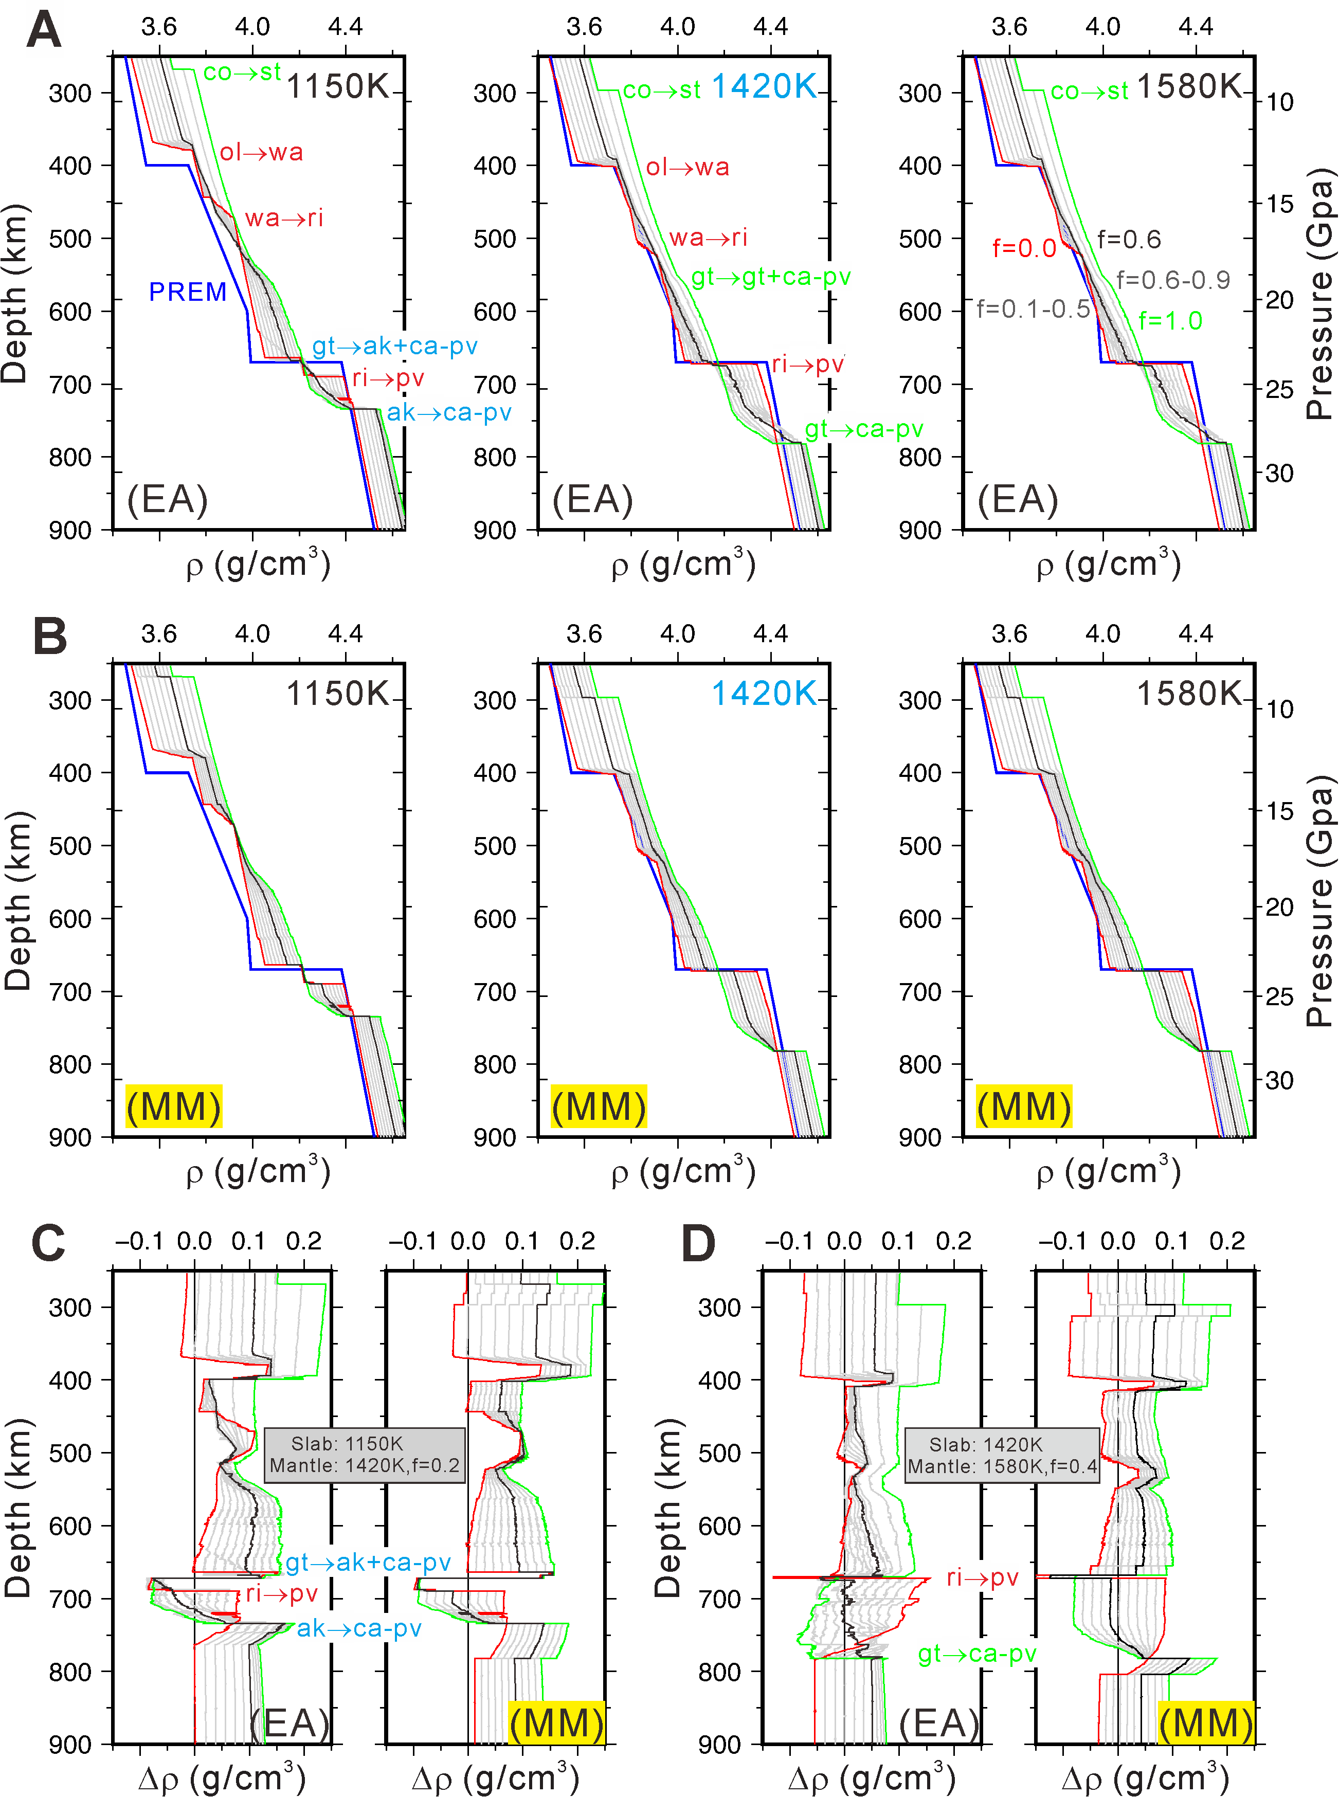

Extended Data Fig.S6|Theoretical variations of density (ρ) and density contrast (Δρ) with depth along different adiabats, computed using the thermodynamic code Perple X³⁵ and the elastic parameter database of ref.³⁸. A) and B) Variations of ρ with depth along the 1150-, 1420- and 1580-K adiabats respectively for the EA and MM mantle. The PREM density model is shown in blue for reference. C) Variations of density contrasts with depth of a relative colder slab (along the Tp=1150 K adiabat) with respect to pyrolitic surrounding mantle (along the Tp=1420 K adiabat), showing strong negative density contrasts thereby upward buoyancy favorable for the slab stagnation at the base of the MTZ, derived from both the phase transitions and the depression of the discontinuities. D) Variations of density contrasts with depth of a slab (along the 1420 K adiabat) with respect to a basalt-enriched (f=0.4) surrounding mantle (along the Tp=1580 K adiabat), together with Fig. 4a showing a slight increase of basalt fraction in the surrounding mantle will reduce negative density contrast and upward buoyancy in the top of the lower mantle.

Extended Data Table S1|Discontinuity depths measured by stacked RF amplitudes for the different sections of the profile
For south of the subduction zone  (x=600-800km) |  |  |  | For center of the subduction zone  (x=900-1100km) |  |  |  | For north of the subduction zone  (x=1400-1800km)
Interpret. | Depth  (km) | Peak amplitude | Stacked waveform | Interpret. | Depth (km) | Peak amplitude | Stacked waveform | Interpret. | Depth (km) | Peak  amplitude | Stacked waveform
 | 307.25 | 0.0230018 | 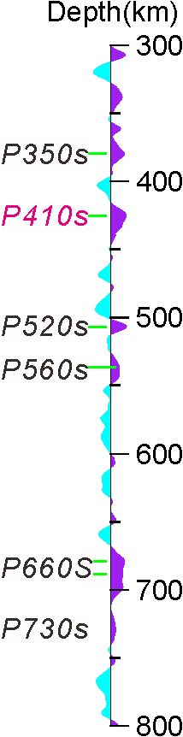 |  | 318.25 | 0.0112543 | 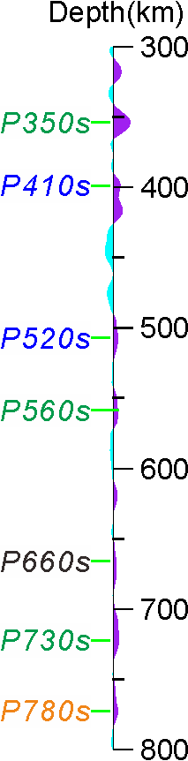 |  | 314.75 | 0.000304154 | 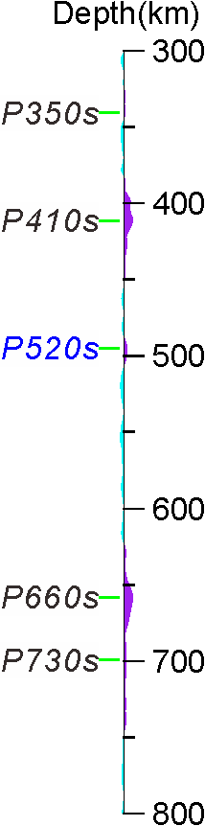
 | 338.25 | 0.0183078 |  | P350S (strong) | 353.75 | 0.0249258 |  | P350S  (very weak) | 328.75 | 0.00173193
P350S  (noisy) | 361.25 | 0.0161366 |  |  |  |  |  |  | 340.75 | 0.00158176
P350S  (noisy) | 379.75 | 0.0217375 |  |  |  |  |  |  | 385.25 | 0.00165736
 | 393.75 | 0.00302285 |  | P410S  (elevated) | 398.75 | 0.0101692 |  |  | 399.25 | 0.0090667
P410S  (depressed) | 425.25 | 0.024723 |  | P410S  (scattered) | 416.75 | 0.0136082 |  | P410S  (normal) | 411.25 | 0.0121882
 | 439.25 | 0.00798696 |  |  |  |  |  |  | 427.75 | 0.00401636
 | 456.25 | 0.00274346 |  |  |  |  |  |  | 441.75 | 0.00160656
 | 477.75 | 0.00472091 |  | P520S  (elevated) | 507.25 | 0.00626512 |  |  | 471.75 | 0.000167203
P520S | 506.75 | 0.0252599 |  |  |  |  |  | P520S  (elevated) | 494.75 | 0.00472421
P560S | 537.75 | 0.0141088
P560S | 541.25 | 0.0141232 |  | P560S | 561.25 | 0.00613857 |  |  | 628.75 | 0.00267822
 | 606.25 | 0.00701148 |  |  | 618.75 | 0.00519292 |  | P660S  (elevated) | 658.25 | 0.0122009
 | 634.75 | 0.00288843 |  |  |  |  |  | P730S (gradient) | 699.25 | 0.00349734
 | 648.75 | 0.00844066 |  |  |  |  |  | P730S (gradient) | 724.75 | 0.00239562
P660S+ | 679.25 | 0.0222621 |  | P660S | 666.25 | 0.00366788 |  | P730S (gradient) | 737.75 | 0.00280778
P660S+ | 688.25 | 0.0192304 |  |  | 676.25 | 0.00349945
P660S+ | 697.75 | 0.0196913 |  | P730S | 722.25 | 0.00783205
P730S | 729.25 | 0.00850215
 | 752.25 | 0.00717267 |  | P780S | 772.75 | 0.00664569
MTZ thickness≈254 km |  |  |  | MTZ thickness≈268 km |  |  |  | MTZ thickness≈247 km
 |  |  |  | P730S/P660S=2.135307 P780S/P660S=1.811861
Note: depths are measured by the maximum amplitudes of the waveforms stacked with all the RFs corrected for the travel-time anomalies predicted by the 3D TX2019 slab model. Data from broader areas are used in the stacking to suppress the high-level noise in the region. Blue and purple colors indicate the observations pertinent to relatively low and high temperatures. Boundaries pertinent to garnet phase transitions are shown in green.

Extended Data Table S2| Comparison of the RF amplitudes stacked with different parts of data for a representative station
station PSPSI, stacked with all the available data |  |  |  | station PSPSI, stacked with the data for x=1100-1200km
Interpretation | Depth(km) | Peak amplitude | Stacked waveform | Interpretation | Depth(km) | Peak amplitude | Stacked waveform
 | 302.75 | -0.00875848 | 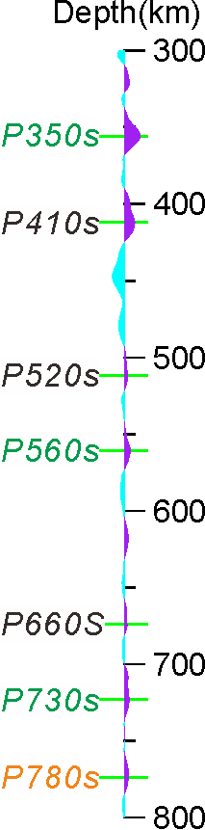 |  |  |  | 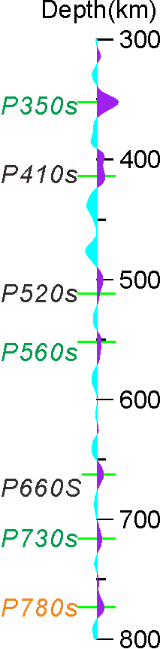
 | 321.25 | 0.00736969 |  |  | 313.75 | 0.00685691
 | 331.25 | -0.00330485
P350S | 355.75 | 0.0221487 |  | P350S | 352.25 | 0.0382021
 | 371.25 | -0.00150361
 | 384.25 | -0.00350885 |  | P410S | 397.75 | 0.0133518
P410S | 412.25 | 0.0148115 |  | P410S | 413.75 | 0.0138384
 | 447.25 | -0.0164337
 | 479.25 | -0.00763163
P520S | 511.75 | 0.00459599 |  | P520S | 500.75 | 0.0108257
 | 527.75 | -0.00324759
P560S | 560.75 | 0.00833266 |  | P560S | 551.75 | 0.00747107
 | 587.25 | -0.00520124 |  |  | 599.75 | 0.00114205
 | 618.75 | 0.00561518
 | 635.25 | -0.000741916 |  |  | 625.25 | 0.00281385
 | 647.75 | -0.00294299
P660S | 673.75 | 0.00401783 |  | P660S | 662.75 | 0.0117146
 | 689.25 | -0.00207868
 | 707.75 | 0.00531691
P730S | 723.25 | 0.0069113 |  | P730S | 715.75 | 0.00854644
 | 739.25 | -0.000148863
 | 744.75 | 0.000514828
 | 754.75 | -0.000336832 |  |  | 752.75 | 0.00302152
P780S | 772.25 | 0.00640409 |  | P780S | 773.25 | 0.0127681
 | 791.75 | -0.00271002
MTZ thickness=261.5km |  |  |  | MTZ thickness=265.0km
P730S/P660S=1.72 P780S/P660S=1.593918 |  |  |  | P730S/P660S=0.729555 P780S/P660S=1.089931
Note: longitude=98.9237°E, latitude=2.6938°N for the station PSPSI.

Extended Data Table S3|End member compositions³⁹ used in the Perple X modeling (in mol%)
Component | Harzburgite  (basalt fraction f=0) | Basalt  (basalt fraction f=1)
SiO₂ | 36.04 | 51.75
MgO | 56.54 | 14.94
FeO | 5.97 | 7.06
CaO | 0.79 | 13.88
Al₂O₃ | 0.65 | 10.19
Na₂O | 0.00 | 2.18

SI References
- Ligorria, J. & Ammon, C. J., 1999. Iterative deconvolution and receiver function estimation. Bull. Seismol. Soc. Am. 89, 1395-1400.
- Saita, T., Suetsugu, D., Ohtaki, T., Takenaka, H., Kanjo, K. & Purwana, I., 2002. Transition zone thickness beneath Indonesia as inferred using the receiver function method for data from the JISNET regional broadband seismic network. Geophys. Res. Lett. 29 (7), 19-1.

