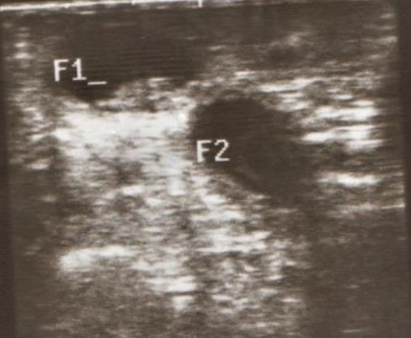
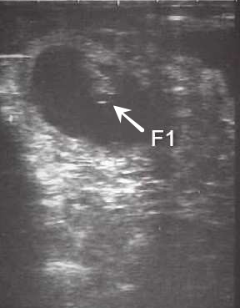
Photo 1. Transrectal ultrasonographic photos of two pregnant does. One had a single embryo at day 32 while the other had twins embryos at day 26.

