Supplementary Figure 2
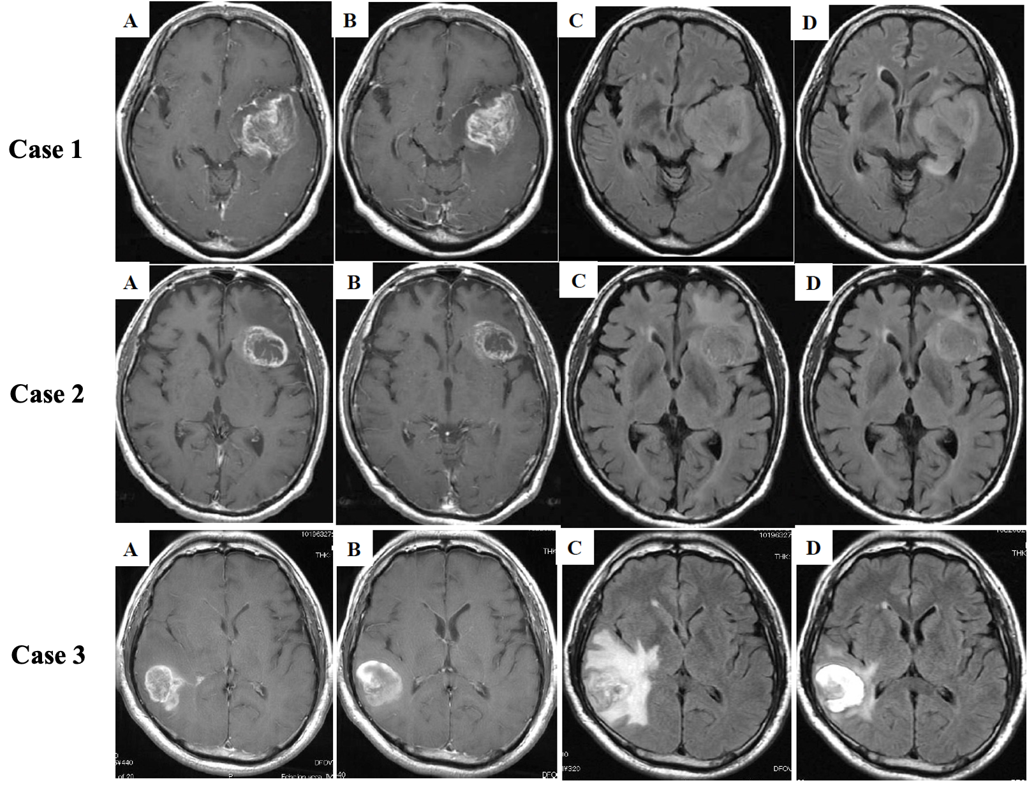
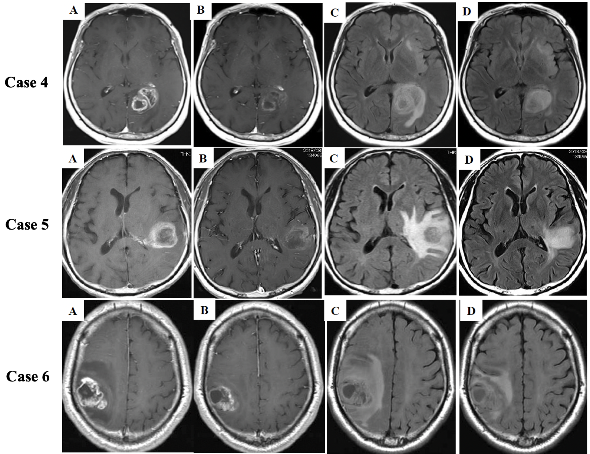
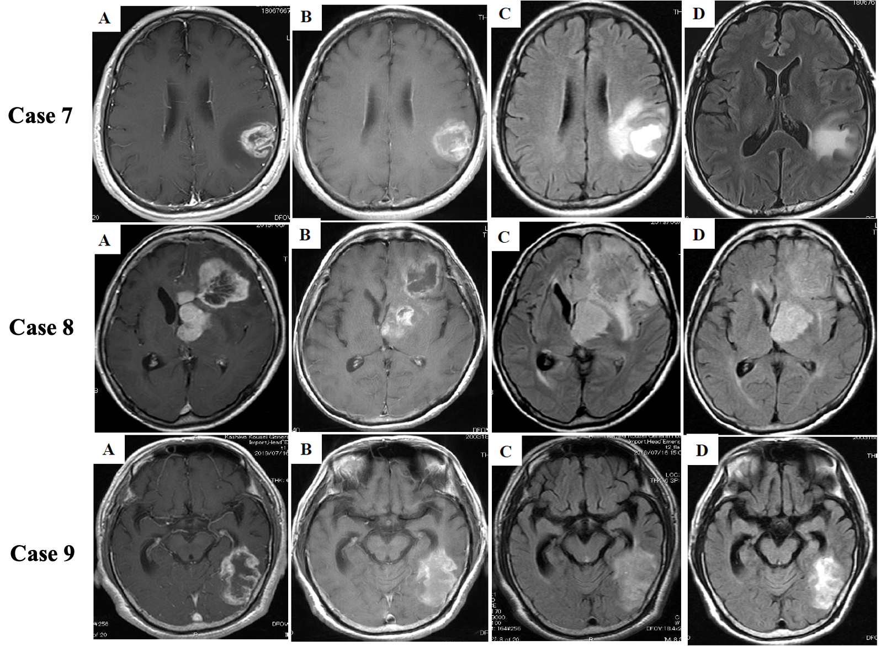
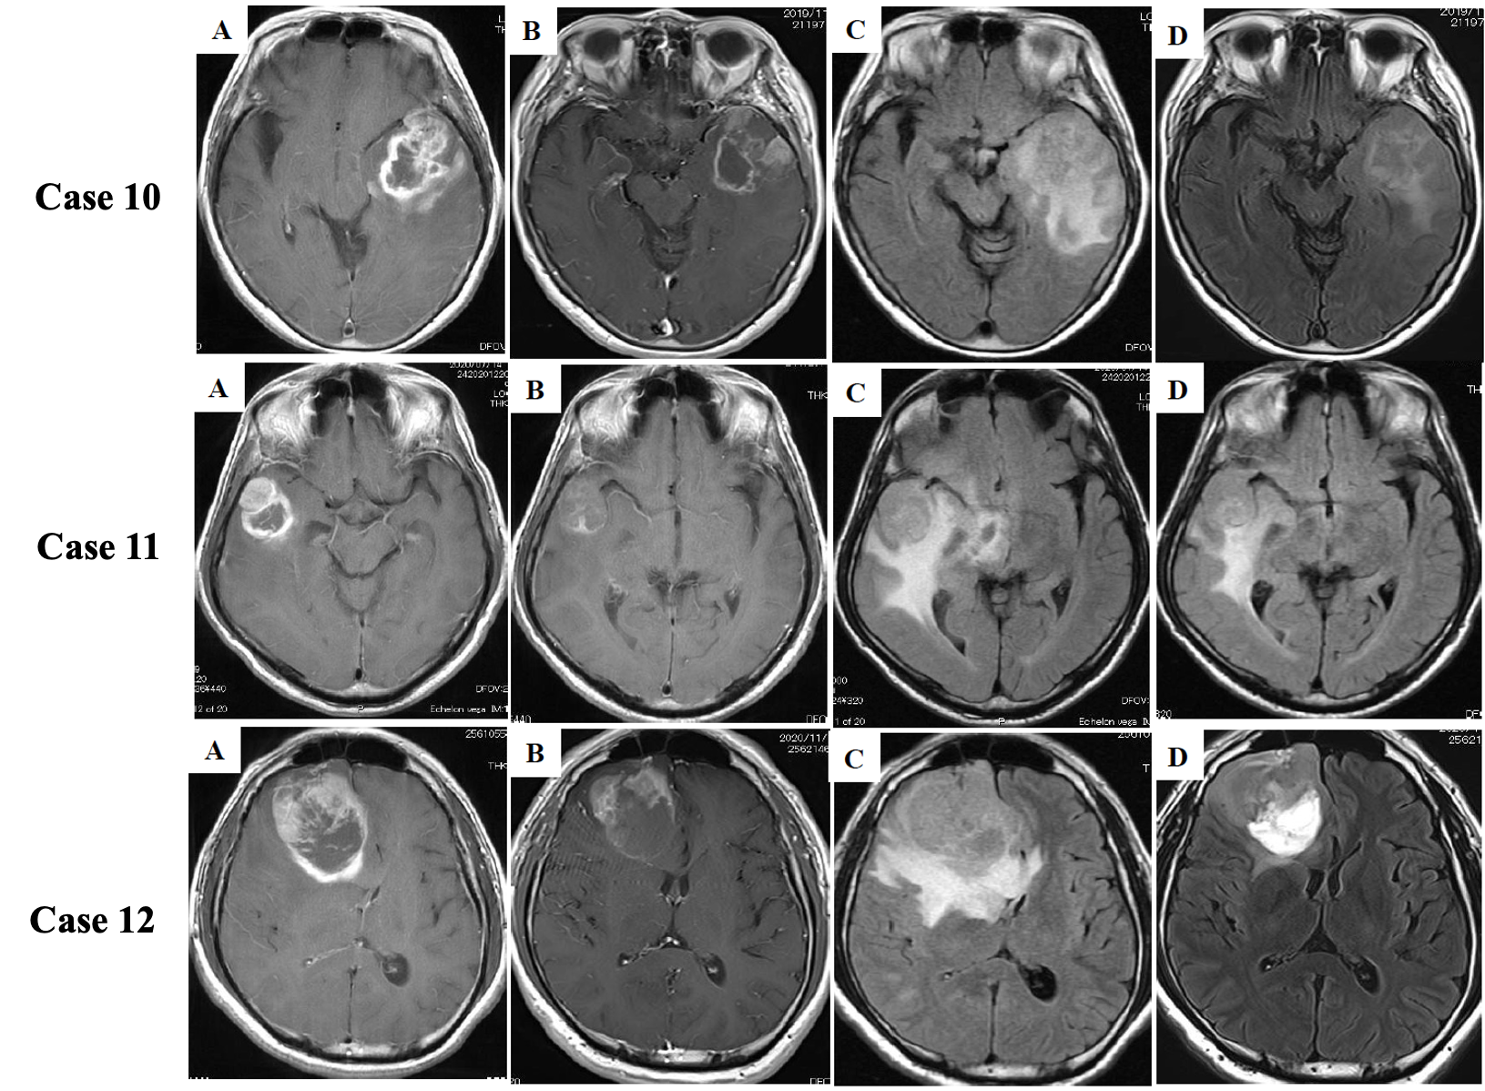
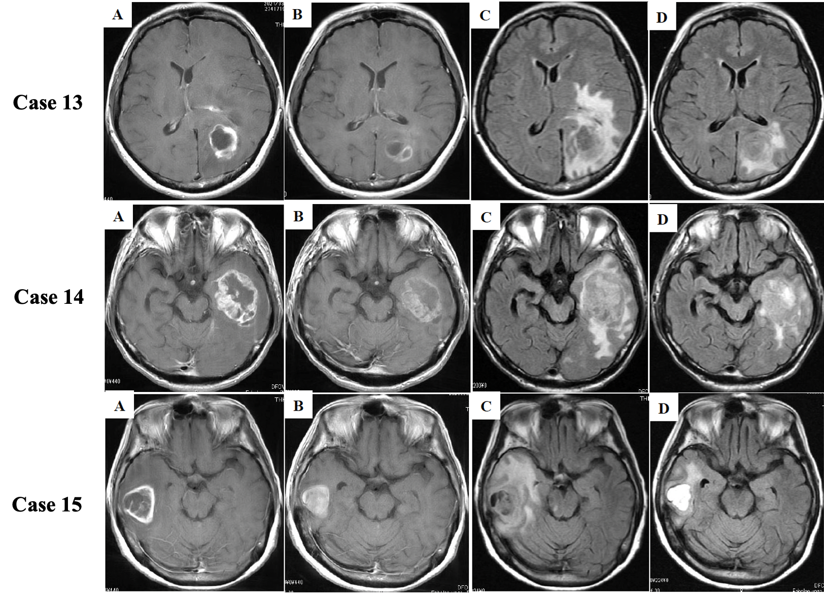

Supplementary Figure 2: T1-weighted contrast-enhanced (T1CE) and fluid attenuated inversion recovery (FLAIR) axial magnetic resonance imagings (MRI) from all patients (Case 1 to 15)
in the present study. (A) Before neoadjuvant bevacizumab (Pre-NeoBev) on T1CE, (B) After neoadjuvant bevacizumab (Post-NeoBev) on T1CE, (C) Pre-NeoBev on FLAIR, and (D) Post-NeoBev on FLAIR.

