Title: Microscale geometrical modulation of PIEZO1 mediated cell mechanosensing via cytoskeletal redistribution buckle
Authors: Haoqing Wang^{1,2,3}, ParhamVatankhah¹, Yao Wang¹, Blake Russel¹, Jasmine Jin¹, Zijing Zhou⁴, Charles D. Cox^{4,5}, Qian Peter Su^{3,6}, Lining Arnold Ju^{1,2,3,7*}
¹ School of Biomedical Engineering, The University of Sydney, Darlington, NSW 2008, Australia
² Charles Perkins Centre, The University of Sydney, Camperdown, NSW 2006, Australia
³ Heart Research Institute, Camperdown, Newtown, NSW 2042, Australia
⁴ Molecular Cardiology and Biophysics Division, Victor Chang Cardiac Research Institute, Sydney, NSW 2010, Australia
⁵ Faculty of Medicine, St. Vincent’s Clinical School, University of New South Wale, Sydney, NSW 2010, Australia
⁶ School of Biomedical Engineering, University of Technology Sydney, Sydney, NSW 2007, Australia
⁷ The University of Sydney Nano Institute (Sydney Nano), The University of Sydney, Camperdown, NSW 2006, Australia

* Correspondence: arnold.ju@sydney.edu.au, qian.su@uts.edu.au

The supporting material contains:
Materials
Supplementary Figures S1-S10

Materials
Chemicals
Name | Source | Catalog Number
Cal-520 AM | Abcam | ab171868
Yoda1 | Cayman Chemical Company | 21904
Latrunculin A | Abcam | ab144290
CK-666 | Sigma-Aldrich | 182515
Jasplakinolide | Life Technologies | J7473
Y-27632 | Sapphire Bioscience | S1049
SPY650-FastAct | Spirochrome | SC505
DMSO, Anhydrous | Thermo Fisher Scientific | D12345
GsMTx4 | Abcam | ab141871
Gadolinium(III) chloride | Sigma-Aldrich | 439770
RPMI Medium 1640 | Thermo Fisher Scientific | 22400-089
Fetal Bovine Serum | Thermo Fisher Scientific | 26140-079
TrypLETM Express | Thermo Fisher Scientific | 12604-021
Human Fibronectin | Thermo Fisher Scientific | 33016-015
Penicillin/Streptomycin | Thermo Fisher Scientific | 15140122
DPBS | Thermo Fisher Scientific | 14040133
Sodium bicarbonate | Sigma-Aldrich | S9638
HEPES | Sigma-Aldrich | H3375
Sodium carbonate | Sigma-Aldrich | S2127
D-(+)-Glucose | Sigma-Aldrich | G7021
Sodium chloride | Sigma-Aldrich | S7653
Potassium chloride | Sigma-Aldrich | P9541

Figure S1 Micropipette orifice diameter and tip angle distribution
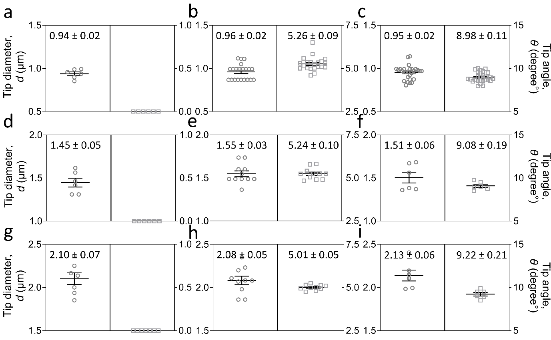
The distribution of micropipette tip angle (right) distribution in this study when tip diameter (left) was set to be 1 μm (a-c), 1.5 μm (d-f), and 2 μm (g-i), respectively. At least six independent experiments were recorded on individual days to obtain the mean of tip diameter and angle and the error bar represents s.e.m.
Figure S2 Drug validation on PIEZO1-mediated Ca²⁺ influx.
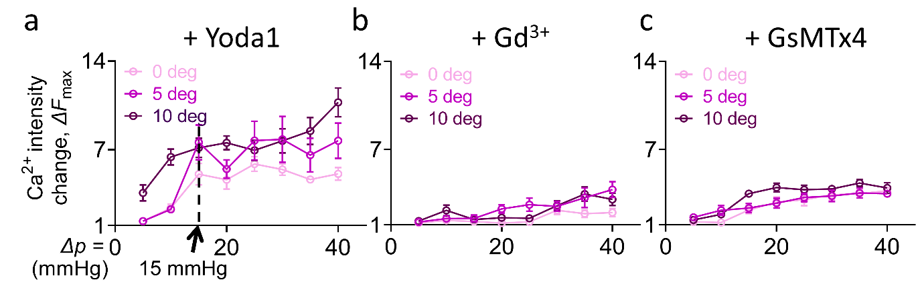
a Piezo1 agonist sensitized RBC calcium-dependent mechanosensing. ∆F_{max}–∆p curve was plotted over the pressure range ∆p = -5 to -40 mmHg. 0.5 μM Yoda1 was flushed into the RBC cell solution before fMPA. Ca²⁺ intensity at low-pressure range was enhanced (-15mmHg, arrow pointed), indicating Yoda1 induced a much lower gating threshold of the calcium influx. b Calcium influx is mediated by ion channels. 50 μM Gd³⁺ blocking suppressed the Ca²⁺ ∆F_{max} across all pressure, indicating the ∆F_{max} is due to the Calcium influx via the ion channels. c The ion channel is membrane tension dependant PIEZO1. After incubation with 2.5 μM GsMTx4, the calcium influx was suppressed by relieved membrane tension. At least ten cells’ responses were measured at each condition to obtain mean ± s.e.m.
Figure S3 Muffled the calcium influx in transgenic Piezo1-KO^{RBC}
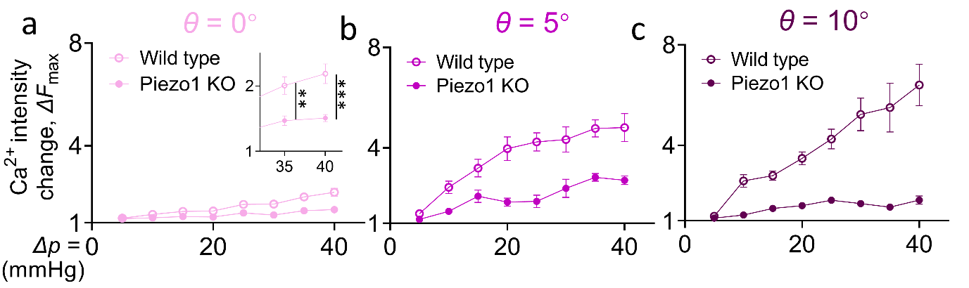
WT and Piezo1-KO^{RBC} were collected from the mice whole blood. fMPA assay was then performed with θ = 0° (a), 5° (b), and 10° (c) micropipette. Ca²⁺ ∆F_{max} exhibited a similar trend over the aspiration pressure range in mice WT RBC (hollow circle) compared to human RBC (Figure 2a), while the response was inhibited in the Piezo1-KO^{RBC} (solid circle). At least ten cells’ responses were measured at each condition to obtain mean ± s.e.m. ** = p < 0.01; *** = p < 0.001, assessed by unpaired, two-tailed Student’s t-test.
Figure S4 Aspirated cell body-to-tongue ratio at all pressure (corresponding to Fig. 2h)
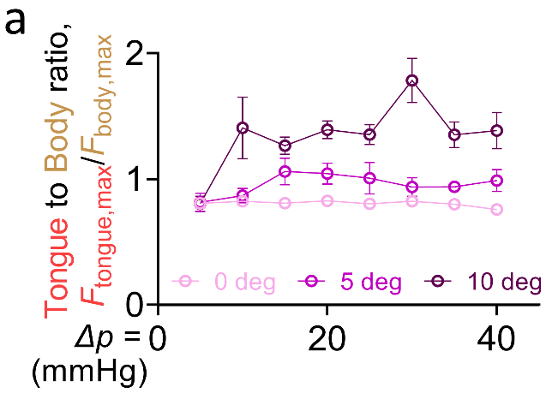
RBC was aspirated by θ = 0° (pink), 5° (magenta) and 10° (purple) micropipette at aspiration pressure ∆p = -5 to -40 mmHg. The difference was not obvious when ∆p = -5 mmHg, implying the aspiration-induced membrane tension change was comparable across all tip angles. However, a noticeable difference was observed across tip angles when the aspiration pressure increased to -15 mmHg and the trend remains the same across the rest of the pressure range. More than 10 cells were aspirated under every condition to obtain mean ± s.e.m.
Figure S5 High local membrane tension induces dumbbell morphology in aspirated RBC
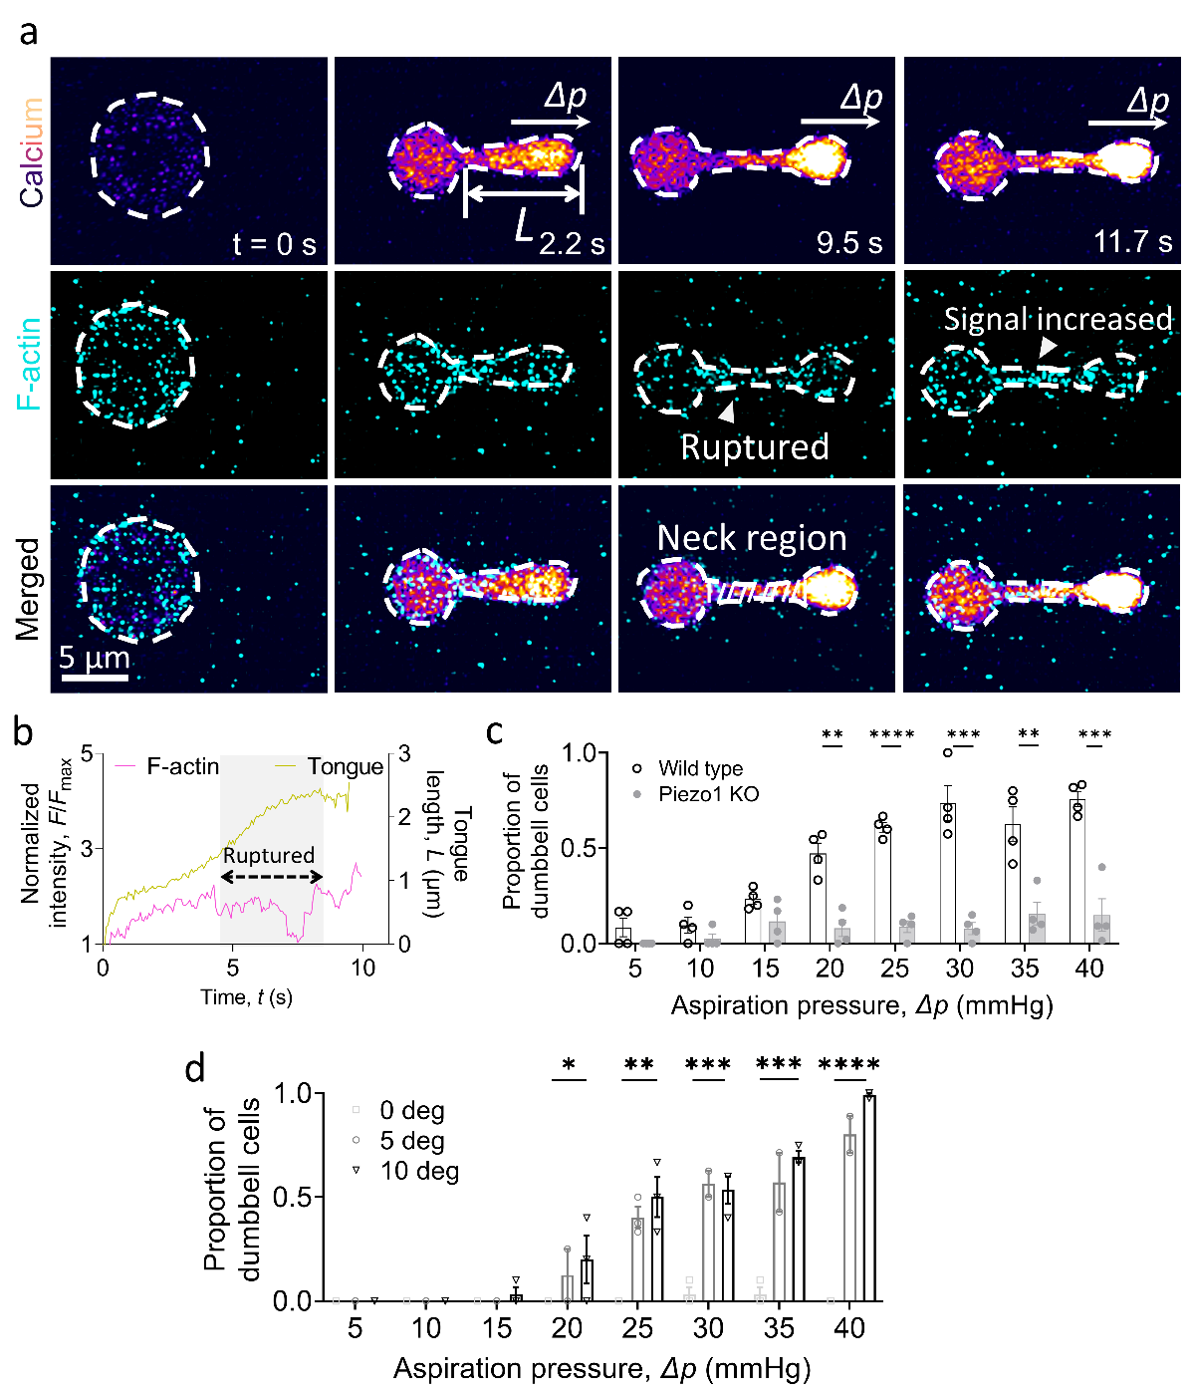
a Representative snapshot of RBC being aspirated by a θ = 10° micropipette. The calcium (top), F-actin (middle) were concurrently captured on the FV3000 confocal microscope. b When the cell was aspirated by ∆p = -40 mmHg, a dumbbell morphology was formed which is signed by a sudden increase in the tongue length, L. The F-actin rupture was indicated by a sudden decrease of the signal during the tongue length increase. c The proportion of bottlenecked cells is PIEZO1 level dependant. When Piezo1-KO^{RBC} was aspirated by the θ = 10° micropipette, a limited number of cells exhibited dumbbell morphology at all pressure. d The dumbbell morphology is mechanical force dependent. Higher tip angles and higher aspiration pressure induced more dumbbell morphology cells. At least three mice samples for each phenotype were tested to obtain mean ± s.e.m. * = p < 0.05; ** = p < 0.01; *** = p < 0.001; **** = p < 0.0001, assessed by unpaired, two-tailed Student’s t-test.
Figure S6 Calcium influx in HEK293T cells is PIEZO1 mediated (corresponding to Fig. 4b).
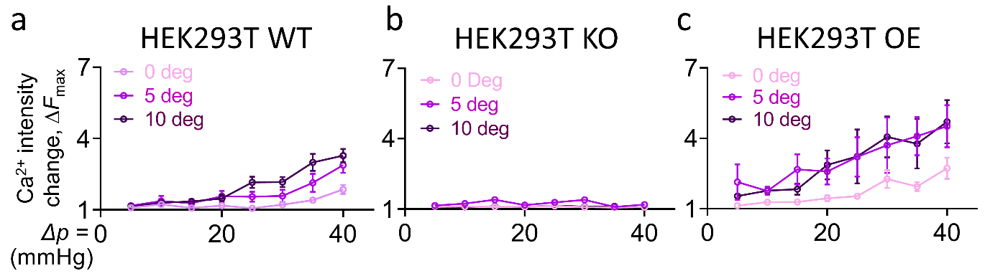
fMPA aspiration assay was performed on WT (a), PIEZO1-KO (b), and PIEZO1-OE (c) HEK293T cells respectively. Calcium influx was completely inhibited when PIEZO1 was eliminated in HEK293T cells¹. In sharp contrast, the response was upregulated by the PIEZO1 expression level. These results demonstrated the calcium influx in the HEK293T cell during fMPA assay was PIEZO1 mediated. At least six cells at all conditions were measured to obtain mean ± s.e.m.

Figure S7 F-actin accumulation is mediated by aspiration force and PIEZO1 expression level dependent.
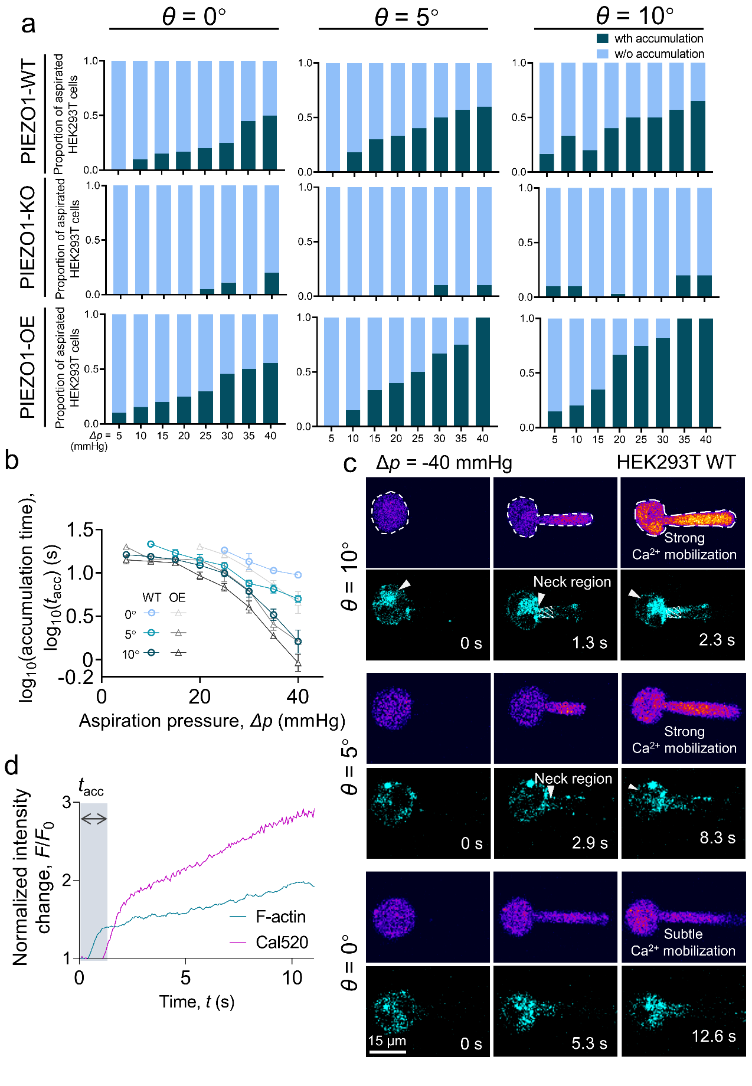
a Full data set of the proportion of aspirated Wild type, PIEZO1-KO, and PIEZO1-OE HEK293Tcells with F-actin accumulation (corresponding to Figure 4c). b Full data set of the F-actin accumulation time of aspirated WT and Piezo1-OE HEK293T (corresponding Figure 4f). All data are shown in mean ± s.e.m. d Representative snapshot of HEK293T WT cell aspirated by θ = 0° (bottom), 5° (middle), and 10° (top) micropipette. The Ca²⁺ and F-actin signal was imaged concurrently while the whole cell Ca²⁺ intensity and F-actin signal inside the neck region was quantified over time. d Representative trace of F-actin signal inside the neck region and Ca²⁺ signal of the whole cell over the aspiration process. F-actin accumulation time was measured from the aspiration starts until the F-actin signal in the neck region increase more than 1.5 fold and stabilize for more than 2 seconds. It is noticed that a Ca²⁺intensity rapid increase happened after F-actin accumulation, indicating that F-actin played a vital role in strong Ca²⁺ mobilization.
Figure S8 Full Ca²⁺ ∆F_{max}–∆p curve of fMPA aspiration on F-actin restricted HEK293T WT cells (corresponding to Fig. 5d)
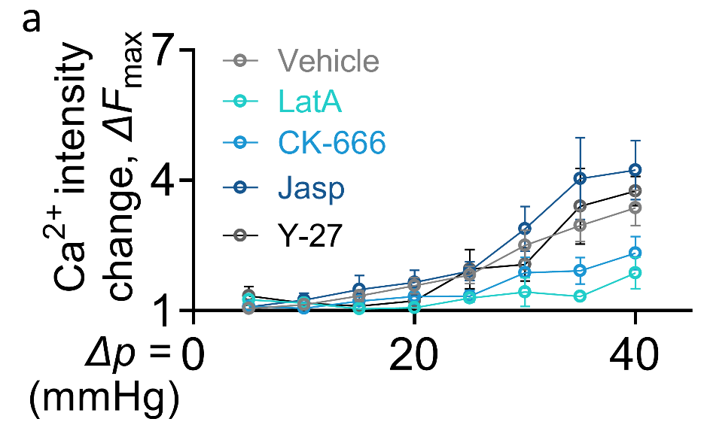
HEK293T WT cells were treated with 1:500 DMSO (Vehicle), 100 μM CK-666, 2.5 μM Latrunculin A (LatA), 10 μM Jasplakinolide (Jasp), and 50 μM Y-27632 (Y-27), respectively, before fMPA was performed. LatA and CK-666 treatment significantly suppress calcium mobilization compared to vehicle-treated ones. In contrast, Jasp stabilized the F-actin structure and further amplified the calcium influx in the aspirated cells at high pressure. F-actin contractility inhibition led to limited effect, indicating that the role of F-actin in PIEZO1 activity amplification is independent of cytoskeleton contractility.

Figure S9 Full Ca²⁺ ∆F_{max}–∆p curve of fMPA aspiration on adhered and suspended HEK293T WT (corresponding to Fig. 6f)
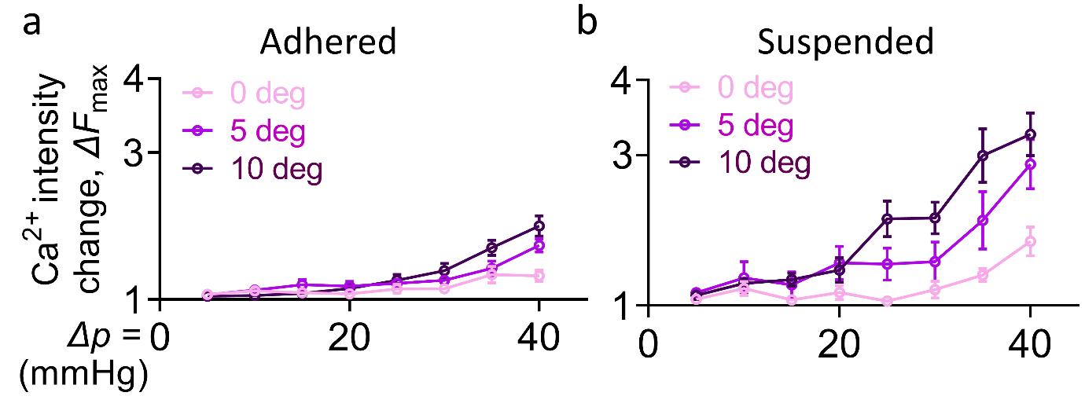
HEK293T cells were aspirated when they were attached to an FN-coated cover glass (a) or suspended in the Tyrode’s buffer (b). Lower Ca²⁺ ∆F_{max} was noticed for adhered cells, indicating that restraining F-actin from moving towards the micropipette tip would prevent the PIEZO1 activity amplification.

Figure S10 Schematic of multi-stage micropipette pulling
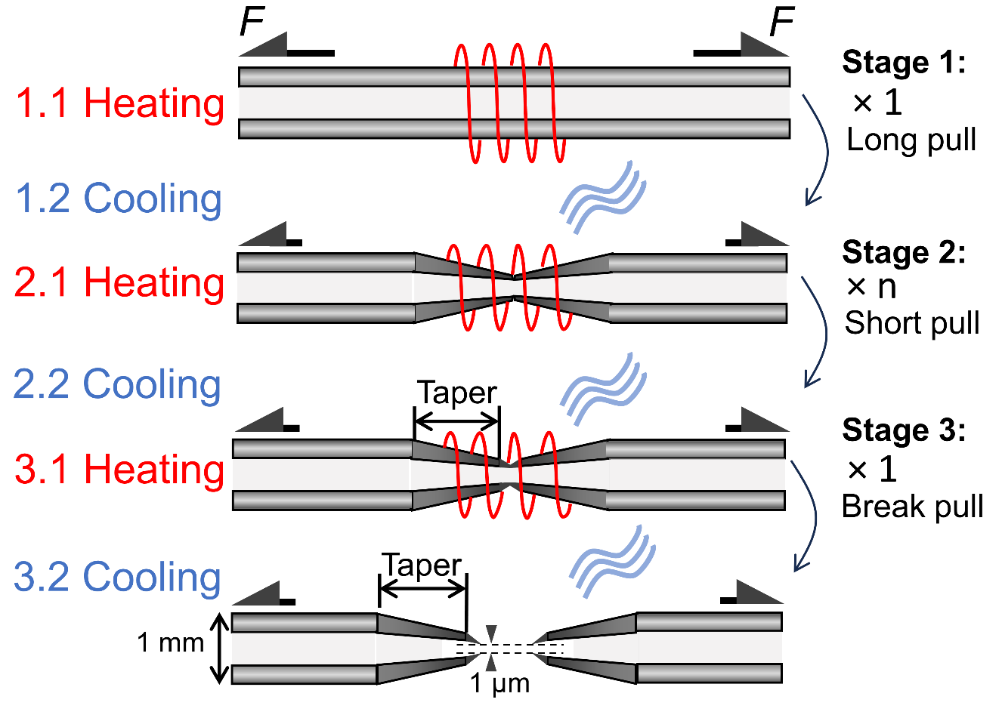
To pull an angled opening micropipette with enough taper length, the glass capillary was mounted on the micropipette puller to perform multi-stage pulling. A constant heat (termed ‘Heat’) was applied by the filament in the middle (red) to turn glass into fluid while the pulley at either end would apply a constant force (F) to slowly pull the capillary apart. When the sensor detected the moving velocity of the pulley reached the preset value (termed ‘Velocity’), the heating would stop, and a strong pressure (termed ‘Pressure’) airflow was facilitated to cool the glass down. In Stage 1, a long pull was utilized to obtain a long taper in the fabricated micropipette, achieved by presetting the Velocity to a high value without breaking the glass. After cooling down, several short pulls were applied in Stage 2 (i.e., low Velocity) to finely fabricate the micropipette into detailed geometries. At last, a slightly longer pull was applied in Stage 3 to give a clean cut between fabricated micropipettes. Detailed parameters are listed in Table 1.

References
1 Dubin, A. E. et al. Endogenous Piezo1 Can Confound Mechanically Activated Channel Identification and Characterization. Neuron 94, 266-270 e263 (2017). https://doi.org:10.1016/j.neuron.2017.03.039

