Supplementary figure 1. ROC curves for predicting AL after esophagectomy 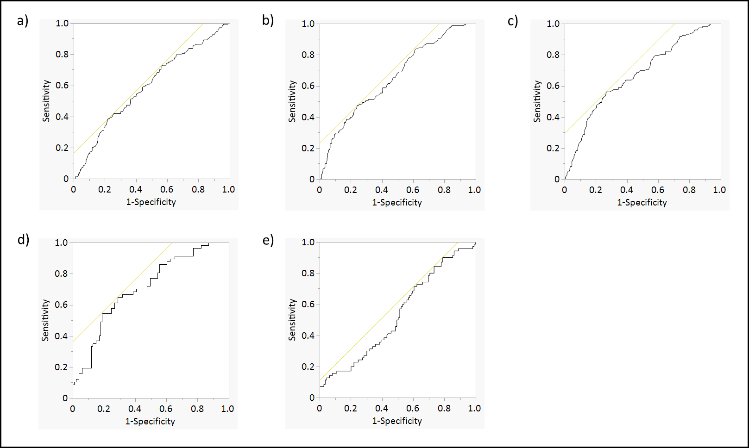

a) CRP on POD 2 (AUC=0.594)
b) CRP on POD 3 (AUC=0.654)
c) CRP on POD 4 (AUC=0.669)
d) Trends in CRP 2 to 3 in patients above the cutoff value of CRP 211 mg/L on POD 2 (AUC=0.709)
e) Trends in CRP 3 to 4 in patients above the cutoff value of CRP 222 mg/L on POD 3 (AUC=0.532)
ROC, receiver operating characteristics; AL, anastomotic leakage; CRP, C-reactive protein; POD, postoperative day; AUC, area under the curve

Supplementary figure 2. ROC curves for predicting severe complications after esophagectomy
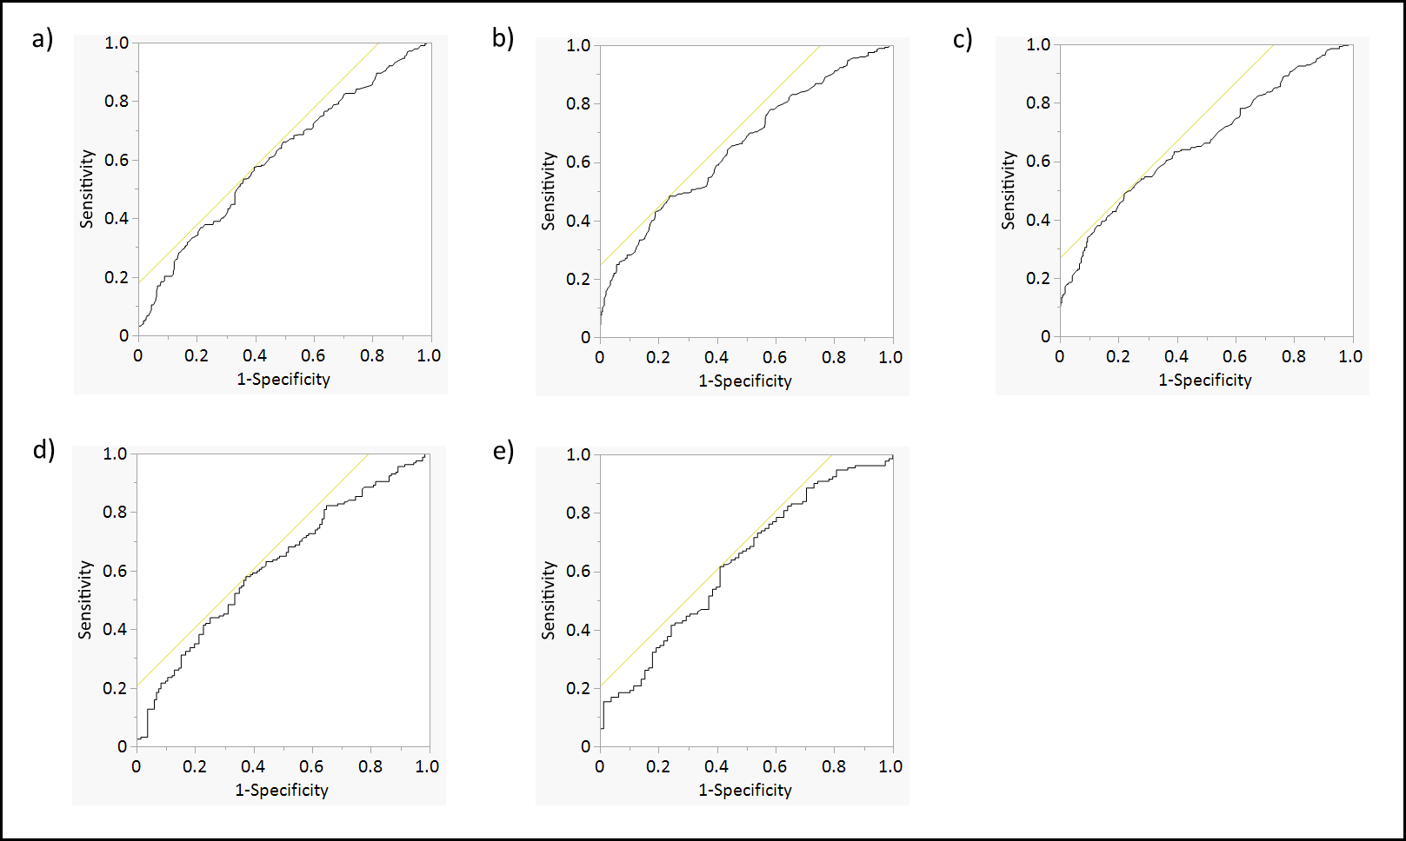
a) CRP on POD 2 (AUC=0.607)
b) CRP on POD 3 (AUC=0.655)
c) CRP on POD 4 (AUC=0.668)
d) Trends in CRP 2 to 3 in patients above the cutoff value of CRP 161 mg/L on POD 2 (AUC=0.616)
e) Trends in CRP 3 to 4 in patients above the cutoff value of CRP 208 mg/L on POD 3 (AUC=0.636)
ROC, receiver operating characteristics; CRP, C-reactive protein; POD, postoperative day; AUC, area under the curve

Supplementary Table 1. Risk of anastomotic leakage in patients above the cutoff value of CRP 211 mg/L on POD 2
 | Univariable analysis |  |  |  | Multivariable analysis
 | OR | 95% CI | p value |  | OR | 95% CI | p value
Age | 0.98 | - | 0.218 |  | 1.01 | 0.96-1.05 | 0.696
Sex
Male | 1.00 | - | - |  | 1.00 | - | -
Female | 0.55 | 0.20-1.47 | 0.229 |  | 0.81 | 0.25-2.40 | 0.706
BMI | 0.95 | - | 0.163 |  | 1.00 | 0.91-1.08 | 0.805
ASA score
1 | 1.00 | - | - |  | 1.00 | - | -
2 | 0.84 | 0.35-2.02 | 0.703 |  | 1.00 | 0.35-2.91 | 0.985
3 | 3.07 | 1.23-7.67 | 0.015 |  | 3.33 | 1.05-11.2 | 0.041
Clinical T factor
0-2 | 1.00 | - | - |  | 1.00 | - | -
3 | 1.13 | 0.49-2.60 | 0.782 |  | 1.29 | 0.38-4.60 | 0.680
4 | 0.71 | 0.23-2.21 | 0.551 |  | 1.10 | 0.23-5.23 | 0.904
Clinical N factor
0 | 1.00 | - | - |  | 1.00 | - | -
1 or more | 0.66 | 0.34-1.28 | 0.219 |  | 0.77 | 0.31-1.92 | 0.574
Neoadjuvant treatment
None | 1.00 | - | - |  | 1.00 | - | -
Chemotherapy | 0.44 | 0.18-1.05 | 0.061 |  | 0.48 | 0.15-1.46 | 0.199
Chemoradiotherapy | 0.89 | 0.41-1.91 | 0.762 |  | 0.78 | 0.26-2.28 | 0.647
Surgical approach
Open | 1.00 | - | - |  | 1.00 | - | -
Hybrid | 1.90 | 0.57-6.37 | 0.296 |  | 1.63 | 0.35-7.18 | 0.525
MIE | 1.93 | 0.91-4.11 | 0.085 |  | 1.39 | 0.51-3.81 | 0.519
Type of operation
McKeown | 1.00 | - | - |  | 1.00 | - | -
Ivor Lewis | 1.28 | 0.62-2.64 | 0.506 |  | 1.17 | 0.48-2.84 | 0.735
Transhiatal | 1.30 | 0.45-3.73 | 0.622 |  | 0.70 | 0.15-2.86 | 0.621
Trend in CRP between POD 2-3
4.65% < | 1.00 | - | - |  | 1.00 | - | -
4.65% or more | 4.59 | 2.29-9.19 | <0.001 |  | 3.67 | 1.66-8.38 | 0.001
CRP, C-reactive protein; POD, postoperative day; OR, odds ratio; CI, confidence interval; BMI, body mass index; ASA-PS, the American Society of Anesthesiologists physical status classification; MIE, minimally invasive esophagectomy

