Supplementary Information for

Observed northward shift of large hailstorms in the eastern United States since 2000
Jimin Liu^{1,2,3}, Jeremy Cheuk-Hin Leung³*, Hong Huang⁴*, Daosheng Xu³, Weijing Li³, Weihong Qian^{3,5}, Banglin Zhang^{1,2,3}
Affiliations
¹ College of Atmospheric Sciences, Lanzhou University, Lanzhou, China
² Department of Atmospheric Science, School of Environmental Studies, China University of Geosciences, Wuhan, China
³ Guangzhou Institute of Tropical and Marine Meteorology/Guangdong Provincial Key Laboratory of Regional Numerical Weather Prediction, CMA, Guangzhou, China
⁴ College of Meteorology and Oceanography, National University of Defense Technology, Changsha, China
⁵ Department of Atmospheric and Oceanic Sciences, Peking University, Beijing, China

Supplementary figures

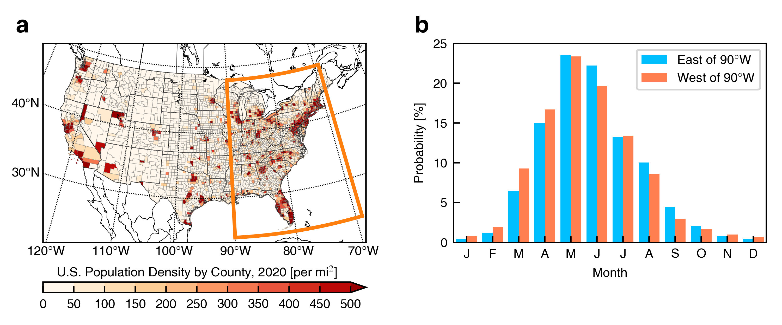
Figure S1 | Population density and hail season in the eastern US. a, Spatial distribution of the US population density (unit: people mi⁻²) in 2020, according to the United States Counties Database. The orange box marks the eastern US (east of 90°W), the region of interest in this study. b, Occurring probability (unit: %) of all hail events (d_{hail} ≥ 0.75) reported over the eastern US (blue bars) and the remaining US (orange bars, except Alaska and Hawaii) in each month from 2000–2022.

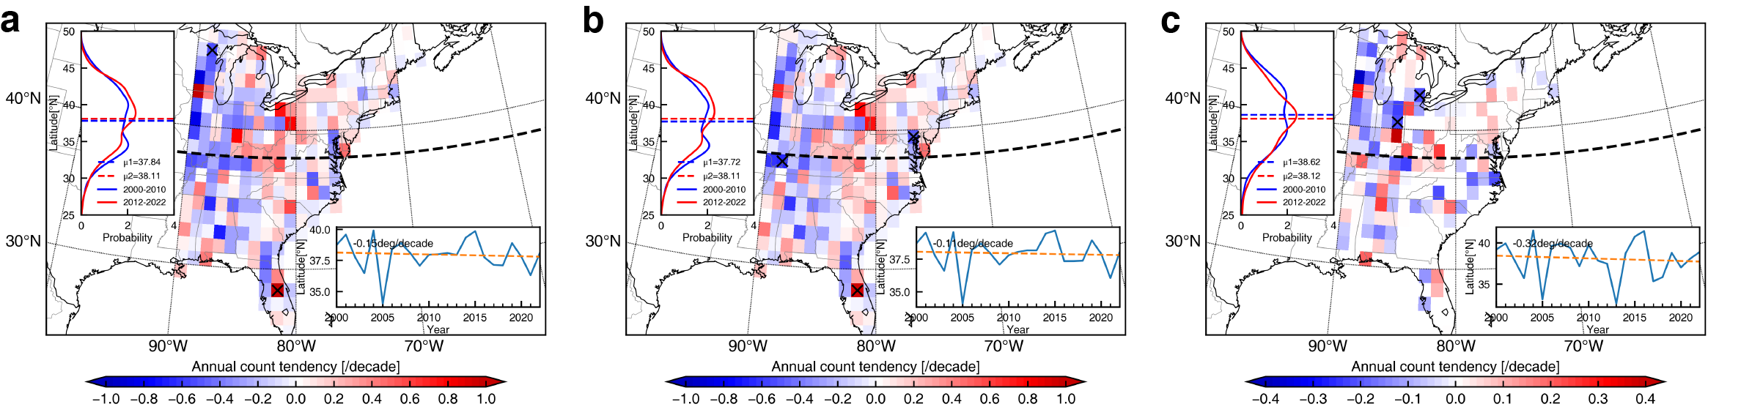
Figure S2 | Changes in the spatial distribution of significant and extreme hail events over the eastern US. a–c, Spatial distribution of tendencies in occurrence frequency (shading, unit: counts/decade, with meshed areas denoting significant tendencies at the 95% confidence level) for hail events with d_{hail} ≥ 2 (a), 2 ≤ d_{hail} < 3 (b), and d_{hail} ≥ 3 (c). Inset includes the average latitude time series (bottom-right, unit: °N) and the differences (bars) of the PDFs (curves, unit: %) between 2000–2010 and 2012–2022 (top-left). The PDF differences in panels (a–b) are statistically significant at the 90% confidence level. The black dashed lines denote the boundary (38°N) between the northeastern and southeastern US.

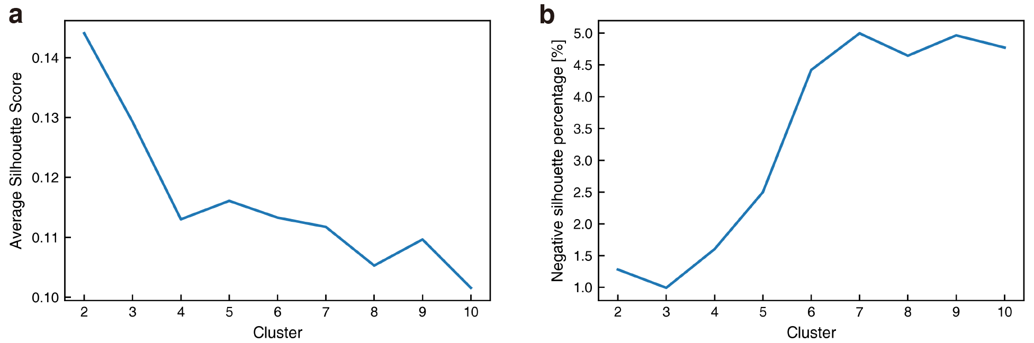
Figure S3 | Determination of the number of hail-favoring weather types in the clustering calculation. a–b, Average silhouette score (a) and negative silhouette percentage (b) against the number of clusters in the K-Means clustering calculation of hail-favoring weather types.

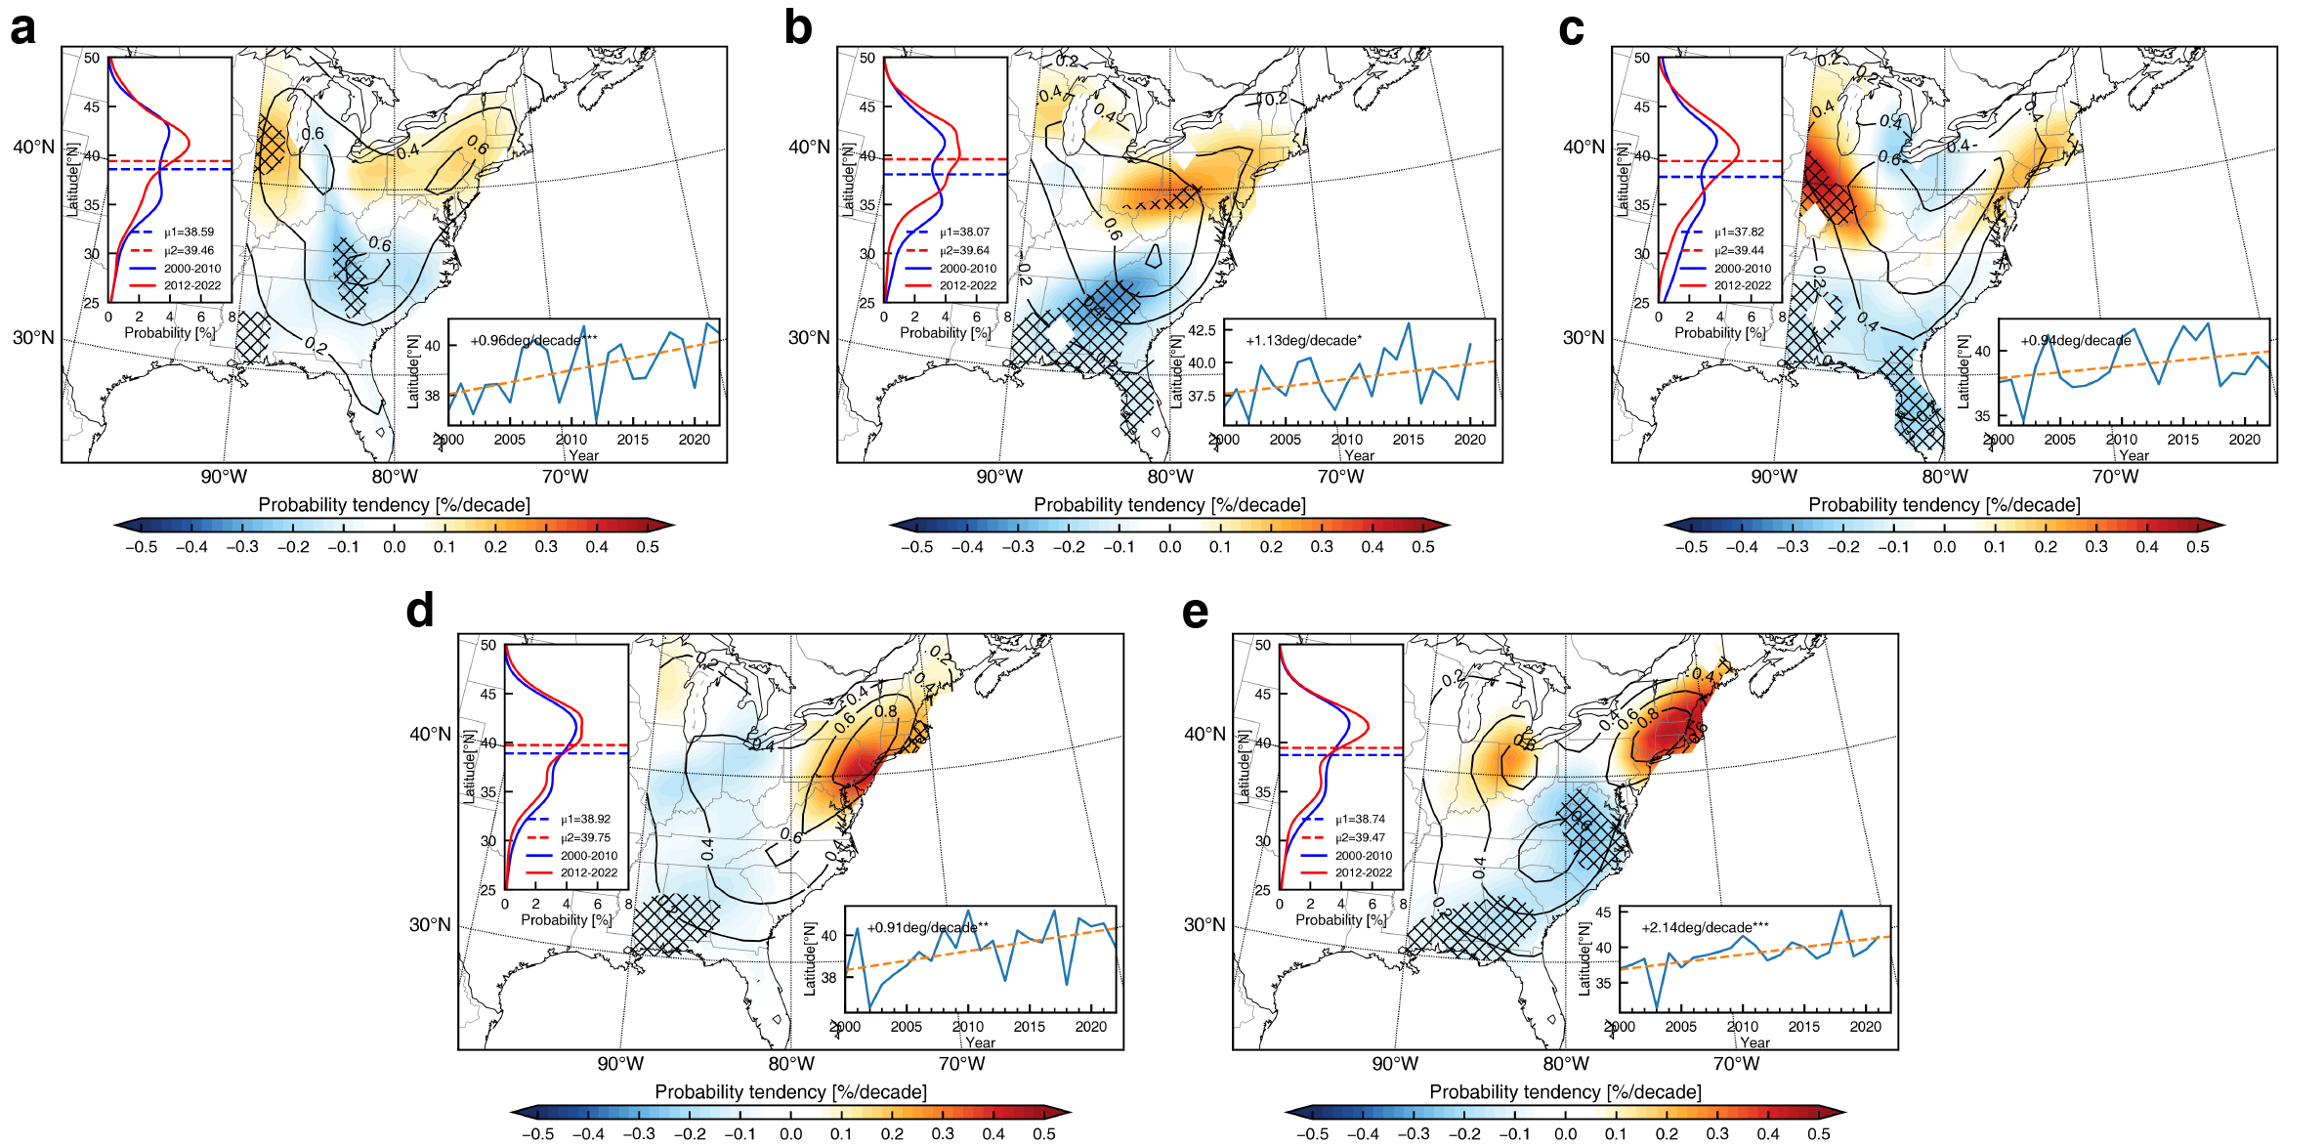
Figure S4 | Change in hail activity of each hail-favoring weather type. a–e, SPDF tendency (shading, unit: % decade⁻¹, with meshed areas denoting significant tendencies at the 95% confidence level) for Type 1 (a), Type 2 (b), Type 3 (c), Type 4 (d), and Type 5 (e). Inset includes the average latitude time series (bottom-right, unit: °N) and the differences (bars) of the PDFs (curves, unit: %) between 2000–2010 and 2012–2022 (top-left). The PDF differences in all panels are statistically significant at the 99% confidence level. The results show that increasing latitudes of hail events are observed in all hail-favoring weather types, which indicates that the northward shift of northeastern US hailstorms may be caused by changes in the atmospheric climatic state.

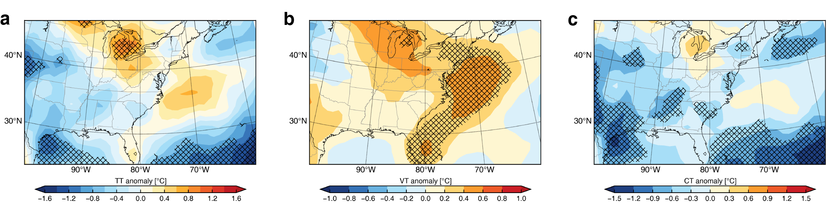
Figure S5 | Spatial changes in atmospheric instability from 2000–2010 to 2012–2022. a–c, Changes in TT (a, unit: °C), VT (b, unit: °C), and CT (c, unit: °C) from 2000–2010 to 2012–2022. Hatch marks denote significant changes in variables at the 95% confidence level.

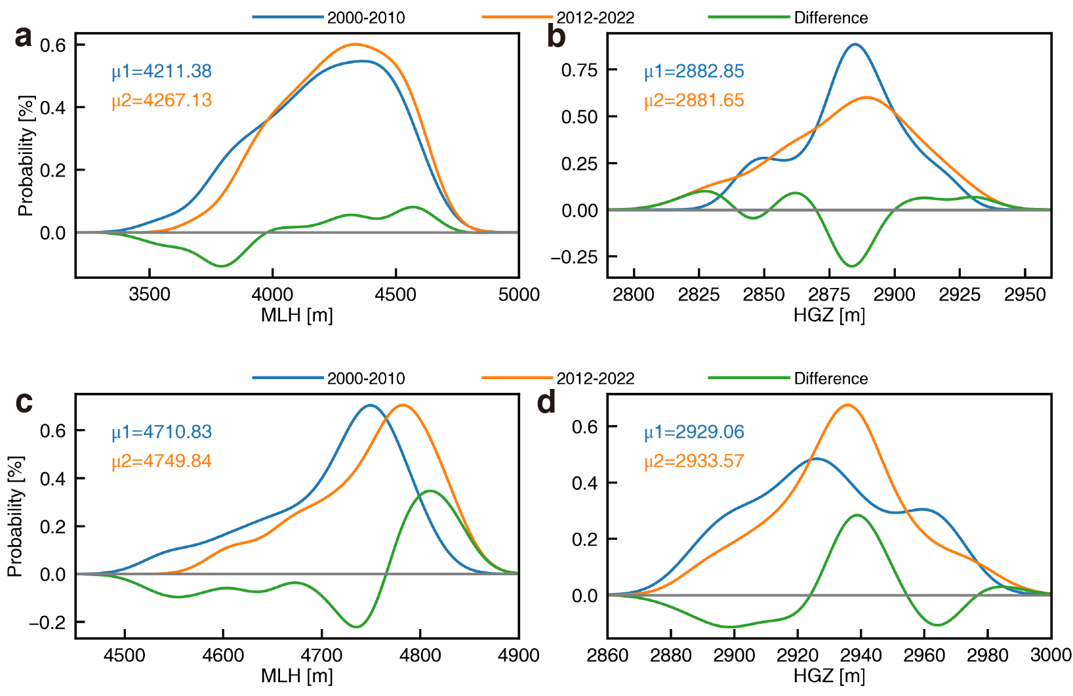
Figure S6 | Changes in MLH and HGZ over the eastern US from 2000–2010 to 2012–2022. a–b, PDFs of the MLH (unit: m) (a) and HGZ (unit: m) (b) over the northeastern US in 2000–2010 (blue line) and 2012–2022 (orange line). The green curves denote their differences. c–d, Same as (a–b), except over the southeastern US. The changes in PDFs in (a–d) are all statistically significant at the 90% confidence level. Analysis of the results show that the more frequent extreme MLH occurrence and reduced HGZ variance are both unfavorable for hail activity in the southeastern US.

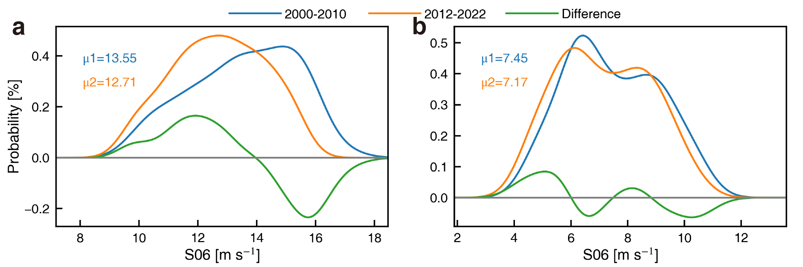
Figure S7 | Changes in vertical wind shear over the eastern US from 2000–2010 to 2012–2022. a–b, PDFs of vertical wind shear (unit: m s⁻¹) over the northeastern (a) and southern (b) US in 2000–2010 (blue line) and 2012–2022 (orange line). The green curves denote their differences. The PDF change in (a) is statistically significant at the 99% confidence level.

