Table 2. Comprehensive molecular docking results of the reference dabrafenib and top-hit natural compounds.
Compound name | Structure | Semi-flexible docking score | Flexible docking score | Interacting residues | H-bond | H-bond number
Dabrafenib | 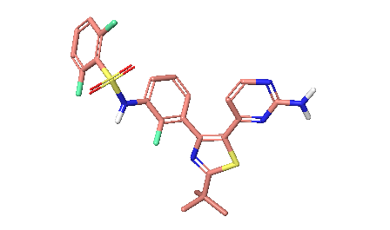 | -8.909 | -9.071 | Lys38, Ile40, Gly41, Arg42, Gly43, Ser46, Val48, Ala61, Ile95, Leu111, Glu112, Leu113, Ala114, Asp115, Gly117, Arg121, Phe168, and Asp179 | ILE40, GLU112 | 2
Scutellarin | 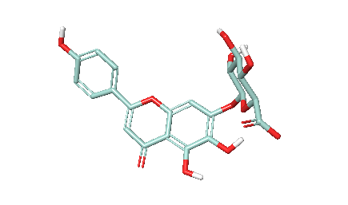 | -10.016 | -11.547 | Ile40, Gly41, Arg42, Gly43, Gln44, Phe45, Ser46, Val48, Ala61, Lys63, Ile95, Leu111, Glu112, Leu113, Ala114, Asp115, Lys163, Phe168, Asp179, Leu 180, and Thr199 | GLN44, SER46, GLU112, ALA114, ASP179, LEU180 | 6
Digallic acid | 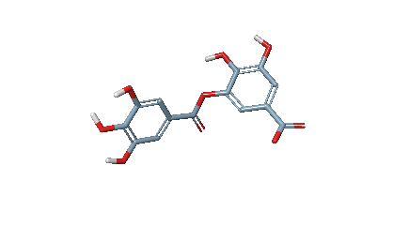 | -11.684 | -13.059 | Ile40, Val48, Ala61, Ile95, Leu111, Glu112, Leu113, Ala114, Asp115, Lys163, Asn166, Phe168, Gly178, Asp179, Leu 180, and Thr199 | GLU112, ALA114, LYS163, ASN166, ASP179 | 6
(-)-Balanol | 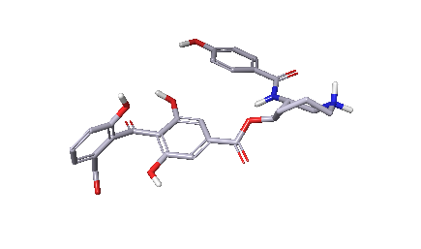 | -12.319 | -15.054 | Ile40, Gly41, Arg42, Gly43, Gln44, Phe45, Ser46, Val48, Ala61, Lys63, Ile95, Leu111, Glu112, Leu113, Ala114, Asp115, Gly117, Asp118, Arg121, Lys163, Phe168, Gly178, Asp179, Leu 180, and Thr199 | PHE45, SER46, ALA114, ASP115, ASP179 | 7

