In silico study to identify novel NEK7 inhibitors from natural source by a combination strategy

Heng Zhang ª, Yu Wang ª, Chenhong Lu ª, Qingcai Jiao ^{a, *}

ª State Key Laboratory of Pharmaceutical Biotechnology, School of Life Sciences, Nanjing University, Nanjing, 210023, China
* Corresponding author
E-mail addresses: jiaoqingcai@126.com (Q. Jiao).

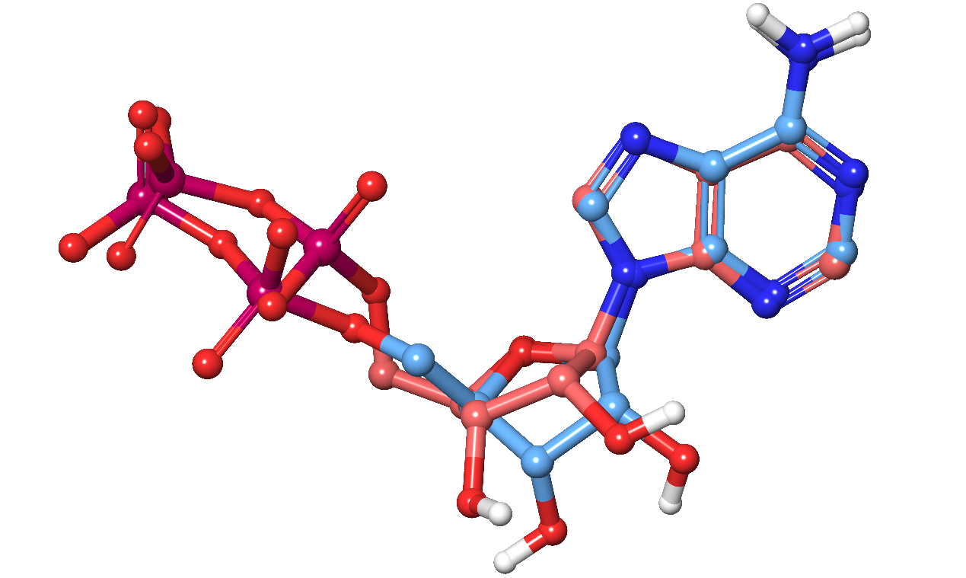
Fig. S1 Comparative overlay of the initial and the re-docked ligand. The initial ligand is depicted in red, while the re-docked ligand, post-optimization of parameters, is illustrated in blue.

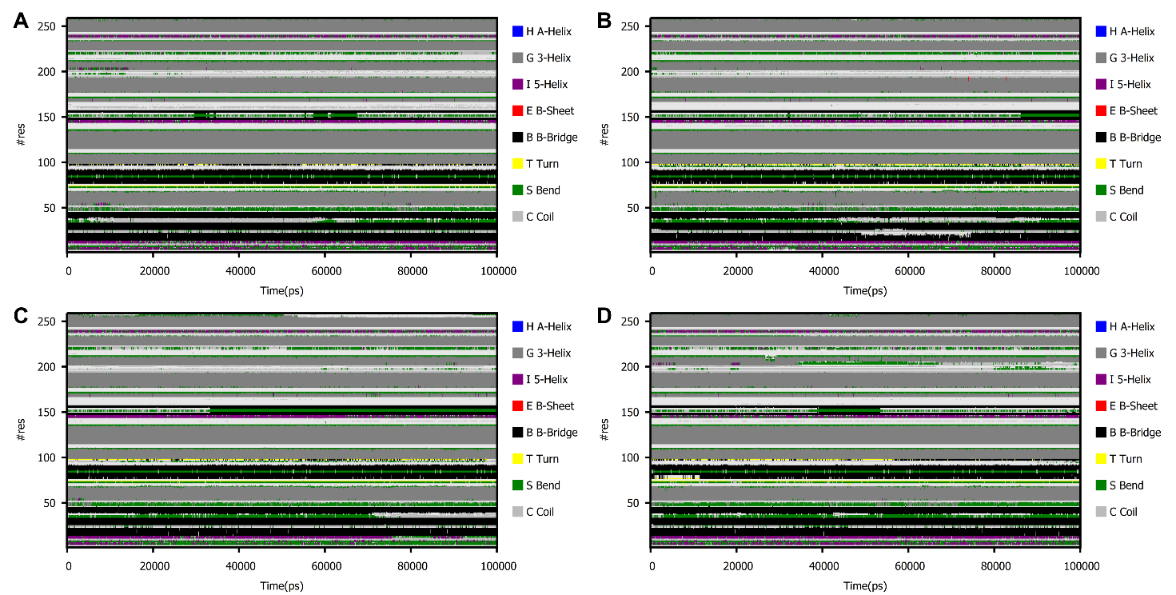
Fig. S2 Time evolution for Secondary structure of (A) dabrafenib, (B) scutellarin, (C) digallic acid, and (D) (-)-balanol.

Table S1 MM-GBSA binding energies of dacomitinib and neratinib complexes (kcal/mol).

Hit compounds | VDWAALS | EEL | EGB | ESURF | ΔG_{gas} | ΔG_{solv} | Binding Energy
Dabrafenib | -30.9384±0.3900 | -2.3950±0.1350 | 8.2080±0.1330 | -5.6753±0.0448 | -33.333±0.3702 | 2.5327±0.1423 | -30.8007±0.4079
Scutellarin | -28.7743±0.4187 | -39.7494±1.4019 | 38.8519±1.2495 | -5.4679±0.0571 | -68.5237±1.4163 | 33.3839±1.3797 | -35.1397±0.4173
Digallic acid | -35.9776±0.4407 | -34.6646±0.8305 | 34.3463±0.6742 | -4.4181±0.049 | -70.6422±0.5790 | 29.9282±0.6928 | -40.7140±0.3278
(-)-Balanol | -39.7278±0.5073 | -12.2731±0.6681 | 13.4127±0.5714 | -5.2556±0.0702 | -52.0009±0.9390 | 8.1570±0.5238 | -43.8438±0.5239

The term VDWAALS denotes the van der Waals energy, EEL corresponds to the electrostatic energy, and EGB signifies the polar solvation energy. Furthermore, ESURF is used to describe the non-polar solvation energy. The total gas phase free energy is indicated by DELTA G gas, while DELTA G solv refers to the total solvation free energy.

