Title: Nitrate-responsive transcriptome analysis of the rice RGA1 mutant reveals G-protein regulation of nitrogen use efficiency (NUE) and associated traits including photosynthesis, water use efficiency and yield

Supplementary Fig. 1. Scatter Plots showing the correlation among replicates in both control (KCl) and treatment (KNO₃) samples. The replicates are highly correlated with R² > 0.9 among each other.

a
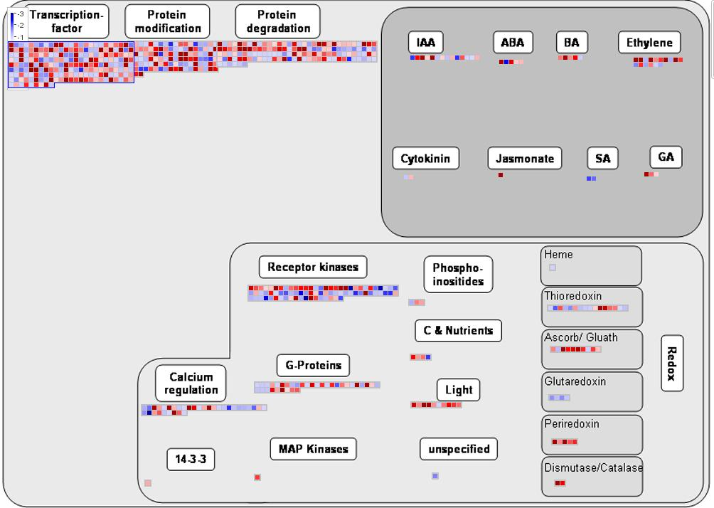
b
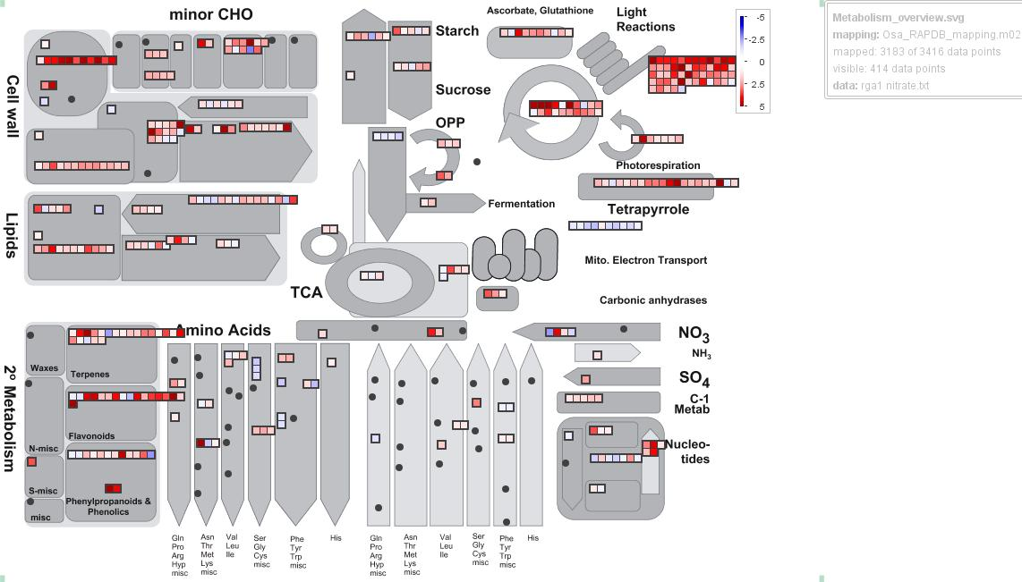
Supplementary Fig. 2. Pathways enriched under regulation overview (a) and metabolism overview (b) in MapMan.

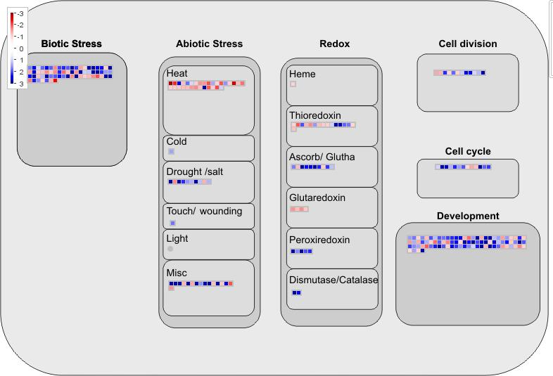
Supplementary Fig. 3. Pathways enriched under cellular responses in MapMan.

Supplementary Fig. 4. Distribution of upregulated and downregulated genes based on their predicted sub-cellular localization from CropPAL2.0.

Supplementary Fig. 5. RGA1-regulated nitrate-responsive molecular complexes associated with different cellular pathways. All the DEGs identified in our study were used to retrieve the experimentally validated interactors from BioGRID, STRING and other databases. The protein–protein interaction (PPI) networks were constructed using DEGs-associated interactors in Cytoscape and molecular complexes were identified using the MCODE plugin in Cytoscape. The red and green nodes represent the upand downregulated DEGs, respectively. Interactors that are not DEGs are assigned with yellow colour.
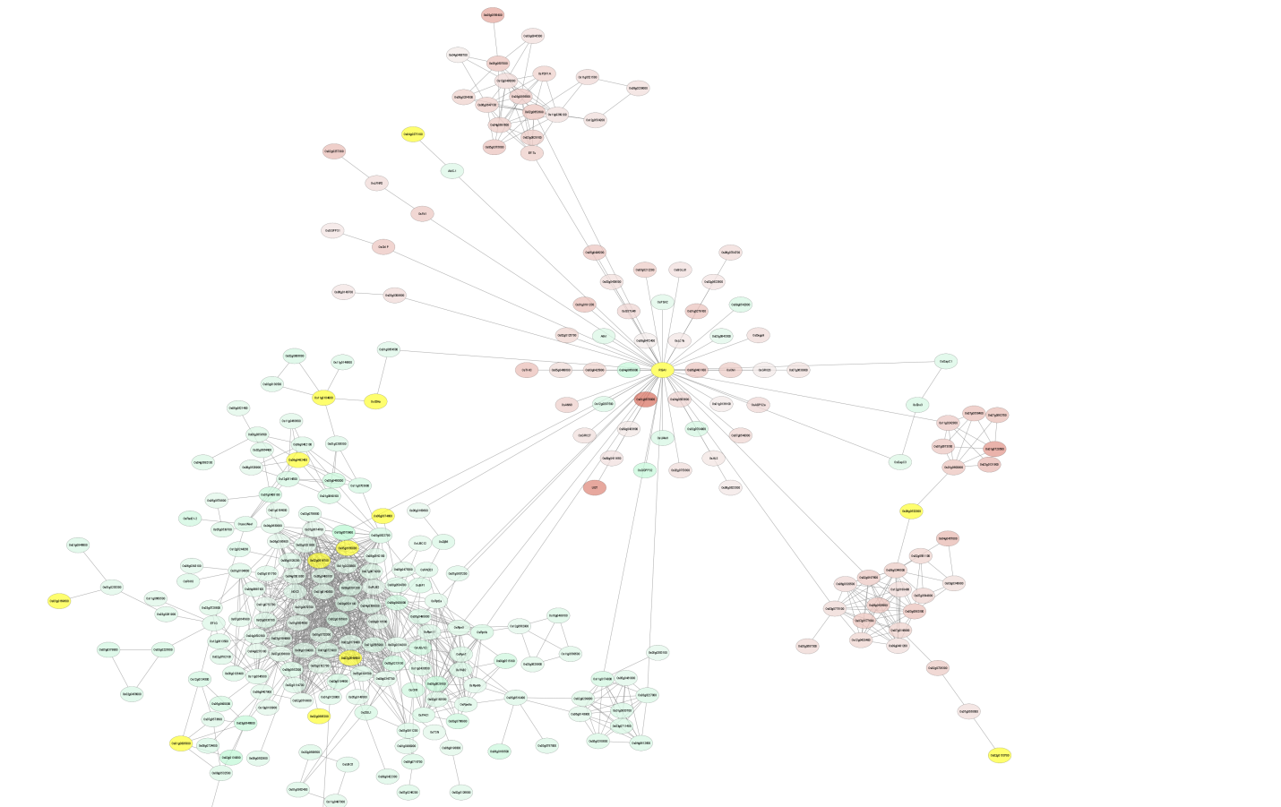
Supplementary Fig. 6. RGA1-regulated nitrate-responsive complete network identified in our study. All the DEGs identified in our study were used to retrieve the experimentally validated interactors from BioGRID, STRING, PRIN and MCRDP databses. The protein–protein interaction (PPI) networks were constructed using DEGs-associated interactors in Cytoscape. The red and green nodes represent the up- and down-regulated DEGs, respectively. Interactors that are not DEGs are assigned with light colour. The center (circled in blue) shows all the experimental interactors of RGA1, most of which are also nitrate responsive.

Supplementary Fig. 7. Heatmap for genes related to important functional categories (These DEGs were related to photosynthesis and/or enzymes and/or C and N metabolism and/or transcription factors and/or RLKs and/or G-proteins and/or MAP Kinases and/or hormones identified in rga1 mutant and the corresponding WT in the current study.
Supplementary Fig. 8. Heatmap for NUE-related genes identified in the current in rga1 mutant and the corresponding WT. NUE-related DEGs were identified in the current nitrate responsive transcriptome on the basis of literature search (Neeraja et al., 2021; Supriya et al., 2021; Sandhu et al., 2021).

Supplementary Fig. 9. Phenotypic and physiological measurements of rice WT and rga1 mutant (d1) in response to two different doses of nitrate. (a) Representative image of 20 day old WT and rga1 mutant seedlings grown with two doses nitrate showing changes in root length in response to the N-doses. Changes in (b) relative water content in response to two different doses of nitrate (1.5 mM or 15 mM) without salt stress and (c) catalase activity of rice WT and rga1 mutant (d1) plants in response to two different doses of nitrate (1.5 mM or 15 mM) with or without salt stress. Measurements were done using leaves from the harvest stage of the same plants used for the data shown in Figure 1b,c, 6 & 8. Bar graphs represent mean ± SE of the data from three biological replicate plants. The statistical significance is calculated using two-way/three-way ANOVA in GraphPad Prism 6.0 and same letters denote non-significant pairs.

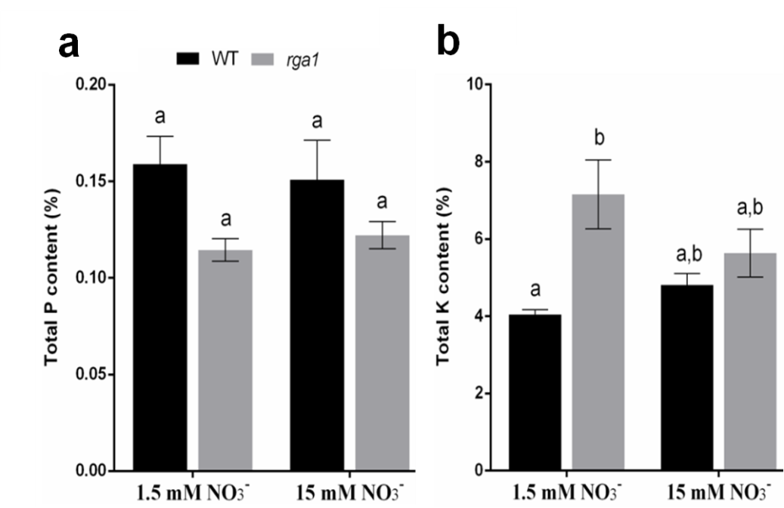
Supplementary Fig. 10. Measurements on phosphorus (a) and potassium (b) contents in rice WT and rga1 mutant (d1) plants at two different doses of nitrate (1.5 mM or 15 mM) at harvest stage. Measurements were done using leaves from the harvest stage of the same plants used for the data shown in Figure 1b,c and 7. Bar graphs represent mean ± SE of the data from four biological replicate plants. The statistical significance is calculated using two-way ANOVA in GraphPad Prism 6.0 and same letters denote non-significant pairs.

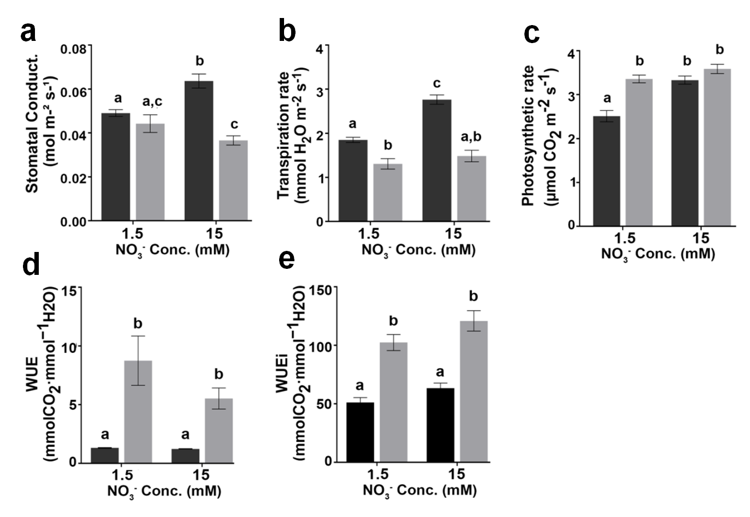
Supplementary Fig. 11. Physiological measurements of 100 day old rice WT and rga1 mutant (d1) in response to two different doses of nitrate (1.5 mM or 15 mM). Measurement of (a) stomatal conductance, (b) transpiration rate, (c) photosynthetic rates (d) water use efficiency (photosynthetic rate/transpiration rate), (e) intrinsic water use efficiency (photosynthetic rate/stomatal conductance) of photosynthetically active fully developed leaf at active tillering stage. Measurements were done using the most photosynthetically active leaves of the same plants used for the data shown in Figure 1a,b and 7. All the measurements were done with maximum light intensity falling at the plant level inside PGC (98 µmol m⁻² s⁻¹). Bar graphs represent mean ± SE of the data from 12 biological replicate plants. The statistical significance is calculated using two-way ANOVA in GraphPad Prism 6.0 and same letters denote non-significant pairs.

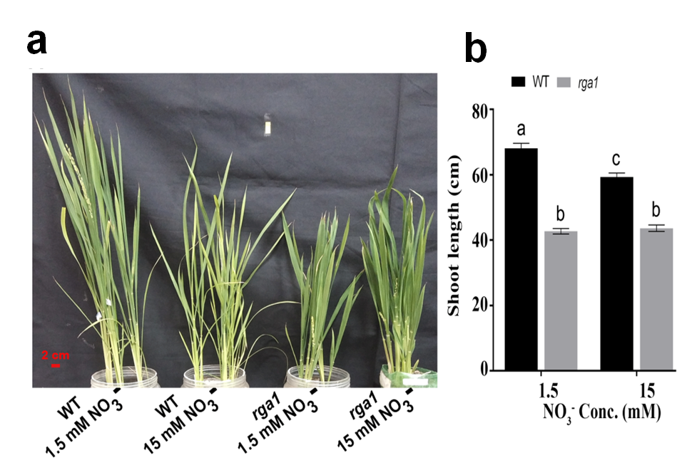
Supplementary Fig. 12. Phenotypic measurements of rice WT and rga1 mutant (d1) in response to two different doses of nitrate. All the measurements were done with maximum light intensity falling at the plant level inside growth chamber (200 µmol m⁻² s⁻¹) during fourth experimental replicate. (a) Representative image of WT and rga1 mutant plants grown in pots with two different concentrations of nitrate. (b) Bar graph representing the shoot length of WT and rga1 mutant plants at heading stage grown in pots with two different concentrations of nitrate. Each bar graph represents mean ± SE of the data from four biological replicates. The statistical significance is calculated using two-way ANOVA in GraphPad Prism 6.0 and same letters denote non-significant pairs.

