Supplementary materials

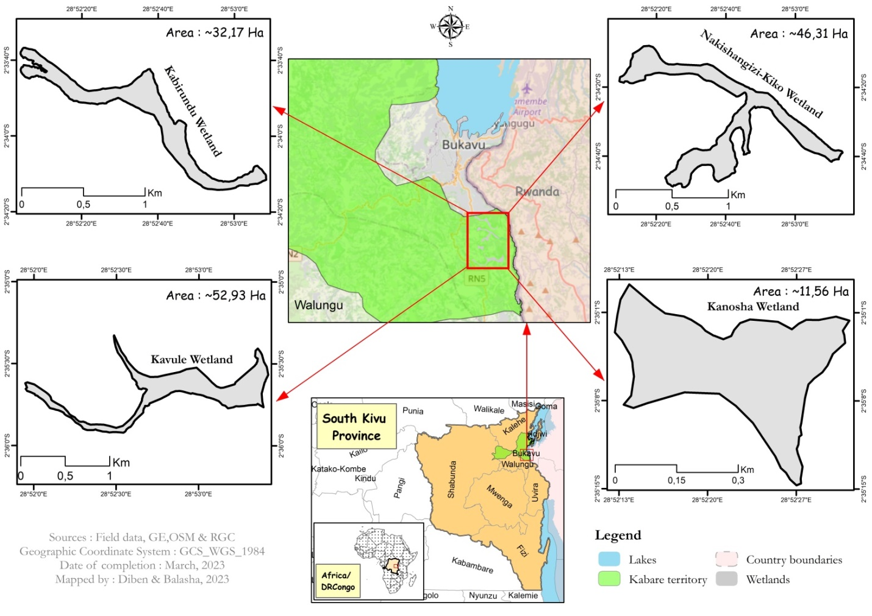
Fig.1. Localization of marshland sites where women grow vegetable around the city of Bukavu

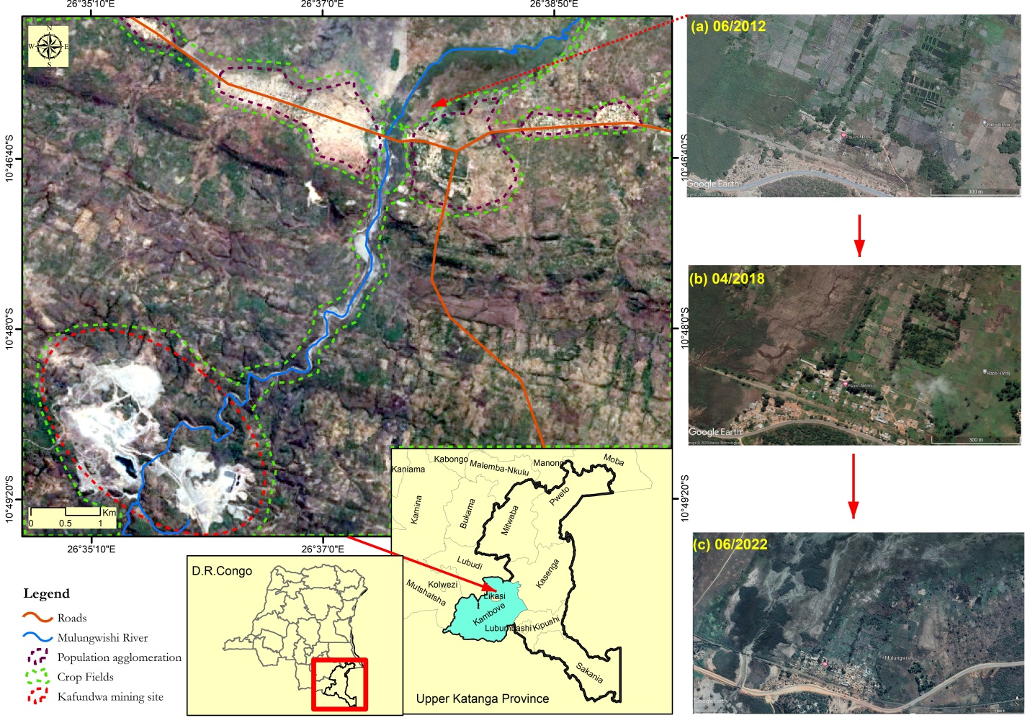
Fig 2. Localization of Mulungwishi Valley, a potential vegetable production site degraded by mining pollution
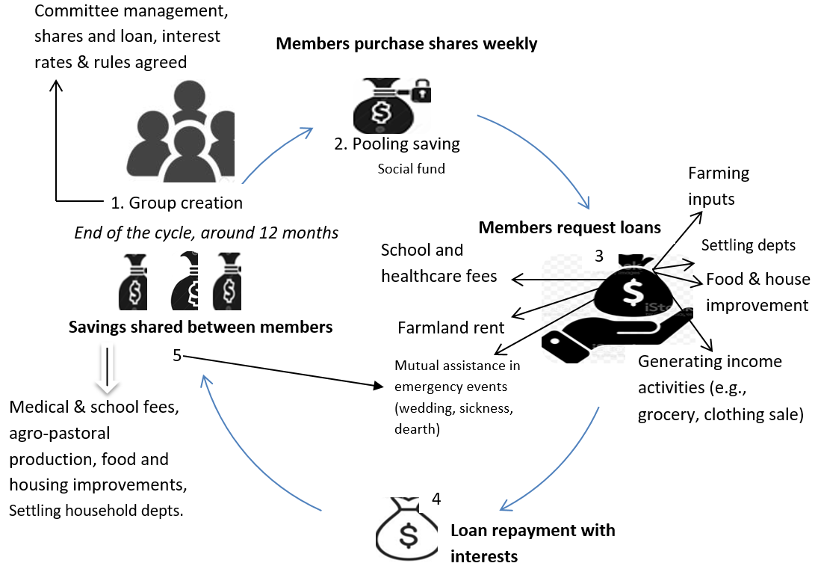
Fig. 3. Diagram illustrating how Village Savings and Loans Associations work in Kabare and Mulungwishi
Adapted from CARE,2021

Fig 5. Vegetable crops in which women farmers were willing to invest heavily

