Article title:
Protective role of M₃ muscarinic acetylcholine receptor in indomethacin-induced small intestinal injury

Journal name:
Journal of Molecular Medicine

Author names:
Yoko Igarashi-Hisayoshi, Eikichi Ihara, Xiaopeng Bai, Yoshimasa Tanaka, Haruei Ogino, Takatoshi Chinen, Yasushi Taguchi, and Yoshihiro Ogawa

Affiliation and e-mail address of the corresponding author:
Yoko Igarashi-Hisayoshi,
Research Center, Mochida Pharmaceutical Co., Ltd., 722 Uenohara, Jimba, Gotemba 412-8524, Japan
Tel: +81-550-89-7881; Fax: +81-550-89-8070
E-mail: yoko.igarashi.729@mochida.co.jp

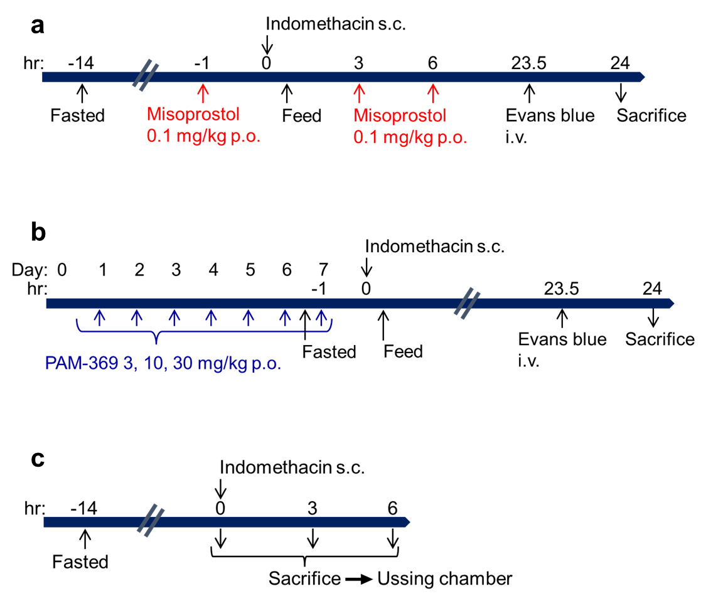

Supplemental Fig. 1. Schematic illustration of the experimental protocols for examining the effects of misoprostol (a) and PAM-369 (b) on indomethacin-induced small intestinal injury in mice and for the examining the effects of indomethacin treatment on changes in the basal and carbachol-induced Isc potentiated by PAM-369 in mouse ileum (c).

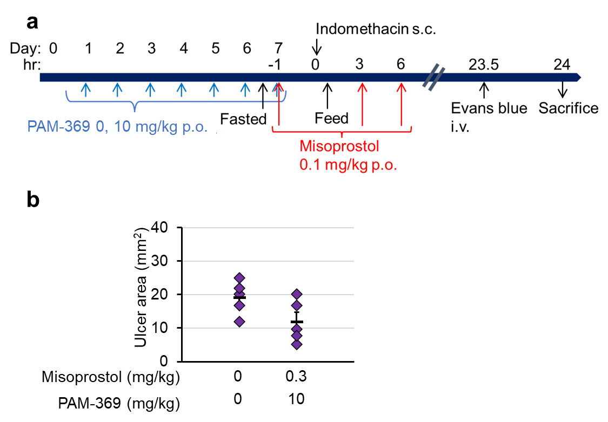
Supplemental Fig. 2. Effects of combination treatment with misoprostol and PAM-369 on indomethacin-induced small intestinal injury in mice. a: A schematic illustration of the experimental protocol is shown. b: Effects of combination treatment of misoprostol and PAM-369 on the ulcer area of small intestine in indomethacin-treated mice (n=5). Misoprostol (0.1 mg/10 mL/kg) or vehicle was orally administered 3 times a day, 1 h before and 3 and 6 h after indomethacin administration. PAM-369 (10 mg/10 mL/kg) or vehicle was orally administered once a day for 1 week. Mice were fasted for 14 h, and 1 h after the first administration of misoprostol and last administration of PAM-369 (day 7), indomethacin (15 mg/10 mL/kg) was subcutaneously administered. Mice were fed soon after indomethacin administration. After 24 h, mice were sacrificed, and their small intestines were excised. Evans blue (5 mL/kg) was intravenously injected into mice 30 min before sacrifice. The areas of lesions in small intestines were calculated with the Image J software program

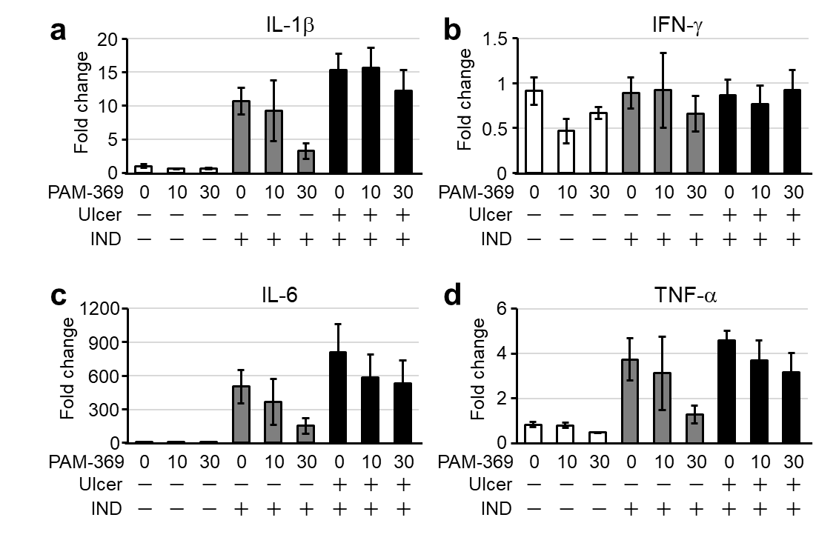

Supplemental Fig. 3. Effects of PAM-369 on indomethacin-induced inflammatory cytokine mRNA up-regulation. a-d: The mRNA expression of IL-1β (a), IFN-γ (b), IL-6 (c), and TNF-α (d) in ileum tissues with or without visible ulcers at 24 h after indomethacin administration (n=3-5). After an overnight 14-h fast, the mice were treated with indomethacin (15 mg/10 mL/kg) subcutaneously just before resuming feed. At 24 h after administration of indomethacin, the mice were sacrificed under isoflurane anesthesia, and their small intestines were excised. To collect samples for mRNA expression, Evans blue was not injected, and ileum segments were dissected and soaked in RNAlater (Sigma-Aldrich). The expression of mRNAs encoding interleukin (IL)-1β (Mm00434228_m1), IL-6 (Mm00446190_m1), interferon-γ (IFN-γ) (Mm01168134_m1), and tumor necrosis factor-α (TNF-α) (Mm00443258_m1) was determined by quantitative PCR using FAM-labeled TaqMan Gene Expression Assay Reagents (Applied Biosystems, Foster City, CA, USA).

