Urocortin-1 Stimulates Colorectal Cancer Cells Migration, Proliferation and Invasion via p53 Signaling Pathway
Xiaolan Guo¹, Ya Li¹, Xiangyu Chen¹, Binghua Sun¹ and Xiaolan Guo¹*
¹ Department of Gastroenterology, the First Affiliated Hospital of Zhengzhou University, Zhengzhou, Henan, China.
*Correspondence:
gxlzdyfy@163.com
Keywords: Colorectal cancer, Urocortin-1, p53, ERK1/2, HCT-116, RKO
Supplementary Figure 1 | The knockout efficiency of lentivirus.
The knockdown efficiency of three different shRNA targeting UCN (shUCN_1, shUCN_2 and shUCN_3). Data are presented as mean ± SEM. *P<0.05.
Supplementary Figure 2 | The effect of knockdown UCN-1 on proliferation of HCT-116 cells and RKO cells.
(a and b) The proliferation of HCT-116 cells (a) and RKO cells (b) after transfected with shUCN or shCtrl.
Supplementary Figure 3 | The Tumor morphology of control and UCN-1 knockout groups. There were no significant differences in HE. Scale bar, 50 μm.
Supplementary Figure 4 | The effect of overexpression of UCN-1 and p53 on proliferation of HCT-116 cells and RKO cells.
(a and b) The proliferation of HCT-116 cells (a) and RKO cells (b) after overexpressing UCN-1 and p53.

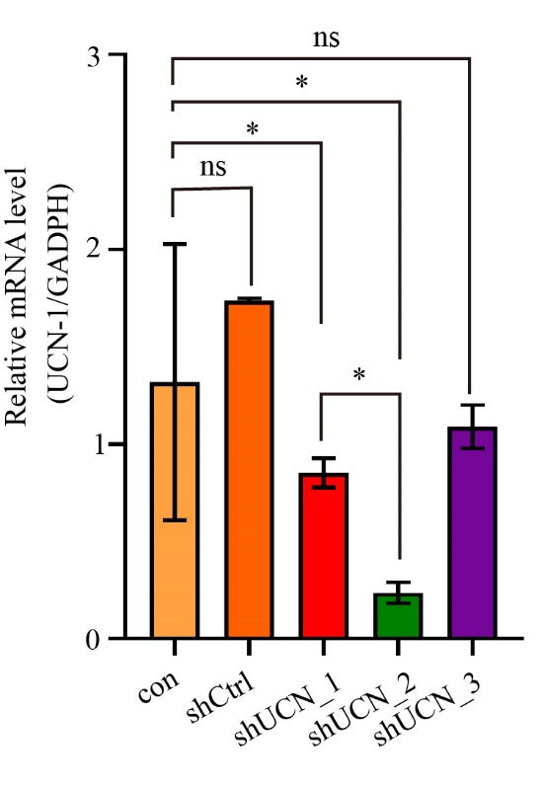
Supplementary Figure 1 | The knockout efficiency of lentivirus.

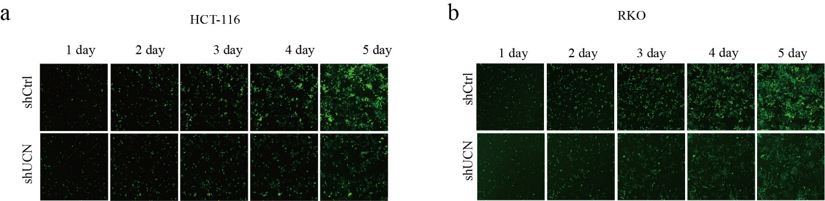
Supplementary Figure 2 | The effect of knockdown UCN-1 on proliferation of HCT-116 cells (a) and RKO cells (b).

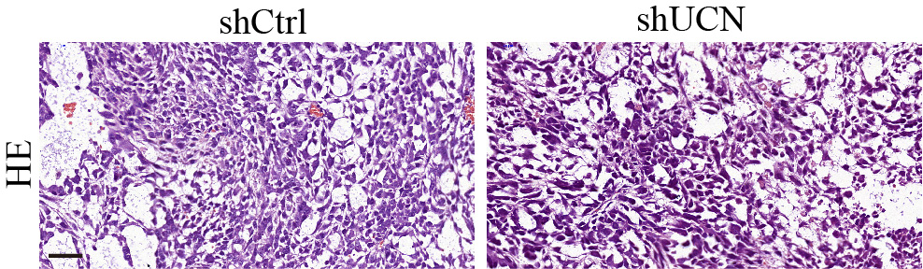
Supplementary Figure 3 | The Tumor morphology of control and UCN-1 knockout groups.
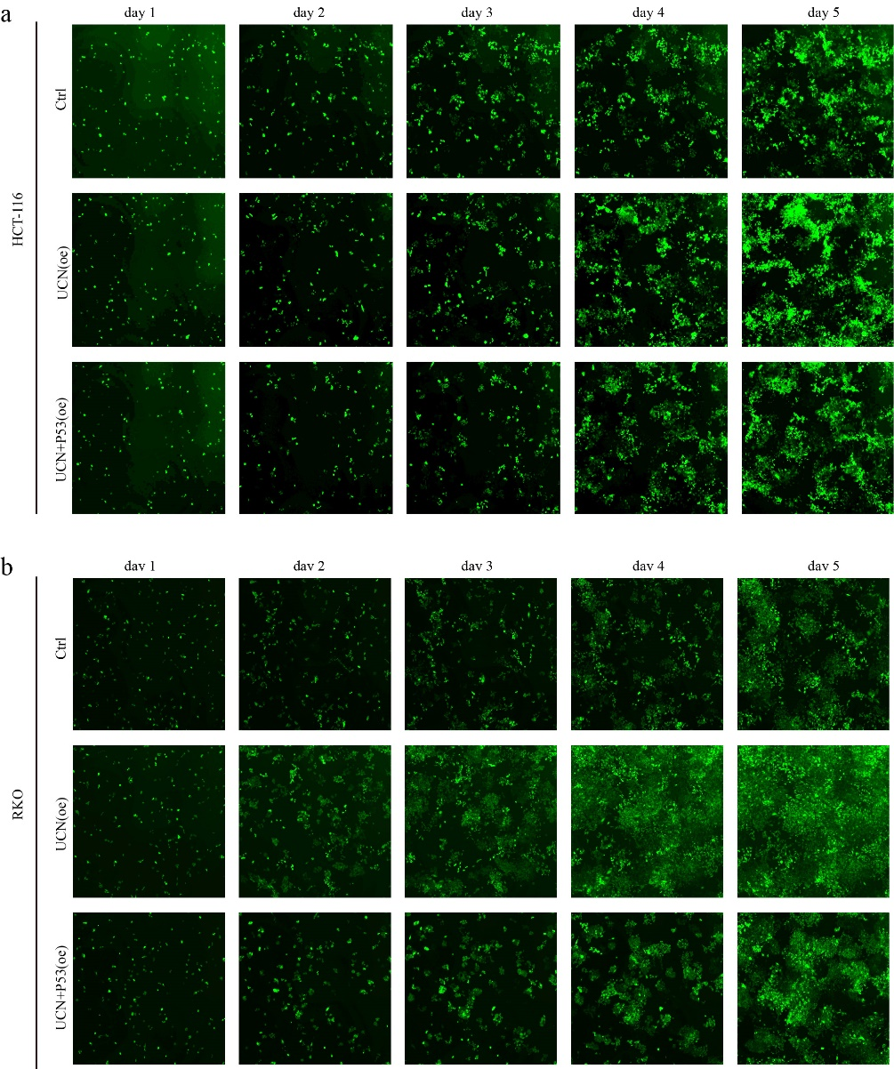
Supplementary Figure 4 | The effect of overexpression of UCN-1 and p53 on proliferation of HCT-116 cells and RKO cells.

