World Journal of Microbiology and Biotechnology
Cellulase with Bacillus velezensis improves physicochemical characteristics, microbiota, and metabolites of two-stage solid-state fermented corn germ meal
Long Chen¹, Yang Guo¹, Xin Liu¹, Lin Zheng¹, Bingdong Wei^{1＊},Zijian Zhao^{2＊}
Institutions:
¹ Institute of Animal Nutrition and Feed, Jilin Academy of Agricultural Sciences, Jilin Gongzhuling 136100, China;
² Institute of Agro-food Technology, Jilin Academy of Agricultural Sciences, Changchun, 130033, China;
Corresponding authors:
Bingdong Wei
Institute of Animal Nutrition and Feed, Jilin Academy of Agricultural Sciences, No. 186 Dong Xinghua Street, Gongzhuling, Jilin Province, 136100, P.R. China
Tel: +86-0434-5163761; Fax: +86-0434-5163761; Email: weibingdong@dlut.edu.cn
Zijian Zhao
Institute of Agro-food Technology, Jilin Academy of Agricultural Sciences, No. 1366 Cai Yu Street, Changchun, Jilin Province, 130033, P.R. China
Tel: +86-0431-87063285; Fax: +86-0431-87063285; Email: zhaojaas@163.com.

Supplementary Material:
Fig S1. Dynamics of bacterial functional profiles during two-stage SSF analyzed by PICRUSt2 (n = 6). (A) Level 1 Kyoto Encyclopedia of Genes and Genomes (KEGG) metabolic pathways. (B) Level 2 KEGG ortholog functional predictions. (C) Level 3 KEGG ortholog functional predictions of the relative abundances of the top 50 metabolic functions. PCGM stands for PCGM-CK-0h, BC24h stands for PCGM-BCL -24h and BC48h stands for PCGM-BCL-48h.
Fig S2. Dynamics of fungal functional profiles during two-stage SSF analyzed by MetaCyc (n = 6). (A) Primary metabolic pathways. (B) Secondary metabolic pathway functional predictions. PCGM stands for PCGM-CK-0h, BC24h stands for PCGM-BCL -24h and BC48h stands for PCGM-BCL-48h.

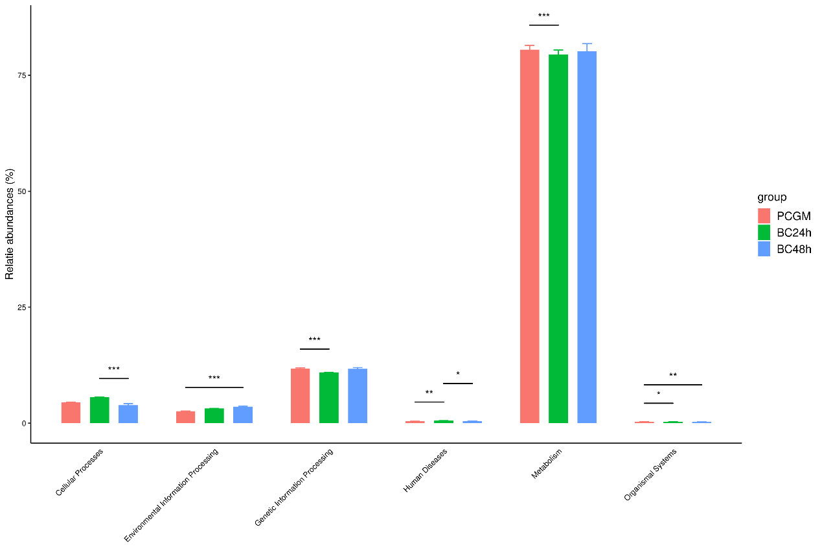
(A)
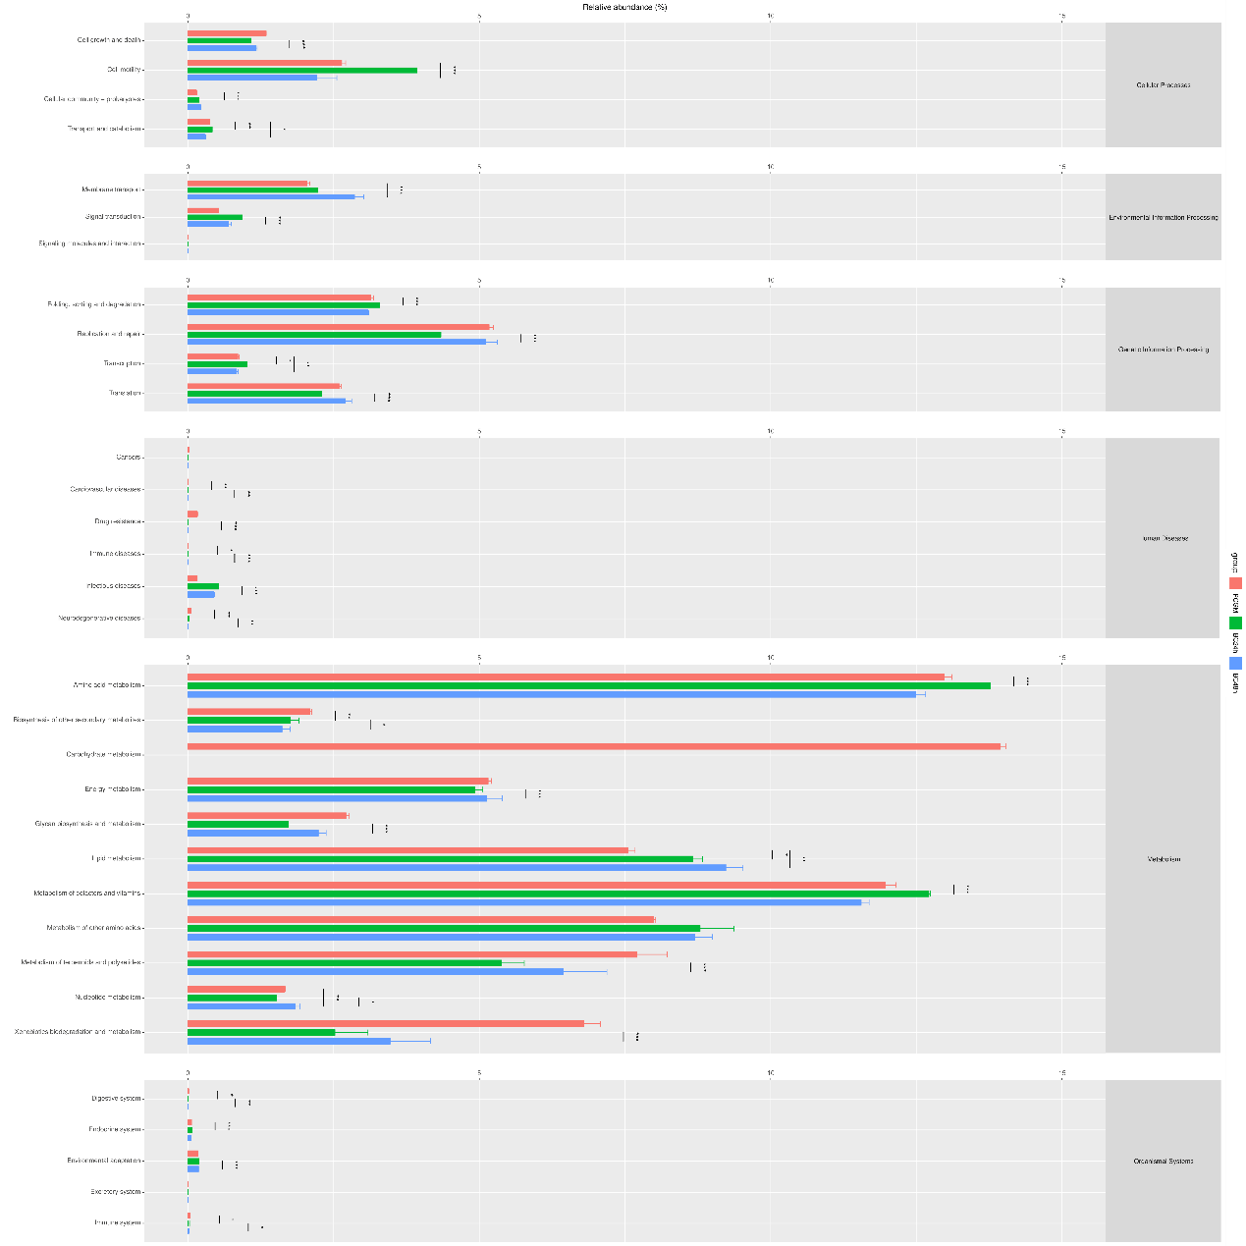
(B)
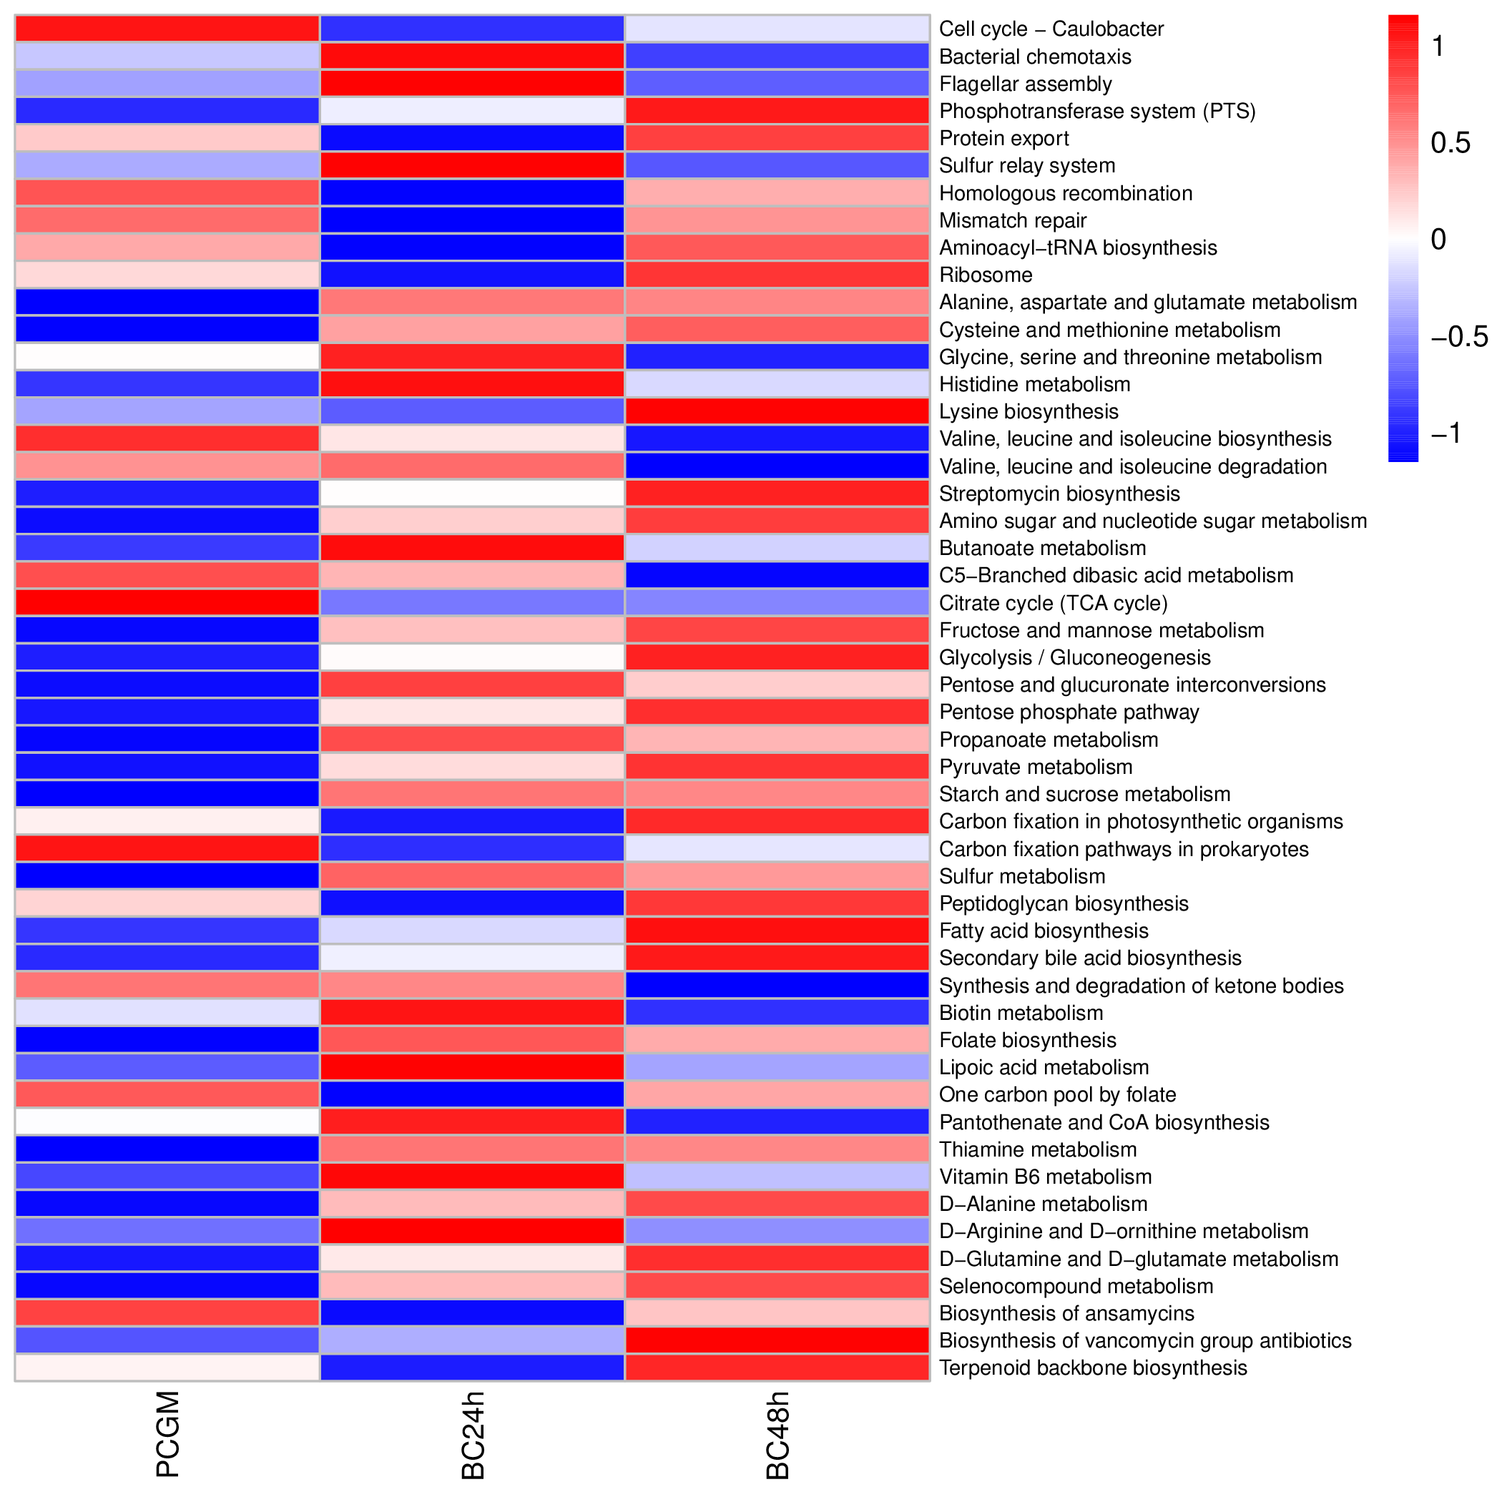
(C)
Fig. S1.
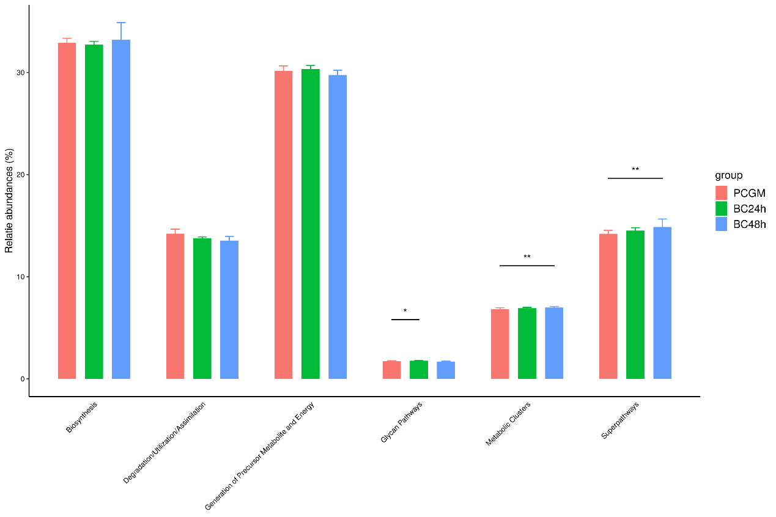
(A)
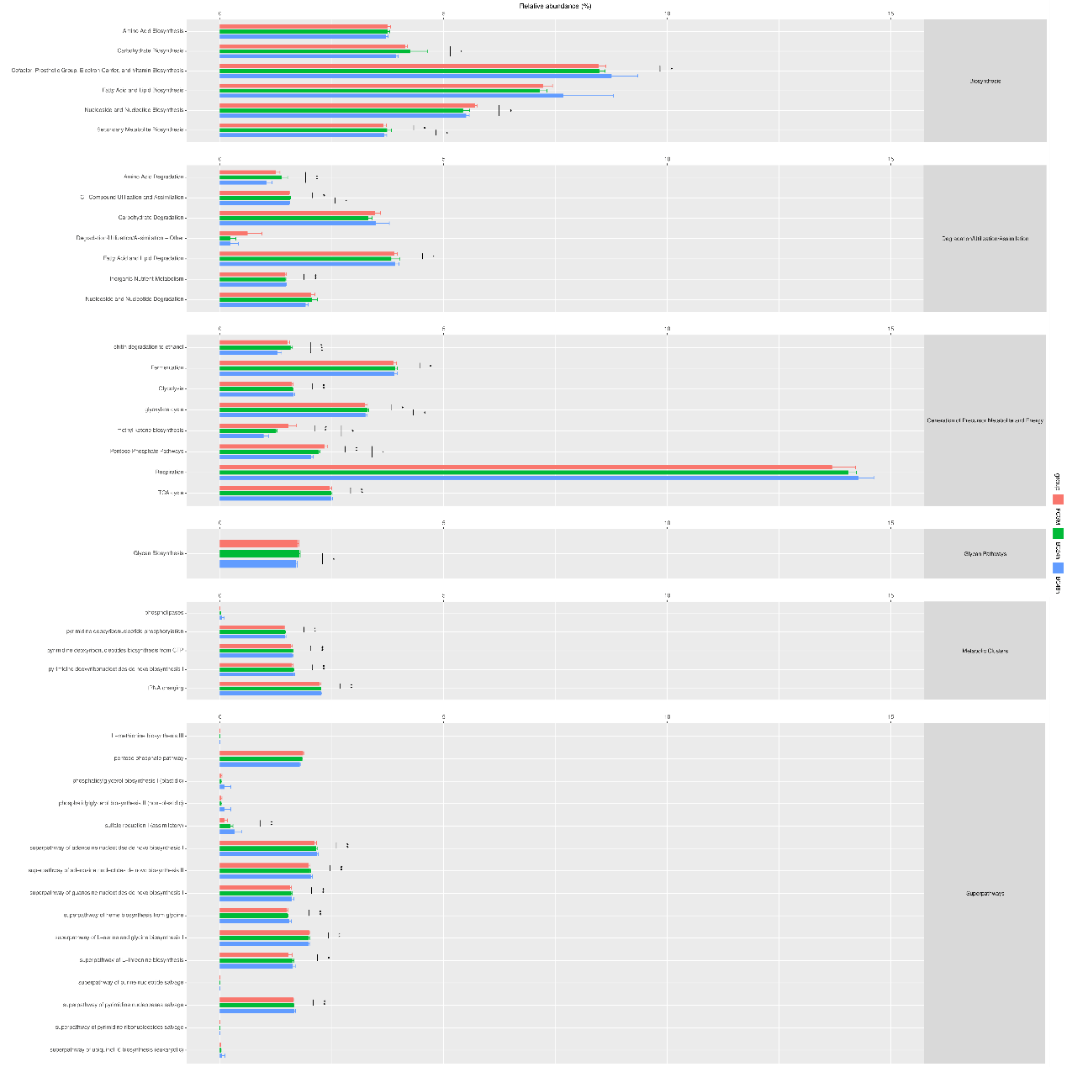
(B)
Fig. S2.

