Synthesis, Crystal Structure and Catechol Oxidase Activity of a Di-nuclear Paddle-Wheel Cu (II) Carboxylate Complex

Priyanka Chakraborty, Abhishikta Chatterjee, Bidyapati Kumar, Sourav Mandalª, Subrata K. Dey *
Department of Chemistry, Sidho-Kanho-Birsha University, Purulia-723104, WB, India E-mail: skdusask@yahoo.ca; skdchem@skbu.ac.in

Abstract
A dinuclear copper (II) complex, Cu₂ (RCOO)₄(L)₂ (1) while [RCOO = benzoate, L= 2-amino-3-chloro-5-trifluoro methyl pyridine], with square pyramidal geometry with four carboxylate bridged groups has been reported. This dinuclear copper (II) unit (with the most robust, frequently occurring paddle wheel structure) was characterised by single crystal X-ray diffraction, IR, UV, CV, TGA and EPR studies. It exhibits catechol oxidase activity in methanol medium and the catecholase activity was monitored by the UV–Vis spectroscopy. The kinetic parameters have been determined by using Michaelis–Menten equation which shows that the complex is an efficient catalyst with very high turnover number. Mechanistic investigation of the catalytic behavior was established with the help of ESI-MS spectra.

Keywords: Copper (II) complex, Crystal Structure, Paddle wheel, Catalytic Oxidation

__________________________________________________________________________________________* Corresponding author: Prof. Subrata K. Dey, E-mail: skdusask@yahoo.ca; skdchem@skbu.ac.in
Department of Chemistry, Sidho-Kanho-Birsha University, Purulia-723104, WB, India
S1: IR spectrum of the complex 1
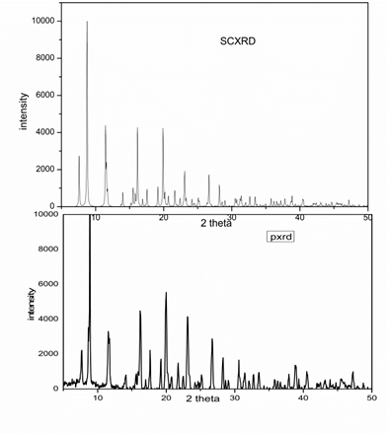
S2: Comparison of SCXRD pattern with the PXRD data.

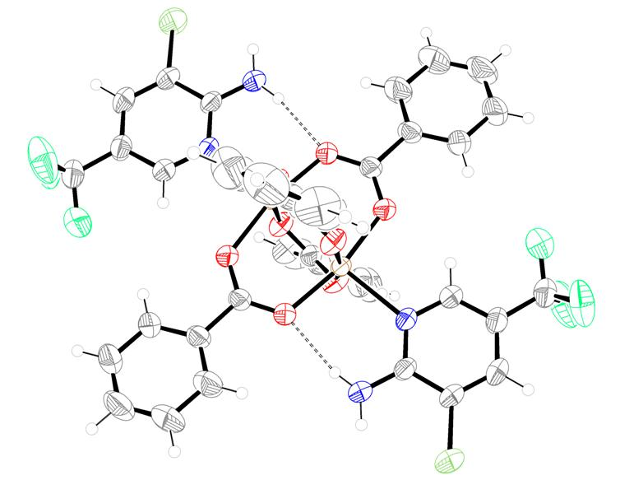

S3: A view of supramolecular chains formed by H bonding

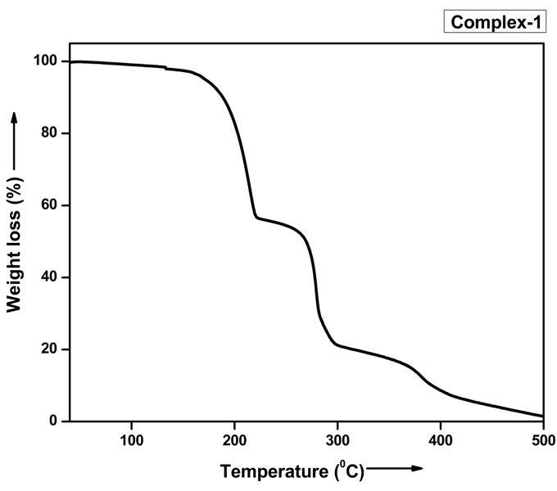

S4: TGA of complex in N₂ atmosphare

S5: EPR study of the complex.

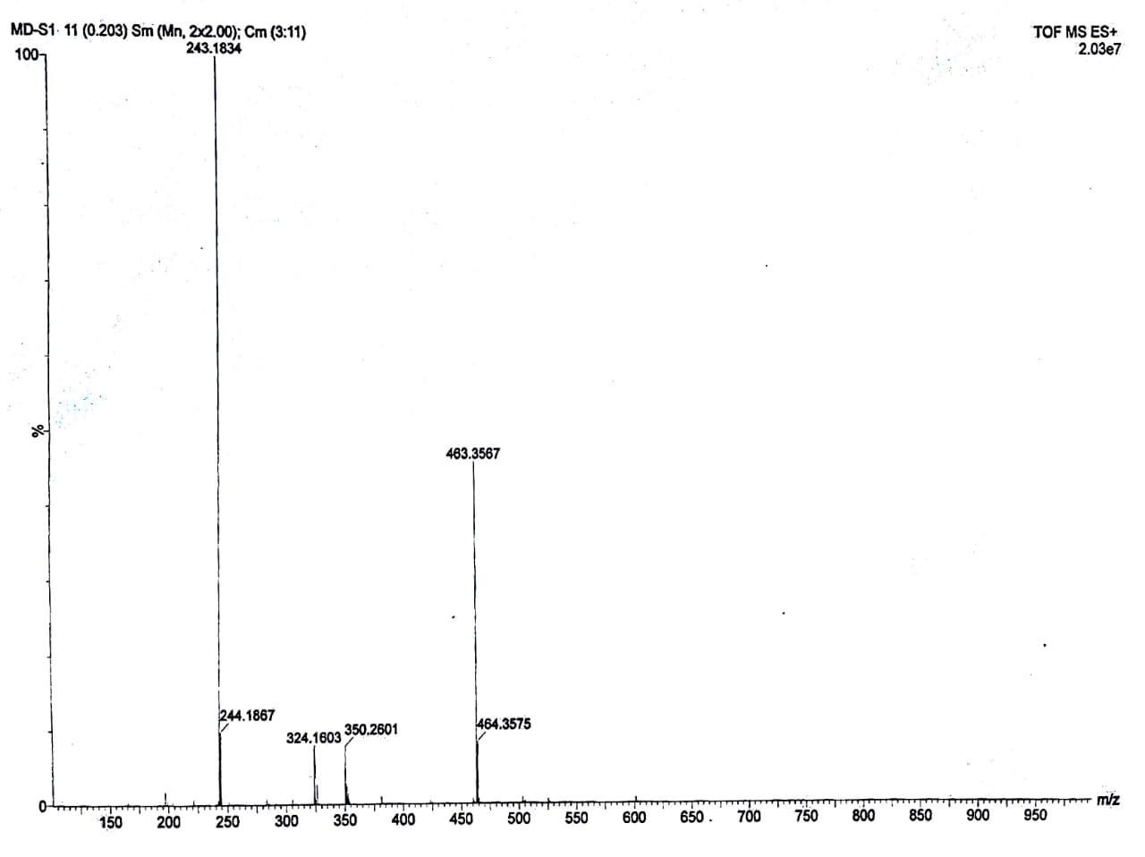

S6: ESI-MS+ (m/z) spectrum for the ultimate catecholase product during the reaction of complex with 3,5-DTBC.

S7: Characterized peak for I₃ ⁻ for qualitative detection of H₂O₂ during catalytic oxidation process.

