Supporting Information

Coaxial electrospinning of Au@silicate/poly(vinyl alcohol) core/shell composite nanofibers with noncovalently immobilized gold nanoparticles to prepare flexible, freestanding, and highly sensitive SERS substrates amenable to large-scale fabrication

Yan-Feng Chen, Yen-Chen Lee, Jimmy Chi-Min Lee, and Chih-Wei Chiu*

Department of Materials Science and Engineering, National Taiwan University of Science and Technology, Taipei 10607, Taiwan

* Corresponding author
E-mail: cwchiu@mail.ntust.edu.tw (Chih-Wei Chiu); Tel.: +886-2-2737-6521; ORCID iD orcid.org/0000-0003-2258-2454.

Yan-Feng Chen and Yen-Chen Lee are both first authors.

Acknowledgments
This research was funded by the National Science and Technology Council (MOST 111-2628-E-011-009-MY3, NSTC 112-2622-8-011-012-TE2, and NSTC 112-2221-E-011-004-MY3) of Taiwan.
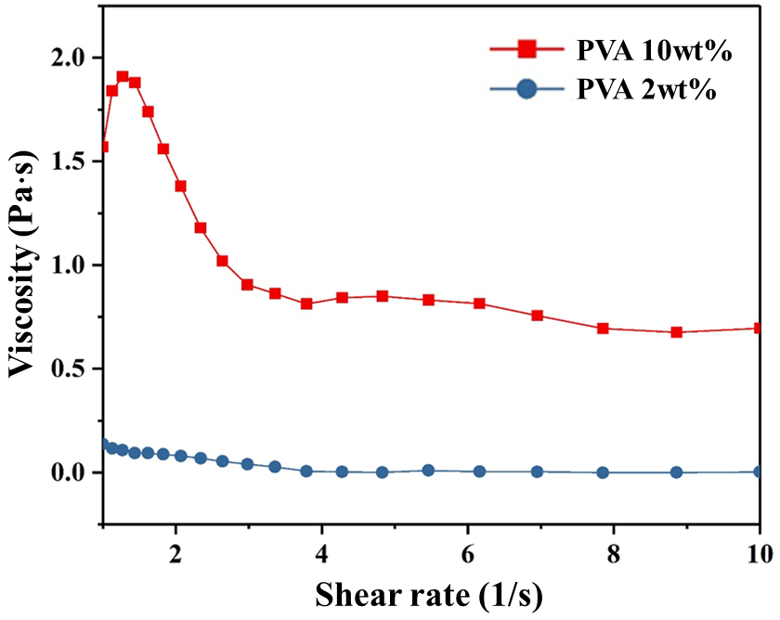
Fig. S1. Viscosity versus shear rate for 10 wt% PVA and 2 wt% PVA aqueous solutions.

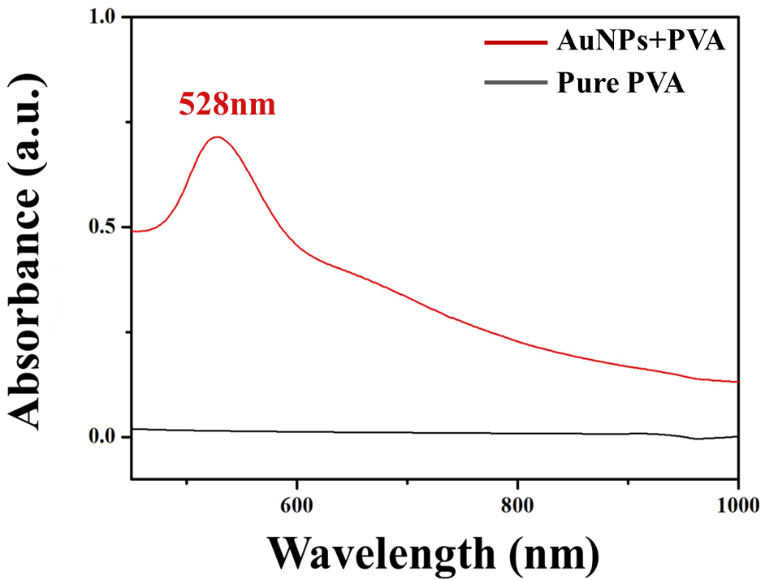
Fig. S2. UV-vis absorption spectra of 5 wt% AuNPs/silicate with a mass ratio of 1:1 in PVA and pure PVA.

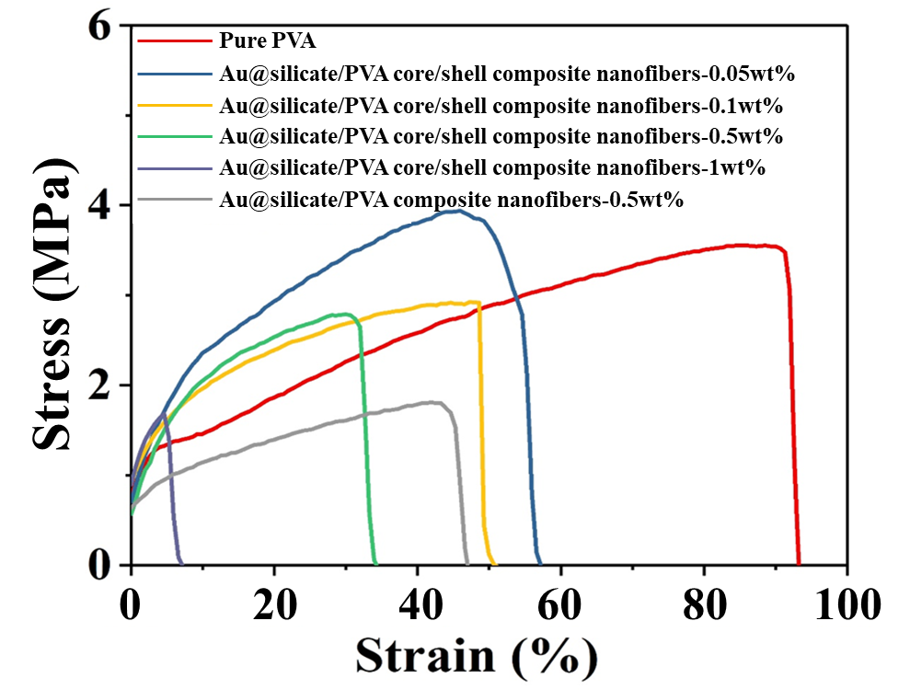
Fig. S3. Stress–strain curves of Au@silicate/PVA core/shell composite nanofibers with different AuNP contents prepared via coaxial electrospinning and a 0.5 wt% AuNPs@silicate/ PVA composite nanofiber prepared via uniaxial electrospinning.

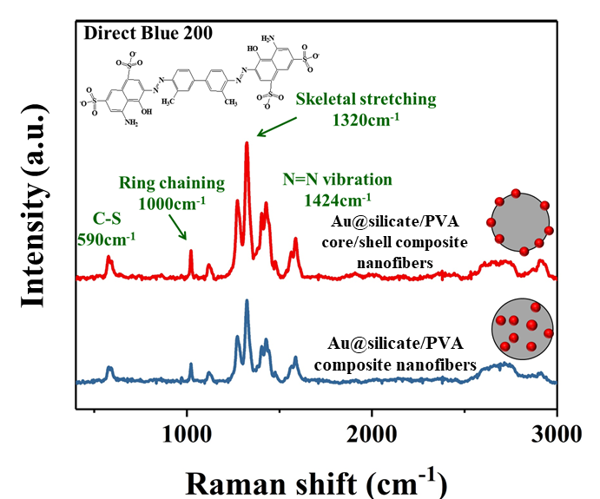
Fig. S4. SERS spectra of 10⁻⁵ M Direct Blue 200 obtained with Au@silicate/PVA core/shell composite nanofiber and AuNPs@silicate/PVA composite nanofiber films. Both nanofibers had an AuNP content of 0.5 wt%.

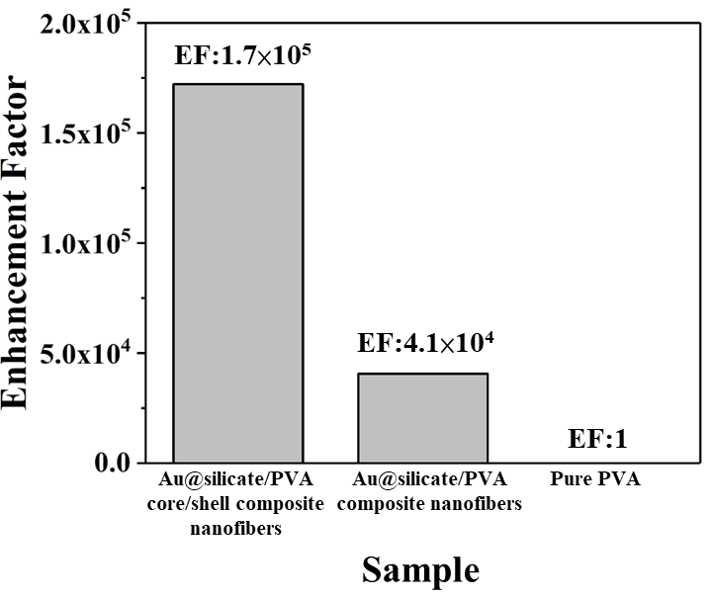
Fig. S5. EFs of Au@silicate/PVA core/shell composite nanofibers, AuNPs@silicate/PVA composite nanofibers, and pure PVA.

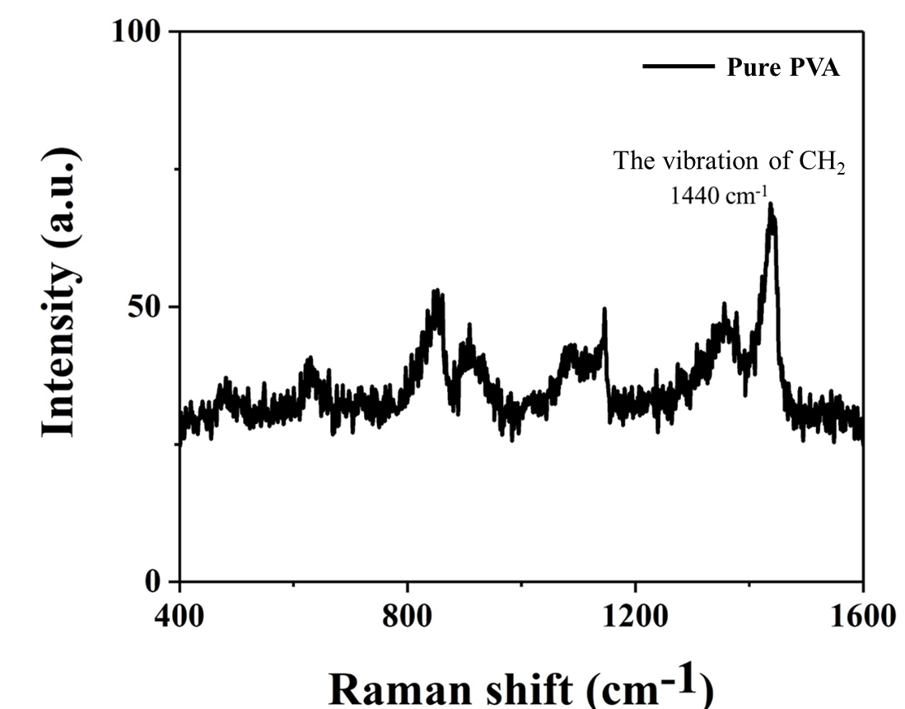
Fig. S6. SERS baseline: the Raman spectra of pure PVA.

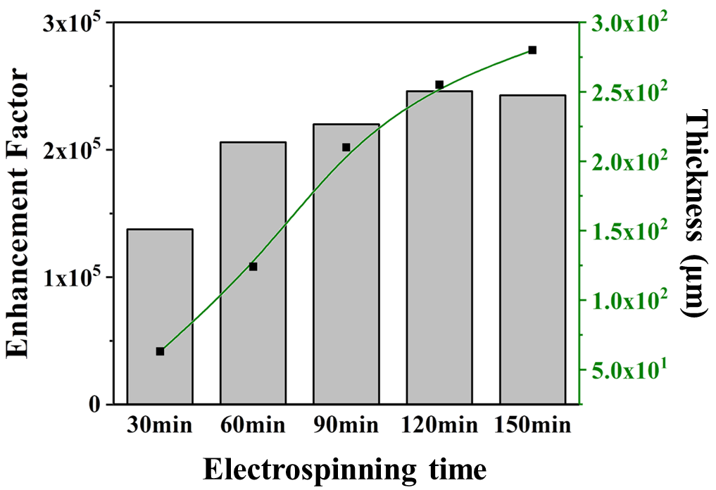
Fig. S7. SERS EF for Direct Blue 200 versus the thickness of the nanofiber film (which increased with the electrospinning time).

