Supplementary Information
5-chloro-3-(2-(2,4-dinitrophenyl) hydrazono)indolin-2-one: synthesis, characterization, and biochemical and computational screening against SARS-CoV-2

Felicite Majoumo-Mbe^{*1}, Neba Abongwa Sangbong¹, Alain Tadjong Tcho¹, Cyril T. Namba-Nzanguim^{1,2}, Conrad V. Simoben², Donatus B. Eni^{*1,2}, Mustafa Alhaji Isa³, Joel Cassel⁴, Joseph M. Salvino⁴, Luis J. Montaner⁴, Ian Tietjen⁴, Fidele Ntie-Kang^{*1,2,5}

¹Department of Chemistry, Faculty of Science, University of Buea, P. O. Box 63, Buea.
²Center for Drug Discovery, Faculty of Science, University of Buea, P. O. Box 63, Buea.
³Department of Microbiology, Faculty of Sciences, University of Maiduguri, PMB 1069, Borno State, Nigeria. ⁴The Wistar Institute, 3601 Spruce Street, Philadelphia, PA 19104 USA ⁵Institute of Pharmacy, Martin-Luther University Halle-Wittenberg, Kurt-Mothes-Strasse 3, 06120 Halle (Saale), Germany.

*Corresponding author, e-mail: fmajoumo@yahoo.fr (FMM); donatus.bekindaka@ubuea.cm (DBE); fidele.ntie-kang@ubuea.cm (FNK)

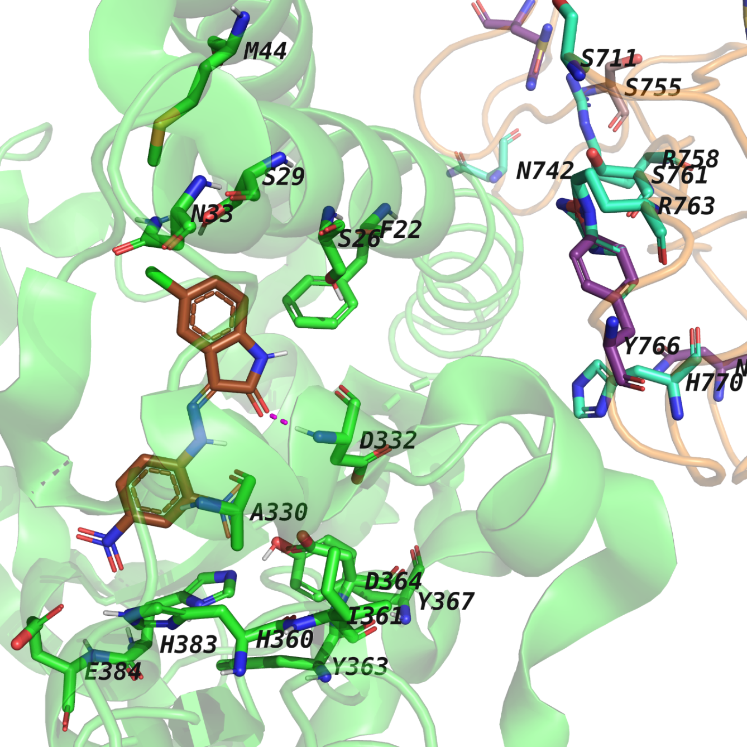
Figure S1: Docking pose of the sythesized ligand (brown stick) within the ACE2 binding site (green cartoon) with the necessary mutations for the Wuhan (WT) variant on the spike RBD (orange ribbon). Visible ACE2 binding site residues are shown as green sticks, while visible residues on spike RBD capable of mutation are shown as sticks.

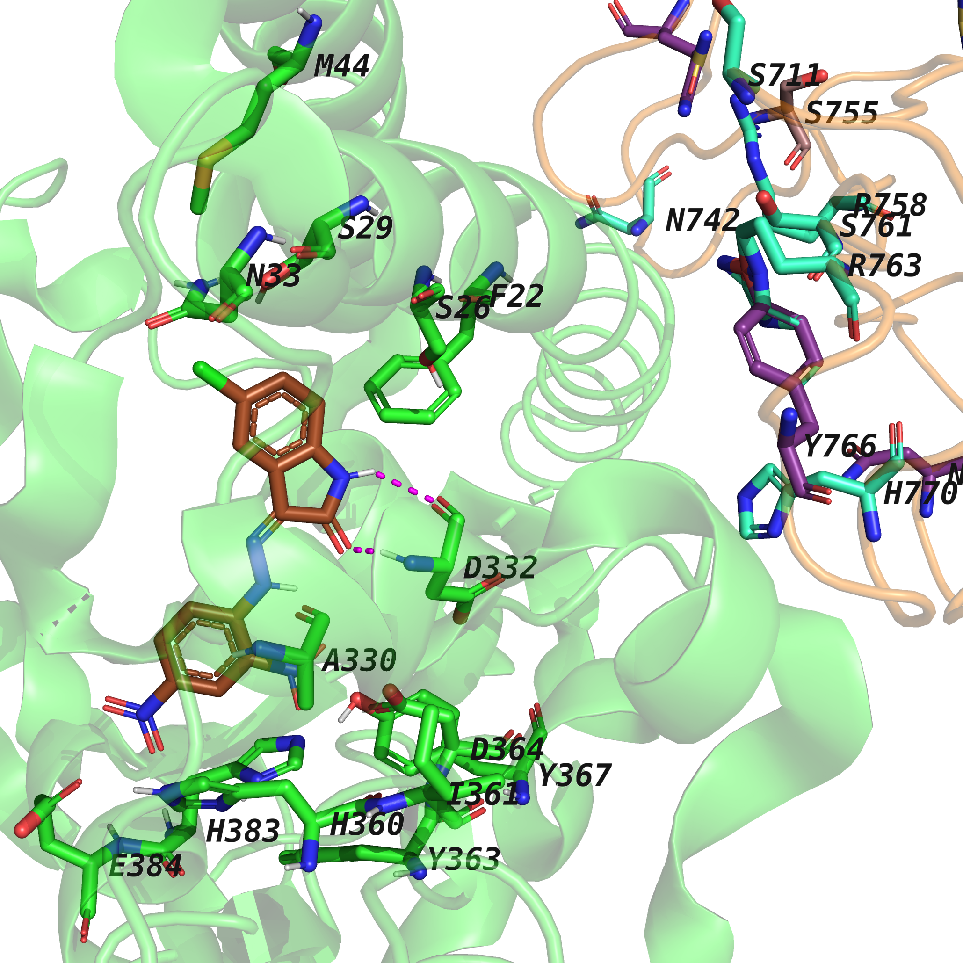
Figure S2: Docking pose of the sythesized ligand (brown stick) within the ACE2 binding site (green cartoon) with the necessary mutations for the beta variant on the spike RBD (orange ribbon). Visible ACE2 binding site residues are shown as green sticks, while visible residues on spike RBD capable of mutation are shown as sticks.

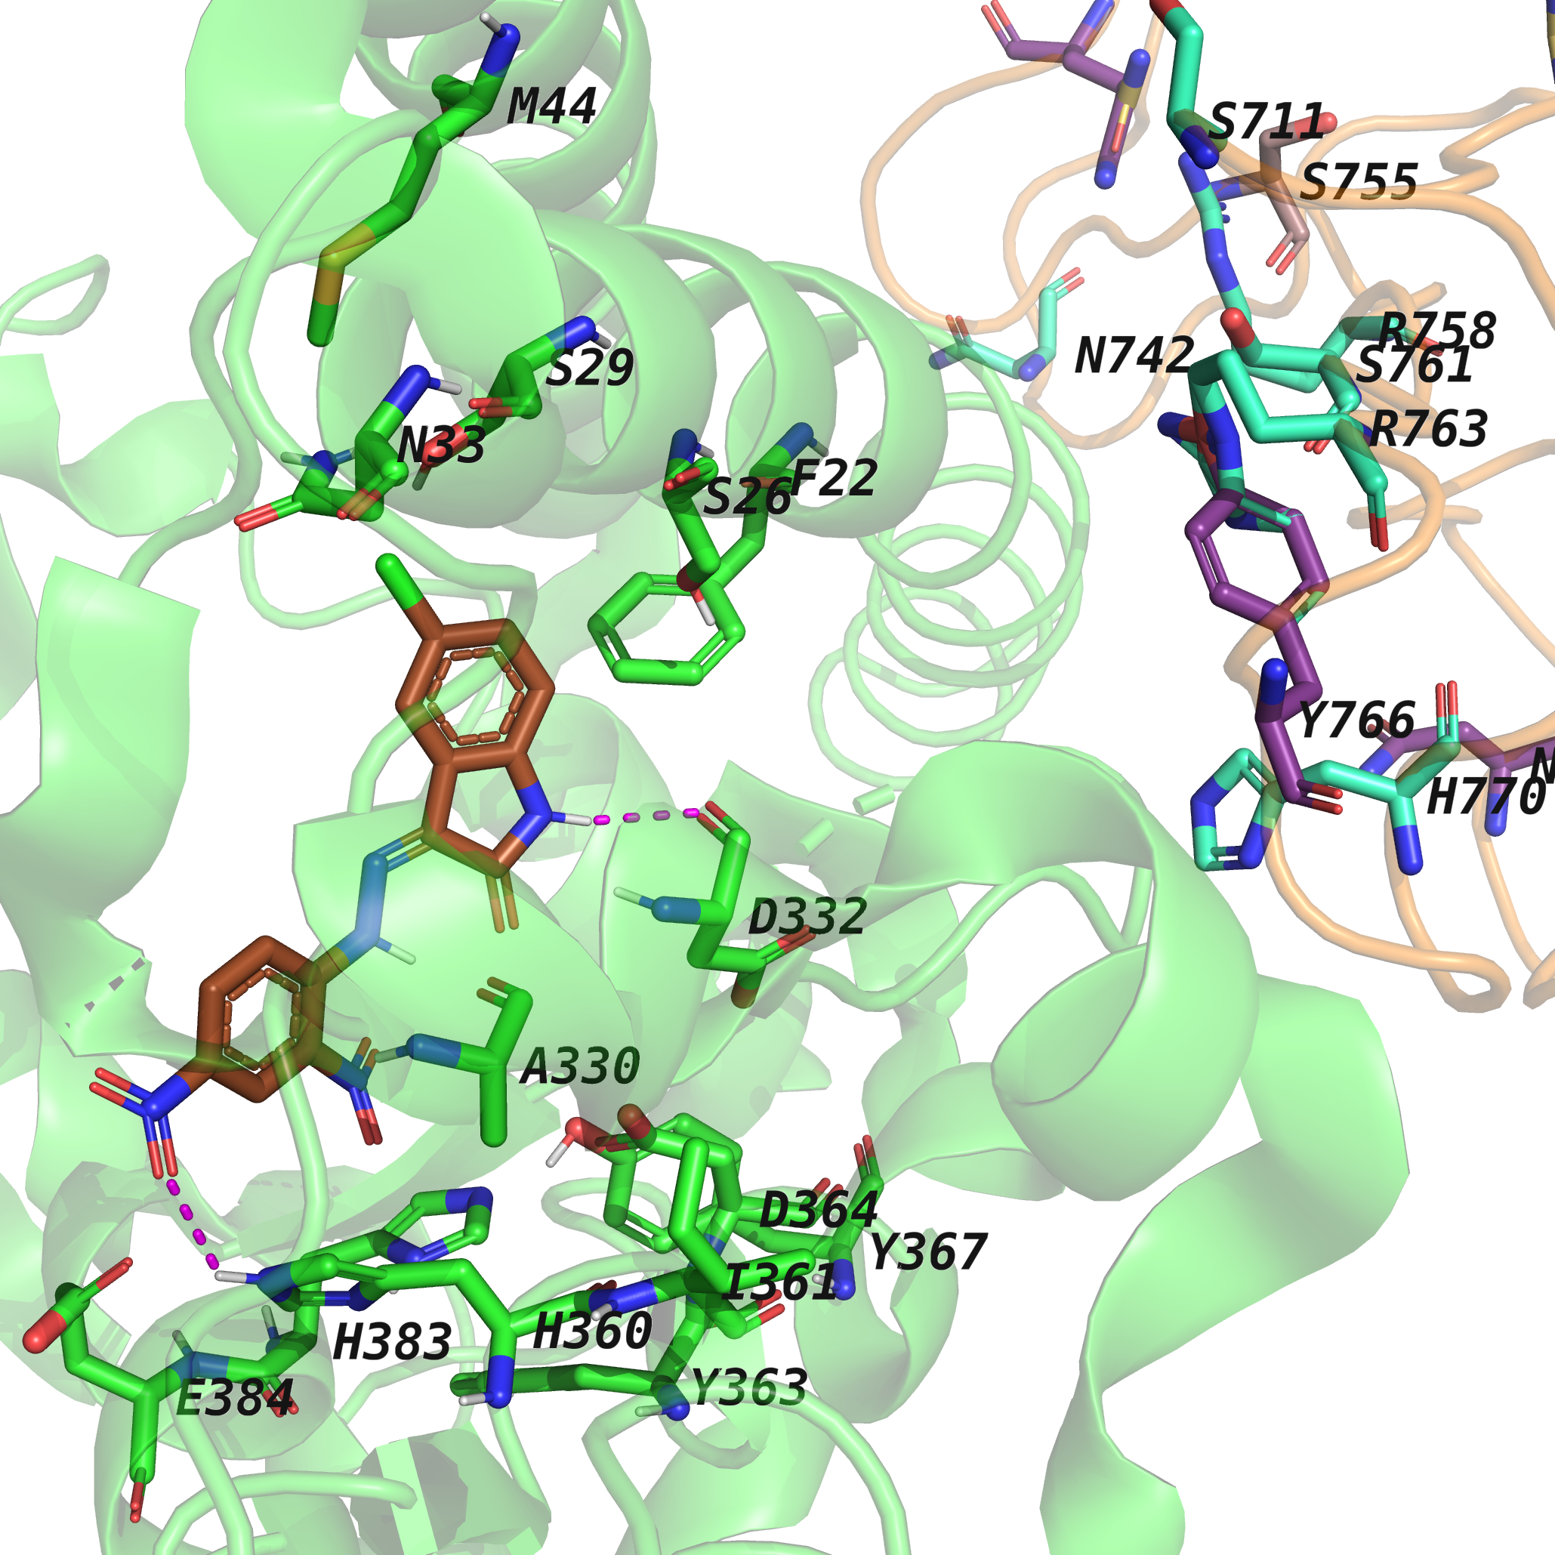
Figure S3: Docking pose of the sythesized ligand (brown stick) within the ACE2 binding site (green cartoon) with the necessary mutations for the delta variant on the spike RBD (orange ribbon). Visible ACE2 binding site residues are shown as green sticks, while visible residues on spike RBD capable of mutation are shown as sticks.

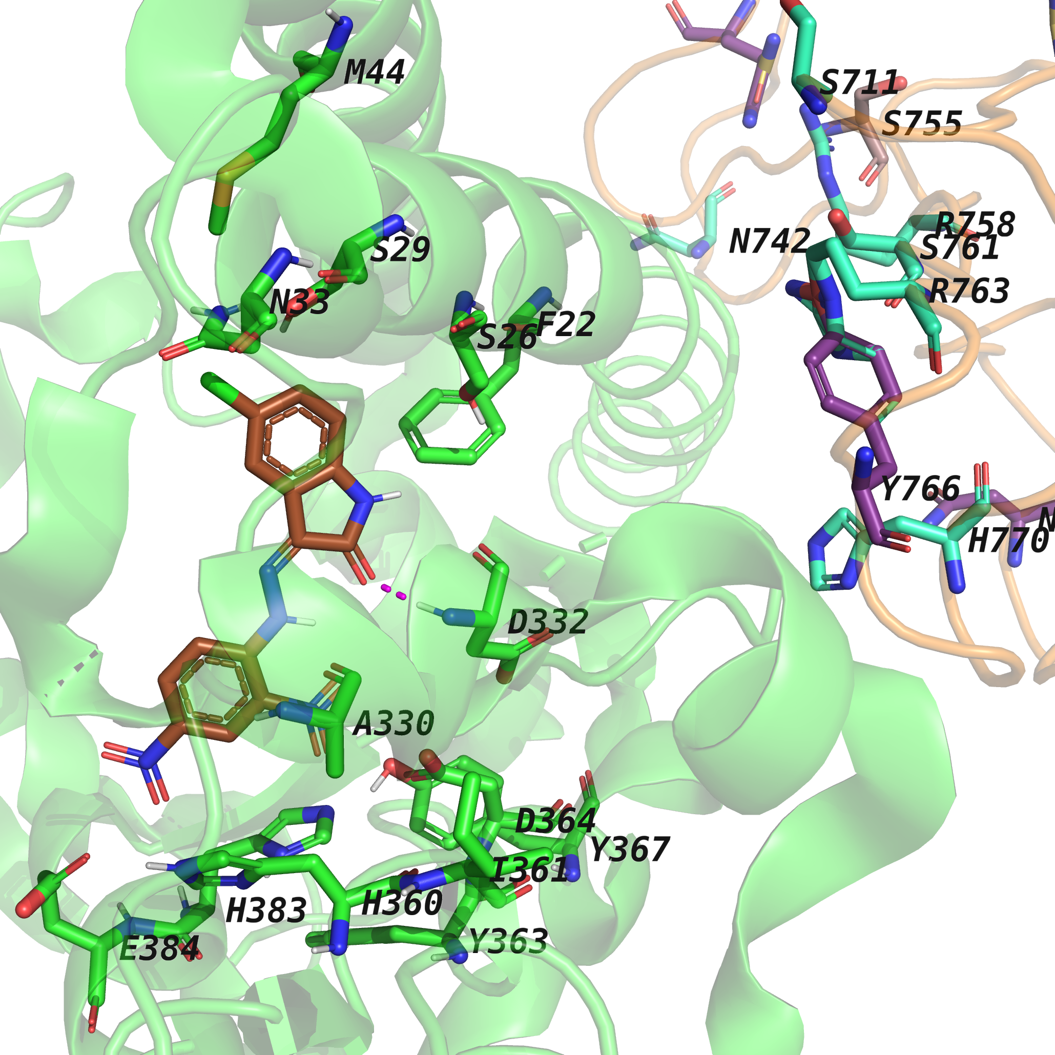
Figure S4: Docking pose of the sythesized ligand (brown stick) within the ACE2 binding site (green cartoon) with the necessary mutations for the lambda variant on the spike RBD (orange ribbon). Visible ACE2 binding site residues are shown as green sticks, while visible residues on spike RBD capable of mutation are shown as sticks.

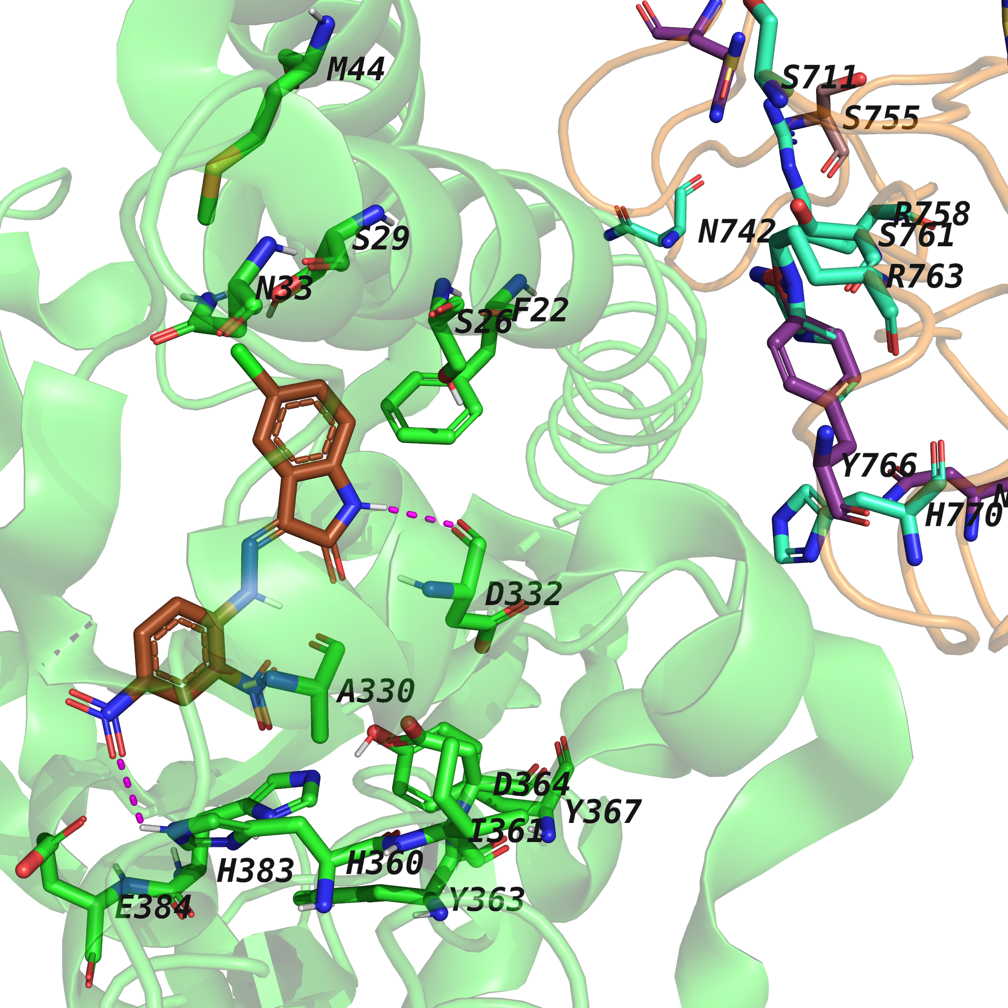
Figure S5: Super Imposition of the pose from all the different variants

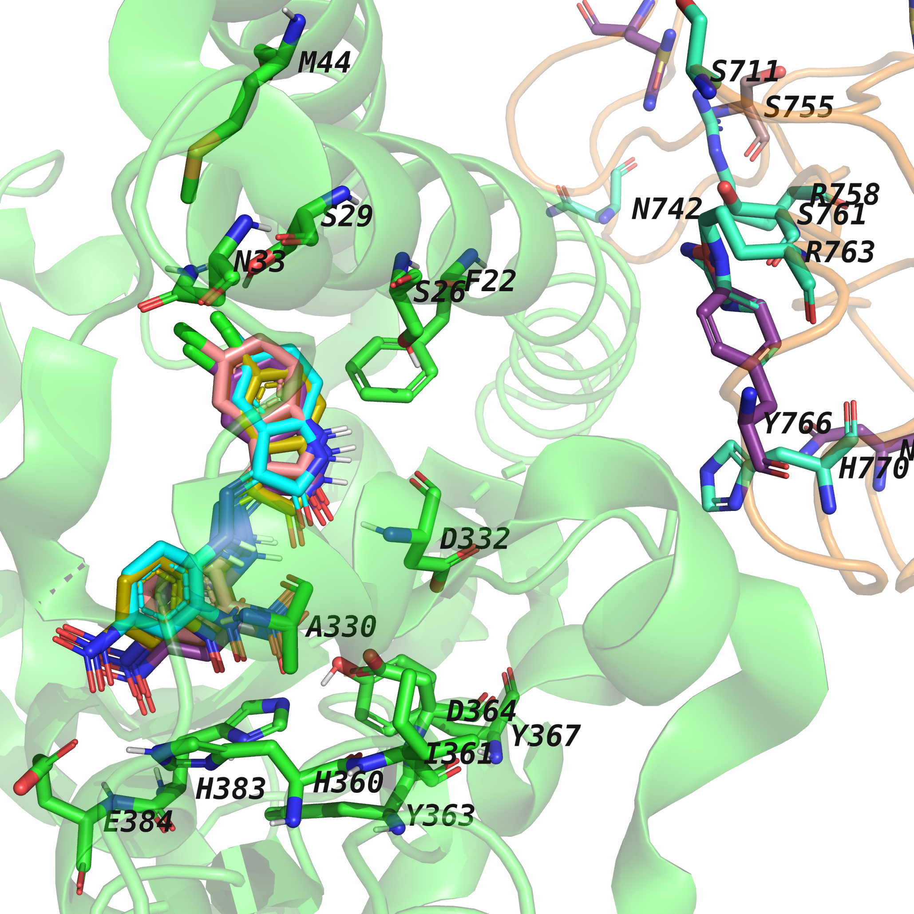
Figure S6: Super imposition of the investigated ligand (brown stick) docking pose from all the different variants within the ACE2 binding site (green cartoon) with the necessary mutations for the Wuhan (WT) variant on the spike RBD (orange ribbon). Visible ACE2 binding site residues are shown as green sticks, while visible residues on spike RBD capable of mutation are shown as sticks.

