Supplementary Information for
Timing of Global Surface Water Transitions Reveals Anthropogenic Dominance of Recent Growth in Water Extent

Gustavo Willy Nagel, Stephen E. Darby, Julian Leyland
Corresponding Author: Gustavo Willy Nagel.
E-mail: gwn1n21@soton.ac.uk

Water indexes use a combination of satellite bands to highlight water features. These water feature identification methods have extensively been used to detect surface water resources in different environments ¹⁻³. Although they have different equations, they normally rely on bands that are highly absorbed by water (such as infrared) and bands less absorbed by water (visible spectrum) ³. To produce water binary maps, a threshold must be applied to separate land from water pixels. However, the great advantage of such indexes is that they are sensitive to small changes in the Earth’s surface signal. As a result, even inside the limits of a satellite pixel, the advance or recession of water will affect the water index and thus can be tracked. However, this high sensitivity is also a challenge to scale up analysis using water indexes. Water is normally affected by a combination of water quality parameters such as chlorophyl-a, organic and inorganic soil particles, and coloured dissolved organic matter ^{4,5}, and the surrounding environment also differs greatly, spanning from forests, mangroves, sand banks, deserts, urban areas; all with an impact on the final water index signal. As a result, to globally detect the time that water permanently advanced and/or receded used Landsat satellite images from 1984 to 2022 we applied different water indexes, regional and local optimum thresholds, and methods to avoid high-frequency fluctuations in water extent using Google Earth Engine (GEE). We divided our analysis in two parts. The first algorithm identifies areas where the water advanced and/or receded (Water Change Algorithm – WCA), while the second algorithm estimates the year that this change occurred (Water Time Track Detection – WTTD).
Landsat’s availability of different infrared bands also allowed a variety of water indexes to be improved and developed, such as the popular Normalized Difference Water Index (NDWI) ⁶, which uses a normalized difference between the green and near infrared band (NIR), and the Modified Normalized Difference Water Index (mNDWI) ³, which uses the mid-infrared (SWIR) band instead of the NIR. However, each index has its own advantages and limitations. As a result, we tested the mNDWI, the NDWI and the proposed Green/Red Normalized Difference Index (grNDWI), which uses a normalization between the green-red mean and the NIR, in different environments and land classes. In the literature, a good water index is usually characterized as one that is capable of differentiating water from land ^{7,8}. However, in addition to this, to be able to track changes along time a good water index also needs to have a smooth and consistent transition from land to water and vice versa.
Figure 1 provides an analysis of the mNDWI, NDWI, and grNDWI water indices in the Amazon region, specifically in Rondônia State, Brazil. This region serves as an illustrative example of how various land covers, including dense forest, low vegetation, urban areas, and complex turbidity dynamics, impact water indices. The graph showcases the mean water index values obtained for different land covers, simulating the temporal transition from exposed soil to low vegetation, forest, and urban areas (Figure 1.b). The mNDWI demonstrates a higher water-land index difference (0.4 from water to soil) compared to either of the grNDWI and NDWI indices, making it more suitable for water detection and identifying pixel-level changes in water content over time. However, the mNDWI exhibits higher values for forest compared to low vegetation, which deviates from the expected index reduction as land cover transitions towards drier conditions in natural environments. In contrast, the grNDWI and NDWI exhibit a consistent decrease in the index from water to forest, following an almost linear relationship (R² of 0.96), and then increasing again in urban areas. Consequently, for natural environments, the grNDWI and NDWI offer a more consistent transition from water to land, making them better candidates for identifying the year of change.
However, while the mNDWI uses the SWIR band, and so is little affected by water quality parameters, both grNDWI and NDWI use the NIR band, which is sensitive to sediment content in the water ⁹ and thus can be affected by a river that changes its turbidity over time. Therefore, the proposed grNDWI uses the red band to counterbalance this effect, creating an index that is slightly less affected by turbidity variability. We tested this hypothesis comparing a water and a land index pixel (Difference = water pixel – land pixel) from both indexes to identify which one had the lower variability between the different locations (Figure 1.c). Indexes with lower location variability between different locations, with different water turbidity concentrations, will perform better to identify the water surface year of change. We selected pixels from the Amazon River, Brazil shoreline, Jurua River, Black River, China shoreline, Yangtze Delta, Mediterranean, and the Solent, UK, and confirmed that the grNDWI has 15.7% less variability. As a result, we used the mNDWI to idenfity areas of water advance and/or recession (WCA) and the grNDWI to estimate the year of change (WTTD).
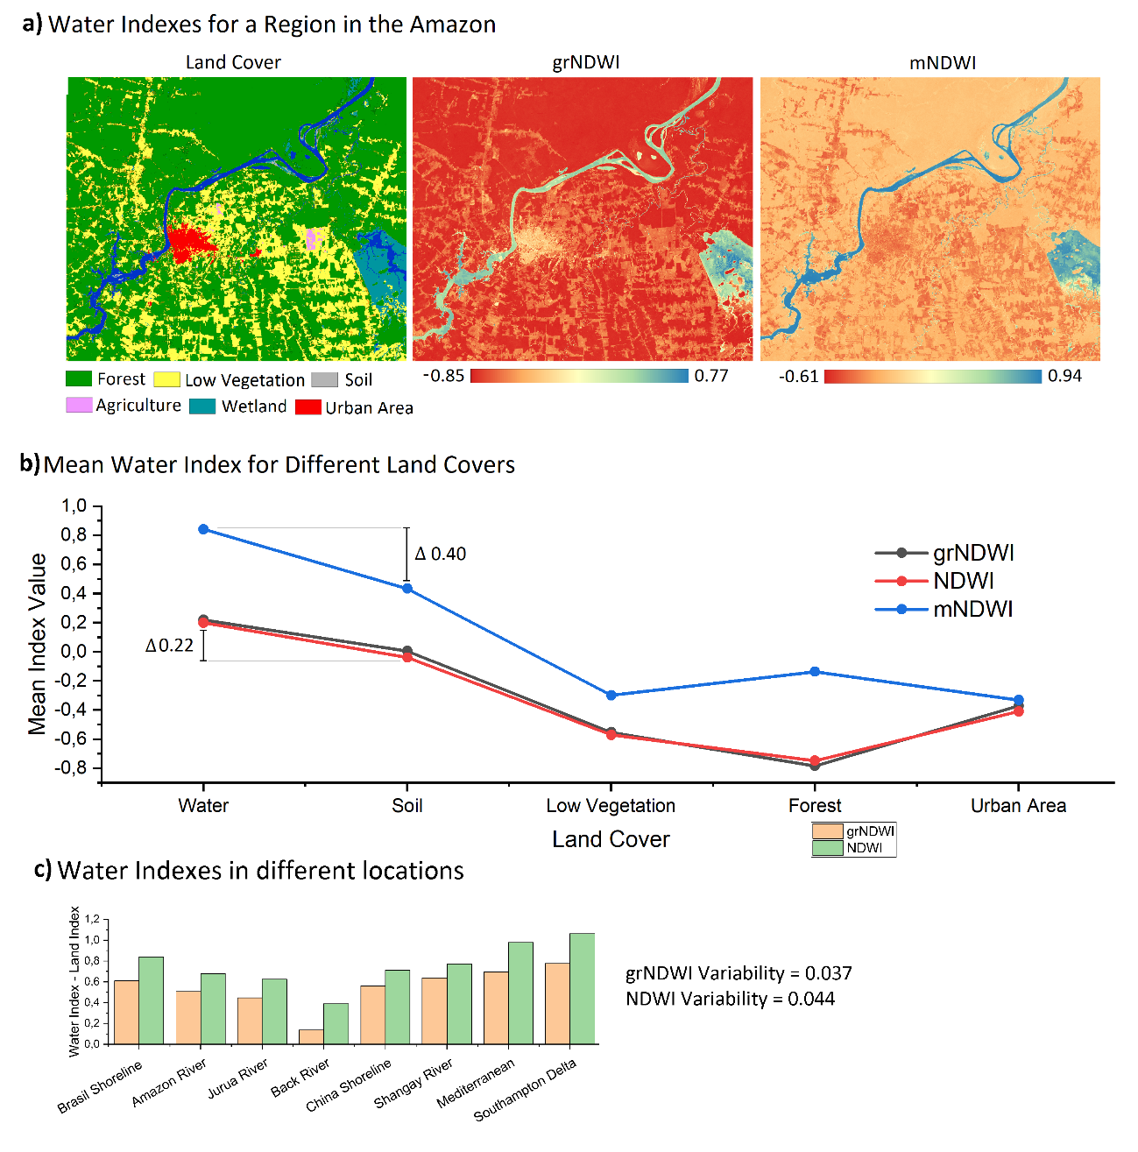
Fig. S1. Comparison between the mNDWI, NDWI and grNDWI indexes for a region of the Amazon Basin (capital of Rondônia State – Brazil) (a). The mean of each water index corresponding to a specific land cover was calculated to simulate temporal transitions from exposed soil to low vegetation, forest, and urban areas (b), and a comparison between grNDWI and mNDWI was performed in different locations (c).
To account for the spatial variability in water index values caused by differences in water quality parameters and surrounding environments, we implemented a zone-based approach. This involved dividing the world into distinct zones based on global watersheds and along the coast where watersheds and regions with similar land cover characteristics were visually merged using a satellite database provided by Google (a total of 244 regions were created). Within each zone, we aimed to determine an optimum threshold that effectively separates water from land using both the grNDWI (Fig. S2.d) and mNDWI indices (Fig. S2.c). To obtain representative data for each zone, we employed an automated process to select the least cloudy Landsat images in areas with potential water presence. Additionally, we applied cloud and snow masks to exclude areas affected by cloud cover and snow accumulation. Fig. S2.a presents an example of the least cloudy images selected for a region in the Middle East, deliberately excluding waterless desert areas. Subsequently, we applied the OTSU Method ^{10,11} to automatically identify the threshold value. This method determines the threshold by maximizing the variability between two classes, in this case, water and land (Fig. S2.b), while minimizing the differences within each class. The threshold values obtained through the OTSU Method were utilized in both the WCA and WTTD algorithms. As explained before, mNDWI is less affected by water quality parameters, so the range of global mNDWI distribution is lower than the grNDWI (Fig. S2.d). By employing zone-specific thresholds, we aimed to account for the spatial variations in water index values, ensuring accurate detection and estimation of permanent water changes in different regions.
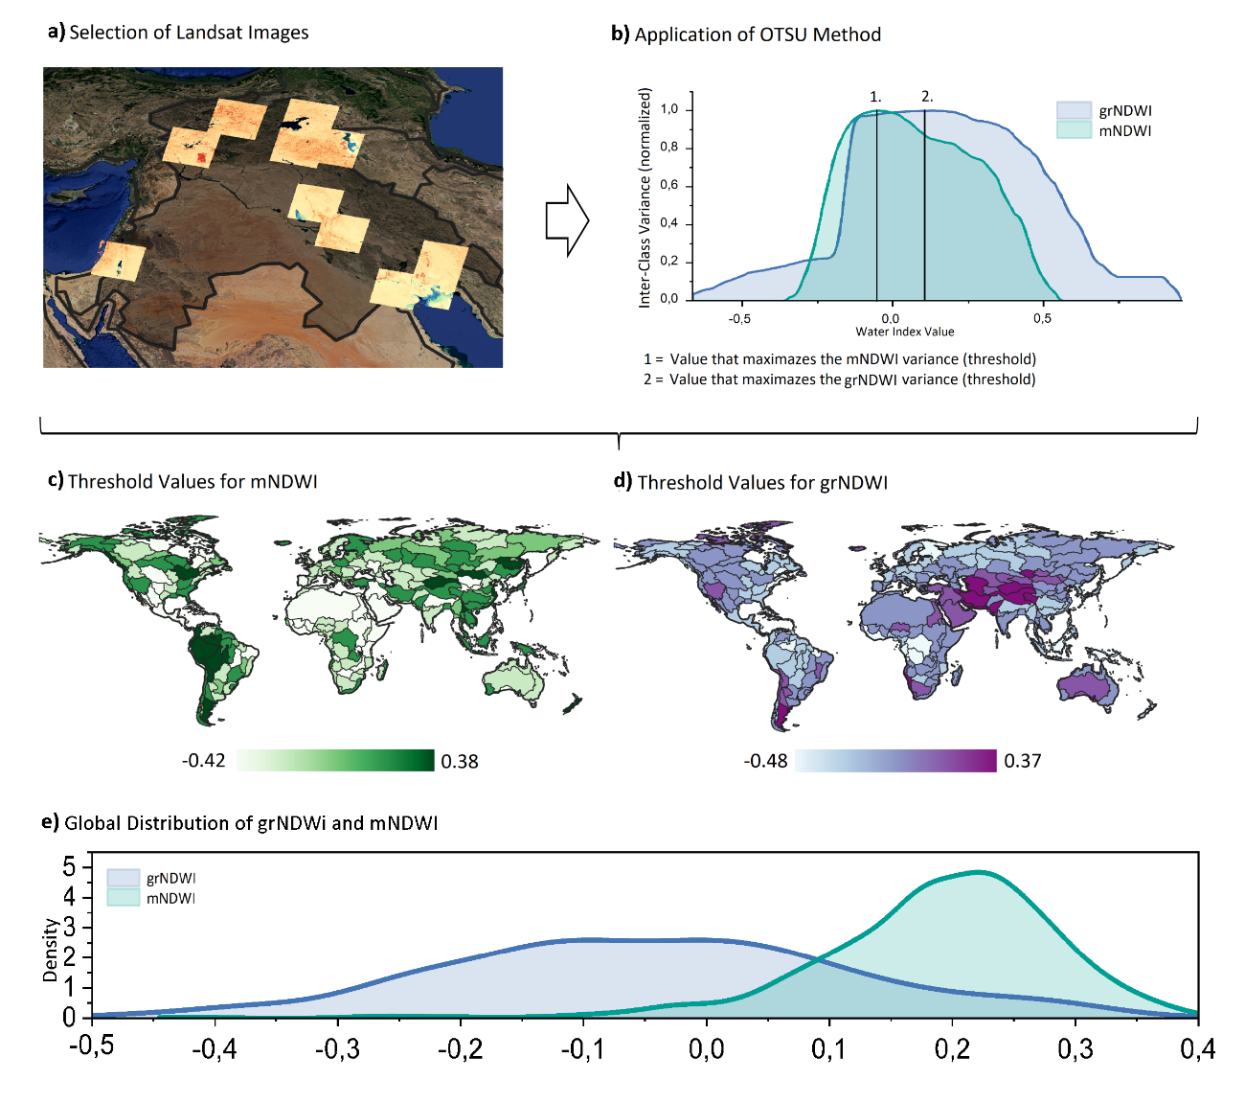
Fig. S2. OTSU methodology (a and b), the threshold result for different regions of the World (c and d), and the global threshold value distribution (e).

The mNDWI slope, or angular coefficient, played a crucial role in the Water Change Detection (WCD) process. It was utilized to determine whether a pixel exhibited a consistent trend of increasing or decreasing water over time. To establish the slope thresholds, we gathered 10,000 points from regions worldwide where we already knew water had either advanced or receded (refer to Figure S3). These slope values were then sorted, and the 5th percentile values were extracted for water-recession points (-0.008 ∆mNDWI/year) and water-advance pixels (0.005 ∆mNDWI/year). Consequently, pixels with a slope below -0.008 ∆mNDWI/year were classified as having a negative trend, while pixels with a slope above 0.005 ∆mNDWI/year were classified as having a positive trend. This information was utilized in the Water Change Detection algorithm. A similar methodology was employed by Nagel, et al. ¹².

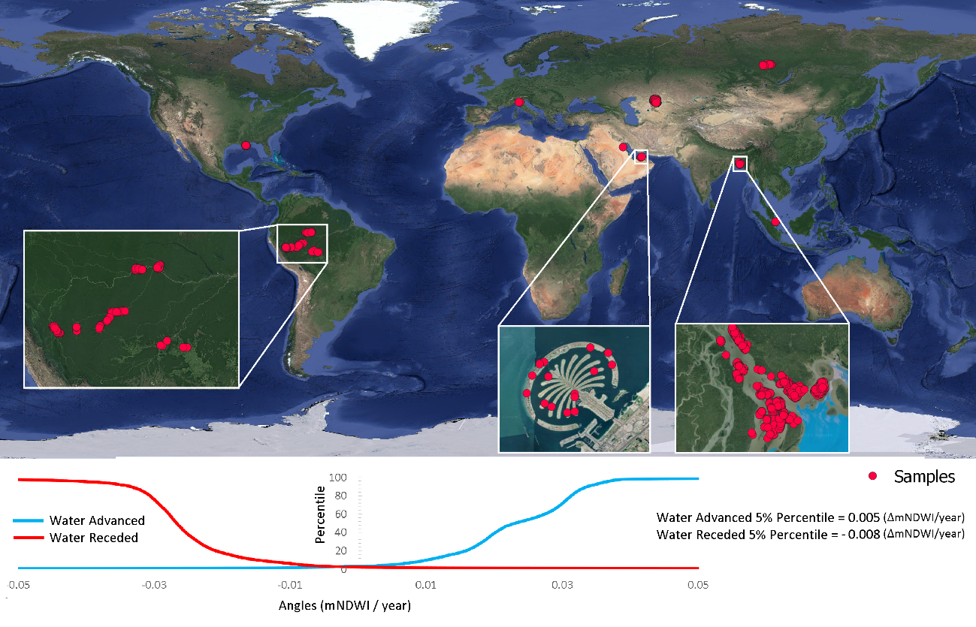
Fig. S3. Sample areas of mNDWI angular coefficient and the angular threshold used to classify advancing and receding pixels (5% percentile threshold).
To ensure the suitability of the Landsat image database for the application of the Water Change Detection (WCD) and Water Time Track Detection (WTTD) algorithms, a series of pre-processing steps were implemented. These steps were carefully designed to enhance the quality and consistency of the data (Fig. S4). The following procedures were executed:
- The Landsat 5, 8, and 9 images were merged to create a comprehensive ImageCollection within the Google Earth Engine (GEE) platform.
- To mitigate the influence of cloud cover on the analysis, images with cloud coverage exceeding 30% were filtered out from the dataset.
- A cloud mask, derived from the CFMask product, was applied to the remaining images. This mask effectively identifies and removes cloud pixels, further reducing the impact of atmospheric interference.
- The mNDWI and grNDWI indexes were calculated for each image. These indices provide valuable information regarding water presence and dynamics, serving as fundamental inputs for the subsequent algorithms.
- An annual composite was generated by calculating the median pixel value for each year. This composite effectively represents the water dynamics for a specific year, incorporating the most representative pixel values from various images captured throughout that year.
- To address the issue of missing data in certain years, a filling technique was implemented. In cases where data was absent for a particular year, the algorithm interpolated a new value based on the preceding and succeeding years.
The interpolated value was computed as the mean of the images captured one year before and one year after the missing year. If the data gap extended beyond one year, the algorithm extended the time interval by considering images from two years prior and two years after the missing year. This process continued iteratively, with the algorithm expanding the time interval until a year with available data was found. However, to maintain data integrity and avoid excessive extrapolation, the maximum allowed time interval was set to a range of four years (-4 to +4). Through these rigorous pre-processing techniques, we constructed a continuous and spatially coherent Landsat image database. The resulting dataset exhibits minimal cloud and atmospheric interference, ensuring the optimal conditions required for the accurate implementation of the WCD and WTTD algorithms. This database serves as a robust foundation for our comprehensive analysis of global water surface dynamics and the estimation of permanent changes over time.
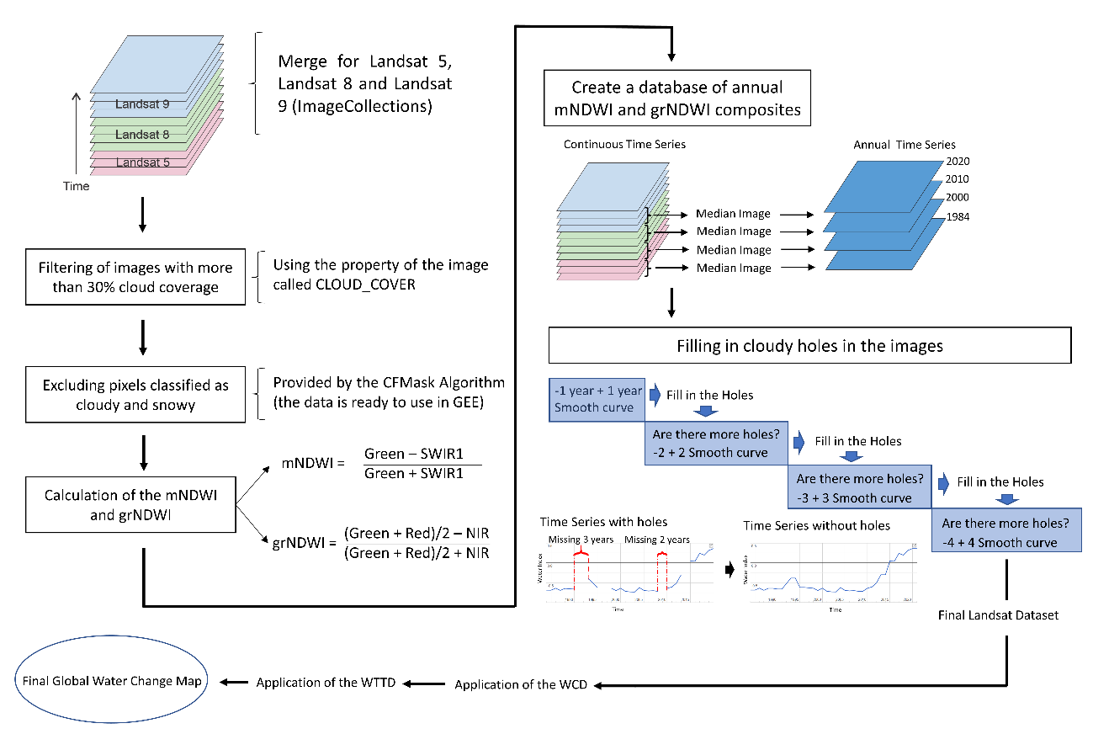
Fig. S4. Flowchart of the water change detection pre-processing.

To ensure the accuracy of the Water Change Detection (WCD) algorithm in identifying trends of water advance and/or recession, it was necessary to have a sufficient number of years of Landsat time series data. Therefore, we excluded regions where the Landsat time series began after 1990, which accounted for only 13% of the global surface (Fig. S5). This exclusion was necessary to maintain the reliability and consistency of the analysis by focusing on areas with longer temporal coverage of Landsat data.
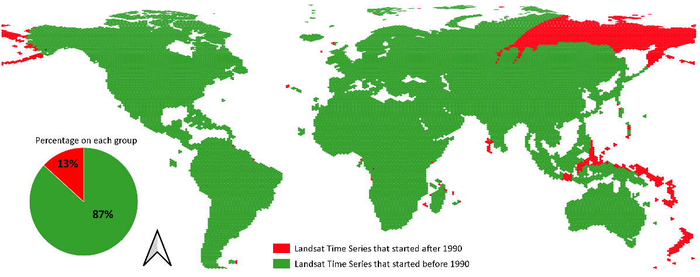
Fig. S5. Areas where Landsat Time Series started after 1990 (excluded from the analysis), and before 1990.
After the processing of global water change, a validation process with 700 samples were performed. Fig. S6. Provides the error distribution (Predicted – Observed) for different water features.
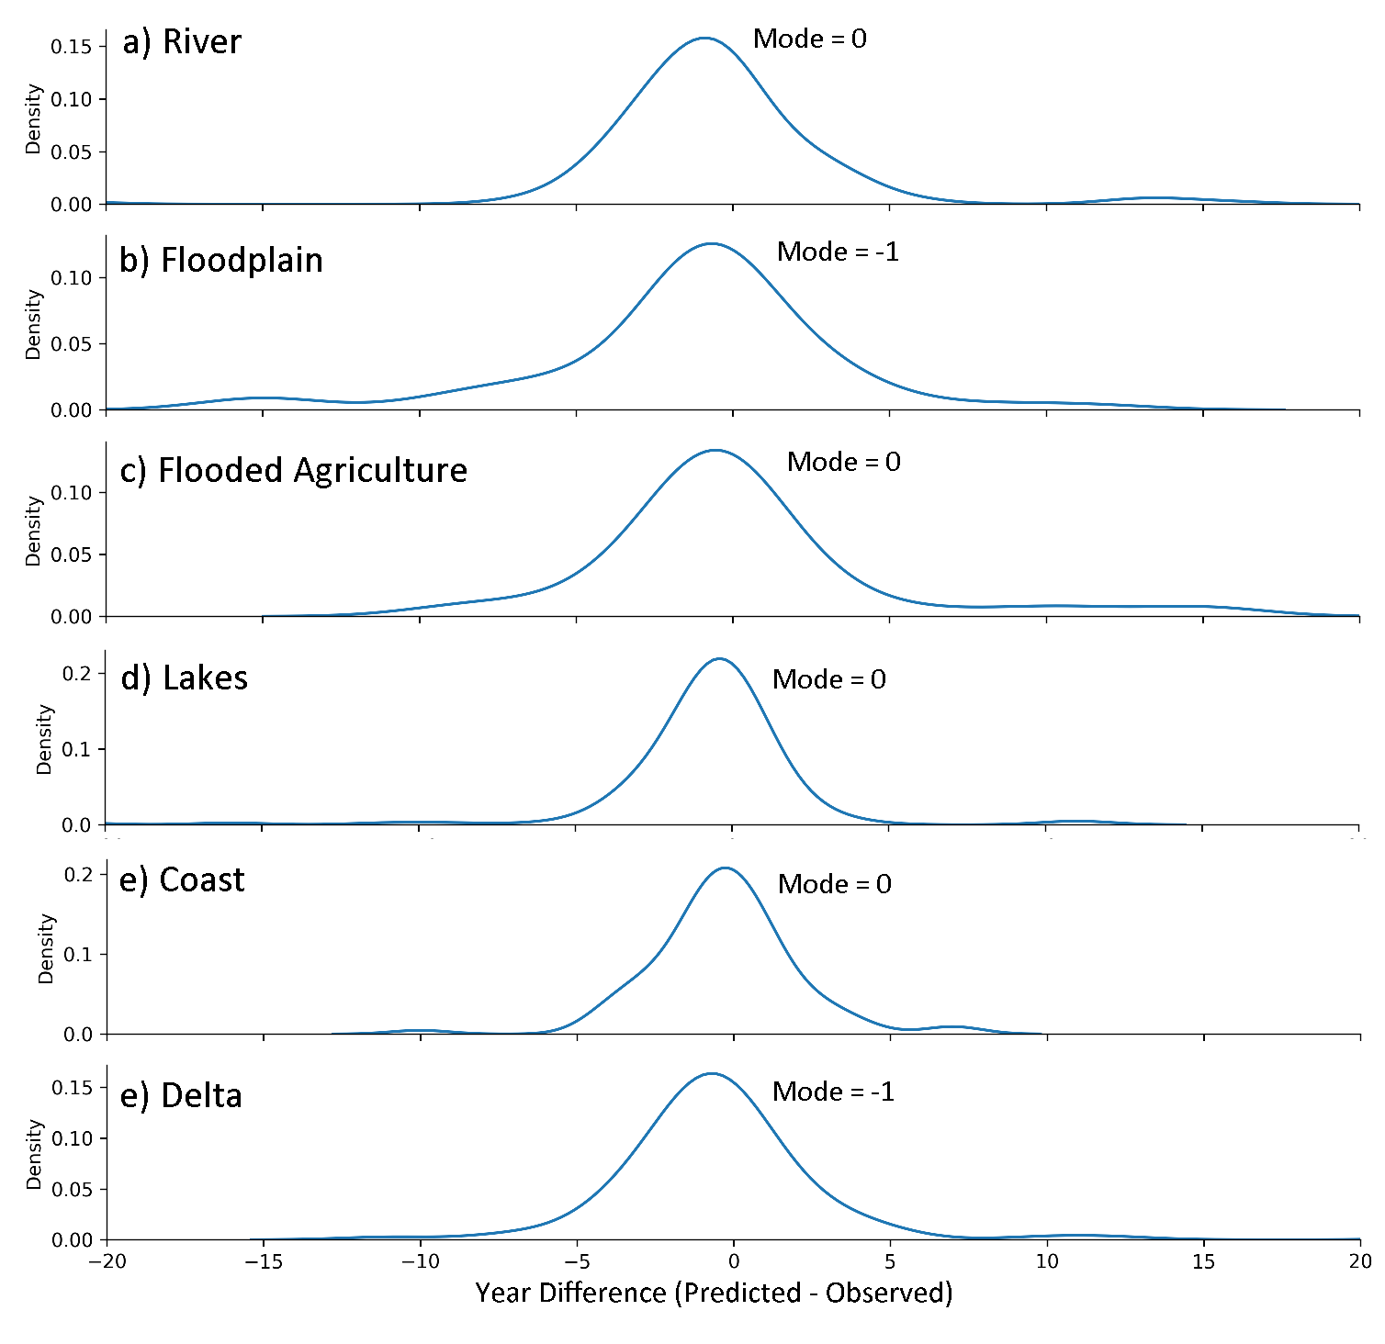
Fig. S6. Distribution of Error between Predicted and Observed years for different water features.

To determine the percentage of water change in different water environments, we utilized existing datasets for rivers, reservoirs/lakes/wetlands, deltas, and oceans. The data sources included Allen and Pavelsky ¹³ for rivers, lakes, and low residency water bodies, additional lakes from Messager, et al. ¹⁴, and ocean areas from Yamazaki, et al. ¹⁵. By dividing the world into hexagons, we calculated the percentage of each water environment type and the total area of advancing and receding water in each grid cell (Fig. S7). The hexagons measured 1,010 km², and so 159,656 hexagons were necessary to cover the whole world. We assumed that the area of water change is directly associated with the type of environment in each region. For instance, a region comprised of 90% rivers would have 90% of water advancing and water receding pixels in rivers, while the remaining 10% would be attributed to other water environments. By multiplying the area of advancing and receding water by the percentage of each water environment type, we could estimate the water change that occurred in lakes/reservoirs, rivers, deltas, and coastal regions.
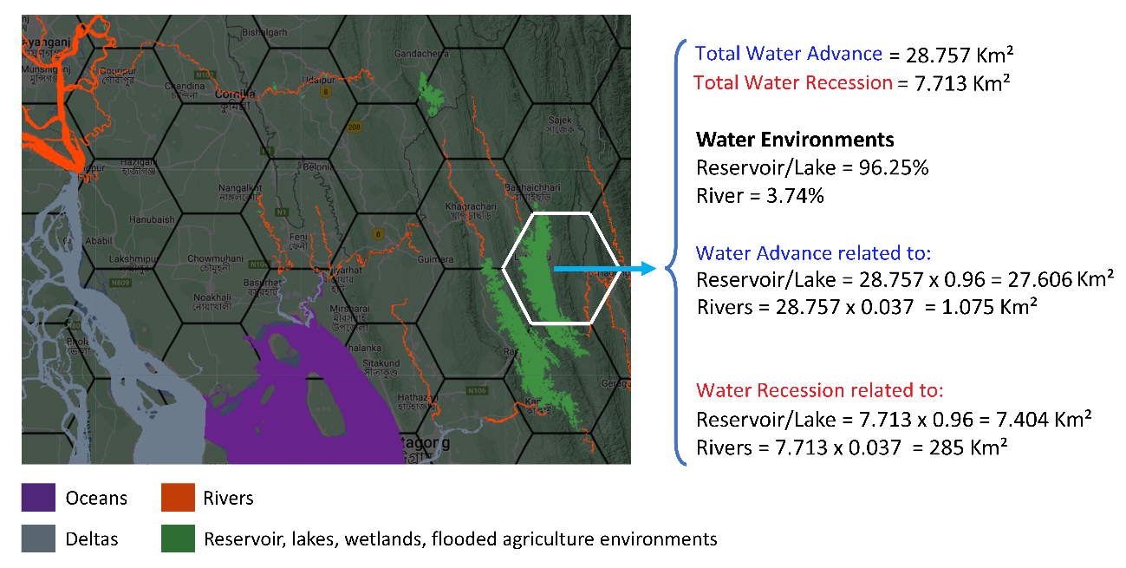
Fig. S7. Estimation of Total Water advance and Total water recession related to different water type environments. The example provided is a region on the Ganges Delta (Bangladesh).

References:
1 Sharma, R. C., Tateishi, R., Hara, K. & Nguyen, L. V. Developing Superfine Water Index (SWI) for Global Water Cover Mapping Using MODIS Data. Remote Sensing 7, 13807-13841 (2015).
2 Acharya, T. D., Subedi, A. & Lee, D. H. Evaluation of Water Indices for Surface Water Extraction in a Landsat 8 Scene of Nepal. Sensors 18, 2580 (2018).
3 Xu, H. Modification of normalised difference water index (NDWI) to enhance open water features in remotely sensed imagery. International Journal of Remote Sensing 27, 3025-3033, doi:10.1080/01431160600589179 (2006).
4 Gholizadeh, M. H., Melesse, A. M. & Reddi, L. A Comprehensive Review on Water Quality Parameters Estimation Using Remote Sensing Techniques. Sensors (Basel) 16, doi:10.3390/s16081298 (2016).
5 Gardner, J. R. et al. The Color of Rivers. Geophysical Research Letters 48, e2020GL088946, doi:https://doi.org/10.1029/2020GL088946 (2021).
6 Gao, B.-c. NDWI—A normalized difference water index for remote sensing of vegetation liquid water from space. Remote Sensing of Environment 58, 257-266, doi:https://doi.org/10.1016/S0034-4257(96)00067-3 (1996).
7 Yang, J. & Du, X. An enhanced water index in extracting water bodies from Landsat TM imagery. Annals of GIS 23, 141-148, doi:10.1080/19475683.2017.1340339 (2017).
8 Fisher, A., Flood, N. & Danaher, T. Comparing Landsat water index methods for automated water classification in eastern Australia. Remote Sensing of Environment 175, 167-182, doi:https://doi.org/10.1016/j.rse.2015.12.055 (2016).
9 Jiang, W. et al. An Effective Water Body Extraction Method with New Water Index for Sentinel-2 Imagery. Water 13 (2021).
10 Otsu, N. A Threshold Selection Method from Gray-Level Histograms. IEEE Transactions on Systems, Man, and Cybernetics 9, 62-66, doi:10.1109/tsmc.1979.4310076 (1979).
11 Tang, W. et al. Improved Spectral Water Index Combined with Otsu Algorithm to Extract Muddy Coastline Data. Water 14, 855, doi:10.3390/w14060855 (2022).
12 Nagel, G. W. et al. Impacts of meander migration on the Amazon riverine communities using Landsat time series and cloud computing. Science of The Total Environment 806, 150449, doi:https://doi.org/10.1016/j.scitotenv.2021.150449 (2022).
13 Allen, G. H. & Pavelsky, T. M. Global extent of rivers and streams. Science 361, 585-588, doi:10.1126/science.aat0636 (2018).
14 Messager, M. L., Lehner, B., Grill, G., Nedeva, I. & Schmitt, O. Estimating the volume and age of water stored in global lakes using a geo-statistical approach. Nature Communications 7, 13603, doi:10.1038/ncomms13603 (2016).
15 Yamazaki, D. et al. MERIT Hydro: A High‐Resolution Global Hydrography Map Based on Latest Topography Dataset. Water Resources Research 55, 5053-5073, doi:10.1029/2019wr024873 (2019).

