All patients underwent triphasic dynamic contrast-enhanced CT scan examination before surgery. Enrolled patients had similar scan procedure: arterial phase scanning was performed with 15–25 seconds delay after contrast injection; portal and delayed phase images were obtained at 70 and 180 seconds, respectively, after contrast injection. The parameters of CT protocols are outlined in Table 1. ROIs were segmented in Figure 1.
Table 1
parameters The Affiliated Hospital of Nantong University
CT version 64-slice spiral CT (SOMATOM Definition, SIEMENS, Germany)
CT tube voltage 120kVP
CT tube current 175 mAs
CT rotation time 0.50s
Constract agent type Ultravist
Contrast agent concertration 300mg/ml
Contrast agent dosage 1.5ml/kg
Contrast agent infused rate 3ml/s
Arterial phase scan 20s after contrast injection
Venous phase scan 70s after contrast injection
Delayed phase scan 180s after contrast injection
Image matrix 512*512
Figure 1: Image segmentation of three phases in abdominal contrast-enhanced CT with one HCC patient. A: arterial phase; V: portal venous phase; D: delayed phase; A1: ROI of arterial phase;
V1: ROI of portal venous phase; D1: ROI of delayed phase.
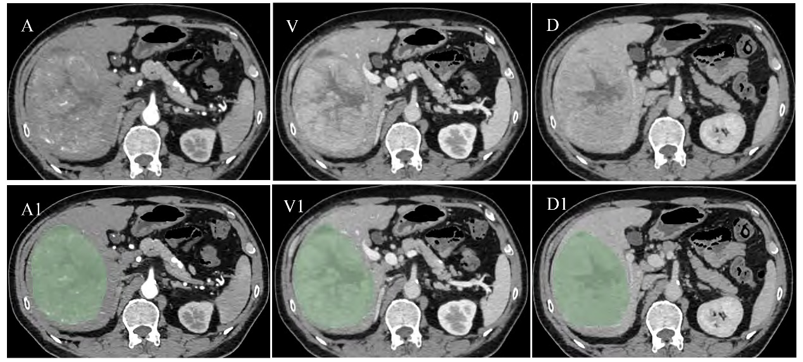

Methods1: immunohistochemical protocol.
Tumor and peritumoral samples were obtained from non-necrotic HCC central and adjacent areas. The c-Met was assessed using paraffin-embedded tissue samples that were cut into 4-μm slices organized at corresponding cores in tissue microarrays. Briefly, tissue microarrays were deparaffinized in xylene and rehydrated through a graded series of ethanol solutions. Then placed tissue chips in the citrate repair solution (PH6.0), repaired the antigen by heating and pressuring, and slowly cooled to room temperature. Washed the chips three times in PBS (PH7.4) for 5 min per time. Next, through blocking endogenous peroxidases and closing by seroma, the chips were stained with rabbit anti-c-Met monoclonal antibody (Cell Signaling Technology) at a diluted ratio of 1:200 in humidified chamber overnight at 4℃. After adding the secondary antibody and DAB color rendering, the results were observed under microscope.

