Online Resource 2
Dynamics of a fragmented forest landscape and its drivers of forest loss, recovery, and stability
Jéssica Stéfane Alves Cunha^{a,b,}*, Jhonathan Gomes dos Santos^{b,c}, Nathan Castro Fonsêca^{a,}, Camila Linhares de Rezende^{d}, Ana Carolina Borges Lins-e-Silva^{a,b,e,}*
ªLaboratório de Ecologia Vegetal, Departamento de Biologia, Universidade Federal Rural de Pernambuco (UFRPE), Rua D. Manoel de Medeiros, 52171-900, Recife, PE, Brasil
^{b}Programa de Pós-Graduação em Ciências Florestais, Departamento de Ciência Florestal, UFRPE, 52171-900, Recife, PE, Brasil
^{c} Centro de Engenharia e Ciências Agrárias (CECA), Universidade Federal de Alagoas (UFAL), 57.100-000, Rio Largo, AL, Brasil
^{d}Fundação Brasileira para o Desenvolvimento Sustentável, FBDS, 22610-180, Rio de Janeiro, RJ, Brasil
^{e}Programa de Pós-Graduação em Etnobiologia e Conservação da Natureza, Departamento de Biologia, UFRPE, 52171-900, Recife, PE, Brasil
* Corresponding authors
E-mail addresses: cunhajsa@gmail.com (J.S.A. Cunha), ana.blsilva@ufrpe.br (A.C.B. Lins-e-Silva)
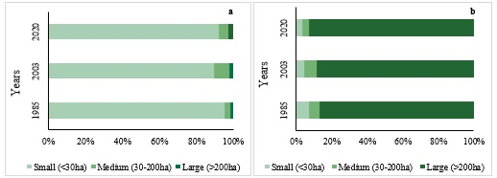
Fig. S1 Distribution of fragment size classes (a) and Occupation of fragment size classes (b) in the forest landscape over the three analysed years (1985, 2003 and 2020) in the Environmental Protection Area (APA) Aldeia-Beberibe, Recife, Pernambuco, Brazil.
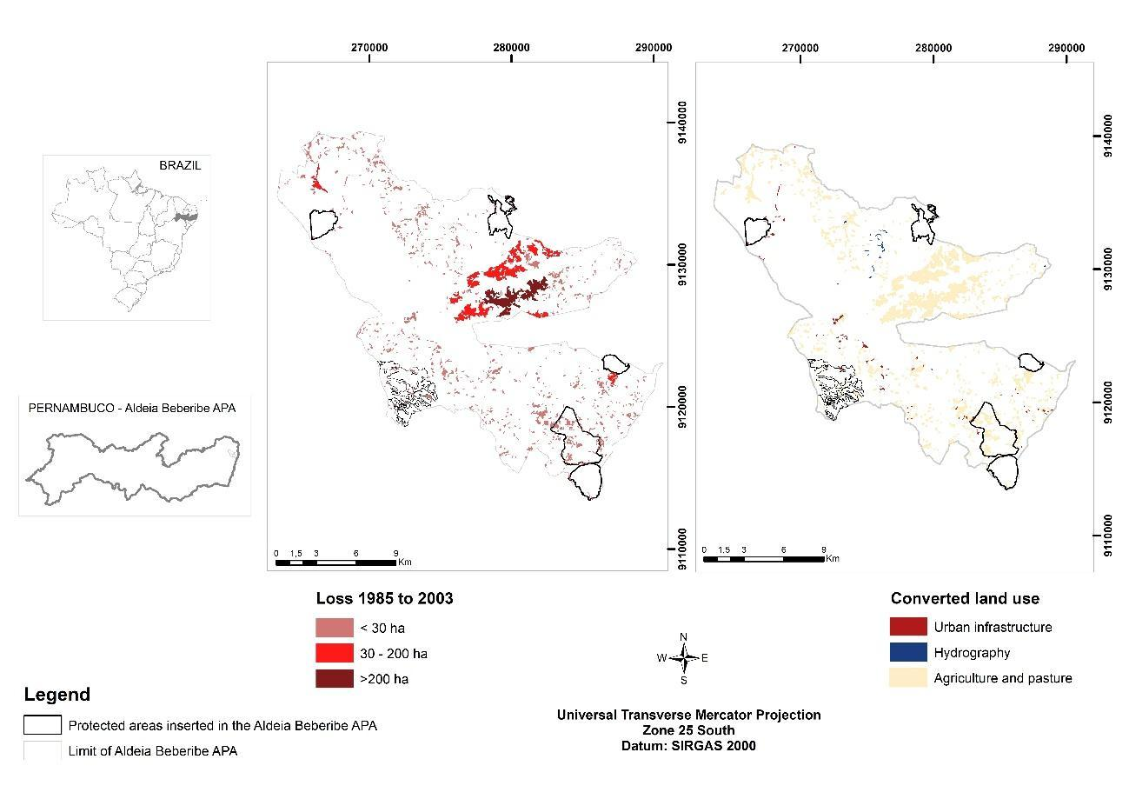
Fig. S2 Forest loss and converted land use in the Environmental Protection Area (APA) Aldeia-Beberibe, Recife, Pernambuco, Brazil, from 1985 to 2003.
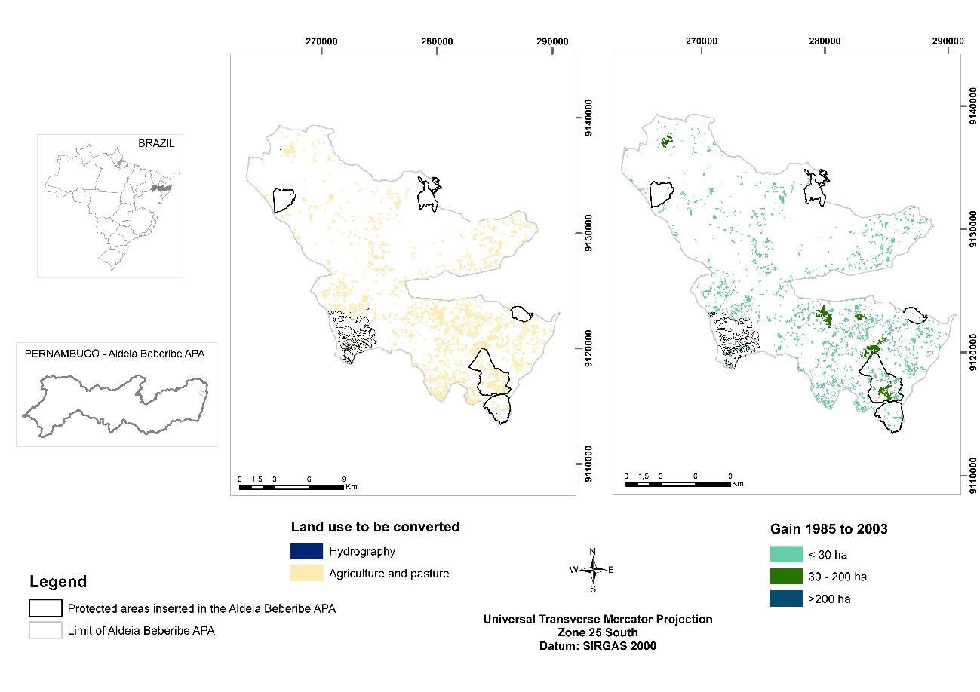Fig. S3 Forest gain and converted land use in the Environmental Protection Area (APA) Aldeia-Beberibe, Recife, Pernambuco, Brazil, between the years 1985 and 2003.
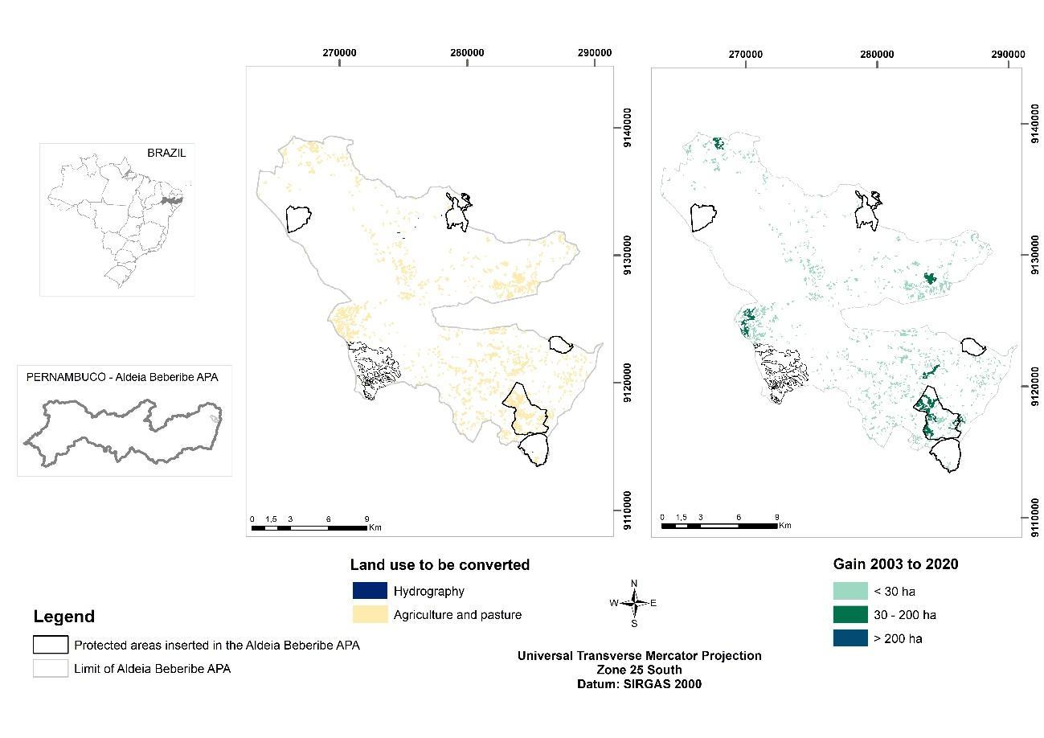Fig. S4 Forest gain and converted land use in the Environmental Protection Area (APA) Aldeia-Beberibe, Recife, Pernambuco, Brazil, between the years 2003 and 2020.
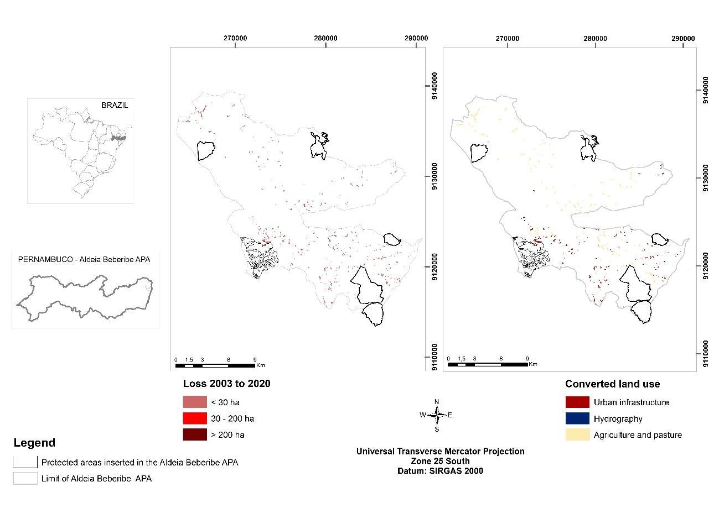Fig. S5 Forest loss and converted land use in the Environmental Protection Area (APA) Aldeia-Beberibe, Recife, Pernambuco, Brazil, from 2003 to 2020.

