Dominance of Cotton leaf curl Multan virus-Rajasthan strain associated with third epidemic of cotton leaf curl disease in Pakistan

Muhammad Arslan Mahmood^{1†}, Nasim Ahmed^{1,2}, Athar Hussain^{1,3}, Rubab Zahra Naqvi¹, Imran Amin¹ and Shahid Mansoor^{1,4}*
¹Agricultural Biotechnology Division, National Institute for Biotechnology and Genetic Engineering (NIBGE) college Pakistan Institute of Engineering and Applied Sciences, Faisalabad, Pakistan
²Biotechnology and Microbiology Group, Department of Zoology, University of Poonch Rawalakot, Azad Jammu and Kashmir, Rawalakot, Pakistan
³Genomics Lab, School of Food and Agricultural Sciences (SFAS), University of Management and Technology (UMT), Lahore, 54000, Pakistan
⁴International Center for Chemical and Biological Sciences, University of Karachi, Karachi, Pakistan
†Current address: Plant Sciences Division, Research School of Biology, The Australian National University, Canberra, ACT 2601, Australia
*Correspondence: Shahid Mansoor: shahidmansoor7@gmail.com

Protein alignment and domain analysis of C1 full-length and C1 mutated protein
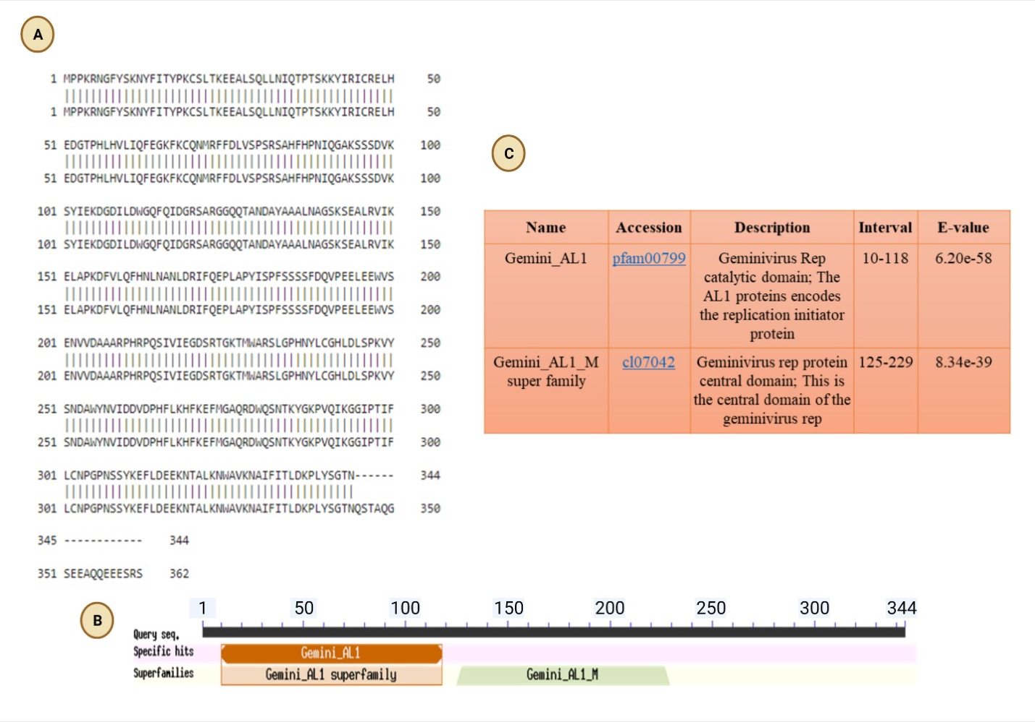
Fig. S1. (A) Alignment of C1 full-length protein (362 aa) with C1 mutated protein (344 aa) showed only 18 amino acids with gaps. (B & C) Domains of both versions of C1 proteins show the same Gemini_AL1 and Gemini_AL1_M superfamily.

Protein alignment and domain analysis of C1 full-length and C1 mutated protein
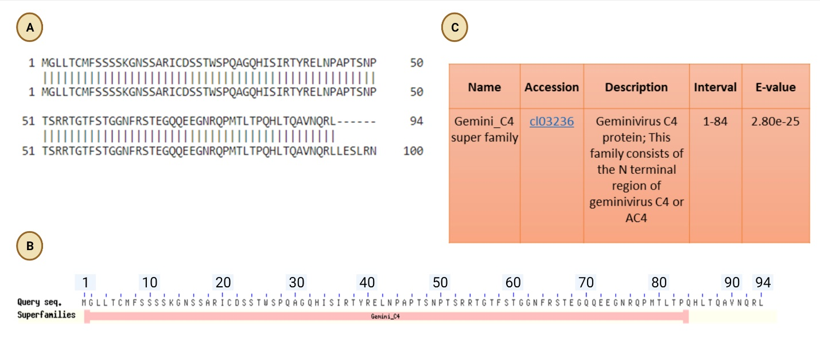
Fig. S2. (A) C4 mutated protein (94 aa) was fully aligned with C4 full-length protein (100 aa) leaving back the six amino acids from full-length protein. (B& C) The domains were conserved in both forms of C4 proteins, the domain is Gemini_C4 Superfamily cl03236.

PSIPRED predicted structures of C1-C1 mutated proteins
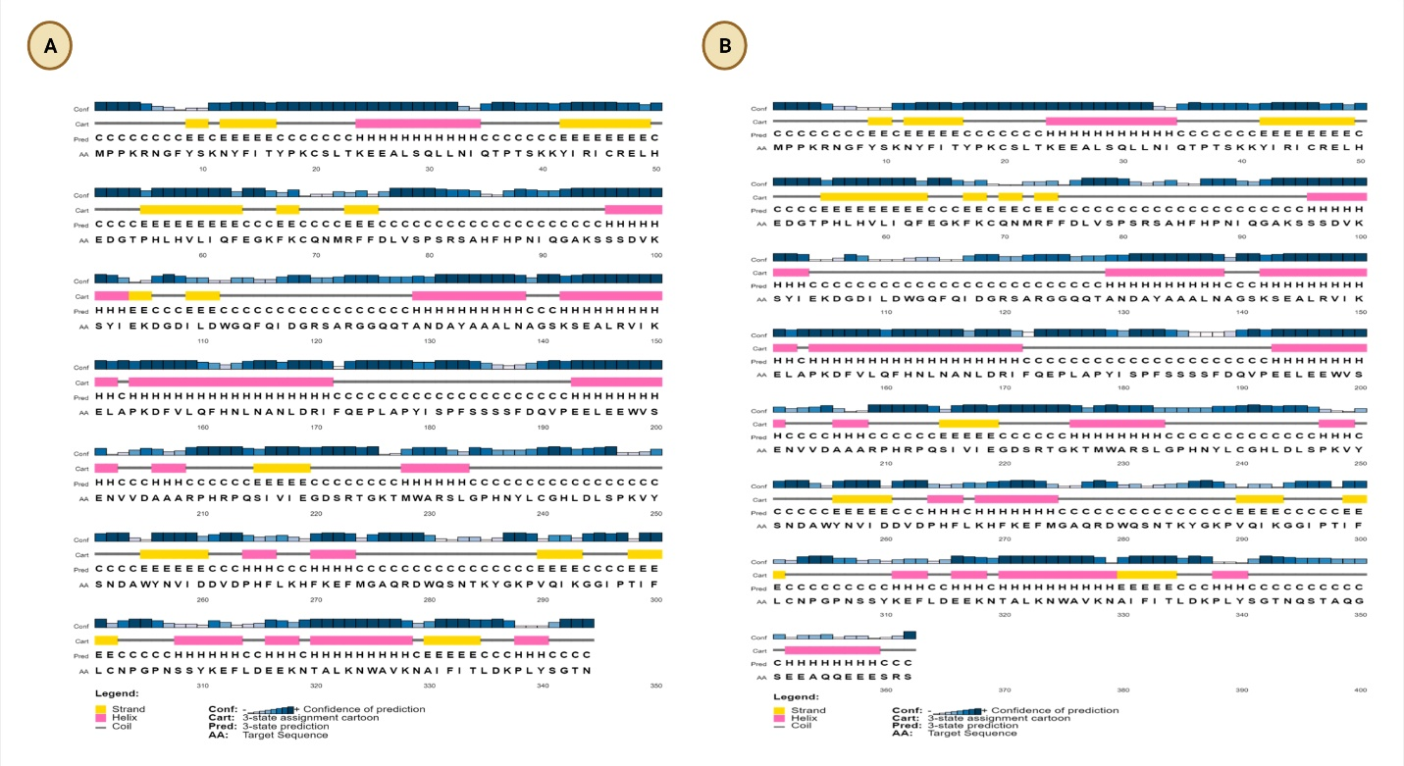
Fig. S3. (A) C1 proteins exhibited extra coil and helix region in the full-length protein. (B) but was lacking in mutated C1 protein.

PSIPRED predicted structures of C4-C4 mutated proteins
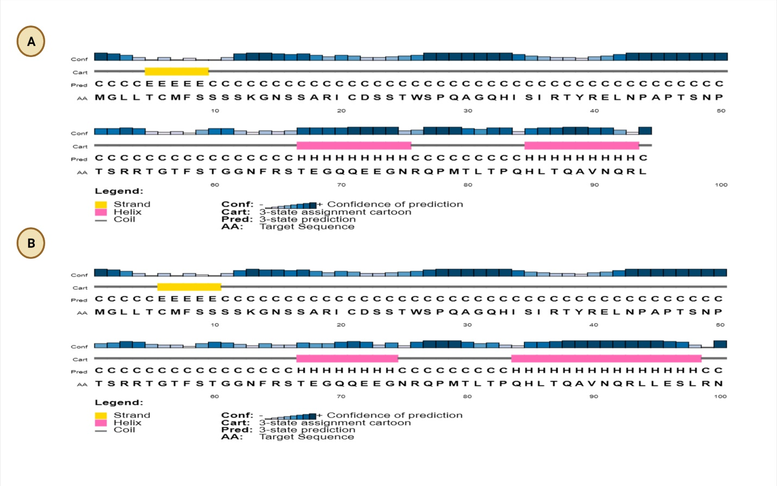
Fig. S4. (A) C4 full-length showed one extra coil and six more helix residues, (B) than the mutated C4 partner protein.

Sequence and motif analysis of C1 proteins
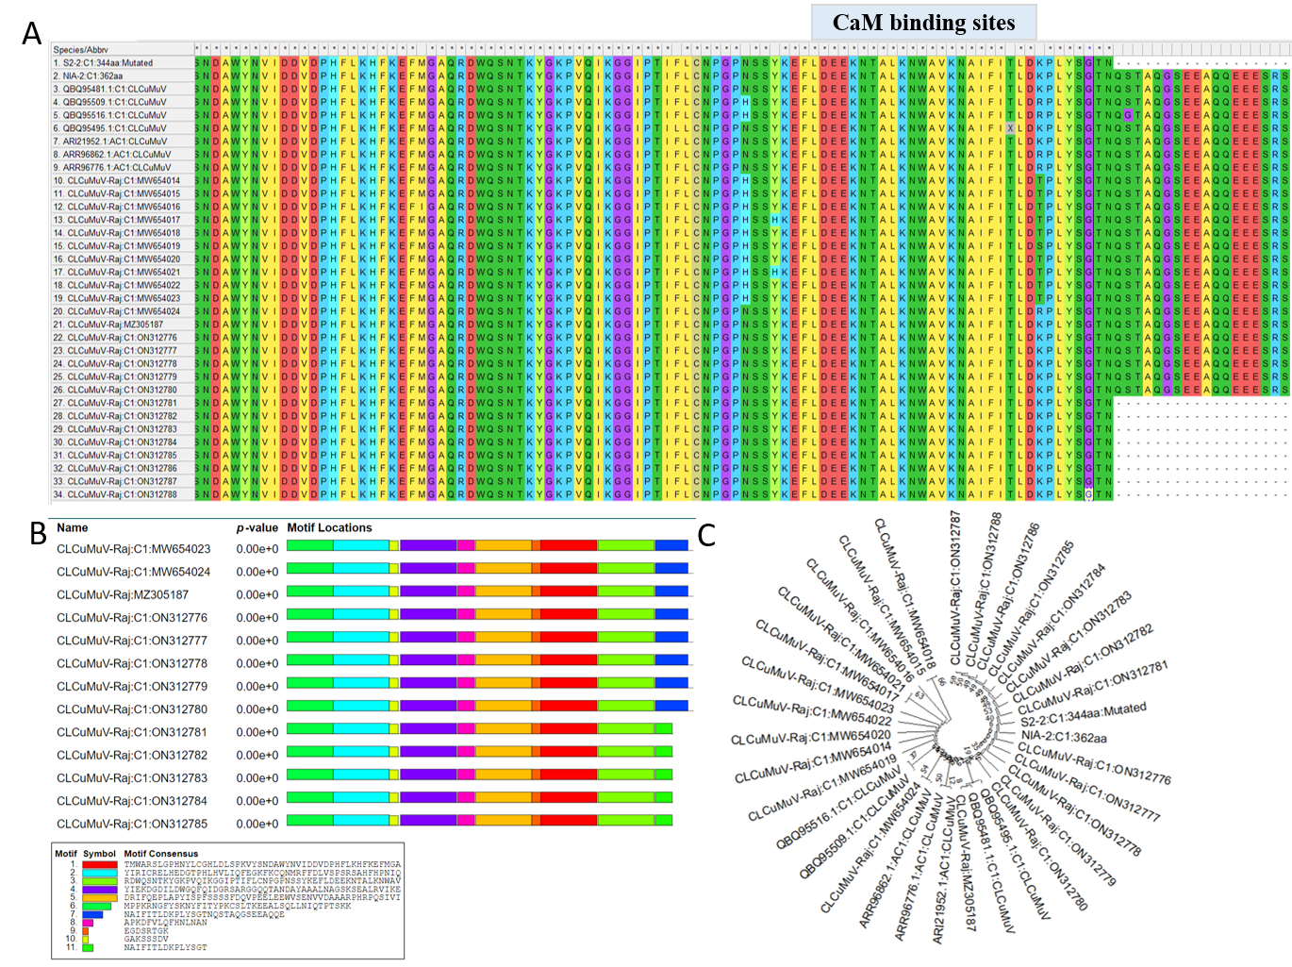
Fig. S5. (A) Multiple sequence alignment of C1 protein of isolated strains with reported C1 proteins (B) Conserved de-novo motifs in C1 proteins (C) Evolutionary analysis of C1 mutated proteins with other reported complete proteins.

Sequence and motif analysis of C4 proteins.
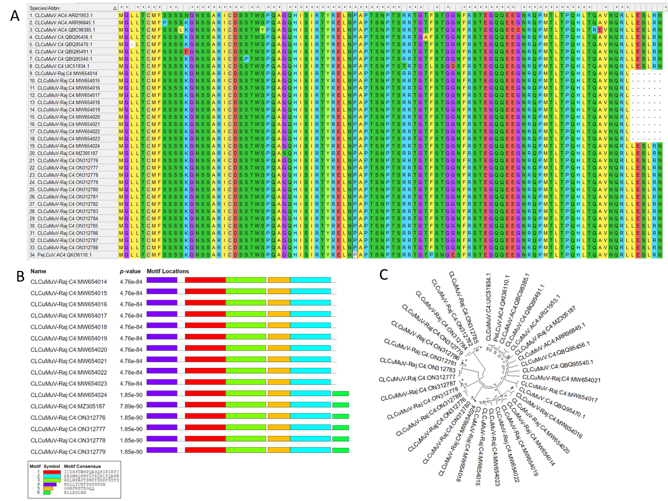
Fig. S6. (A) Multiple sequence alignment of C4 protein of isolated strains with reported C4 proteins (B) Conserved de-novo motifs in C4 proteins (C) Evolutionary analysis of C4 mutated proteins with other reported complete proteins.

