Additional Files

Temporal dynamics of the fecal microbiome in female pigs from early life through estrus, parturition, and weaning of the first litter of piglets

Tara N. Gaire¹, H. Morgan Scott², Noelle R. Noyes³, Aaron C. Ericsson⁴, Michael D. Tokach⁵, Hayden William⁵, Mariana B. Menegat⁵, Javier Vinasco², T. G. Nagaraja¹, Victoriya V. Volkova¹

¹Department of Diagnostic Medicine/Pathobiology, College of Veterinary Medicine, Kansas State University, Manhattan, KS, 66506, USA
²Department of Veterinary Pathobiology, School of Veterinary Medicine and Biomedical Sciences, Texas A&M University, College Station, TX, 77843, USA
³Department of Veterinary Population Medicine, College of Veterinary Medicine, University of Minnesota, St. Paul, MN, 55108, USA
⁴Department of Veterinary Pathobiology, College of Veterinary Medicine, University of Missouri, MO, 65211, USA
⁵Department of Animal Sciences and Industry, College of Agriculture, Kansas State University, Manhattan, KS, 66506, USA

Corresponding author:
T. G. Nagaraja (tnagaraj@vet.k-state.edu)

Additional file 1: Table S1. Metadata and 16S rRNA sequencing reads for all samples included in this study
SampleID | S.Name | PigID | Age, weeks | Input reads | Filtered | Denoised  Forward | Denoised Reverse | Merged | Nonchimeric
VV073.A1 | VV073 | 292 | 3 | 34519 | 31843 | 31480 | 31025 | 29714 | 29573
VV074.A2 | VV074 | 296 | 3 | 130784 | 121382 | 119955 | 119143 | 108748 | 97178
VV075.A3 | VV075 | 389 | 3 | 148671 | 138336 | 135568 | 133903 | 118404 | 105234
VV076.A4 | VV076 | 391 | 3 | 162638 | 149808 | 146614 | 143694 | 126437 | 111605
VV077.A5 | VV077 | 363 | 3 | 143400 | 132857 | 130914 | 129590 | 118417 | 103335
VV078.A6 | VV078 | 366 | 3 | 824 | 747 | 692 | 675 | 586 | 586
VV079.A7 | VV079 | 369 | 3 | 142823 | 132462 | 130380 | 129393 | 114296 | 93785
VV080.A8 | VV080 | 379 | 3 | 85086 | 78117 | 76864 | 76184 | 74326 | 73800
VV081.A9 | VV081 | 292 | 6 | 177169 | 163390 | 160335 | 159439 | 141562 | 122710
VV082.A10 | VV082 | 296 | 6 | 144475 | 133163 | 131158 | 129822 | 116146 | 101787
VV083.A11 | VV083 | 389 | 6 | 163031 | 151061 | 148166 | 146660 | 127285 | 109346
VV084.A12 | VV084 | 391 | 6 | 148294 | 136660 | 134436 | 132882 | 117515 | 103864
VV085.B1 | VV085 | 363 | 6 | 118474 | 110251 | 107701 | 106278 | 91017 | 80022
VV086.B2 | VV086 | 366 | 6 | 184222 | 168940 | 165705 | 164434 | 145388 | 122224
VV087.B3 | VV087 | 369 | 6 | 166438 | 153127 | 150644 | 149113 | 135061 | 119029
VV088.B4 | VV088 | 379 | 6 | 161940 | 150144 | 147124 | 145297 | 125630 | 108829
VV089.B5 | VV089 | 292 | 10 | 159394 | 146935 | 144025 | 142099 | 125048 | 110846
VV090.B6 | VV090 | 296 | 10 | 172962 | 158812 | 155420 | 153703 | 134532 | 116415
VV091.B7 | VV091 | 389 | 10 | 159957 | 147484 | 144679 | 142671 | 123467 | 100592
VV092.B8 | VV092 | 391 | 10 | 173189 | 159450 | 156484 | 154421 | 134954 | 114314
VV093.B9 | VV093 | 363 | 10 | 169092 | 155419 | 151730 | 149826 | 127480 | 106820
VV094.B10 | VV094 | 366 | 10 | 156873 | 145344 | 142699 | 140553 | 121671 | 102092
VV095.B11 | VV095 | 369 | 10 | 156481 | 144048 | 140845 | 139258 | 120193 | 101094
VV096.B12 | VV096 | 379 | 10 | 152090 | 140438 | 137908 | 136319 | 118956 | 100683
VV097.C1 | VV097 | 292 | 12 | 176392 | 162072 | 158732 | 157255 | 137451 | 113636
VV098.C2 | VV098 | 296 | 12 | 183844 | 168589 | 165610 | 164497 | 144794 | 118811
VV099.C3 | VV099 | 389 | 12 | 160077 | 146641 | 143651 | 142034 | 124522 | 107313
VV100.C4 | VV100 | 391 | 12 | 161010 | 148167 | 144768 | 143257 | 124468 | 105955
VV101.C5 | VV101 | 363 | 12 | 184089 | 169050 | 165757 | 164302 | 143024 | 115655
VV102.C6 | VV102 | 366 | 12 | 162843 | 149833 | 146531 | 144963 | 126377 | 108224
VV103.C7 | VV103 | 369 | 12 | 177228 | 163647 | 160322 | 158682 | 138501 | 115165
VV104.C8 | VV104 | 379 | 12 | 172025 | 157458 | 154360 | 152464 | 133020 | 111684
VV105.C9 | VV105 | 292 | 22 | 160153 | 146394 | 142788 | 141203 | 120008 | 100473
VV106.C10 | VV106 | 296 | 22 | 153110 | 141767 | 138323 | 135844 | 115266 | 101487
VV107.C11 | VV107 | 389 | 22 | 151643 | 140313 | 137358 | 135419 | 117194 | 99433
VV108.C12 | VV108 | 391 | 22 | 118810 | 109335 | 106813 | 104986 | 91486 | 82930
VV109.D1 | VV109 | 363 | 22 | 156765 | 145015 | 141995 | 140268 | 121404 | 104429
VV110.D2 | VV110 | 366 | 22 | 149415 | 138143 | 134726 | 133305 | 114791 | 101782
VV111.D3 | VV111 | 369 | 22 | 156100 | 144845 | 141191 | 139157 | 118849 | 103156
VV112.D4 | VV112 | 379 | 22 | 167218 | 153913 | 150959 | 149615 | 131753 | 110322
VV113.D5 | VV113 | 292 | 32 | 145914 | 135589 | 132639 | 130493 | 112082 | 94330
VV114.D6 | VV114 | 296 | 32 | 167535 | 153977 | 149912 | 147414 | 125305 | 106546
VV115.D7 | VV115 | 389 | 32 | 158592 | 147615 | 144000 | 142421 | 121446 | 98101
VV116.D8 | VV116 | 391 | 32 | 150030 | 139220 | 135992 | 133719 | 114372 | 98672
VV117.D9 | VV117 | 363 | 32 | 166815 | 154067 | 150179 | 148360 | 125231 | 105734
VV118.D10 | VV118 | 366 | 32 | 141885 | 131891 | 128694 | 126917 | 107169 | 92707
VV119.D11 | VV119 | 369 | 32 | 139365 | 130285 | 127324 | 125785 | 108392 | 89317
VV120.D12 | VV120 | 379 | 32 | 150261 | 139409 | 136080 | 133930 | 114504 | 97082
VV121.E1 | VV121 | 292 | 49 | 168610 | 155118 | 151047 | 149310 | 125602 | 101501
VV122.E2 | VV122 | 296 | 49 | 145031 | 133603 | 130489 | 129551 | 112353 | 93903
VV123.E3 | VV123 | 389 | 49 | 164945 | 153662 | 150329 | 147595 | 127199 | 112124
VV124.E4 | VV124 | 391 | 49 | 158383 | 147100 | 143602 | 141671 | 121721 | 105325
VV125.E5 | VV125 | 363 | 49 | 170028 | 157368 | 153675 | 151151 | 128955 | 105780
VV126.E6 | VV126 | 366 | 49 | 177098 | 162012 | 158745 | 157331 | 138504 | 117794
VV127.E7 | VV127 | 369 | 49 | 180053 | 165384 | 161679 | 159711 | 137941 | 118098
VV128.E8 | VV128 | 379 | 49 | 145794 | 135503 | 132724 | 131310 | 115889 | 101105
VV129.E9 | VV129 | 292 | 50 | 160527 | 148185 | 145143 | 143202 | 124308 | 106087
VV130.E10 | VV130 | 296 | 50 | 142549 | 131813 | 129388 | 127957 | 114525 | 100471
VV131.E11 | VV131 | 389 | 50 | 140201 | 129858 | 126975 | 124792 | 107163 | 93480
VV132.E12 | VV132 | 391 | 50 | 158559 | 146709 | 143328 | 141159 | 121119 | 106897
VV133.F1 | VV133 | 363 | 50 | 143601 | 130898 | 127424 | 125356 | 107003 | 94713
VV134.F2 | VV134 | 366 | 50 | 141990 | 130982 | 127324 | 125230 | 104468 | 89524
VV135.F3 | VV135 | 369 | 50 | 143913 | 132510 | 129152 | 126940 | 108578 | 95292
VV136.F4 | VV136 | 379 | 50 | 146094 | 134928 | 131454 | 128820 | 109327 | 94388
VV137.F5 | VV137 | 292 | 53 | 147395 | 135043 | 132097 | 130474 | 115191 | 97420
VV138.F6 | VV138 | 296 | 53 | 169281 | 155246 | 151954 | 150096 | 131886 | 109368
VV139.F7 | VV139 | 389 | 53 | 165092 | 150426 | 147264 | 145372 | 127188 | 108038
VV140.F8 | VV140 | 391 | 53 | 149635 | 137323 | 134789 | 133148 | 119033 | 104236
VV141.F9 | VV141 | 363 | 53 | 162322 | 148311 | 144649 | 142091 | 121991 | 108081
VV142.F10 | VV142 | 366 | 53 | 134822 | 124314 | 121318 | 119000 | 101303 | 90306
VV143.F11 | VV143 | 369 | 53 | 130335 | 120035 | 117466 | 115644 | 101567 | 91707
VV144.F12 | VV144 | 379 | 53 | 151880 | 139766 | 136376 | 133509 | 113621 | 99241

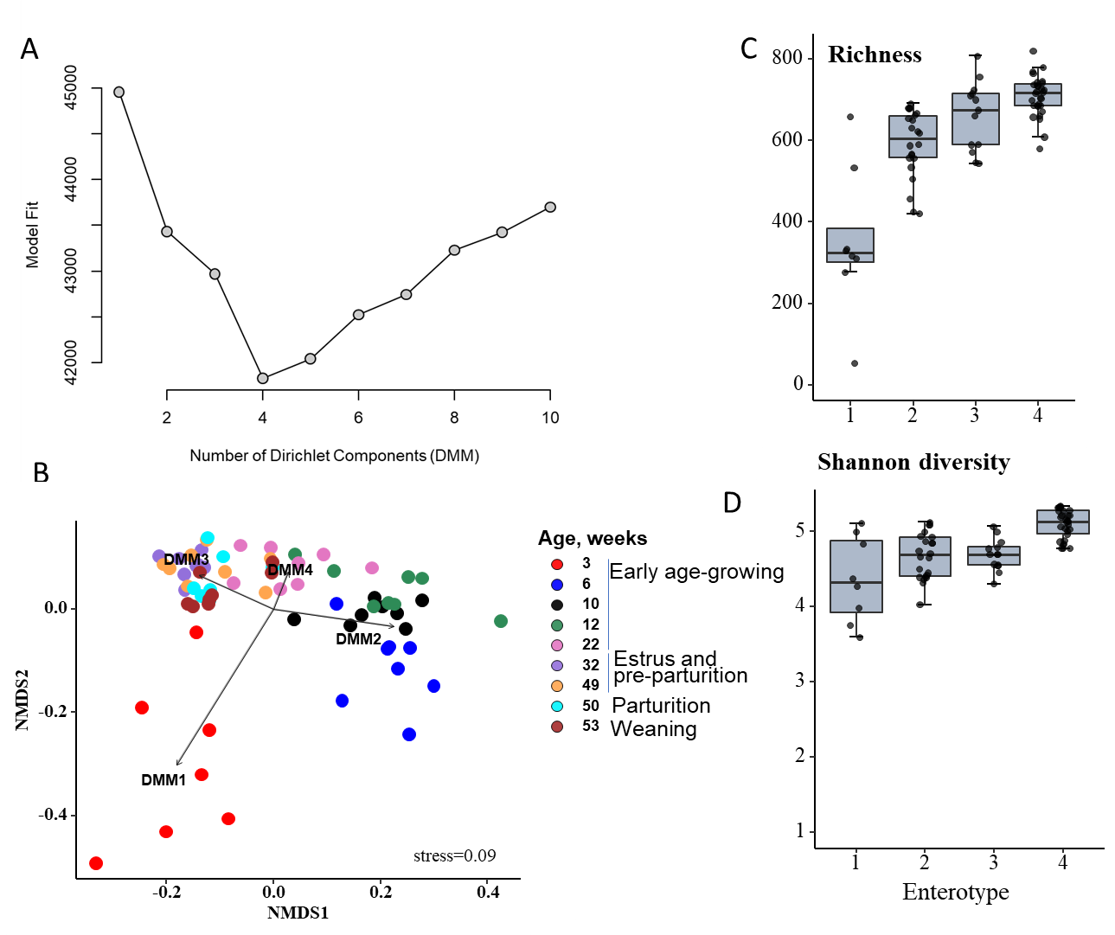

Additional File 2. FigS1 A-D. A) Model fit for the number of Dirichlet mixture components (K) (DMM clusters) using the Laplace approximation to the negative log model. B) NMDS plot showing overall microbial composition with enterotypes (DMM 1-4 represent Enterotypes), C-D) Alpha diversity values (richness and Shannon’s diversity, respectively) per each DMM cluster/Enterotype.
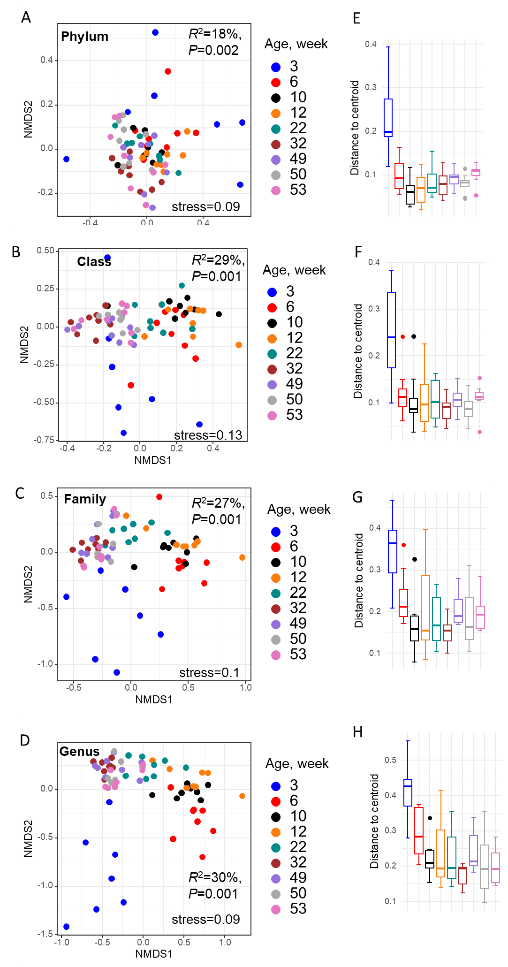
Additional File 3. FigS2. Non-metric multidimensional scaling (NMDS) ordinating plot based on Bray-Curtis distances illustrates variation in microbial community structures by stages at: A-D) Phylum, Class, Family and Genus levels and E-H) Beta-dispersion values (distance to centroid) for each age group and for each respective taxonomic level. R² represents the amount of variability explained by the stages and the associated P-value is based on PERMANOVA analysis.

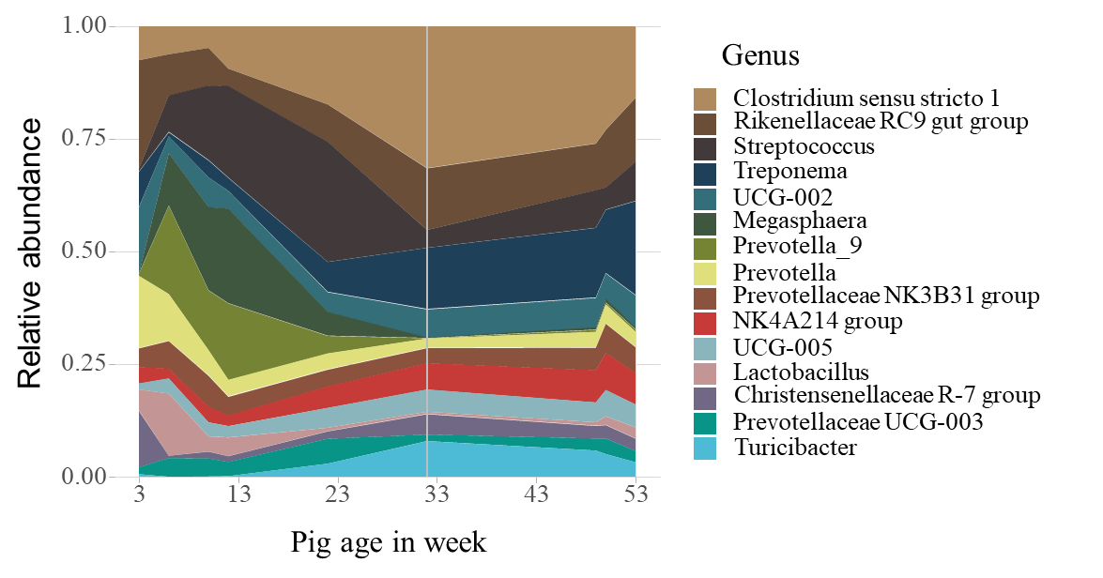
Additional File 4. FigS3. Relative abundance of the top 15 bacterial genera across pig age.

Additional File 5: Table S2. Complete list of microbial features (genera) whose abundances were associated with age of pig (in weeks) as determined by the MaAsLin 2 (Microbiome Multivariable Associations with Linear Models) approach.
Feature (genus) | coef | stderr | N | N.not.0 | pval | qval | trajectories
Prevotella_7 | -0.13274 | 0.019947 | 72 | 45 | 5.29E-09 | 3.20E-08 | decrease
Intestinimonas | -0.10801 | 0.008799 | 72 | 56 | 4.02E-19 | 4.87E-17 | decrease
Ligilactobacillus | -0.10721 | 0.016107 | 72 | 49 | 5.26E-09 | 3.20E-08 | decrease
Agathobacter | -0.09832 | 0.015016 | 72 | 35 | 8.24E-09 | 4.75E-08 | decrease
Blautia | -0.09729 | 0.014316 | 72 | 57 | 4.52E-09 | 3.04E-08 | decrease
HT002 | -0.09723 | 0.012309 | 72 | 43 | 2.80E-11 | 2.60E-10 | decrease
Chlamydia | -0.09415 | 0.013463 | 72 | 30 | 1.29E-09 | 9.72E-09 | decrease
Dorea | -0.08894 | 0.010154 | 72 | 46 | 7.30E-13 | 1.10E-11 | decrease
Holdemanella | -0.08592 | 0.014519 | 72 | 48 | 1.09E-07 | 4.56E-07 | decrease
UCG.003 | -0.07872 | 0.011018 | 72 | 39 | 1.12E-09 | 9.03E-09 | decrease
Prevotella_9 | -0.07449 | 0.01632 | 72 | 67 | 2.09E-05 | 5.49E-05 | decrease
Dialister | -0.07414 | 0.020918 | 72 | 50 | 0.000706 | 0.001294 | decrease
Clostridium.sensu.stricto.6 | -0.07381 | 0.015534 | 72 | 51 | 1.04E-05 | 2.92E-05 | decrease
Faecalibacterium | -0.07298 | 0.016169 | 72 | 56 | 2.51E-05 | 6.32E-05 | decrease
Collinsella | -0.07272 | 0.012852 | 72 | 51 | 3.11E-07 | 1.07E-06 | decrease
Lachnospiraceae.NK4A136.group | -0.07016 | 0.008593 | 72 | 69 | 1.84E-11 | 1.86E-10 | decrease
X.Eubacterium..eligens.group | -0.07013 | 0.013445 | 72 | 34 | 1.77E-06 | 5.64E-06 | decrease
Fournierella | -0.06855 | 0.014774 | 72 | 51 | 1.58E-05 | 4.25E-05 | decrease
Shuttleworthia | -0.06429 | 0.014795 | 72 | 43 | 4.61E-05 | 0.000112 | decrease
Subdoligranulum | -0.06323 | 0.018865 | 72 | 63 | 0.001297 | 0.002343 | decrease
X.Eubacterium..xylanophilum.group | -0.06175 | 0.013009 | 72 | 40 | 1.06E-05 | 2.92E-05 | decrease
CAG.873 | -0.05921 | 0.011482 | 72 | 19 | 2.23E-06 | 6.93E-06 | decrease
Erysipelotrichaceae.UCG.006 | -0.05809 | 0.00907 | 72 | 29 | 1.50E-08 | 7.24E-08 | decrease
Cloacibacillus | -0.05672 | 0.017036 | 72 | 17 | 0.001391 | 0.002439 | decrease
Lachnospiraceae.FCS020.group | -0.05338 | 0.010368 | 72 | 49 | 2.79E-06 | 8.43E-06 | decrease
Veillonella | -0.05265 | 0.011929 | 72 | 16 | 3.60E-05 | 8.90E-05 | decrease
Catenibacterium | -0.05097 | 0.017161 | 72 | 32 | 0.004079 | 0.006761 | decrease
Anaerostipes | -0.05001 | 0.009401 | 72 | 22 | 1.18E-06 | 3.87E-06 | decrease
Lactobacillus | -0.04952 | 0.014978 | 72 | 72 | 0.001564 | 0.002704 | decrease
Sutterella | -0.04738 | 0.012879 | 72 | 60 | 0.000457 | 0.000937 | decrease
X.Ruminococcus..torques.group | -0.04577 | 0.012654 | 72 | 28 | 0.000559 | 0.001108 | decrease
Intestinibacter | -0.04528 | 0.007762 | 72 | 64 | 1.54E-07 | 5.82E-07 | decrease
X.Ruminococcus..gauvreauii.group | -0.04451 | 0.011371 | 72 | 39 | 0.000208 | 0.000458 | decrease
Acidaminococcus | -0.0442 | 0.015616 | 72 | 49 | 0.006063 | 0.009286 | decrease
Megasphaera | -0.04018 | 0.023035 | 72 | 66 | 0.085523 | 0.10893 | decrease
Mogibacterium | -0.03821 | 0.009601 | 72 | 66 | 0.000181 | 0.000405 | decrease
Alistipes | -0.03819 | 0.017717 | 72 | 45 | 0.034567 | 0.04753 | decrease
Eisenbergiella | -0.03762 | 0.011276 | 72 | 22 | 0.001359 | 0.002419 | decrease
Colidextribacter | -0.03513 | 0.009845 | 72 | 71 | 0.000654 | 0.001236 | decrease
X.Eubacterium..ruminantium.group | -0.03495 | 0.015256 | 72 | 52 | 0.025325 | 0.035631 | decrease
Butyricicoccus | -0.03488 | 0.008432 | 72 | 61 | 9.65E-05 | 0.000229 | decrease
Alloprevotella | -0.03438 | 0.008413 | 72 | 72 | 0.000115 | 0.000267 | decrease
X.Eubacterium..hallii.group | -0.03393 | 0.011689 | 72 | 67 | 0.004947 | 0.008089 | decrease
Sharpea | -0.03351 | 0.015384 | 72 | 59 | 0.032777 | 0.045586 | decrease
Catenisphaera | -0.02808 | 0.013318 | 72 | 54 | 0.038595 | 0.051318 | decrease
Lachnoclostridium | -0.02714 | 0.013277 | 72 | 64 | 0.044719 | 0.057564 | decrease
Marvinbryantia | -0.02658 | 0.009244 | 72 | 57 | 0.005492 | 0.00863 | decrease
Streptococcus | -0.02446 | 0.016166 | 72 | 71 | 0.134744 | 0.168083 | decrease
Limosilactobacillus | -0.0241 | 0.01698 | 72 | 62 | 0.160806 | 0.194575 | decrease
Anaerovibrio | -0.02403 | 0.015142 | 72 | 66 | 0.117045 | 0.147525 | decrease
Selenomonas | -0.0212 | 0.017083 | 72 | 42 | 0.21912 | 0.257413 | decrease
Fusobacterium | -0.01863 | 0.014079 | 72 | 22 | 0.190094 | 0.227736 | decrease
Incertae.Sedis | -0.01846 | 0.007533 | 72 | 71 | 0.016749 | 0.024127 | decrease
Prevotella | -0.01767 | 0.005734 | 72 | 72 | 0.002939 | 0.005008 | decrease
Roseburia | -0.01607 | 0.011224 | 72 | 69 | 0.156744 | 0.191576 | decrease
Coprococcus | -0.01463 | 0.011311 | 72 | 67 | 0.200124 | 0.237402 | decrease
Solobacterium | -0.0095 | 0.014218 | 72 | 62 | 0.50602 | 0.541845 | decrease
Oribacterium | -0.00923 | 0.009527 | 72 | 70 | 0.335842 | 0.379784 | decrease
Phascolarctobacterium | -0.0047 | 0.006174 | 72 | 72 | 0.448743 | 0.493618 | decrease
Oxalobacter | -0.00199 | 0.013185 | 72 | 56 | 0.88046 | 0.918411 | decrease
Olsenella | -0.00079 | 0.015375 | 72 | 53 | 0.959095 | 0.965273 | decrease
Pyramidobacter | -0.00068 | 0.015465 | 72 | 55 | 0.965273 | 0.965273 | decrease
Lachnospira | -0.0005 | 0.010549 | 72 | 63 | 0.96222 | 0.965273 | decrease
X.Eubacterium..nodatum.group | 0.00111 | 0.013507 | 72 | 50 | 0.934732 | 0.958497 | increase
Succinivibrio | 0.00162 | 0.013131 | 72 | 70 | 0.902228 | 0.933074 | increase
Helicobacter | 0.004274 | 0.013555 | 72 | 54 | 0.753557 | 0.799829 | increase
Campylobacter | 0.004276 | 0.014378 | 72 | 68 | 0.767023 | 0.807041 | increase
Oscillospira | 0.005912 | 0.007948 | 72 | 72 | 0.459694 | 0.501108 | increase
Prevotellaceae.UCG.003 | 0.007866 | 0.009706 | 72 | 72 | 0.420431 | 0.466717 | increase
UCG.004 | 0.008156 | 0.007753 | 72 | 71 | 0.296404 | 0.338349 | increase
Peptococcus | 0.008657 | 0.010664 | 72 | 61 | 0.41995 | 0.466717 | increase
Escherichia.Shigella | 0.012333 | 0.017595 | 72 | 65 | 0.485666 | 0.524693 | increase
UCG.002 | 0.013579 | 0.006482 | 72 | 72 | 0.040213 | 0.052889 | increase
Rikenellaceae.RC9.gut.group | 0.013698 | 0.005205 | 72 | 72 | 0.010451 | 0.015612 | increase
Sphaerochaeta | 0.013893 | 0.00929 | 72 | 72 | 0.139262 | 0.171946 | increase
Prevotellaceae.NK3B31.group | 0.014711 | 0.005099 | 72 | 72 | 0.005194 | 0.008297 | increase
Corynebacterium | 0.016072 | 0.014884 | 72 | 27 | 0.283948 | 0.327216 | increase
Mitsuokella | 0.01837 | 0.01681 | 72 | 59 | 0.278233 | 0.323714 | increase
Monoglobus | 0.021536 | 0.007654 | 72 | 71 | 0.006352 | 0.009607 | increase
Parabacteroides | 0.021958 | 0.010256 | 72 | 70 | 0.035763 | 0.048621 | increase
Christensenellaceae.R.7.group | 0.022359 | 0.008725 | 72 | 72 | 0.012538 | 0.018501 | increase
Ruminococcus | 0.024127 | 0.011768 | 72 | 70 | 0.044093 | 0.057368 | increase
Desulfovibrio | 0.02832 | 0.009938 | 72 | 70 | 0.005743 | 0.008909 | increase
X.Eubacterium..siraeum.group | 0.03151 | 0.014855 | 72 | 62 | 0.037455 | 0.050356 | increase
Prevotellaceae.UCG.004 | 0.034158 | 0.011801 | 72 | 69 | 0.005211 | 0.008297 | increase
Anaerosporobacter | 0.034987 | 0.00968 | 72 | 38 | 0.000599 | 0.001169 | increase
Bifidobacterium | 0.035406 | 0.011921 | 72 | 64 | 0.004077 | 0.006761 | increase
Oscillibacter | 0.037009 | 0.009471 | 72 | 71 | 0.00023 | 0.000497 | increase
UCG.008 | 0.038238 | 0.015945 | 72 | 39 | 0.019152 | 0.027263 | increase
UCG.007 | 0.041711 | 0.007632 | 72 | 28 | 8.41E-07 | 2.83E-06 | increase
UCG.009 | 0.042212 | 0.007225 | 72 | 71 | 1.48E-07 | 5.82E-07 | increase
NK4A214.group | 0.042233 | 0.00449 | 72 | 71 | 1.29E-13 | 2.23E-12 | increase
Z20 | 0.042932 | 0.016865 | 72 | 48 | 0.013111 | 0.019114 | increase
XBB1006 | 0.044592 | 0.012471 | 72 | 39 | 0.000677 | 0.001261 | increase
Lachnospiraceae.UCG.001 | 0.0485 | 0.013251 | 72 | 53 | 0.000485 | 0.000978 | increase
Frisingicoccus | 0.048572 | 0.010704 | 72 | 46 | 2.30E-05 | 5.92E-05 | increase
Family.XIII.UCG.001 | 0.049238 | 0.010022 | 72 | 67 | 6.70E-06 | 1.93E-05 | increase
p.1088.a5.gut.group | 0.049721 | 0.013023 | 72 | 65 | 0.000288 | 0.000611 | increase
UCG.005 | 0.05193 | 0.010587 | 72 | 71 | 5.85E-06 | 1.73E-05 | increase
Family.XIII.AD3011.group | 0.052185 | 0.008586 | 72 | 71 | 7.83E-08 | 3.38E-07 | increase
X.Anaerorhabdus..furcosa.group | 0.053468 | 0.008515 | 72 | 67 | 3.54E-08 | 1.59E-07 | increase
Lachnospiraceae.NK4B4.group | 0.054871 | 0.009684 | 72 | 49 | 3.01E-07 | 1.07E-06 | increase
Clostridium.sensu.stricto.1 | 0.057217 | 0.008316 | 72 | 72 | 3.23E-09 | 2.30E-08 | increase
X.Eubacterium..brachy.group | 0.057283 | 0.009688 | 72 | 53 | 1.49E-07 | 5.82E-07 | increase
Candidatus.Saccharimonas | 0.057437 | 0.014146 | 72 | 55 | 0.000126 | 0.000288 | increase
Quinella | 0.059511 | 0.009056 | 72 | 31 | 1.11E-08 | 5.79E-08 | increase
dgA.11.gut.group | 0.059895 | 0.00926 | 72 | 70 | 1.15E-08 | 5.79E-08 | increase
Lachnospiraceae.UCG.007 | 0.061499 | 0.007592 | 72 | 40 | 1.19E-11 | 1.31E-10 | increase
Candidatus.Soleaferrea | 0.066799 | 0.010718 | 72 | 67 | 3.03E-08 | 1.41E-07 | increase
Lachnospiraceae.AC2044.group | 0.071135 | 0.012198 | 72 | 63 | 2.05E-07 | 7.51E-07 | increase
Bacteroides | 0.075565 | 0.020057 | 72 | 65 | 0.00034 | 0.00071 | increase
Prevotellaceae.UCG.001 | 0.076137 | 0.02126 | 72 | 61 | 0.000627 | 0.001205 | increase
Terrisporobacter | 0.077184 | 0.011642 | 72 | 70 | 8.80E-09 | 4.84E-08 | increase
Treponema | 0.089811 | 0.012395 | 72 | 71 | 4.45E-10 | 3.84E-09 | increase
Anaeroplasma | 0.096057 | 0.008927 | 72 | 51 | 1.74E-16 | 5.26E-15 | increase
Romboutsia | 0.126062 | 0.014671 | 72 | 54 | 1.48E-12 | 1.99E-11 | increase
Fibrobacter | 0.13004 | 0.011243 | 72 | 61 | 6.67E-18 | 4.03E-16 | increase
Cellulosilyticum | 0.132838 | 0.011778 | 72 | 51 | 2.12E-17 | 8.53E-16 | increase
Papillibacter | 0.138037 | 0.016378 | 72 | 34 | 6.37E-12 | 7.71E-11 | increase
Turicibacter | 0.143535 | 0.013771 | 72 | 64 | 2.42E-15 | 5.86E-14 | increase
Lachnospiraceae.XPB1014.group | 0.148002 | 0.015997 | 72 | 52 | 9.15E-14 | 1.84E-12 | increase
Coeff- the model coefficient value (effect size), stderr: the standard error from the model; N: the total number of samples used in the model for this association N.not.0: the total of number of these samples in which the feature is non-zero. pval: the significance of this association. qval: the corrected significance is computed with p.adjust using the BH correction method.
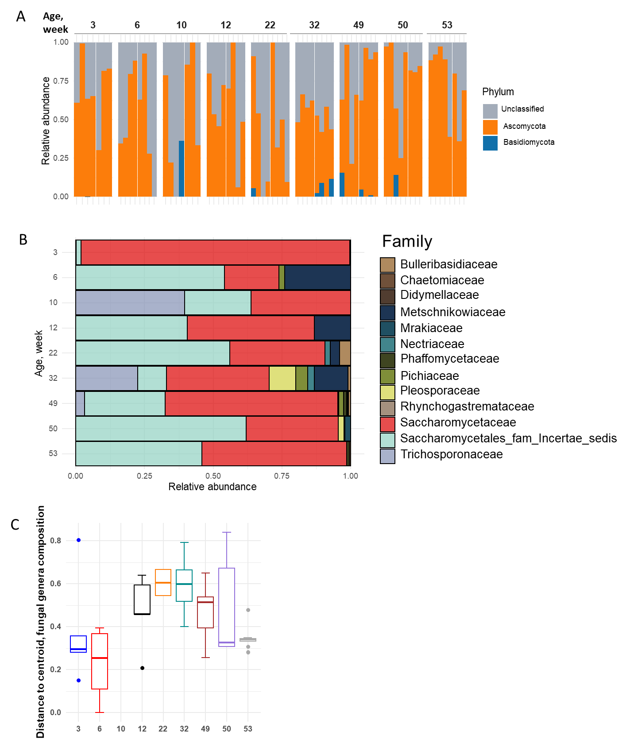
Additional File 6. FigS4. Relative abundance of fungi at A) phylum and B) family levels, and C) distance to centroid (beta dispersion of overall fecal fungi composition at genus level) for each age group.
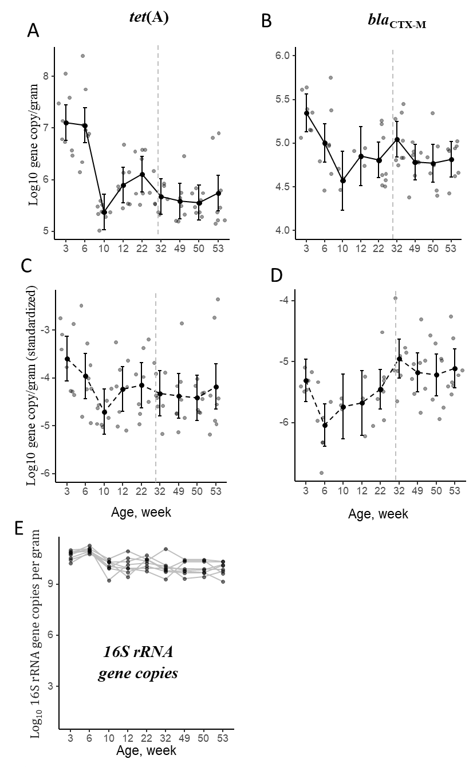
Additional File 7. FigS5. Mean changes in (A) nonstandardized log10 tet(A), (B) nonstandardized log10 bla_{CTX-M}, (C) standardized (to 16S rRNA) log10 tet(A), and (D) standardized (to 16S rRNA) log10 bla_{CTX-M} log₁₀ gene copy numbers per gram wet feces over time (pig age in weeks), and (E) Total log10 16S rRNA gene copies per gram wet feces over time (pig age in weeks

