Supplementary
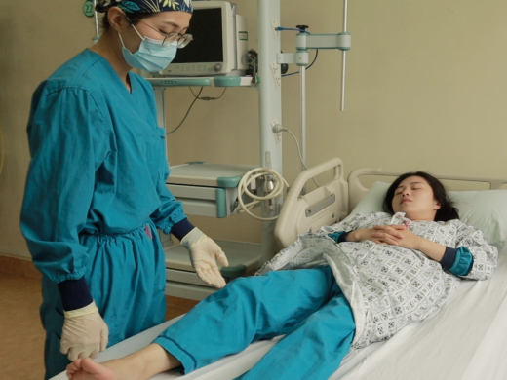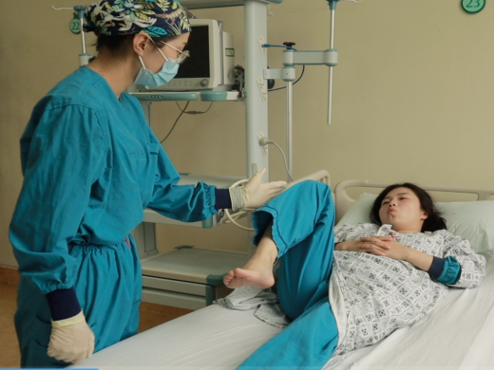
(a) (b)
Figure 1 Examples of training movements. Supine hip and knee flexion (a-b, anti-body weight): In a supine position, relax both lower limbs, with both hands placed by the sides or on the abdomen. While exhaling, simultaneously bend the knee and hip joints, attempting to achieve a 90-degree hip flexion. Maintain this position for 3-5 seconds. During inhalation, slowly return to the original position
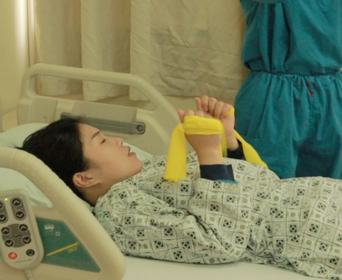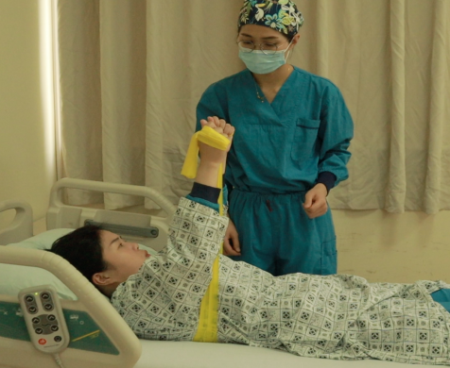
(c) (d)
Figure 1 Examples of training movements. Supine chest press (c-d, anti-elastic band): Assume a supine or semi-supine position, with the resistance band looped underneath the scapulae and extending from both sides of the axillae. Grasp the ends of the resistance band with both hands, palms facing each other, and maintain a neutral forearm position. Keep the arms close to the torso, fully extend them upwards, and position the hands above the shoulders. Hold this position for 3-5 seconds, then slowly relax and return to the initial position.
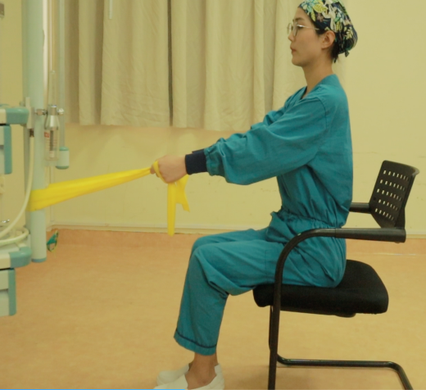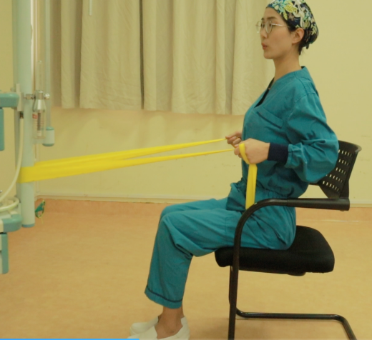
(e) (f)
Figure 1 Examples of training movements. Seated rowing (e-f, anti-elastic band): Sit down and fix the elastic band in front of the body at approximately waist height. Adjust the sitting position facing the elastic band, with the shoulders sinking, arms extended forward, and hands holding the two ends of the elastic band, palms facing each other, at an appropriate width. Keep the body stable, back straight, upper arms close to the trunk, shoulders extended backward, scapulae adducted, and chest lifted for 3-5 seconds before relaxing and returning to the initial position.
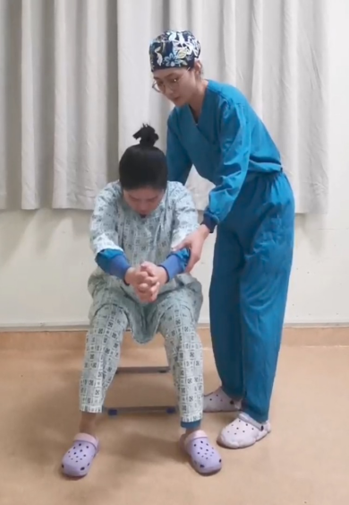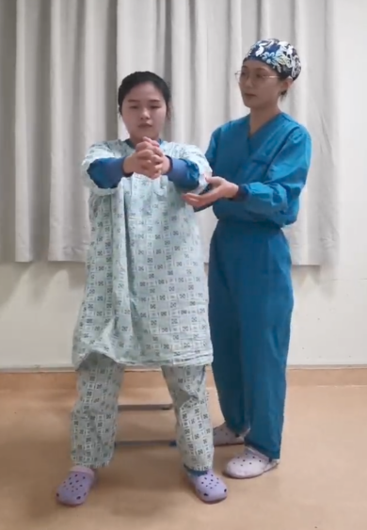
(g) (h)
Figure 1 Examples of training movements. Sit-to-stand exercise (g-h, anti-self-body weight): Select an appropriate height chair (approximately level with the lower leg), with the patient's feet flat on the ground and shoulder-width apart, toes inward, and knees beyond the ankles. Cross the patient's hands forward, lean forward, shift the center of gravity forward, and move the buttocks to the edge of the chair. The lower limbs exert force to stand up, extend the hip joint, and straighten the whole body. When sitting down, lean forward slightly, bend the hip and knee joints first, and then sit down slowly. If the patient is unable to complete the sit-to-stand exercise independently, the operator can assist the patient in standing up by pulling the patient's back waistband upwards.

