An integrative analysis reveals the prognostic and immunological role of TIMP gene family in pan-cancer

Jiaxin Wang1,2,3,4,5*, Yankuo Liu1,2,3,4,5*, Zhong luo1, Fei Zhang6, Huidan Shen1, Xiaodong Chen2,3,4,5, Zhaohong Chen 2,3,4,5#, Chiyu Jia7#, Yueying Fan8#, Zexin Zhang2,3,4,5,7,8#

1 School of Medicine, Xiamen University, Xiamen, Fujian, 361000, China.
2 Burn & Wound Repair Department, Fujian Medical University Union Hospital, Fuzhou, Fujian, 350001, China
3 Fujian Burn Institute, Fujian Medical University Union Hospital, Fuzhou, Fujian, 350001, China
4 Fujian Burn Medical Center, Fujian Medical University Union Hospital, Fuzhou, Fujian, 350001, China
5 Fujian Provincial Key Laboratory of Burn and Trauma, Fujian Medical University Union Hospital, Fuzhou, Fujian, 350001, China
6 Chinese People's Liberation Army medical school. No.28, Fuxing Road, Haidian District, Beijing, 100853, China.
7 The First Affiliated Hospital, Department of Burn and Plastic Surgery, Hengyang Medical School, University of South China, Hengyang, Hunan, 421001, China.
8 Department of Burns and Plastic & Wound Repair Surgery, Xiang’an Hospital of Xiamen University, School of Medicine, Xiamen University, Xiamen, Fujian, 361102, China
* These authors have contributed equally to this work and share first authorship.

#Coresponding author
Zexin Zhang
Department of Burns and Plastic & Wound Repair Surgery, Xiang’an Hospital of Xiamen University, School of Medicine, Xiamen University, Xiamen 361102, China
E-mail: 582463681@qq.com

Yueying Fan
Department of Burns and Plastic & Wound Repair Surgery, Xiang’an Hospital of Xiamen University, School of Medicine, Xiamen University, Xiamen 361102, China
E-mail: fan3169839464@163.com

Chiyu Jia
The First Affiliated Hospital, Department of Burn and Plastic Surgery, Hengyang Medical School, University of South China, Hengyang, Hunan 421001, China.
E-mail: jiachiyu@qq.com

Figure SF1
SF1 Relative mRNA expression levels of TIMP gene family in two types of tumors. (A-D) Breast Cancer, (E-H) Hepatocellular carcinoma. The experiments were repeated three times. * P< 0.05, ** P< 0.01, and *** P< 0.001.

Figure SF2
SF2 The protein expression of TIMP gene family in GBM, PAAD, and UCEC. (A) TIMP1, (B) TIMP2, (C) TIMP3. The red box indicates the gene expression in primary tumors, and the blue box indicates the gene expression in normal tissues. * P < 0.05, *** P < 0.001, **** P < 0.0001.

Figure SF3
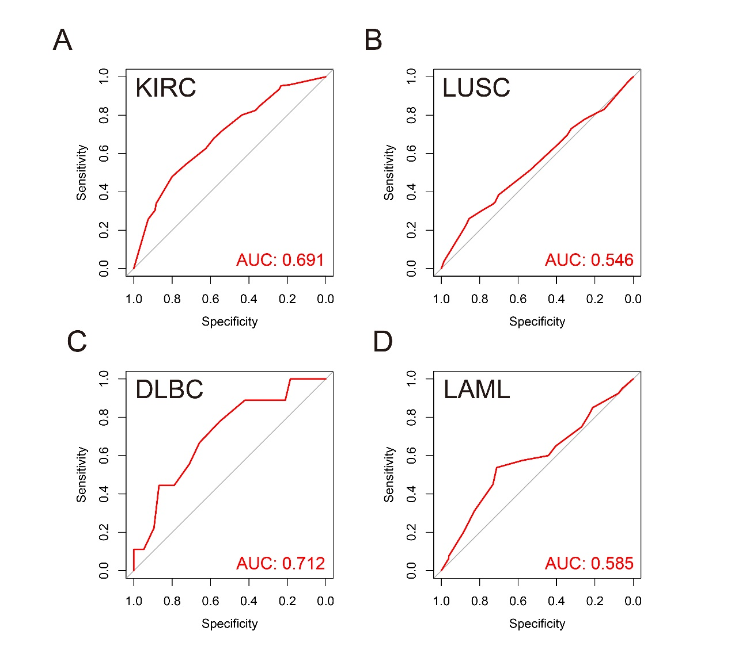
SF3 ROC curves of the prognostic signature based on four TIMP genes at 1-year in (A) KIRC, (B) LUSC, (C) DLBC, (D) LAML.

Figure SF4
SF4 The correlation analysis between TIMP family expression and tumor mutation burden (TMB) in diverse cancers. (A) TIMP1, (B) TIMP2, (C) TIMP3, (D) TIMP4.

Figure SF5
SF5 The correlation analysis between TIMP family expression and microsatellite instability (MSI) in diverse cancers. (A) TIMP1, (B) TIMP2, (C) TIMP3, (D) TIMP4.

