Supplementary Materials

Table 1
Volatile compounds identified in RAPT samples from different storage durations
Volatile compounds | RI | Concentration (μg/100g)
Volatile compounds | RI | T0 | T1 | T2 | T3 | T4 | T5 | T6 | T7 | T8 | T9 | T10
Hexanal | 800 | - | 0.45±0.06 | 6.04±0.80 | - | - | 1.38±0.22 | 0.41±0.02 | 0.52±0.06 | 0.53±0.01 | 0.64±0.12 | 0.65±0.05
3-methyl-Butanoic acid | 811 | 4.44±0.50^{ef} | 5.86±1.09^{g} | 1.92±0.03^{bc} | 3.04±0.48^{d} | 5.12±0.40^{f} | 3.75±0.37de | 0.66±0.06ª | 1.81±0.28^{bc} | 1.22±0.06^{ab} | 1.27±0.10^{ab} | 2.08±0.03^{c}
2-methyl-Butanoic acid | 811 | 5.03±0.82 ^{f} | 4.55±0.76 ^{f} | 2.37±0.03 ^{c} | 3.26±0.32 e | 3.13±0.05 de | 2.52±0.31 ^{cd} | 0.61±0.10 ª | 1.09±0.19 ^{ab} | 0.64±0.13 ª | 1.35±0.23 ^{b} | 1.43±0.08 ^{b}
1-ethyl-1H-Pyrrole | 829 | 1.37±0.02 | 0.95±0.03 | - | - | - | - | - | - | - | - | -
1,2,5,5-tetram  ethyl-1,3-Cycl  opentadiene | 840 | 2.78±0.36^{bc} | 2.32±0.07^{bc} | 1.44±0.26ª | 5.37±0.76e | 3.68±0.63^{d} | 2.02±0.25^{ab} | 2.26±0.11^{bc} | 1.52±0.23ª | 2.38±0.26^{bc} | 2.2±0.140^{bc} | 4.30±0.33^{d}
(Z)-3-Hexen-1-ol | 851 | 3.02±0.21 | 2.92±0.28 | - | - | - | - | - | - | - | - | -
2-Hexenal | 853 | - | - | 3.34±0.56 | 6.65±0.39 | 11.02±0.49 | 3.75±0.44 | 5.88±1.00 | 3.16±0.53 | 7.68±1.61 | 6.13±0.51 | 6.79±0.82
1-Hexanol | 867 | 5.58±0.07^{f} | 5.80±0.79^{f} | 3.05±0.03cd | 4.06±0.30e | 4.62±0.73e | 3.20±0.39^{d} | 2.29±0.10^{b} | 2.14±0.36^{ab} | 3.01±0.16^{cd} | 1.53±0.31ª | 2.36±0.35^{bc}
p-Xylene | 870 | 1.79±0.28^{ab} | 1.92±0.21^{abc} | 1.72±0.29^{ab} | 5.71±0.40^{f} | 4.22±0.61e | 1.67±0.32ª | 2.62±0.07^{d} | 2.54±0.26^{d} | 2.88±0.03^{d} | 2.46±0.18^{cd} | 2.28±0.46^{bcd}
2-Heptanone | 889 | 4.15±0.54de | 3.94±0.20de | 2.78±0.01^{ab} | 3.81±0.57^{c} | 5.83±0.77^{f} | 4.58±0.08e | 2.99±0.29^{ab} | 2.36±0.30ª | 3.06±0.11^{b} | 3.98±0.12de | 2.34±0.17ª
Heptanal | 901 | 4.58±0.76^{ab} | 4.51±0.48^{ab} | 7.8±0.18de | 6.68±0.53^{cd} | 8.71±1.07e | 7.09±0.42^{d} | 7.03±1.17^{d} | 3.42±0.45ª | 7.60±0.13de | 5.69±0.35^{bc} | 5.16±1.03^{b}
2-Propenoic acid, butyl ester | 902 | 1.23±0.13 | - | - | - | - | - | - | - | - | - | -
2-butoxy-Ethanol | 907 | - | 0.46±0.05 | - | - | 1.59±0.02 | - | 0.94±0.18 | 0.50±0.06 | 0.38±0.07 | 0.64±0.07 | 0.66±0.09
Hexanoic acid, methyl ester | 924 | - | - | - | - | 0.99±0.06 | - | 0.39±0.04 | 2.36±0.30 | 0.50±0.03 | - | -
Camphene | 933 | - | - | - | - | - | - | 1.20±0.10 | 1.32±0.23 | - | - | -
α-Pinene | 939 | 0.58±0.09^{ab} | 0.64±0.07^{bc} | 0.45±0.07ª | 0.50±0.01ª | 0.78±0.03^{cd} | 0.77±0.11^{cd} | 0.82±0.12^{d} | 1.05±0.09e | 1.04±0.07e | 1.04±0.08e | 0.75±0.04^{cd}
2-Octanone | 952 | 0.53±0.04 | - | - | - | - | 1.36±0.24 | - | - | - | - | -
Hexanoic acid | 961 | 26.59±3.60 | 25.95±2.40 | 9.51±1.53 | - | 27.39±0.27 | 26.98±5.34 | - | - | - | - | -
1-(3-methylenecyclopentyl)-Ethanone | 963 | - | - | - | - | - | - | 0.73±0.03 | 0.59±0.09 | - | - | -
Benzaldehyde | 966 | 14.77±0.67ª | 18.15±0.58^{ab} | 35.90±4.64^{d} | 26.23±1.89^{c} | 46.78±4.13e | 24.25±4.58^{bc} | 18.65±1.86^{ab} | 20.73±1.42^{abc} | 23.83±4.25^{bc} | 21.93±4.13^{bc} | 24.15±4.26^{bc}
3,5,5-trimethyl-2-Hexene | 968 | 37.93±1.16^{g} | 19.55±2.69^{f} | 7.66±1.02^{d} | 7.12±0.70^{cd} | 10.46±1.57e | 8.69±1.55de | 3.33±0.50^{ab} | 3.30±0.58^{ab} | 2.89±0.56ª | 4.41±0.10^{ab} | 5.28±0.87^{bc}
2-Methylenecyclohexanol | 974 | - | - | - | - | - | - | 2.71±0.49 | 3.34±0.68 | 3.81±0.08 | 4.78±0.69 | -
1-Octen-3-ol | 976 | 95.72±2.24^{g} | 51.67±5.98^{f} | 26.59±2.40^{d} | 23.11±2.95^{cd} | 36.69±1.59e | 21.79±1.34^{c} | 11.90±0.74ª | 12.06±2.07ª | 12.57±1.39^{ab} | 17.11±0.51^{b} | 15.51±2.53^{ab}
2,3-Octanedione | 986 | 7.45±0.87^{c} | 4.24±0.16^{ab} | 5.39±0.86^{b} | 9.51±1.89^{d} | 7.45±1.40^{c} | 4.07±0.83^{ab} | 3.12±0.16ª | 2.74±0.52ª | 3.71±0.43ª | 2.65±0.02ª | 3.08±0.32ª
6-methyl-5-Hepten-2-one | 987 | 19.46±1.55^{ef} | 14.85±0.99^{cd} | 12.83±1.47^{abc} | 16.39±3.17^{cde} | 21.93±3.56^{f} | 17.33±3.32de | 10.80±1.05^{ab} | 9.99±1.93^{ab} | 9.30±1.33ª | 13.45±0.59^{bc} | 12.93±0.69^{abc}
β-Myrcene | 992 | - | 17.95±0.84 | - | - | - | 21.02±3.18 | - | - | - | 16.13±0.84 | 12.85±1.02
(2R,5R)-2-Methyl-5-(prop-1-en-2-yl)-2-vinyltetrahydrofuran | 993.8 | 4.74±0.32ª | 5.62±0.07^{ab} | 4.89±0.76^{ab} | 7.50±1.42^{cd} | 11.66±1.55e | 6.53±1.16^{abc} | 5.03±0.01^{ab} | 5.78±1.14^{abc} | 6.62±0.14^{bc} | 8.92±1.46^{d} | 6.30±0.58^{abc}
Octanal | 1001 | 7.28±0.09^{ab} | 6.62±0.67^{ab} | 6.01±0.27ª | 6.26±1.19ª | 18.80±0.89^{d} | 11.07±1.91^{c} | 6.98±0.59^{ab} | 6.21±0.97ª | 8.56±1.28^{b} | 8.36±1.42^{b} | 7.43±1.07^{ab}
(E,E)-2,4-Heptadienal | 1011 | 11.52±0.35^{abc} | 10.40±0.30ª | 10.68±2.06^{ab} | 15.28±0.40e | 18.85±1.86^{f} | 11.11±1.87^{ab} | 13.18±1.21^{bcde} | 12.34±2.32^{abcd} | 14.41±0.18de | 14.13±0.28de | 13.92±1.45^{cde}
α-Terpinene | 1018 | 4.93±0.23^{ab} | 5.96±0.12^{cd} | 4.64±0.50^{ab} | 6.40±0.19^{d} | 8.56±0.11e | 5.97±0.39^{cd} | 4.82±0.46^{ab} | 5.12±0.45^{bc} | 5.40±0.35^{bc} | 6.67±1.18^{d} | 4.03±0.64ª
Benzyl chloride | 1019 | 1.50±0.05^{d} | 1.01±0.13^{abc} | 1.06±0.18^{bc} | 1.62±0.08de | 1.72±0.07e | 1.05±0.18^{abc} | 1.15±0.15^{bc} | 0.97±0.16^{ab} | 1.22±0.09^{c} | 0.82±0.09ª | 0.94±0.01^{ab}
o-Cymene | 1026 | 4.22±0.16 | - | - | 15.27±2.08 | - | 19.3±3.55 | - | - | - | - | -
2-ethyl-1-Hexanol | 1026.3 | 3.74±0.64ª | 56.79±4.80^{f} | 33.71±6.19^{c} | 32.19±3.17^{c} | 60.63±5.05^{f} | 19.3±3.55^{b} | 28.46±0.87^{c} | 49.97±1.65e | 42.02±0.52^{d} | 56.39±0.84^{f} | 49.57±3.43e
D-Limonene | 1030 | 44.37±7.79^{b} | 68.31±1.50^{d} | 74.91±12.27^{cd} | 27.88±3.64^{d} | 74.48±4.30ª | 57.35±11.33^{bc} | 45.45±3.18^{b} | 55.43±8.92^{b} | 53.03±4.01^{b} | 69.44±5.84^{cd} | 43.89±7.40^{b}
Benzyl alcohol | 1034.4 | 14.21±0.19 | - | - | 12.43±0.26 | - | - | - | - | - | - | -
2,6-dimethyl-5-Heptenal | 1044 | 25.51±0.37e | 21.35±1.30^{cd} | 18.09±3.51^{bc} | 25.65±2.28e | 24.54±3.10de | 20.66±2.77^{c} | 13.24±0.91ª | 14.65±2.43^{ab} | 15.89±0.06^{ab} | 13.44±1.49ª | 12.94±0.81ª
Benzeneacetaldehyde | 1049 | 11.93±0.26^{ab} | 9.98±0.62ª | 11.99±1.36^{ab} | 22.67±0.96^{d} | 22.44±3.00^{d} | 11.63±1.93^{ab} | 12.24±1.19^{ab} | 12.24±2.10^{ab} | 19.25±0.65^{c} | 14.11±0.30^{b} | 17.16±0.73^{c}
(Z)-3,7-dimethyl-1,3,6-Octatriene | 1051 | 6.53±0.26^{ab} | 8.29±0.68^{cde} | 7.43±0.68^{abcd} | 9.44±0.35e | 10.86±0.37^{f} | 7.81±0.93^{bcd} | 6.94±0.38^{ab} | 6.44±0.86ª | 7.14±0.44^{abc} | 8.52±0.54de | 7.54±1.29^{abcd}
1H-Pyrrole-2-carboxaldehyde, 1-ethyl- | 1054 | 25.94±0.51e | 23.39±2.05de | 23.00±4.15de | 24.66±3.13de | 32.01±2.66^{f} | 20.12±3.50^{cd} | 10.05±0.31ª | 12.15±2.43ª | 9.05±1.36ª | 13.20±0.29^{ab} | 17.39±3.04^{bc}
2-Octenal, (E)- | 1056.7 | - | - | - | - | - | - | - | 2.11±0.31 | - | 2.87±0.05 | -
Ethanone, 1-(1H-pyrrol-2-yl)- | 1063.2 | 13.99±1.34^{bc} | 13.35±0.74^{b} | 13.25±0.65^{b} | 25.82±0.14^{d} | 23.12±2.73^{d} | 16.67±2.63^{c} | 11.84±0.82^{ab} | 12.01±1.22^{ab} | 12.96±2.29^{ab} | 12.39±2.09^{ab} | 9.93±1.76ª
γ-Terpinene | 1064 | 12.38±2.06^{bc} | 13.80±1.93^{cd} | 15.40±2.70^{d} | 12.75±0.50^{bcd} | 10.23±0.88^{b} | 6.90±0.21ª | 6.32±0.08ª | 10.18±1.49^{b} | 7.18±0.67ª | 13.09±0.20^{cd} | 12.61±2.44^{bcd}
(E)-2-Octen-1-ol | 1067 | 59.44±2.59^{g} | 34.28±3.24^{f} | 28.8±2.29e | 27.26±0.19e | 27.93±0.66e | 18.67±1.05^{d} | 13.39±0.38^{c} | 9.72±1.11^{b} | 6.22±0.82ª | 9.99±0.55^{b} | 9.81±0.55^{b}
1-Octanol | 1068 | 20.41±0.43c | 25.39±1.53^{d} | 27.68±5.06^{d} | 49.66±0.06^{f} | 39.84±2.93e | 26.91±4.28^{d} | 8.53±1.21^{ab} | 7.62±0.37ª | 12.67±0.51^{b} | 10.15±0.95^{ab} | 10.55±1.29^{ab}
trans-Linalool oxide (furanoid) | 1076 | 46.04±4.44^{ab} | 44.25±4.77^{ab} | 61.16±6.85^{cd} | 76.5±14.48e | 67.97±2.44de | 52.65±7.51^{bc} | 41.15±3.95^{ab} | 38.55±5.53ª | 43.51±7.40^{ab} | 43.03±2.98^{ab} | 49.44±1.17^{ab}
endo-2-Methylbicyclo[3.3.1]nonane | 1083.34372 | 0.85±0.12 | - | - | - | - | - | - | 1.53±0.16 | - | - | -
cis-5-ethenyltet  rahydro-α, α, 5-trimethyl-2-Fu  ranmethanol | 1088 | 90.90±3.28^{cd} | 88.30±8.28^{cd} | 103.91±8.67de | 93.83±18.50^{cde} | 108.56±3.73e | 79.86±12.01^{bc} | 65.34±8.57^{ab} | 52.30±9.05ª | 61.88±6.83ª | 66.3±3.94^{ab} | 66.69±8.19^{ab}
3,5-Octadien-2-one | 1093 | - | - | - | - | 19.47±0.73 | - | 9.12±0.41 | - | - | - | -
3-Cyclohexen-1-one, 3,5,5-trimethyl- | 1097 | 1.56±0.25 | - | - | - | - | - | - | - | - | - | -
2-Cyclohexen-1-one, 3,4,4-trimethyl- | 1097 | - | - | 0.63±0.05 | - | 0.94±0.10 | 0.73±0.14 | - | - | 0.67±0.11 | - | -
Linalool | 1106 | 271.51±2.55de | 253.54±15.61de | 275.46±46.89e | 482.41±5.36^{g} | 332.09±29.48^{f} | 231.47±27.77^{cd} | 182.61±19.81^{ab} | 161.46±29.32ª | 209.00±6.52^{bc} | 201.65±8.40^{abc} | 184.53±20.76^{ab}
3,7-dimethyl-1,5,7-Octatrien-3-ol | 1106 | 70.30±1.19^{def} | 63.29±5.05^{cd} | 82.77±13.45^{f} | 78.88±14.00^{ef} | 112.34±3.17^{g} | 67.20±11.20de | 51.62±2.36^{bc} | 43.34±8.27^{ab} | 29.66±4.87ª | 41.49±1.24^{ab} | 37.53±1.89ª
(E,E)-2,4-Octadienal | 1113 | - | - | - | - | - | - | - | 3.16±0.45 | - | 3.53±0.07 | -
2,6-dimethyl-Cyclohexanol | 1114 | 28.45±0.56^{bc} | 27.36±3.32^{bc} | 43.77±7.89^{d} | 31.94±3.72^{c} | 32.85±5.38^{c} | 23.78±4.75^{b} | 13.27±2.32ª | 11.37±1.90ª | 13.43±1.89ª | 11.54±0.61ª | 16.37±0.01ª
Phenylethyl Alcohol | 1116 | 22.40±0.32 | 19.74±1.41 | - | 34.19±5.41 | 32.15±0.47 | - | - | 12.63±2.50 | - | 13.73±1.58 | -
2-ethyl-Hexanoic acid | 1116.7 | - | 4.03±0.50 | - | 6.62±1.15 | - | - | - | - | 4.68±0.53 | - | -
2,6,6-trimethyl-2-Cyclohexene-1-carboxaldehyde | 1122.9 | - | - | - | - | 4.65±0.74 | - | 6.71±0.41 | 8.39±0.84 | 5.51±0.94 | 8.16±0.76 | 9.35±1.53
Isophorone | 1124 | 2.69±0.28ª | 2.79±0.48ª | 4.72±0.86^{cd} | 5.18±0.67^{d} | 5.61±0.60^{d} | 3.94±0.47^{bc} | 2.52±0.09ª | 2.67±0.45ª | 2.84±0.52ª | 2.67±0.21ª | 3.72±0.45^{b}
(E,Z)-2,6-dimethyl-2,4,6-Octatriene | 1131 | - | - | 1.99±0.22 | - | - | - | - | - | - | - | 1.59±0.12
E,E-2,6-Dimethyl-1,3,5,7-octatetraene | 1132 | 2.73±0.18 | 1.91±0.15 | 2.7±0.07 | - | 2.64±0.37 | 1.17±0.18 | - | - | - | 0.92±0.06 | -
3-Nonen-2-one | 1136 | 1.37±0.22^{ab} | 1.49±0.14^{abc} | 1.73±0.23^{abc} | 2.79±0.34^{d} | 3.50±0.62e | 2.51±0.27^{d} | 1.24±0.17ª | 1.32±0.16ª | 1.48±0.24^{abc} | 1.96±0.18^{c} | 1.89±0.14^{bc}
Benzyl nitrile | 1143 | - | - | - | - | 3.57±0.37 | 2.35±0.31 | 2.43±0.36 | 2.60±0.09 | 1.22±0.04 | - | 1.67±0.28
(R,S)-5-Ethyl-6-methyl-3E-hepten-2-one | 1143.9 | 6.47±1.25 | - | - | - | - | - | - | - | - | - | -
1,2-dimethoxy-Benzene | 1146 | 6.51±1.21ª | 11.85±1.11de | 16.85±0.59^{f} | 17.19±1.41^{f} | 17.24±0.52^{f} | 16.19±0.95^{f} | 9.68±1.61^{bc} | 8.28±1.34^{ab} | 7.99±0.63^{ab} | 10.65±0.19^{cd} | 13.52±0.09e
(E,E)-2,6-Nonadienal | 1146 | - | - | - | - | - | 1.89±0.26 | - | 1.38±0.11 | - | - | 1.49±0.27
2,3,3-trimethyl-Bicyclo[2.2.1]heptan-2-ol | 1148 | 5.41±0.61^{ef} | 4.97±0.92^{cde} | 5.39±0.21^{ef} | 7.85±0.97^{g} | 6.21±0.16^{f} | 5.14±0.52de | 4.32±0.49^{bcd} | 3.15±0.04ª | 4.01±0.83^{abc} | 5.94±0.12^{ef} | 3.78±0.01^{ab}
1-Nonanol | 1169.2 | 10.81±0.17^{cd} | 8.38±0.42^{ab} | 11.53±1.74^{d} | 17.39±1.81e | 19.69±2.21^{f} | 10.48±0.52^{cd} | 8.98±0.36^{bc} | 8.03±1.46^{ab} | 6.94±0.48^{ab} | 7.74±0.07^{ab} | 6.53±0.09ª
3,4-Dimetho  xytoluene | 1172 | - | - | - | - | - | - | 2.03±0.29 | - | - | 3.09±0.13 | 4.14±0.84
DL-Menthol | 1173 | 48.93±0.51^{ab} | 58.07±1.32^{bc} | 74.09±10.77^{d} | 77.28±11.84^{d} | 67.90±7.93^{cd} | 45.88±9.17^{ab} | 48.32±2.93^{ab} | 46.46±5.97^{ab} | 45.21±0.99^{ab} | 39.29±2.84ª | 176.36±15.6e
Octanoic acid | 1173 | 14.04±0.41^{c} | 15.77±0.98^{c} | 26.17±4.85de | 29.59±4.36^{ef} | 32.27±2.50^{f} | 23.99±1.71^{d} | 4.60±0.34ª | 7.59±1.22^{ab} | 7.69±1.30^{ab} | 9.55±1.81^{b} | 15.06±2.67^{c}
(R)- 4-methyl-1-(1-meth  ylethyl)-3-Cycl  ohexen-1-ol | 1175 | 13.83±0.27ª | 19.14±1.47^{b} | 22.41±3.93^{bc} | 32.01±5.03^{d} | 31.49±3.08^{d} | 25.00±2.56^{c} | 19.52±1.30^{b} | 18.24±3.07^{ab} | 21.57±1.50^{bc} | 22.86±0.80^{bc} | 21.79±1.69^{bc}
(3R,6S)-2,2,6-Trimethyl-6-vinyltetrahydro-2H-pyran-3-ol | 1183 | 8.88±0.55^{c} | 8.23±1.24^{abc} | 12.01±2.03^{d} | 14.64±2.63e | 11.63±1.26^{d} | 8.25±0.38^{abc} | 7.13±1.16^{abc} | 6.01±0.71ª | 8.44±0.70^{bc} | 6.29±0.56^{ab} | 7.52±0.01^{abc}
Methyl salicylate | 1187 | 39.34±0.18 | 29.65±2.16 | 35.28±4.83 | 37.53±3.98 | - | - | - | - | - | - | -
4-trimethyl-α, α-Benzeneme  thanol | 1188 | - | - | - | - | - | - | - | - | - | - | 7.23±0.58
α-Terpineol | 1190 | 102.34±0.95ª | 136.06±8.53^{bc} | 165.38±28.08^{d} | 193.80±8.27e | 200.51±12.53e | 152.52±11.32^{bcd} | 125.56±20.12^{ab} | 103.74±18.79ª | 152.97±13.65^{bcd} | 133.27±8.64^{bc} | 159.20±20.92^{cd}
Naphthalene | 1190 | 2.48±0.16 | 3.40±0.20 | 4.29±0.63 | - | 7.94±0.61 | - | - | - | 4.14±0.18 | - | -
1-ethyl-2,5-Pyrrolidinedione | 1191 | 2.90±0.36 | - | - | 14.26±2.61 | - | - | 6.88±1.17 | 4.39±0.86 | 6.94±1.22 | 6.30±0.38 | 5.52±0.25
2,6,6-trimethyl-1,3-Cyclohexadiene-1-carboxaldehyde | 1205 | 24.66±0.15^{d} | 22.10±1.60^{c} | 26.42±0.11de | 32.52±3.37^{f} | 35.64±0.08^{g} | 27.49±2.06e | 20.81±0.18^{c} | 14.67±0.09ª | 17.96±0.67^{b} | 16.29±1.32^{ab} | 16.06±0.77^{ab}
2,3-dihydro-Benzofuran | 1219 | 6.05±0.18 | 5.11±0.56 | 5.99±0.93 | 7.64±1.31 | 8.01±1.3 | 4.69±0.09 | 3.74±0.58 | 2.98±0.37 | 4.18±0.48 | - | -
2,6,6-trimethyl-1-Cyclohexene-1-carboxaldehyde | 1220 | 24.58±0.27^{d} | 17.79±1.31^{c} | 19.28±1.60^{c} | 26.38±0.49e | 27.02±1.39e | 13.92±1.17^{b} | 10.2±0.25ª | 8.32±1.44ª | 9.82±0.26ª | 9.07±0.27ª | 9.93±1.29ª
(Z)- 3,7-dimethyl-2,6-Octadien-1-ol | 1229 | 13.34±0.56ª | 15.85±1.18^{ab} | 20.89±3.5^{c} | 30.34±5.58^{d} | 28.89±4.37^{d} | 19.98±0.65^{bc} | 12.41±1.81ª | 12.58±2.31ª | 16.28±0.63^{abc} | 14.45±1.12ª | 13.31±1.17ª
Geraniol | 1258 | 43.95±1.12^{bcd} | 48.22±3.67^{cd} | 64.18±11.11e | 78.40±1.24^{f} | 82.65±3.82^{f} | 51.55±1.73^{d} | 32.38±6.4ª | 31.83±6.24ª | 41.33±2.65^{abc} | 35.81±2.48^{ab} | 38.93±7.02^{abc}
Nonanoic acid | 1272.1 | 23.46±1.49^{c} | 22.45±1.56^{c} | 41.20±3.75^{ef} | 36.43±5.82e | 43.80±4.25^{f} | 28.84±3.00^{d} | 9.37±1.39ª | 10.63±1.78^{ab} | 14.64±2.14^{ab} | 15.60±1.83^{b} | 11.26±0.02^{ab}
6-Undecanone | 1274 | 16.73±0.62de | 13.70±1.14^{bc} | 16.81±2.70de | 14.53±0.10^{cd} | 19.20±3.09e | 11.11±1.64^{b} | 6.71±0.69ª | 8.20±1.35ª | 7.09±0.79ª | 7.56±1.28ª | 8.49±0.18ª
Indole | 1294 | - | - | - | - | - | - | - | - | - | 1.26±0.09 | -
1-Tridecene | 1294 | - | - | 1.81±0.25 | 2.63±0.04 | 2.38±0.27 | 0.94±0.13 | 1.56±0.15 | 1.49±0.25 | 1.49±0.26 | 1.37±0.28 | 1.28±0.02
2,6,10,10-tetramethyl-1-Oxaspiro[4.5]dec-6-ene | 1305.2 | 6.59±0.89 | 6.91±1.18 | 5.19±0.52 | - | - | 4.41±0.59 | - | - | 2.56±0.30 | - | 3.61±0.42
5,6,7,7a-tetrahydro-3,6-dimethyl-2(4H)-Benzofuranone | 1314 | 6.23±0.89 | - | - | - | - | - | - | - | - | - | -
1,2,3-Trimethoxybenzene | 1317 | - | - | 2.33±0.32 | - | 3.47±0.22 | 2.52±0.16 | 2.88±0.44 | 2.14±0.30 | 0.92±0.11 | 2.68±0.24 | 1.90±0.20
2,6-dimethoxy-Phenol | 1357 | 1.32±0.06 | 1.84±0.36 | - | - | - | - | - | - | - | - | -
dihydro-5-pentyl-2(3H)-Furanone | 1362 | 7.83±0.15^{f} | 2.84±0.17ª | 5.15±0.63^{d} | 3.83±0.63^{bc} | 9.06±0.17^{g} | 6.00±0.60e | 4.38±0.50^{c} | 3.08±0.54^{ab} | 3.07±0.51^{ab} | 5.79±0.36de | 3.60±0.26^{abc}
10-Undecenoic acid, methyl ester | 1371 | 13.9±0.39 | 14.65±1.05 | 16.25±1.70 | - | 16.55±1.88 | - | - | - | - | - | -
Propanoic acid, 2-methyl-, | 1380 | 0.99±0.07ª | 1.09±0.03ª | 3.45±0.50^{bc} | 4.33±0.05^{cd} | 5.16±0.73^{d} | 2.87±0.43^{b} | 1.54±0.30ª | 9.35±1.48e | 3.96±0.54^{c} | 4.34±0.17^{cd} | 3.98±0.43^{c}
(E)-1-(2,6,6-trimethyl-1,3-cyclohexadien-1-yl)-2-Buten-1-one | 1388 | 3.38±0.01^{ab} | 4.05±0.39^{bc} | 5.4±0.48^{d} | 5.69±0.69^{d} | 6.73±0.80e | 4.62±0.07^{c} | 2.99±0.01ª | 2.79±0.25ª | 3.10±0.26ª | 2.82±0.01ª | 2.93±0.36ª
1-Tetradecene | 1392 | - | - | 0.62±0.11 | - | - | - | 2.99±0.07 | - | 1.20±0.24 | - | 1.98±0.32
6,10-dimethyl-2-Undecanone | 1407 | 3.55±0.02 | 3.94±0.33 | 4.05±0.34 | - | 6.08±0.39 | 5.47±0.68 | - | 4.02±0.26 | 4.20±0.05 | - | -
[3R-(3α,3aβ,7β,8aα)]- 2,3,4,7,8,8a-hexahydro-3,6,8  ,8-tetramethyl-1H-3a,7-Meth  anoazulene | 1408 | - | - | 17.11±2.37 | 20.25±3.83 | 16.42±1.83 | 20.17±3.77 | 6.75±0.57 | 6.85±1.16 | 6.44±0.97 | 10.93±0.46 | 18.69±3.47
Dodecanal | 1412 | - | 1.42±0.20 | - | 4.66±0.65 | 1.25±0.20 | 1.18±0.09 | 0.84±0.14 | 0.98±0.09 | - | 2.45±0.14 | 1.27±0.02
Longifolene | 1412.6 | - | - | - | - | 4.11±0.66 | 2.94±0.54 | 4.58±0.39 | 3.23±0.43 | - | 3.40±0.71 | 1.43±0.16
α-Ionone | 1421 | 15.43±2.62^{b} | 15.14±0.62^{b} | 15.13±1.86^{b} | 22.50±4.34^{c} | 20.08±1.97^{c} | 12.99±0.56^{ab} | 10.08±0.28ª | 11.30±1.48ª | 10.96±0.53ª | 13.04±2.33^{ab} | 15.44±1.88^{b}
6-Methyl-6-(5-methylfuran-2-yl)heptan-2-one | 1426 | - | - | 3.79±0.44 | 33.09±5.04 | - | 2.83±0.31 | - | - | - | - | -
4-(2,2,6-trimethyl-7-oxabicyclo[4.1.0]hept-1-yl)-3-Buten-2-one | 1428 | - | - | 8.27±1.49 | - | - | - | - | - | - | 2.53±0.35 | -
Ionone | 1429 | - | - | 23.66±0.28 | - | - | 19.49±1.88 | 10.24±0.92 | 4.26±0.54 | - | 4.04±0.52 | -
4-(2,6,6-trimethyl-1-cyclohexen-1-yl)-2-Butanone | 1433 | 4.48±0.36 | - | 2.48±0.32 | 2.75±0.24 | - | - | - | - | - | - | 3.73±0.25
6,10-dimethyl-5,9-Undecadien-2-one | 1434 | 34.61±6.73^{d} | 29.03±0.59^{c} | 31.08±3.02^{cd} | 16.66±2.97^{ab} | 32.01±3.25^{cd} | 20.95±0.92^{b} | 11.81±0.46ª | 13.46±1.74ª | 12.94±0.14ª | 14.56±0.89ª | 14.19±2.36ª
4-(2,6,6-Trimethylcyclohexa-1,3-dienyl)but-3-en-2-one | 1440 | 8.04±0.23ª | 13.17±0.81^{b} | 17.77±2.81^{c} | 23.54±1.55^{d} | 26.62±2.64e | 19.55±0.75^{c} | 11.73±0.86^{b} | 11.58±1.50^{b} | 13.08±0.23^{b} | 11.62±0.47^{b} | 13.19±2.58^{b}
trans-β-Ionone | 1457 | 61.66±2.27^{c} | 59.18±2.87^{c} | 63.9±9.36^{c} | 56.33±5.05^{c} | 75.95±5.35^{d} | 47.80±1.19^{b} | 35.30±2.34ª | 28.51±3.80ª | 32.33±0.55ª | 28.8±1.16ª | 31.45±5.12ª
1-Dodecanol | 1457 | 3.56±0.06ª | 5.59±0.20^{b} | 6.27±0.75^{bc} | 5.68±0.74^{b} | 9.00±0.62^{d} | 7.30±0.22^{c} | 5.71±0.46^{b} | 5.73±1.13^{b} | 7.46±0.68^{c} | 6.96±0.93^{c} | 7.22±0.24^{c}
(+)-Valencene | 1491 | 4.85±0.33 | 4.41±0.29 | 5.4±0.91 | - | 4.94±0.35 | 2.21±0.23 | 2.57±0.09 | 2.00±0.32 | - | - | -
cis-hexahydro-8a-methyl-1,8(2H,5H)-Naphthalenedione | 1517 | 28.42±0.95 | - | - | - | - | 22.57±0.2 | - | - | 16.95±0.67 | - | -
Butylated Hydroxytoluene | 1517.5 | 1.39±0.13 | 1.50±0.08 | 1.66±0.30 | 1.03±0.02 | 0.99±0.09 | 0.66±0.13 | - | - | - | - | -
(R)-5,6,7,7a-tetrahydro-4,4,7a-trimethyl-2(4H)-Benzofuranone, | 1525 | 31.72±1.51^{ab} | 33.55±3.10^{abc} | 43.40±6.44^{bc} | 72.09±14.23^{d} | 72.4±10.57^{d} | 45.21±6.16^{c} | 33.06±1.47^{abc} | 30.34±5.95ª | 44.20±5.88^{bc} | 34.16±1.14^{abc} | 33.48±1.59^{abc}
(E)-3,7,11-trimethyl-1,6,10-Dodecatrien-3-ol | 1551 | 4.31±0.14 | 7.80±0.22 | - | - | - | 7.56±0.24 | - | - | 4.03±0.20 | - | 4.24±0.15
2,4-Di-tert-butylphenol | 1555 | 16.86±1.65ª | 19.54±1.14^{ab} | 21.46±3.21^{abc} | 19.50±3.05^{ab} | 35.94±2.87^{d} | 26.11±0.39^{c} | 22.37±1.31^{bc} | 19.52±2.73^{ab} | 24.38±3.57^{bc} | 24.94±4.67^{c} | 24.68±3.04^{bc}
n-Nonylcyclohexane | 1556 | - | - | - | - | - | - | - | - | 4.66±0.29 | 6.94±0.95 | 6.10±0.88
Methanone, dicyclohexyl- | 1576 | 18.32±0.71^{bcd} | 18.43±1.31^{bcd} | 21.86±3.22^{d} | 21.84±4.21^{d} | 28.70±3.46e | 19.76±0.95^{bcd} | 16.31±2.43^{abc} | 12.81±2.04ª | 18.14±2.48^{bcd} | 15.45±0.71^{ab} | 20.52±3.81^{cd}
2,2,4-Trimethyl-1,3-pentanediol diisobutyrate | 1587.5 | 7.82±0.15^{b} | 15.79±0.66^{g} | 16.20±0.46^{g} | 10.78±0.20de | 9.14±0.68^{bc} | 20.42±0.46^{h} | 5.73±0.87ª | 10.15±1.67^{cd} | 11.94±0.60e | 13.91±0.21^{f} | 13.90±1.77^{f}
Cedrol | 1607.9 | - | 11.23±0.02 | 18.63±1.21 | 7.36±1.05 | 17.59±1.29 | 12.45±0.08 | 15.94±0.56 | 30.98±4.02 | 30.57±2.25 | 37.09±0.57 | 31.47±4.95
Tetradecanal | 1614 | - | - | - | 1.63±0.05 | - | - | 5.98±0.23 | - | - | - | 7.23±1.46
Benzophenone | 1664 | - | - | 14.89±2.63 | 3.83±0.12 | 9.30±0.49 | 11.12±1.08 | - | 8.18±0.94 | 10.74±0.29 | 7.49±1.23 | 7.25±0.74
2,2',5,5'-tetramethyl-1,1'-Biphenyl | 1668.5 | - | - | - | - | - | - | 1.56±0.09 | 1.22±0.18 | - | 1.22±0.02 | 1.39±0.16
2-hexyl-1-Decanol | 1790 | 5.40±0.18 | - | - | - | - | - | - | - | 6.05±0.77 | 9.29±0.05 | 6.56±1.18
3,4-diethyl-1,1'-Biphenyl | 1792 | - | 11.24±0.26 | - | - | - | 28.4±1.82 | - | 12.51±1.53 | - | - | 10.7±0.49
Neophytadiene | 1840 | 21.12±0.02e | 22.90±2.62^{ef} | 25.74±5.10^{f} | 16.80±1.99^{cd} | 25.51±0.77^{f} | 19.01±2.47de | 13.37±2.20^{bc} | 13.39±2.31^{bc} | 16.89±0.72^{cd} | 11.20±0.05^{ab} | 8.99±1.41ª
Dodecylcyclohexane | 1864 | 2.73±0.36ª | 3.48±0.13^{ab} | 8.83±1.48e | 6.67±0.73^{d} | 4.66±0.41^{bc} | 6.84±0.55^{d} | 5.97±0.20^{cd} | 4.67±0.68^{bc} | 4.80±0.75^{bc} | 5.84±0.95^{cd} | 4.01±0.55^{b}
Phytol | 2045 | 16.50±1.15de | 24.40±2.06^{f} | 23.47±1.53^{f} | 14.73±2.26^{cd} | 16.69±1.21de | 18.51±3.07e | 14.36±2.81^{cd} | 11.28±2.02^{bc} | 13.83±0.87^{cd} | 8.48±1.24^{ab} | 7.63±0.99ª
Decanoic acid, methyl ester | 1282 | - | - | - | 16.38±1.25 | - | 14.87±1.95 | 10.06±0.38 | 9.18±0.42 | - | - | -
n-Hexadecanoic acid | 1968 | - | - | - | - | 40.59±4.43 | - | - | - | - | - | -
1-Decanol | 1258 | - | - | - | - | 9.67±0.92 | 5.48±0.3 | - | 4.07±0.29 | - | - | -
Sulfurous acid, butyl tetradecyl ester | 2434 | 3.34±0.56 | 2.15±0.19 | - | - | 2.22±0.20 | 1.87±0.08 | - | - | - | 1.25±0.15 | 1.33±0.12
ª RI =Retention index of aroma compounds on HP-5MS UI Column; RI were obtained from NIST Chemistry WebBook.(https://webbook.nist.gov/chemistry/name-ser/)
^{b} Concentrations of aroma compounds in T0, T1, T2,T3, T4, T5, T6, T7, T8, T9 and T10 were represented RAPT samples from eleven different aging years, respectively; values with different letters (a-h) in a row are significantly using Duncan’s multiple comparison tests ( p < 0.05 ) .
^{c} All the above aroma compounds were identified by MS and RI values, except. Phytol, Decanoic acid, methyl ester, n-Hexadecanoic acid , 1-Decanol and Sulfurous acid, butyl tetradecyl ester is identified by MS

Table 2
Key volatile compounds identified in RAPT samples from different years of storage
Volatile compounds | Class | Odor | Threshold(μg/kg) | OAV |  |  |  |  |  |  |  |  |  |  | ACI(%)
 |  |  |  | T0 | T1 | T2 | T3 | T4 | T5 | T6 | T7 | T8 | T9 | T10
DL-Menthol | Woody | mint-like,woody | 1000 | 0.5 | 0.6 | 0.7 | 0.8 | 0.7 | 0.5 | 0.5 | 0.5 | 0.5 | 0.4 | 1.8 | <0
Linalool | Floral&fruity | Citrus-like, flowery | 0.6 | 4525.1 | 4225.6 | 4591.1 | 8040.2 | 5534.9 | 3857.9 | 3043.5 | 2691.1 | 3483.4 | 3360.8 | 3075.5 | 0.72~8.28
α-Terpineol | Floral | flowery | 4.08 | 250.8 | 333.5 | 405.3 | 475 | 491.5 | 373.8 | 307.7 | 254.3 | 374.9 | 326.7 | 390.2 | 0.06~0.63
Geraniol | Floral&fruity | Rose-like, citrus-like | 3.2 | 137.3 | 150.7 | 200.6 | 245 | 258.3 | 161.1 | 101.2 | 99.5 | 129.1 | 111.9 | 121.7 | 0.03~0.25
trans-Linalool oxide (furanoid) | Floral | floral | 3000 | 0.2 | 0.1 | 0.2 | 0.3 | 0.2 | 0.2 | 0.1 | 0.1 | 0.1 | 0.1 | 0.2 | <0
trans-β-Ionone | Floral | Flowery, violet-like | 0.007 | 88081.6 | 84544.4 | 91283.8 | 80478.2 | 108493 | 68278.6 | 50430.3 | 40730.3 | 46186 | 41143.2 | 44931.8 | 14.41~85.82
D-Limonene | Fruity | Citrus-like, carrot-like | 13 | 34.1 | 52.5 | 57.6 | 21.4 | 57.3 | 44.1 | 35 | 42.6 | 40.8 | 53.4 | 33.8 | 0.01~0.09
Benzaldehyde | Fruity | Cherry-like | 320 | 0.5 | 0.6 | 1.1 | 0.8 | 1.5 | 0.8 | 0.6 | 0.6 | 0.7 | 0.7 | 0.8 | <0
1H-Pyrrole-2-carboxaldehyde, 1-ethyl- | Roasted | Bread-like，roasty | 65000 | <0.1 | <0.1 | <0.1 | <0.1 | <0.1 | <0.1 | <0.1 | <0.1 | <0.1 | <0.1 | <0.1 | <0
Octanoic acid | Cheese flavor | Carrot-like, musty Cheese, fat | 190 | 0.7 | 0.8 | 1.4 | 1.6 | 1.7 | 1.3 | 0.2 | 0.4 | 0.4 | 0.5 | 0.8 | <0
α-Ionone | Floral | Flowery, violet-like | 0.4 | 385.8 | 378.5 | 378.1 | 562.5 | 501.9 | 324.9 | 251.9 | 282.4 | 274.1 | 326 | 386 | 0.06~0.62
Benzeneacetaldehyde | Floral | Lilac and hyacinth-like | 4 | 29.8 | 24.9 | 30 | 56.7 | 56.1 | 29.1 | 30.6 | 30.6 | 48.1 | 35.3 | 42.9 | 0~0.06
2,6,6-trimethyl-1,3-Cyclohexadiene-1-carboxaldehyde | Woody | Woody,herbal | 3 | 82.2 | 73.7 | 88.1 | 108.4 | 118.8 | 91.6 | 69.4 | 48.9 | 59.9 | 54.3 | 53.5 | 0.01~0.12
(E,E)-2,4-Heptadienal | Floral | Fatty, flowery | 0.032 | 3598.6 | 3248.6 | 3338.5 | 4774.2 | 5892 | 3473.1 | 4117.8 | 3857.1 | 4501.8 | 4416.6 | 4351.2 | 0.55~7.76
1,2-dimethoxy-Benzene | Stale | Sweet and Musty | 3.17 | 20.5 | 37.4 | 53.2 | 54.2 | 54.4 | 51.1 | 30.5 | 26.1 | 25.2 | 33.6 | 42.7 | 0.01~0.06
(Z)-3,7-dimethyl-2,6-Octadien-1-ol | Floral&fruity | Citrus-like,Floral | 49 | 2.7 | 3.2 | 4.3 | 6.2 | 5.9 | 4.1 | 2.5 | 2.6 | 3.3 | 2.9 | 2.7 | 0~0.01
6-methyl-5-Hepten-2-one | Fruity | Citrus-like, apple-like | 50 | 3.9 | 3 | 2.6 | 3.3 | 4.4 | 3.5 | 2.2 | 2 | 1.9 | 2.7 | 2.6 | 0~0.01
1-Octanol | Floral&fruity | Rose-like or lemon-like | 0.8 | 255.1 | 317.3 | 346 | 620.8 | 497.9 | 336.4 | 106.6 | 95.2 | 158.4 | 126.8 | 131.8 | 0.06~0.64
Nonanoic acid | Stale | Moldy, pungent | 26 | 9 | 8.6 | 15.8 | 14 | 16.8 | 11.1 | 3.6 | 4.1 | 5.6 | 6 | 4.3 | 0~0.01
2,6,6-trimethyl-1-Cyclohexene-1-carboxaldehyde | - | - | 5 | 49.2 | 35.6 | 38.6 | 52.8 | 54 | 27.8 | 20.4 | 16.6 | 19.6 | 18.1 | 19.9 | 0.01~0.05
1-Octen-3-ol | Green | Mushroom-like, green | 45 | 21.3 | 11.5 | 5.9 | 5.1 | 8.2 | 4.8 | 2.6 | 2.7 | 2.8 | 3.8 | 3.4 | 0~0.01
1-(1H-pyrrol-2-yl)-Ethanone | Nutty | Nutty, musty | 3.4 | 41.2 | 39.3 | 39 | 75.9 | 68 | 49 | 34.8 | 35.3 | 38.1 | 36.4 | 29.2 | 0.01~0.08
Octanal | Fruity | Citrus-like, soapy | 0.0455 | 1600.9 | 1455.3 | 1320.7 | 1376.8 | 4131.4 | 2432.5 | 1534.7 | 1365 | 1880.6 | 1836.4 | 1632.4 | 0.25~3.52
1-Dodecanol | Fatty | Fatty, soapy | 6.1 | 5.8 | 9.2 | 10.3 | 9.3 | 14.8 | 12 | 9.4 | 9.4 | 12.2 | 11.4 | 11.8 | 0~0.02
1-Nonanol | Floral | rose-like | 11 | 9.8 | 7.6 | 10.5 | 15.8 | 17.9 | 9.5 | 8.2 | 7.3 | 6.3 | 7 | 5.9 | 0~0.02
Heptanal | Fatty | Citrus-like, fatty | 9.7 | 4.7 | 4.7 | 8 | 6.9 | 9 | 7.3 | 7.2 | 3.5 | 7.8 | 5.9 | 5.3 | 0~0.01
Isophorone | Woody | Woody | 3000 | <0.1 | <0.1 | <0.1 | <0.1 | <0.1 | <0.1 | <0.1 | <0.1 | <0.1 | <0.1 | <0.1 | <0
Dihydro-5-pentyl-2(3H)-Furanone | Cheese flavor | Coconut, creamy, waxy with fatty milky notes | 4.5 | 17.4 | 6.3 | 11.5 | 8.5 | 20.1 | 13.3 | 9.7 | 6.8 | 6.8 | 12.9 | 8 | 0~0.02
(E)-1-(2,6,6-trimethyl-1,3-cyclohexadien-1-yl)-,2-Buten-1-one | Floral&fruity | apple-like, rose-like | 1000 | <0.1 | <0.1 | 0.1 | 0.1 | 0.1 | <0.1 | <0.1 | <0.1 | <0.1 | <0.1 | <0.1 | <0
2-Heptanone | Fruity | cabbage-like | 70 | 0.6 | 0.6 | 0.4 | 0.5 | 0.8 | 0.7 | 0.4 | 0.3 | 0.4 | 0.6 | 0.3 | <0
3-methyl-Butanoic acid | Cheese flavor | Cheese-like | 10000 | <0.1 | <0.1 | <0.1 | <0.1 | <0.1 | <0.1 | <0.1 | <0.1 | <0.1 | <0.1 | <0.1 | <0
1-Hexanol | Green | Green, grassy | 40 | 1.4 | 1.4 | 0.8 | 1 | 1.2 | 0.8 | 0.6 | 0.5 | 0.8 | 0.4 | 0.6 | <0
p-Xylene | Chemical | Plastic, green, | 60 | 0.3 | 0.3 | 0.3 | 1 | 0.7 | 0.3 | 0.4 | 0.4 | 0.5 | 0.4 | 0.4 | <0
2-methyl-Butanoic acid | Cheese flavor | Butter, cheese-like | 15 | 3.4 | 3 | 1.6 | 2.2 | 2.1 | 1.7 | 0.4 | 0.7 | 0.4 | 0.9 | 1 | <0
α-Pinene | Woody | Fresh, woody | 48 | 0.1 | 0.1 | 0.1 | 0.1 | 0.2 | 0.2 | 0.2 | 0.2 | 0.2 | 0.2 | 0.2 | <0
(Z)-3-Hexen-1-ol | Green | Grass | 0.0002 | 151243.8 | 145866.1 | ND | ND | ND | ND | ND | ND | ND | ND | ND | 0~40.33
1-ethyl-1H-Pyrrole | Roasted | Burnt, roasted | 3 | 4.6 | 3.2 | ND | ND | ND | ND | ND | ND | ND | ND | ND | <0
Methyl salicylate | Green | wintergreen | 10 | 39.3 | 29.7 | 35.3 | 37.5 | ND | ND | ND | ND | ND | ND | ND | 0~0.04
Phenylethyl Alcohol | Floral&fruity | Rose-like | 9 | 24.9 | 21.9 | 29.4 | 38 | 35.7 | 19.1 | ND | 14 | 7 | 15.3 | ND | 0~0.04
β-Myrcene | Woody | Pepper-like,carrot-like | 0.75 | ND | 239.3 | ND | ND | ND | 280.2 | ND | ND | ND | 215.1 | 171.3 | 0~0.41
Tetradecanal | Chemical | Alkane | 60 | ND | ND | ND | 0.3 | ND | ND | 1 | ND | ND | ND | 1.2 | <0
1-Decanol | Floral&fruity | orange-like, floral | 23 | ND | ND | ND | ND | 4.2 | 2.4 | ND | 1.8 | ND | ND | ND | <0
Naphthalene | Chemical | pungent dry tarry | 50 | 0.5 | 0.7 | 0.9 | ND | 1.6 | ND | ND | ND | 0.8 | ND | ND | <0
2,3-dihydro-Benzofuran | Chemical | Tar-like , pungent | 48 | 1.3 | 1.1 | 1.2 | 1.6 | 1.7 | 1 | 0.9 | 0.6 | 0.9 | ND | ND | <0
1-Oxaspiro[4.5]dec-6-ene, 2,6,10,10-tetramethyl- | Woody | Herbal | 0.0002 | 329594.6 | 345510 | 259316.6 | ND | ND | 220607.8 | ND | ND | 128021.3 | ND | 180540.2 | 0~76.48
Benzyl alcohol | Floral&fruity | Rose-like, cherry-like | 5500 | <0.1 | ND | ND | <0.1 | ND | ND | ND | ND | ND | ND | ND | <0
Ionone | Floral | Flowery, violet-like | 1500 | ND | ND | 0.2 | ND | ND | 0.1 | 0.1 | <0.1 | ND | <0.1 | ND | <0
(E)-2-Octenal | Green | Green | 3 | ND | ND | ND | ND | ND | ND | ND | 7 | ND | 9.6 | ND | 0~0.02
2,6-dimethoxy-Phenol | Chemical | phenolic, smoky, woody | 400 | v | <0.1 | ND | ND | ND | ND | ND | ND | ND | ND | ND | <0
(E,E)-2,6-Nonadienal | Green | cucumber-like, grren | 1 | ND | ND | ND | ND | ND | 18.9 | ND | 13.8 | ND | ND | 14.9 | 0~0.03
Dodecanal | Green | Green,soapy,citrus-like | 1.07 | ND | 13.3 | ND | 43.5 | 11.7 | 11.1 | 7.8 | 9.2 | ND | 22.9 | 11.9 | 0~0.04
Indole | Floral | Floral, animal-like | 500 | 0.1 | ND | <0.1 | ND | ND | ND | ND | ND | <0.1 | <0.1 | ND | <0
Hexanoic acid, methyl ester | Fruity | Pine apple-like | 10 | ND | ND | ND | ND | 1 | ND | 0.4 | 2.4 | 0.5 | ND | ND | <0
2-Octanone | Woody | Woody, Herbal | 50 | 0.1 | ND | ND | ND | ND | 0.3 | ND | ND | ND | ND | ND | <0
2-butoxy-Ethanol | - | - | 2600 | ND | <0.1 | ND | ND | <0.1 | ND | <0.1 | <0.1 | <0.1 | <0.1 | <0.1 | <0
Hexanal | Green | Green | 9 | ND | 0.5 | 6.7 | ND | ND | 1.5 | 0.5 | 0.6 | 0.6 | 0.7 | 0.7 | <0
1,2,3-Trimethoxybenzene | Stale | Stale and Musty | 0.75 | ND | ND | 31.1 | ND | 46.3 | 33.6 | 38.4 | 28.5 | 12.3 | 35.7 | 25.3 | 0~0.07
ª OT = Odor thresholds
^{b} ND, the compounds was not detected
^{c} All the odor thresholds were obtained from: (Guo et al., 2021; Hao et al., 2023; Tatsu et al., 2020; Zhai et al., 2022; Zheng et al., 2023; Zhu et al., 2021)

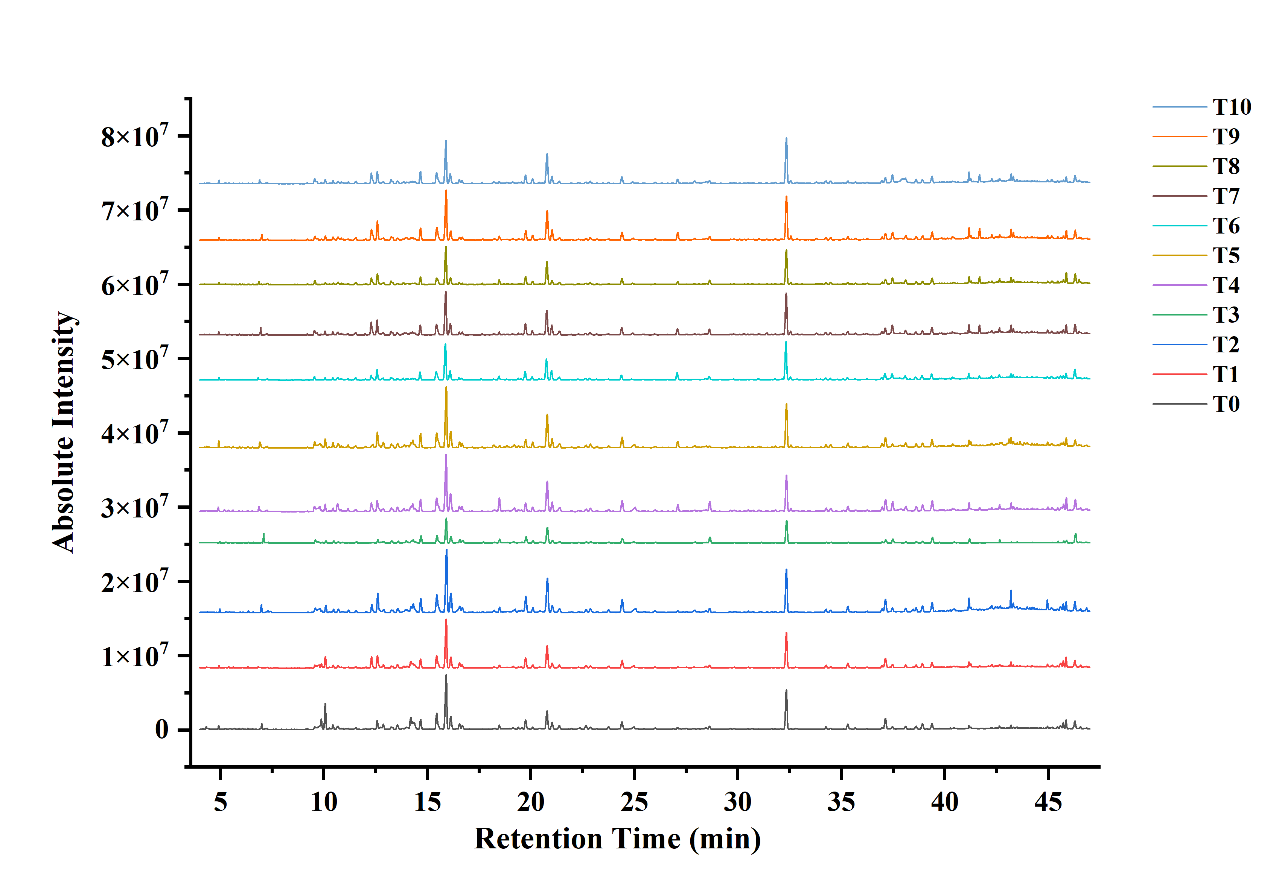
Fig. S1 Total ion chromatograms (TIC) of aroma compounds in RAPT

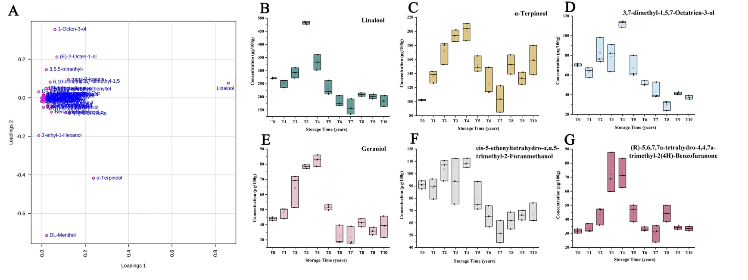
Fig. S2 Multivariate statistical analysis of volatile compounds and during RAPT storage (a) loadings plot (b-g) Comparison of the accurate contents of differential compounds screened by loadings plot

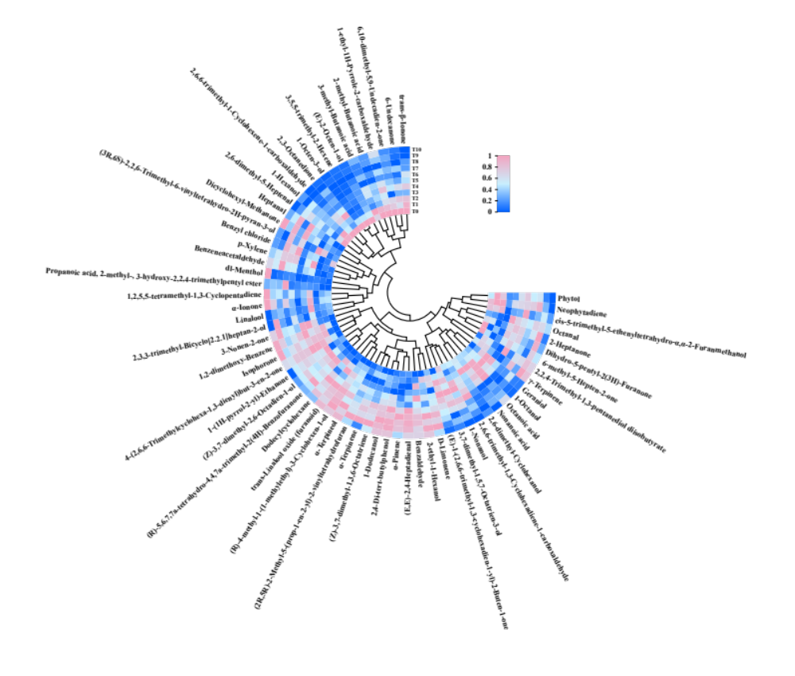
Fig. S3 Heat map of differential volatile compounds in the samples of RAPT at various storage time points (Relative content)

