Investigation of the molecular mechanism of Xiangsha Liujun Pill in the treatment of gastritis based on network pharmacology and molecular docking
Jiaen Wei, Zhengxiu Li, Tingting Tang, Ruolan Yu, Xuejing Cao, Yong Liu, Zunnan Huang

Supplementary Materials

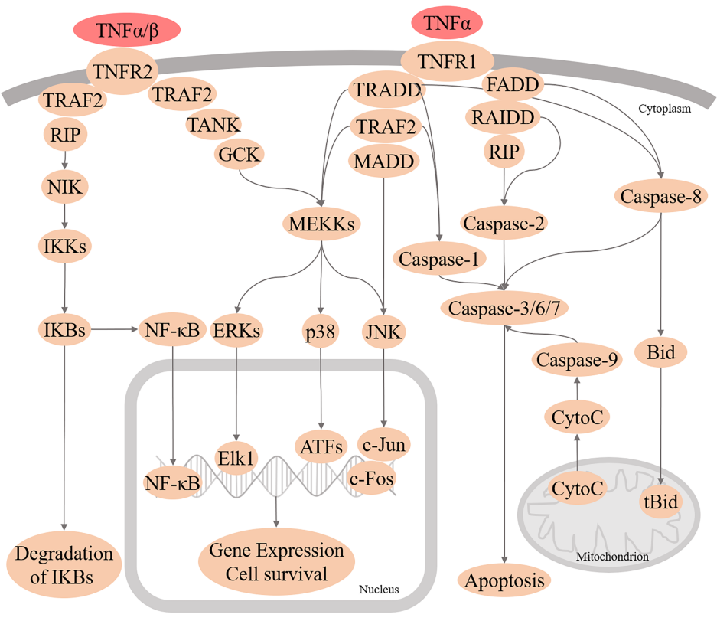
Figure 1S：Detailed information on the TNF signaling pathway

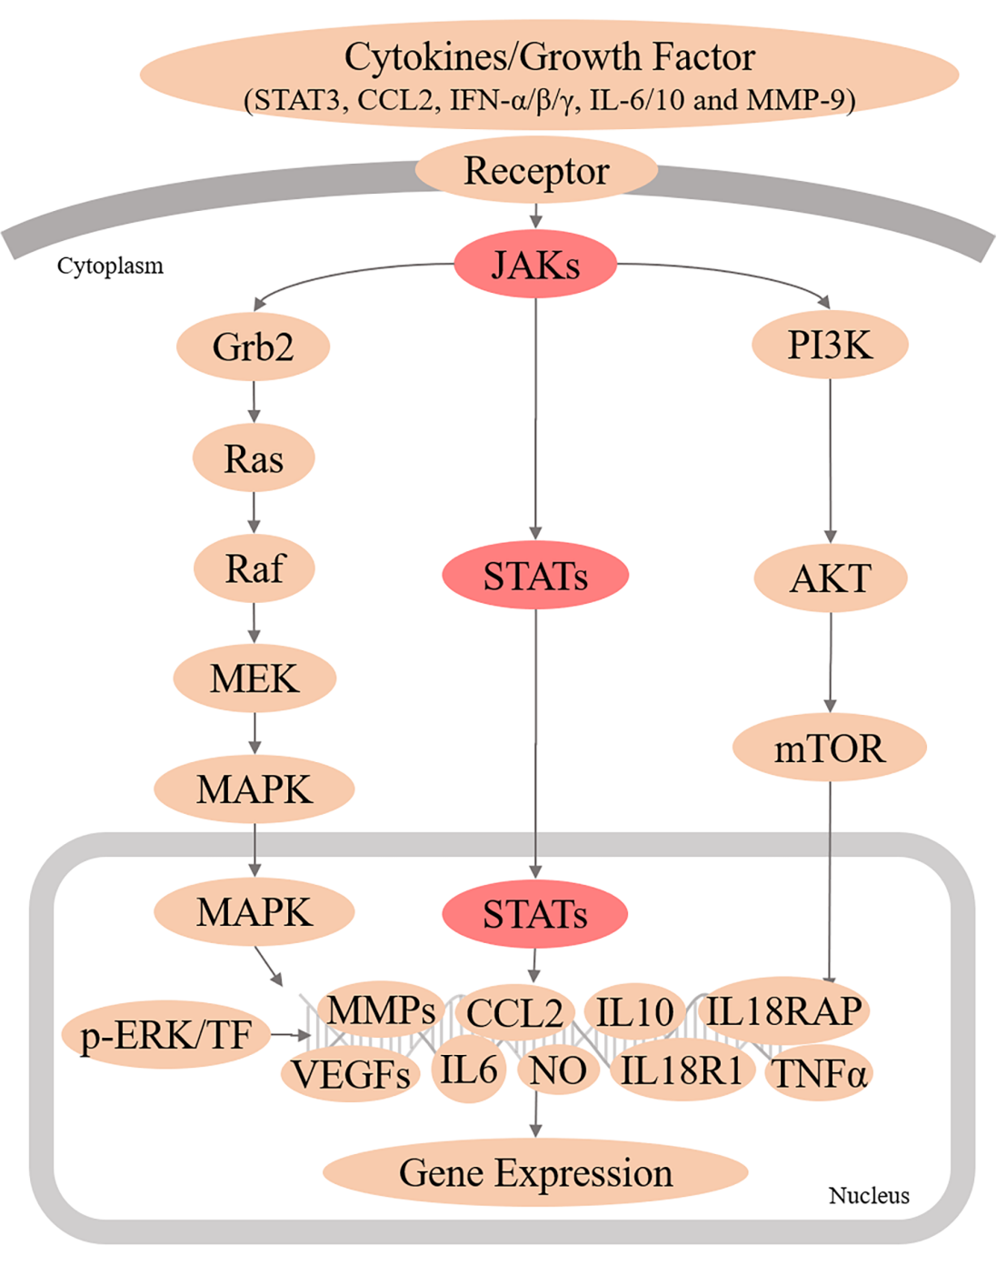
Figure 2S: Detailed information on the JAK-STAT signaling pathway.
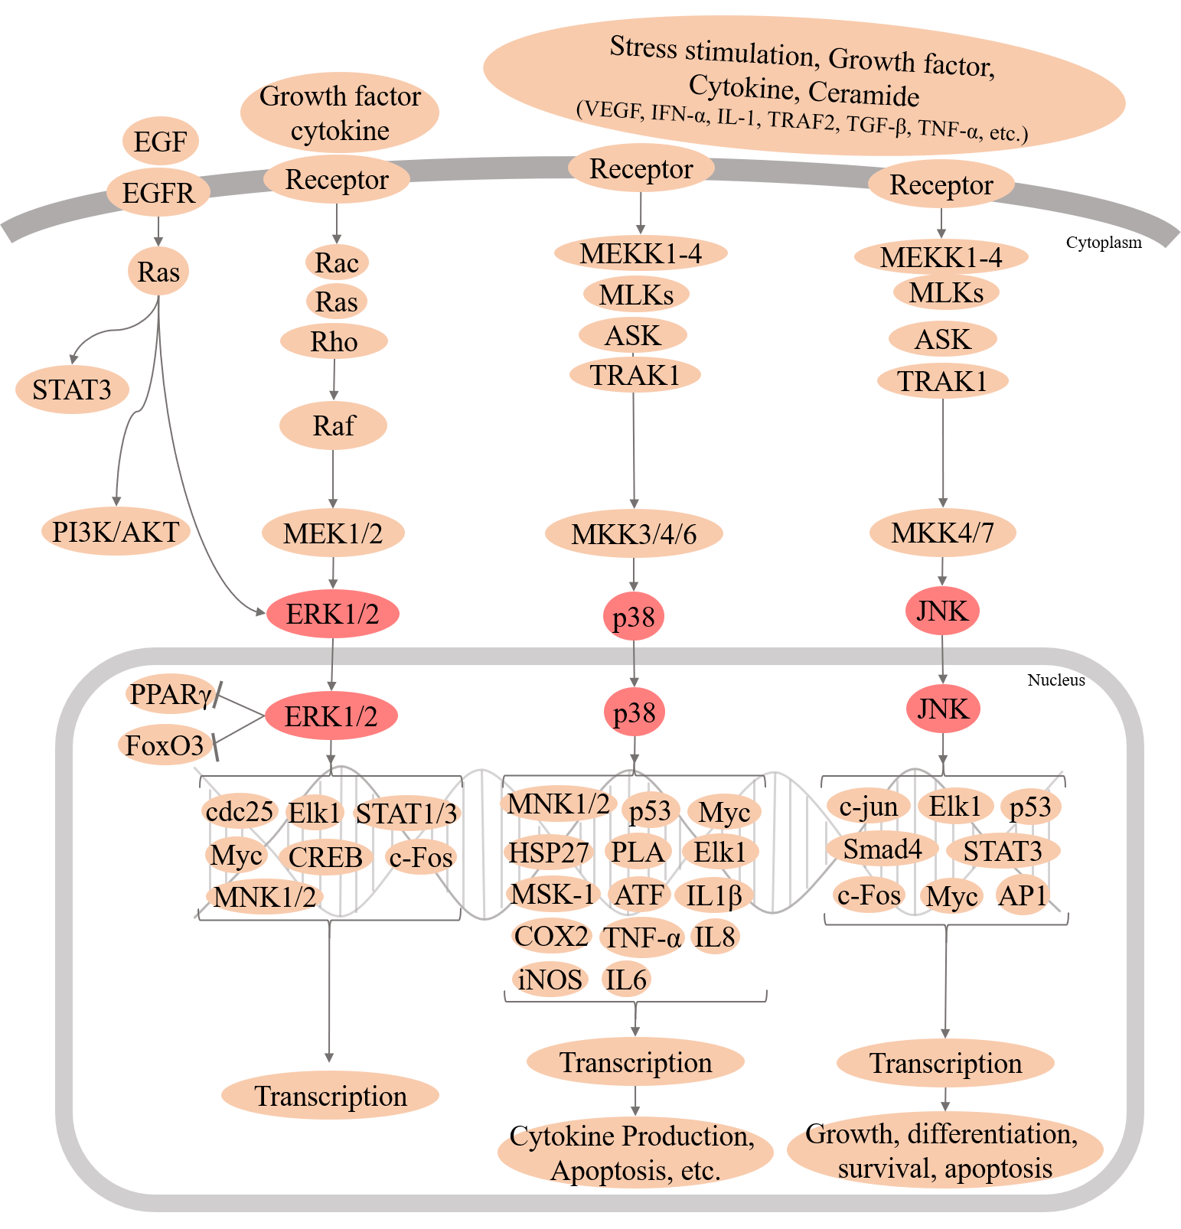
Figure 3S: Detailed information on the MAPK signaling pathway.

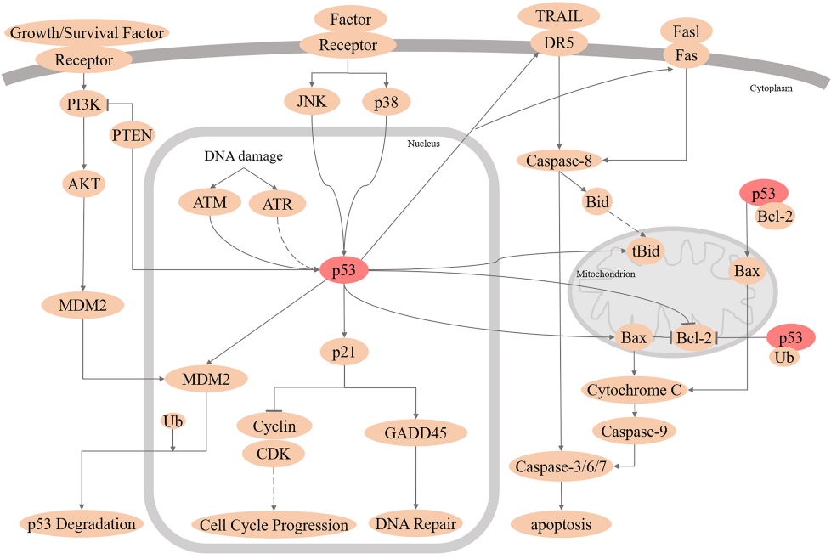
Figure 4S: Detailed information on the p53 signaling pathway.

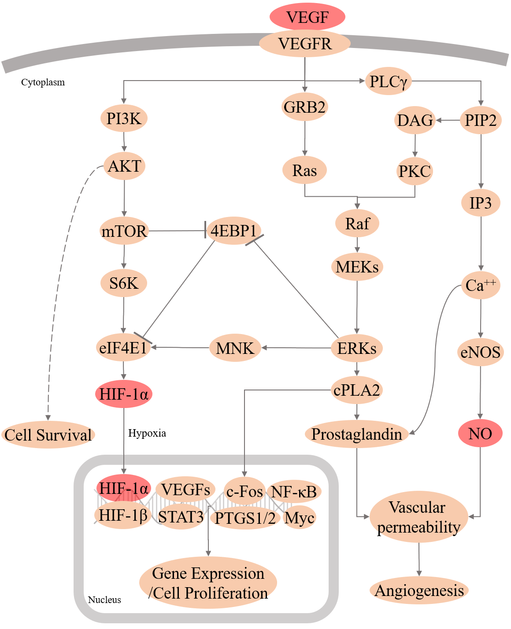
Figure 5S: Detailed information on the NO/VEGF signaling pathway.

Table 1S: Information on 118 active components in Xiangsha Liujun Pill. The following abbreviations indicate the 10 herbs in Xiangsha Liujun Pill: Radix Aucklandiae (RA, muxiang), Amomum (AM, sharen), Ginger (GI, shengjiang), Codonopsis (CO, dangshen), Atractylodes (AT, baizhu), Poria (PO, fuling), Glycyrrhiza (GL, gancao), Tangerine Peel (TP, chenpi), Pinellia (PI, banxia), and Jujube (JU, dazao).
Mol ID | Molecule Name | MW | AlogP | Hdon | Hacc | OB(%) | Caco-2 | BBB | DL | FASA | HL | Herb
MOL010813 | Benzo[a]carbazole | 217.28 | 4.23 | 1 | 0 | 35.22 | 1.87 | 1.65 | 0.22 | 0.4 | 11.43 | RA
MOL010839 | Lappadilactone | 494.68 | 4.27 | 1 | 6 | 38.56 | -0.12 | -0.62 | 0.73 | 0.35 | 9.35 | RA
MOL000211 | Mairin | 456.78 | 6.52 | 2 | 3 | 55.38 | 0.73 | 0.22 | 0.78 | 0.26 | 8.87 | RA
MOL000359 | Sitosterol | 414.79 | 8.08 | 1 | 1 | 36.91 | 1.32 | 0.87 | 0.75 | 0.22 | 5.37 | RA
MOL000449 | Stigmasterol | 412.77 | 7.64 | 1 | 1 | 43.83 | 1.44 | 1 | 0.76 | 0.22 | 5.57 | RA/AM/GI
MOL010828 | Cynaropicrin* | 346.41 | 1.6 | 2 | 6 | 67.5 | -0.1 | -0.83 | 0.38 | 0.34 | 1.38 | RA
MOL000358 | Beta-sitosterol | 414.79 | 8.08 | 1 | 1 | 36.91 | 1.32 | 0.99 | 0.75 | 0.23 | 5.36 | AM/GI
MOL001755 | 24-Ethylcholest-4-en-3-one | 412.77 | 8.18 | 0 | 1 | 36.08 | 1.46 | 1.22 | 0.76 | 0.25 | 5.49 | AM
MOL001771 | Poriferast-5-en-3beta-ol | 414.79 | 8.08 | 1 | 1 | 36.91 | 1.45 | 1.14 | 0.75 | 0 | 5.07 | AM
MOL001973 | Sitosteryl acetate | 456.83 | 8.46 | 0 | 2 | 40.39 | 1.39 | 1.11 | 0.85 | 0.22 | 6.34 | AM
MOL003975 | Icosa-11,14,17-trienoic acid methyl ester | 320.57 | 7.11 | 0 | 2 | 44.81 | 1.52 | 1.07 | 0.23 | 0.21 | 5.39 | AM
MOL007514 | Methyl icosa-11,14-dienoate | 322.59 | 7.55 | 0 | 2 | 39.67 | 1.47 | 1.1 | 0.23 | 0.18 | 5.24 | AM
MOL007535 | (5S,8S,9S,10R,13R,14S,17R)-17-[(1R,4R)-4-Ethyl-1,5-dimethylhexyl]-10,13-dimethyl-2,4,5,7,8,9,11,12,14,15,16,17-dodecahydro-1H-cyclopenta[a]phenanthrene-3,6-dione | 428.77 | 6.66 | 0 | 2 | 33.12 | 0.9 | 0.44 | 0.79 | 0.25 | 6.56 | AM
MOL007536 | Stigmasta-5,22-dien-3-beta-yl acetate | 454.81 | 8.02 | 0 | 2 | 46.44 | 1.41 | 1.1 | 0.86 | 0.22 | 5.68 | AM
MOL000131 | EIC* | 280.5 | 6.39 | 1 | 2 | 41.9 | 1.16 | 0.9 | 0.14 | 0.25 | 7.5 | AM
MOL001312 | 9-Hexadecenoic acid* | 254.46 | 5.92 | 1 | 2 | 35.78 | 1.1 | 0.85 | 0.1 | 0.2 | 5.61 | AM
MOL001398 | Methyl linolenate* | 292.51 | 6.2 | 0 | 2 | 46.15 | 1.48 | 1.09 | 0.17 | 0.24 | 5.95 | AM
MOL002153 | 1H-Cycloprop(e)azulen-7-ol, decahydro-1,1,7-trimethyl-4-methylene-, (1aR-(1aalpha,4aalpha,7beta,7abeta,7balpha))-* | 220.39 | 3.01 | 1 | 1 | 82.33 | 1.37 | 1.49 | 0.12 | 0.28 | 12.04 | AM
MOL002697 | Junipene* | 204.39 | 4.18 | 0 | 0 | 44.07 | 1.82 | 2.14 | 0.11 | 0.25 | 12.2 | AM
MOL000570 | Nonox D* | 219.3 | 4.29 | 1 | 1 | 39.82 | 1.88 | 1.61 | 0.13 | 0.46 | 5 | AM
MOL000612 | (-)-alpha-cedrene* | 204.39 | 4.12 | 0 | 0 | 55.56 | 1.81 | 2.16 | 0.1 | 0.24 | 4.82 | AM
MOL000675 | oleic acid* | 282.52 | 6.84 | 1 | 2 | 33.13 | 1.17 | 0.78 | 0.14 | 0.2 | 4.99 | AM
MOL000676 | DBP* | 278.38 | 4.2 | 0 | 4 | 64.54 | 0.8 | 0.56 | 0.13 | 0.34 | 5.41 | AM
MOL007544 | Isospathulenol* | 220.39 | 3.01 | 1 | 1 | 83.38 | 1.25 | 1.29 | 0.12 | 0.27 | 11.81 | AM
MOL000937 | 58870_FLUKA* | 204.39 | 4.36 | 0 | 0 | 49.01 | 1.82 | 2.08 | 0.1 | 0.22 | 12.47 | AM
MOL006129 | 6-Methylgingediacetate2 | 394.56 | 4.55 | 0 | 6 | 48.73 | 0.55 | -0.16 | 0.32 | 0.25 | 5.44 | GI
MOL002140 | Perlolyrine | 264.3 | 3.2 | 2 | 3 | 65.95 | 0.88 | 0.15 | 0.27 | 0.21 | 12.62 | CO
MOL003896 | 7-Methoxy-2-methyl isoflavone | 266.31 | 3.36 | 0 | 3 | 42.56 | 1.16 | 0.56 | 0.2 | 0.33 | 16.89 | CO/GL
MOL005321 | Frutinone A | 264.24 | 2.7 | 0 | 4 | 65.9 | 0.89 | 0.46 | 0.34 | 0.47 | 19.1 | CO
MOL008400 | Glycitein | 284.28 | 2.32 | 2 | 5 | 50.48 | 0.56 | -0.29 | 0.24 | 0.3 | 16.32 | CO
MOL008411 | 11-Hydroxyrankinidine | 356.46 | 1.04 | 2 | 6 | 40 | 0.29 | -0.19 | 0.66 | 0.28 | 10.8 | CO
MOL000072 | 8β-Ethoxy atractylenolide Ⅲ | 276.41 | 3.68 | 0 | 3 | 35.95 | 1.08 | 1.12 | 0.21 | 0 | 8.34 | AT
MOL000020 | 12-Senecioyl-2E,8E,10E-atractylentriol | 312.39 | 2.5 | 0 | 4 | 62.4 | 0.01 | -1.37 | 0.22 | 0.12 | 6.07 | AT
MOL000021 | 14-Acetyl-12-senecioyl-2E,8E,10E-atractylentriol | 355.44 | 3.21 | 0 | 5 | 60.31 | 0.33 | -1.09 | 0.31 | 0.05 | 5.32 | AT
MOL000033 | (3S,8S,9S,10R,13R,14S,17R)-10,13-Dimethyl-17-[(2R,5S)-5-propan-2-yloctan-2-yl]-2,3,4,7,8,9,11,12,14,15,16,17-dodecahydro-1H-cyclopenta[a]phenanthren-3-ol | 428.82 | 8.54 | 1 | 1 | 36.23 | 1.45 | 1.09 | 0.78 | 0 | 5.22 | AT
MOL000022 | 14-Acetyl-12-senecioyl-2E,8Z,10E-atractylentriol | 356.45 | 3.54 | 1 | 5 | 63.37 | 0.42 | -1.14 | 0.3 | 0 | 6.43 | AT
MOL000028 | α-Amyrin* | 426.8 | 7.35 | 1 | 1 | 39.51 | 1.42 | 1.28 | 0.76 | 0 | 3.83 | AT
MOL000025 | α-Longipinene* | 204.39 | 4.12 | 0 | 0 | 53.26 | 1.83 | 2.14 | 0.12 | 0 | 12.06 | AT
MOL000043 | Atractylenolide Ⅰ* | 230.33 | 3.32 | 0 | 2 | 37.37 | 1.3 | 1.29 | 0.15 | 0 | 7.1 | AT
MOL000044 | Atractylenolide II * | 232.35 | 3.57 | 0 | 2 | 47.5 | 1.3 | 1.37 | 0.15 | 0 | 7.21 | AT
MOL000045 | Atractylenolide Ⅲ* | 248.35 | 2.93 | 1 | 3 | 68.11 | 0.75 | 0.63 | 0.17 | 0 | 7.17 | AT
MOL000057 | DIBP * | 278.38 | 3.92 | 0 | 4 | 49.63 | 0.85 | 0.68 | 0.13 | 0 | 3.94 | AT
MOL000066 | Alloaromadendrene * | 204.39 | 4.22 | 0 | 0 | 53.46 | 1.83 | 2.1 | 0.1 | 0 | 12.51 | AT
MOL000296 | Hederagenin | 414.79 | 8.08 | 1 | 1 | 36.91 | 1.32 | 0.96 | 0.75 | 0 | 5.35 | PO
MOL000273 | (2R)-2-[(3S,5R,10S,13R,14R,16R,17R)-3,16-Dihydroxy-4,4,10,13,14-pentamethyl-2,3,5,6,12,15,16,17-octahydro-1H-cyclopenta[a]phenanthren-17-yl]-6-methylhept-5-enoic acid | 470.76 | 5.41 | 3 | 4 | 30.93 | 0.01 | -0.76 | 0.81 | 0 | 6.81 | PO
MOL000275 | Trametenolic acid | 456.78 | 7.03 | 2 | 3 | 38.71 | 0.52 | -0.14 | 0.8 | 0 | 7.78 | PO
MOL000276 | 7,9(11)-Dehydropachymic acid | 526.83 | 6.1 | 2 | 5 | 35.11 | 0.03 | -0.87 | 0.81 | 0 | 7.34 | PO
MOL000279 | Cerevisterol | 430.74 | 5.15 | 3 | 3 | 37.96 | 0.28 | -0.39 | 0.77 | 0 | 5.31 | PO
MOL000280 | (2R)-2-[(3S,5R,10S,13R,14R,16R,17R)-3,16-Dihydroxy-4,4,10,13,14-pentamethyl-2,3,5,6,12,15,16,17-octahydro-1H-cyclopenta[a]phenanthren-17-yl]-5-isopropyl-hex-5-enoic acid (Dehydrotumulosic acid) | 484.79 | 5.72 | 3 | 4 | 31.07 | 0.05 | -0.7 | 0.82 | 0 | 7.42 | PO
MOL000282 | Ergosta-7,22E-dien-3beta-ol | 398.74 | 7.18 | 1 | 1 | 43.51 | 1.32 | 0.91 | 0.72 | 0 | 5.11 | PO
MOL000285 | (2R)-2-[(5R,10S,13R,14R,16R,17R)-16-Hydroxy-3-keto-4,4,10,13,14-pentamethyl-1,2,5,6,12,15,16,17-octahydrocyclopenta[a]phenanthren-17-yl]-5-isopropyl-hex-5-enoic acid (Polyporenic acid C) | 482.77 | 5.68 | 2 | 4 | 38.26 | 0.12 | -0.57 | 0.82 | 0 | 6.77 | PO
MOL000287 | 3beta-Hydroxy-24-methylene-8-lanostene-21-oic acid | 470.81 | 7.33 | 2 | 3 | 38.7 | 0.61 | -0.04 | 0.81 | 0 | 6.59 | PO
MOL000289 | Pachymic acid | 528.85 | 6.54 | 2 | 5 | 33.63 | 0.1 | -0.57 | 0.81 | 0 | 9.27 | PO
MOL000290 | Poricoic acid A | 498.77 | 5.94 | 3 | 5 | 30.61 | -0.14 | -0.93 | 0.76 | 0 | 8.26 | PO
MOL000291 | Poricoic acid B | 484.74 | 5.64 | 3 | 5 | 30.52 | -0.08 | -0.87 | 0.75 | 0 | 8.67 | PO
MOL000292 | Poricoic acid C | 482.77 | 7.11 | 2 | 4 | 38.15 | 0.32 | -0.41 | 0.75 | 0 | 7.73 | PO
MOL000300 | Dehydroeburicoic acid | 453.75 | 6.35 | 1 | 3 | 44.17 | 0.38 | -0.16 | 0.83 | 0.04 | 7.04 | PO
MOL000283 | Ergosterol peroxide | 430.74 | 7.17 | 1 | 3 | 40.36 | 0.84 | 0.34 | 0.81 | 0 | 3.43 | PO
MOL001484 | Inermine | 284.28 | 2.44 | 1 | 5 | 75.18 | 0.89 | 0.4 | 0.54 | 0.3 | 11.72 | GL
MOL001792 | DFV | 256.27 | 2.57 | 2 | 4 | 32.76 | 0.51 | -0.29 | 0.18 | 0.42 | 17.89 | GL
MOL002311 | Glycyrol | 366.39 | 4.85 | 2 | 6 | 90.78 | 0.71 | -0.2 | 0.67 | 0.28 | 9.85 | GL
MOL000239 | Jaranol | 314.31 | 2.09 | 2 | 6 | 50.83 | 0.61 | -0.22 | 0.29 | 0.29 | 15.5 | GL
MOL002565 | Medicarpin | 270.3 | 2.66 | 1 | 4 | 49.22 | 1 | 0.53 | 0.34 | 0.31 | 8.46 | GL
MOL003656 | Lupiwighteone | 338.38 | 3.92 | 3 | 5 | 51.64 | 0.68 | -0.23 | 0.37 | 0.36 | 15.63 | GL
MOL000392 | Formononetin | 268.28 | 2.58 | 1 | 4 | 69.67 | 0.78 | 0.02 | 0.21 | 0 | 17.04 | GL
MOL004808 | Glyasperin B | 370.43 | 4.02 | 3 | 6 | 65.22 | 0.47 | -0.09 | 0.44 | 0 | 16.1 | GL
MOL004810 | Glyasperin F | 354.38 | 2.97 | 3 | 6 | 75.84 | 0.43 | -0.15 | 0.54 | 0 | 15.64 | GL
MOL004814 | Isotrifoliol | 298.26 | 2.99 | 2 | 6 | 31.94 | 0.53 | -0.25 | 0.42 | 0 | 7.91 | GL
MOL004815 | (E)-1-(2,4-Dihydroxyphenyl)-3-(2,2-dimethylchromen-6-yl)prop-2-en-1-one | 322.38 | 3.96 | 2 | 4 | 39.62 | 0.66 | -0.12 | 0.35 | 0 | 16.16 | GL
MOL004828 | Glepidotin A | 338.38 | 3.9 | 3 | 5 | 44.72 | 0.79 | 0.06 | 0.35 | 0 | 16.09 | GL
MOL004829 | Glepidotin B | 340.4 | 3.88 | 3 | 5 | 64.46 | 0.46 | -0.09 | 0.34 | 0 | 15.98 | GL
MOL004835 | Glypallichalcone | 284.33 | 3.4 | 1 | 4 | 61.6 | 0.76 | 0.23 | 0.19 | 0 | 17.01 | GL
MOL004838 | 8-(6-Hydroxy-2-benzofuranyl)-2,2-dimethyl-5-chromenol | 308.35 | 4.2 | 2 | 4 | 58.44 | 1 | 0.34 | 0.38 | 0.34 | 8.71 | GL
MOL004848 | Licochalcone G | 354.43 | 4.35 | 3 | 5 | 49.25 | 0.64 | -0.04 | 0.32 | 0.35 | 15.75 | GL
MOL004855 | Licoricone | 382.44 | 4.16 | 2 | 6 | 63.58 | 0.53 | -0.14 | 0.47 | 0 | 16.37 | GL
MOL004856 | Gancaonin A | 352.41 | 4.17 | 2 | 5 | 51.08 | 0.8 | 0.13 | 0.4 | 0 | 16.82 | GL
MOL004857 | Gancaonin B | 368.41 | 3.91 | 3 | 6 | 48.79 | 0.58 | -0.1 | 0.45 | 0 | 16.49 | GL
MOL004863 | 3-(3,4-Dihydroxyphenyl)-5,7-dihydroxy-8-(3-methylbut-2-enyl)chromone | 354.38 | 3.65 | 4 | 6 | 66.37 | 0.52 | -0.13 | 0.41 | 0 | 15.81 | GL
MOL004864 | 5,7-dihydroxy-3-(4-methoxyphenyl)-8-(3-methylbut-2-enyl)chromone | 352.41 | 4.17 | 2 | 5 | 30.49 | 0.9 | 0.21 | 0.41 | 0 | 14.99 | GL
MOL004866 | 2-(3,4-Dihydroxyphenyl)-5,7-dihydroxy-6-(3-methylbut-2-enyl)chromone ((Gancaonin O)) | 354.38 | 3.92 | 4 | 6 | 44.15 | 0.48 | -0.28 | 0.41 | 0 | 16.77 | GL
MOL004882 | Licocoumarone | 340.4 | 4.98 | 3 | 5 | 33.21 | 0.84 | 0.06 | 0.36 | 0 | 9.66 | GL
MOL004883 | Licoisoflavone | 354.38 | 3.65 | 4 | 6 | 41.61 | 0.37 | -0.27 | 0.42 | 0 | 16.09 | GL
MOL004884 | Licoisoflavone B | 352.36 | 2.85 | 3 | 6 | 38.93 | 0.46 | -0.18 | 0.55 | 0 | 15.73 | GL
MOL004885 | Licoisoflavanone | 354.38 | 2.97 | 3 | 6 | 52.47 | 0.39 | -0.22 | 0.54 | 0 | 15.67 | GL
MOL004891 | Shinpterocarpin | 322.38 | 3.46 | 1 | 4 | 80.3 | 1.1 | 0.68 | 0.73 | 0.32 | 6.5 | GL
MOL004907 | Glyzaglabrin | 298.26 | 2.1 | 2 | 6 | 61.07 | 0.34 | -0.2 | 0.35 | 0 | 21.2 | GL
MOL004910 | Glabranin | 324.4 | 4.42 | 2 | 4 | 52.9 | 0.97 | 0.31 | 0.31 | 0 | 16.24 | GL
MOL004912 | Glabrone | 336.36 | 3.12 | 2 | 5 | 52.51 | 0.59 | -0.11 | 0.5 | 0 | 16.09 | GL
MOL004913 | 1,3-Dihydroxy-9-methoxy-6-benzofurano[3,2-c]chromenone | 298.26 | 2.99 | 2 | 6 | 48.14 | 0.48 | -0.19 | 0.43 | 0 | 8.87 | GL
MOL004915 | Eurycarpin A | 338.38 | 3.92 | 3 | 5 | 43.28 | 0.43 | -0.06 | 0.37 | 0 | 17.1 | GL
MOL004941 | (2R)-7-Hydroxy-2-(4-hydroxyphenyl)chroman-4-one | 256.27 | 2.57 | 2 | 4 | 71.12 | 0.41 | -0.25 | 0.18 | 0 | 18.09 | GL
MOL004945 | (2S)-7-Hydroxy-2-(4-hydroxyphenyl)-8-(3-methylbut-2-enyl)chroman-4-one | 324.4 | 4.42 | 2 | 4 | 36.57 | 0.72 | -0.04 | 0.32 | 0 | 17.95 | GL
MOL004948 | Isoglycyrol | 366.39 | 4.36 | 1 | 6 | 44.7 | 0.91 | 0.05 | 0.84 | 0 | 6.69 | GL
MOL004957 | HMO | 268.28 | 2.58 | 1 | 4 | 38.37 | 0.79 | 0.25 | 0.21 | 0 | 16.56 | GL
MOL004959 | 1-Methoxyphaseollidin | 354.43 | 4.25 | 2 | 5 | 69.98 | 1.01 | 0.48 | 0.64 | 0 | 9.53 | GL
MOL000497 | Licochalcone α | 338.43 | 4.62 | 2 | 4 | 40.79 | 0.82 | -0.21 | 0.29 | 0 | 16.2 | GL
MOL004989 | 6-Prenylated eriodictyol | 356.4 | 3.89 | 4 | 6 | 39.22 | 0.4 | -0.29 | 0.41 | 0 | 16.52 | GL
MOL004991 | 7-Acetoxy-2-methylisoflavone | 294.32 | 3.15 | 0 | 4 | 38.92 | 0.74 | 0.16 | 0.26 | 0 | 17.49 | GL
MOL005000 | Gancaonin G | 352.41 | 4.17 | 2 | 5 | 60.44 | 0.78 | 0.23 | 0.39 | 0 | 16.13 | GL
MOL005001 | Gancaonin H | 420.49 | 4.71 | 3 | 6 | 50.1 | 0.6 | -0.14 | 0.78 | 0 | 16.64 | GL
MOL005003 | Licoagrocarpin | 338.43 | 4.51 | 1 | 4 | 58.81 | 1.23 | 0.61 | 0.58 | 0.27 | 9.45 | GL
MOL005007 | Glyasperin M | 368.41 | 3.22 | 2 | 6 | 72.67 | 0.49 | -0.04 | 0.59 | 0 | 15.57 | GL
MOL005012 | Licoagroisoflavone | 336.36 | 3.48 | 2 | 5 | 57.28 | 0.71 | 0.09 | 0.49 | 0 | 19.64 | GL
MOL005016 | Odoratin | 314.31 | 2.3 | 2 | 6 | 49.95 | 0.42 | -0.24 | 0.3 | 0 | 16.35 | GL
MOL005017 | Phaseol | 336.36 | 4.87 | 2 | 5 | 78.77 | 0.76 | -0.06 | 0.58 | 0 | 9.64 | GL
MOL005018 | Xambioona | 388.49 | 4.68 | 0 | 4 | 54.85 | 1.09 | 0.52 | 0.87 | 0 | 14.5 | GL
MOL004328 | Naringenin | 272.27 | 2.3 | 3 | 5 | 59.29 | 0.28 | -0.37 | 0.21 | 0.4 | 16.98 | TP
MOL005100 | 5,7-Dihydroxy-2-(3-hydroxy-4-methoxyphenyl)chroman-4-one | 302.3 | 2.28 | 3 | 6 | 47.74 | 0.28 | -0.3 | 0.27 | 0.31 | 16.51 | TP
MOL005815 | Citromitin | 404.45 | 3 | 0 | 8 | 86.9 | 0.88 | 0.16 | 0.51 | 0.14 | 15.62 | TP
MOL005828 | Nobiletin | 402.43 | 3.04 | 0 | 8 | 61.67 | 1.05 | -0.08 | 0.52 | 0.13 | 16.2 | TP
MOL002670 | Cavidine | 353.45 | 3.72 | 0 | 5 | 35.64 | 1.08 | 0.63 | 0.81 | 0 | 5.78 | PI
MOL002714 | Baicalein | 270.25 | 2.33 | 3 | 5 | 33.52 | 0.63 | -0.05 | 0.21 | 0.36 | 16.25 | PI
MOL000519 | Coniferin | 314.41 | 3.16 | 2 | 4 | 31.11 | 0.42 | -0.18 | 0.32 | 0.27 | 28.1 | PI
MOL012921 | Stepharine | 297.38 | 1.82 | 1 | 4 | 31.55 | 0.64 | 0.17 | 0.33 | 0.23 | 10.31 | JU
MOL012992 | Mauritine D | 342.46 | 1.62 | 2 | 6 | 89.13 | 0.59 | 0.62 | 0.45 | 0.03 | 4.91 | JU
MOL001454 | Berberine | 336.39 | 3.45 | 0 | 4 | 36.86 | 1.24 | 0.57 | 0.78 | 0.19 | 6.57 | JU
MOL001522 | (S)-Coclaurine | 285.37 | 2.83 | 3 | 4 | 42.35 | 0.7 | 0.06 | 0.24 | 0.29 | 4.41 | JU
MOL000787 | Fumarine | 353.4 | 2.95 | 0 | 6 | 59.26 | 0.56 | -0.13 | 0.83 | 0.3 | 23.46 | JU
Note: The compounds with an asterisk (*) in the Molecule Name column are included after adjusting the parameters.

Table 2S: Information on 180 gastritis-related targets.
No. | Full Gene Name | Gene Name | No. | Full Gene Name | Gene Name
1 | Prostaglandin-endoperoxide synthase 2 | PTGS2 | 91 | Peroxisome proliferator-activated receptor gamma, coactivator-related 1 | PPRC1
2 | Tumor necrosis factor | TNF | 92 | Adhesion G protein-coupled receptor L1 | ADGRL1
3 | Gastric intrinsic factor | GIF | 93 | Prostaglandin D2 receptor 2 | PTGDR2
4 | NFKB inhibitor alpha | NFKBIA | 94 | Leukocyte immunoglobulin-like receptor B1 | LILRB1
5 | C-C motif chemokine ligand 2 | CCL2 | 95 | SET domain containing 2 | SETD2
6 | Interleukin 1 beta | IL1B | 96 | Zinc ribbon domain containing 1 | ZNRD1
7 | S100 Calcium-binding protein A8 | S100A8 | 97 | Forkhead box P3 | FOXP3
8 | C-X-C Motif chemokine ligand 8 | CXCL8 | 98 | Hepcidin antimicrobial peptide | HAMP
9 | LPS-responsive beige-like anchor protein | LRBA | 99 | Activation-induced cytidine deaminase | AICDA
10 | Tumor protein p53 | TP53 | 100 | Defensin beta 103B | DEFB103B
11 | Interleukin 10 | IL10 | 101 | LINE1-type transposase domain containing 1 | L1TD1
12 | Gastrin | GAST | 102 | Keratin 20 | KRT20
13 | Toll like receptor 4 | TLR4 | 103 | Methyl-CpG-binding domain protein 3 | MBD3
14 | Interleukin 1 alpha | IL1A | 104 | Phospholipase C epsilon 1 | PLCE1
15 | Nuclear factor kappa B subunit 1 | NFKB1 | 105 | alpha-1,4-N-Acetylglucosaminyltransferase | A4GNT
16 | Cytochrome c oxidase subunit II | COX2 | 106 | Epstein-Barr virus induced 3 | EBI3
17 | Mucosal vascular addressin cell adhesion molecule 1 | MADCAM1 | 107 | ABL proto-oncogene 1, non-receptor tyrosine kinase | ABL1
18 | Interleukin 1 receptor antagonist | IL1RN | 108 | Atrophin 1 | ATN1
19 | Leptin | LEP | 109 | Epidermal growth factor receptor | EGFR
20 | Spermine oxidase | SMOX | 110 | Fc fragment of IgG receptor IIIa | FCGR3A
21 | Caudal type homeobox 1 | CDX1 | 111 | Fc fragment of IgG receptor IIIb | FCGR3B
22 | Cyclin-dependent kinase inhibitor 2A | CDKN2A | 112 | Fos proto-oncogene, AP-1 transcription factor subunit | FOS
23 | Cadherin 1 | CDH1 | 113 | FosB proto-oncogene, AP-1 transcription factor subunit | FOSB
24 | Nucleotide-binding oligomerization domain containing 1 | NOD1 | 114 | GATA-binding protein 6 | GATA6
25 | Secreted phosphoprotein 1 | SPP1 | 115 | Growth hormone-releasing hormone | GHRH
26 | Myeloperoxidase | MPO | 116 | C-X-C Motif chemokine ligand 1 | CXCL1
27 | Heme oxygenase 1 | HMOX1 | 117 | Hepatocyte growth factor | HGF
28 | ATP-binding cassette subfamily B member 1 | ABCB1 | 118 | Hypoxia-inducible factor 1 subunit alpha | HIF1A
29 | Mucin 1, cell surface associated | MUC1 | 119 | Major histocompatibility complex, class II, DQ alpha 1 | HLA-DQA1
30 | Selectin L | SELL | 120 | Interferon gamma | IFNG
31 | Interleukin 4 | IL4 | 121 | Immunoglobulin heavy locus | IGH
32 | Matrix metallopeptidase 9 | MMP9 | 122 | Interleukin 6 | IL6
33 | Interleukin 17A | IL17A | 123 | Interleukin 6 signal transducer | IL6ST
34 | mutL homolog 1 | MLH1 | 124 | Defensin beta 1 | DEFB1
35 | Interleukin 32 | IL32 | 125 | Cytochrome P450 family 3 subfamily A member 4 | CYP3A4
36 | TBC1 domain family member 9 | TBC1D9 | 126 | Cytochrome P450 family 2 subfamily C member 19 | CYP2C19
37 | Telomerase reverse transcriptase | TERT | 127 | Angiotensinogen | AGT
38 | Signal transducer and activator of transcription 3 | STAT3 | 128 | Angiotensin II receptor type 1 | AGTR1
39 | Caveolin 1 | CAV1 | 129 | Autoimmune regulator | AIRE
40 | Caudal type homeobox 2 | CDX2 | 130 | Apurinic/apyrimidinic endodeoxyribonuclease 1 | APEX1
41 | Defensin beta 4A | DEFB4A | 131 | ATPase H+/K+ transporting non-gastric alpha2 subunit | ATP12A
42 | Cholecystokinin B receptor | CCKBR | 132 | BCL2-associated athanogene 1 | BAG1
43 | Angiotensin I-converting enzyme | ACE | 133 | BCL2, apoptosis regulator | BCL2
44 | Urocortin | UCN | 134 | C-X-C Motif chemokine receptor 5 | CXCR5
45 | Tumor protein p73 | TP73 | 135 | Kruppel-like factor 5 | KLF5
46 | Secretory leukocyte peptidase inhibitor | SLPI | 136 | Runt-related transcription factor 3 | RUNX3
47 | Toll like receptor 2 | TLR2 | 137 | Ectonucleoside triphosphate diphosphohydrolase 1 | ENTPD1
48 | AT-rich interaction domain 1A | ARID1A | 138 | CD44 molecule (Indian blood group) | CD44
49 | Carbohydrate sulfotransferase 2 | CHST2 | 139 | CD69 molecule | CD69
50 | BMS1, ribosome biogenesis factor | BMS1 | 140 | C-C Motif chemokine receptor 6 | CCR6
51 | Leucine-rich pentatricopeptide repeat containing | LRPPRC | 141 | Corticotropin-releasing hormone | CRH
52 | Smoothened, frizzled class receptor | SMO | 142 | Colony-stimulating factor 2 | CSF2
53 | Prominin 1 | PROM1 | 143 | Interleukin 15 | IL15
54 | Nuclear receptor subfamily 0 group B member 2 | NR0B2 | 144 | Interleukin 18 | IL18
55 | TNF receptor superfamily member 1A | TNFRSF1A | 145 | Ornithine decarboxylase 1 | ODC1
56 | Trefoil factor 1 | TFF1 | 146 | Phosphatidylethanolamine-binding protein 1 | PEBP1
57 | Trefoil factor 2 | TFF2 | 147 | Serpin family E member 1 | SERPINE1
58 | Leucine-rich repeat containing G protein-coupled receptor 5 | LGR5 | 148 | Serpin family B member 2 | SERPINB2
59 | Transforming growth factor beta 1 | TGFB1 | 149 | Progastricsin | PGC
60 | Prostate stem cell antigen | PSCA | 150 | Macrophage migration inhibitory factor | MIF
61 | SRY-box 9 | SOX9 | 151 | POU class 5 homeobox 1 | POU5F1
62 | Wnt family member 5A | WNT5A | 152 | Peroxisome proliferator-activated receptor gamma | PPARG
63 | Vitamin D receptor | VDR | 153 | Proteinase 3 | PRTN3
64 | B cell CLL/lymphoma 10 | BCL10 | 154 | Prostaglandin D2 synthase | PTGDS
65 | MicroRNA 650 | MIR650 | 155 | Prostaglandin-endoperoxide synthase 1 | PTGS1
66 | MicroRNA 146a | MIR146A | 156 | RB transcriptional corepressor 1 | RB1
67 | MicroRNA let-7c | MIRLET7C | 157 | S100 Calcium-binding protein A9 | S100A9
68 | Hashimoto thyroiditis | HT | 158 | C-C Motif chemokine ligand 20 | CCL20
69 | Tumor protein p53 inducible nuclear protein 1 | TP53INP1 | 159 | Selectin E | SELE
70 | Thymic stromal lymphopoietin | TSLP | 160 | Secreted frizzled related protein 5 | SFRP5
71 | Regenerating family member 4 | REG4 | 161 | Ecto-5'-nucleotidase | NT5E
72 | Defensin beta 4B | DEFB4B | 162 | Nitric oxide synthase 2 | NOS2
73 | Rho GTPase-activating protein 24 | ARHGAP24 | 163 | Neutrophil migration | NM
74 | MicroRNA 150 | MIR150 | 164 | C-X-C Motif chemokine ligand 10 | CXCL10
75 | MicroRNA 203a | MIR203A | 165 | Pancreatic and duodenal homeobox 1 | PDX1
76 | MicroRNA 210 | MIR210 | 166 | Interleukin 1 receptor-associated kinase 1 | IRAK1
77 | Pepsinogen 3, group I (pepsinogen A) | PGA3 | 167 | Integrin subunit alpha X | ITGAX
78 | MicroRNA 499a | MIR499A | 168 | Jun proto-oncogene, AP-1 transcription factor subunit | JUN
79 | MicroRNA 193b | MIR193B | 169 | JunB proto-oncogene, AP-1 transcription factor subunit | JUNB
80 | MicroRNA 494 | MIR494 | 170 | JunD proto-oncogene, AP-1 transcription factor subunit | JUND
81 | MicroRNA 490 | MIR490 | 171 | Lymphotoxin beta receptor | LTBR
82 | MicroRNA 370 | MIR370 | 172 | MET proto-oncogene, receptor tyrosine kinase | MET
83 | MicroRNA 9-1 | MIR9-1 | 173 | KIT ligand | KITLG
84 | MicroRNA 7-1 | MIR7-1 | 174 | Major intrinsic protein of lens fiber | MIP
85 | Thioredoxin domain containing 5 | TXNDC5 | 175 | Matrix metallopeptidase 2 | MMP2
86 | Retrotransposon Gag like 10 | RTL10 | 176 | Matrix metallopeptidase 3 | MMP3
87 | RRAD and GEM-like GTPase 1 | REM1 | 177 | mutS homolog 2 | MSH2
88 | Ghrelin and obestatin prepropeptide | GHRL | 178 | Mucin 5AC, oligomeric mucus/gel-forming | MUC5AC
89 | Hematopoietic prostaglandin D synthase | HPGDS | 179 | Mucin 6, oligomeric mucus/gel-forming | MUC6
90 | Adhesion G protein-coupled receptor L2 | ADGRL2 | 180 | Sonic hedgehog | SHH

Table 3S: Information on 327 predictive targets based on 118 active components.
No. | Gene Name | No. | Gene Name | No. | Gene Name | No. | Gene Name
1 | ABAT | 83 | CDK1 | 165 | HSD3B1 | 247 | PIM1
2 | ABCA1 | 84 | CDK2 | 166 | HSD3B2 | 248 | PKIA
3 | ABCB1 | 85 | CDK4 | 167 | HSP90 | 249 | PLA2G1B
4 | ABCB11 | 86 | CDK5R1 | 168 | HTR2A | 250 | PLA2G4A
5 | ABCC1 | 87 | CDK6 | 169 | HTR2B | 251 | PLAU
6 | ABCC1 | 88 | CES1 | 170 | HTR2C | 252 | PLB1
7 | ABCG2 | 89 | CFTR | 171 | HTR3A | 253 | PNLIP
8 | ABCG5 | 90 | CHEK1 | 172 | HTR7 | 254 | POLB
9 | ABCG8 | 91 | CHRM1 | 173 | ICAM1 | 255 | POLK
10 | ACHE | 92 | CHRM2 | 174 | IGF2 | 256 | PON1
11 | ACP1 | 93 | CHRM3 | 175 | IGHG1 | 257 | PPARA
12 | ACSL1 | 94 | CHRM4 | 176 | IL10 | 258 | PPARA
13 | ADH1A | 95 | CHRM5 | 177 | IL1B | 259 | PPARD
14 | ADH1B | 96 | CHRNA2 | 178 | IL2 | 260 | PPARG
15 | ADH1C | 97 | CHRNA7 | 179 | IL4 | 261 | PPIG
16 | ADIPOQ | 98 | CREB1 | 180 | IL6 | 262 | PRKACA
17 | ADORA1 | 99 | CTRB1 | 181 | IL8 | 263 | PRKCA
18 | ADORA3 | 100 | CTSK | 182 | JUN | 264 | PRSS1
19 | ADRA1A | 101 | CYCS | 183 | KCNH2 | 265 | PRSS3
20 | ADRA1B | 102 | CYP17A1 | 184 | KCNMA1 | 266 | PTGES
21 | ADRA1D | 103 | CYP19A1 | 185 | KDM4E | 267 | PTGS1
22 | ADRA2A | 104 | CYP1A1 | 186 | KDR | 268 | PTGS2
23 | ADRA2B | 105 | CYP1A2 | 187 | KIAA0101 | 269 | PTPN1
24 | ADRA2B | 106 | CYP1B1 | 188 | KIF11 | 270 | PTPN2
25 | ADRA2C | 107 | CYP2D6 | 189 | LBH | 271 | PTPRF
26 | ADRA2C | 108 | CYP3A4 | 190 | LDLR | 272 | Q604_UNBC03069G0001
27 | ADRB1 | 109 | CYP51A1 | 191 | LHCGR | 273 | Q92731
28 | ADRB2 | 110 | CYP7A1 | 192 | LMNB1 | 274 | RAPGEF1
29 | AHR | 111 | DAK | 193 | LRP1 | 275 | RELA
30 | AKR1B1 | 112 | DDC | 194 | LTA4H | 276 | RHO
31 | AKR1B10 | 113 | DGAT1 | 195 | LYZ | 277 | RNASE3
32 | AKR1C1 | 114 | DHCR24 | 196 | MAOA | 278 | RORC
33 | AKT1 | 115 | DNMT3A | 197 | MAOB | 279 | RXRA
34 | AKT1 | 116 | DPP4 | 198 | MAP2 | 280 | RXRB
35 | ALB | 117 | DRD1 | 199 | MAPK1 | 281 | SAE1
36 | ALDH2 | 118 | DRD2 | 200 | MAPK10 | 282 | SCD
37 | ALOX12 | 119 | DRD5 | 201 | MAPK14 | 283 | SCN5A
38 | ALOX15 | 120 | EGFR | 202 | MAPK3 | 284 | SERPINA6
39 | ALOX5 | 121 | EGLN1 | 203 | MAPK8 | 285 | SHBG
40 | APOB | 122 | EIF6 | 204 | MCL1 | 286 | SIGMAR1
41 | APOD | 123 | EPHB2 | 205 | MME | 287 | SIRT1
42 | APOE | 124 | ESR1 | 206 | MMP13 | 288 | SLC25A26
43 | APP | 125 | ESR2 | 207 | MMP2 | 289 | SLC27A4
44 | AR | 126 | F10 | 208 | MMP8 | 290 | SLC2A4
45 | ATP5F1B | 127 | F2 | 209 | MMP9 | 291 | SLC6A2
46 | ATP5G2 | 128 | F2R | 210 | MPO | 292 | SLC6A3
47 | BAD | 129 | F3 | 211 | MT-ND6 | 293 | SLC6A4
48 | BAX | 130 | F7 | 212 | MTTP | 294 | SLCO1B1
49 | BCHE | 131 | FAAH | 213 | MYC | 295 | SOAT1
50 | BCL2 | 132 | FABP1 | 214 | NCOA1 | 296 | SOAT2
51 | BDNF | 133 | FABP3 | 215 | NCOA2 | 297 | SOD1
52 | BIRC5 | 134 | FABP4 | 216 | NFATC1 | 298 | SP1
53 | CA1 | 135 | FABP5 | 217 | NMRK2 | 299 | SPTAN1
54 | CA12 | 136 | FADS2 | 218 | NOS2 | 300 | SRC
55 | CA13 | 137 | FASN | 219 | NOS3 | 301 | SRD5A1
56 | CA14 | 138 | FFAR1 | 220 | NOX5 | 302 | SRD5A2
57 | CA2 | 139 | FOS | 221 | NPC1L1 | 303 | SREBF1
58 | CA3 | 140 | FOSL1 | 222 | NR1H2 | 304 | SREBF2
59 | CA4 | 141 | FOSL2 | 223 | NR1H3 | 305 | STAT3
60 | CA5A | 142 | FPGS | 224 | NR1I2 | 306 | SYT7
61 | CA5B | 143 | FUT7 | 225 | NR1I3 | 307 | TDRD7
62 | CA6 | 144 | GABRA1 | 226 | NR3C1 | 308 | TERT
63 | CA7 | 145 | GABRA2 | 227 | NR3C2 | 309 | TGFB1
64 | CA9 | 146 | GABRA3 | 228 | OBE_14155 | 310 | TIMP1
65 | CACNA1S | 147 | GABRA5 | 229 | ODC1 | 311 | TMPRSS11D
66 | CALM | 148 | GABRA6 | 230 | OPRD1 | 312 | TNF
67 | CASP3 | 149 | GCG | 231 | OPRM1 | 313 | TNFRSF11B
68 | CASP3 | 150 | GOT1 | 232 | P03372 | 314 | TOP1
69 | CASP8 | 151 | GRIA2 | 233 | P04150 | 315 | top-2
70 | CASP8 | 152 | GRK6 | 234 | P22303 | 316 | TOP2A
71 | CASP9 | 153 | GSK3B | 235 | P35228 | 317 | TP53
72 | CAT | 154 | GSR | 236 | PARP1 | 318 | TPO
73 | CBR1 | 155 | GSTP1 | 237 | PCSK9 | 319 | TRPV1
74 | CCK | 156 | HDAC6 | 238 | PDE10A | 320 | TYR
75 | CCL2 | 157 | HDC | 239 | PDE3A | 321 | UGT1A1
76 | CCNA2 | 158 | HIF1A | 240 | Pde4 | 322 | UGT1A10
77 | CCNB1 | 159 | HMGCR | 241 | PDE4A | 323 | UGT1A7
78 | CCND1 | 160 | HMOX1 | 242 | PDE4D | 324 | UGT1A8
79 | CD163 | 161 | HRH1 | 243 | PDE5A | 325 | UGT1A9
80 | CD81 | 162 | HSD11B1 | 244 | PGF | 326 | VEGFA
81 | CDC25B | 163 | HSD17B1 | 245 | PGR | 327 | XDH
82 | CDK1 | 164 | HSD17B2 | 246 | PIK3CG

Table 4S: Information on 21 experimentally verified targets obtained by searching the PubMed database
Target Name | Gene Name | MOL ID | Compound | Verified
 |  |  |  | Computation-ally | Experiment-  ally
Matrix metalloproteinase-2 | MMP2 | MOL004328 | Naringenin | [80] | [80]
Matrix metalloproteinase-2 | MMP2 | MOL000675 | Oleic acid | [81] | [81]
Heme oxygenase 1 | HMOX1 | MOL000043 | Atractylenolide Ⅰ | / | [82]
Heme oxygenase 1 | HMOX1 | MOL002714 | Baicalein  (5,6,7-trihydroxyflavone) | / | [83-89]
Heme oxygenase 1 | HMOX1 | MOL001454 | Berberine | / | [90,91]
Heme oxygenase 1 | HMOX1 | MOL000131 | EIC  (Linoleic acid/linolic acid/telfairic acid) | / | [92]
Heme oxygenase 1 | HMOX1 | MOL004328 | Naringenin | / | [93-98]
Heme oxygenase 1 | HMOX1 | MOL005828 | Nobiletin  (5,6,7,8,3',4'-hexamethoxyflavon) | / | [51,99]
Heme oxygenase 1 | HMOX1 | MOL000289 | Pachymic acid  (PA) | / | [100]
Interleukin-10 | IL10 | MOL004328 | Naringenin | [52] | [52]
Interleukin-10 | IL10 | MOL000449 | Stigmasterol  (beta-Stigmasterol) | [101] | /
Signal transducer and activator of transcription 3 | STAT3 | MOL000283 | Ergosterol peroxide | / | [48]
Signal transducer and activator of transcription 3 | STAT3 | MOL000296 | Hederagenin | / | [102]
Signal transducer and activator of transcription 3 | STAT3 | MOL000211 | Mairin  (Betulic acid/betulinic acid) | / | [73]
Signal transducer and activator of transcription 3 | STAT3 | MOL005828 | Nobiletin  (5,6,7,8,3',4'-hexamethoxyflavon) | / | [49,50]
Prostaglandin G/H synthase 2 | PTGS2 | MOL002714 | Baicalein  (5,6,7-trihydroxyflavone) | / | [103]
Prostaglandin G/H synthase 2 | PTGS2 | MOL001454 | Berberine | [104,105] | [104]
Prostaglandin G/H synthase 2 | PTGS2 | MOL000358 | beta-Sitosterol | [106] | /
Prostaglandin G/H synthase 2 | PTGS2 | MOL000028 | α-Amyrin | [107] | [107]
Interleukin-1 β | IL1B | MOL003896 | 7-Methoxy-2-methyl isoflavone | [108] | /
Interleukin-1 β | IL1B | MOL000392 | Formononetin  (FMN) | [108] | /
Interleukin-1 β | IL1B | MOL004328 | Naringenin | [108] | /
Proto-oncogene c-Fos | FOS | MOL000211 | Mairin  (Betulic acid/betulinic acid) | [109] | [109]
Interleukin-4 | IL4 | MOL004328 | Naringenin | [110] | [110]
Transcription factor AP-1 | JUN | MOL002714 | Baicalein  (5,6,7-trihydroxyflavone) | [111] | [112]
Transcription factor AP-1 | JUN | MOL000449 | Stigmasterol  (beta-Stigmasterol) | [113] | /
Peroxisome proliferator-activated receptor gamma | PPARG | MOL001454 | Berberine | / | [114-120]
Peroxisome proliferator-activated receptor gamma | PPARG | MOL000358 | beta-Sitosterol | [106] | /
Peroxisome proliferator-activated receptor gamma | PPARG | MOL000676 | DBP  (Di-n-butyl phthalate/dibutyl phthalate) | / | [121]
Peroxisome proliferator-activated receptor gamma | PPARG | MOL000392 | Formononetin  (FMN) | / | [122]
Peroxisome proliferator-activated receptor gamma | PPARG | MOL000211 | Mairin  (Betulic acid/betulinic acid) | [123] | [124] [123]
Peroxisome proliferator-activated receptor gamma | PPARG | MOL004328 | Naringenin | [125] | [125-127]  [99]
Peroxisome proliferator-activated receptor gamma | PPARG | MOL000028 | α-Amyrin | [128] | [128]
Tumor necrosis factor | TNF | MOL002714 | Baicalein  (5,6,7-trihydroxyflavone) | [129] | /
Tumor necrosis factor | TNF | MOL001454 | Berberine | / | [40]
Tumor necrosis factor | TNF | MOL000358 | beta-Sitosterol | [129] | /
Tumor necrosis factor | TNF | MOL000392 | Formononetin  (FMN) | [130] | [130]
Tumor necrosis factor | TNF | MOL000449 | Stigmasterol  (beta-Stigmasterol) | [101,129] | /
Cytochrome P450 3A4 | CYP3A4 | MOL002714 | Baicalein  (5,6,7-trihydroxyflavone) | [131] | /
Cytochrome P450 3A4 | CYP3A4 | MOL001454 | Berberine | [132] | [132]
Cytochrome P450 3A4 | CYP3A4 | MOL004328 | Naringenin | [133] | [133]
Interleukin-6 | IL6 | MOL003896 | 7-Methoxy-2-methyl isoflavone | [108] | /
Interleukin-6 | IL6 | MOL000392 | Formononetin  (FMN) | [108] | /
Interleukin-6 | IL6 | MOL004328 | Naringenin | [52,108] | [52]
Cellular tumor antigen p53 | TP53 | MOL000044 | Atractylenolide II | / | [67]
Cellular tumor antigen p53 | TP53 | MOL001454 | Berberine | [134-136] | [134,135,137-143]
Cellular tumor antigen p53 | TP53 | MOL000676 | DBP  (Di-n-butyl phthalate/dibutyl phthalate) | [66,144] | [66,144]
Epidermal growth factor receptor erbB1 | EGFR | MOL002714 | Baicalein  (5,6,7-trihydroxyflavone) | [145,146] | [146]
Epidermal growth factor receptor erbB1 | EGFR | MOL001454 | Berberine | / | [59]
Epidermal growth factor receptor erbB1 | EGFR | MOL000392 | Formononetin  (FMN) | [60] | [60]
Prostaglandin G/H synthase 1 | PTGS1 | MOL000358 | beta-Sitosterol | [147] | /
Prostaglandin G/H synthase 1 | PTGS1 | MOL000497 | Licochalcone a | / | [75]
Apoptosis regulator Bcl-2 | BCL2 | MOL000358 | beta-Sitosterol | [148,149] | /
Apoptosis regulator Bcl-2 | BCL2 | MOL000497 | Licochalcone a | [148] | /
Apoptosis regulator Bcl-2 | BCL2 | MOL004328 | Naringenin | [52] | [52]
Matrix metalloproteinase-9 | MMP9 | MOL002714 | Baicalein  (5,6,7-trihydroxyflavone) | [80] | /
Matrix metalloproteinase-9 | MMP9 | MOL001454 | Berberine | [80] | /
Matrix metalloproteinase-9 | MMP9 | MOL004328 | Naringenin | [52] | [52]
Chemokine (C-C motif) ligand 2 | CCL2 | MOL003896 | 7-Methoxy-2-methyl isoflavone | [108] | /
Chemokine (C-C motif) ligand 2 | CCL2 | MOL001454 | Berberine | / | [68]
Chemokine (C-C motif) ligand 2 | CCL2 | MOL000392 | Formononetin  (FMN) | [108] | /
Chemokine (C-C motif) ligand 2 | CCL2 | MOL004328 | Naringenin | [108] | /
Chemokine (C-C motif) ligand 2 | CCL2 | MOL005828 | Nobiletin  (5,6,7,8,3',4'-Hexamethoxyflavon) | / | [51]
Hypoxia-inducible factor 1-α | HIF1A | MOL002714 | Baicalein  (5,6,7-Trihydroxyflavone) | / | [150]
Hypoxia-inducible factor 1-α | HIF1A | MOL001454 | Berberine | [151] | [68,92]
Hypoxia-inducible factor 1-α | HIF1A | MOL000358 | beta-Sitosterol | [151] | /
Hypoxia-inducible factor 1-α | HIF1A | MOL000211 | Mairin  (Betulic acid/betulinic acid) | / | [73]
Hypoxia-inducible factor 1-α | HIF1A | MOL005828 | Nobiletin  (5,6,7,8,3',4'-Gexamethoxyflavon) | / | [74]
P-glycoprotein 1 | ABCB1 | MOL000043 | Atractylenolide Ⅰ | / | [152]
P-glycoprotein 1 | ABCB1 | MOL001454 | Berberine | / | [153]
P-glycoprotein 1 | ABCB1 | MOL005828 | Nobiletin (5,6,7,8,3',4'-Hexamethoxyflavon) | [154] | [154]

Table 5S: LibDock results of the 118 active components and five targets that have not been verified experimentally (as determined by a search of the PubMed database).
Molecule ID | Molecule Name | LibDock Score (Protein Name/PDB ID)
Molecule ID | Molecule Name | TERT/  5UGW | NOS2/  3E7G | MPO/  4C1M | TGFB1/  6B8Y | ODC1/  4ZGY
MOL000020 | 12-Senecioyl-2E,8E,10E-atractylentriol | 109.973 | 112.665 | 114.751 | 115.694 | 128.76
MOL000021 | 14-Acetyl-12-senecioyl-2E,8E,10E-atractylentriol | 114.635 | / | 124.053 | 126.593 | 136.17
MOL000022 | 14-Acetyl-12-senecioyl-2E,8Z,10E-atractylentriol | 93.8157 | 118.104 | 122.441 | 126.306 | 133.478
MOL000025 | α-Longipinene | 53.4708 | / | / | / | /
MOL000028 | α-Amyrin | / | / | 81.6692 | / | /
MOL000033 | (3S,8S,9S,10R,13R,14S,17R)-10,13-Dimethyl-17-[(2R,5S)-5-propan-2-yloctan-2-yl]-2,3,4,7,8,9,11,12,14,15,16,17-dodecahydro-1H-cyclopenta[a]phenanthren-3-ol | / | / | 121.206 | 110.588 | 112.892
MOL000043 | Atractylenolide I | 75.9458 | / | 61.2291 | 88.7059 | /
MOL000044 | Atractylenolide II | 74.3729 | / | 78.5214 | 72.1278 | 79.1222
MOL000045 | Atractylenolide III | 77.1227 | / | / | / | 82.8762
MOL000057 | DIBP | 86.7777 | 54.5366 | 79.7703 | 92.3651 | 96.3224
MOL000066 | Alloaromadendrene | 68.1888 | / | 67.3519 | 70.6091 | 60.296
MOL000072 | 8β-Ethoxy atractylenolide Ⅲ | 80.2605 | / | 86.1516 | 90.7835 | 93.0815
MOL000131 | EIC | 107.136 | 112.544 | 126.909 | 118.756 | 122.993
MOL000211 | Mairin | / | / | 95.4412 | / | /
MOL000239 | Jaranol | 70.9641 | / | 73.627 | 91.5171 | 87.0756
MOL000273 | (2R)-2-[(3S,5R,10S,13R,14R,16R,17R)-3,16-Dihydroxy-4,4,10,13,14-pentamethyl-2,3,5,6,12,15,16,17-octahydro-1H-cyclopenta[a]phenanthren-17-yl]-6-methylhept-5-enoic acid | / | / | 115.653 | 116.652 | 111.344
MOL000275 | Trametenolic acid | 56.6065 | 100.299 | 116.758 | 125.909 | 116.161
MOL000276 | 7,9(11)-Dehydropachymic acid | / | / | 121.043 | / | 112.052
MOL000279 | Cerevisterol | 74.6388 | / | 119.058 | 113.146 | 114.908
MOL000280 | (2R)-2-[(3S,5R,10S,13R,14R,16R,17R)-3,16-Dihydroxy-4,4,10,13,14-pentamethyl-2,3,5,6,12,15,16,17-octahydro-1H-cyclopenta[a]phenanthren-17-yl]-5-isopropyl-hex-5-enoic acid (Dehydrotumulosic acid) | / | / | 117.218 | 131.713 | 109.627
MOL000282 | Ergosta-7,22E-dien-3beta-ol | 65.181 | / | 106.103 | 115.829 | 110.242
MOL000283 | Ergosterol peroxide | 33.6831 | / | 114.777 | 118.238 | 101.573
MOL000285 | (2R)-2-[(5R,10S,13R,14R,16R,17R)-16-Hydroxy-3-keto-4,4,10,13,14-pentamethyl-1,2,5,6,12,15,16,17-octahydrocyclopenta[a]phenanthren-17-yl]-5-isopropyl-hex-5-enoic acid (Polyporenic acid C) | / | / | 120.913 | 137.186 | 105.182
MOL000287 | 3beta-Hydroxy-24-methylene-8-lanostene-21-oic acid | 69.2809 | / | 116.612 | 122.267 | 104.315
MOL000289 | Pachymic acid | 53.3729 | / | 148.124 | / | /
MOL000290 | Poricoic acid A | / | / | 117.086 | / | 82.6842
MOL000291 | Poricoic acid B | / | / | 116.361 | / | /
MOL000292 | Poricoic acid C | / | / | 117.748 | / | /
MOL000296 | Hederagenin | 36.5334 | / | 69.4902 | / | /
MOL000300 | Dehydroeburicoic acid | / | / | 122.739 | 67.7628 | 120.27
MOL000358 | beta-Sitosterol | 55.4423 | / | 124.129 | 118.066 | 122.202
MOL000359 | Sitosterol | 55.4423 | / | 124.129 | 118.066 | 122.202
MOL000392 | Formononetin | 72.3451 | / | 81.5526 | 94.2542 | 86.038
MOL000449 | Stigmasterol | 70.329 | / | 113.307 | 100.531 | 115.809
MOL000497 | Licochalcone a | 86.3398 | 123.336 | 108.305 | 114.048 | 78.8749
MOL000519 | Coniferin | 96.0847 | 90.0367 | 113.709 | 105.978 | 95.9227
MOL000570 | Nonox D | 66.4373 | / | 80.401 | 87.7784 | 83.4142
MOL000612 | (-)-alpha-Cedrene | 58.2743 | / | 67.5659 | / | /
MOL000675 | Oleic acid | 105.406 | 117.742 | 133.869 | 120.796 | 125.917
MOL000676 | DBP | 85.7469 | 71.6988 | 84.8622 | 100.956 | 101.239
MOL000787 | Fumarine | 73.5037 | / | 101.904 | / | /
MOL000937 | 58870_FLUKA | 54.4944 | / | 65.1532 | 70.0602 | /
MOL001312 | 9-Hexadecenoic acid | 103.717 | 106.627 | 119.037 | 112.545 | 117.414
MOL001398 | Methyl linolenate | 113.882 | 71.2663 | 129.841 | 119.901 | 126.617
MOL001454 | Berberine | 50.1701 | / | 95.6591 | 93.5443 | 103.803
MOL001484 | Inermine | 79.4001 | / | / | 106.173 | 95.4751
MOL001522 | (S)-Coclaurine | 94.3881 | 89.3731 | 99.6116 | 120.812 | 98.8517
MOL001755 | 24-Ethylcholest-4-en-3-one | 81.6403 | 96.9826 | 110.88 | 102.823 | 102.078
MOL001771 | Poriferast-5-en-3beta-ol | 49.1221 | / | 116.272 | 116.832 | 105.271
MOL001792 | DFV | 73.2497 | 127.444 | 122.574 | / | 119.171
MOL001973 | Sitosteryl acetate | 91.6039 | 123.648 | 137.244 | 120.428 | 115.43
MOL002140 | Perlolyrine | 92.0393 | 107.685 | 107.601 | 106.582 | 98.081
MOL002153 | 1H-Cycloprop(e)azulen-7-ol, decahydro-1,1,7-trimethyl-4-methylene-, (1aR-(1aalpha,4aalpha,7beta,7abeta,7balpha))- | 61.8753 | / | / | / | 78.8482
MOL002311 | Glycyrol | 74.9713 | / | 89.9668 | 120.07 | 101.448
MOL002565 | Medicarpin | 78.6601 | / | 86.365 | 98.7151 | 93.3604
MOL002670 | Cavidine | 77.4762 | / | 99.2203 | 96.8665 | 81.1253
MOL002697 | Junipene | 53.9964 | / | 72.6477 | 72.0092 | 71.2694
MOL002714 | Baicalein | 86.3631 | / | / | 113.075 | 68.4733
MOL003656 | Lupiwighteone | 89.7338 | / | 110.25 | 117.639 | 116.659
MOL003896 | 7-Methoxy-2-methyl isoflavone | 51.7429 | / | 76.1359 | / | 89.6625
MOL003975 | Icosa-11,14,17-trienoic acid methyl ester | 121.066 | 125.361 | 124.667 | 128.472 | 133.503
MOL004328 | Naringenin | 86.8778 | / | 76.5841 | 121.483 | 111.035
MOL004808 | Glyasperin B | 100.781 | 81.5015 | 114.504 | 111.205 | 98.2908
MOL004810 | Glyasperin F | 83.1807 | / | 105.012 | 107.743 | 88.1134
MOL004814 | Isotrifoliol | 80.2471 | / | / | 103.148 | 104.387
MOL004815 | (E)-1-(2,4-Dihydroxyphenyl)-3-(2,2-dimethylchromen-6-yl)prop-2-en-1-one | 98.7594 | 72.6013 | 100.109 | 120.071 | 100.504
MOL004828 | Glepidotin A | 104.133 | 69.4456 | 100.462 | 117.413 | 103.15
MOL004829 | Glepidotin B | 102.043 | / | 112.408 | 119.167 | 119.492
MOL004835 | Glypallichalcone | 81.8004 | / | 93.9347 | 103.175 | 98.5257
MOL004838 | 8-(6-Hydroxy-2-benzofuranyl)-2,2-dimethyl-5-chromenol | 77.1037 | / | 90.7635 | 101.055 | /
MOL004848 | Licochalcone G | 85.3576 | 92.9778 | 121.238 | 114.954 | 84.9062
MOL004855 | Licoricone | 59.2545 | / | 90.8044 | 86.8605 | 121.09
MOL004856 | Gancaonin A | 84.789 | / | 113.525 | 125.659 | 111.155
MOL004857 | Gancaonin B | 82.0395 | / | 110.159 | 123.811 | 102.314
MOL004863 | 3-(3,4-Dihydroxyphenyl)-5,7-dihydroxy-8-(3-methylbut-2-enyl)chromone | 91.0697 | / | 106.012 | 113.483 | 112.281
MOL004864 | 5,7-Dihydroxy-3-(4-methoxyphenyl)-8-(3-methylbut-2-enyl)chromone | 90.1446 | / | 108.14 | 125.514 | 117.935
MOL004866 | 2-(3,4-Dihydroxyphenyl)-5,7-dihydroxy-6-(3-methylbut-2-enyl)chromone (Gancaonin O) | 97.1044 | / | 118.893 | 131.879 | 96.8491
MOL004882 | Licocoumarone | 90.574 | 95.388 | 110.724 | 129.229 | 106.583
MOL004883 | Licoisoflavone | 87.7714 | 116.898 | 106.448 | 111.744 | 102.476
MOL004884 | Licoisoflavone B | 71.282 | / | 79.4069 | 122.834 | /
MOL004885 | Licoisoflavanone | 85.5901 | 114.134 | 109.841 | 118.355 | 97.0232
MOL004891 | Shinpterocarpin | 74.1738 | / | / | 92.353 | 77.7499
MOL004907 | Glyzaglabrin | 66.2176 | / | 86.5721 | 95.6211 | /
MOL004910 | Glabranin | 103.768 | / | 105.183 | 118.807 | 115.13
MOL004912 | Glabrone | 69.2515 | / | 87.2085 | 117.456 | 97.283
MOL004913 | 1,3-Dihydroxy-9-methoxy-6-benzofurano[3,2-c]chromenone | 89.089 | / | 107.453 | 99.5102 | 104.105
MOL004915 | Eurycarpin A | 83.8531 | 122.727 | 96.2132 | 123.383 | 97.9253
MOL004941 | (2R)-7-Hydroxy-2-(4-hydroxyphenyl)chroman-4-one | 77.8659 | / | 93.4309 | 103.715 | 100.939
MOL004945 | (2S)-7-Hydroxy-2-(4-hydroxyphenyl)-8-(3-methylbut-2-enyl)chroman-4-one | 96.5737 | 112.508 | 108.311 | 118.904 | 116.53
MOL004948 | Isoglycyrol | 63.2121 | / | 44.5916 | 101.867 | /
MOL004957 | 3-(4-Hydroxyphenyl)-7-methoxy-4H-chromen-4-one | 76.2067 | / | 98.5538 | 114.472 | 93.6034
MOL004959 | 1-Methoxyphaseollidin | 89.089 | / | 107.453 | 99.1721 | 104.105
MOL004989 | 6-Prenylated eriodictyol | 91.2609 | / | 120.511 | 128.437 | 119.538
MOL004991 | 7-Acetoxy-2-methylisoflavone | 62.037 | / | 76.8461 | 87.9355 | 67.2487
MOL005000 | Gancaonin G | 85.1589 | / | 101.006 | 107.569 | 112.03
MOL005001 | Gancaonin H | 80.4772 | / | 118.075 | 148.977 | 137.079
MOL005003 | Licoagrocarpin | 87.4058 | / | 104.247 | 129.106 | 111.281
MOL005007 | Glyasperin M | 83.1024 | / | 106.53 | 134 | 118.76
MOL005012 | Licoagroisoflavone | 74.9488 | 77.5646 | 97.5838 | 118.62 | 90.6591
MOL005016 | Odoratin | 86.3303 | / | 90.3923 | 94.6103 | 96.3822
MOL005017 | Phaseol | 97.2493 | 88.2448 | 100.831 | 117.202 | 118.179
MOL005018 | Xambioona | 74.5576 | / | 108.089 | / | 94.2175
MOL005100 | 5,7-Dihydroxy-2-(3-hydroxy-4-methoxyphenyl)chroman-4-one | 94.9167 | 88.313 | 87.9035 | 115.274 | 104.923
MOL005321 | Frutinone A | 75.8623 | / | 87.1973 | 100.962 | 93.7403
MOL005815 | Citromitin | 30.0817 | / | 76.011 | 46.5541 | 53.0546
MOL005828 | Nobiletin | / | / | 60.0611 | 50.1899 | 84.6857
MOL006129 | 6-Methylgingediacetate2 | 87.9163 | 86.4844 | 114.516 | 111.039 | 129.809
MOL007514 | Methyl icosa-11,14-dienoate | 114.284 | 110.791 | 125.707 | 137.655 | 135.688
MOL007535 | (5S,8S,9S,10R,13R,14S,17R)-17-[(1R,4R)-4-Ethyl-1,5-dimethylhexyl]-10,13-dimethyl-2,4,5,7,8,9,11,12,14,15,16,17-dodecahydro-1H-cyclopenta[a]phenanthrene-3,6-dione | 55.8947 | 103.746 | 127.624 | 122.139 | 110.225
MOL007536 | Stigmasta-5,22-dien-3-beta-yl acetate | 56.5229 | / | 113.483 | 112.227 | 120.715
MOL007544 | Isospathulenol | 48.5325 | / | / | / | /
MOL008400 | Glycitein | 72.1262 | 91.6889 | 85.217 | 93.229 | 87.7074
MOL008411 | 11-Hydroxyrankinidine | 78.3605 | / | 89.394 | 98.562 | /
MOL010813 | Benzo[a]carbazole | 77.5148 | / | 89.2934 | 98.7886 | 82.7812
MOL010828 | Cynaropicrin | 98.2832 | / | 106.442 | 99.054 | 97.4122
MOL010839 | Lappadilactone | / | / | / | / | 113.194
MOL012921 | Stepharine | 77.681 | / | 41.7316 | 69.6589 | /
MOL012992 | Mauritine D | / | / | / | / | /

