Supplementary data
Novel 4-nitroimidazole analogues: Synthesis, biological evaluation and molecular dynamics simulation

Yaseen A. Al-Soud,^{1,}* Sondos O. Al-Sawakhnah,¹ Raed A. Al-Qawasmeh,² Najim A. Al-Masoudi,^{3,*} Ala’a H. Al-Ahmad, Lamia Al-Maliki,⁴ Lasse van Geelen,⁵ Rainer Kalscheuer,⁵ Bahjat A. Saeed,⁶ Amneh Shtaiwi, & Holger Stark⁷

^{1.} Department of Chemistry, College of Science, University of Al al-Bayt, Al-Mafraq, Jordan
^{2.} Department of Chemistry, College of Sciences, University of Sharjah, Sharjah 27272, UAE
^{3.} Department of Chemistry, College of Science, University of Basrah, Basrah, Iraq.
Present address: 78464 Konstanz, Germany
⁴ Department of Molecular and Medical Biotechnology, Al-Nahrain University, Baghdad, Iraq.
^{5.} Institute of Pharmaceutical Biology and Biotechnology, Heinrich- Heine -University Düsseldorf, 40225
Duesseldorf, Germany
^{6.} Department of Chemistry, College of Education of Applied Science, University of Basrah, Basrah, Iraq.
^{7.} Faculty of Pharmacy, Middle East University, Queen Alia Airport Street, 11610 Amman, Jordan.
^{8.} Institute of Pharmaceutical and Medicinal Chemistry, Heinrich- Heine -University Düsseldorf, Universitaetsstr. 1, 40225 Duesseldorf, Germany

Table 2. In vitro antiviral activity and cytotoxicity of compounds 7-18 in the virus host cell lines.
EC₅₀ (μM) CC₅₀ (μM)

HEL-299 Hep3B MDCK Hep2 VeroE6
7 | > 50 | > 50 | > 50 | > 50 | > 50 | > 50
8 | > 50 | > 50 | > 50 | 25.0 | > 50 | > 50
9 | > 50 | > 50 | > 50 | > 50 | > 50 | > 50
10 | > 50 | > 50 | > 50 | > 50 | 20.9 | > 50
11 | > 50 | > 50 | > 50 | > 50 | > 50 | > 50
12 | > 50 | > 50 | > 50 | > 50 | > 50 | > 50
13 | > 50 | > 50 | > 50 | > 50 | 29.2 | > 50
14 | > 50 | > 50 | > 50 | > 50 | > 50 | > 50
15 | > 50 | > 50 | > 50 | > 50 | 23.7 | > 50
16 | > 50 | > 50 | > 50 | > 50 | > 50 | > 50
17 | > 50 | 4.8 | 2.6 | 5.7 | 25.7 | 18.8
18 | > 50 | 25.1 | 7.7 | 24.3 | 24.7 | 20.3
Remdesivir |  | > 10 (0.09)* | > 10 (0.01)* | - | > 10 (0.08)* | -
Ribavirin |  | > 250 | - | 80.2±18.6 (5.2)* | - | -
* EC₅₀ ((μM)

IR and NMR and DEPT spectra
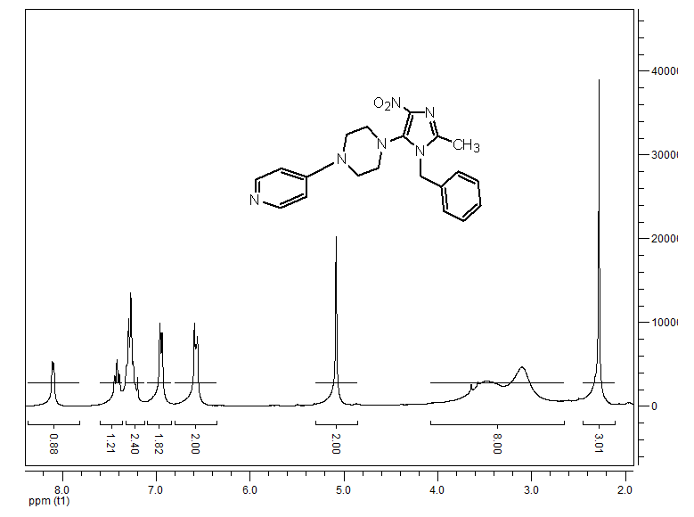
Fig. S1. ¹H NMR spectrum of 7

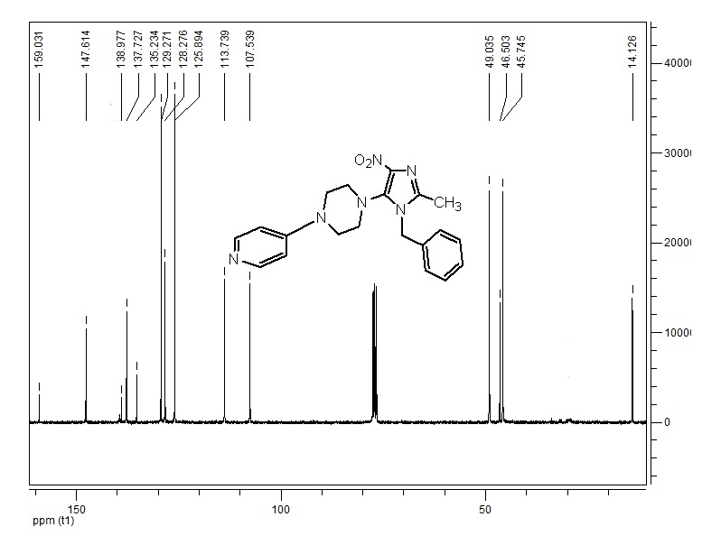
Fig. S2. ¹³C NMR spectrum of 7
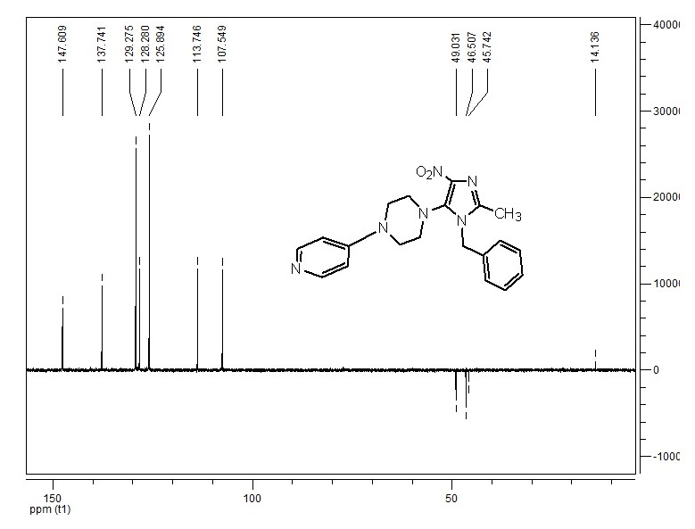
Fig. S3. DPET NMR spectrum of 7

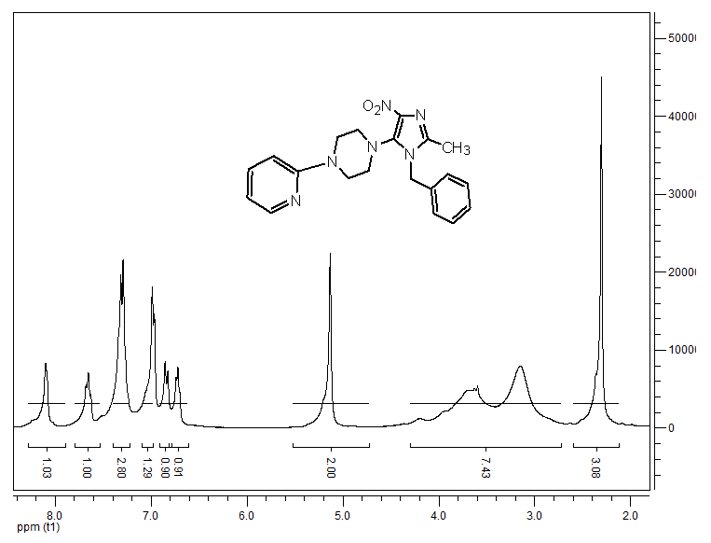
Fig. S4. ¹H NMR spectrum of 8
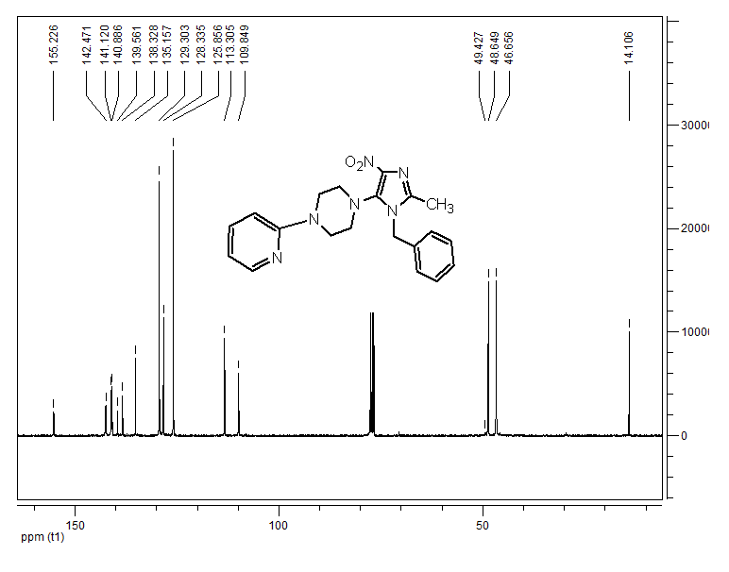
Fig. S5. ¹³C NMR spectrum of 8

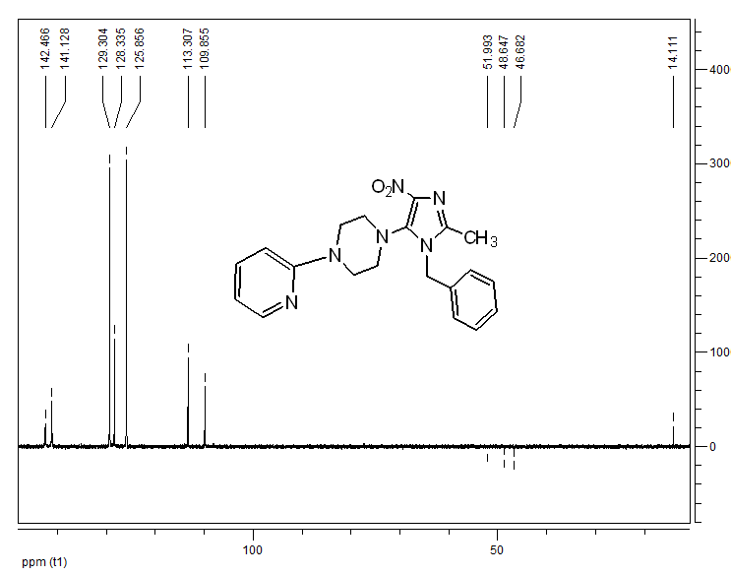
Fig. S6. DPET NMR spectrum of 8
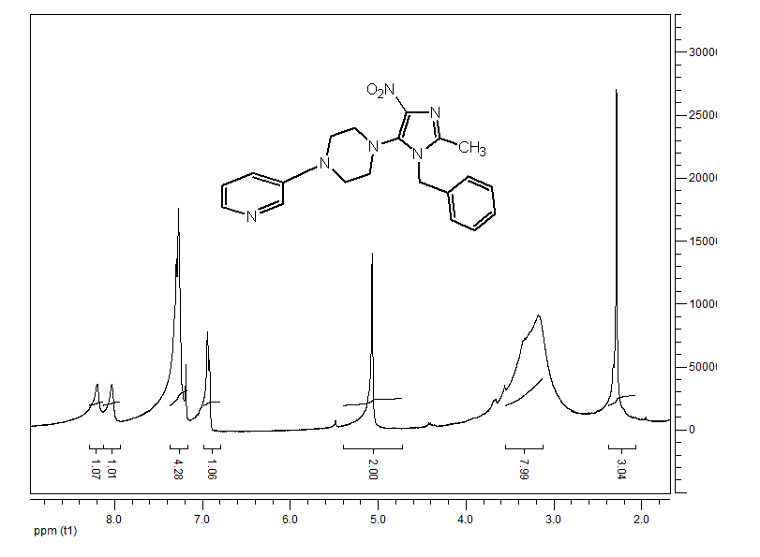
Fig. S7. ¹H NMR spectrum of 9

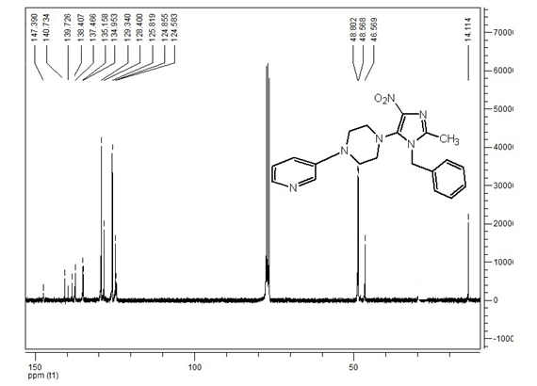
Fig. S8. ¹³C NMR spectrum of 9

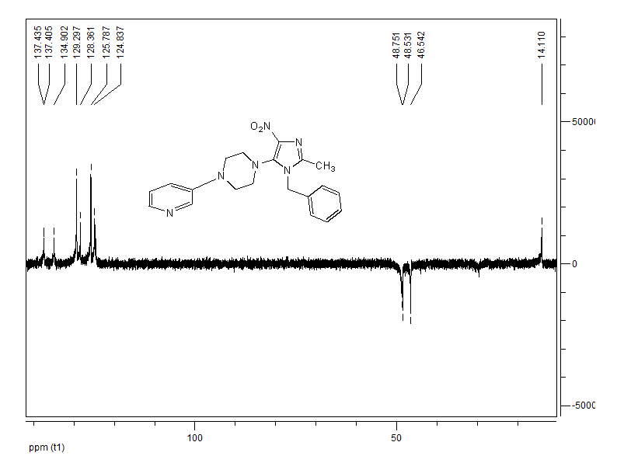
Fig. S9. DPET NMR spectrum of 9

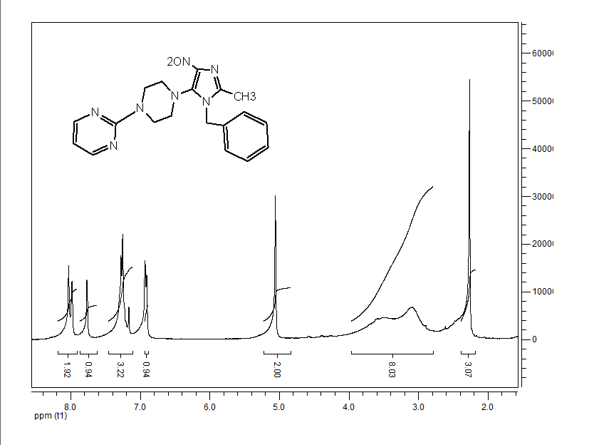
Fig. S10. ¹H NMR spectrum of 10

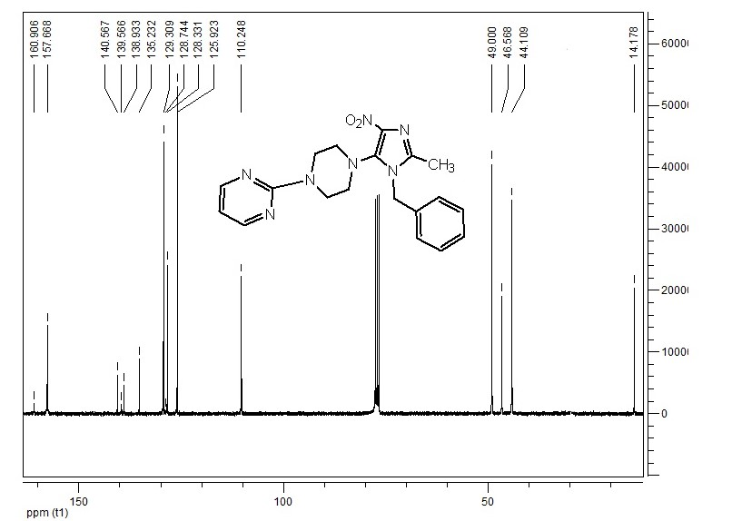
Fig. S11. ¹³C NMR spectrum of 10

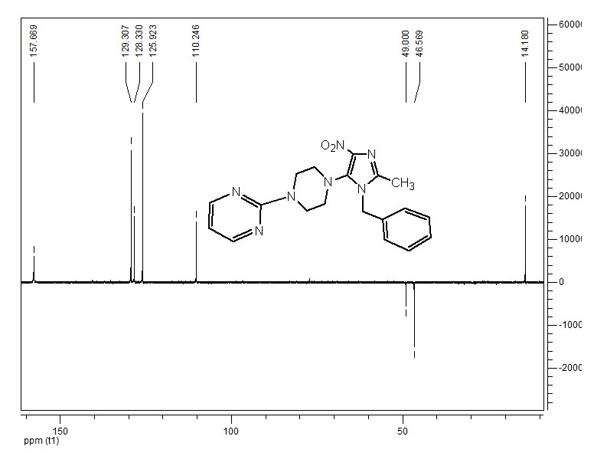
Fig. S12. DPET NMR spectrum of 10
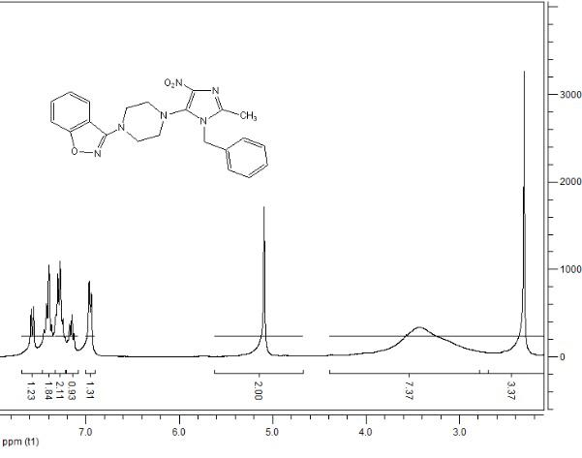
Fig. S13. ¹H NMR spectrum of 11

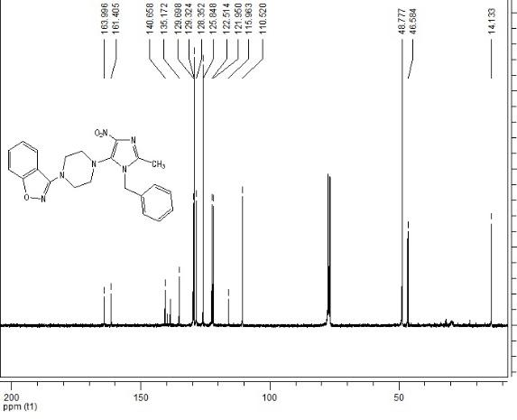
Fig. S14. ¹³C NMR spectrum of 11

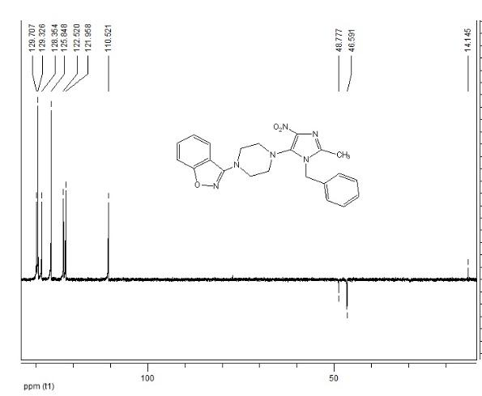
Fig. S15. DPET NMR spectrum of 11

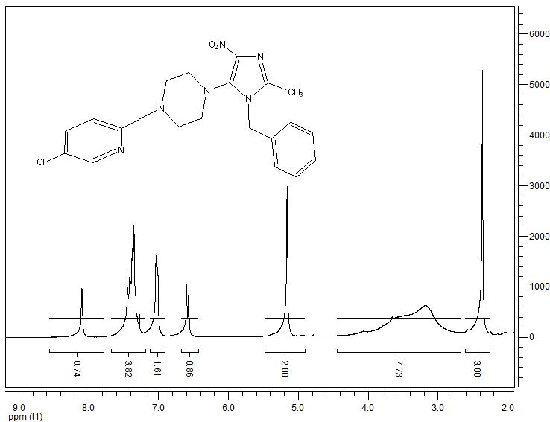
Fig. S16. ¹H NMR spectrum of 12

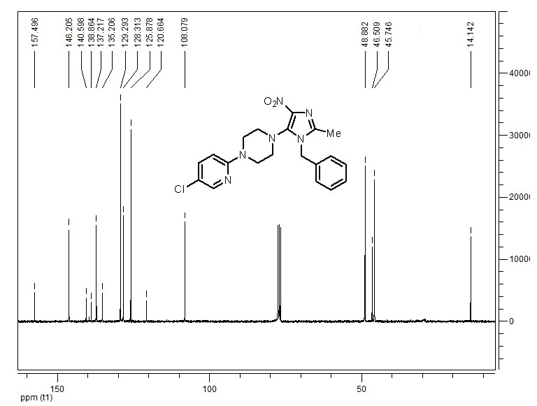
Fig. S17. ¹³C NMR spectrum of 12

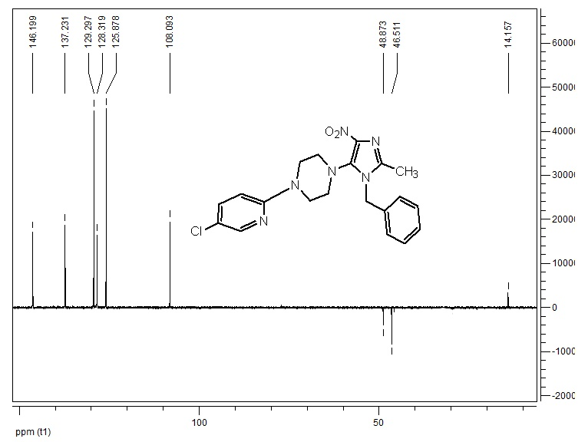
Fig. S18. DPET NMR spectrum of 12
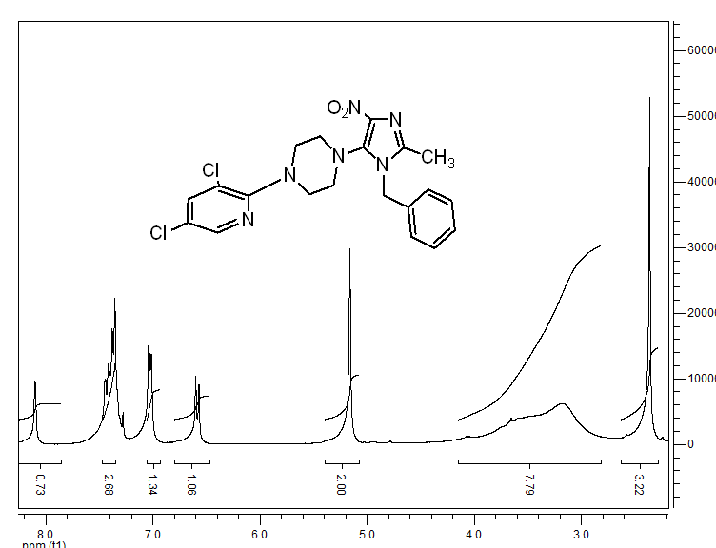
Fig. S19. ¹H NMR spectrum of 13

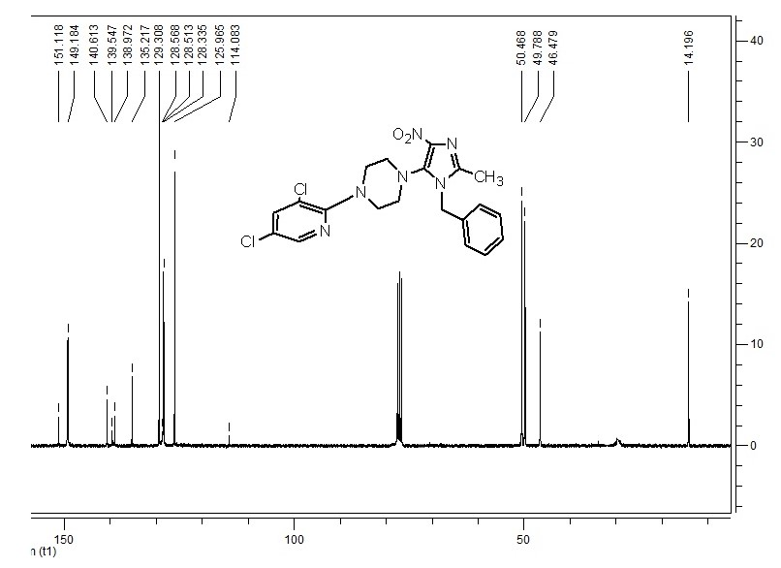
Fig. S20. ¹³C NMR spectrum of 13
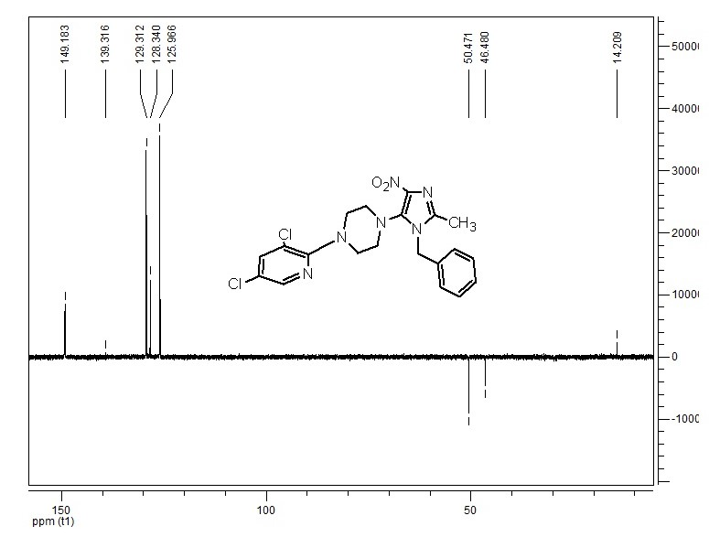
Fig. S21. DPET NMR spectrum of 13

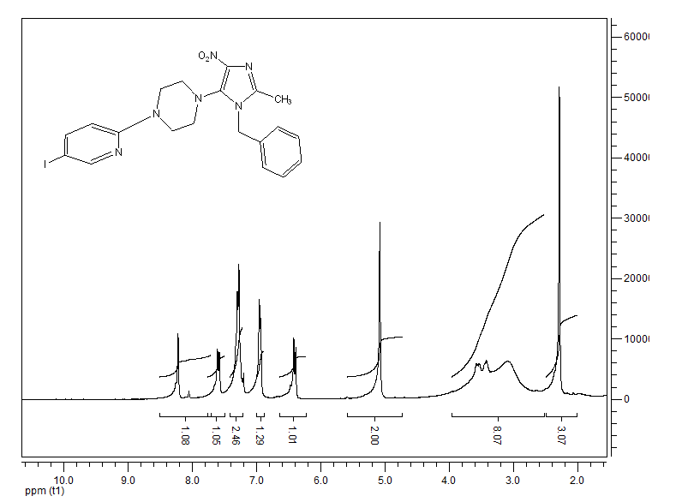
Fig. S22. ¹H NMR spectrum of 14
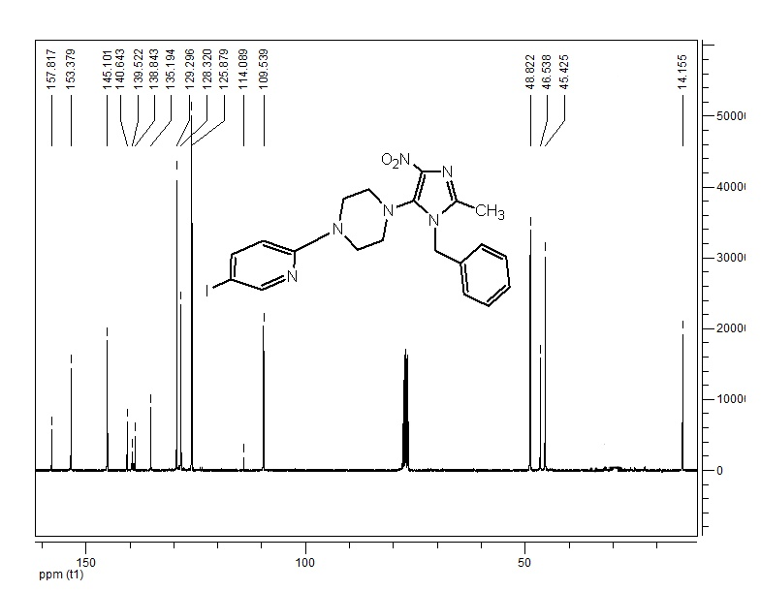
Fig. S23. ¹³C NMR spectrum of 14

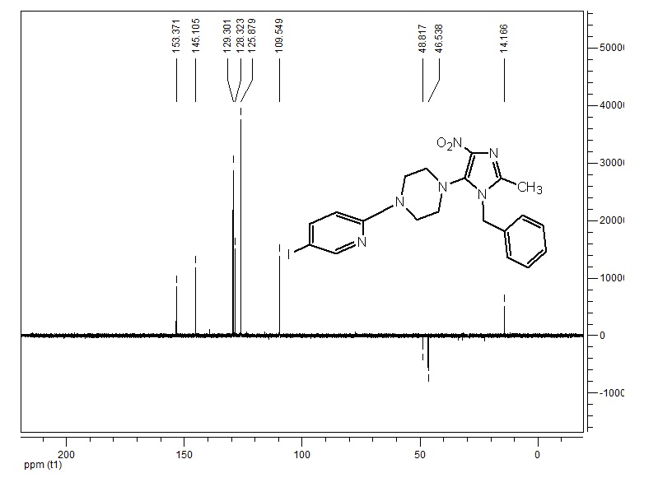
Fig. S24. DPET NMR spectrum of 14
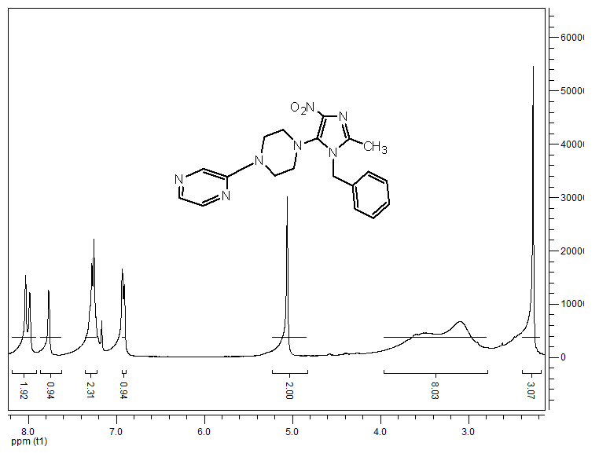
Fig. S25. ¹H NMR spectrum of 15

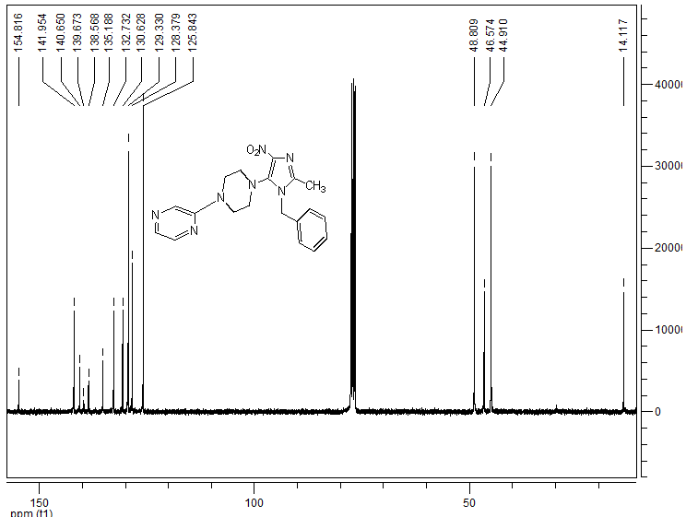
Fig. S26. ¹³C NMR spectrum of 15

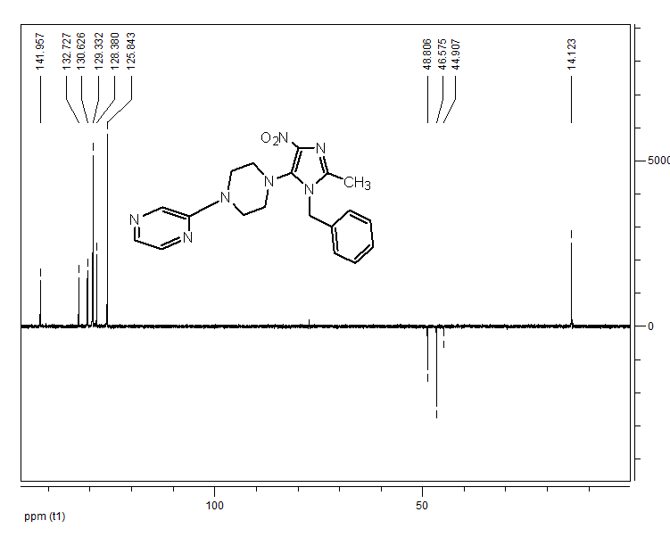
Fig. S27. DPET NMR spectrum of 15

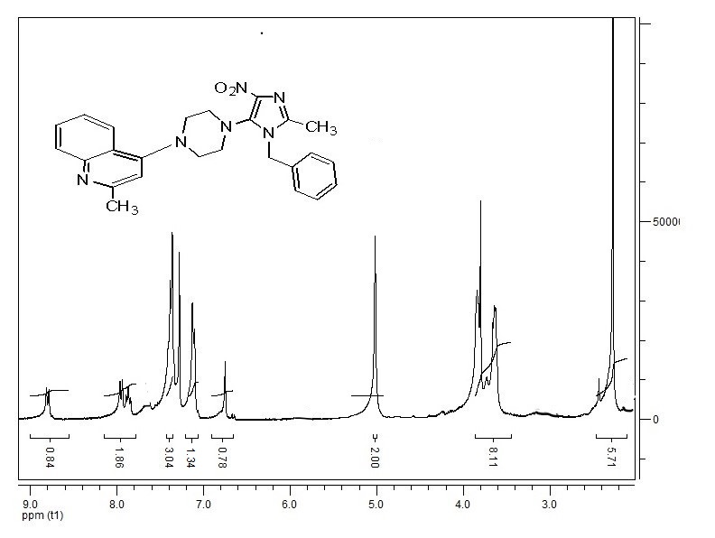
Fig. S28. ¹H NMR spectrum of 16
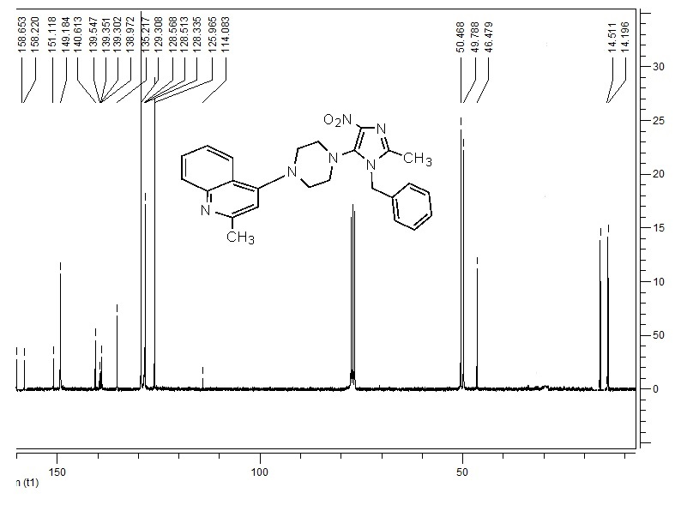
Fig. S29. ¹³C NMR spectrum of 16

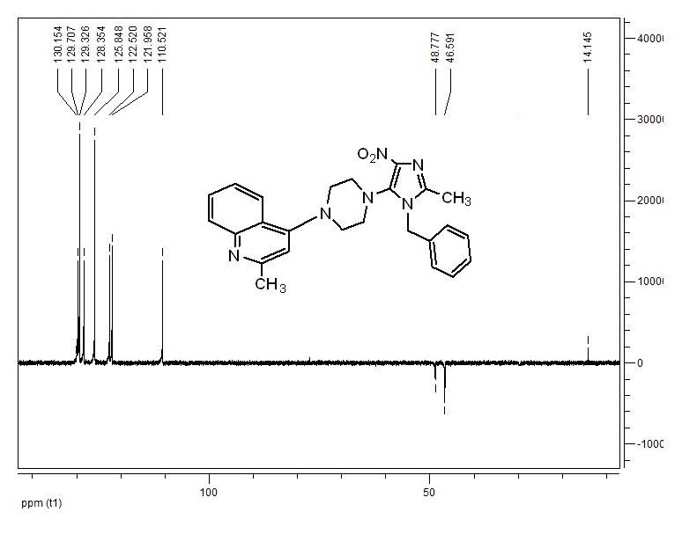
Fig. S30. DPET NMR spectrum of 16
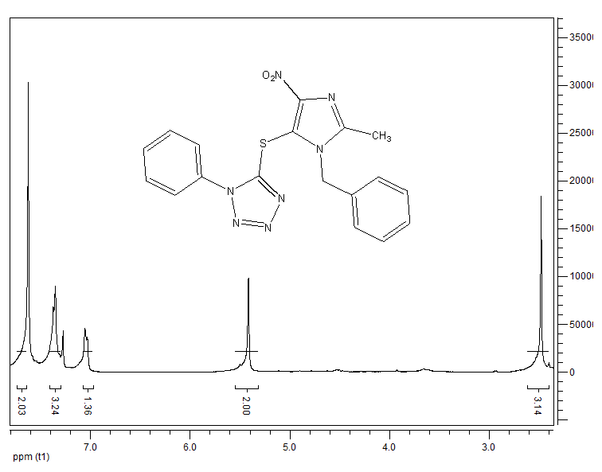
Fig. S31. ¹H NMR spectrum of 17

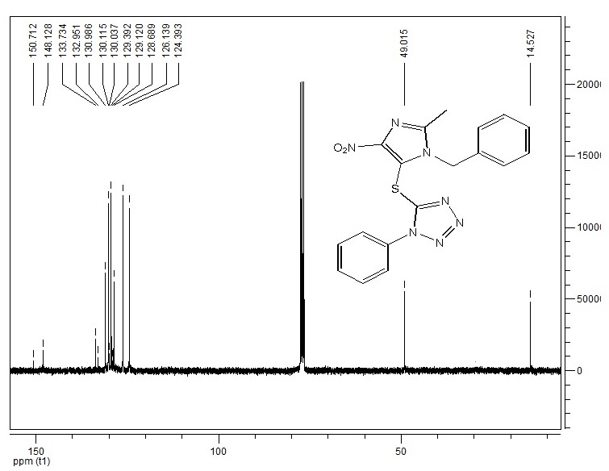
Fig. S32. ¹³C NMR spectrum of 17
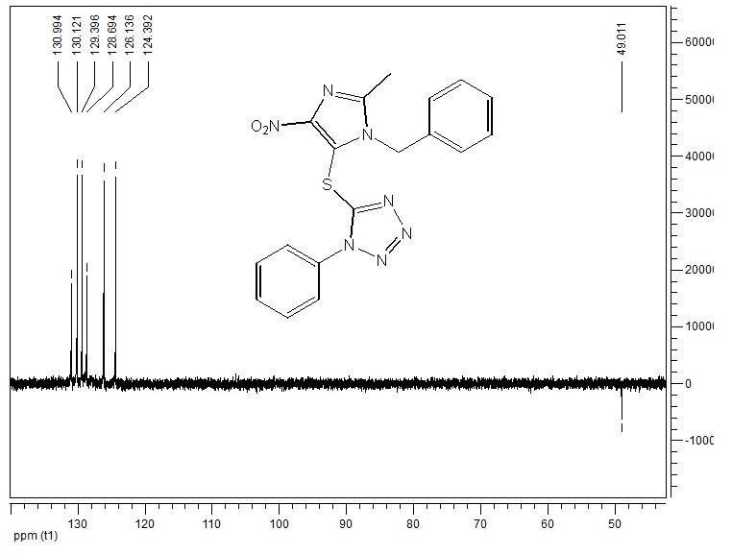
Fig. S33. DPET NMR spectrum of 17

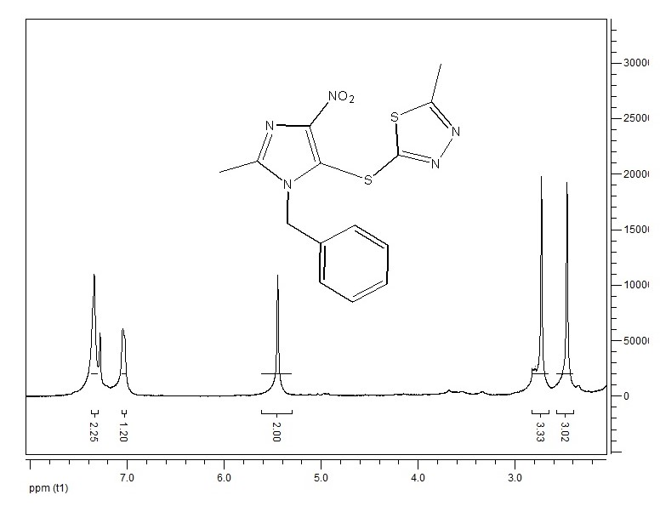
Fig. S34. ¹H NMR spectrum of 18
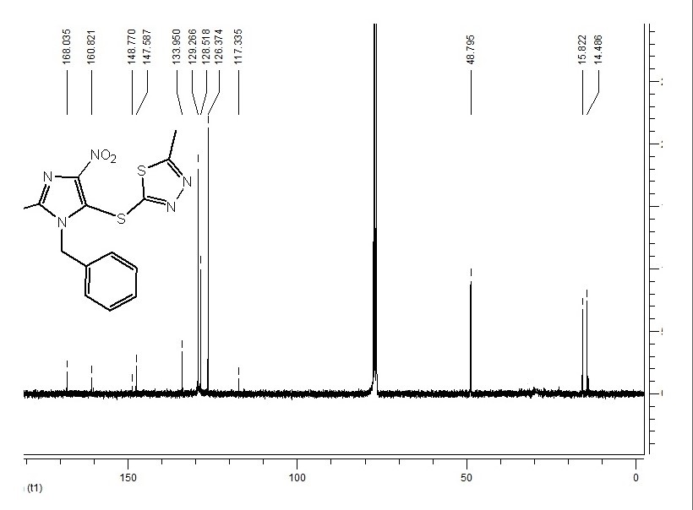
Fig. S35. ¹³C NMR spectrum of 18

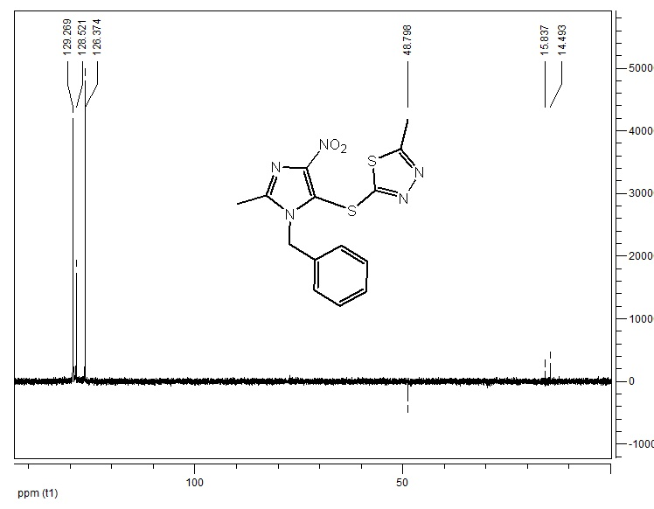
Fig. S36. DPET NMR spectrum of 18

