Supplementary Figures:
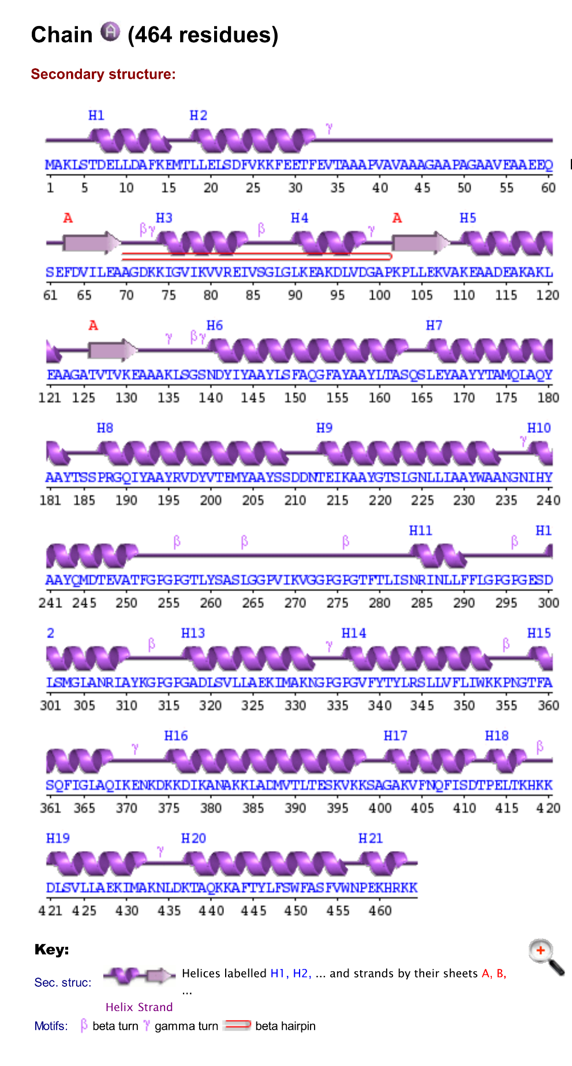

Fig. S1. Secondary structure of multiepitope vaccine construct.
Fig. S2. The B-cell discontinuous epitopes with a score value of more than 0.70.
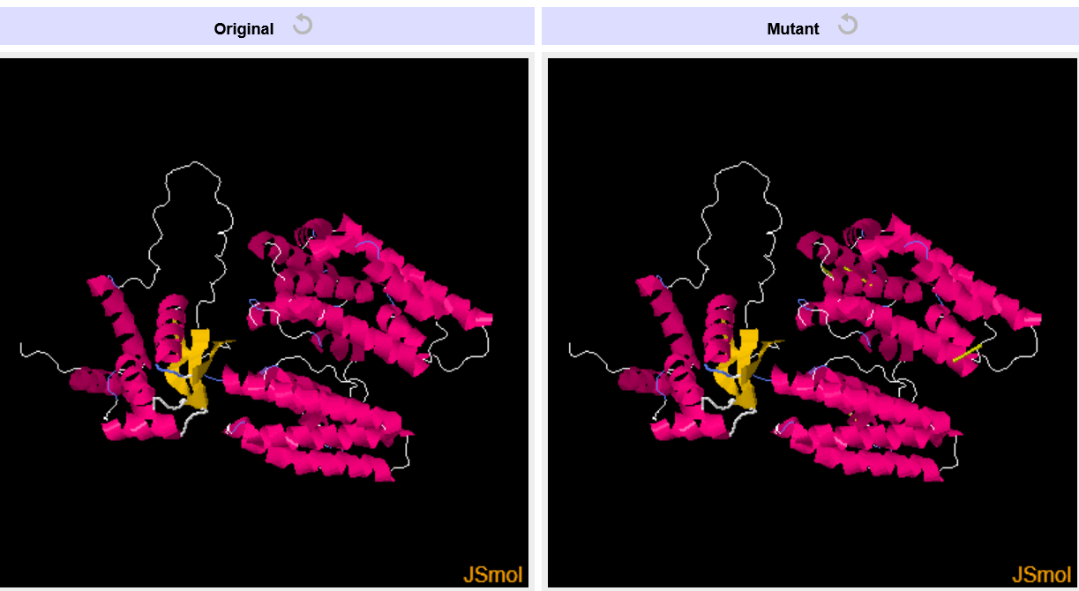

Fig. S3. Disulfide engineering of multiepitope vaccine construct.

