Supplemental Information for
The mechanism of room-temperature oxidation of a Ti₃C₂T_{x} MXene determined via environmental transmission electron microscopy and molecular dynamics
Yuying Liu^{†a,c}, Zhihao Shi^{†b}, Tingbin Liang^{†a}, Dehui Zhengª, Zhichao Yangª, Zhen Wangª, Jian Zhou^{b,}*, Shuangbao Wang^{a,c,d,}*
ªKey Laboratory of LCR Materials and Devices of Yunnan Province, National Center for International Research on Photoelectric and Energy Materials, School of Materials and Energy, Yunnan University, Kunming 650091, PR China
^{b}School of Iron and Steel, Soochow University, Suzhou, 215137, PR China
^{c}Collaborative Innovation Center of Renewable Energy Materials & School of Physical Science and Technology, Guangxi University, Nanning 530004, PR China
^{d}Electron Microscopy Center, Yunnan University, Kunming 650091, PR China
†These authors contributed equally to this work.
*Corresponding authors: E-mail: sbwang0617@ynu.edu.cn (S.B.W.); jzhou@suda.edu.cn (J.Z.)

Table of Contents:

1. Composition of pristine Ti₃C₂T_{x}
2. Microstructure and composition of oxidized Ti₃C₂T_{x}
3. Surface area analyses of the Ti₃C₂T_{x} before and after oxidation
4. Time-resolved oxidation viewed from basal plane of Ti₃C₂T_{x}
5. Effect of e⁻ beam on stability of Ti₃C₂T_{x}
6. Reactive MD simulations of oxidation of different crystal planes at RT
7. Reactive MD simulations of Ti₃C₂T_{x} oxidation at 900 K
8. Surface nature of different crystal planes at 300 K
Figure S1 to S12
Movie S1 to S5
References

- Composition of pristine Ti₃C₂T_{x}

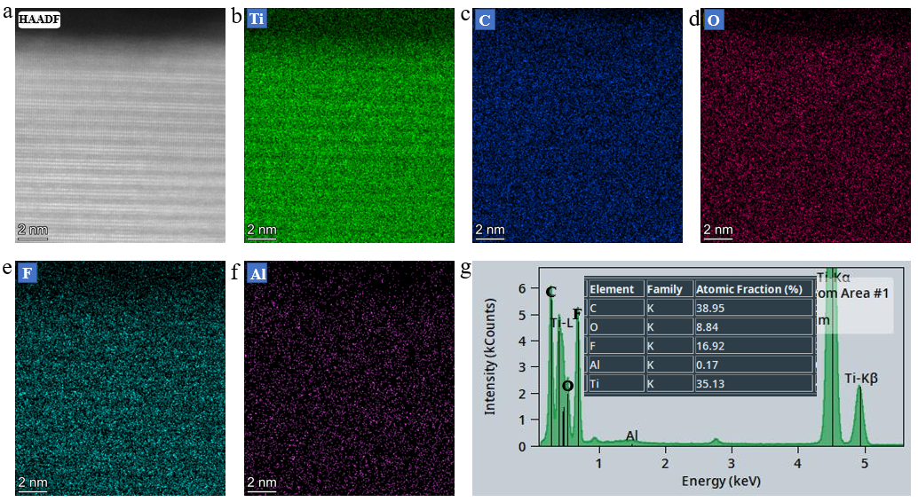
Figure S1 | STEM-EDS elemental analysis of the pristine Ti₃C₂T_{x}. a STEM-HAADF image. b-f Elemental mappings of Ti, C, O, F and Al from a. g EDS spectrum line acquired from a. Inset in g is the quantitative result of chemical composition, showing the residual Al in Ti₃C₂T_{x} sample.

- Microstructure and composition of oxidized Ti₃C₂T_{x}

It can be seen from Supplementary Fig. 2d that no additional diffraction spots are identified in the FFT image apart from diffraction spots of γ/α-type TiO₂ and amorphous rings of disordered regions. This implies the formation of nanocrystalline TiO₂ and completely decomposed Ti₃C₂T_{x} structure under the action of O₂. As a result, the irregular regions with bright contrast in the HAADF images of Supplementary Fig. 2a-c (e.g. the regions pointed by yellow arrows) arise from TiO₂ nano-islands and the supported amorphous 2D nanosheet according to the mass-thickness contrast of HAADF ¹. In contrast, the dark regions such as those pointed out by blue arrows in HAADF images indicate the gaps between TiO₂ islands on the C nanosheet.
Supplementary Fig. 3 shows the composition characteristics of Ti₃C₂T_{x} after exposure in air for 20 d at RT. It is seen that there is a largely increased O content (~42 at.%) in oxidized sample, as compared to the O content (~9 at.%) in pristine Ti₃C₂T_{x} shown in Supplementary Fig. 1.The unevenly distributed Ti and O in their elemental mappings confirm the composite structures of TiO₂ nano-islands on the C nanosheet. In addition, the nearly equal content of O and Ti indicates that not all Ti atoms in Ti₃C₂T_{x} structure forms TiO₂ during oxidation. Moreover, it is found that the dark regions have also the segregation of Ti, C, O, F, and Al, demonstrating the amorphous C nanosheets containing traces of Ti, O, F, and Al.

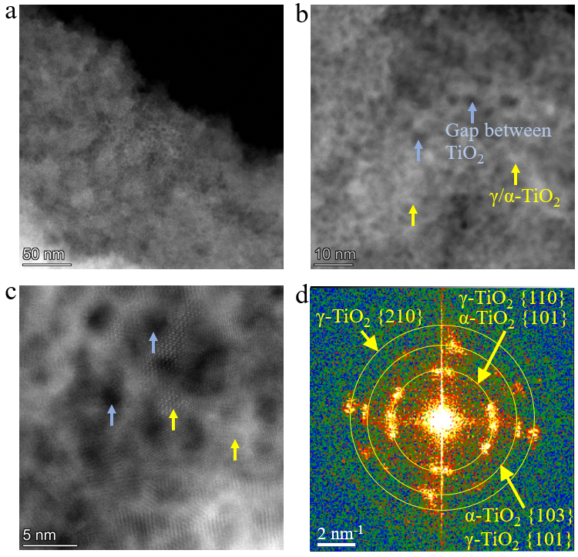
Figure S2 | HAADF-STEM characterizations of the Ti₃C₂T_{x} sample after exposure in air for 20 d at RT. a-c Representative HAADF images of the oxide nano-islands on the 2D nanosheet. d The indexed Fast Fourier transform (FFT) image of c, demonstrating the observed oxide islands belong to γ- and α-type TiO₂ nanocrystalline.

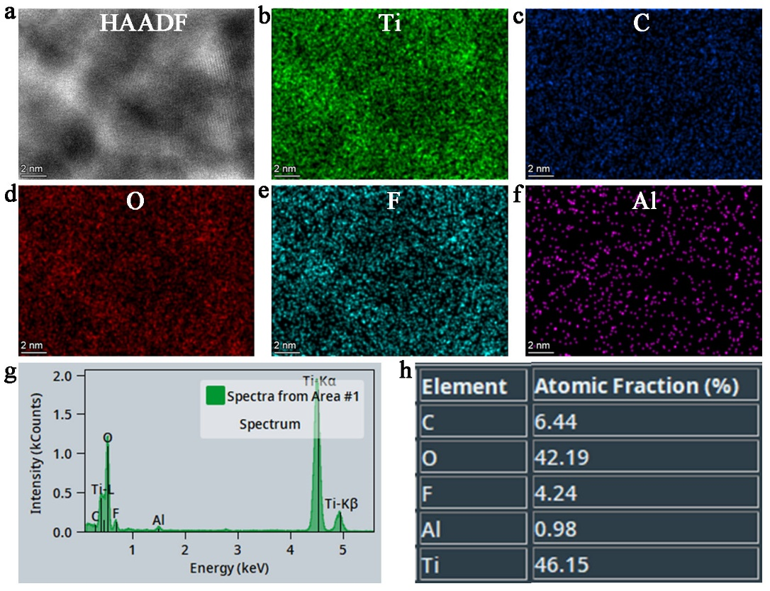
Figure S3 | STEM-EDS elemental analysis of the Ti₃C₂T_{x} after exposure in air for 20 d at RT. a STEM-HAADF image. b-f Elemental mappings of Ti, C, O, F and Al from a. g EDS spectrum line acquired from a. h The quantitative result of chemical composition, showing the significant O segregation in oxidized sample.

- Surface area analyses of the Ti₃C₂T_{x} before and after oxidation

Supplementary Fig. 4 shows the N₂ adsorption and desorption isotherm curves of the samples after oxidation for 30 min and 20 days in air at RT, which belong to typical type IV curve ². The calculation result shows the sample oxidized for 30 min has a specific surface area of ~7.19 m² g⁻¹, which fall in line with a previous report ³. The specific surface area decreases to ~3.68 m² g⁻¹ for the sample oxidized for 20 days.

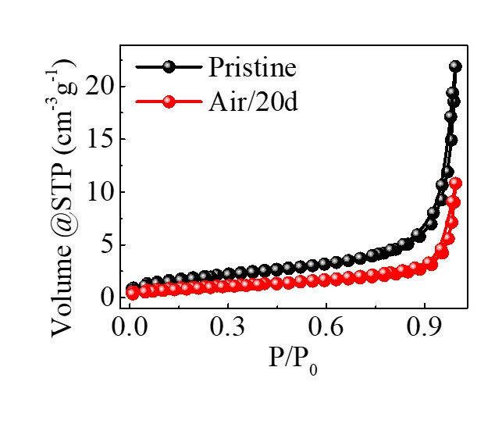
Figure S4 | N₂ adsorption/desorption curves at -196 °C of the Ti₃C₂T_{x} before and after exposure in air for 20 d at RT using the Brunauer-Emmett-Teller (BET) method.

- Time-resolved oxidation viewed from basal plane of Ti₃C₂T_{x}

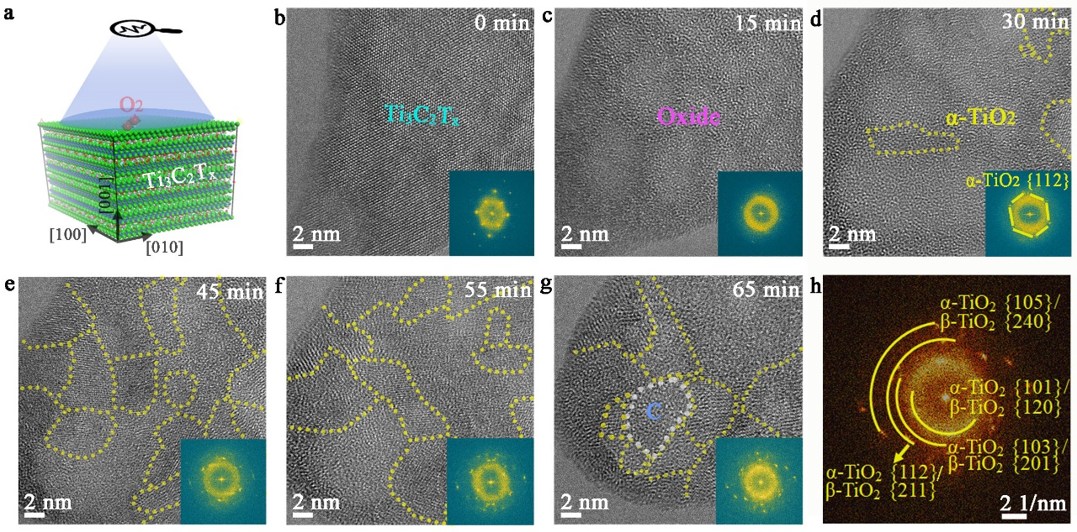
Figure S5 | Time-resolved plan-view AC-HRTEM images acquired from Ti₃C₂T_{x} oxidized for different time. a Schematic illustration showing the plan-view observation. b-g 0 min, 15 min, 30 min, 45 min, 55 min, and 65 min of reaction time, respectively. Insets show FFTs from corresponding HRTEM images. h The indexed FFT image of g, showing the coexistence of α- and β-TiO₂.

- Effect of e⁻ beam on stability of Ti₃C₂T_{x}

Under imaging conditions of the e⁻ beam dose rate below 10⁴ e/nm²·s, the atomic configuration of the Ti₃C₂T_{x} maintains unchanged even after 5 min of e⁻ beam exposure (Supplementary Fig. 6), suggesting the excellent stability of Ti₃C₂T_{x} under consecutive e⁻ beam irradiation when O₂ was missing. Moreover, the comparative experiments performed according to the procedures established by Gai.⁴ indicate that the surface structural change is identical under the controlled beam and blank beam conditions (Supplementary Fig. 7), meaning the negligible effect of the e⁻ beam on the intrinsic oxidation reaction.

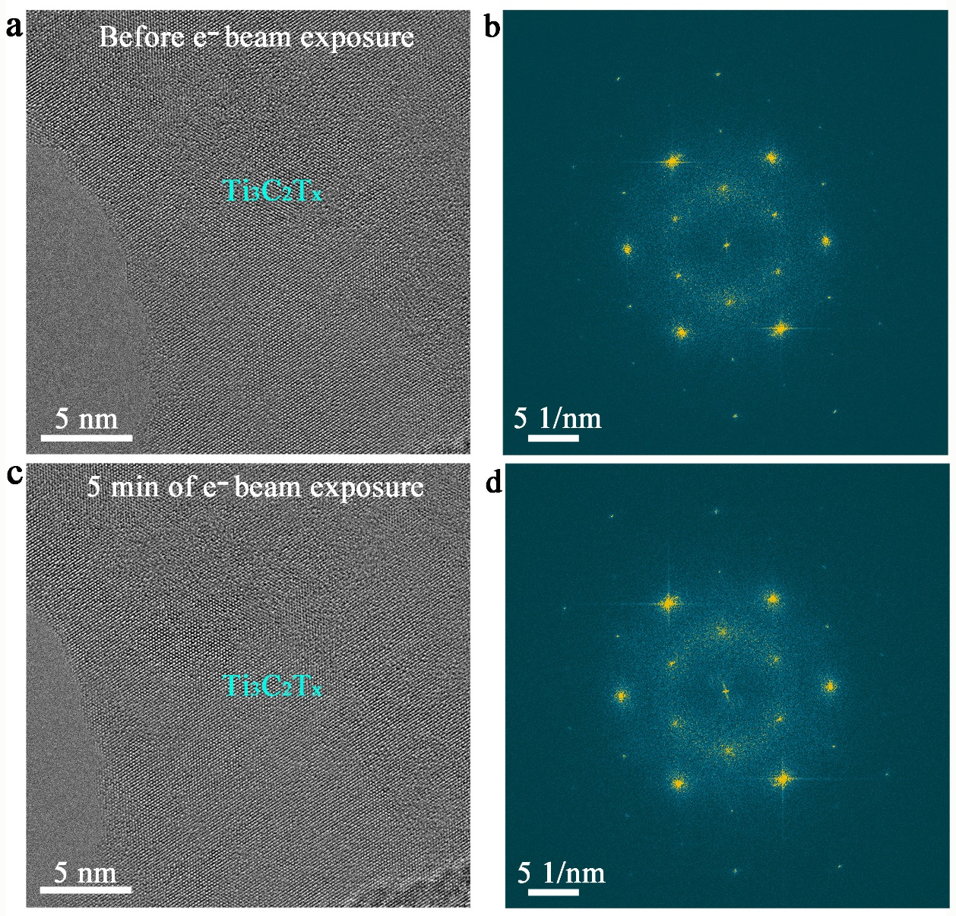
Figure S6 | Time-resolved plan-view AC-HRTEM images from Video S1 demonstrating excellent stability of Ti₃C₂T_{x} during e⁻ beam irradiation with electron dose rate of 10⁴ e/nm²·s in high vacuum column (gas pressure of ∼3 × 10⁻⁸ mbar) of ETEM. a and b HRTEM image and corresponding FFTs from the sample before e⁻ beam exposure. c and d HRTEM image and corresponding FFTs from the sample after continuous e⁻ beam exposure of 5 min.

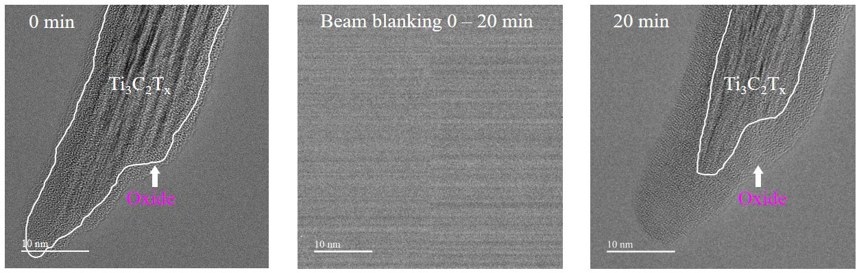
Figure S7 | The cross-sectional structural change of the Ti₃C₂T_{x} upon exposure to a continuous flow of O₂ gas at RT and pO2 ≈ 10⁻² mbar under a beam-blanking condition, showing a continuous oxide formation (in an amorphous form) on the Ti₃C₂T_{x} without e⁻ beam illumination.

- Reactive MD simulations of oxidation of different crystal planes at RT

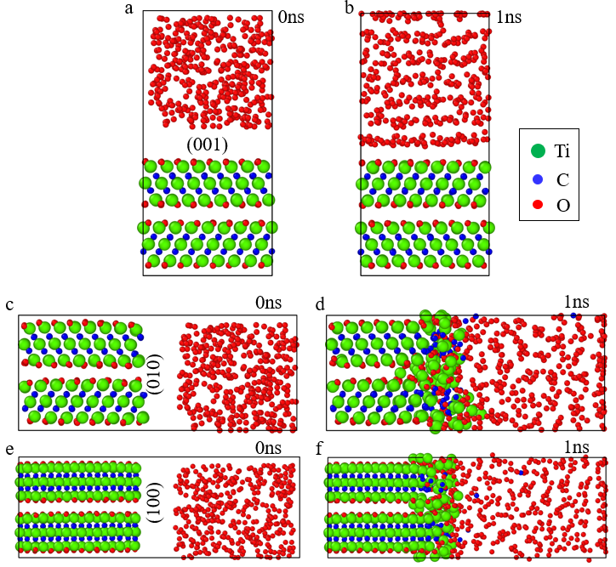
Figure S8 | Structural changes occurred on different crystal planes of Ti₃C₂O₂ before and after exposing in O₂ for 1 ns at 300 K obtained by reactive MD simulations, showing the unreacted (001) plane after oxidizing for 1 ns. a and b The crystal plane (001). c and d The crystal plane (010). e and f The crystal plane (100).

- Reactive MD simulations of Ti₃C₂T_{x} oxidation at 900 K

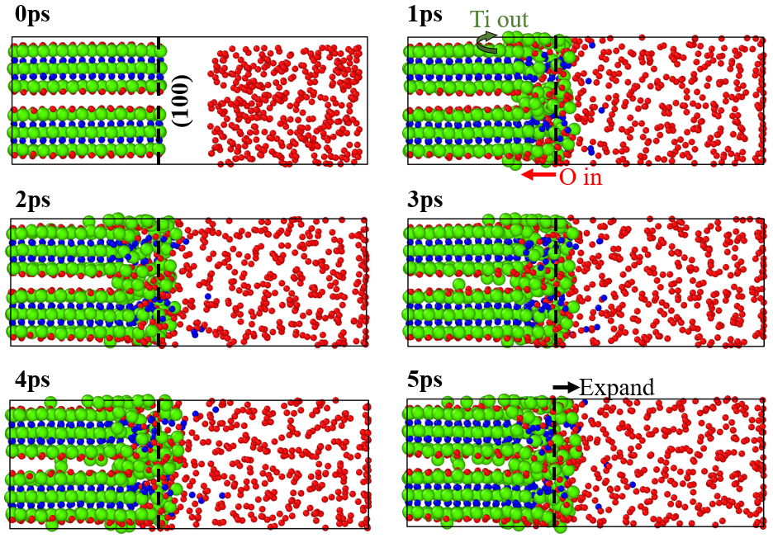
Figure S9 | Snapshots of early-stage oxidation occurred on the (100) plane of Ti₃C₂T_{x} obtained by reactive MD simulations at 900 K. The dotted lines indicate the original positions of (100) surface.

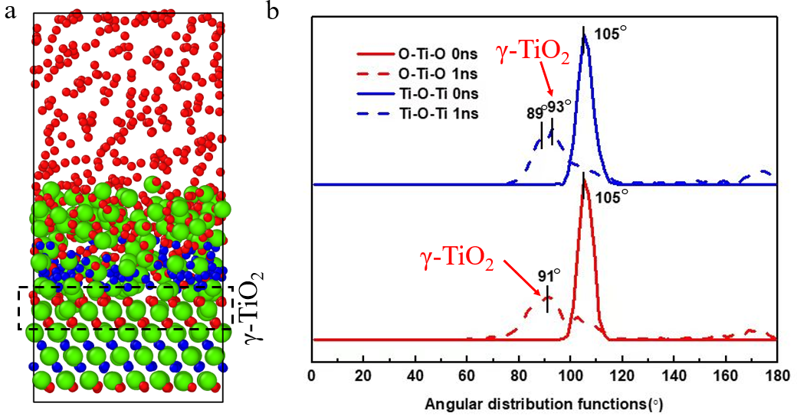
Figure S10 | The γ-TiO₂ phase detected by reactive MD simulations at 900 K and 1 ns. a The Snapshot of the oxidation occurred on the (001) plane of Ti₃C₂O₂. b The bond angle analysis of O-Ti-O and Ti-O-Ti before and after oxidation reactions. The dotted box in a indicate the formed γ-TiO₂ phase.

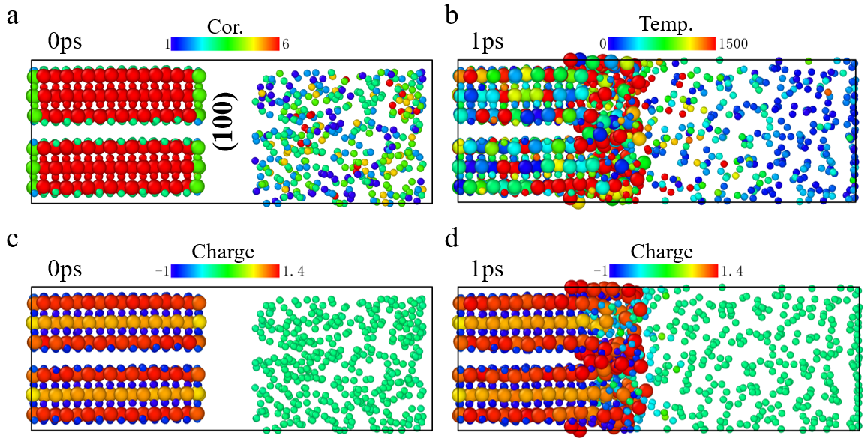
Figure S11 | The nature of interface between Ti₃C₂O₂ (100) and O₂ molecules before and after oxidation for 1 ps at 900 K calculated from ReaxFF favored MD simulations. a-d The (100) plane-associated coordination before reaction, temperature variation after reaction, and charge distribution before and after reaction, respectively. Cor., coordination; Temp., temperature.

- Surface nature of different crystal planes at 300 K

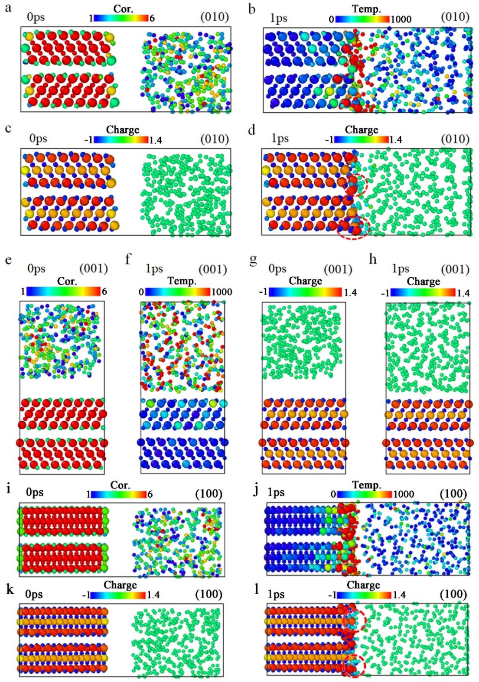
Figure S12 | The nature of different interfaces between Ti₃C₂O₂ and O₂ molecules before and after oxidation for 1 ps at 300 K calculated from ReaxFF favored MD simulations. a-d, e-h and i-l The (010), (001) and (100) plane-associated coordination before reaction, temperature variation after reaction, and charge distribution before and after reaction, respectively.

Captions for the in-situ captured movies

Movie S1:

In-situ atomic-scale observation demonstrating the excellent stability of Ti₃C₂T_{x} during e⁻ beam irradiation with electron dose rate of 10⁴ e/nm²·s in high vacuum column (gas pressure of ∼3 × 10⁻⁸ mbar) of ETEM. The video is 16 times faster than actual time.

Movie S2:

In-situ atomic-scale observation of early-stage oxidation process of Ti₃C₂T_{x} in O₂ viewed from cross section.

Movie S3:

In-situ low-magnification HRTEM observation of long-time O₂ exposure of Ti₃C₂T_{x} viewed from cross section.

Movie S4:

In-situ atomic-scale observation of the oxidation process of Ti₃C₂T_{x} in O₂ viewed from basal plane.

Movie S5:

In-situ reactive MD simulations showing a thin γ-TiO₂ with a thickness of 3 atomic layers beneath the disordered region at 29 ps. The reaction time in the movie ranges from 4 ps to 29 ps.

References:
1 Nellist, P. D. & Pennycook, S. J. Incoherent imaging using dynamically scattered coherent electrons. Ultramicroscopy 78, 111-124 (1999).
2 Buttersack, C. Modeling of type IV and V sigmoidal adsorption isotherms. Phys. Chem. Chem. Phys. 21, 5614-5626 (2019).
3 Yang, X., Yao, Y., Wang, Q., Zhu, K., Ye, K., Wang, G., Cao, D. & Yan, J. 3D Macroporous Oxidation-Resistant Ti3C2Tx MXene Hybrid Hydrogels for Enhanced Supercapacitive Performances with Ultralong Cycle Life. Adv. Funct. Mater. 32, 2109479 (2022).
4 Gai, P. L., Boyes, E. D., Helveg, S., Hansen, P. L., Giorgio, S. & Henry, C. R. Atomic-Resolution Environmental Transmission Electron Microscopy for Probing Gas–Solid Reactions in Heterogeneous Catalysis. MRS Bulletin 32, 1044-1050 (2007).

